NurseRoster.jar生成操作说明
一、在optaplanner-examples项目中删除与nurserostering（排班）无关的包，只留下如图一所示的包
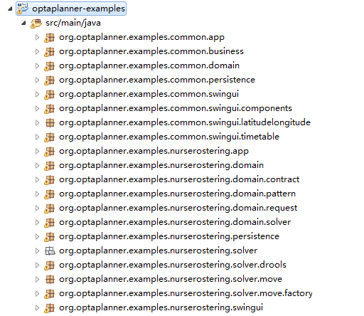
图一
二、修改相关代码
1、增加类。在org.optaplanner.examples.common.swingui包中添加SolverAndPersistence类。
package org.optaplanner.examples.common.swingui;

import java.io.File;
import java.io.PrintStream;
import java.util.concurrent.ExecutionException;
import java.util.concurrent.TimeUnit;

import javax.swing.SwingWorker;

import org.optaplanner.examples.common.business.SolutionBusiness;
import org.slf4j.Logger;
import org.slf4j.LoggerFactory;

public class SolverAndPersistence<Solution_> {
protected final transient Logger logger = LoggerFactory.getLogger(getClass());

private final SolutionBusiness<Solution_> solutionBusiness;

public SolverAndPersistence(SolutionBusiness<Solution_> solutionBusiness) {
this.solutionBusiness = solutionBusiness;
}

public String init(String path, PrintStream stddOut, PrintStream ps, int seconds) {
File file = new File(path);
try {
solutionBusiness.openSolution(file);
} catch (Exception e) {
e.printStackTrace(ps);
stddOut.println(0);
return "File：" + file.getAbsolutePath() + " openSolution error!";
}
Solution_ planningProblem = solutionBusiness.getSolution();
Thread thread = new Thread(new SolveWorker2(planningProblem));
thread.start();
if (seconds != 0) {
try {
TimeUnit.SECONDS.timedJoin(thread, seconds);
} catch (Exception e) {
e.printStackTrace(ps);
stddOut.println(0);
return "Son thread error!";
}
if (thread.isAlive()) {
solutionBusiness.terminateSolvingEarly();
}
} else {
try {
thread.join();
} catch (Exception e) {

e.printStackTrace(ps);
stddOut.println(0);
return "Son thread error!";
}
}

File exportFile = new File(path.replaceAll("\\.xml$", "") + "_solved.xml");
try {
solutionBusiness.exportSolution(exportFile);
} catch (Exception e) {
e.printStackTrace(ps);
stddOut.println(0);
return "Solution export error!";
}
stddOut.println(1);
return exportFile.getAbsolutePath();
}

protected class SolveWorker2 implements Runnable {

protected final Solution_ planningProblem;

public SolveWorker2(Solution_ planningProblem) {
this.planningProblem = planningProblem;
}

@Override
public void run() {
Solution_ bestSolution = solutionBusiness.solve(planningProblem);
solutionBusiness.setSolution(bestSolution);
}
}
}

2、修改类。
- 删除所有类中的main方法。
- 在org.optaplanner.examples.common.business包 SolutionBusiness类中增加public void registerForBestSolutionChanges(final SolverAndPersistence solverAndPersistence)方法。
public void registerForBestSolutionChanges(final SolverAndPersistence solverAndPersistence) {
solver.addEventListener(event -> {
// Called on the Solver thread, so not on the Swing Event thread
/*
* Avoid ConcurrentModificationException when there is an unprocessed ProblemFactChange
* because the paint method uses the same problem facts instances as the Solver's workingSolution
* unlike the planning entities of the bestSolution which are cloned from the Solver's workingSolution
*/
if (solver.isEveryProblemFactChangeProcessed()) {
// The final is also needed for thread visibility
final Solution_ newBestSolution = event.getNewBestSolution();
skipToBestSolutionRef.set(newBestSolution);
SwingUtilities.invokeLater(() -> {
// Called on the Swing Event thread
Solution_ skipToBestSolution = skipToBestSolutionRef.get();
// Skip this event if a newer one arrived meanwhile to avoid flooding the Swing Event thread
if (newBestSolution != skipToBestSolution) {
return;
}
guiScoreDirector.setWorkingSolution(newBestSolution);
});
}
});
}

- 在org.optaplanner.examples.common.business包 SolutionBusiness类中修改了public void terminateSolvingEarly()方法。
public void terminateSolvingEarly() {
solver.terminateEarly();
Solution_ solution = solver.getBestSolution();
this.setSolution(solution);
}

- 在org.optaplanner.examples.common.persistence包AbstractSolutionDao类中删除public AbstractSolutionDao(String dirName)构造方法。
public AbstractSolutionDao(String dirName) {
this.dirName = dirName;
}

- 在org.optaplanner.examples.nurserostering.app包NurseRosteringApp类中增加public String init(String path, PrintStream stddOut, PrintStream ps, int secondes)和public SolutionBusiness<NurseRoster> createSolutionBusiness()方法，并添加了main方法（程序入口函数）。
public String init(String path, PrintStream stddOut, PrintStream ps, int secondes) {
solutionBusiness = createSolutionBusiness();
solverAndPersistence = new SolverAndPersistence<>(solutionBusiness);
return solverAndPersistence.init(path, stddOut, ps, secondes);
}

public SolutionBusiness<NurseRoster> createSolutionBusiness() {
SolutionBusiness<NurseRoster> solutionBusiness = new SolutionBusiness<>(this);
solutionBusiness.setSolutionDao(createSolutionDao());
solutionBusiness.setExporter(createSolutionExporter());
solutionBusiness.setSolver(createSolver());
return solutionBusiness;
}

public static void main(String[] args){
if (args.length == 0) return;
PrintStream stddOut = System.out;
PrintStream ps = null;
PrintStream pss = null;
try {
ps = new PrintStream(new FileOutputStream("D:\\NurseRoster.log", true));
} catch (FileNotFoundException e) {
System.out.println("D:\\NurseRoster.log");
return;

}
try {
pss = new PrintStream(new FileOutputStream("D:\\NurseRoster.debug.log", true));
} catch (FileNotFoundException e) {
e.printStackTrace(ps);
}

int seconds = 0;
if (args.length >= 2) {
try {
seconds = Integer.parseInt(args[1]);
} catch (Exception e) {
e.printStackTrace(ps);
}
}

System.setOut(pss);
String filePath = new NurseRosteringApp().init(args[0], stddOut, ps, seconds);
System.out.println(filePath);
ps.close();
pss.close();
System.exit(0);
}

- 修改该maven项目的pom.xml文件。替换原文件中的<build></build>中的内容为如下内容。
<build>
<resources>
<resource>
<directory>src/main/java</directory>
<includes>
<include>**/*.*</include>
</includes>
</resource>
<resource>
<directory>src/main/resources</directory>
<includes>
<include>**/*.*</include>
</includes>
</resource>
</resources>

<pluginManagement>
<plugins>
<plugin>
<groupId>org.apache.maven.plugins</groupId>
<artifactId>maven-assembly-plugin</artifactId>
<configuration>
<archive>
<manifest> <mainClass>org.optaplanner.examples.nurserostering.app.NurseRosteringApp
</mainClass>
</manifest>
</archive>
<descriptorRefs>
<descriptorRef>jar-with-dependencies</descriptorRef>
</descriptorRefs>
</configuration>
</plugin>
</plugins>
</pluginManagement>
</build>

- 打包代码，获取NurseRoster.jar
- 使用maven命令：clean package assembly:single -Dcheckstyle.skip=true -Dmaven.test.skip=true对项目进行打包。具体操作如下：
第一步：更新项目。
选中项目，鼠标右键-->Maven-->Update Project...
第二步：使用maven命令打包。
选中项目，鼠标右键-->Run As-->5 Maven build...出现如图二所示界面，在红色箭头处输入“clean package assembly:single -Dcheckstyle.skip=true -Dmaven.test.skip=true”命令，点击“Run”按钮，等待一段时间（大概30秒左右）即可完成打包。
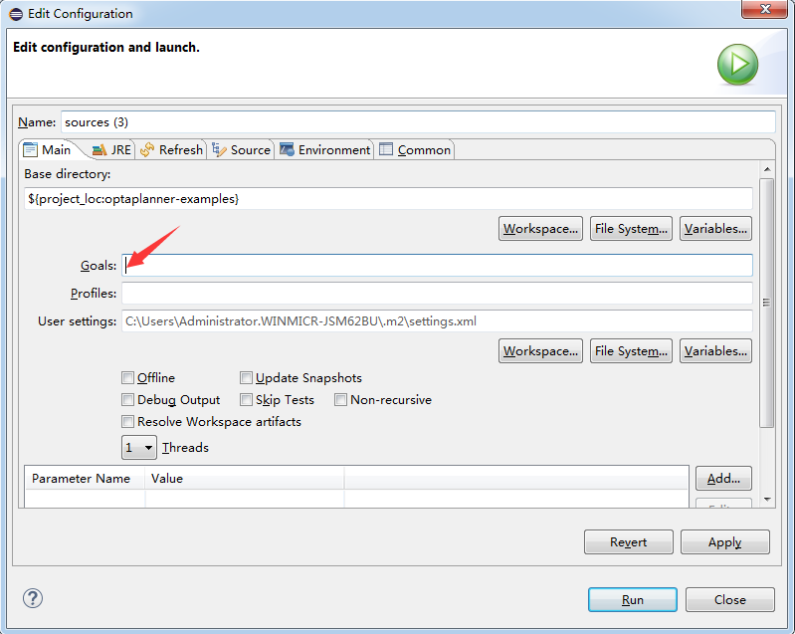
- 通过打包命令，在项目主目录下会生成一个target文件夹，该文件夹下有一个名为optaplanner-examples-7.0.0.Final-jar-with-dependencies.jar的jar包，该jar包即为我们所需要的NurseRoster.jar，重命名即可。
- 源代码在Windows和Linux中的区别
区别：在程序入口函数中，Windows中的两个日志文件路分别为“D:\\NurseRoster.log”和“D:\\NurseRoster.debug.log”，Linux中的两个日志文件路分别为“/data/logs/NurseRoster.log”和“/data/logs/NurseRoster.debug.log”。文件路径可根据需要自行修改。
注意：以上所有内容皆是使用eclipse完成。

