新建类SolverAndPersistence
package org.optaplanner.examples.common.swingui;

import java.io.File;
import java.io.PrintStream;
import java.util.concurrent.ExecutionException;
import java.util.concurrent.TimeUnit;

import javax.swing.SwingWorker;

import org.optaplanner.core.api.solver.Solver;
import org.optaplanner.examples.common.business.SolutionBusiness;
import org.slf4j.Logger;
import org.slf4j.LoggerFactory;

public class SolverAndPersistence<Solution_> {
protected final transient Logger logger = LoggerFactory.getLogger(getClass());

private final SolutionBusiness<Solution_> solutionBusiness;

public SolverAndPersistence(SolutionBusiness<Solution_> solutionBusiness) {
this.solutionBusiness = solutionBusiness;
}

public String init(String path, PrintStream stddOut, PrintStream ps, int seconds) {
File file = new File(path);
try {
solutionBusiness.openSolution(file);
} catch (Exception e) {
e.printStackTrace(ps);
stddOut.println(0);
return "File：" + file.getAbsolutePath() + " openSolution error!";
}
Solution_ planningProblem = solutionBusiness.getSolution();
SolveWorker solveWorker = new SolveWorker(planningProblem);
solveWorker.execute();
// Thread thread = new Thread(new SolveWorker(planningProblem));
// thread.start();
if (seconds != 0) {
try {
Thread.sleep(seconds * 1000);
} catch (InterruptedException e) {
e.printStackTrace(ps);
stddOut.println(0);
return "Son thread error!--1";
}
solutionBusiness.terminateSolvingEarly();
Solver<Solution_> solver = solutionBusiness.getSolver();
if (solver.isTerminateEarly()) {
Solution_ solution = solver.getBestSolution();
solutionBusiness.setSolution(solution);
}

// try {
// TimeUnit.SECONDS.timedJoin(thread, seconds);
// } catch (Exception e) {
// e.printStackTrace(ps);
// stddOut.println(0);
// return "Son thread error!";
// }
// if (thread.isAlive()) {
// solutionBusiness.terminateSolvingEarly();
// Solver<Solution_> solver = solutionBusiness.getSolver();
// if (solver.isTerminateEarly()) {
// Solution_ solution = solver.getBestSolution();
// solutionBusiness.setSolution(solution);
// }
// }
} else {
while (true) {
if (!solveWorker.getFlag()) {
try {
Thread.sleep(10 * 1000);
} catch (InterruptedException e) {
e.printStackTrace(ps);
stddOut.println(0);
return "Son thread error!--2";
}
} else {
break;
}
}

// try {
// thread.join();
// } catch (Exception e) {
// e.printStackTrace(ps);
// stddOut.println(0);
// return "Son thread error!";
// }
}

File exportFile = new File(path.replaceAll("\\.xml$", "") + "_solved.xml");
try {
solutionBusiness.exportSolution(exportFile);
} catch (Exception e) {
e.printStackTrace(ps);
stddOut.println(0);
return "Solution export error!";
}
stddOut.println(1);
return exportFile.getAbsolutePath();
}

protected class SolveWorker2 implements Runnable {

protected final Solution_ planningProblem;

public SolveWorker2(Solution_ planningProblem) {
this.planningProblem = planningProblem;
}
@Override
public void run() {
Solution_ bestSolution = solutionBusiness.solve(planningProblem);
solutionBusiness.setSolution(bestSolution);
}
}

protected class SolveWorker extends SwingWorker<Solution_, Void> {

protected final Solution_ planningProblem;
private boolean flag = false;

public SolveWorker(Solution_ planningProblem) {
this.planningProblem = planningProblem;
}

public boolean getFlag() {
return this.flag;
}

@Override
protected Solution_ doInBackground() throws Exception {
return solutionBusiness.solve(planningProblem);
}

@Override
protected void done() {
try {
Solution_ bestSolution = get();
solutionBusiness.setSolution(bestSolution);
flag = true;
} catch (InterruptedException e) {
Thread.currentThread().interrupt();
throw new IllegalStateException("Solving was interrupted.", e);
} catch (ExecutionException e) {
throw new IllegalStateException("Solving failed.", e.getCause());
} finally {
System.out.println("Solved.");
}
}

}
}

设置主方法入口
public static void main(String[] args){
if (args.length == 0) return;
PrintStream stddOut = System.out;
PrintStream ps = null;
PrintStream pss = null;
try {
ps = stddOut;
//ps = new PrintStream(new FileOutputStream("/data/logs/NurseRoster.log", true));
} catch (Exception e) {
//System.out.println("/data/logs/NurseRoster.log not exist.");
return;
}
pss = stddOut;
try {
//pss = new PrintStream(new FileOutputStream("/data/logs/NurseRoster.debug.log", true));
} catch (Exception e) {
e.printStackTrace(ps);
}

int seconds = 0;
if (args.length >= 2) {
try {
seconds = Integer.parseInt(args[1]);
} catch (Exception e) {
e.printStackTrace(ps);
}
}
System.setOut(pss);
String filePath = new NurseRosteringApp().init(args[0], stddOut, ps, seconds);
System.out.println(filePath);
ps.close();
pss.close();
System.exit(0);
}
public String init(String path, PrintStream stddOut, PrintStream ps, int secondes) {
solutionBusiness = createSolutionBusiness();
solverAndPersistence = new SolverAndPersistence<>(solutionBusiness);
return solverAndPersistence.init(path, stddOut, ps, secondes);
}

public SolutionBusiness<NurseRoster> createSolutionBusiness() {
SolutionBusiness<NurseRoster> solutionBusiness = new SolutionBusiness<>(this);
solutionBusiness.setSolutionFileIO(createSolutionFileIO());
solutionBusiness.setExporter(createSolutionExporter());
solutionBusiness.setSolver(createSolver());
return solutionBusiness;
}

在SolutionBusiness类中添加
public Solver<Solution_> getSolver() {

return this.solver;
}

在org.optaplanner.examples.nurserostering.domain.pattern添加规则中需要的类
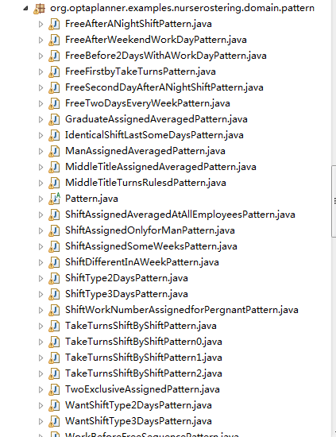

在Employee中添加自己定义的一些变量
在ShiftAssignment中对这些变量进行应用
