Vallejo Public Library Website

Typography and Color Design Document

1. Typography Selection and Justification
The typography for the Vallejo Public Library website is designed to prioritize readability, accessibility, and clarity for a diverse user base ranging from children to elderly users. As a public service website, the primary goal of typography is to support efficient information consumption rather than visual decoration.
The website uses Inter, a sans-serif typeface from Google Fonts, as the primary font across all pages.
Inter (Google Fonts):
https://fonts.google.com/specimen/Inter
Inter was specifically designed for digital interfaces and screen-based reading. It features a large x-height, open letterforms, and clear distinction between similar characters, which significantly improves legibility at both small and large font sizes. These characteristics are especially important for older users and users with reduced vision, while still remaining clear and modern for younger audiences.
Sans-serif typefaces are widely recommended for screen-based content due to their clean strokes and reduced visual noise. By avoiding decorative or serif-heavy fonts, the design minimizes cognitive load and allows users to focus on content such as book information, search results, and library services.
Using a single, consistent typeface across navigation, body text, headings, and forms also reinforces visual consistency and predictability throughout the website. This consistency helps users quickly understand page structure and improves usability, particularly for first-time visitors and users who may not be familiar with digital library systems.
Overall, the selected typography aligns with established typography theory by emphasizing legibility, simplicity, and functional clarity, making it well suited for a public library website serving a broad and inclusive community.

2. Color Palette and Color Theory Justification
The color palette for the Vallejo Public Library website is designed to convey trust, calmness, and accessibility, while maintaining a welcoming and professional appearance appropriate for a public institution.
A light neutral shade (#FAF9F9) is used as the primary background color throughout the website. This soft off-white background reduces eye strain, enhances readability, and ensures that content remains the main focus of each page. Light backgrounds are particularly effective for long reading sessions and for users with visual sensitivities.
The light accent color (#8EA6AF) is applied to secondary areas such as content sections, form backgrounds, and the footer. This muted blue-gray provides subtle visual separation between sections without creating strong contrast, helping users distinguish content areas while maintaining a calm and cohesive visual flow.
The main brand color (#B2D3EC) establishes the website’s visual identity. This soft, desaturated blue evokes openness, learning, and approachability—qualities closely associated with libraries and educational spaces. As a light brand color, it is suitable for larger background areas such as featured sections or highlighted content, reinforcing brand identity without overwhelming users.
The dark shade (#315BA0) serves as the primary functional color. It is used for navigation elements, links, primary buttons, and key headings. This darker blue provides strong contrast against light backgrounds, ensuring accessibility and legibility while conveying reliability and professionalism typical of educational and public service institutions.

Color Palette Reference Image
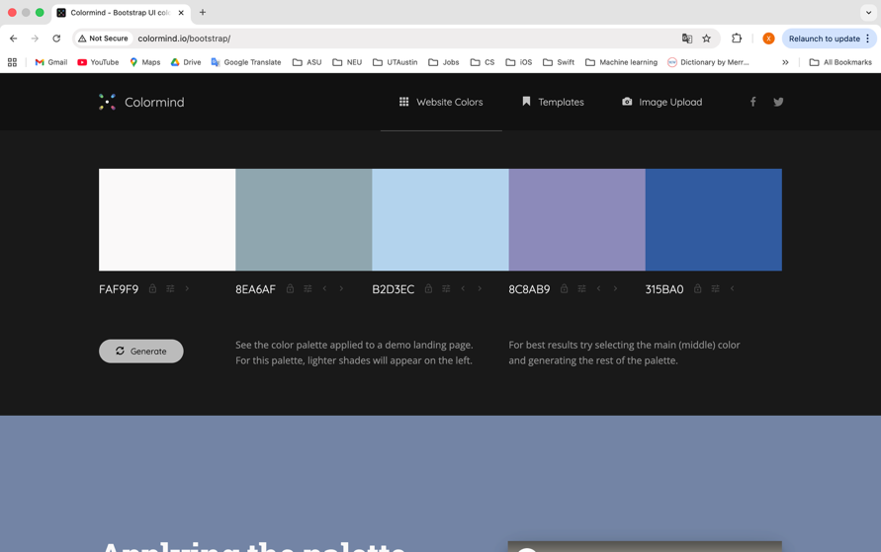
(The image above illustrates the selected color palette and the visual relationship between background colors, accent colors, brand color, and functional elements.)

The overall palette follows core color theory principles by balancing light and dark values to create clear visual hierarchy, using cool colors to communicate stability and trust, and applying contrast selectively to guide user attention to important actions such as searching the catalog or signing up for a library card.

