Web Management System of APP Analysis  
  
1. Toolkit

1). Django  
Django is a Python-based free and open-source web framework, which follows the model-template-view (MTV) architectural pattern.It is maintained by the Django Software Foundation (DSF)

Django's primary goal is to ease the creation of complex, database-driven websites. The framework emphasizes reusability and "pluggability" of components, less code, low coupling, rapid development, and the principle of don't repeat yourself.Python is used throughout, even for settings files and data models. Django also provides an optional administrative create, read, update and delete interface that is generated dynamically through introspection and configured via admin models.

2). Node.js

Node.js is an open-source, cross-platform, JavaScript runtime environment that executes JavaScript code outside of a web browser. Node.js lets developers use JavaScript to write command line tools and for server-side scripting—running scripts server-side to produce dynamic web page content before the page is sent to the user's web browser. Consequently, Node.js represents a "JavaScript everywhere" paradigm, unifying web-application development around a single programming language, rather than different languages for server- and client-side scripts.

Though .js is the standard filename extension for JavaScript code, the name "Node.js" doesn't refer to a particular file in this context and is merely the name of the product. Node.js has an event-driven architecture capable of asynchronous I/O. These design choices aim to optimize throughput and scalability in web applications with many input/output operations, as well as for real-time Web applications (e.g., real-time communication programs and browser games).

3). Restful

Representational state transfer (REST) is a software architectural style that defines a set of constraints to be used for creating Web services. Web services that conform to the REST architectural style, called RESTful Web services, provide interoperability between computer systems on the Internet. RESTful Web services allow the requesting systems to access and manipulate textual representations of Web resources by using a uniform and predefined set of stateless operations. Other kinds of Web services, such as SOAP Web services, expose their own arbitrary sets of operations.

"Web resources" were first defined on the World Wide Web as documents or files identified by their URLs. However, today they have a much more generic and abstract definition that encompasses everything, entity, or action that can be identified, named, addressed, handled, or performed, in any way whatsoever, on the Web. In a RESTful Web service, requests made to a resource's URI will elicit a response with a payload formatted in HTML, XML, JSON, or some other format. The response can confirm that some alteration has been made to the resource state, and the response can provide hypertext links to other related resources. When HTTP is used, as is most common, the operations (HTTP methods) available are GET, HEAD, POST, PUT, PATCH, DELETE, CONNECT, OPTIONS and TRACE.

2. Framework

The frontend and backend use restful api to communicate.

0) Setting the ip and port.

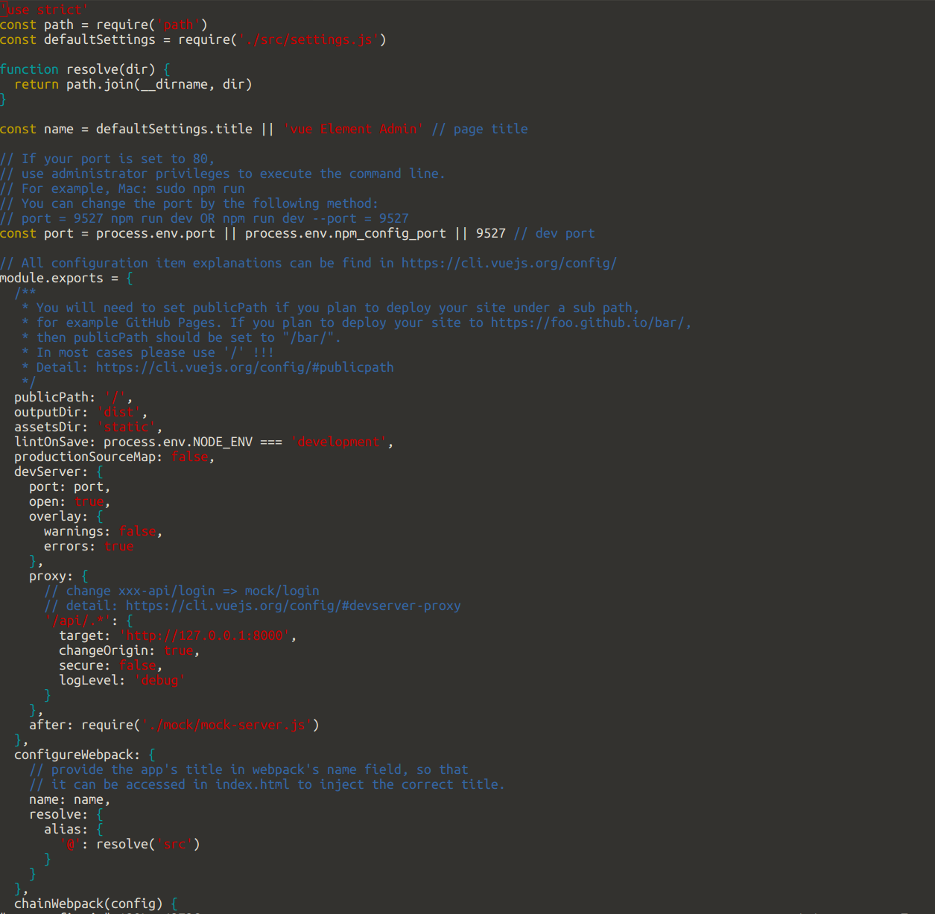

1) Request from frontend with Node.js

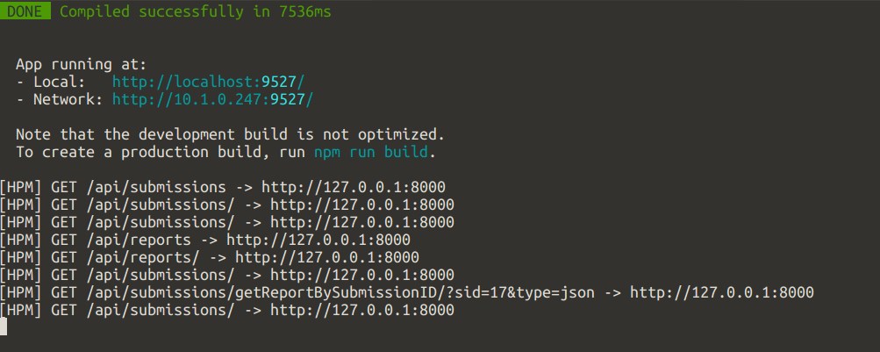

2) The frontend page before receiving the response from backend

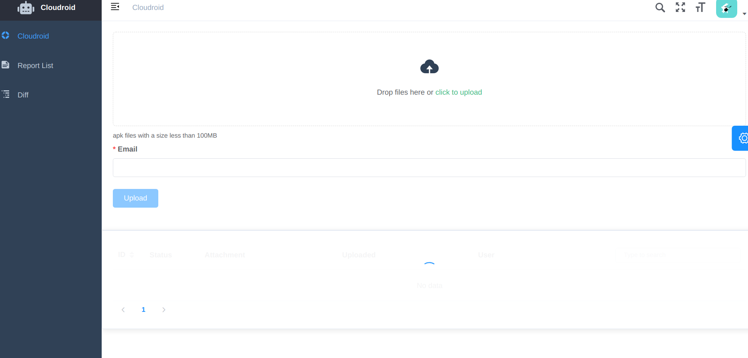

3) The frontpage after receiving the response from backend  
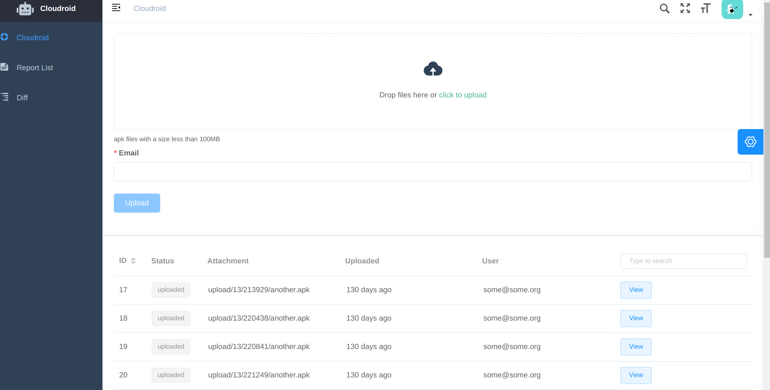

4) The response shown in the backend

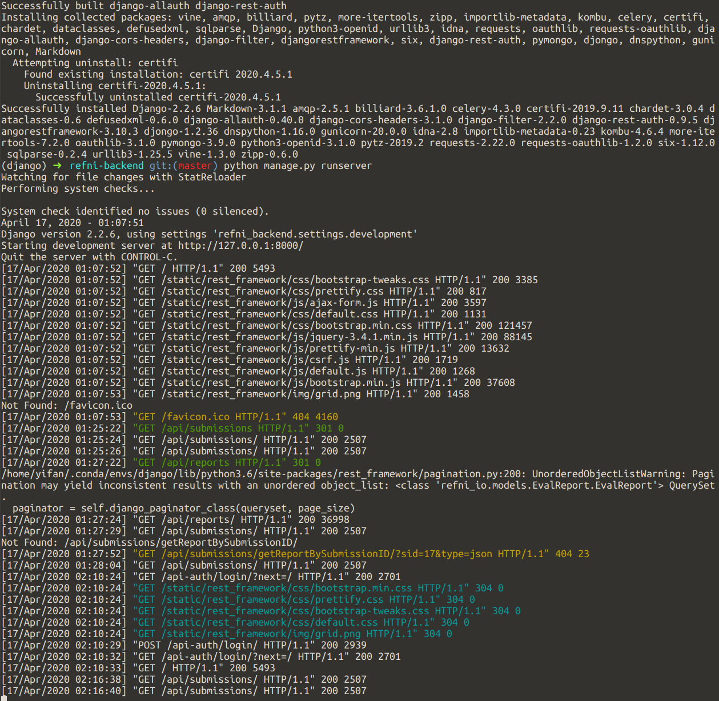

5) After the frontend receive the response, the front page is able to get the information of each application

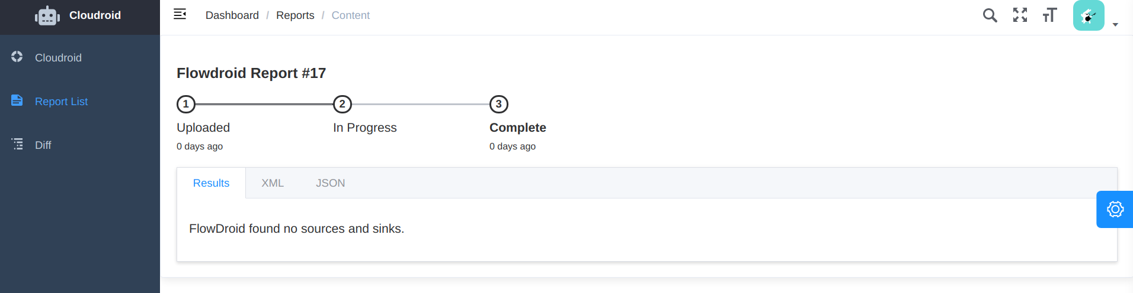

And the report list

