1. IGHA(Improved greedy heuristic algorithm) Pickup capacitated vehicle routing problem with three-dimensional loading constraints: Model and algorithms

fragile lifo

initialization, space selection, block selection, space splitting, **space merging,** and feasibility testing.

**sequently**

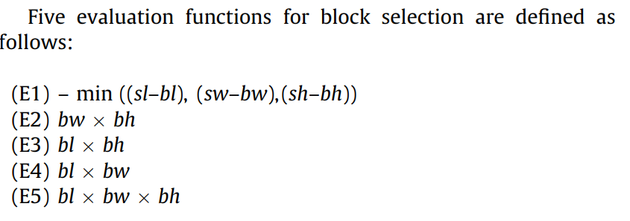

1. ITRSA(Improved tree search algorithm) Pickup capacitated vehicle routing problem with three-dimensional loading constraints: Model and algorithms

fragile lifo

an extension of the GHA, s initialization, node generation, space splitting, **space**

**merging**, feasibility testing, and node removal.

**simultaneously**



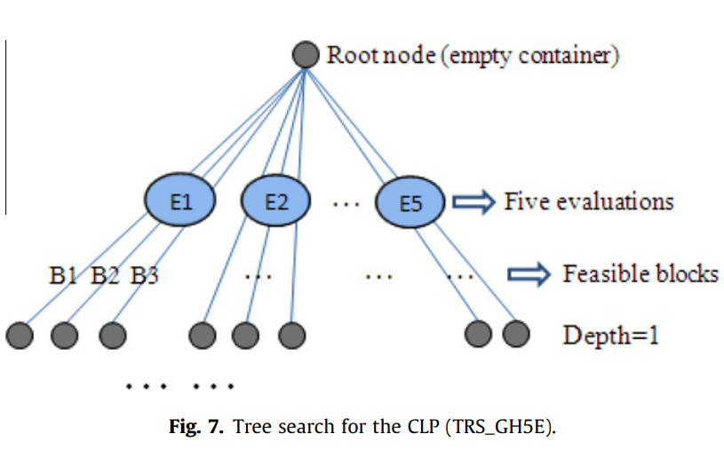

tested in 100 randomly generated instances

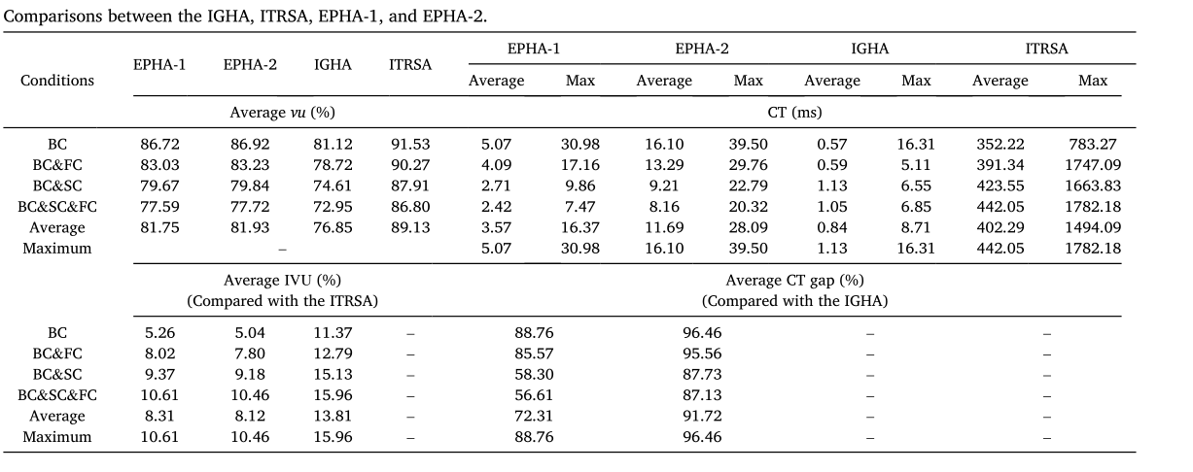

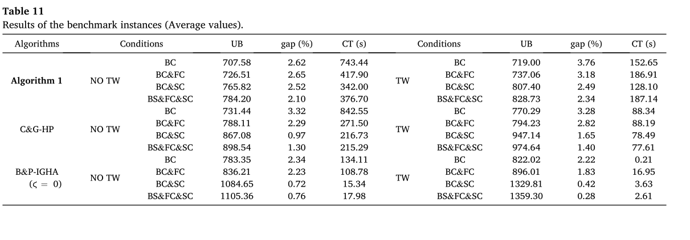

1. the Deepest-Bottom-Left-Fill heuristic and the Maximum Touching Area heuristic

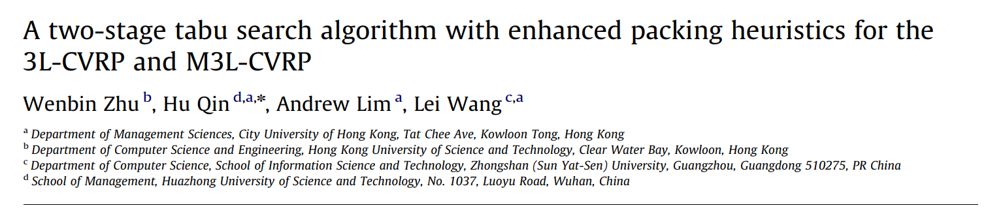

Tabu search + Deepest-Bottom-Left-Fill & Maximum Touching Area

Fragile Lifo Supporting area.

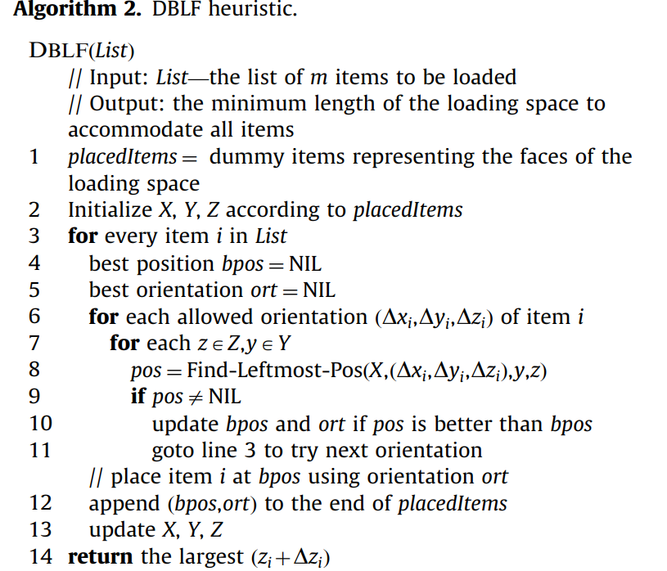

The correctness and efficiency of the MTA heuristic relies on the fact that the position that maximizes the touching area must coincide with a grid point.

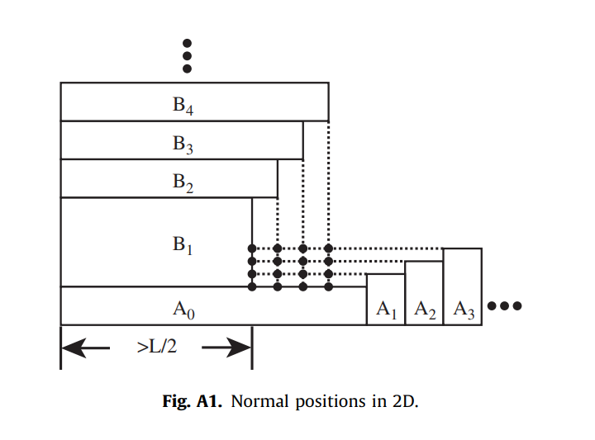

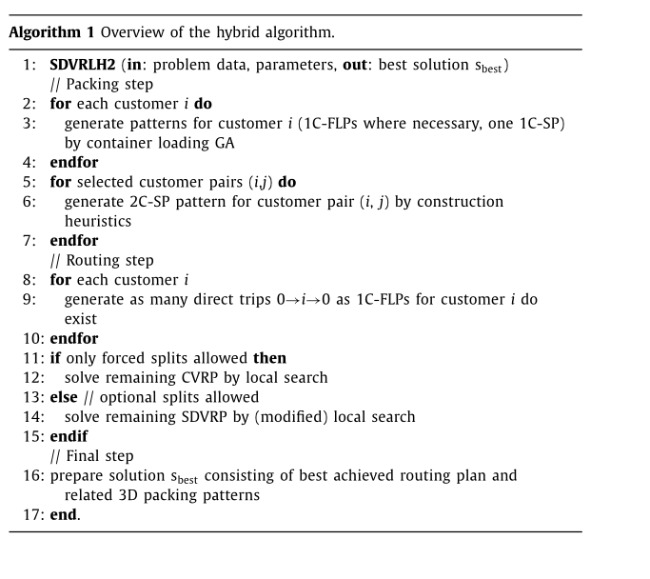

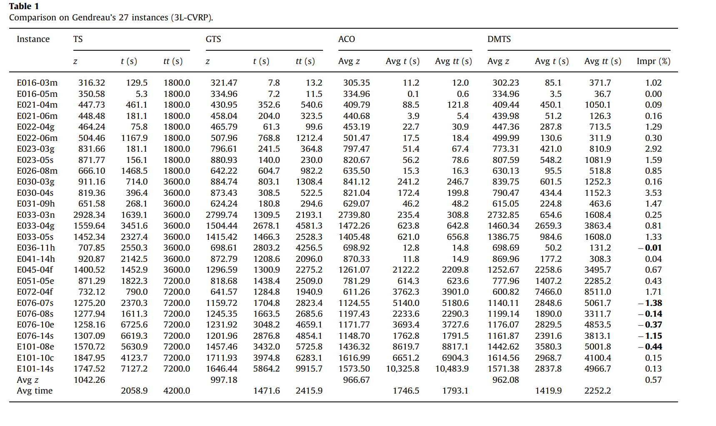

4.

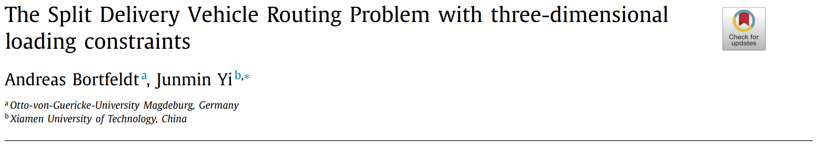

Load first, route second.

genetic algorithm (1C- FLP, 1C-SP) and two construction heuristics (2C-SP)

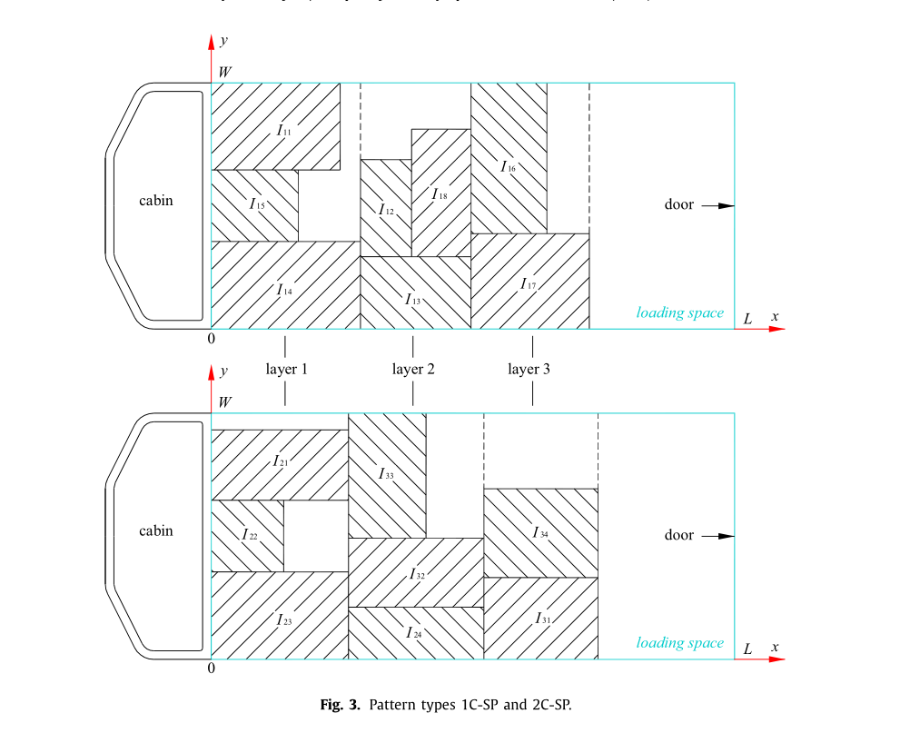

5. 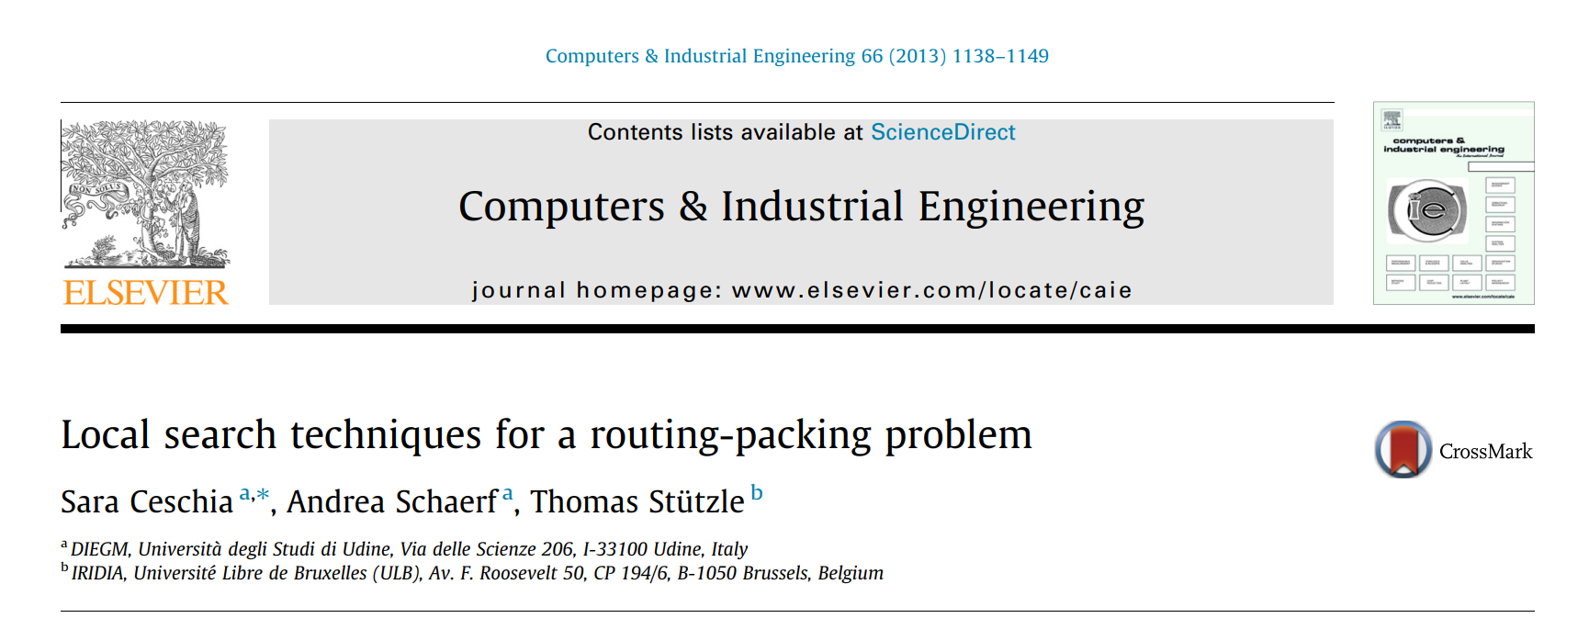

SA

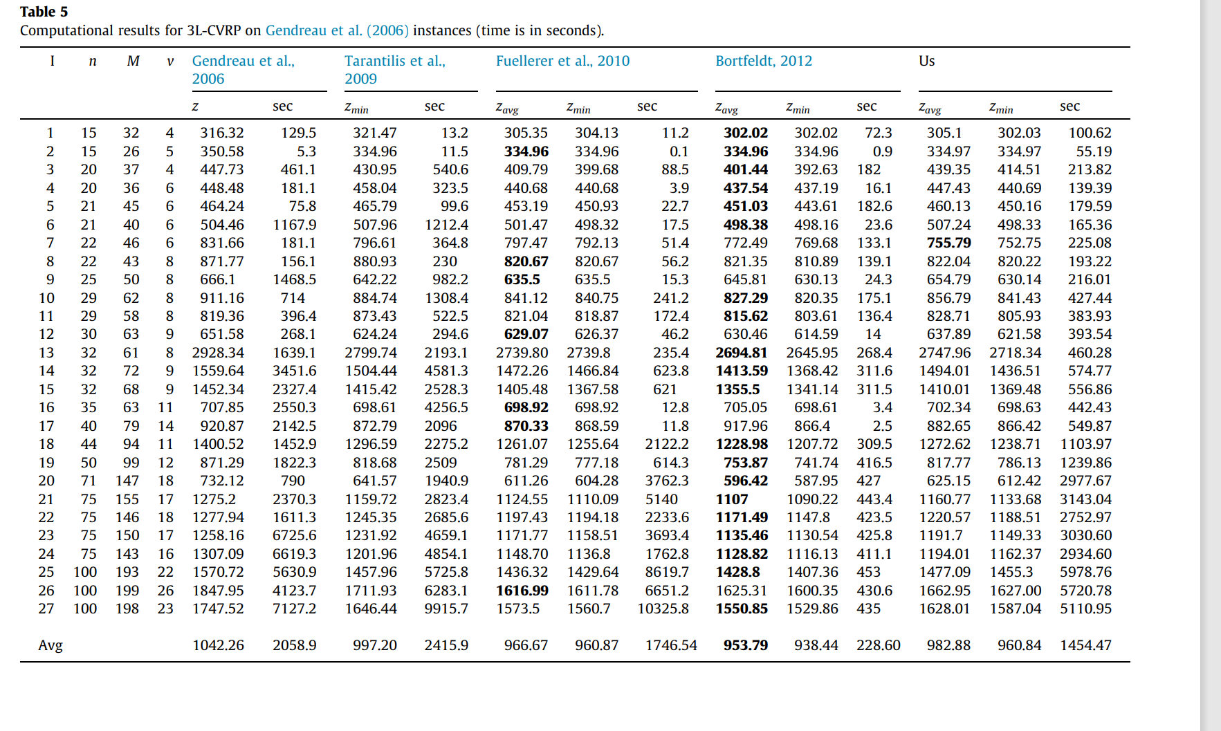

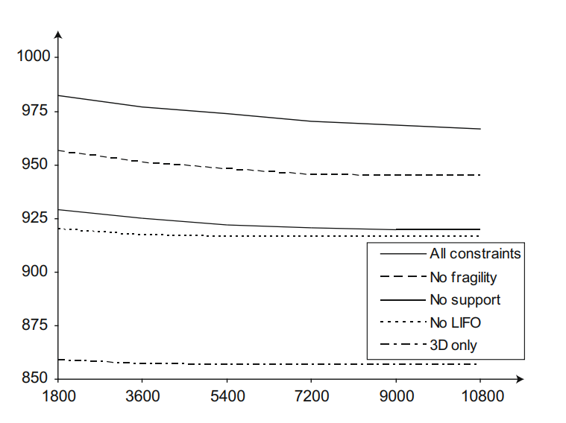

1. fragility flag 𝑓𝑖,𝑘 (non-fragile first) non f 不能放在 f上（Fragility constraint) no non-fragile items are placed on top of fragile items.
2. lifo 