Technical Report

Xunhui Zhang, Yue Yu, Tao Wang, Ayushi Rastogi, Huaimin Wang

1. **Factor correlation heatmaps**

The heatmap of correlation between factors can be seen in Figure 1, 2 and 3, which represents the correlation between continuous factors, the correlation between categorical factors and the correlation between continuous and categorical factors.

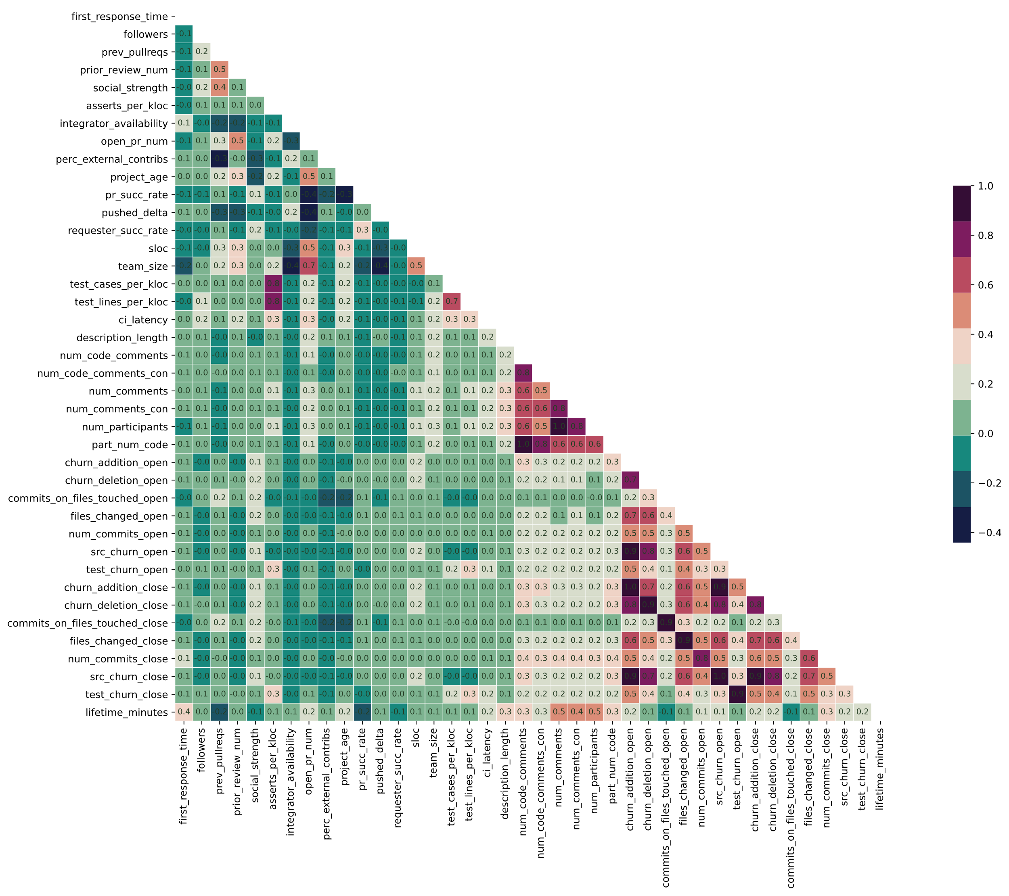

Fig 1. Heatmap of Spearman correlation coefficients

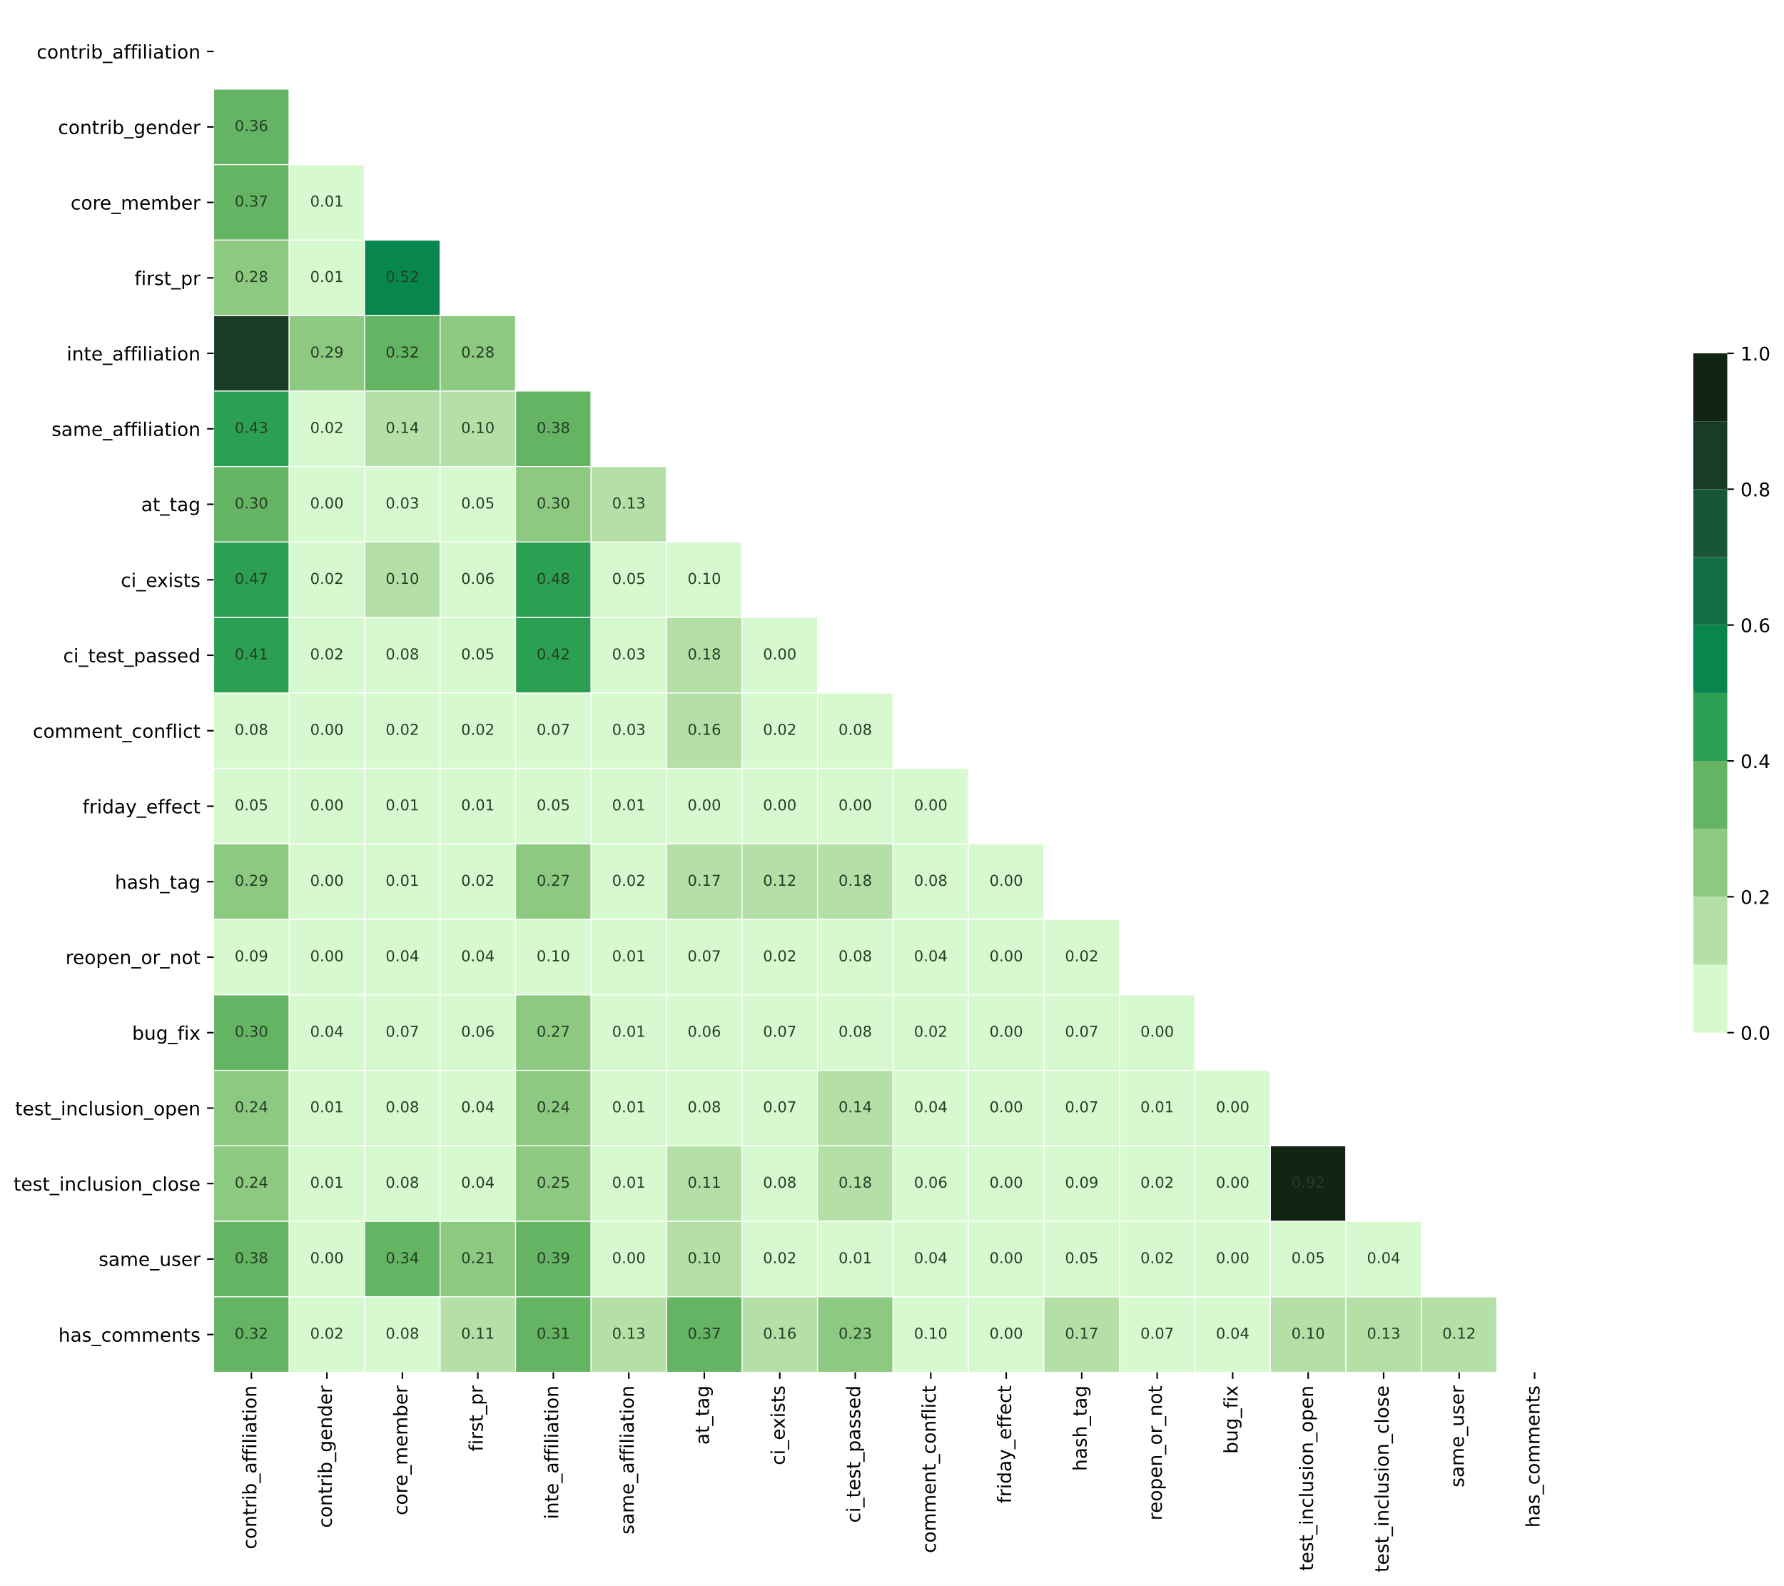

Fig 2. Heatmap of Cramer’s V value

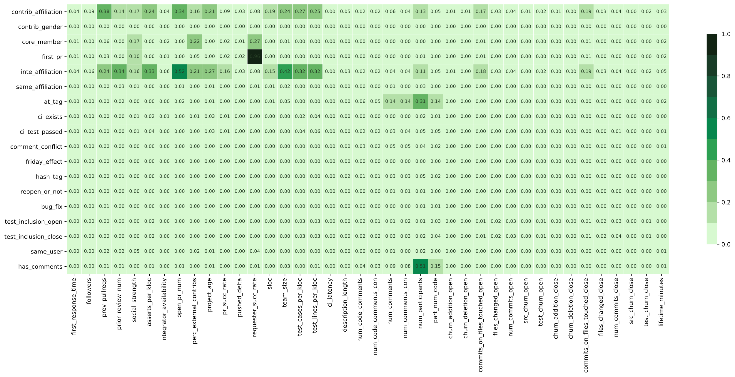

Fig 3. Heatmap of partial Eta-square value

1. **Strong correlation network**

Figure 4 presents the correlation network among strongly correlated factors, where node size and text size are positively correlated with node’s degree. So does the node color depth.

|  |  |
| --- | --- |
|  |  |
| 4a. At pull request open time | 4b. At pull request close time |

Fig 4. Correlation network of strongly correlated factors