首先双击安装rubyinstaller-2.3.3-x64.exe

选择安装路径，并勾选上Add Ruby executables to your PATH

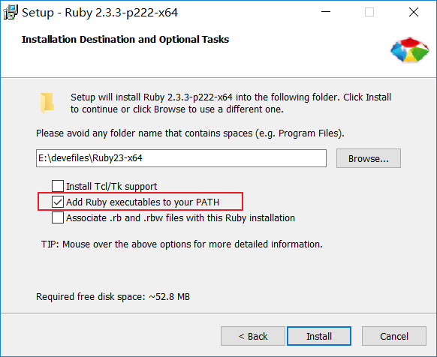

安装完毕后在命令行中执行ruby –v效果如下图所示

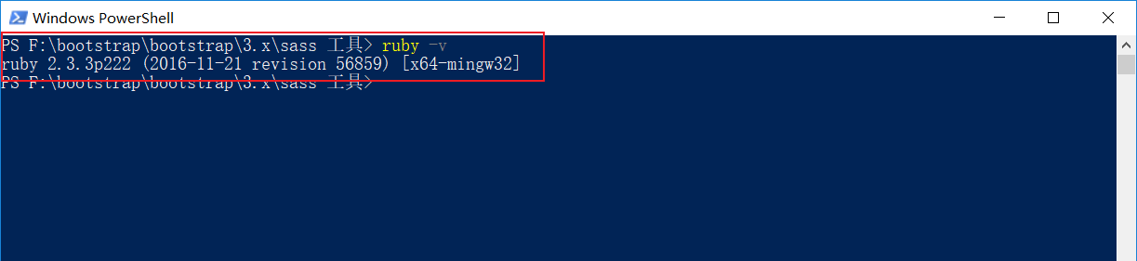

在命令行输入

gem install sass

gem install compass

如果显示失败的话那么就需要更换gem源

gem sources --remove https://rubygems.org/

gem sources -a http://ruby.sdutlinux.org/

gem sources -l

再次执行命令

gem install sass

gem install compass

全部安装完毕后会出现如下图所示结果

