INSTRUCTIONS INCLUDED WITH AN ANONYMOUS QUESTIONNAIRE
1. Information on the research project
You are invited to participate in the following research project: User Experiences with Super Apps.
Summary: This study examines users’ experiences when moving between related services in a fictional super app. You will complete two short prototype tasks and answer a questionnaire about your experience. The questionnaire was developed as part of a master’s thesis at HEC Montréal.

The following pages contain an anonymous questionnaire, which we invite you to complete. Since your first impressions best reflect your true opinions, we ask that you please answer the questions included in this questionnaire without any hesitation. There is no time limit for completing the questionnaire, although we have estimated that it should take about 5 minutes.
2. Research ethics considerations
The information collected will be anonymous and will remain strictly confidential. It will be used solely for the advancement of knowledge and the dissemination of the overall results in academic or professional forums.

The online data collection provider agrees to refrain from disclosing any personal information (or any other information concerning participants in this study) to any other users or to any third party, unless the respondent expressly agrees to such disclosure or unless such disclosure is required by law.

You are free to refuse to participate in this project and you may decide to stop answering the questions at any time. By completing this questionnaire, you will be considered as having given your consent to participate in our research project and to the potential use of data collected from this questionnaire in future research. Since the questionnaire is anonymous, once completed, it will not be feasible to remove your data from the data set, as it will not be possible to determine which data are yours.

If you have any questions about this research, please contact the principal investigator, Ran Zheng, at the email address indicated below.

HEC Montréal’s Research Ethics Board has determined that the data collection related to this study meets the ethics standards for research involving humans. If you have any questions related to ethics, please contact the REB secretariat at (514) 340-6051 or by email at cer@hec.ca.
Thank you for your valuable cooperation!
Ran Zheng
Master’s student
HEC Montréal
ran.zheng@hec.ca

Appendix D - Questionnaire Instructions and Survey
Questionnaire
A. Prototype task
You will now complete two short tasks in a fictional web-based super app prototype called “Voya X.” The super app and all tasks are simulated. No real ride, delivery, food order, payment, or commercial transaction will take place.
First, complete the ride-service task. After the ride task, complete the second service task assigned by the study system. When both tasks are complete, return to the questionnaire and answer the questions based on your experience.
Assigned prototype link: https://hci-paper-exp.vercel.app/
Task materials for REB review
Participants will see only the task sequence assigned by the study system. The four condition materials are included below for REB review and will not be shown together to participants.
Condition G1 - Ride to Courier
Condition details for REB review: No data carryover, no contextual prompt, and no nearby-option filtering.
Participant-facing ride task instruction: Book a ride to 1000 Saint-Catherine Street West. Please complete the ride-booking task in the prototype.
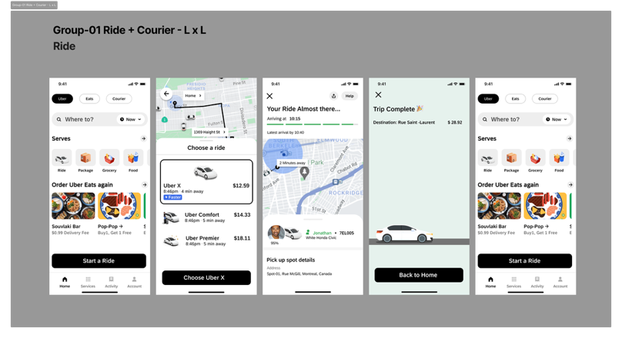
Participant-facing Courier task instruction: After completing the ride task, send a package to 1000 Saint-Catherine Street West using the Courier service. Please complete the courier task in the prototype.
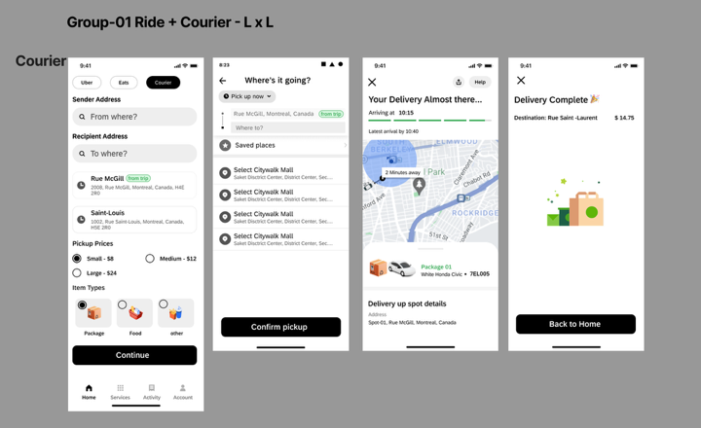
Condition G2 - Ride to Courier
Condition details for REB review: The ride destination address is carried over, a “Send Now” prompt is shown, and nearby courier options are filtered.
Participant-facing ride task instruction: Book a ride to 1000 Saint-Catherine Street West. Please complete the ride-booking task in the prototype.
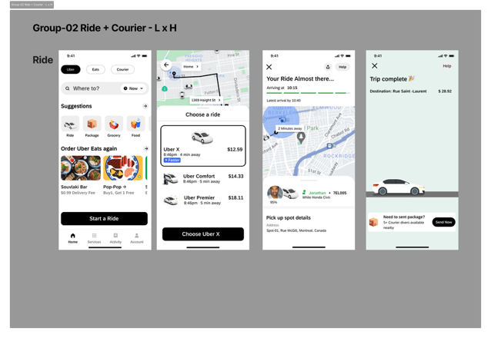
Participant-facing Courier task instruction: After completing the ride task, use the suggested "Send Now" option to send a package to the same destination. Please complete the courier task in the prototype.
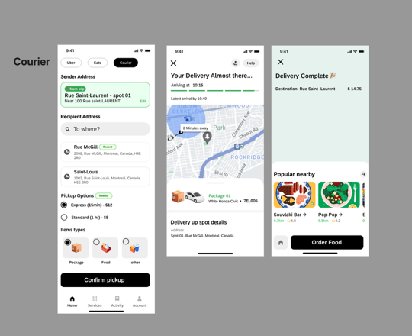
Condition G3 - Ride to Eats
Condition details for REB review: Participants manually re-enter information, use generic navigation, and see an unfiltered food-ordering list.
Participant-facing ride task instruction: Book a ride to 1000 Saint-Catherine Street West. Please complete the ride-booking task in the prototype.
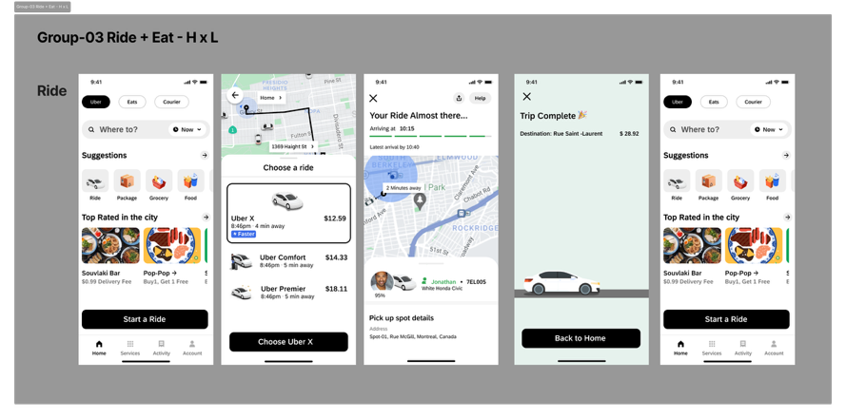
Participant-facing Eats task instruction: After completing the ride task, order food using the Eats service. Please complete the food-ordering task in the prototype.
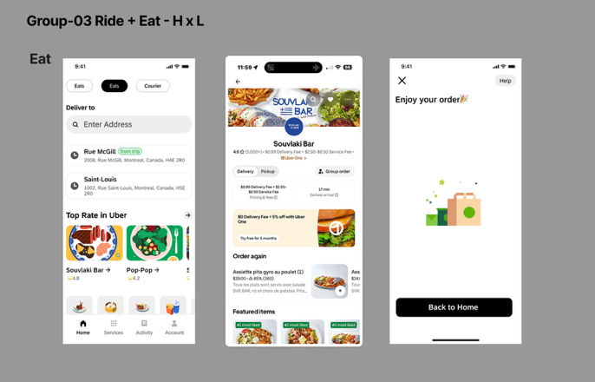
Condition G4 - Ride to Eats
Condition details for REB review: The ride destination address is carried over, an “Eat” prompt is shown, and nearby restaurant options are filtered.
Participant-facing ride task instruction: Book a ride to 1000 Saint-Catherine Street West. Please complete the ride-booking task in the prototype.
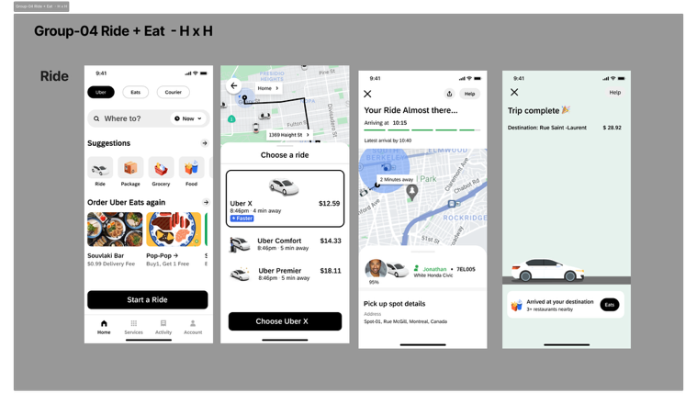
Participant-facing Eats task instruction: After completing the ride task, use the suggested "Eat" option to order food near the same destination. Please complete the food-ordering task in the prototype.
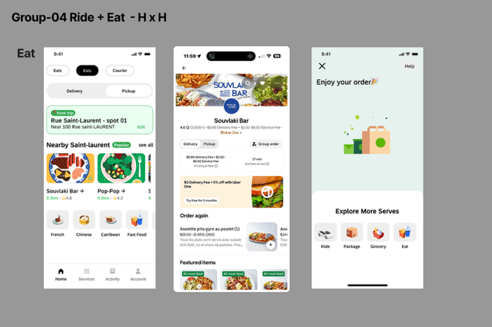
Measurement adaptation table for REB review
The table below summarizes the source constructs, original measures, and the adapted questionnaire items used in this study.
Construct | Reference | Original Measures | Adapted measures
Cognitive load | Hart & Staveland (1988); NASA-TLX | 1. Mental demand  2. Effort  3. Frustration | 1. How much mental activity was required to complete these tasks?  2. How hard did you have to work mentally to reach your performance?  3. How stressed or annoyed did you feel during the tasks?
Perceived usability | Brooke (1996); adapted to the super app transition context | 1. The system is easy to use  2. The task can be completed efficiently  3. The interaction feels smooth | 1. I found this super app easy to use for these consecutive tasks.  2. I felt I could efficiently complete my goal using this super app.  3. The transition between the two services in the super app felt smooth.  4. The super app made it easy to continue from the first service to the second service.
Continuance intention | Bhattacherjee (2001); Venkatesh et al. (2003) | 1. I intend to continue using the system  2. I predict I would continue using the system  3. I plan to continue using the system | 1. I would use this super app again for similar service tasks.  2. I intend to use this super app again if I need to complete similar tasks.  3. I would choose this super app again for similar tasks.
Manipulation checks | Study-specific manipulation checks | Not applicable | 1. The super app prompted me with the next service at the right moment.  2. The super app automatically carried my data into the next service.  3. The second service felt different from the ride service.  4. The two service tasks required different kinds of actions.
B. Post-task questionnaire
Please answer the following questions based on the two tasks you just completed.
Response scale for cognitive load items:
1 = Very low / Not at all 7 = Very high / Very much
Cognitive load
1. How much mental activity was required to complete these tasks?
1 2 3 4 5 6 7
2. How hard did you have to work mentally to reach your performance?
1 2 3 4 5 6 7
3. How stressed or annoyed did you feel during the tasks?
1 2 3 4 5 6 7
Response scale for the following statements:
1 = Strongly disagree 7 = Strongly agree
Perceived usability
4. I found this super app easy to use for these consecutive tasks.
1 2 3 4 5 6 7
5. I felt I could efficiently complete my goal using this super app.
1 2 3 4 5 6 7
6. The transition between the two services in the super app felt smooth.
1 2 3 4 5 6 7
7. The super app made it easy to continue from the first service to the second service.
1 2 3 4 5 6 7
Continuance intention
8. I would use this super app again for similar service tasks.
1 2 3 4 5 6 7
9. I intend to use this super app again if I need to complete similar tasks.
1 2 3 4 5 6 7
10. I would choose this super app again for similar tasks.
1 2 3 4 5 6 7
Manipulation checks
11. The super app prompted me with the next service at the right moment.
1 2 3 4 5 6 7
12. The super app automatically carried my data into the next service.
1 2 3 4 5 6 7
13. The second service felt different from the ride service.
1 2 3 4 5 6 7
14. The two service tasks required different kinds of actions.
1 2 3 4 5 6 7
C. Background questions
Please answer the following questions about your background and prior app use.
1. How often do you use mobile service applications such as ride-hailing, food delivery, courier, payment, or shopping apps?
☐ Never
☐ Rarely
☐ Monthly
☐ Weekly
☐ Daily
2. How familiar are you with super apps or multi-service apps that combine several services in one platform?
☐ Not familiar at all
☐ Slightly familiar
☐ Moderately familiar
☐ Very familiar
☐ Extremely familiar
3. How long have you used super apps or multi-service apps?
☐ I have never used one
☐ Less than 6 months
☐ 6-12 months
☐ 1-2 years
☐ 3 years or more
☐ Not sure
4. How often do you switch between different services or features within the same app?
☐ Never
☐ Rarely
☐ Sometimes
☐ Often
☐ Always
5. What is your age group?
☐ 18-24
☐ 25-34
☐ 35-44
☐ 45-54
☐ 55-64
☐ 65 or older
☐ Prefer not to answer
6. What is your gender?
☐ Woman
☐ Man
☐ Non-binary / another gender identity
☐ Prefer not to answer
D. End of questionnaire
Thank you for completing the questionnaire. After submission, you will see a short debriefing explaining that Voya X and the task scenarios were fictional and created only for research purposes.

