Instrumental Variable Analysis Results Summary
Table: Instrumental variable estimates for EVI and O3 exposures on Phenotypic Age Acceleration using slope squared as IV for EVI and temperature inversion days as IV for O3
Exposure | Model Type | Buffer | Coefficient (SE) | P-value | 95% CI
EVI | Single-exposure | 1KM | -33.917 (15.863) | 0.0326 | [-65.020, -2.813]
EVI | Single-exposure | 500m | -44.672 (21.154) | 0.0348 | [-86.149, -3.195]
O3 | Single-exposure | 1KM | 27.211 (6.491) | <0.0001 | [14.483, 39.938]
O3 | Single-exposure | 500m | 26.771 (6.396) | <0.0001 | [14.230, 39.313]
EVI | Dual-exposure | 1KM | -29.192 (16.288) | 0.0732 | [-61.129, 2.744]
O3 | Dual-exposure | 1KM | 23.164 (7.294) | 0.0015 | [8.862, 37.465]
EVI | Dual-exposure | 500m | -35.917 (21.034) | 0.0878 | [-77.159, 5.324]
O3 | Dual-exposure | 500m | 26.860 (6.847) | <0.0001 | [13.436, 40.284]

Note: Single-exposure models include only one exposure (EVI or O3), while dual-exposure models include both exposures simultaneously.

Forest Plot of Instrumental Variable Estimates
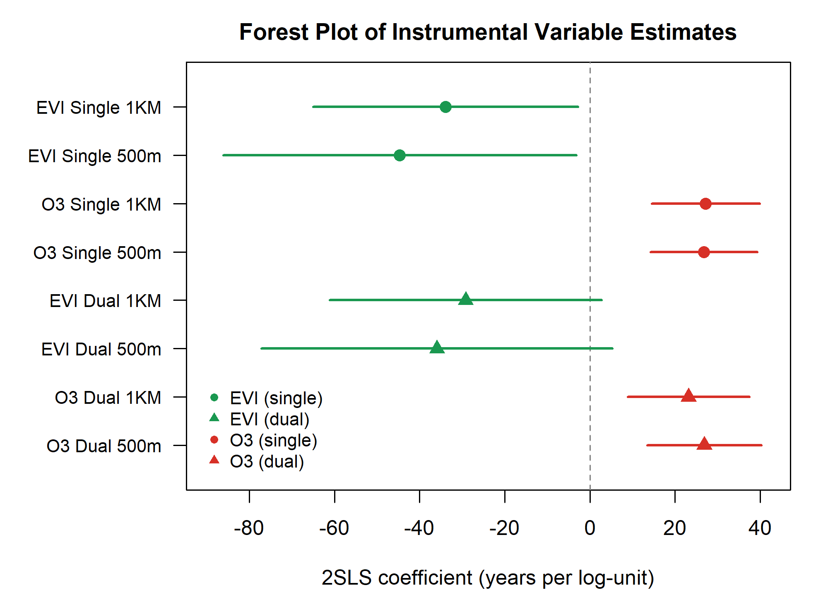

Methods
Instrumental variable analysis was conducted to estimate the causal effects of: (1) Green vegetation exposure measured by Enhanced Vegetation Index (EVI) and (2) Ozone pollution exposure (O3) on phenotypic age acceleration.
Instrumental variables: - EVI: squared slope within 500m buffer (25-degree threshold) - O3: temperature inversion days
All models were adjusted for age, sex, education, household consumption, retirement status,pension insurance, smoking, drinking, BMI, hypertension, dyslipidemia, year fixed effects,and principal components of climate variables.

