**综合题：用SQL表达以下语义**

基于这样的三个关系表，即学生表S、课程表C和学生选课表SC，结构如下：

S（Sno, Sname, Ssex, Sage, Sdept）

C (Cno, Cname, Credit)

SC (Sno, Cno, Grade)

其中Sno为学号，Sname为性名，Ssex为性别，Sage为年龄，Sdept为系，Cno为课程号，Cname为课程名，Ccredit为学分，Grade为成绩。

CREATE TABLE S(Sno VARCHAR(20),Sname VARCHAR(20),Ssex VARCHAR(20),Sage INT,Sdept VARCHAR(20),PRIMARY KEY (Sno));

CREATE TABLE C(Cno VARCHAR(20),Cname VARCHAR(20),Ccredit INT, PRIMARY KEY (Cno));

CREATE TABLE SC(Sno VARCHAR(20),Cno VARCHAR(20),Grade INT, PRIMARY KEY (Sno,Cno), FOREIGN KEY (Sno) REFERENCES S(Sno),FOREIGN KEY (Cno) REFERENCES C(Cno));

INSERT INTO S VALUES(“001”,”刘晨”,”M”,18,”CS”);

INSERT INTO S VALUES(“002”,”王华”,”F”,18,”MA”);

INSERT INTO S VALUES(“003”,”顾魏”,”M”,17,”IS”);

INSERT INTO S VALUES(“004”,”levi”,”M”,21,”CS”);

INSERT INTO S VALUES(“005”,”林之校”,”F”,20,”CS”);

INSERT INTO S VALUES(“006”,”羽生结弦”,”M”,26,”CS”);

INSERT INTO S VALUES("007","韩商言","M",NULL,"IS");

INSERT INTO S VALUES("008","佟年","F",NULL,"TS");

INSERT INTO C VALUES(“01”,“数据库”,4);

INSERT INTO C VALUES(“02”,“数据结构”,5);

INSERT INTO C VALUES(“03”,“算法设计与分析”,3);

INSERT INTO C VALUES(“04”,“C语言程序设计”,2);

INSERT INTO SC VALUES(“001”,“01”,96);

INSERT INTO SC VALUES(“002”,“02”,86);

INSERT INTO SC VALUES(“003”,“01”,76);

INSERT INTO SC VALUES(“004”,“03”,66);

INSERT INTO SC VALUES(“005”,“02”,56);

INSERT INTO SC VALUES(“006”,“03”,86);

INSERT INTO SC VALUES(“006”,“02”,76);

INSERT INTO SC VALUES(“003”,“03”,60);

INSERT INTO SC VALUES(“003”,“02”,70);

INSERT INTO SC VALUES(“003”,“04”,75);

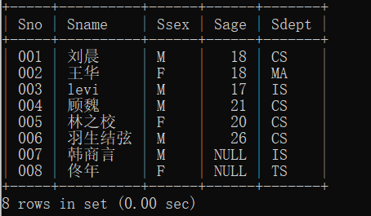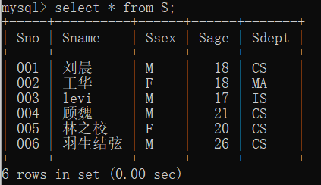

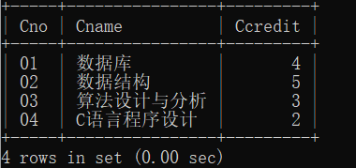

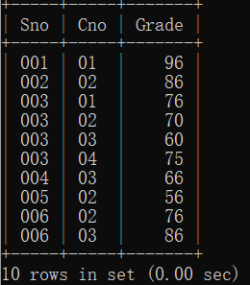

1. 检索出年龄大于等于18小于等于20的学生姓名和性别

SELECT Sname,Ssex FROM S WHERE Sage>=18 AND Sage<=20;

SELECT Sname,Ssex FROM S WHERE Sage BETWEEN 18 AND 20;

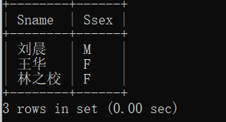

1. 查询年龄不在16至25岁之间（不含16和25岁）的学生学号和姓名

SELECT Sno,Sname FROM S WHERE Sage<16 OR Sage>25;

SELECT Sname,Ssex FROM S WHERE Sage NOT BETWEEN 16 AND 25;

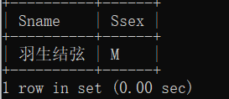

1. 检索年龄为空值的学生姓名

SELECT Sname FROM S WHERE Sage IS NULL;

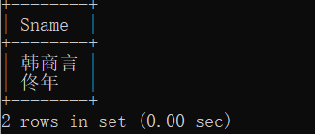

1. 查询不是“CS”系，“MA”系，“IS”系的学生姓名和性别

SELECT Sname,Ssex From S WHERE Sdept NOT IN (“CS”,”MA”,”IS”);

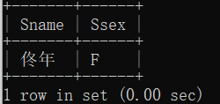

1. 查询学分最多的课程名

SELECT Cname FROM C WHERE Ccredit IN (SELECT MAX(Ccredit) FROM C);

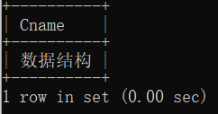

1. 检索所有比“王华”年龄大的学生姓名、年龄和性别

SELECT Sname,Sage,Ssex FROM S WHERE Sage>(SELECT Sage FROM S WHERE Sname=”王华”);

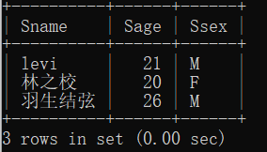

1. 检索选修02号课程的学生中成绩最高的学生的学号

SELECT Sno FROM SC WHERE Cno=”02” AND Grade IN (SELECT MAX(Grade) FROM SC WHERE Cno=”02”);

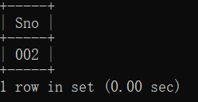

1. 查询没有任何一门课程成绩超过90分的所有学生的信息

SELECT * FROM S WHERE Sno IN(SELECT Sno FROM SC GROUP BY Sno HAVING MAX(Grade)<90);

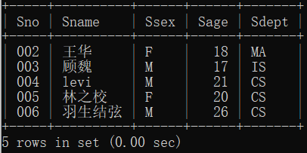

1. 查询没有选修“01”号课程的学生姓名

SELECT SName FROM S WHERE Sno NOT IN(SELECT Sno FROM SC WHERE Cno=”01”);

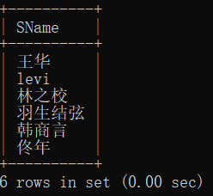

1. 查询选修了课程名为“数据库”的学生姓名和成绩

SELECT Sname,Grade FROM S,C,SC WHERE S.Sno=SC.Sno AND C.Cno=SC.Cno AND Cname=”数据库”;

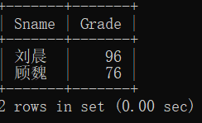

1. 按分数降序排序，输出“计科系”学生选修了“数据库”课程的学生的姓名和分数

SELECT Sname,Grade From S,C,SC WHERE S.Sno=SC.Sno AND C.Cno=SC.Cno AND Sdept=“CS” AND Cname=”数据库” ORDER BY Grade DESC;

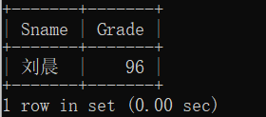

1. 查询共有多少学生选修了“数据库”

SELECT COUNT(*) FROM S,C,SC WHERE S.Sno=SC.Sno AND C.Cno=SC.Cno AND C.Cname=”数据库”;

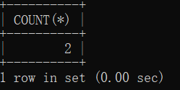

1. 查询各门课程的课程号及其选课人数

SELECT Cno,COUNT(SNO) FROM SC GROUP BY Cno;

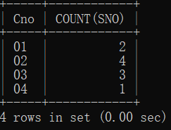

1. 统计每一年龄选修课程的学生人数

SELECT Sage,COUNT(Sno) FROM S WHERE EXISTS(SELECT * FROM SC WHERE S.Sno=SC.Sno) GROUP BY Sage;

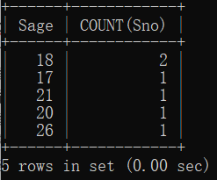

1. 查询每个学生已获得的总学分（成绩>=60可获得该门课程学分）

SELECT S.Sno,SUM(Ccredit) FROM S,C,SC WHERE S.Sno=SC.Sno AND C.Cno=SC.Cno AND EXISTS (SELECT * FROM SC WHERE SC.Sno=S.Sno AND Grade>=60) GROUP BY S.Sno;

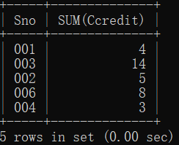

1. 检索选修2门及以上课程的学生的学号和其总成绩(不统计不及格的课程)，并要求按总成绩的降序排列出来。

SELECT Sno,SUM(Grade) FROM SC First WHERE Sno IN(SELECT Sno FROM SC GROUP BY SC.Sno HAVING COUNT(SC.Cno)>=2) AND Grade>=60 GROUP BY Sno;

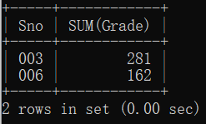

1. 查询选修过两门及以上课程的学生的学号

SELECT SC.Sno FROM S,SC WHERE S.Sno=SC.Sno GROUP BY SC.Sno HAVING Count(*)>=2;

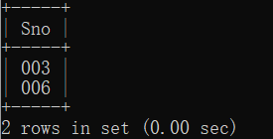

1. 查询已获得的总学分高于等于5分的女生的学号

SELECT SC.Sno FROM S,SC,C WHERE S.Sno=SC.Sno AND C.Cno=SC.Cno AND Ssex=”F” AND Grade>=60 GROUP BY SC.Sno HAVING SUM(Ccredit)>=5;

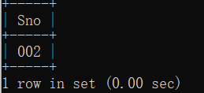

1. 查询平均成绩在90分以上的信息系的学生的学号和平均成绩

SELECT S.Sno,AVG(Grade) FROM S,SC WHERE S.Sno=SC.Sno GROUP BY SC.Sno HAVING AVG(Grade)>90;

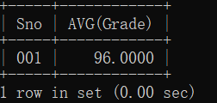

1. 查询“levi” 同学没有选修的课程名”

SELECT Cname FROM C WHERE Cno NOT IN(SELECT C.Cno FROM S,C,SC WHERE S.Sno=SC.Sno AND C.Cno=SC.Cno AND Sname=”levi”);

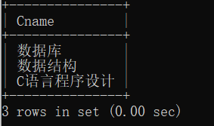

1. 查询选修了全部课程且全部通过考试的学生的学号和姓名

SELECT S.Sno,Sname FROM S,SC WHERE S.Sno=SC.Sno GROUP BY S.Sno HAVING COUNT(Cno)=(SELECT COUNT(*) FROM C) AND MIN(Grade)>=60;

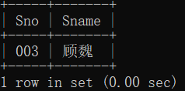

1. 查询选修了全部课程的信息系的学生的学号和姓名

SELECT S.Sno,Sname FROM S,SC WHERE S.Sno=SC.Sno AND Sdept=”IS” GROUP BY S.Sno HAVING COUNT(Cno)=(SELECT COUNT(*) FROM C);

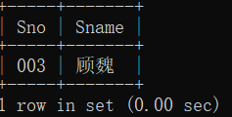

1. 把学生“刘晨”所选修的课程的成绩加10分

UPDATE SC SET Grade=Grade+10 WHERE Sno=(SELECT Sno FROM S WHERE Sname=”刘晨”);

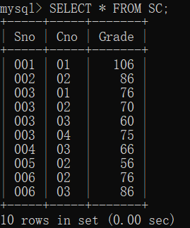

1. 创建学生成绩表视图view_student_course_grade，包括学号、姓名、课程、成绩

CREATE VIEW view_student_course_grade AS SELECT S. Sno,Sname,Cno,Grade FROM S,SC WHERE S.Sno=SC.Sno WITH CHECK OPTION;

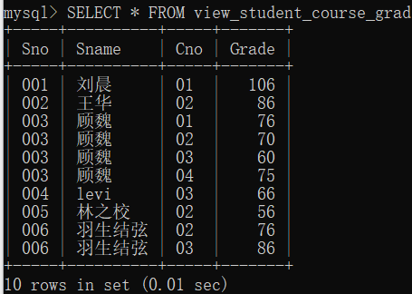

1. 定义一个有关学生学号及其平均成绩视图view_student_average_grade

CREATE VIEW view_student_average_grade AS SELECT Sno,AVG(Grade) FROM SC GROUP BY Sno;

