服务端安装说明

Hardware Info:

CPU: i7 6800K
Chipset: X99
RAM: 32GB DDR4
NVidia Titan X Pascal 12GB

OS:
These Fails: (Additional Hardware → install driver no response → relogin cannot enter desktop environment)
ubuntu-16.10-desktop-amd64
UbuntuKylin-1604-ukui-amd64

This one succeeds:
YakketyYak 16.10 Minimal Boot CD | Requires an Internet LAN Connection. Wireless Wifi driver may be unavailable

Install Titan X Driver
Additional Drivers →Using NVIDIA binary driver → Apply Changes → reboot → Screen resolution becomes normal
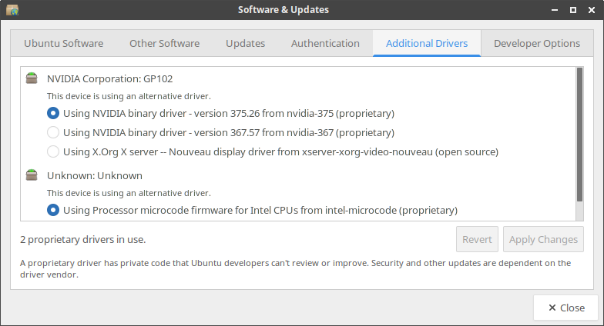
Install CUDA

https://developer.nvidia.com/cuda-downloads
Select Target Platform : Linux > x_64_64 > Ubuntu > 16.04 (there is not a 16.10 yet) > deb (local)

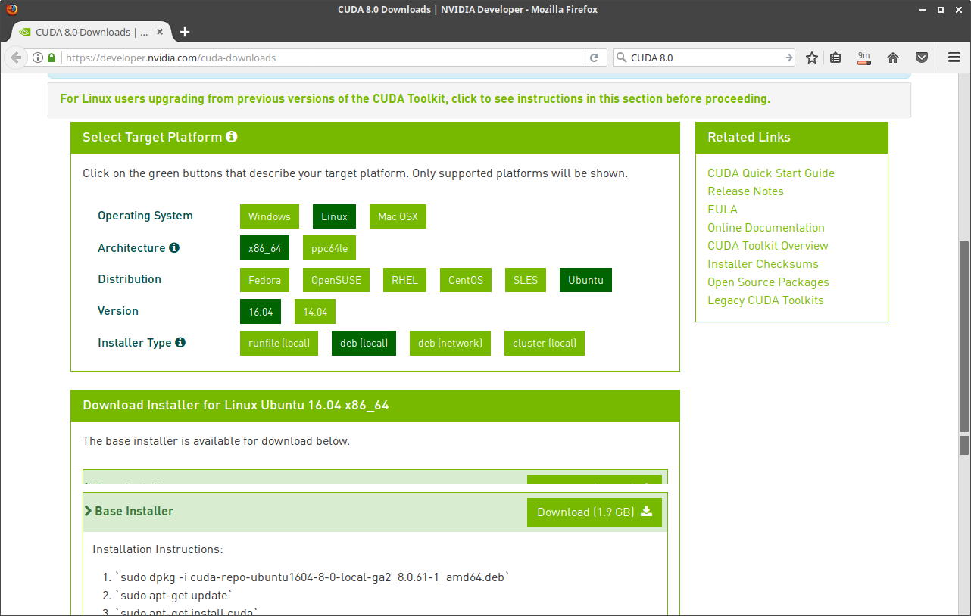
Download the 1.9GB deb file. Follow the instructions:`sudo dpkg -i cuda-repo-ubuntu1604-8-0-local-ga2_8.0.61-1_amd64.deb`
`sudo apt-get update`
`sudo apt-get install cuda`

Compile CUDA samples
cd /usr/local/cuda-8.0/samples/
sudo make -j10 all

Error1: gcc version not supported. The system uses gcc 6
Solution:

sudo gedit /usr/local/cuda/include/host_config.h

// comment out the #error line

#if __GNUC__ > 5
// #error -- unsupported GNU version! gcc versions later than 5 are not supported!

// install gcc 5 and set it as default gcc
// To figure out the current priorities of gcc
update-alternatives --query gcc
// Install gcc 5
sudo apt-get install gcc-5
update-alternatives --install /usr/bin/gcc gcc /usr/bin/gcc-5 50
update-alternatives --install /usr/bin/gcc gcc /usr/bin/gcc-6 50
// Make sure gcc 5 is the default
update-alternatives --config gcc

Error2: /usr/bin/ld: cannot find -lnvcuvid
Solution:
// Make sure the libs exist
zys@ubuntu:~$ sudo find / -name libnvcuvid.*
[sudo] password for zys:
zys
/usr/lib/nvidia-375/libnvcuvid.so.1
/usr/lib/nvidia-375/libnvcuvid.so.375.26
/usr/lib/nvidia-375/libnvcuvid.so
/usr/lib32/nvidia-375/libnvcuvid.so.1
/usr/lib32/nvidia-375/libnvcuvid.so.375.26
/usr/lib32/nvidia-375/libnvcuvid.so

// Enter the project dir that throws error. Edit the findglib.mk file
cd /usr/local/cuda-8.0/samples/3_Imaging/cudaDecodeGL
sudo gedit findgllib.mk

revise to make sure UBUNTU_PKG_NAME = "nvidia-375"

// Run deviceQuery to make sure CUDA works
zys@ubuntu:/usr/local/cuda-8.0/samples/bin/x86_64/linux/release$ ./deviceQuery
./deviceQuery Starting...

CUDA Device Query (Runtime API) version (CUDART static linking)

Detected 1 CUDA Capable device(s)

Device 0: "TITAN X (Pascal)"
CUDA Driver Version / Runtime Version 8.0 / 8.0
CUDA Capability Major/Minor version number: 6.1
Total amount of global memory: 12189 MBytes (12781158400 bytes)
(28) Multiprocessors, (128) CUDA Cores/MP: 3584 CUDA Cores
GPU Max Clock rate: 1531 MHz (1.53 GHz)
Memory Clock rate: 5005 Mhz
Memory Bus Width: 384-bit
L2 Cache Size: 3145728 bytes
Maximum Texture Dimension Size (x,y,z) 1D=(131072), 2D=(131072, 65536), 3D=(16384, 16384, 16384)
Maximum Layered 1D Texture Size, (num) layers 1D=(32768), 2048 layers
Maximum Layered 2D Texture Size, (num) layers 2D=(32768, 32768), 2048 layers
Total amount of constant memory: 65536 bytes
Total amount of shared memory per block: 49152 bytes
Total number of registers available per block: 65536
Warp size: 32
Maximum number of threads per multiprocessor: 2048
Maximum number of threads per block: 1024
Max dimension size of a thread block (x,y,z): (1024, 1024, 64)
Max dimension size of a grid size (x,y,z): (2147483647, 65535, 65535)
Maximum memory pitch: 2147483647 bytes
Texture alignment: 512 bytes
Concurrent copy and kernel execution: Yes with 2 copy engine(s)
Run time limit on kernels: Yes
Integrated GPU sharing Host Memory: No
Support host page-locked memory mapping: Yes
Alignment requirement for Surfaces: Yes
Device has ECC support: Disabled
Device supports Unified Addressing (UVA): Yes
Device PCI Domain ID / Bus ID / location ID: 0 / 1 / 0
Compute Mode:
< Default (multiple host threads can use ::cudaSetDevice() with device simultaneously) >

deviceQuery, CUDA Driver = CUDART, CUDA Driver Version = 8.0, CUDA Runtime Version = 8.0, NumDevs = 1, Device0 = TITAN X (Pascal)
Result = PASS

Install cudnn

Go to Nvidia site, download and install:
1. libcudnn5-dev_5.1.10-1+cuda8.0_amd64.deb Developer library
2. libcudnn5-doc_5.1.10-1+cuda8.0_amd64.deb Code samples
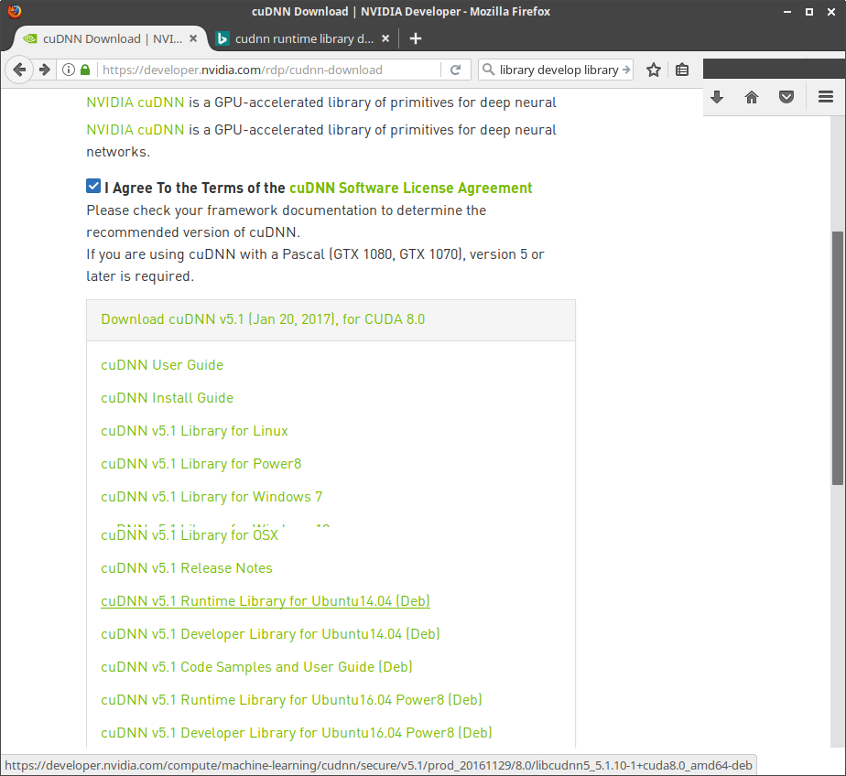
To ensure cuDNN is installed correctly, go to /usr/src/cudnn_samples_v5/mnistCUDNN

“sudo make” and test the generated mnistCUDNN:

root@ubuntu:/usr/src/cudnn_samples_v5/mnistCUDNN$ ./mnistCUDNN image=data/five_28x28.pgm
cudnnGetVersion() : 5110 , CUDNN_VERSION from cudnn.h : 5110 (5.1.10)
Host compiler version : GCC 5.4.1
There are 1 CUDA capable devices on your machine :
device 0 : sms 28 Capabilities 6.1, SmClock 1531.0 Mhz, MemSize (Mb) 12189, MemClock 5005.0 Mhz, Ecc=0, boardGroupID=0
Using device 0
Loading image data/five_28x28.pgm
Performing forward propagation ...
Testing cudnnGetConvolutionForwardAlgorithm ...
Fastest algorithm is Algo 1
Testing cudnnFindConvolutionForwardAlgorithm ...
^^^^ CUDNN_STATUS_SUCCESS for Algo 0: 0.022528 time requiring 0 memory
^^^^ CUDNN_STATUS_SUCCESS for Algo 2: 0.036864 time requiring 57600 memory
^^^^ CUDNN_STATUS_SUCCESS for Algo 1: 0.051200 time requiring 19508 memory
^^^^ CUDNN_STATUS_SUCCESS for Algo 7: 0.077824 time requiring 2057744 memory
^^^^ CUDNN_STATUS_SUCCESS for Algo 5: 0.112640 time requiring 205008 memory
Resulting weights from Softmax:
0.0000000 0.0000008 0.0000000 0.0000002 0.0000000 0.9999820 0.0000154 0.0000000 0.0000012 0.0000006

Result of classification: 5

Caffe prerequisite:
sudo apt-get install libprotobuf-dev libleveldb-dev libsnappy-dev libopencv-dev libhdf5-serial-dev protobuf-compiler
sudo apt-get install --no-install-recommends libboost-all-dev
sudo apt-get install libatlas-base-dev
sudo apt-get install libgflags-dev libgoogle-glog-dev liblmdb-dev

Compile Caffe
sudo apt-get install git
git clone “https://github.com/BVLC/caffe.git”
cp Makefile.config.example Makefile.config
sudo gedit Makefile.config

uncomment “USE_CUDNN := 1”

Revise:
INCLUDE_DIRS := $(PYTHON_INCLUDE) /usr/local/include
LIBRARY_DIRS := $(PYTHON_LIB) /usr/local/lib /usr/lib
To:
# Whatever else you find you need goes here.
INCLUDE_DIRS := $(PYTHON_INCLUDE) /usr/local/include /usr/include/hdf5/serial
LIBRARY_DIRS := $(PYTHON_LIB) /usr/local/lib /usr/lib /usr/lib/i386-linux-gnu/hdf5/serial
or
# Whatever else you find you need goes here.
INCLUDE_DIRS := $(PYTHON_INCLUDE) /usr/local/include /usr/include/hdf5/serial
LIBRARY_DIRS := $(PYTHON_LIB) /usr/local/lib /usr/lib /usr/lib/x86_64-linux-gnu/hdf5/serial/

(
zys@ubuntu:~/caffe-master$ sudo find / -name libhdf5.so
/usr/lib/x86_64-linux-gnu/hdf5/serial/libhdf5.so
)

save & close

sudo make -j12 all
-j12 to enable parallel compile (i7 6800K has 6 cores)

Error1:

AR -o .build_release/lib/libcaffe.a
LD -o .build_release/lib/libcaffe.so.1.0.0-rc5
/usr/bin/ld: cannot find -lhdf5_hl
/usr/bin/ld: cannot find -lhdf5
collect2: error: ld returned 1 exit status
Makefile:572: recipe for target '.build_release/lib/libcaffe.so.1.0.0-rc5' failed
make: *** [.build_release/lib/libcaffe.so.1.0.0-rc5] Error 1

测试mnist例子：
cd $CAFFE_ROOT
./data/mnist/get_mnist.sh
./examples/mnist/create_mnist.sh
./examples/mnist/train_lenet.sh

实测发现，Titan X Pascal开启cuDNN的情况下，train耗时约10s；不开启cuDNN约2min。
而ThinkPad Carbon X1 （CPU模式）和NVIDIA Jetson TK1 （GPU模式+cuDNN）耗时均在12min左右。
速度差距明显，达到了70多倍

Use pycaffe for prediction

sudo make -j12
sudo make -j12 pycaffe

error:
fatal error: numpy/arrayobject.h: No such file or directory
solution:

python
>>> import numpy

check if numpy is installed

check site-packages directory
>>> import site; site.getsitepackages()
['/usr/local/lib/python2.7/dist-packages', '/usr/lib/python2.7/dist-packages']

Check which folder numpy is installed in.

revise Makefile.config accordingly:

# NOTE: this is required only if you will compile the python interface.
# We need to be able to find Python.h and numpy/arrayobject.h.
PYTHON_INCLUDE := /usr/include/python2.7 \
/usr/local/lib/python2.7/dist-packages/numpy/core/include
# /usr/lib/python2.7/dist-packages/numpy/core/include

export PYTHONPATH=/home/zys/caffe-master/distribute/python
export LD_LIBRARY_PATH=/home/zys/caffe-master/distribute/lib

Or persist the parameter by conf file:
sudo gedit /etc/ld.so.conf.d/caffe.conf
add the line:
/home/zys/caffe-master/distribute/lib
sudo ldconfig

write a test python script file (test_googlenet.py) as follows:

#coding=utf-8

import numpy
import os
import sys
import caffe

caffe_root = '/home/zys/caffe-master/'
sys.path.insert(0,caffe_root+'Python')

MODEL_FILE =caffe_root+'models/bvlc_googlenet/deploy.prototxt'
PRETRAINED =caffe_root+'models/bvlc_googlenet/bvlc_googlenet.caffemodel'

#cpu模式

caffe.set_mode_gpu()

#定义使用的神经网络模型
#image_dims : dimensions to scale input for cropping/sampling.
# Default is to scale to net input size for whole-image crop.
# mean, input_scale, raw_scale, channel_swap: params for
# preprocessing options.

net = caffe.Classifier(MODEL_FILE, PRETRAINED,
mean=numpy.load(caffe_root +'python/caffe/imagenet/ilsvrc_2012_mean.npy').mean(1).mean(1),
channel_swap=(2,1,0),
raw_scale=255,
# image_dims=(224, 224)
)

imagenet_labels_filename = caffe_root +'data/ilsvrc12/synset_words.txt'
labels =numpy.loadtxt(imagenet_labels_filename, str, delimiter='\t')

#对目标路径中的图像，遍历并分类

for root,dirs,files in os.walk(caffe_root + "examples/images/"):
for file in files:
#加载要分类的图片

IMAGE_FILE = os.path.join(root,file).decode('gbk').encode('utf-8');
input_image = caffe.io.load_image(IMAGE_FILE)
print("\n---- {} ----".format(IMAGE_FILE))

#预测图片类别

prediction = net.predict([input_image])
print 'predicted class:',prediction[0].argmax()

# 输出概率最大的前5个预测结果

top_k = net.blobs['prob'].data[0].flatten().argsort()[-1:-6:-1]
print labels[top_k]

python test_googlenet.py

