服务端安装说明

Hardware Info:

CPU: i7 6800K
Chipset: X99
RAM: 32GB DDR4
NVidia Titan X Pascal 12GB

OS:
These Fails: (Additional Hardware → install driver no response → relogin cannot enter desktop environment)
ubuntu-16.10-desktop-amd64
UbuntuKylin-1604-ukui-amd64

This one succeeds:
YakketyYak 16.10 Minimal Boot CD | Requires an Internet LAN Connection. Wireless Wifi driver may be unavailable

Install Titan X Driver
Additional Drivers →Using NVIDIA binary driver → Apply Changes → reboot → Screen resolution becomes normal
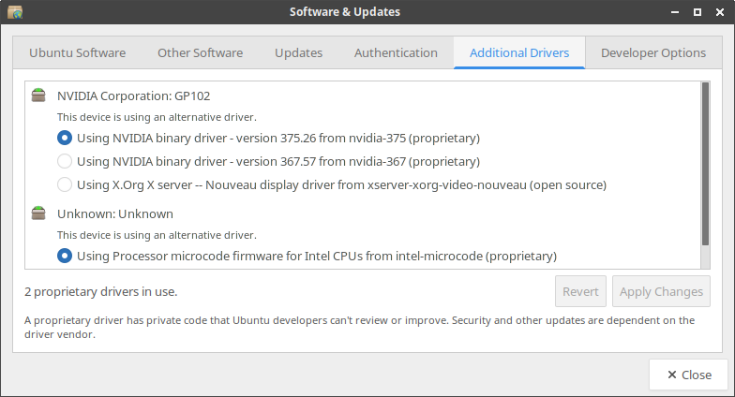
Install CUDA

https://developer.nvidia.com/cuda-downloads
Select Target Platform : Linux > x_64_64 > Ubuntu > 16.04 (there is not a 16.10 yet) > deb (local)

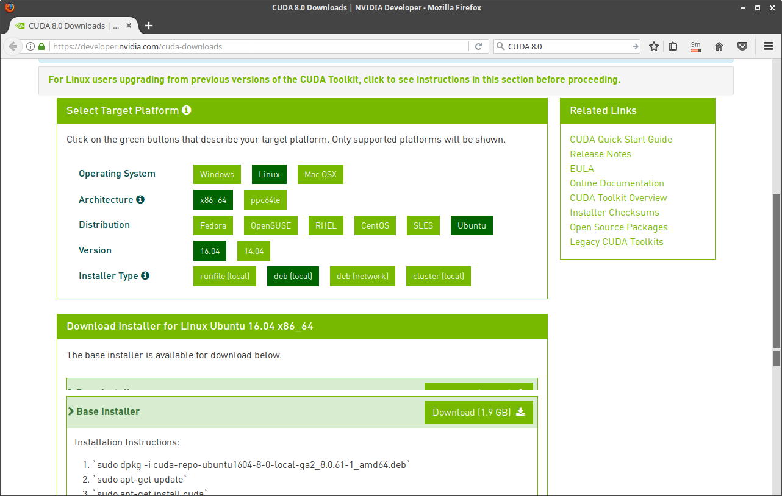
Download the 1.9GB deb file. Follow the instructions:`sudo dpkg -i cuda-repo-ubuntu1604-8-0-local-ga2_8.0.61-1_amd64.deb`
`sudo apt-get update`
`sudo apt-get install cuda`

Problem:
Processing triggers for libc-bin (2.23-0ubuntu7) ...
/sbin/ldconfig.real: /usr/lib/nvidia-375/libEGL.so.1 is not a symbolic link

/sbin/ldconfig.real: /usr/lib32/nvidia-375/libEGL.so.1 is not a symbolic link
Solution:
sudo mv /usr/lib/nvidia-375/libEGL.so.1 /usr/lib/nvidia-375/libEGL.so.1.org

sudo mv /usr/lib32/nvidia-375/libEGL.so.1 /usr/lib32/nvidia-375/libEGL.so.1.org

sudo ln -s /usr/lib/nvidia-375/libEGL.so.375.66 /usr/lib/nvidia-375/libEGL.so.1

sudo ln -s /usr/lib32/nvidia-375/libEGL.so.375.66 /usr/lib32/nvidia-375/libEGL.so.1

Compile CUDA samples
cd /usr/local/cuda-8.0/samples/
sudo make -j10 all

Error1: gcc version not supported. The system uses gcc 6
Solution:

sudo gedit /usr/local/cuda/include/host_config.h

// comment out the #error line

#if __GNUC__ > 5
// #error -- unsupported GNU version! gcc versions later than 5 are not supported!

// install gcc 5 and set it as default gcc
// To figure out the current priorities of gcc
update-alternatives --query gcc
// Install gcc 5
sudo apt-get install gcc-5
update-alternatives --install /usr/bin/gcc gcc /usr/bin/gcc-5 50
update-alternatives --install /usr/bin/gcc gcc /usr/bin/gcc-6 50
// Make sure gcc 5 is the default
update-alternatives --config gcc

Error2: /usr/bin/ld: cannot find -lnvcuvid
Solution:
// Make sure the libs exist
zys@ubuntu:~$ sudo find / -name libnvcuvid.*
[sudo] password for zys:
zys
/usr/lib/nvidia-375/libnvcuvid.so.1
/usr/lib/nvidia-375/libnvcuvid.so.375.26
/usr/lib/nvidia-375/libnvcuvid.so
/usr/lib32/nvidia-375/libnvcuvid.so.1
/usr/lib32/nvidia-375/libnvcuvid.so.375.26
/usr/lib32/nvidia-375/libnvcuvid.so

// Enter the project dir that throws error. Edit the findglib.mk file
cd /usr/local/cuda-8.0/samples/3_Imaging/cudaDecodeGL
sudo gedit findgllib.mk

revise to make sure UBUNTU_PKG_NAME = "nvidia-375"

// Run deviceQuery to make sure CUDA works
zys@ubuntu:/usr/local/cuda-8.0/samples/bin/x86_64/linux/release$ ./deviceQuery
./deviceQuery Starting...

CUDA Device Query (Runtime API) version (CUDART static linking)

Detected 1 CUDA Capable device(s)

Device 0: "TITAN X (Pascal)"
CUDA Driver Version / Runtime Version 8.0 / 8.0
CUDA Capability Major/Minor version number: 6.1
Total amount of global memory: 12189 MBytes (12781158400 bytes)
(28) Multiprocessors, (128) CUDA Cores/MP: 3584 CUDA Cores
GPU Max Clock rate: 1531 MHz (1.53 GHz)
Memory Clock rate: 5005 Mhz
Memory Bus Width: 384-bit
L2 Cache Size: 3145728 bytes
Maximum Texture Dimension Size (x,y,z) 1D=(131072), 2D=(131072, 65536), 3D=(16384, 16384, 16384)
Maximum Layered 1D Texture Size, (num) layers 1D=(32768), 2048 layers
Maximum Layered 2D Texture Size, (num) layers 2D=(32768, 32768), 2048 layers
Total amount of constant memory: 65536 bytes
Total amount of shared memory per block: 49152 bytes
Total number of registers available per block: 65536
Warp size: 32
Maximum number of threads per multiprocessor: 2048
Maximum number of threads per block: 1024
Max dimension size of a thread block (x,y,z): (1024, 1024, 64)
Max dimension size of a grid size (x,y,z): (2147483647, 65535, 65535)
Maximum memory pitch: 2147483647 bytes
Texture alignment: 512 bytes
Concurrent copy and kernel execution: Yes with 2 copy engine(s)
Run time limit on kernels: Yes
Integrated GPU sharing Host Memory: No
Support host page-locked memory mapping: Yes
Alignment requirement for Surfaces: Yes
Device has ECC support: Disabled
Device supports Unified Addressing (UVA): Yes
Device PCI Domain ID / Bus ID / location ID: 0 / 1 / 0
Compute Mode:
< Default (multiple host threads can use ::cudaSetDevice() with device simultaneously) >

deviceQuery, CUDA Driver = CUDART, CUDA Driver Version = 8.0, CUDA Runtime Version = 8.0, NumDevs = 1, Device0 = TITAN X (Pascal)
Result = PASS

Install cudnn

Go to Nvidia site, download and install:
1. libcudnn5_5.1.10-1+cuda8.0_amd64.deb Runtime library
2. libcudnn5-dev_5.1.10-1+cuda8.0_amd64.deb Developer library
3. libcudnn5-doc_5.1.10-1+cuda8.0_amd64.deb Code samples
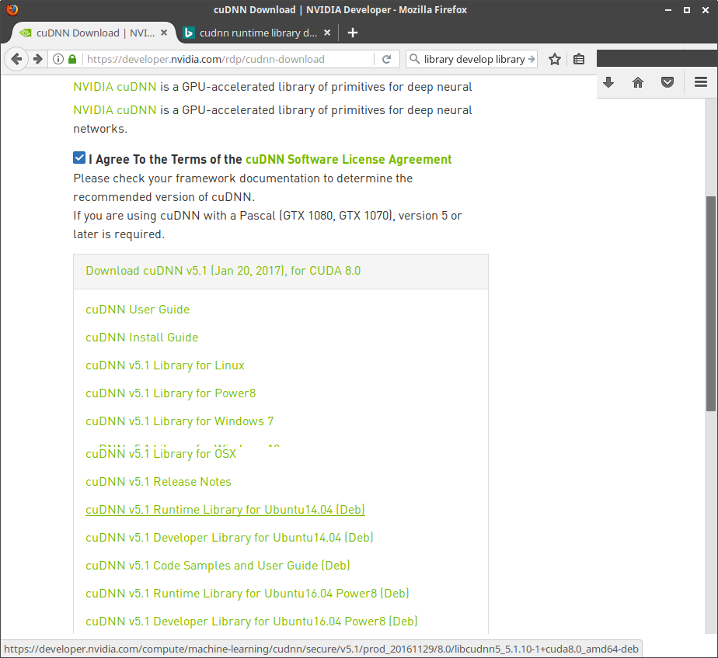
To ensure cuDNN is installed correctly, go to /usr/src/cudnn_samples_v5/mnistCUDNN

“sudo make” and test the generated mnistCUDNN:

root@ubuntu:/usr/src/cudnn_samples_v5/mnistCUDNN$ ./mnistCUDNN image=data/five_28x28.pgm
cudnnGetVersion() : 5110 , CUDNN_VERSION from cudnn.h : 5110 (5.1.10)
Host compiler version : GCC 5.4.1
There are 1 CUDA capable devices on your machine :
device 0 : sms 28 Capabilities 6.1, SmClock 1531.0 Mhz, MemSize (Mb) 12189, MemClock 5005.0 Mhz, Ecc=0, boardGroupID=0
Using device 0
Loading image data/five_28x28.pgm
Performing forward propagation ...
Testing cudnnGetConvolutionForwardAlgorithm ...
Fastest algorithm is Algo 1
Testing cudnnFindConvolutionForwardAlgorithm ...
^^^^ CUDNN_STATUS_SUCCESS for Algo 0: 0.022528 time requiring 0 memory
^^^^ CUDNN_STATUS_SUCCESS for Algo 2: 0.036864 time requiring 57600 memory
^^^^ CUDNN_STATUS_SUCCESS for Algo 1: 0.051200 time requiring 19508 memory
^^^^ CUDNN_STATUS_SUCCESS for Algo 7: 0.077824 time requiring 2057744 memory
^^^^ CUDNN_STATUS_SUCCESS for Algo 5: 0.112640 time requiring 205008 memory
Resulting weights from Softmax:
0.0000000 0.0000008 0.0000000 0.0000002 0.0000000 0.9999820 0.0000154 0.0000000 0.0000012 0.0000006

Result of classification: 5

Caffe prerequisite:
sudo apt-get install libprotobuf-dev libleveldb-dev libsnappy-dev libopencv-dev libhdf5-serial-dev protobuf-compiler
sudo apt-get install --no-install-recommends libboost-all-dev
sudo apt-get install libatlas-base-dev libgflags-dev libgoogle-glog-dev liblmdb-dev

Compile NV Caffe

NVcaffe is the NVIDIA branch of Caffe with optimizations for GPU. NVcaffe uses cuDNN and is used by DIGITS for training DNNs. To install it, clone the NVcaffe repo from GitHub and compile from source. First some prequisite packages for Caffe are installed, including the Python bindings required by DIGITS:
$ sudo apt-get install --no-install-recommends build-essential cmake git gfortran libatlas-base-dev libboost-filesystem-dev libboost-python-dev libboost-system-dev libboost-thread-dev libgflags-dev libgoogle-glog-dev libhdf5-serial-dev libleveldb-dev liblmdb-dev libprotobuf-dev libsnappy-dev protobuf-compiler python-all-dev python-dev python-h5py python-matplotlib python-numpy python-opencv python-pil python-pip python-protobuf python-scipy python-skimage python-sklearn python-setuptools
$ sudo apt-get install libopencv-dev python-opencv
$ sudo pip install --upgrade pip
$ git clone http://github.com/NVIDIA/caffe
$ cd caffe
$ sudo pip install -r python/requirements.txt
$ mkdir build
$ cd build
$ cmake ../ -DCUDA_USE_STATIC_CUDA_RUNTIME=OFF
$ make -j12 all
$ make pycaffe

Compile BLVC Caffe
sudo apt-get install git
git clone “https://github.com/BVLC/caffe.git”
cp Makefile.config.example Makefile.config
sudo gedit Makefile.config

uncomment “USE_CUDNN := 1”

Revise:
INCLUDE_DIRS := $(PYTHON_INCLUDE) /usr/local/include
LIBRARY_DIRS := $(PYTHON_LIB) /usr/local/lib /usr/lib
To:
# Whatever else you find you need goes here.
INCLUDE_DIRS := $(PYTHON_INCLUDE) /usr/local/include /usr/include/hdf5/serial
LIBRARY_DIRS := $(PYTHON_LIB) /usr/local/lib /usr/lib /usr/lib/i386-linux-gnu/hdf5/serial
or
# Whatever else you find you need goes here.
INCLUDE_DIRS := $(PYTHON_INCLUDE) /usr/local/include /usr/include/hdf5/serial
LIBRARY_DIRS := $(PYTHON_LIB) /usr/local/lib /usr/lib /usr/lib/x86_64-linux-gnu/hdf5/serial/

(
zys@ubuntu:~/caffe-master$ sudo find / -name libhdf5.so
/usr/lib/x86_64-linux-gnu/hdf5/serial/libhdf5.so
)

save & close

sudo make -j12 all
-j12 to enable parallel compile (i7 6800K has 6 cores)

Error1:

AR -o .build_release/lib/libcaffe.a
LD -o .build_release/lib/libcaffe.so.1.0.0-rc5
/usr/bin/ld: cannot find -lhdf5_hl
/usr/bin/ld: cannot find -lhdf5
collect2: error: ld returned 1 exit status
Makefile:572: recipe for target '.build_release/lib/libcaffe.so.1.0.0-rc5' failed
make: *** [.build_release/lib/libcaffe.so.1.0.0-rc5] Error 1

测试mnist例子：
cd $CAFFE_ROOT
./data/mnist/get_mnist.sh
./examples/mnist/create_mnist.sh
./examples/mnist/train_lenet.sh

实测发现，Titan X Pascal开启cuDNN的情况下，train耗时约10s；不开启cuDNN约2min。
而ThinkPad Carbon X1 （CPU模式）和NVIDIA Jetson TK1 （GPU模式+cuDNN）耗时均在12min左右。
速度差距明显，达到了70多倍

Use pycaffe for prediction

sudo make -j12
sudo make -j12 pycaffe

error:
fatal error: numpy/arrayobject.h: No such file or directory
solution:

python
>>> import numpy

check if numpy is installed

check site-packages directory
>>> import site; site.getsitepackages()
['/usr/local/lib/python2.7/dist-packages', '/usr/lib/python2.7/dist-packages']

Check which folder numpy is installed in.

revise Makefile.config accordingly:

# NOTE: this is required only if you will compile the python interface.
# We need to be able to find Python.h and numpy/arrayobject.h.
PYTHON_INCLUDE := /usr/include/python2.7 \
/usr/local/lib/python2.7/dist-packages/numpy/core/include
# /usr/lib/python2.7/dist-packages/numpy/core/include

export PYTHONPATH=/home/zys/caffe-master/distribute/python
export LD_LIBRARY_PATH=/home/zys/caffe-master/distribute/lib

Or persist the parameter by conf file:
sudo gedit /etc/ld.so.conf.d/caffe.conf
add the line:
/home/zys/caffe-master/distribute/lib
sudo ldconfig

write a test python script file (test_googlenet.py) as follows:

#coding=utf-8

import numpy
import os
import sys
import caffe

caffe_root = '/home/zys/caffe-master/'
sys.path.insert(0,caffe_root+'Python')

MODEL_FILE =caffe_root+'models/bvlc_googlenet/deploy.prototxt'
PRETRAINED =caffe_root+'models/bvlc_googlenet/bvlc_googlenet.caffemodel'

#cpu模式

caffe.set_mode_gpu()

#定义使用的神经网络模型
#image_dims : dimensions to scale input for cropping/sampling.
# Default is to scale to net input size for whole-image crop.
# mean, input_scale, raw_scale, channel_swap: params for
# preprocessing options.

net = caffe.Classifier(MODEL_FILE, PRETRAINED,
mean=numpy.load(caffe_root +'python/caffe/imagenet/ilsvrc_2012_mean.npy').mean(1).mean(1),
channel_swap=(2,1,0),
raw_scale=255,
# image_dims=(224, 224)
)

imagenet_labels_filename = caffe_root +'data/ilsvrc12/synset_words.txt'
labels =numpy.loadtxt(imagenet_labels_filename, str, delimiter='\t')

#对目标路径中的图像，遍历并分类

for root,dirs,files in os.walk(caffe_root + "examples/images/"):
for file in files:
#加载要分类的图片

IMAGE_FILE = os.path.join(root,file).decode('gbk').encode('utf-8');
input_image = caffe.io.load_image(IMAGE_FILE)
print("\n---- {} ----".format(IMAGE_FILE))

#预测图片类别

prediction = net.predict([input_image])
print 'predicted class:',prediction[0].argmax()

# 输出概率最大的前5个预测结果

top_k = net.blobs['prob'].data[0].flatten().argsort()[-1:-6:-1]
print labels[top_k]

python test_googlenet.py

