Data Prepare:

linux way:

cd /mnt/seagate/ROP_Unclassified_2016/
for f in $(find . -name '*.jpg' -or -name '*.doc'); do cp $f /mnt/seagate/$RANDOM$RANDOM$RANDOM$RANDOM.jpg; done

windows way:

Use System.App.Web.ROP.Tool.Label.exe

INSTALL NVIDIA-DIGITS

sudo apt-get install --no-install-recommends git graphviz python-dev python-flask python-flaskext.wtf python-gevent python-h5py python-numpy python-pil python-pip python-protobuf python-scipy
git clone https://github.com/NVIDIA/DIGITS.git
// this session only
# export CAFFE_ROOT=/home/zys/caffe-master/
export CAFFE_ROOT=/home/zys/NVcaffe/ # should use NV flavor

// write to user profile
echo "export CAFFE_ROOT=/home/zys/NVcaffe/" >> ~/.profile
source ~/.profile
echo $CAFFE_ROOT

ERROR:

zys@ubuntu:~/DIGITS$ ./digits-devserver
___ ___ ___ ___ _____ ___
| \_ _/ __|_ _|_ _/ __|
| |) | | (_ || | | | \__ \
|___/___\___|___| |_| |___/ 5.1-dev

"/home/zys/NVcaffe/" from CAFFE_ROOT does not point to a valid installation of Caffe.
Use the envvar CAFFE_ROOT to indicate a valid installation.
Traceback (most recent call last):
File "/usr/lib/python2.7/runpy.py", line 174, in _run_module_as_main
"__main__", fname, loader, pkg_name)
File "/usr/lib/python2.7/runpy.py", line 72, in _run_code
exec code in run_globals
File "/home/zys/DIGITS/digits/__main__.py", line 70, in <module>
main()
File "/home/zys/DIGITS/digits/__main__.py", line 53, in main
import digits.config
File "digits/config/__init__.py", line 7, in <module>
from . import ( # noqa
File "digits/config/caffe.py", line 226, in <module>
executable, version, flavor = load_from_envvar('CAFFE_ROOT')
File "digits/config/caffe.py", line 37, in load_from_envvar
import_pycaffe(python_dir)
File "digits/config/caffe.py", line 126, in import_pycaffe
import caffe
File "/home/zys/NVcaffe/python/caffe/__init__.py", line 1, in <module>
from .pycaffe import Net, SGDSolver, NesterovSolver, AdaGradSolver, RMSPropSolver, AdaDeltaSolver, AdamSolver
File "/home/zys/NVcaffe/python/caffe/pycaffe.py", line 15, in <module>
import caffe.io
File "/home/zys/NVcaffe/python/caffe/io.py", line 8, in <module>
from caffe.proto import caffe_pb2
File "/home/zys/NVcaffe/python/caffe/proto/caffe_pb2.py", line 23, in <module>
0\x64\x65t_fg_threshold\x18\x36 \x01(\x02:\x03\x30.5\x12\x1d\n\x10\x64\x65t_bg_threshold\x18\x37 \x01(\x02:\x03\x30.5\x12\x1d\n\x0f\x64\x65t_fg_fraction\x18\x38 \x01(\x02:\x04\x30.25\x12\x1a\n\x0f\x64\x65t_context_pad\x18: \x01(\r:\x01\x30\x12\x1b\n\rdet_crop_mode\x18; \x01(\t:\x04warp\x12\x12\n\x07new_num\x18< \x01(\x05:\x01\x30\x12\x17\n\x0cnew_channels\x18= \x01(\x05:\x01\x30\x12\x15\n\nnew_height\x18> \x01(\x05:\x01\x30\x12\x14\n\tnew_width\x18? \x01(\x05:\x01\x30\x12\x1d\n\x0eshuffle_images\x18@ \x01(\x08:\x05\x66\x61lse\x12\x15\n\nconcat_dim\x18\x41 \x01(\r:\x01\x31\x12\x36\n\x11hdf5_output_param\x18\xe9\x07 \x01(\x0b\x32\x1a.caffe.HDF5OutputParameter\".\n\nPoolMethod\x12\x07\n\x03MAX\x10\x00\x12\x07\n\x03\x41VE\x10\x01\x12\x0e\n\nSTOCHASTIC\x10\x02\"W\n\x0ePReLUParameter\x12&\n\x06\x66iller\x18\x01 \x01(\x0b\x32\x16.caffe.FillerParameter\x12\x1d\n\x0e\x63hannel_shared\x18\x02 \x01(\x08:\x05\x66\x61lse*\x1c\n\x05Phase\x12\t\n\x05TRAIN\x10\x00\x12\x08\n\x04TEST\x10\x01')
TypeError: __init__() got an unexpected keyword argument 'syntax'

SOLUTION: reinstall protobuf

zys@ubuntu:~/DIGITS$ sudo pip uninstall protobuf // this uninstalls 2.6.1
zys@ubuntu:~/DIGITS$ sudo pip install protobuf // this installs 3.2.0

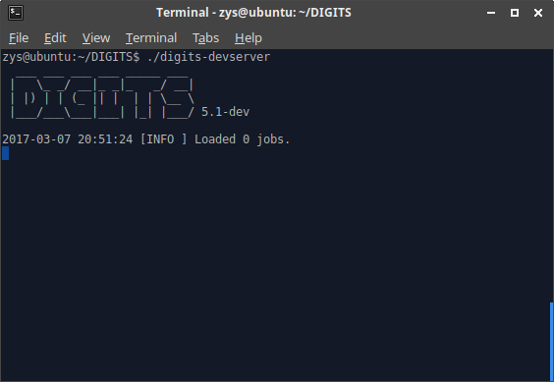

Open browser, go to http://localhost:5000

Example: MNIST

https://github.com/NVIDIA/DIGITS/blob/master/docs/GettingStarted.md

Use the python script “download_mnist.py” to prepare MNIST data set:

# Download and extract the MNIST dataset
# Modified by zys for Pyhont 3

import gzip
import os
import struct
import urllib.request
import shutil

import numpy as np
import PIL.Image

class MnistDownloader:
"""
See details about the MNIST dataset here:
http://yann.lecun.com/exdb/mnist/
"""
def __init__(self, outdir, clean=False, file_extension='png'):
"""
Arguments:
outdir -- directory where to download and create the dataset
if this directory doesn't exist, it will be created
Keyword arguments:
clean -- delete outdir first if it exists
file_extension -- image format for output images
"""
self.outdir = outdir
self.mkdir(self.outdir, clean=clean)
self.file_extension = file_extension.lower()

def getData(self):
"""
This is the main function that should be called by the users!
Downloads the dataset and prepares it for DIGITS consumption
"""
for url in self.urlList():
self.__downloadFile(url)

self.uncompressData()

self.processData()
print ("Dataset directory is created successfully at {}".format(self.outdir))

def __downloadFile(self, url):
"""
Downloads the url
"""
download_path = os.path.join(self.outdir, os.path.basename(url))
if not os.path.exists(download_path):
print ("Downloading url={} ...".format(url))
urllib.request.urlretrieve(url, download_path)

def mkdir(self, d, clean=False):
"""
Safely create a directory
Arguments:
d -- the directory name
Keyword arguments:
clean -- if True and the directory already exists, it will be deleted and recreated
"""
if os.path.exists(d):
if clean:
shutil.rmtree(d)
else:
return
os.mkdir(d)

def urlList(self):
return [
'http://yann.lecun.com/exdb/mnist/train-images-idx3-ubyte.gz',
'http://yann.lecun.com/exdb/mnist/train-labels-idx1-ubyte.gz',
'http://yann.lecun.com/exdb/mnist/t10k-images-idx3-ubyte.gz',
'http://yann.lecun.com/exdb/mnist/t10k-labels-idx1-ubyte.gz',
]

def uncompressData(self):
for zipped, unzipped in [
('train-images-idx3-ubyte.gz', 'train-images.bin'),
('train-labels-idx1-ubyte.gz', 'train-labels.bin'),
('t10k-images-idx3-ubyte.gz', 'test-images.bin'),
('t10k-labels-idx1-ubyte.gz', 'test-labels.bin'),
]:
zipped_path = os.path.join(self.outdir, zipped)
assert os.path.exists(zipped_path), 'Expected "%s" to exist' % zipped
unzipped_path = os.path.join(self.outdir, unzipped)
if not os.path.exists(unzipped_path):
print ("Uncompressing file={} ...".format(zipped))
with gzip.open(zipped_path) as infile, open(unzipped_path, 'wb') as outfile:
outfile.write(infile.read())

def processData(self):
self.__extract_images('train-images.bin', 'train-labels.bin', 'train')
self.__extract_images('test-images.bin', 'test-labels.bin', 'test')

def __extract_images(self, images_file, labels_file, phase):
"""
Extract information from binary files and store them as images
"""
labels = self.__readLabels(os.path.join(self.outdir, labels_file))
images = self.__readImages(os.path.join(self.outdir, images_file))
assert len(labels) == len(images), '%d != %d' % (len(labels), len(images))

output_dir = os.path.join(self.outdir, phase)
self.mkdir(output_dir, clean=True)
with open(os.path.join(output_dir, 'labels.txt'), 'w') as outfile:
for label in range(10):
outfile.write('%s\n' % label)
with open(os.path.join(output_dir, '%s.txt' % phase), 'w') as outfile:
for index, image in enumerate(images):
dirname = os.path.join(output_dir, labels[index])
self.mkdir(dirname)
filename = os.path.join(dirname, '%05d.%s' % (index, self.file_extension))
image.save(filename)
outfile.write('%s %s\n' % (filename, labels[index]))

def __readLabels(self, filename):
"""
Returns a list of ints
"""
print ('Reading labels from {} ...'.format(filename))
labels = []
with open(filename, 'rb') as infile:
infile.read(4) # ignore magic number
count = struct.unpack('>i', infile.read(4))[0]
data = infile.read(count)
for byte in data:
# http://stackoverflow.com/questions/42347498/translating-python-2-byte-checksum-calculator-to-python-3
label = byte #struct.unpack('>B', byte)[0]
labels.append(str(label))
return labels

def __readImages(self, filename):
"""
Returns a list of PIL.Image objects
"""
print ('Reading images from {} ...'.format(filename))
images = []
with open(filename, 'rb') as infile:
infile.read(4) # ignore magic number
count = struct.unpack('>i', infile.read(4))[0]
rows = struct.unpack('>i', infile.read(4))[0]
columns = struct.unpack('>i', infile.read(4))[0]

for i in range(count):
data = infile.read(rows * columns)
image = np.fromstring(data, dtype=np.uint8)
image = image.reshape((rows, columns))
image = 255 - image # now black digit on white background
images.append(PIL.Image.fromarray(image))
return images

# Execute
MnistDownloader("g:/mnist", False).getData()

Create Dataset and Train Model
Example: MNIST fine tune

https://github.com/NVIDIA/DIGITS/tree/master/examples/fine-tuning

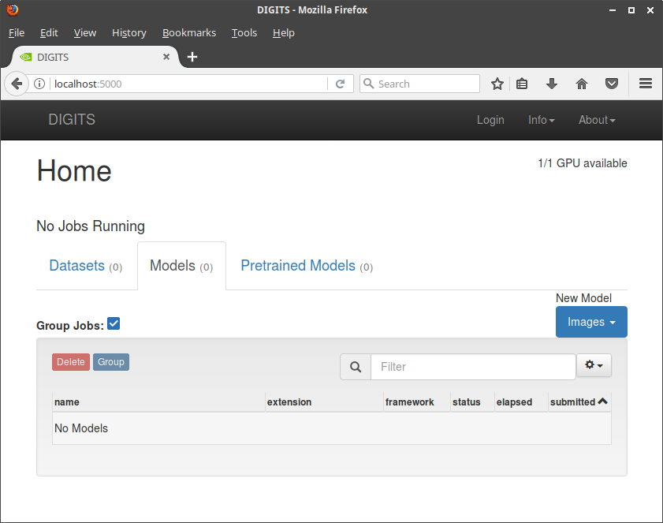

SET DATASETS

zys@ubuntu:~/DIGITS$ lsblk
NAME MAJ:MIN RM SIZE RO TYPE MOUNTPOINT
sr0 11:0 1 1024M 0 rom
sda 8:0 0 931.5G 0 disk
└─sda1 8:1 0 931.5G 0 part /media/zys/Seagate Backup Plus Drive
nvme0n1 259:0 0 238.5G 0 disk
├─nvme0n1p5 259:5 0 14.9G 0 part [SWAP]
├─nvme0n1p3 259:3 0 16M 0 part
├─nvme0n1p1 259:1 0 450M 0 part
├─nvme0n1p6 259:6 0 105.1G 0 part /
├─nvme0n1p4 259:4 0 118G 0 part /media/zys/0A24AF0D24AEFAB9
└─nvme0n1p2 259:2 0 100M 0 part

zys@ubuntu:~$ ll /dev | grep sda1
brw-rw---- 1 root disk 8, 1 Mar 7 22:31 sda1

mkdir -p ~/seagate // create if not exist
sudo mount /dev/sda1 ~/seagate

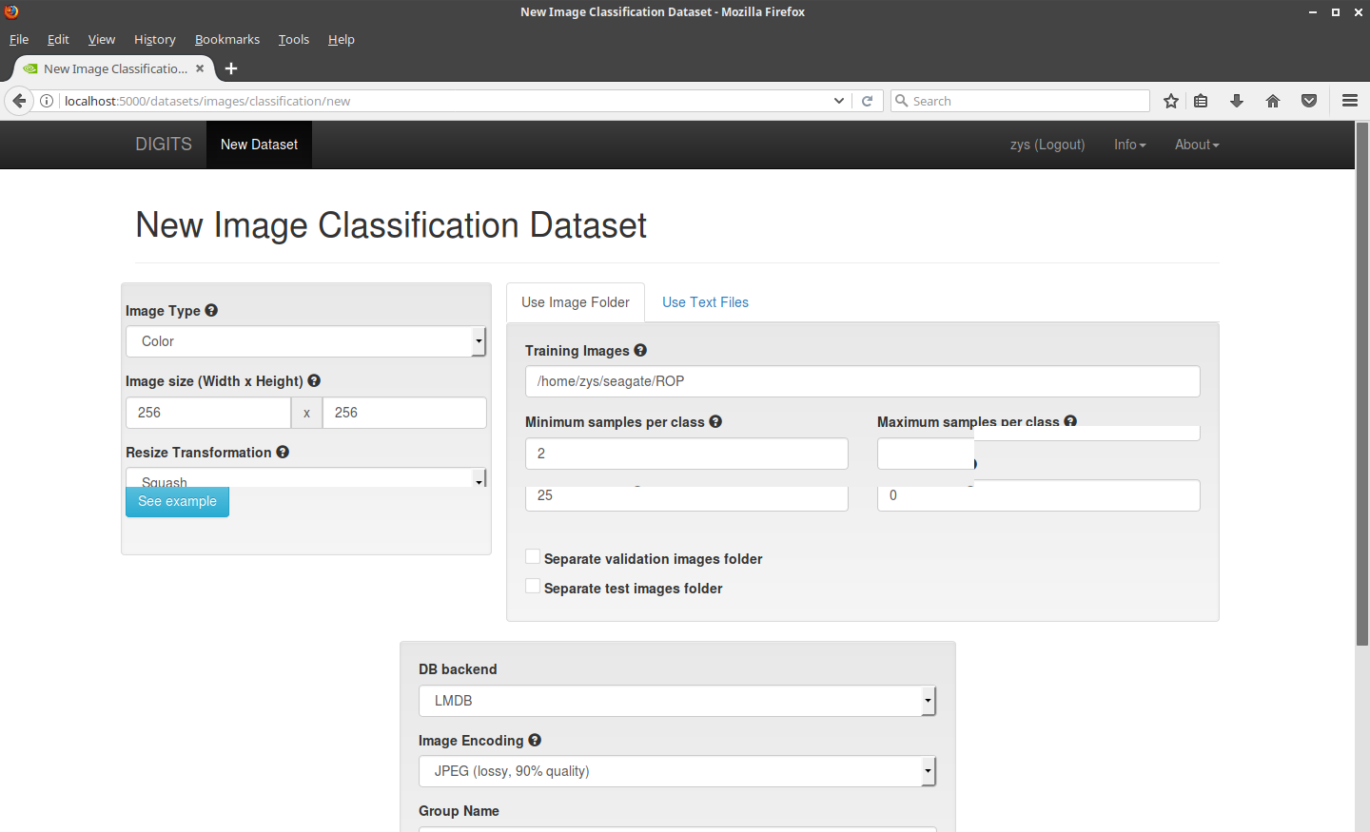
Use 256X256 to use GoogLeNet

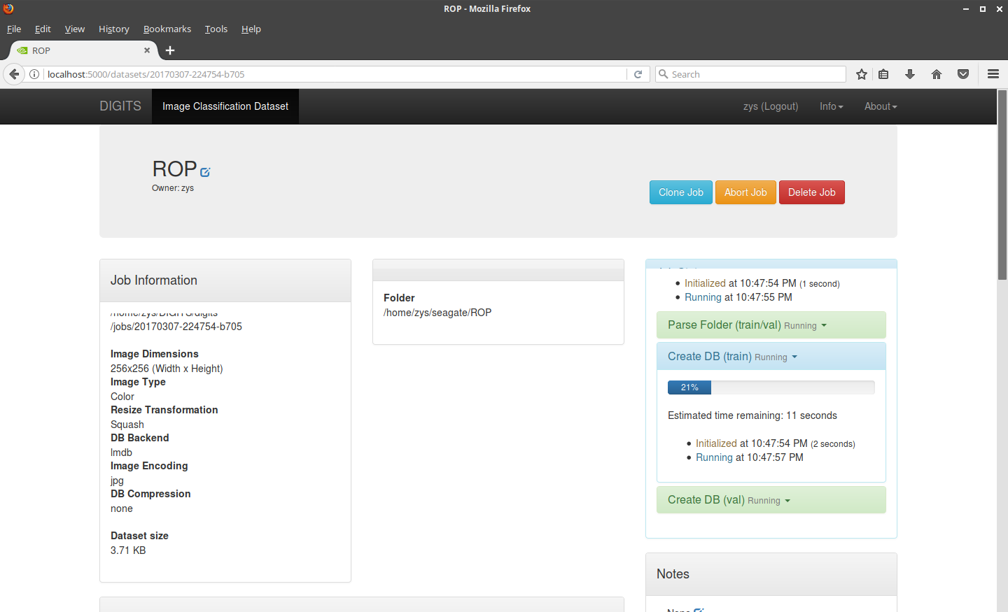

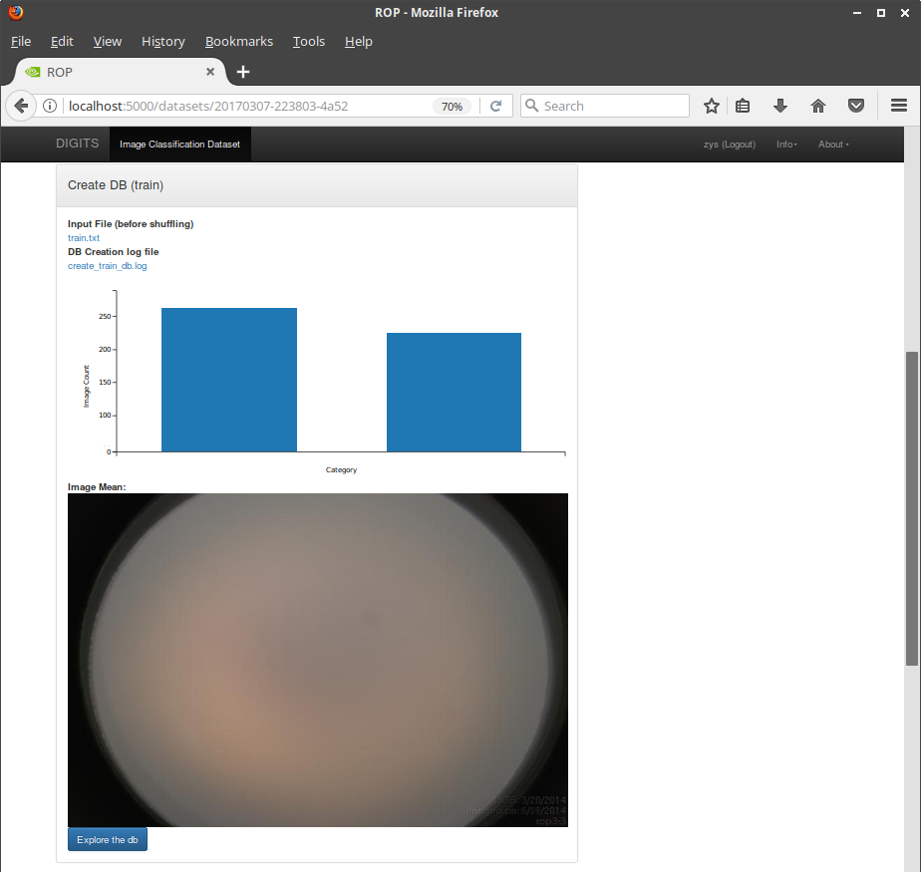

Finetune for RetCam and non-RetCam classifier

generate_train_test_txt.sh:

If output two many:
data_layer.cpp:73] Restarting data prefetching from start.
Means:

- You gave the wrong .txt file to data layer
- The format of the .txt file is not as expected by Caffe
- Very few number of data is present in the file.

