Example: finetune_flickr_style in Caffe

solver.prototxt:

net: "models/finetune_flickr_style/train_val.prototxt"
test_iter: 100
test_interval: 1000
# lr for fine-tuning should be lower than when starting from scratch. Original AlexNet uses 0.01
base_lr: 0.001
lr_policy: "step"
gamma: 0.1
# stepsize should also be lower, as we're closer to being done. Original AlexNet uses 100000
stepsize: 20000
display: 20
max_iter: 100000
momentum: 0.9
weight_decay: 0.0005
snapshot: 10000
snapshot_prefix: "models/finetune_flickr_style/finetune_flickr_style"
# uncomment the following to default to CPU mode solving
solver_mode: GPU

train_val.prototxt

layer {
# rename layer name
name: "fc8_flickr"
type: "InnerProduct"
bottom: "fc7"
top: "fc8_flickr"
# lr_mult is set to higher than for other layers, because this layer is starting from random while the others are already trained
param {
# Original AlexNet uses 1
lr_mult: 10
decay_mult: 1
}
param {
# Original AlexNet uses 2
lr_mult: 20
decay_mult: 0
}
inner_product_param {
# change to your number of classes. Original AlexNet has 1000 classes
num_output: 20
weight_filler {
type: "gaussian"
std: 0.01
}
bias_filler {
type: "constant"
value: 0
}
}
}

Train:

./build/tools/caffe train -solver models/finetune_flickr_style/solver.prototxt -weights models/bvlc_reference_caffenet/bvlc_reference_caffenet.caffemodel -gpu 0

Finetune for ROP

caffe-master/models/finetune_alexnet_rop/solver.prototxt

net: "models/finetune_alexnet_rop/train_val.prototxt"
test_iter: 100
test_interval: 1000
# lr for fine-tuning should be lower than when starting from scratch. Original AlexNet uses 0.01
base_lr: 0.001
lr_policy: "step"
gamma: 0.1
# stepsize should also be lower, as we're closer to being done. Original AlexNet uses 100000
stepsize: 20000
display: 20
max_iter: 100000
momentum: 0.9
weight_decay: 0.0005
snapshot: 10000
snapshot_prefix: "models/finetune_alexnet_rop/finetune_alexnet_rop"
# uncomment the following to default to CPU mode solving
solver_mode: GPU

Comparison with caffe-master/models/bvlc_alexnet/solver.prototxt
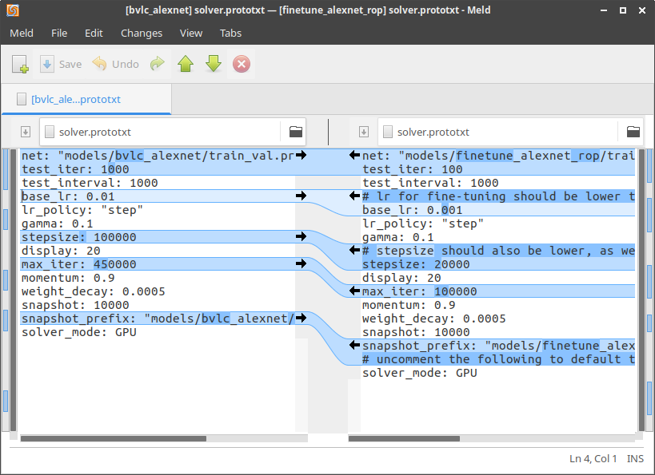

caffe-master/models/finetune_alexnet_rop/train_val.prototxt

name: "RopCaffeNet"
layer {
name: "data"
type: "Data"
top: "data"
top: "label"
include {
phase: TRAIN
}
transform_param {
mirror: true
crop_size: 227
# because it's finetuning. We use the mean file of ImageNet, other than RetCam
mean_file: "data/ilsvrc12/imagenet_mean.binaryproto"
}
data_param {
source: "data/rop/train_db"
batch_size: 50
backend: LMDB
}
}
layer {
name: "data"
type: "Data"
top: "data"
top: "label"
include {
phase: TEST
}
transform_param {
mirror: false
crop_size: 227
mean_file: "data/ilsvrc12/imagenet_mean.binaryproto"
}
data_param {
source: "data/rop/val_db"
batch_size: 50
backend: LMDB
}
}
… ...
layer {
name: "fc8_rop"
type: "InnerProduct"
bottom: "fc7"
top: "fc8_rop"
# lr_mult is set to higher than for other layers, because this layer is starting from random while the others are already trained
param {
lr_mult: 10
decay_mult: 1
}
param {
lr_mult: 20
decay_mult: 0
}
inner_product_param {
num_output: 2
weight_filler {
type: "gaussian"
std: 0.01
}
bias_filler {
type: "constant"
value: 0
}
}
}
layer {
name: "accuracy"
type: "Accuracy"
bottom: "fc8_rop"
bottom: "label"
top: "accuracy"
include {
phase: TEST
}
}
layer {
name: "loss"
type: "SoftmaxWithLoss"
bottom: "fc8_rop"
bottom: "label"
top: "loss"
}

change deploy.prototxt accrodingly

name: "RopCaffeNet"
layer {
name: "data"
type: "Input"
top: "data"
input_param { shape: { dim: 10 dim: 3 dim: 227 dim: 227 } }
}
… …
layer {
name: "fc8_rop"
type: "InnerProduct"
bottom: "fc7"
top: "fc8_rop"
# lr_mult is set to higher than for other layers, because this layer is starting from random while the others are already trained
param {
lr_mult: 10
decay_mult: 1
}
param {
lr_mult: 20
decay_mult: 0
}
inner_product_param {
num_output: 2
weight_filler {
type: "gaussian"
std: 0.01
}
bias_filler {
type: "constant"
value: 0
}
}
}
layer {
name: "prob"
type: "Softmax"
bottom: "fc8_rop"
top: "prob"
}

TRAIN

./build/tools/caffe train -solver models/finetune_alexnet_rop/solver.prototxt -weights models/bvlc_reference_caffenet/bvlc_reference_caffenet.caffemodel -gpu 0

TEST

export PYTHONPATH=/home/zys/caffe-master/distribute/python
export LD_LIBRARY_PATH=/home/zys/caffe-master/distribute/lib
python test_rop.py

test_rop.py

#coding=utf-8

import numpy
import os
import sys
import caffe

caffe_root = '/home/zys/caffe-master/'
sys.path.insert(0,caffe_root+'Python')

MODEL_FILE =caffe_root+'models/finetune_alexnet_rop/deploy.prototxt'
PRETRAINED =caffe_root+'models/finetune_alexnet_rop/finetune_alexnet_rop_iter_100000.caffemodel'

#cpu模式

caffe.set_mode_gpu()

#定义使用的神经网络模型
#image_dims : dimensions to scale input for cropping/sampling.
# Default is to scale to net input size for whole-image crop.
# mean, input_scale, raw_scale, channel_swap: params for
# preprocessing options.

net = caffe.Classifier(MODEL_FILE, PRETRAINED,
mean=numpy.load(caffe_root +'python/caffe/imagenet/ilsvrc_2012_mean.npy').mean(1).mean(1),
channel_swap=(2,1,0),
raw_scale=255,
# image_dims=(224, 224)
)

imagenet_labels_filename = caffe_root +'models/finetune_alexnet_rop/rop/labels.txt'
labels =numpy.loadtxt(imagenet_labels_filename, str, delimiter='\t')

#对目标路径中的图像，遍历并分类

for root,dirs,files in os.walk(caffe_root + "examples/images/ROP/"):
for file in files:
#加载要分类的图片

IMAGE_FILE = os.path.join(root,file).decode('gbk').encode('utf-8');
input_image = caffe.io.load_image(IMAGE_FILE)
print("\n---- {} ----".format(IMAGE_FILE))

#预测图片类别

prediction = net.predict([input_image])
print 'predicted class:',prediction[0].argmax()

# 输出概率最大的前5个预测结果

top_k = net.blobs['prob'].data[0].flatten().argsort()[-1:-6:-1]
print labels[top_k]

