Example: finetune_flickr_style in Caffe

solver.prototxt:

net: "models/finetune_flickr_style/train_val.prototxt"
test_iter: 100
test_interval: 1000
# lr for fine-tuning should be lower than when starting from scratch. Original AlexNet uses 0.01
base_lr: 0.001
lr_policy: "step"
gamma: 0.1
# stepsize should also be lower, as we're closer to being done. Original AlexNet uses 100000
stepsize: 20000
display: 20
max_iter: 100000
momentum: 0.9
weight_decay: 0.0005
snapshot: 10000
snapshot_prefix: "models/finetune_flickr_style/finetune_flickr_style"
# uncomment the following to default to CPU mode solving
solver_mode: GPU

train_val.prototxt

layer {
# rename layer name
name: "fc8_flickr"
type: "InnerProduct"
bottom: "fc7"
top: "fc8_flickr"
# lr_mult is set to higher than for other layers, because this layer is starting from random while the others are already trained
param {
# Original AlexNet uses 1
lr_mult: 10
decay_mult: 1
}
param {
# Original AlexNet uses 2
lr_mult: 20
decay_mult: 0
}
inner_product_param {
# change to your number of classes. Original AlexNet has 1000 classes
num_output: 20
weight_filler {
type: "gaussian"
std: 0.01
}
bias_filler {
type: "constant"
value: 0
}
}
}

Train:

./build/tools/caffe train -solver models/finetune_flickr_style/solver.prototxt -weights models/bvlc_reference_caffenet/bvlc_reference_caffenet.caffemodel -gpu 0

Finetune for ROP

caffe-master/models/finetune_alexnet_rop/solver.prototxt

net: "models/finetune_alexnet_rop/train_val.prototxt"
test_iter: 100
test_interval: 1000
# lr for fine-tuning should be lower than when starting from scratch. Original AlexNet uses 0.01
base_lr: 0.001
lr_policy: "step"
gamma: 0.1
# stepsize should also be lower, as we're closer to being done. Original AlexNet uses 100000
stepsize: 20000
display: 20
max_iter: 100000
momentum: 0.9
weight_decay: 0.0005
snapshot: 10000
snapshot_prefix: "models/finetune_alexnet_rop/finetune_alexnet_rop"
# uncomment the following to default to CPU mode solving
solver_mode: GPU

Comparison with caffe-master/models/bvlc_alexnet/solver.prototxt
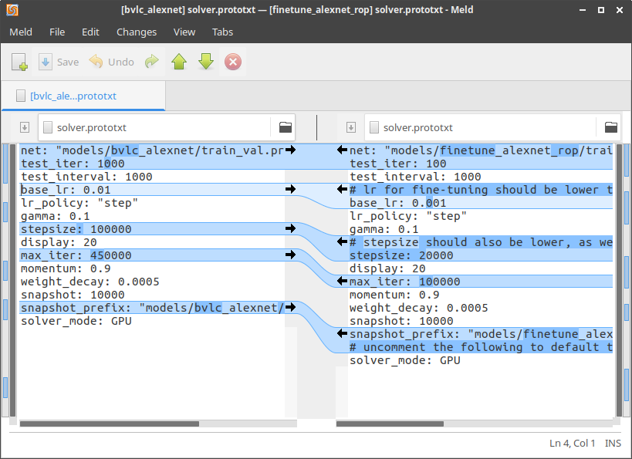

caffe-master/models/finetune_alexnet_rop/train_val.prototxt

name: "RopCaffeNet"
layer {
name: "data"
type: "Data"
top: "data"
top: "label"
include {
phase: TRAIN
}
transform_param {
mirror: true
crop_size: 227
# because it's finetuning. We use the mean file of ImageNet, other than RetCam
mean_file: "data/ilsvrc12/imagenet_mean.binaryproto"
}
data_param {
source: "data/rop/train_db"
batch_size: 50
backend: LMDB
}
}
layer {
name: "data"
type: "Data"
top: "data"
top: "label"
include {
phase: TEST
}
transform_param {
mirror: false
crop_size: 227
mean_file: "data/ilsvrc12/imagenet_mean.binaryproto"
}
data_param {
source: "data/rop/val_db"
batch_size: 50
backend: LMDB
}
}
… ...
layer {
name: "fc8_rop"
type: "InnerProduct"
bottom: "fc7"
top: "fc8_rop"
# lr_mult is set to higher than for other layers, because this layer is starting from random while the others are already trained
param {
lr_mult: 10
decay_mult: 1
}
param {
lr_mult: 20
decay_mult: 0
}
inner_product_param {
num_output: 2
weight_filler {
type: "gaussian"
std: 0.01
}
bias_filler {
type: "constant"
value: 0
}
}
}
layer {
name: "accuracy"
type: "Accuracy"
bottom: "fc8_rop"
bottom: "label"
top: "accuracy"
include {
phase: TEST
}
}
layer {
name: "loss"
type: "SoftmaxWithLoss"
bottom: "fc8_rop"
bottom: "label"
top: "loss"
}

TRAIN

TEST

Data Prepare:

cd /mnt/seagate/ROP_Unclassified_2016/
for f in $(find . -name '*.jpg' -or -name '*.doc'); do cp $f /mnt/seagate/$RANDOM$RANDOM$RANDOM$RANDOM.jpg; done

INSTALL NVIDIA-DIGITS

sudo apt-get install --no-install-recommends git graphviz python-dev python-flask python-flaskext.wtf python-gevent python-h5py python-numpy python-pil python-pip python-protobuf python-scipy
git clone https://github.com/NVIDIA/DIGITS.git
// this session only
export CAFFE_ROOT=/home/zys/caffe-master/

// write to user profile
echo "export CAFFE_ROOT=/home/zys/caffe-master/" >> ~/.profile
source ~/.profile
echo $CAFFE_ROOT

ERROR:

zys@ubuntu:~/DIGITS$ ./digits-devserver
___ ___ ___ ___ _____ ___
| \_ _/ __|_ _|_ _/ __|
| |) | | (_ || | | | \__ \
|___/___\___|___| |_| |___/ 5.1-dev

"/home/zys/NVcaffe/" from CAFFE_ROOT does not point to a valid installation of Caffe.
Use the envvar CAFFE_ROOT to indicate a valid installation.
Traceback (most recent call last):
File "/usr/lib/python2.7/runpy.py", line 174, in _run_module_as_main
"__main__", fname, loader, pkg_name)
File "/usr/lib/python2.7/runpy.py", line 72, in _run_code
exec code in run_globals
File "/home/zys/DIGITS/digits/__main__.py", line 70, in <module>
main()
File "/home/zys/DIGITS/digits/__main__.py", line 53, in main
import digits.config
File "digits/config/__init__.py", line 7, in <module>
from . import ( # noqa
File "digits/config/caffe.py", line 226, in <module>
executable, version, flavor = load_from_envvar('CAFFE_ROOT')
File "digits/config/caffe.py", line 37, in load_from_envvar
import_pycaffe(python_dir)
File "digits/config/caffe.py", line 126, in import_pycaffe
import caffe
File "/home/zys/NVcaffe/python/caffe/__init__.py", line 1, in <module>
from .pycaffe import Net, SGDSolver, NesterovSolver, AdaGradSolver, RMSPropSolver, AdaDeltaSolver, AdamSolver
File "/home/zys/NVcaffe/python/caffe/pycaffe.py", line 15, in <module>
import caffe.io
File "/home/zys/NVcaffe/python/caffe/io.py", line 8, in <module>
from caffe.proto import caffe_pb2
File "/home/zys/NVcaffe/python/caffe/proto/caffe_pb2.py", line 23, in <module>
0\x64\x65t_fg_threshold\x18\x36 \x01(\x02:\x03\x30.5\x12\x1d\n\x10\x64\x65t_bg_threshold\x18\x37 \x01(\x02:\x03\x30.5\x12\x1d\n\x0f\x64\x65t_fg_fraction\x18\x38 \x01(\x02:\x04\x30.25\x12\x1a\n\x0f\x64\x65t_context_pad\x18: \x01(\r:\x01\x30\x12\x1b\n\rdet_crop_mode\x18; \x01(\t:\x04warp\x12\x12\n\x07new_num\x18< \x01(\x05:\x01\x30\x12\x17\n\x0cnew_channels\x18= \x01(\x05:\x01\x30\x12\x15\n\nnew_height\x18> \x01(\x05:\x01\x30\x12\x14\n\tnew_width\x18? \x01(\x05:\x01\x30\x12\x1d\n\x0eshuffle_images\x18@ \x01(\x08:\x05\x66\x61lse\x12\x15\n\nconcat_dim\x18\x41 \x01(\r:\x01\x31\x12\x36\n\x11hdf5_output_param\x18\xe9\x07 \x01(\x0b\x32\x1a.caffe.HDF5OutputParameter\".\n\nPoolMethod\x12\x07\n\x03MAX\x10\x00\x12\x07\n\x03\x41VE\x10\x01\x12\x0e\n\nSTOCHASTIC\x10\x02\"W\n\x0ePReLUParameter\x12&\n\x06\x66iller\x18\x01 \x01(\x0b\x32\x16.caffe.FillerParameter\x12\x1d\n\x0e\x63hannel_shared\x18\x02 \x01(\x08:\x05\x66\x61lse*\x1c\n\x05Phase\x12\t\n\x05TRAIN\x10\x00\x12\x08\n\x04TEST\x10\x01')
TypeError: __init__() got an unexpected keyword argument 'syntax'

SOLUTION: reinstall protobuf

zys@ubuntu:~/DIGITS$ sudo pip uninstall protobuf // this uninstalls 2.6.1
zys@ubuntu:~/DIGITS$ sudo pip install protobuf // this installs 3.2.0

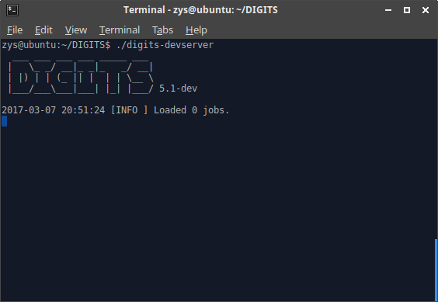

Open browser, go to http://localhost:5000

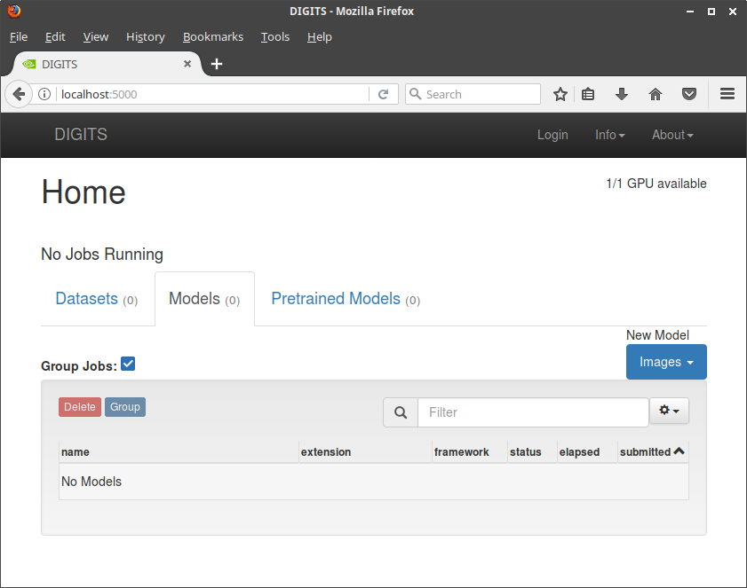

SET DATASETS

zys@ubuntu:~/DIGITS$ lsblk
NAME MAJ:MIN RM SIZE RO TYPE MOUNTPOINT
sr0 11:0 1 1024M 0 rom
sda 8:0 0 931.5G 0 disk
└─sda1 8:1 0 931.5G 0 part /media/zys/Seagate Backup Plus Drive
nvme0n1 259:0 0 238.5G 0 disk
├─nvme0n1p5 259:5 0 14.9G 0 part [SWAP]
├─nvme0n1p3 259:3 0 16M 0 part
├─nvme0n1p1 259:1 0 450M 0 part
├─nvme0n1p6 259:6 0 105.1G 0 part /
├─nvme0n1p4 259:4 0 118G 0 part /media/zys/0A24AF0D24AEFAB9
└─nvme0n1p2 259:2 0 100M 0 part

zys@ubuntu:~$ ll /dev | grep sda1
brw-rw---- 1 root disk 8, 1 Mar 7 22:31 sda1

mkdir -p ~/seagate // create if not exist
sudo mount /dev/sda1 ~/seagate

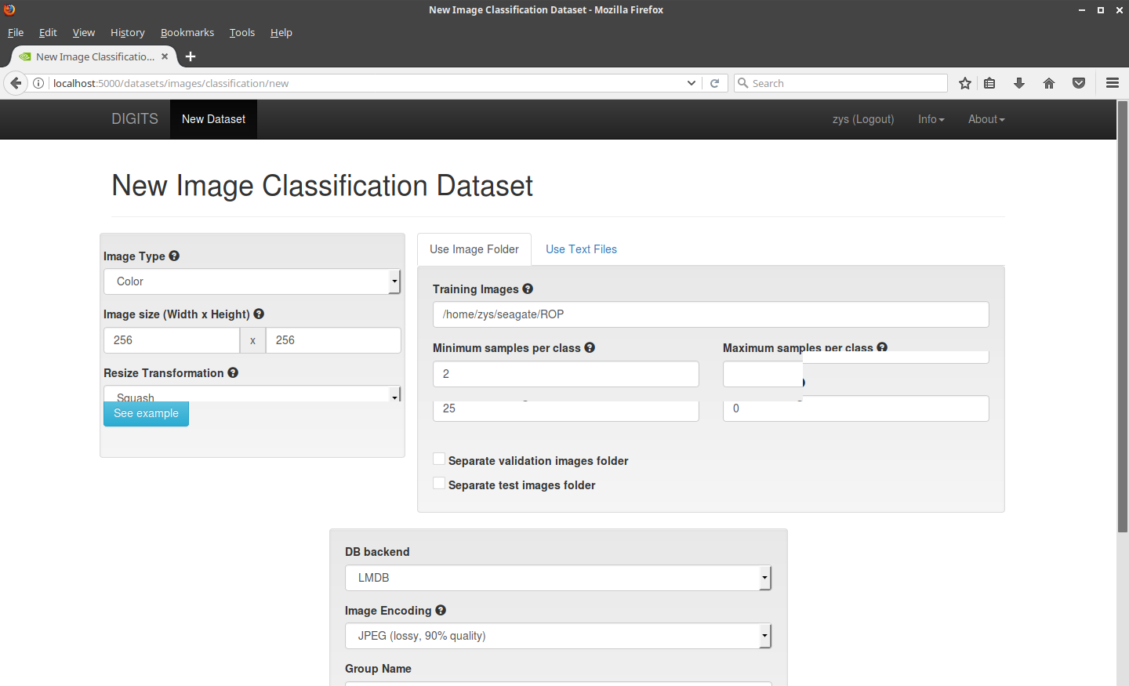
Use 256X256 to use GoogLeNet

