CAPSDAC Principal Data Engineer Upgrade
Enrollment Forecasting Data Platform
Prepared for Principal Data Engineer / AI Data Platform interviews
Prepared by: Yu Zhang
Updated: 2026
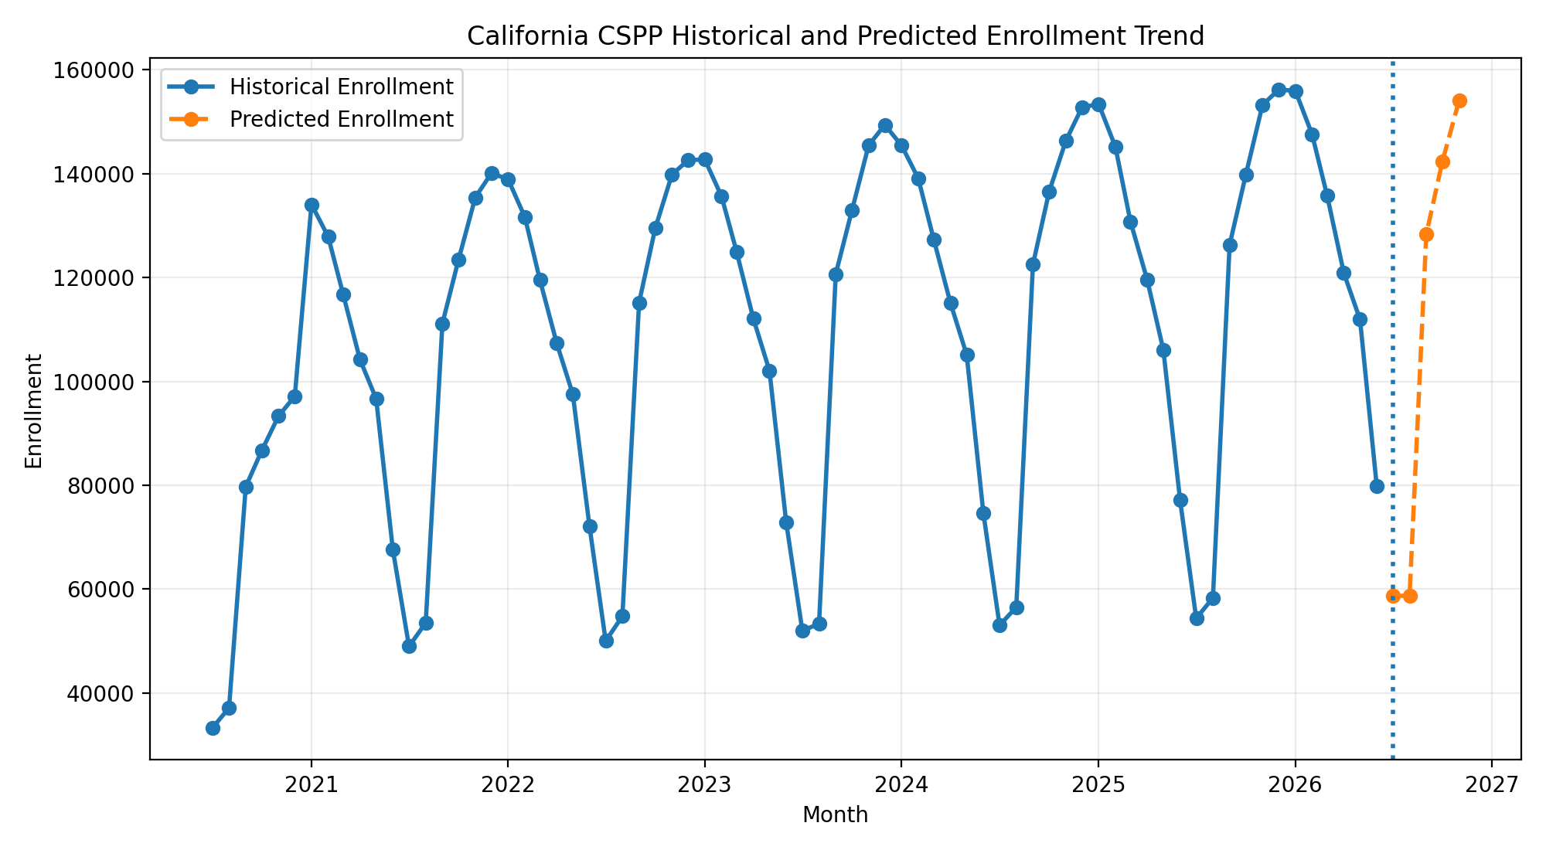
Figure 1. California CSPP historical and predicted enrollment trend from the upgraded CAPSDAC forecast package.

Abstract
This report describes an upgraded CAPSDAC enrollment forecasting portfolio project designed for Principal Data Engineer and AI Data Platform interviews. The system converts a notebook-style forecasting workflow into a governed data product with data contracts, modular Python code, reproducible training, executive reporting, and an AWS productionization roadmap. The package uses de-identified synthetic sample data and demonstrates how monthly CSPP enrollment snapshots can support statewide, vendor, and site-level capacity planning.

Executive Summary
Forecast signal | Predicted statewide enrollment remains stable-to-positive over the near-term forecast horizon, with expected seasonal variation.
Vendor pattern | Forecast demand is concentrated among leading providers, creating both planning leverage and concentration risk.
Site pattern | Top California sites show persistent differences in demand, supporting targeted capacity support rather than uniform expansion.
Engineering upgrade | The project is reorganized as a production-style data product with validation, contracts, source modules, CI/CD, orchestration, monitoring, and cloud architecture.
Decision use | Best used for aggregate planning, staffing readiness, budget timing, and risk review; not for individual eligibility or certified enrollment counts.

1. Background and Principal Data Engineer Positioning
The public CAPSDAC repository already communicates an education analytics question: whether monthly enrollment snapshots can forecast near-term CSPP enrollment and identify county, site, and vendor drivers. For a Principal Data Engineer role, the key improvement is to show platform leadership: how data is governed, validated, automated, monitored, and delivered as a reliable product. This upgrade preserves the forecasting story while adding production-grade engineering patterns.

2. Repository Upgrade Strategy
The upgraded package keeps the original domain narrative but reorganizes the code into reusable modules under src/capsdac_ml, adds data contracts under data/contracts, stores synthetic source data under data/raw, writes model-ready features under data/processed, saves model artifacts under models, publishes forecast outputs under outputs, and adds deployment scaffolding for Glue, SageMaker, Step Functions, Airflow, Terraform, and GitHub Actions. This changes the project from a reporting demo into an interview-ready data platform.

3. Target Architecture
The target architecture follows a lakehouse pattern. Bronze contains immutable source snapshots, Silver contains validated and conformed parquet tables, Gold contains forecast-ready feature and contribution marts, and the ML layer trains and scores recursive forecasts. Consumption happens through CSV outputs, Streamlit dashboards, director reports, and future Athena or QuickSight tables.

4. Data Strategy and Governance
The public package uses synthetic, de-identified sample data. The production design assumes secure CAPSDAC extracts and explicitly prevents child names, addresses, dates of birth, guardian identifiers, credentials, and internal screenshots from entering the public repository. Data contracts define required columns, grain, quality rules, and privacy boundaries. This is essential for education data because schema drift and privacy leakage can create operational and compliance risks.

5. Machine Learning Methodology
The model uses monthly lag features, rolling averages, and calendar seasonality indicators. A Random Forest Regressor captures nonlinear local patterns at the site level, and recursive forecasting generates short-horizon predictions for future months. This approach is appropriate for a planning use case because it captures annual seasonality, recent enrollment momentum, and site/vendor variation without requiring individual child-level prediction.

6. Model Performance and Interpretability
The generated holdout metrics are MAE 4.13, RMSE 5.49, and R2 1.00 on the synthetic sample. Feature importance indicates that prior-year and recent-lag enrollment signals are the dominant drivers, consistent with the original report's observation that lag-based seasonality is central to the forecast logic.

7. Forecast Results and Planning Interpretation
The statewide forecast supports stable-to-positive near-term demand. Vendor-level results show concentration among a small number of providers, and site-level results show that high-demand sites remain consistently above lower-ranked sites across the forecast horizon. The planning implication is targeted allocation rather than broad uniform expansion.

8. Productionization Roadmap
The AWS production roadmap uses S3, Glue, Step Functions, SageMaker, Athena, QuickSight, CloudWatch, KMS, IAM, and Lake Formation. The operational roadmap adds row-count monitoring, schema drift alerts, missing vendor/site detection, forecast drift checks, model registry, backtesting, and executive publishing workflows.

9. Interview Talking Points
A strong interview framing is: I converted an education ML forecasting workflow into a governed data platform. I designed the lakehouse layers, data contracts, reusable Python modules, recursive forecast model, contribution outputs, reporting layer, cloud deployment plan, and privacy controls. This demonstrates both data engineering leadership and applied ML understanding.

10. Conclusion
The upgraded CAPSDAC package is now better aligned with Principal Data Engineer expectations. It shows how to own a domain-critical data product from source ingestion through validation, feature engineering, modeling, reporting, governance, and productionization. The strongest story is not just that the model predicts enrollment; it is that the platform makes forecasting reliable, auditable, repeatable, and useful for executive planning.

Key Figures
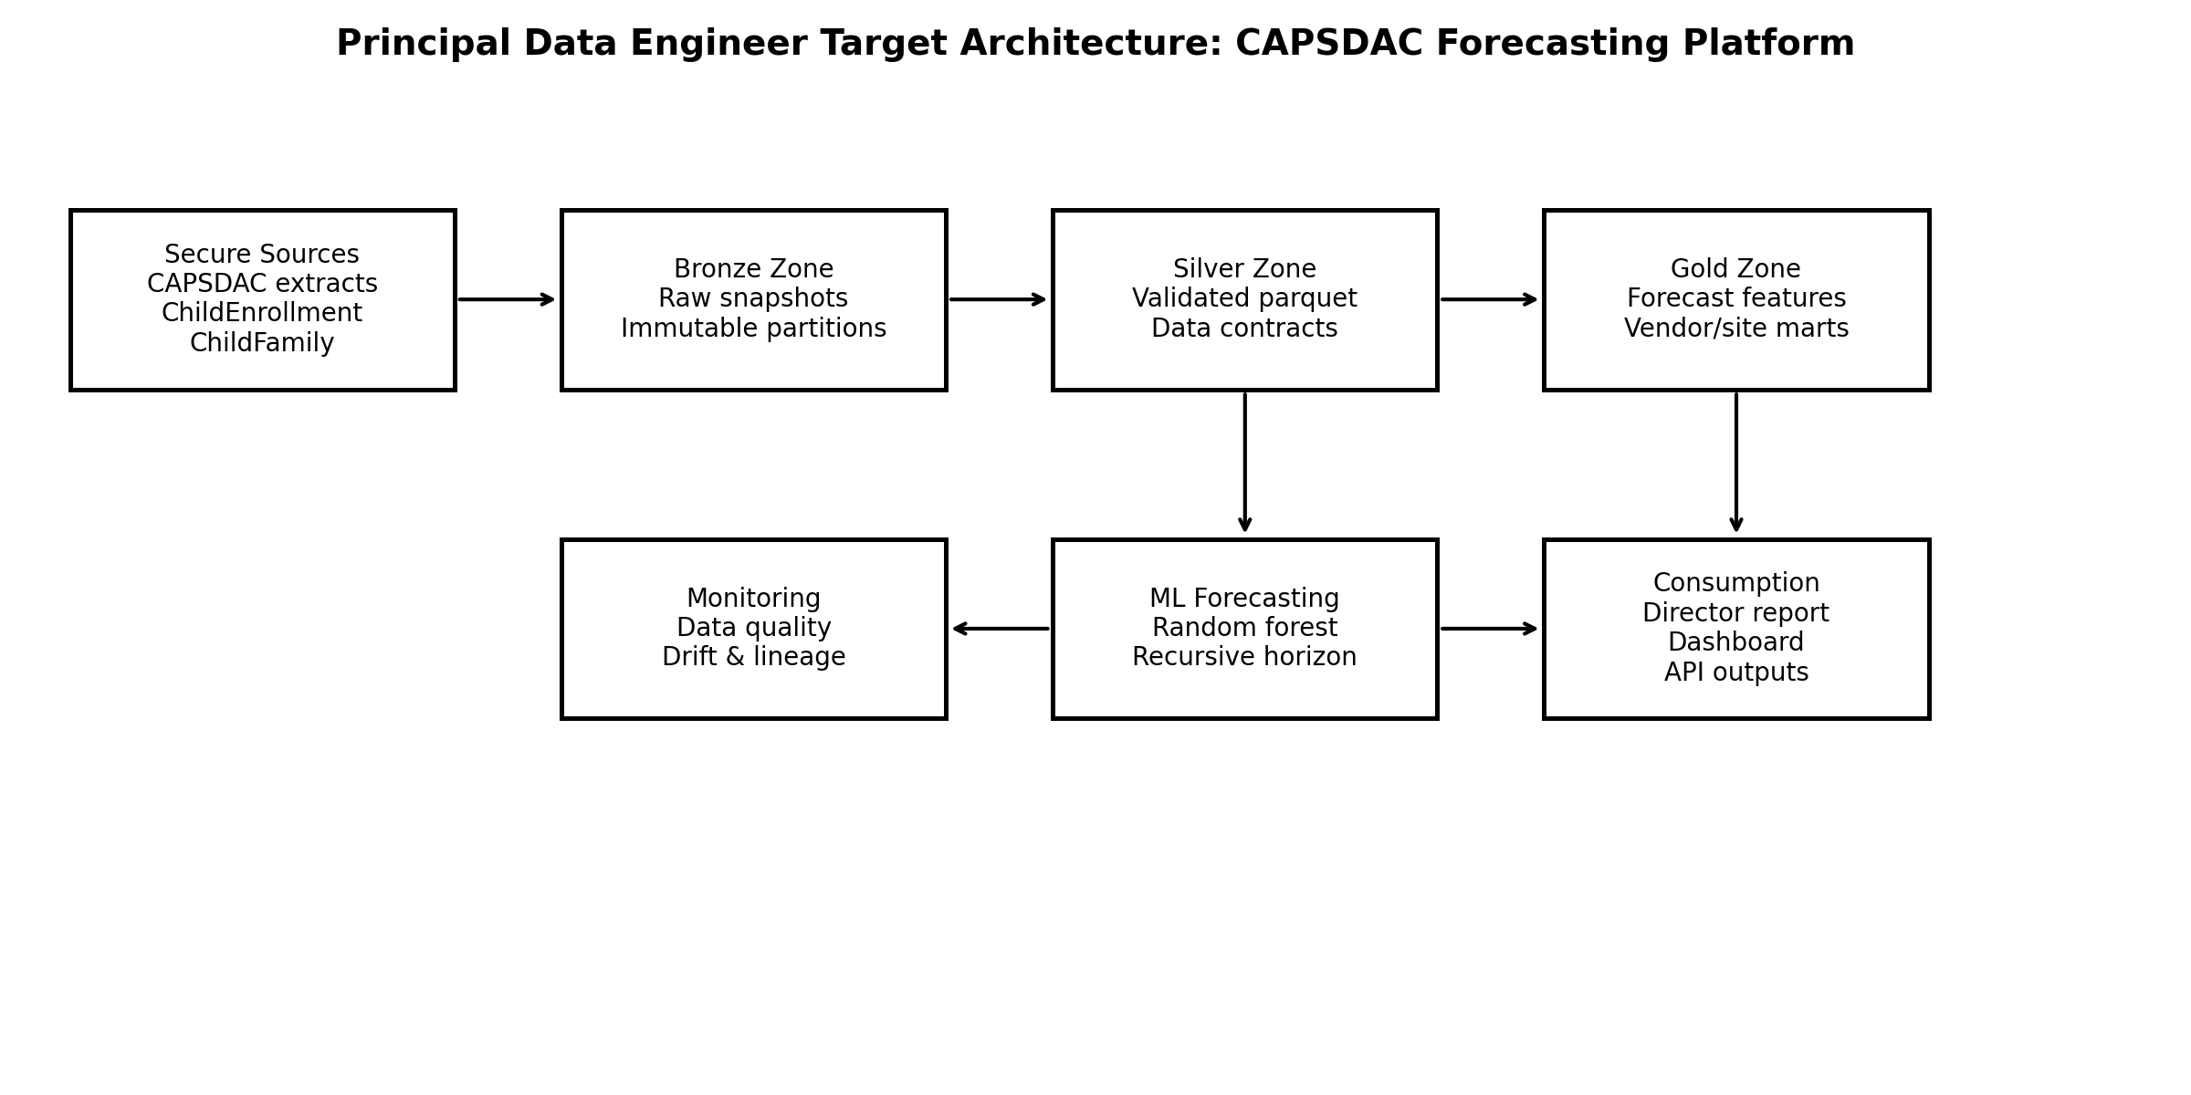
Figure 2. Principal Data Engineer target architecture for the CAPSDAC forecast data product.
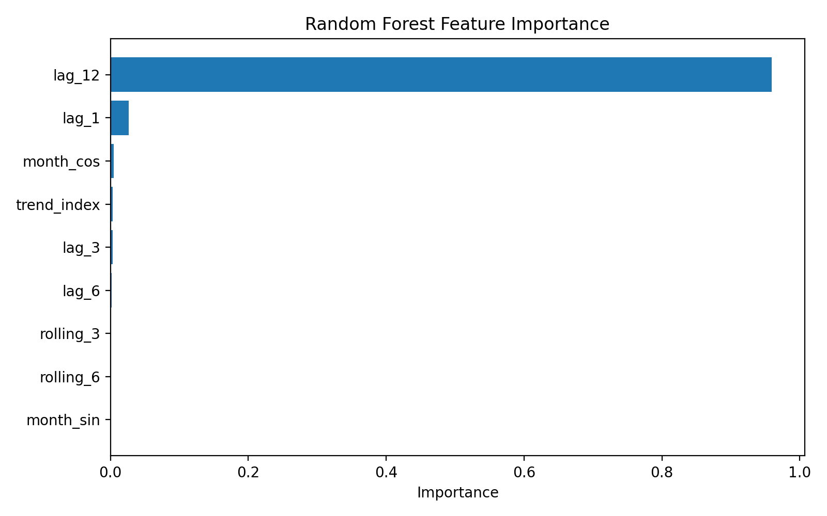
Figure 3. Random forest feature importance showing the relative contribution of lag, rolling, and seasonal features.
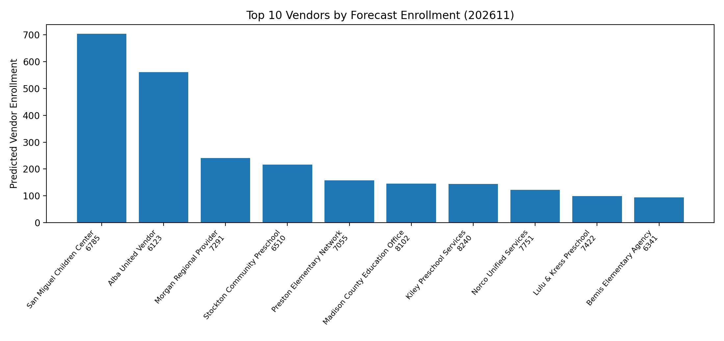
Figure 4. Top vendors by forecast enrollment, highlighting demand concentration and operational risk.
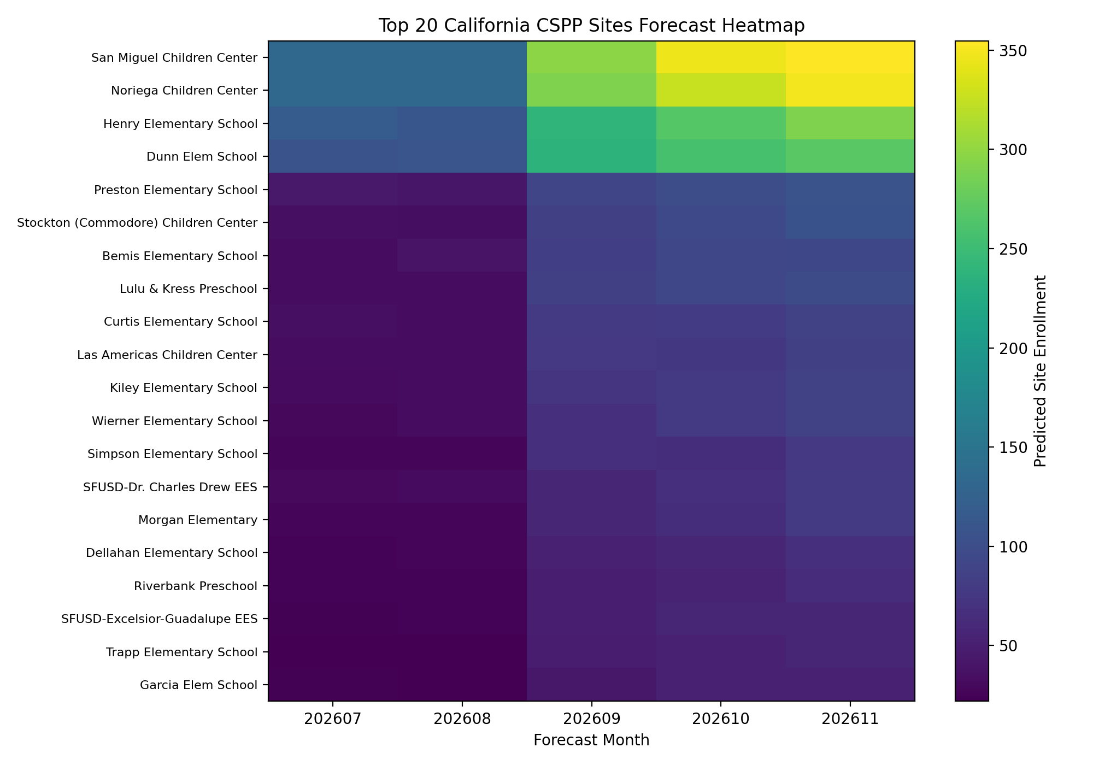
Figure 5. Top California CSPP sites forecast heatmap for near-term capacity planning.

Appendix: Repository Contents
The downloadable package includes reusable source modules, data contracts, synthetic raw and processed datasets, trained model artifacts, forecast outputs, generated figures, tests, AWS deployment skeletons, and executive materials. It is designed for public GitHub presentation and interview walkthroughs.

