Using Students’ AP and IB Course Taking to Predict STEM Education Equity
for High School Students
Methods
yuzhang1@seattleschools.org
Data Resource
We obtained the data from the school districts of the cohorts of the students of 12th grade from 2013 to 2019 who were expected to graduate the next year. The data contain their last four years' records of course taking from 9th to 12th and include any AP/IB course-taking record of “0” in the districts. The data contain several attributes of each student including gender, ELL, race, special education, advanced learning, highly capable, and GPA.
The recent research deal with the problems of predicting the students’ performance evaluated the model via cross-validation. As part of the research, we executed 100 iterations for each classification model and train 80% of the data while 20% of the test datasets. the prediction outcomes are the students at-risk of AP/IB coursee access, I experiment with Logistic regression (LR), Support Vector Machine (SVM) and Decision Tree (DT), The scikit learn implementation is used to all the models.
Methods
In this paper, we focus on this setting by predicting if the students at risk of low_ap access in high school using the data available to the ends of middle school. More specifically, we the GPA, credits, and other attributes flag of grade 12 along with other demographic attributes and predict the outcomes variable with high_ap or low_ap. In this section, we address the following questions:
- How does each model perform when evaluation using the metrics of precision, recall, and AUC for logistic regression, SVM, and Decision Tree?
- How do we ensure the probabilities score estimated by the various algorithms are goodness of fit and show the robustness of ranking the students at-risk in AP/IB course access?
- What are the recommendations of the school district in using the algorithm to target on the students have limit in AP/IB course for the schools to reliability deploy the interventions?

Results
- Logistic regression
Figure 1. Confusion Matrix of STEM AP/IB Course (test data)
Probability | Predicted  low_ap | Predicted  high_ap | Total
Actual low_ap | 4567 | 207 | 4774
 | TN | FP
 | .78 | .37
Actual high_ap | 1266 | 373 | 1639
 | FN | TP
 | .22 | .64
Total | 5833 | 580 | 6413

Figure 2. Confusion Matrix of Literacy AP/IB Course
Probability | Predicted  low_ap | Predicted  high_ap | Total
Actual low_ap | 3702 | 192 | 3894
 | TN | FP
 | .63 | .33
Actual high_ap | 2131 | 388 | 2519
 | FN | TP
 | .37 | .67
Total | 5833 | 580 | 6413

The logistic regression model shows the probability of confusion matrix for the binary classification of the actual and predicted score of the students assigned to the high_ap and low_ap. The confusion of matrix for STEM AP/IB course show a high probability of accuracy score for the low_ap access students. On the other hand, the Literacy AP/IB score has a higher probability of predicting the high_ap students.
The True negative score for the STEM AP/IB course is .78 which means the model predicts the students are low_ap have .78 chances that the students are within that group. On the other hand, for the Literacy AP/IB course, the model predicts the students are low_ap only have a .63 chance that the students are within the group.

2. SVM
Figure 2. AUC curves
STEM AP/IB Course Access Literacy AP/IB Course Access
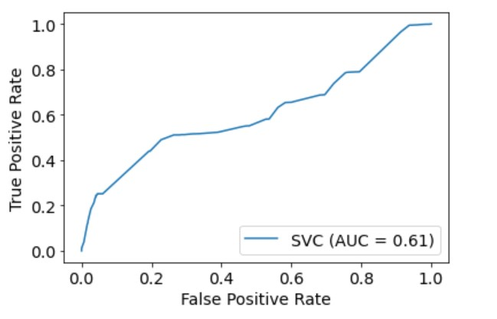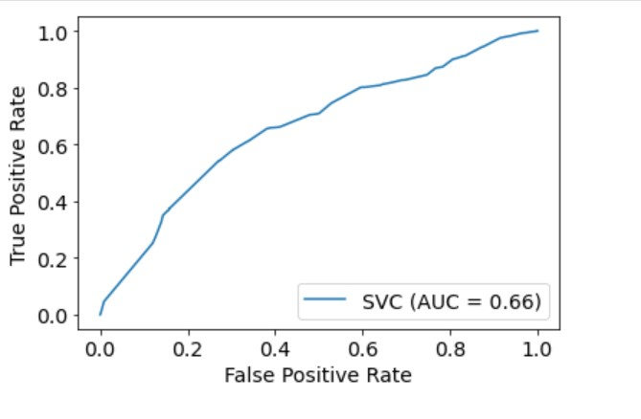
2.1 AUC curve for Model Performance Evaluation
Support Vector machines estimate the signed distance of a data pointed from the nearest hyperplane and plat to convert these distances into the probability tree. For the SVM model, The AUC (area under the curve) is indicated to evaluate the metrics of classification of the model performance. The current method design is the ranking of the students is the data available are related to the binary classification outcomes as low_ap and high_ap access students. The results indicated the AUC for STEM AP/IB course is .61 and for Literacy AP/IB course .66. The model performance is mediocre in the classification of the low_ap and high_ap students as the assigning either below mean course-taking number to be the low_ap and above mean to be the high_ap access for STEM AP/IB course (AUC curve near 0 is worst measure of separation: 0.5 means mode has not class separation; model near 1 means the good measure of separation).
The SVM prediction model of AUC score for the Literacy AP/IB course is .66 which has comparable mediocre but slightly higher results than the STEM AP/IB course results.

2.2 True positive
Figure 2. Precision-Recall Curve
STEM AP/IB Course Access Literacy AP/IB Course Access
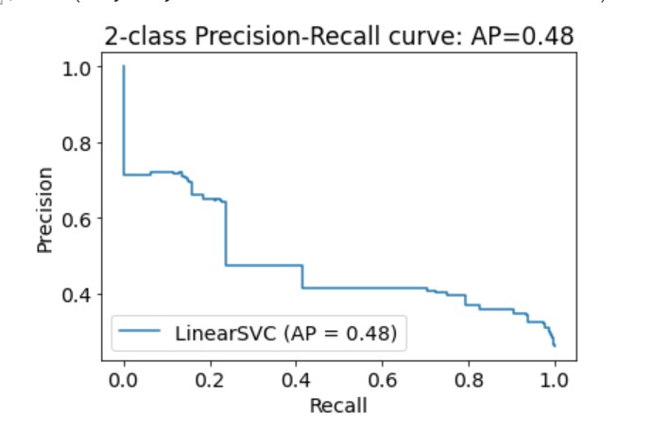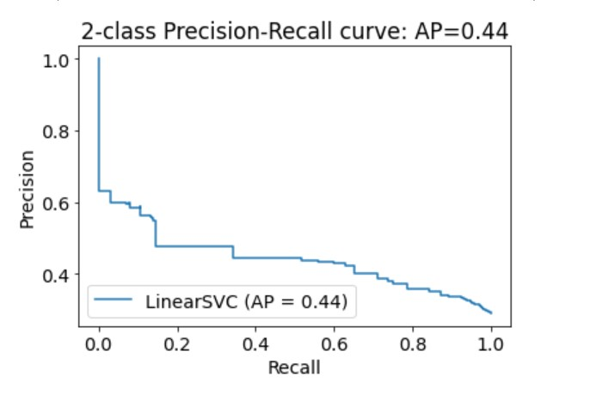
The precision and recall curve value represent 1 – AUC score. The result indicated the classification for STEM AP/IB course access has a slightly higher True positive score than the Literacy AP/IB course access. The students that are assigned to high_ap STEM access but have 48% chance are within the group. However, the students are high_ap Literacy access have 44% chances are in groups.

- Decision Tree
For the decision tree, each data point to its leaf nodes and probability of low_ap and high_ap are equivalent on the corresponding leaf nodes on time. Before the decision tree algorithm, the Random Forest algorithm is introduced to train data and computed the score across years in the same manner. The probability assigned to the particular student is computed as the same weighted mean of precited class probabilities of specific classifiers (e.g., either 1 or 0) in the ensemble. Although according to the theory, the higher weight should be assigned to the recent years like 2017, 2018, 2019 school year, the current study didn’t adopt the weighted means for recent years. In addition, the current study didn’t use the cohort analysis to train the same particular student cohorts as computed in previous years, the next analysis should introduce such training data.
STEM AP/IB Course Access

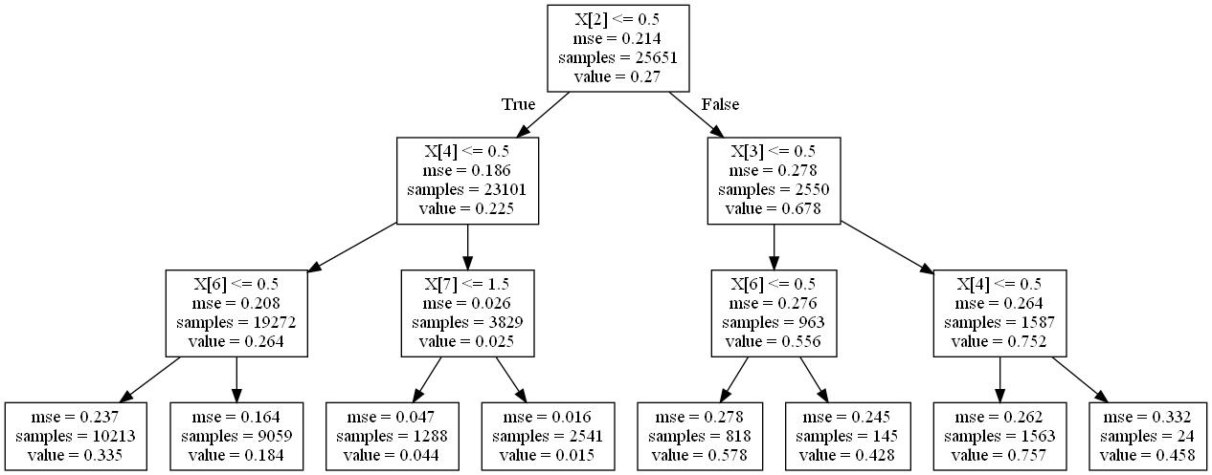
Literacy AP/IB Course Access
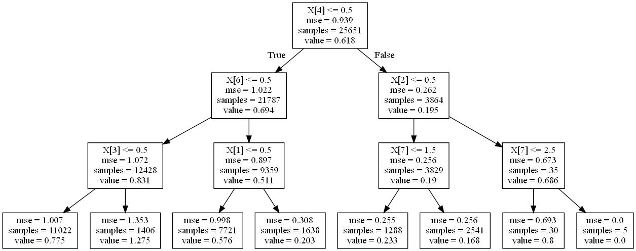

Table 2. Decision Tree for Feature Importance of STEM and Literacy AP/IB Course
AP/IB Course | STEM | Literacy
1 | Advanced Learning | Special Education
2 | Special Education | SOCFFEJ
3 | SOCFFEJ | Highly capable
4 | Race | ELL

The results of the decision tree shown on the top feature for the STEM AP/IB course is advanced learning. On the split of the second leaf node, the feature of special education was used to measure the variance and importance to the parent nodes, mean value .225 is the shared importance of the overall model. The split of a third level leaf node of SOCFFEJ and Race contributes to the .26 and .025 features of importance to the leaf nodes of special education.
On the Literacy AP/IB course, special education is the top-ranking feature. SOCFFEJ contributes .69 feature importance of the parent nodes. On the split, highly capable contribute .83 and ELL contribute .51.
Next plan (this section is still in composing)
Feature Importance
The next is to understand the factor that contributed most heavily to the prediction. The threshold of the base end of the 12th approach is to compute the feature of importance depending on the algorithm of the decision tree. For example, according to the decision tree, we introduce the feature importance of the maximum number depth to target on the student’s group and estimate the markers on the STEM and Literacy AP/IB course. On the other hand, combining with the logistic regression and SVM model, the feature importance is the absolute value of each features’ coefficient. Based on the absolute values of the final importance score, we rank all the features with the highest importance based on that classifier or metrics and then assign and rank at-risk scores to each student by the algorithm.

Identify the risk before the off-track

The metrics can be the ratio of the number of students who were identified to be at-risk k to the total number of the students who were low_ap before they are off-track for the districts, for instance, if the 100 students of the entire dataset and the algorithm identify the 70 are the at-risk of low_ap before their AP and IB outcome the next year, the target student’s identification of the off-track is .70.

References
Lakkaraju, et al., (2015). A Machine Learning Framework to Identify Students at Risk of Adverse Academic Outcomes. ACM Journal. https://doi.org/10.1145/2783258.2788620
DSSG. The Students Early Warning: Identifying High School Students at-risk of learning and on-time Graduation. https://github.com/dssg/student-early-warning

