Logistic Regression Model Evaluation Methods
Logistic Regression is a widely used algorithm for binary classification tasks, where the objective is to predict the probability of a class label, often represented as 0 or 1. As this model outputs probabilities rather than discrete class labels, it requires specific evaluation methods to assess its performance effectively.

Evaluation Methods:
- Accuracy:
  - This is the simplest metric for evaluating a logistic regression model, representing the percentage of correct predictions (both True Positives and True Negatives) out of all predictions. However, it can be misleading when the data is imbalanced (i.e., when one class is significantly more frequent than the other).
- Log-Loss (Cross-Entropy Loss):
  - Log-Loss evaluates how well the predicted probabilities align with the true labels. It penalizes wrong predictions more heavily when the model is confident but incorrect. The formula is: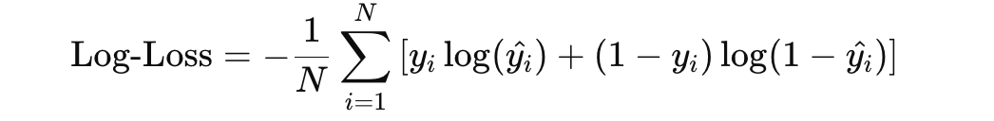
where $y_{i}$ is the true label and is the $y_{i}^{^}$predicted probability.
- Confusion Matrix:
  - The confusion matrix provides a breakdown of correct and incorrect classifications by categorizing them into four groups: True Positives (TP), True Negatives (TN), False Positives (FP), and False Negatives (FN). From this, other metrics like Precision, Recall, and F1-Score can be derived.
- Precision and Recall:
  - Precision is the proportion of positive predictions that are actually correct:

  - Recall (or Sensitivity) measures how many actual positive cases were identified:
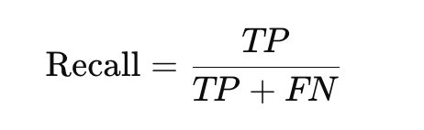
- These metrics are especially important when dealing with imbalanced datasets, where accuracy alone might not be sufficient.
- F1-Score:
  - The F1-Score is the harmonic mean of Precision and Recall, providing a balanced measure between the two: 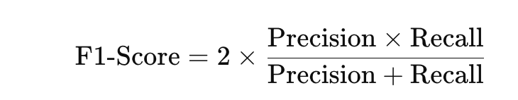
- This is particularly useful when you need a single metric to evaluate the model's performance, especially in situations where Precision and Recall are imbalanced.
- AUC-ROC Curve:
  - The Area Under the Curve (AUC) of the Receiver Operating Characteristic (ROC) curve is a performance measurement for classification problems at various thresholds. The ROC curve plots the True Positive Rate (Recall) against the False Positive Rate (1 - Specificity). A higher AUC indicates a better performing model.
The AUC provides a value between 0 and 1, where 1 means perfect classification, and 0.5 means random guessing.

Keynotes:
- Threshold Sensitivity: Logistic regression produces probabilities, and the decision threshold (usually 0.5) can impact the model's classification results. Varying this threshold can help optimize Precision, Recall, or F1-Score depending on the problem requirements.
- Multiclass Classification: Logistic regression can be extended to multiclass classification using techniques like One-vs-All (OvA) or Softmax regression (Multinomial Logistic Regression). In these cases, the evaluation methods such as Accuracy, Log-Loss, and AUC are extended to multiple classes.
- Imbalanced Data: Logistic regression models may be biased toward the majority class when dealing with imbalanced data. In such cases, techniques like class weighting, oversampling, or undersampling may be applied to address the imbalance.
Logistic regression remains a powerful and interpretable model for binary classification, and these evaluation methods are crucial in understanding its effectiveness and identifying areas for improvement.

Confusion Matrix Example
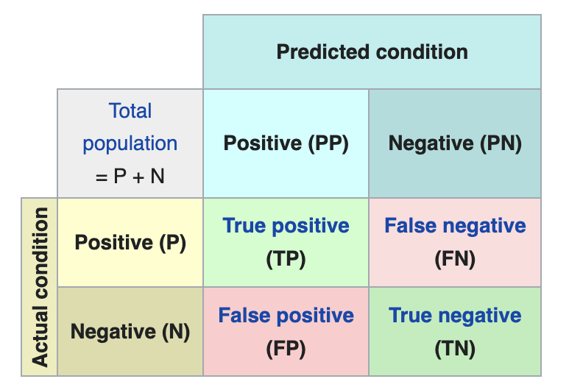

Figure of Cancer vs Non-Cancer

Total (20) |  | Predicted Condition
Cancer 10 | Non-cancer 10 | Cancer | Non-cancer
Actual Condition | Cancer | 6 | 4
Actual Condition | Non-cancer | 2 | 8

Accuracy (ACC): 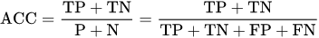

F1 Score
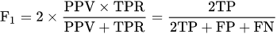

Sensitivity/Recall/True Positive Rate (TPR)
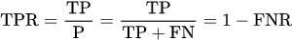

Specificity (SP), Selectivity, Or True Negative Rate (TNR):
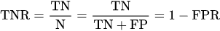

Precision Positive Predictive Value(SP)/ Positive Predictive Value (PPV):


False Positive Rate (FPR)
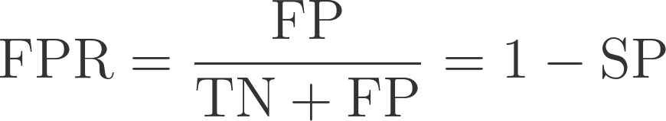

Error Rate
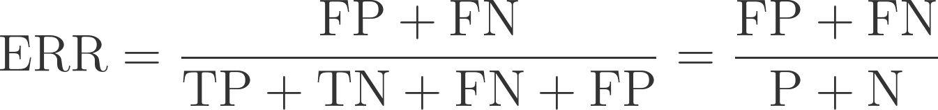

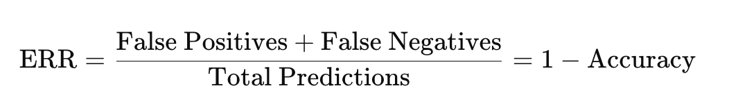

Matthews Correlation Coefficient (MCC)
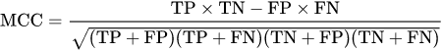

Could you please complete the calculation as shown below?

Evaluation Metrics | Name | Answers
Error Rate | ERR | 6 / 20 = 0.3
Accuracy | ACC | 14 / 20 = 0.7
Sensitivity | SN | 6 / 10 = 0.6
True Positive Rate | TPR | 6 / 10 = 0.6
Recall | REC | 6 / 10 = 0.6
Specificity | SP | 8 / 10 = 0.8
True Negative Rate | TNR | 8 / 10 = 0.8
Precision | PREC | 6 / 8 =0.75
Positive Predictive Value | PPV | 6 / 8 =0.75
False Positive Rate | FPR | 2 / 10 = 0.2

Sample of Classification Reports
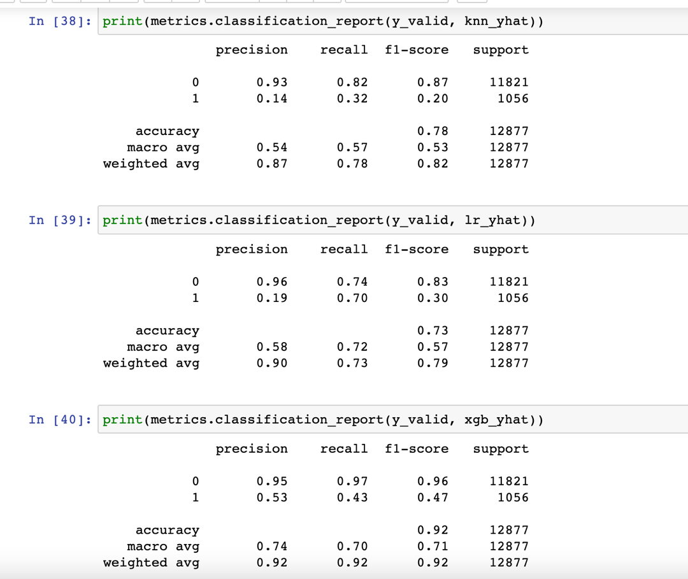

Sample of Pair Plots
