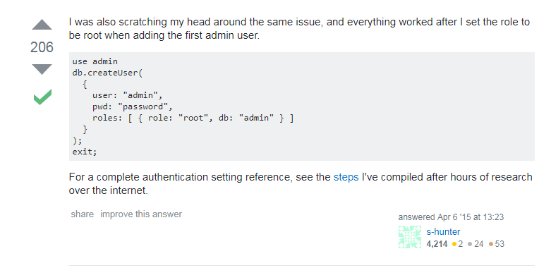

use admin

db.createUser(

{

user: "admin",

pwd: "password",

roles: [ { role: "root", db: "admin" } ]

}

);

exit;

> mongo

> use admin

> show dbs

> show users

> show collections