|  | 文档编号 |  | 版本 | V0.1 | 密级 |  |
| --- | --- | --- | --- | --- | --- | --- |
| 项目名称 | 东方证券DevOps平台详细设计 | | | | |
| 项目来源 |  | | | | |

**东方证券DevOps平台详细设计说明书**

文档变更记录

| 版本 | 日期 | 拟稿和修改 | 作者 | 说明 |
| --- | --- | --- | --- | --- |
| V0.1 | 2019.11.18 | 创建 | 彭骄 | 创建 |

# 引言

## 编写目的和范围

为了进一步明确开发任务、开发流程，达到快速敏捷开发的目的。该文档主要将东方证券DevOps平台进行模块化设计。

## 2.2术语表

## 2.3参考资料

# 工具及环境

## 研发语言及工具

开发工具选择 IDEA

## 第三方工具

1. Jenkins
2. Jfrog
3. bitbucket

# 模块设计

## 3.1 devops_platform平台设置模块

devops_platform 主要是处理平台应用，环境，服务，版本创建以及和其它模块进行交互。

**3.1.1环境类型**

**3.1.1.1 功能描述**

环境类型是环境的基础信息字段，主要用于资源隔离，不同类型的环境之间是相互独立，由平台的管理员来定义和配置。

**3.1.1.2 页面**

**3.1.1.2.1 分页查询**

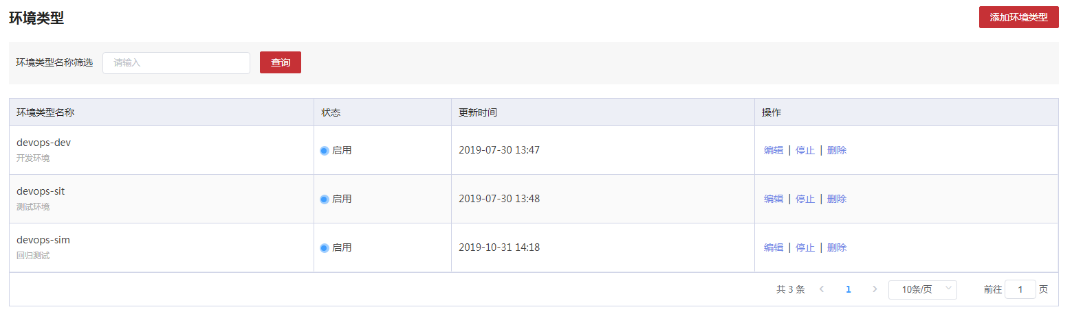3.1.1.2.2 创建

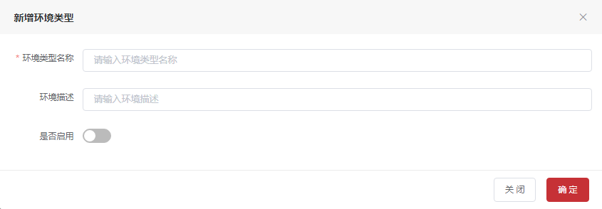3.1.1.2.3 编辑

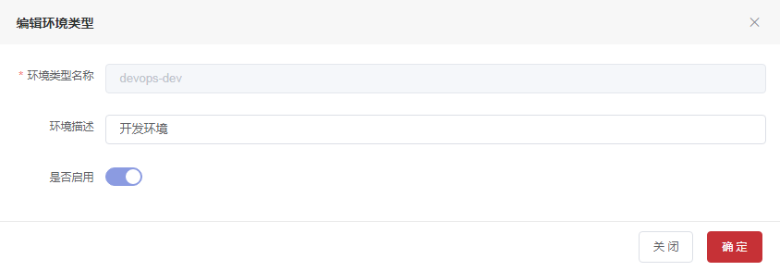**3.1.1.3 表字段**

**3.1.1.3.1数据表名：environment_type 注释： 环境类型**

|  |  |  |  |
| --- | --- | --- | --- |
| 字段 | 数据类型 | 注释 | 类型 |
| en_id | int(11) | 主键唯一标识 | 主键 |
| name | varchar(255) | 环境名 |  |
| stutas | int(1) | 环境状态：1启用，0未启用 |  |
| create_time | datetime | 创建时间 |  |
| update_time | datetime | 修改时间 |  |
| create_by | varchar(255) | 创建人 |  |
| update_by | varchar(255) | 修改人 |  |
| remark | varchar(255) | 备注 |  |
| del_flag | int(1) | 删除标识1未删除,0删除 |  |
| partition_id | int(11) | 分区id |  |

3.1.1.4 api 接口

3.1.1.4.1 增加环境类型

|  |  |  |  |  |
| --- | --- | --- | --- | --- |
| 增加环境类型 | | | | |
| 接口描述 | 增加环境类型 | | | |
| URL | /environmentType/add | | | |
| 请求方式 | post | | | |
| 请求类型 | application/json | | | |
| 返回类型 | */* | | | |
| 参数名 | 数据类型 | 参数类型 | 是否必填 | 说明 |
| type | body | EnvironmentType | Y | 环境类型 |
| 状态码 | 描述 | 说明 | | |
| 200 | OK | OK | | |
| 201 | Created | Created | | |
| 401 | Unauthorized | Unauthorized | | |
| 403 | Forbidden | Forbidden | | |
| 404 | Not Found | Not Found | | |
| 示例 | | | | |
| 请求参数 | {"createBy":"创建人","createTime":"创建时间格式为(date-time)","delFlag":"删除标识,0废弃,1正常格式为(int32)","enID":"唯一标识格式为(int64)","name":"环境类型名","partitionId":"分区id格式为(int32)","remark":"备注","stutas":"状态格式为(int32)","updateBy":"修改人","updateTime":"修改时间格式为(date-time)"} | | | |
| 返回值 | {"body":"","statusCode":"","statusCodeValue":"格式为(int32)"} | | | |

##### 3.1.1.4.2 根据环境类型名称查询

|  |  |  |  |  |
| --- | --- | --- | --- | --- |
| 根据环境类型名称查询 | | | | |
| 接口描述 | 根据环境类型名称查询 | | | |
| URL | /environmentType/findByName | | | |
| 请求方式 | get | | | |
| 请求类型 | application/json | | | |
| 返回类型 | */* | | | |
| 参数名 | 数据类型 | 参数类型 | 是否必填 | 说明 |
| pageNumber | integer | query | N | 页号 |
| pageSize | integer | query | N | 页面大小 |
| sort | string | query | N | 排序字段 |
| order | string | query | N | 排序方式 asc/desc |
| name | string | query | N | 环境类型名 |
| 状态码 | 描述 | 说明 | | |
| 200 | OK | OK | | |
| 401 | Unauthorized | Unauthorized | | |
| 403 | Forbidden | Forbidden | | |
| 404 | Not Found | Not Found | | |
| 示例 | | | | |
| 请求参数 | {"name":"string","pageSize":0,"pageNumber":0,"sort":"string","order":"string"} | | | |
| 返回值 | {"code":"格式为(int32)","data":{"current":"格式为(int64)","pages":"格式为(int64)","records":[{"createBy":"创建人","createTime":"创建时间格式为(date-time)","delFlag":"删除标识,0废弃,1正常格式为(int32)","enID":"唯一标识格式为(int64)","name":"环境类型名","partitionId":"分区id格式为(int32)","remark":"备注","stutas":"状态格式为(int32)","updateBy":"修改人","updateTime":"修改时间格式为(date-time)"}],"searchCount":"","size":"格式为(int64)","total":"格式为(int64)"},"message":"","success":"","timestamp":"格式为(int64)"} | | | |

##### 3.1.1.4.3 根据partitionIds获取有效的环境类型

|  |  |  |  |  |
| --- | --- | --- | --- | --- |
| 根据partitionIds获取有效的环境类型 | | | | |
| 接口描述 | 根据partitionIds获取有效的环境类型 | | | |
| URL | /environmentType/findBypartitionIds | | | |
| 请求方式 | post | | | |
| 请求类型 | application/json | | | |
| 返回类型 | */* | | | |
| 参数名 | 数据类型 | 参数类型 | 是否必填 | 说明 |
| list | body | {} | Y | list |
| 状态码 | 描述 | 说明 | | |
| 200 | OK | OK | | |
| 201 | Created | Created | | |
| 401 | Unauthorized | Unauthorized | | |
| 403 | Forbidden | Forbidden | | |
| 404 | Not Found | Not Found | | |
| 示例 | | | | |
| 请求参数 | {} | | | |
| 返回值 | {"body":"","statusCode":"","statusCodeValue":"格式为(int32)"} | | | |

##### 3.1.1.4.4根据id校验是否应用

|  |  |  |  |  |
| --- | --- | --- | --- | --- |
| 根据id校验是否应用 | | | | |
| 接口描述 | 根据id校验是否应用 | | | |
| URL | /environmentType/isQuote | | | |
| 请求方式 | post | | | |
| 请求类型 | application/json | | | |
| 返回类型 | */* | | | |
| 参数名 | 数据类型 | 参数类型 | 是否必填 | 说明 |
| id | body | {} | Y | id |
| 状态码 | 描述 | 说明 | | |
| 200 | OK | OK | | |
| 201 | Created | Created | | |
| 401 | Unauthorized | Unauthorized | | |
| 403 | Forbidden | Forbidden | | |
| 404 | Not Found | Not Found | | |
| 示例 | | | | |
| 请求参数 | {} | | | |
| 返回值 | {"body":"","statusCode":"","statusCodeValue":"格式为(int32)"} | | | |

##### 3.1.1.4.5根据id删除

|  |  |  |  |  |
| --- | --- | --- | --- | --- |
| 根据id删除 | | | | |
| 接口描述 | 根据id删除 | | | |
| URL | /environmentType/{id} | | | |
| 请求方式 | delete,patch | | | |
| 请求类型 | application/json | | | |
| 返回类型 | */* | | | |
| 参数名 | 数据类型 | 参数类型 | 是否必填 | 说明 |
| id | integer | path | Y | id |
| 状态码 | 描述 | 说明 | | |
| 200 | OK | OK | | |
| 204 | No Content | No Content | | |
| 401 | Unauthorized | Unauthorized | | |
| 403 | Forbidden | Forbidden | | |
| 示例 | | | | |
| 请求参数 | {"id":0} | | | |
| 返回值 | {"code":"格式为(int32)","data":"","message":"","success":"","timestamp":"格式为(int64)"} | | | |

3.1.2制品库节点

3.1.2.1 功能描述

制品库节点功能是对Artifactory制品仓库节点信息的管理，在应用建制品库的时 可以选择创建在哪个制品库节点上。

3.1.2.2 页面

3.1.2.1 分页查询

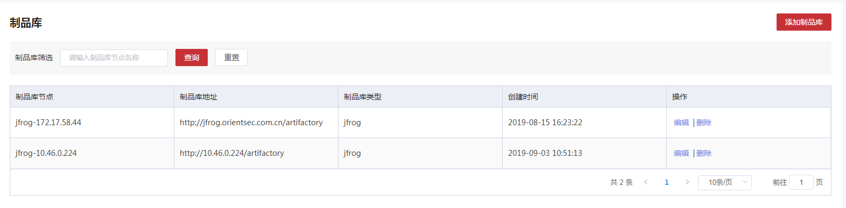3.1.2.2 创建

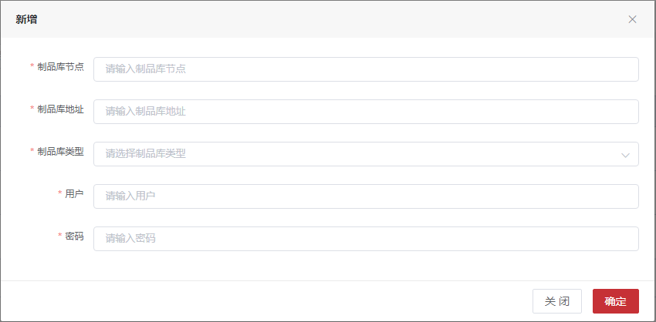3.1.2.3 编辑

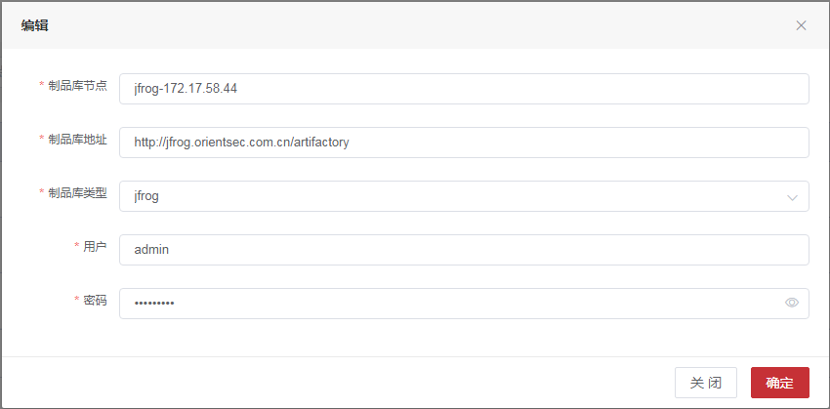3.1.2.3 表字段

3.1.2.3.1 **数据表名：t_products_node 注释： 制品节点**

|  |  |  |  |
| --- | --- | --- | --- |
| 字段 | 数据类型 | 注释 | 类型 |
| node_id | int(11) | 唯一标识 | 主键 |
| node_name | varchar(255) | 制品库节点名称 |  |
| type | int(3) | 制品库类型 |  |
| address | varchar(500) | 地址 |  |
| create_time | datetime | 创建时间 |  |
| founder | varchar(255) | 创建人 |  |
| del_flag | int(1) | 1未删除，0已删除 |  |
| user_name | varchar(255) | 用户名 |  |
| password | varchar(255) | 密码 |  |

3.1.2.4 API接口

##### 3.1.2.4.1增加制品库节点

|  |  |  |  |  |
| --- | --- | --- | --- | --- |
| 增加制品库节点 | | | | |
| 接口描述 | 增加制品库节点 | | | |
| URL | /productsnode/add | | | |
| 请求方式 | post | | | |
| 请求类型 | application/json | | | |
| 返回类型 | */* | | | |
| 参数名 | 数据类型 | 参数类型 | 是否必填 | 说明 |
| productsNode | body | ProductsNode | Y | 制品库节点类 |
| 状态码 | 描述 | 说明 | | |
| 200 | OK | OK | | |
| 201 | Created | Created | | |
| 401 | Unauthorized | Unauthorized | | |
| 403 | Forbidden | Forbidden | | |
| 404 | Not Found | Not Found | | |
| 示例 | | | | |
| 请求参数 | {"address":"地址","createTime":"创建时间格式为(date-time)","delFlag":"1未删除，0已删除格式为(int32)","founder":"创建人","nodeId":"唯一标识格式为(int32)","nodeName":"制品库节点名称","password":"密码","type":"制品库类型格式为(int32)","userName":"用户名"} | | | |
| 返回值 | {"code":"格式为(int32)","data":"","message":"","success":"","timestamp":"格式为(int64)"} | | | |

##### 3.1.2.4.2查找所有制品库节点

|  |  |  |  |  |
| --- | --- | --- | --- | --- |
| 查找所有制品库节点 | | | | |
| 接口描述 | 查找所有制品库节点 | | | |
| URL | /productsnode/findAll | | | |
| 请求方式 | get | | | |
| 请求类型 | application/json | | | |
| 返回类型 | */* | | | |
| 参数名 | 数据类型 | 参数类型 | 是否必填 | 说明 |
| 状态码 | 描述 | 说明 | | |
| 200 | OK | OK | | |
| 401 | Unauthorized | Unauthorized | | |
| 403 | Forbidden | Forbidden | | |
| 404 | Not Found | Not Found | | |
| 示例 | | | | |
| 请求参数 | {} | | | |
| 返回值 | {"code":"格式为(int32)","data":"","message":"","success":"","timestamp":"格式为(int64)"} | | | |

##### 3.1.2.4.3按照制品库节点名称查找

|  |  |  |  |  |
| --- | --- | --- | --- | --- |
| 按照制品库节点名称查找 | | | | |
| 接口描述 | 按照制品库节点名称查找 | | | |
| URL | /productsnode/findByName | | | |
| 请求方式 | get | | | |
| 请求类型 | application/json | | | |
| 返回类型 | */* | | | |
| 参数名 | 数据类型 | 参数类型 | 是否必填 | 说明 |
| pageNumber | integer | query | N | 页号 |
| pageSize | integer | query | N | 页面大小 |
| sort | string | query | N | 排序字段 |
| order | string | query | N | 排序方式 asc/desc |
| name | string | query | N | 节点名称 |
| 状态码 | 描述 | 说明 | | |
| 200 | OK | OK | | |
| 401 | Unauthorized | Unauthorized | | |
| 403 | Forbidden | Forbidden | | |
| 404 | Not Found | Not Found | | |
| 示例 | | | | |
| 请求参数 | {"name":"string","pageSize":0,"pageNumber":0,"sort":"string","order":"string"} | | | |
| 返回值 | {"code":"格式为(int32)","data":"","message":"","success":"","timestamp":"格式为(int64)"} | | | |

##### 3.1.2.4.4修改制品库节点

|  |  |  |  |  |
| --- | --- | --- | --- | --- |
| 修改制品库节点 | | | | |
| 接口描述 | 修改制品库节点 | | | |
| URL | /productsnode/{id} | | | |
| 请求方式 | put,delete | | | |
| 请求类型 | application/json | | | |
| 返回类型 | */* | | | |
| 参数名 | 数据类型 | 参数类型 | 是否必填 | 说明 |
| id | integer | path | Y | id |
| productsNode | body | ProductsNode | Y | 制品库节点类 |
| 状态码 | 描述 | 说明 | | |
| 200 | OK | OK | | |
| 201 | Created | Created | | |
| 401 | Unauthorized | Unauthorized | | |
| 403 | Forbidden | Forbidden | | |
| 404 | Not Found | Not Found | | |
| 示例 | | | | |
| 请求参数 | {"address":"地址","createTime":"创建时间格式为(date-time)","delFlag":"1未删除，0已删除格式为(int32)","founder":"创建人","nodeId":"唯一标识格式为(int32)","nodeName":"制品库节点名称","password":"密码","type":"制品库类型格式为(int32)","userName":"用户名"} | | | |
| 返回值 | {"code":"格式为(int32)","data":"","message":"","success":"","timestamp":"格式为(int64)"} | | | |

3.1.3 配置中心

3.1.3.1 功能描述

对Apollo的配置进行管理和设置

3.1.3.2 页面

3.1.3.2.1 分页查询

3.1.3.2.2 创建

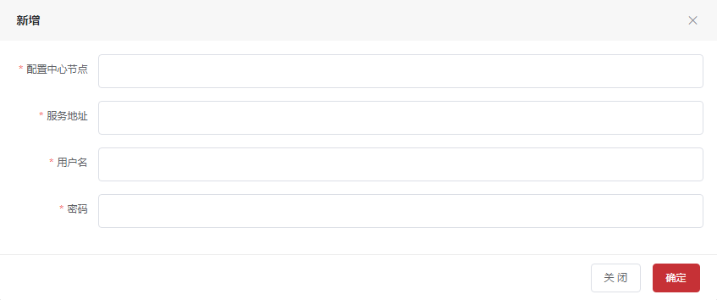3.1.3.3 表字段

3.1.3.3.1 **数据表名：configuration_center 注释： 配置中心**

|  |  |  |  |
| --- | --- | --- | --- |
| 字段 | 数据类型 | 注释 | 类型 |
| configuration_id | int(11) | 唯一标识 | 主键 |
| center_node | varchar(255) | 配置中心节点 |  |
| server_address | varchar(255) | 服务器地址 |  |
| user_name | varchar(255) | 用户名 |  |
| password | varchar(50) | 密码 |  |
| del_flag | int(1) | 删除标志，0未删除，1已删除 |  |

3.1.3.4 API接口

##### 3.1.3.4.1增加配置中心

|  |  |  |  |  |
| --- | --- | --- | --- | --- |
| 增加配置中心 | | | | |
| 接口描述 | 增加配置中心 | | | |
| URL | /configurationCenter/add | | | |
| 请求方式 | post | | | |
| 请求类型 | application/json | | | |
| 返回类型 | */* | | | |
| 参数名 | 数据类型 | 参数类型 | 是否必填 | 说明 |
| config | body | ConfigurationCenter | Y | 配置中心类 |
| 状态码 | 描述 | 说明 | | |
| 200 | OK | OK | | |
| 201 | Created | Created | | |
| 401 | Unauthorized | Unauthorized | | |
| 403 | Forbidden | Forbidden | | |
| 404 | Not Found | Not Found | | |
| 示例 | | | | |
| 请求参数 | {"centerNode":"配置中心节点","configurationId":"唯一标识格式为(int32)","delFlag":"删除标识格式为(int32)","password":"密码","serverAddress":"服务器地址","userName":"用户名"} | | | |
| 返回值 | {"code":"格式为(int32)","data":"","message":"","success":"","timestamp":"格式为(int64)"} | | | |

##### 3.1.3.4.2按照配置中心节点查询

|  |  |  |  |  |
| --- | --- | --- | --- | --- |
| 按照配置中心节点查询 | | | | |
| 接口描述 | 按照配置中心节点查询 | | | |
| URL | /configurationCenter/findByNodeSearch | | | |
| 请求方式 | get | | | |
| 请求类型 | application/json | | | |
| 返回类型 | */* | | | |
| 参数名 | 数据类型 | 参数类型 | 是否必填 | 说明 |
| pageNumber | integer | query | N | 页号 |
| pageSize | integer | query | N | 页面大小 |
| sort | string | query | N | 排序字段 |
| order | string | query | N | 排序方式 asc/desc |
| node | string | query | N | 配置中心节点 |
| 状态码 | 描述 | 说明 | | |
| 200 | OK | OK | | |
| 401 | Unauthorized | Unauthorized | | |
| 403 | Forbidden | Forbidden | | |
| 404 | Not Found | Not Found | | |
| 示例 | | | | |
| 请求参数 | {"pageSize":0,"node":"string","pageNumber":0,"sort":"string","order":"string"} | | | |
| 返回值 | {"code":"格式为(int32)","data":{"current":"格式为(int64)","pages":"格式为(int64)","records":[{"centerNode":"配置中心节点","configurationId":"唯一标识格式为(int32)","delFlag":"删除标识格式为(int32)","password":"密码","serverAddress":"服务器地址","userName":"用户名"}],"searchCount":"","size":"格式为(int64)","total":"格式为(int64)"},"message":"","success":"","timestamp":"格式为(int64)"} | | | |

##### 3.1.3.4.3按照id删除配置

|  |  |  |  |  |
| --- | --- | --- | --- | --- |
| 按照id删除配置 | | | | |
| 接口描述 | 按照id删除配置 | | | |
| URL | /configurationCenter/{id} | | | |
| 请求方式 | delete,patch | | | |
| 请求类型 | application/json | | | |
| 返回类型 | */* | | | |
| 参数名 | 数据类型 | 参数类型 | 是否必填 | 说明 |
| id | integer | path | Y | id |
| 状态码 | 描述 | 说明 | | |
| 200 | OK | OK | | |
| 204 | No Content | No Content | | |
| 401 | Unauthorized | Unauthorized | | |
| 403 | Forbidden | Forbidden | | |
| 示例 | | | | |
| 请求参数 | {"id":0} | | | |
| 返回值 | {"code":"格式为(int32)","data":"","message":"","success":"","timestamp":"格式为(int64)"} | | | |

3.1.4 应用管理

3.1.4.1 功能概述

应用系统是指运行在企业内的单纯的软件系统，比如一个App、Web应用程序，在DevOps平台里是以应用系统的视角进行相关功能的管理。

在DevOps平台周边相关集成平台和工具之间，应用系统与之都有映射关系，具体映射关系如下：

1. 与Jira的关系

在用户的Jira使用场景中会有两种使用场景，一种是一个项目就只包含一个应用系统；另一种是一个项目会包含多个应用系统。所以在建立映射关系的时候，是在Jira的Issue上建立了自定义字段“所属应用”，DevOps平台的应用系统映射到这个“所属应用”上。

1. 与BOC的关系

DevOps平台的应用系统映射BOC平台的“租户”。

应用系统管理功能要实现对应用系统的添加、编辑、列表显示和删除功能，这里应用系统的添加有两种处理流程，分别是：

1. 是一个老项目系统，在Jira中已经创建过，流程是通过DevOps平台创建应用系统，创建时选择关联到的Jira项目和所属应用
2. 是一个新项目系统，在任务工具和平台中都没有创建过，流程是先在Jira中创建项目，再创建自定义字段“所属应用”的可选项，并调用DevOps平台创建应用系统的接口。

对应用系统的编辑和删除功能都不与Jira再同步处理，仅在DevOps做相关处理，对于删除功能，应做删除提醒，并做逻辑删除。

3.1.4.2 页面

3.1.4.2.1 应用分类查询

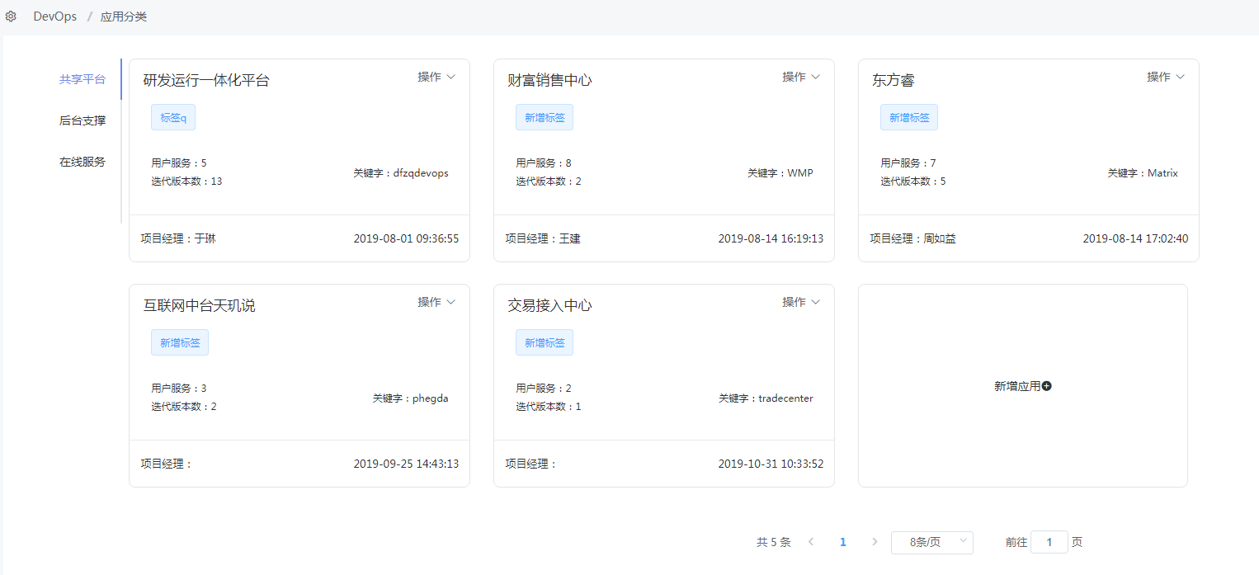3.1.4.2.2 创建

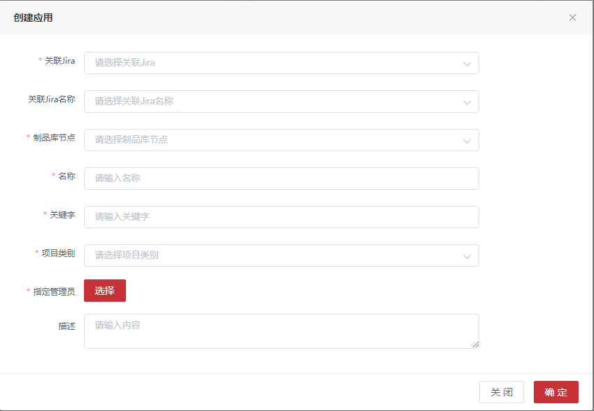3.1.4.2.3 编辑

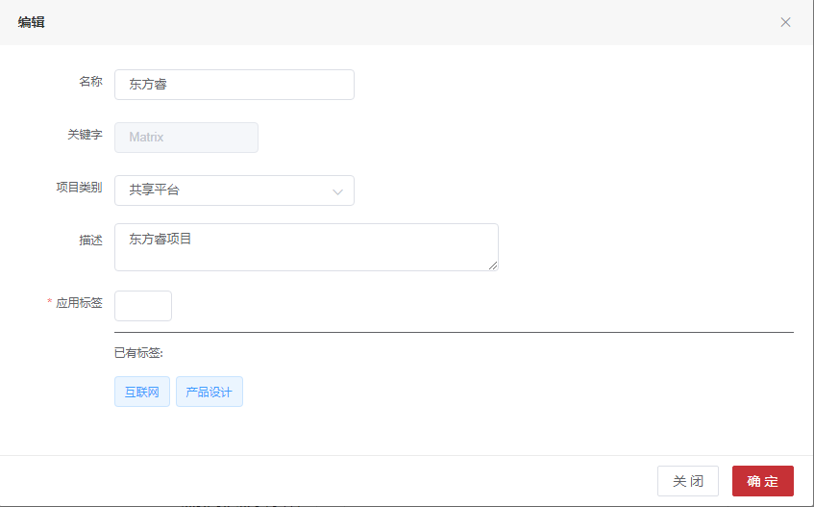3.1.4.3 表字段

3.1.4.3.1**数据表名：t_application 注释： 应用系统**

|  |  |  |  |
| --- | --- | --- | --- |
| 字段 | 数据类型 | 注释 | 类型 |
| application_id | int(11) | 唯一标识 | 主键 |
| application_name | varchar(255) | 应用名称 |  |
| type_id | int(11) | 应用系统类型id |  |
| principal_id | int(11) | 负责人id |  |
| principal | varchar(255) | 负责人 |  |
| create_time | datetime | 创建时间 |  |
| founder | varchar(255) | 创建人 |  |
| description | varchar(2048) | 应用描述 |  |
| del_flag | int(1) | 删除标识,0未删除,1已删除 |  |
| abbreviation | varchar(100) | 英文名称 |  |
| jira_type | varchar(255) | jira类型 |  |
| jira_application_id | int(11) | jira应用ID |  |
| jira_project_id | int(11) | jira项目ID |  |
| jira_project_name | varchar(255) | jira项目名 |  |
| env_id | int(11) | 租户ID |  |
| jira_application_name | varchar(255) | jira应用名称 |  |
| initial_flag | int(1) | 初始化标志:0未,1已 |  |

3.1.4.3.2**数据表名：t_application_label 注释： 应用系统和标签关系表**

|  |  |  |  |
| --- | --- | --- | --- |
| 字段 | 数据类型 | 注释 | 类型 |
| id | int(11) | 唯一标识 | 主键 |
| label_id | int(11) | 标签id |  |
| application_id | int(11) | 应用id |  |
| del_flag | int(1) | 删除标识,0未删除,1已删除 |  |

3.1.4.3.3**数据表名：t_application_record 注释： 应用系统记录**

|  |  |  |  |
| --- | --- | --- | --- |
| 字段 | 数据类型 | 注释 | 类型 |
| id | int(11) | 唯一标识 | 主键 |
| user_id | varchar(50) | 用户标识 |  |
| last_id | int(11) | 上一次浏览应用id |  |

3.1.4.3.4**数据表名：t_label 注释： 应用系统标签**

|  |  |  |  |
| --- | --- | --- | --- |
| 字段 | 数据类型 | 注释 | 类型 |
| label_id | int(11) | 唯一标识 | 主键 |
| label_name | varchar(255) | 标签名称 |  |
| del_flag | int(1) | 删除标识,0未删除,1已删除 |  |

3.1.4.3.5 **数据表名：t_application_type 注释： 应用系统类型**

|  |  |  |  |
| --- | --- | --- | --- |
| 字段 | 数据类型 | 注释 | 类型 |
| type_id | int(11) | 唯一标识 | 主键 |
| type_name | varchar(255) | 类型名称 |  |
| del_flag | int(1) | 删除标识,0未删除,1已删除 |  |
| abbreviation | varchar(50) | 英文简称 |  |

3.1.4.3.6**数据表名：t_application_user 注释： 应用系统菜单**

|  |  |  |  |
| --- | --- | --- | --- |
| 字段 | 数据类型 | 注释 | 类型 |
| id | int(11) | 唯一标识 | 主键 |
| type_id | int(11) | 应用系统类型id |  |
| user_id | varchar(50) | 用户标识 |  |
| del_flag | int(1) | 删除标识,0未删除,1已删除 |  |

3.1.4.4 API接口

##### 3.1.4.4.1 创建建应用系统

|  |  |  |  |  |
| --- | --- | --- | --- | --- |
| 创建建应用系统 | | | | |
| 接口描述 | 创建建应用系统 | | | |
| URL | /application/add | | | |
| 请求方式 | post | | | |
| 请求类型 | application/json | | | |
| 返回类型 | */* | | | |
| 参数名 | 数据类型 | 参数类型 | 是否必填 | 说明 |
| application | body | Application | Y | 应用实体类 |
| 状态码 | 描述 | 说明 | | |
| 200 | OK | OK | | |
| 201 | Created | Created | | |
| 401 | Unauthorized | Unauthorized | | |
| 403 | Forbidden | Forbidden | | |
| 404 | Not Found | Not Found | | |
| 示例 | | | | |
| 请求参数 | {"abbreviation":"英文简称","applicationId":"唯一标识格式为(int32)","applicationName":"应用名称","createTime":"创建时间格式为(date-time)","delFlag":"删除标识,0未删除,1已删除格式为(int32)","description":"应用描述","envId":"租户ID格式为(int32)","envUserId":[{}],"founder":"创建人","initialFlag":"初始化标志:0未,1已格式为(int32)","jiraApplicationId":"jira应用ID格式为(int32)","jiraApplicationName":"jira应用名称","jiraProjectId":"jira项目ID格式为(int32)","jiraProjectName":"jira项目名","jiraType":"jira类型","labels":[{"delFlag":"删除标识,0未删除,1已删除格式为(int32)","labelId":"唯一标识格式为(int32)","labelName":"标签名称"}],"principal":"负责人","principalId":"负责人ID格式为(int32)","productsNodeId":"制品库节点格式为(int32)","serviceNumber":"服务数量格式为(int32)","typeId":"应用系统类型id格式为(int32)","vesionNumber":"版本数量格式为(int32)"} | | | |
| 返回值 | {"code":"格式为(int32)","data":"","message":"","success":"","timestamp":"格式为(int64)"} | | | |

##### 3.1.4.4.2根据ApplicationId查询应用列表

|  |  |  |  |  |
| --- | --- | --- | --- | --- |
| 根据ApplicationId查询应用列表 | | | | |
| 接口描述 | 根据ApplicationId查询应用列表 | | | |
| URL | /application/findByApplicationId | | | |
| 请求方式 | post | | | |
| 请求类型 | application/json | | | |
| 返回类型 | */* | | | |
| 参数名 | 数据类型 | 参数类型 | 是否必填 | 说明 |
| vo | body | ApplicationVo | Y | vo |
| 状态码 | 描述 | 说明 | | |
| 200 | OK | OK | | |
| 201 | Created | Created | | |
| 401 | Unauthorized | Unauthorized | | |
| 403 | Forbidden | Forbidden | | |
| 404 | Not Found | Not Found | | |
| 示例 | | | | |
| 请求参数 | {"applicationId":"ID格式为(int32)","applicationName":"应用名称","envId":"租户ID格式为(int32)","jiraApplicationId":"jira应用系统id格式为(int32)","typeId":"应用系统类型id格式为(int32)"} | | | |
| 返回值 | {"body":"","statusCode":"","statusCodeValue":"格式为(int32)"} | | | |

##### 3.1.4.4.3获取应用信息

|  |  |  |  |  |
| --- | --- | --- | --- | --- |
| 获取应用信息 | | | | |
| 接口描述 | 获取应用信息 | | | |
| URL | /application/getApplicationInfo | | | |
| 请求方式 | get | | | |
| 请求类型 | application/json | | | |
| 返回类型 | */* | | | |
| 参数名 | 数据类型 | 参数类型 | 是否必填 | 说明 |
| appId | integer | query | Y | appId |
| 状态码 | 描述 | 说明 | | |
| 200 | OK | OK | | |
| 401 | Unauthorized | Unauthorized | | |
| 403 | Forbidden | Forbidden | | |
| 404 | Not Found | Not Found | | |
| 示例 | | | | |
| 请求参数 | {"appId":0} | | | |
| 返回值 | {"body":"","statusCode":"","statusCodeValue":"格式为(int32)"} | | | |

##### 3.1.4.4.4删除应用

|  |  |  |  |  |
| --- | --- | --- | --- | --- |
| 删除应用 | | | | |
| 接口描述 | 删除应用 | | | |
| URL | /application/getApplicationInfo/{appId} | | | |
| 请求方式 | delete | | | |
| 请求类型 | application/json | | | |
| 返回类型 | */* | | | |
| 参数名 | 数据类型 | 参数类型 | 是否必填 | 说明 |
| appId | integer | path | Y | appId |
| 状态码 | 描述 | 说明 | | |
| 200 | OK | OK | | |
| 204 | No Content | No Content | | |
| 401 | Unauthorized | Unauthorized | | |
| 403 | Forbidden | Forbidden | | |
| 示例 | | | | |
| 请求参数 | {"appId":0} | | | |
| 返回值 | {"body":"","statusCode":"","statusCodeValue":"格式为(int32)"} | | | |

##### 3.1.4.4.5获取单条应用

|  |  |  |  |  |
| --- | --- | --- | --- | --- |
| 获取单条应用 | | | | |
| 接口描述 | 获取单条应用 | | | |
| URL | /application/getOneApp | | | |
| 请求方式 | post | | | |
| 请求类型 | application/json | | | |
| 返回类型 | */* | | | |
| 参数名 | 数据类型 | 参数类型 | 是否必填 | 说明 |
| vo | body | ApplicationVo | Y | vo |
| 状态码 | 描述 | 说明 | | |
| 200 | OK | OK | | |
| 201 | Created | Created | | |
| 401 | Unauthorized | Unauthorized | | |
| 403 | Forbidden | Forbidden | | |
| 404 | Not Found | Not Found | | |
| 示例 | | | | |
| 请求参数 | {"applicationId":"ID格式为(int32)","applicationName":"应用名称","envId":"租户ID格式为(int32)","jiraApplicationId":"jira应用系统id格式为(int32)","typeId":"应用系统类型id格式为(int32)"} | | | |
| 返回值 | {"body":"","statusCode":"","statusCodeValue":"格式为(int32)"} | | | |

##### 3.1.4.4.6根据租户查询应用列表

|  |  |  |  |  |
| --- | --- | --- | --- | --- |
| 根据租户查询应用列表 | | | | |
| 接口描述 | 根据租户查询应用列表 | | | |
| URL | /application/selectApplication | | | |
| 请求方式 | post | | | |
| 请求类型 | application/json | | | |
| 返回类型 | */* | | | |
| 参数名 | 数据类型 | 参数类型 | 是否必填 | 说明 |
| vo | body | AppVo | Y | vo |
| 状态码 | 描述 | 说明 | | |
| 200 | OK | OK | | |
| 201 | Created | Created | | |
| 401 | Unauthorized | Unauthorized | | |
| 403 | Forbidden | Forbidden | | |
| 404 | Not Found | Not Found | | |
| 示例 | | | | |
| 请求参数 | {"envId":[{}],"pageVo":{"order":"排序方式 asc/desc","pageNumber":"页号格式为(int32)","pageSize":"页面大小格式为(int32)","sort":"排序字段"},"typeId":"应用类型ID格式为(int32)"} | | | |
| 返回值 | {"code":"格式为(int32)","data":"","message":"","success":"","timestamp":"格式为(int64)"} | | | |

##### 3.1.4.4.6修改应用系统

|  |  |  |  |  |
| --- | --- | --- | --- | --- |
| 修改应用系统 | | | | |
| 接口描述 | 修改应用系统 | | | |
| URL | /application/update | | | |
| 请求方式 | put | | | |
| 请求类型 | application/json | | | |
| 返回类型 | */* | | | |
| 参数名 | 数据类型 | 参数类型 | 是否必填 | 说明 |
| application | body | Application | Y | 应用实体类 |
| 状态码 | 描述 | 说明 | | |
| 200 | OK | OK | | |
| 201 | Created | Created | | |
| 401 | Unauthorized | Unauthorized | | |
| 403 | Forbidden | Forbidden | | |
| 404 | Not Found | Not Found | | |
| 示例 | | | | |
| 请求参数 | {"abbreviation":"英文简称","applicationId":"唯一标识格式为(int32)","applicationName":"应用名称","createTime":"创建时间格式为(date-time)","delFlag":"删除标识,0未删除,1已删除格式为(int32)","description":"应用描述","envId":"租户ID格式为(int32)","envUserId":[{}],"founder":"创建人","initialFlag":"初始化标志:0未,1已格式为(int32)","jiraApplicationId":"jira应用ID格式为(int32)","jiraApplicationName":"jira应用名称","jiraProjectId":"jira项目ID格式为(int32)","jiraProjectName":"jira项目名","jiraType":"jira类型","labels":[{"delFlag":"删除标识,0未删除,1已删除格式为(int32)","labelId":"唯一标识格式为(int32)","labelName":"标签名称"}],"principal":"负责人","principalId":"负责人ID格式为(int32)","productsNodeId":"制品库节点格式为(int32)","serviceNumber":"服务数量格式为(int32)","typeId":"应用系统类型id格式为(int32)","vesionNumber":"版本数量格式为(int32)"} | | | |
| 返回值 | {"code":"格式为(int32)","data":"","message":"","success":"","timestamp":"格式为(int64)"} | | | |

##### 3.1.4.4.7修改应用初始化标志

|  |  |  |  |  |
| --- | --- | --- | --- | --- |
| 修改应用初始化标志 | | | | |
| 接口描述 | 修改应用初始化标志 | | | |
| URL | /application/updateInitialFlag/{applicationId} | | | |
| 请求方式 | post | | | |
| 请求类型 | application/json | | | |
| 返回类型 | */* | | | |
| 参数名 | 数据类型 | 参数类型 | 是否必填 | 说明 |
| applicationId | integer | path | Y | applicationId |
| 状态码 | 描述 | 说明 | | |
| 200 | OK | OK | | |
| 201 | Created | Created | | |
| 401 | Unauthorized | Unauthorized | | |
| 403 | Forbidden | Forbidden | | |
| 404 | Not Found | Not Found | | |
| 示例 | | | | |
| 请求参数 | {"applicationId":0} | | | |
| 返回值 | {"body":"","statusCode":"","statusCodeValue":"格式为(int32)"} | | | |

##### 3.1.4.4.8工作台应用列表接口

|  |  |  |  |  |
| --- | --- | --- | --- | --- |
| 工作台应用列表接口 | | | | |
| 接口描述 | 工作台应用列表接口 | | | |
| URL | /application/workbenchAppList/{envIds} | | | |
| 请求方式 | get | | | |
| 请求类型 | application/json | | | |
| 返回类型 | */* | | | |
| 参数名 | 数据类型 | 参数类型 | 是否必填 | 说明 |
| envIds | string | path | Y | envIds |
| 状态码 | 描述 | 说明 | | |
| 200 | OK | OK | | |
| 401 | Unauthorized | Unauthorized | | |
| 403 | Forbidden | Forbidden | | |
| 404 | Not Found | Not Found | | |
| 示例 | | | | |
| 请求参数 | {"envIds":"string"} | | | |
| 返回值 | {"body":"","statusCode":"","statusCodeValue":"格式为(int32)"} | | | |

##### 3.1.4.4.9 增加应用系统用户记录

|  |  |  |  |  |
| --- | --- | --- | --- | --- |
| 增加应用系统用户记录 | | | | |
| 接口描述 | 增加应用系统用户记录 | | | |
| URL | /applicationRecord/add | | | |
| 请求方式 | post | | | |
| 请求类型 | application/json | | | |
| 返回类型 | */* | | | |
| 参数名 | 数据类型 | 参数类型 | 是否必填 | 说明 |
| record | body | ApplicationRecord | Y | 应用系统用户记录 |
| 状态码 | 描述 | 说明 | | |
| 200 | OK | OK | | |
| 201 | Created | Created | | |
| 401 | Unauthorized | Unauthorized | | |
| 403 | Forbidden | Forbidden | | |
| 404 | Not Found | Not Found | | |
| 示例 | | | | |
| 请求参数 | {"id":"唯一标识格式为(int32)","lastApp":{"abbreviation":"英文简称","applicationId":"唯一标识格式为(int32)","applicationName":"应用名称","createTime":"创建时间格式为(date-time)","delFlag":"删除标识,0未删除,1已删除格式为(int32)","description":"应用描述","envId":"租户ID格式为(int32)","envUserId":[{}],"founder":"创建人","initialFlag":"初始化标志:0未,1已格式为(int32)","jiraApplicationId":"jira应用ID格式为(int32)","jiraApplicationName":"jira应用名称","jiraProjectId":"jira项目ID格式为(int32)","jiraProjectName":"jira项目名","jiraType":"jira类型","labels":[{"delFlag":"删除标识,0未删除,1已删除格式为(int32)","labelId":"唯一标识格式为(int32)","labelName":"标签名称"}],"principal":"负责人","principalId":"负责人ID格式为(int32)","productsNodeId":"制品库节点格式为(int32)","serviceNumber":"服务数量格式为(int32)","typeId":"应用系统类型id格式为(int32)","vesionNumber":"版本数量格式为(int32)"},"lastId":"上一次浏览应用id格式为(int32)","newApp":{"abbreviation":"英文简称","applicationId":"唯一标识格式为(int32)","applicationName":"应用名称","createTime":"创建时间格式为(date-time)","delFlag":"删除标识,0未删除,1已删除格式为(int32)","description":"应用描述","envId":"租户ID格式为(int32)","envUserId":[{}],"founder":"创建人","initialFlag":"初始化标志:0未,1已格式为(int32)","jiraApplicationId":"jira应用ID格式为(int32)","jiraApplicationName":"jira应用名称","jiraProjectId":"jira项目ID格式为(int32)","jiraProjectName":"jira项目名","jiraType":"jira类型","labels":[{"delFlag":"删除标识,0未删除,1已删除格式为(int32)","labelId":"唯一标识格式为(int32)","labelName":"标签名称"}],"principal":"负责人","principalId":"负责人ID格式为(int32)","productsNodeId":"制品库节点格式为(int32)","serviceNumber":"服务数量格式为(int32)","typeId":"应用系统类型id格式为(int32)","vesionNumber":"版本数量格式为(int32)"},"userId":"用户标识"} | | | |
| 返回值 | {"code":"格式为(int32)","data":"","message":"","success":"","timestamp":"格式为(int64)"} | | | |

##### 3.1.4.4.10按照用户查找应用记录

|  |  |  |  |  |
| --- | --- | --- | --- | --- |
| 按照用户查找应用记录 | | | | |
| 接口描述 | 按照用户查找应用记录 | | | |
| URL | /applicationRecord/{userId} | | | |
| 请求方式 | get | | | |
| 请求类型 | application/json | | | |
| 返回类型 | */* | | | |
| 参数名 | 数据类型 | 参数类型 | 是否必填 | 说明 |
| userId | string | query | N | userId |
| 状态码 | 描述 | 说明 | | |
| 200 | OK | OK | | |
| 401 | Unauthorized | Unauthorized | | |
| 403 | Forbidden | Forbidden | | |
| 404 | Not Found | Not Found | | |
| 示例 | | | | |
| 请求参数 | {"userId":"string"} | | | |
| 返回值 | {"code":"格式为(int32)","data":"","message":"","success":"","timestamp":"格式为(int64)"} | | | |

##### 3.1.4.4.11添加应用类型

|  |  |  |  |  |
| --- | --- | --- | --- | --- |
| 添加应用类型 | | | | |
| 接口描述 | 添加应用类型 | | | |
| URL | /applicationType/add | | | |
| 请求方式 | post | | | |
| 请求类型 | application/json | | | |
| 返回类型 | */* | | | |
| 参数名 | 数据类型 | 参数类型 | 是否必填 | 说明 |
| record | body | ApplicationType | Y | 应用类型 |
| 状态码 | 描述 | 说明 | | |
| 200 | OK | OK | | |
| 201 | Created | Created | | |
| 401 | Unauthorized | Unauthorized | | |
| 403 | Forbidden | Forbidden | | |
| 404 | Not Found | Not Found | | |
| 示例 | | | | |
| 请求参数 | {"abbreviation":"英文简称","delFlag":"删除标识,0未删除,1已删除格式为(int32)","typeId":"唯一标识格式为(int32)","typeName":"类型名称"} | | | |
| 返回值 | {"code":"格式为(int32)","data":"","message":"","success":"","timestamp":"格式为(int64)"} | | | |

##### 3.1.4.4.12查找所有应用系统类型

|  |  |  |  |  |
| --- | --- | --- | --- | --- |
| 查找所有应用系统类型 | | | | |
| 接口描述 | 查找所有应用系统类型 | | | |
| URL | /applicationType/findAll | | | |
| 请求方式 | get | | | |
| 请求类型 | application/json | | | |
| 返回类型 | */* | | | |
| 参数名 | 数据类型 | 参数类型 | 是否必填 | 说明 |
| 状态码 | 描述 | 说明 | | |
| 200 | OK | OK | | |
| 401 | Unauthorized | Unauthorized | | |
| 403 | Forbidden | Forbidden | | |
| 404 | Not Found | Not Found | | |
| 示例 | | | | |
| 请求参数 | {} | | | |
| 返回值 | {"code":"格式为(int32)","data":"","message":"","success":"","timestamp":"格式为(int64)"} | | | |

##### 3.1.4.4.13按照id修改应用类型

|  |  |  |  |  |
| --- | --- | --- | --- | --- |
| 按照id修改应用类型 | | | | |
| 接口描述 | 按照id修改应用类型 | | | |
| URL | /applicationType/{typeId} | | | |
| 请求方式 | put,delete | | | |
| 请求类型 | application/json | | | |
| 返回类型 | */* | | | |
| 参数名 | 数据类型 | 参数类型 | 是否必填 | 说明 |
| typeId | integer | path | Y | typeId |
| record | body | ApplicationType | Y | 应用类型 |
| 状态码 | 描述 | 说明 | | |
| 200 | OK | OK | | |
| 201 | Created | Created | | |
| 401 | Unauthorized | Unauthorized | | |
| 403 | Forbidden | Forbidden | | |
| 404 | Not Found | Not Found | | |
| 示例 | | | | |
| 请求参数 | {"abbreviation":"英文简称","delFlag":"删除标识,0未删除,1已删除格式为(int32)","typeId":"唯一标识格式为(int32)","typeName":"类型名称"} | | | |
| 返回值 | {"code":"格式为(int32)","data":"","message":"","success":"","timestamp":"格式为(int64)"} | | | |

##### 3.1.4.4.14按照用户查找所有应用系统类型

|  |  |  |  |  |
| --- | --- | --- | --- | --- |
| 按照用户查找所有应用系统类型 | | | | |
| 接口描述 | 按照用户查找所有应用系统类型 | | | |
| URL | /applicationType/{userId} | | | |
| 请求方式 | get | | | |
| 请求类型 | application/json | | | |
| 返回类型 | */* | | | |
| 参数名 | 数据类型 | 参数类型 | 是否必填 | 说明 |
| userId | string | path | Y | userId |
| 状态码 | 描述 | 说明 | | |
| 200 | OK | OK | | |
| 401 | Unauthorized | Unauthorized | | |
| 403 | Forbidden | Forbidden | | |
| 404 | Not Found | Not Found | | |
| 示例 | | | | |
| 请求参数 | {"userId":"string"} | | | |
| 返回值 | {"code":"格式为(int32)","data":"","message":"","success":"","timestamp":"格式为(int64)"} | | | |

##### 3.1.4.4.15添加应用系统类型和用户关系

|  |  |  |  |  |
| --- | --- | --- | --- | --- |
| 添加应用系统类型和用户关系 | | | | |
| 接口描述 | 添加应用系统类型和用户关系 | | | |
| URL | /applicationUser/add | | | |
| 请求方式 | post | | | |
| 请求类型 | application/json | | | |
| 返回类型 | */* | | | |
| 参数名 | 数据类型 | 参数类型 | 是否必填 | 说明 |
| record | body | ApplicationUser | Y | 应用系统类型和用户关系类 |
| 状态码 | 描述 | 说明 | | |
| 200 | OK | OK | | |
| 201 | Created | Created | | |
| 401 | Unauthorized | Unauthorized | | |
| 403 | Forbidden | Forbidden | | |
| 404 | Not Found | Not Found | | |
| 示例 | | | | |
| 请求参数 | {"delFlag":"删除标识,0未删除,1已删除格式为(int32)","id":"唯一标识格式为(int32)","typeId":"应用系统类型id格式为(int32)","userId":"用户标识"} | | | |
| 返回值 | {"code":"格式为(int32)","data":"","message":"","success":"","timestamp":"格式为(int64)"} | | | |

##### 3.1.4.4.16查找应用系统类型和用户关系

|  |  |  |  |  |
| --- | --- | --- | --- | --- |
| 查找应用系统类型和用户关系 | | | | |
| 接口描述 | 查找应用系统类型和用户关系 | | | |
| URL | /applicationUser/findAll | | | |
| 请求方式 | get | | | |
| 请求类型 | application/json | | | |
| 返回类型 | */* | | | |
| 参数名 | 数据类型 | 参数类型 | 是否必填 | 说明 |
| 状态码 | 描述 | 说明 | | |
| 200 | OK | OK | | |
| 401 | Unauthorized | Unauthorized | | |
| 403 | Forbidden | Forbidden | | |
| 404 | Not Found | Not Found | | |
| 示例 | | | | |
| 请求参数 | {} | | | |
| 返回值 | {"code":"格式为(int32)","data":"","message":"","success":"","timestamp":"格式为(int64)"} | | | |

##### 3.1.4.4.17按照id修改应用系统类型和用户关系

|  |  |  |  |  |
| --- | --- | --- | --- | --- |
| 按照id修改应用系统类型和用户关系 | | | | |
| 接口描述 | 按照id修改应用系统类型和用户关系 | | | |
| URL | /applicationUser/{id} | | | |
| 请求方式 | put,delete | | | |
| 请求类型 | application/json | | | |
| 返回类型 | */* | | | |
| 参数名 | 数据类型 | 参数类型 | 是否必填 | 说明 |
| id | integer | path | Y | id |
| record | body | ApplicationUser | Y | 应用系统类型和用户关系类 |
| 状态码 | 描述 | 说明 | | |
| 200 | OK | OK | | |
| 201 | Created | Created | | |
| 401 | Unauthorized | Unauthorized | | |
| 403 | Forbidden | Forbidden | | |
| 404 | Not Found | Not Found | | |
| 示例 | | | | |
| 请求参数 | {"delFlag":"删除标识,0未删除,1已删除格式为(int32)","id":"唯一标识格式为(int32)","typeId":"应用系统类型id格式为(int32)","userId":"用户标识"} | | | |
| 返回值 | {"code":"格式为(int32)","data":"","message":"","success":"","timestamp":"格式为(int64)"} | | | |

##### 3.1.4.4.18 添加应用标签

|  |  |  |  |  |
| --- | --- | --- | --- | --- |
| 添加应用标签 | | | | |
| 接口描述 | 添加应用标签 | | | |
| URL | /label/add | | | |
| 请求方式 | post | | | |
| 请求类型 | application/json | | | |
| 返回类型 | */* | | | |
| 参数名 | 数据类型 | 参数类型 | 是否必填 | 说明 |
| record | body | LabelVo | Y | record |
| 状态码 | 描述 | 说明 | | |
| 200 | OK | OK | | |
| 201 | Created | Created | | |
| 401 | Unauthorized | Unauthorized | | |
| 403 | Forbidden | Forbidden | | |
| 404 | Not Found | Not Found | | |
| 示例 | | | | |
| 请求参数 | {"applicationId":"应用id格式为(int32)","delFlag":"删除标识,0未删除,1已删除格式为(int32)","labelId":"唯一标识格式为(int32)","labelName":"标签名称"} | | | |
| 返回值 | {"code":"格式为(int32)","data":"","message":"","success":"","timestamp":"格式为(int64)"} | | | |

##### 3.1.4.4.19按照id删除应用标签

|  |  |  |  |  |
| --- | --- | --- | --- | --- |
| 按照id删除应用标签 | | | | |
| 接口描述 | 按照id删除应用标签 | | | |
| URL | /label/delete | | | |
| 请求方式 | delete | | | |
| 请求类型 | application/json | | | |
| 返回类型 | */* | | | |
| 参数名 | 数据类型 | 参数类型 | 是否必填 | 说明 |
| record | body | LabelVo | Y | record |
| 状态码 | 描述 | 说明 | | |
| 200 | OK | OK | | |
| 204 | No Content | No Content | | |
| 401 | Unauthorized | Unauthorized | | |
| 403 | Forbidden | Forbidden | | |
| 示例 | | | | |
| 请求参数 | {"applicationId":"应用id格式为(int32)","delFlag":"删除标识,0未删除,1已删除格式为(int32)","labelId":"唯一标识格式为(int32)","labelName":"标签名称"} | | | |
| 返回值 | {"code":"格式为(int32)","data":"","message":"","success":"","timestamp":"格式为(int64)"} | | | |

##### 3.1.4.4.20查找所有应用标签

|  |  |  |  |  |
| --- | --- | --- | --- | --- |
| 查找所有应用标签 | | | | |
| 接口描述 | 查找所有应用标签 | | | |
| URL | /label/findAll | | | |
| 请求方式 | get | | | |
| 请求类型 | application/json | | | |
| 返回类型 | */* | | | |
| 参数名 | 数据类型 | 参数类型 | 是否必填 | 说明 |
| 状态码 | 描述 | 说明 | | |
| 200 | OK | OK | | |
| 401 | Unauthorized | Unauthorized | | |
| 403 | Forbidden | Forbidden | | |
| 404 | Not Found | Not Found | | |
| 示例 | | | | |
| 请求参数 | {} | | | |
| 返回值 | {"code":"格式为(int32)","data":"","message":"","success":"","timestamp":"格式为(int64)"} | | | |

##### 3.1.4.4.21按照ApplicationId查找应用标签

|  |  |  |  |  |
| --- | --- | --- | --- | --- |
| 按照ApplicationId查找应用标签 | | | | |
| 接口描述 | 按照ApplicationId查找应用标签 | | | |
| URL | /label/selectByApplicationId | | | |
| 请求方式 | get | | | |
| 请求类型 | application/json | | | |
| 返回类型 | */* | | | |
| 参数名 | 数据类型 | 参数类型 | 是否必填 | 说明 |
| labelId | integer | query | N | 唯一标识 |
| labelName | string | query | N | 标签名称 |
| delFlag | integer | query | N | 删除标识,0未删除,1已删除 |
| applicationId | integer | query | N | 应用id |
| 状态码 | 描述 | 说明 | | |
| 200 | OK | OK | | |
| 401 | Unauthorized | Unauthorized | | |
| 403 | Forbidden | Forbidden | | |
| 404 | Not Found | Not Found | | |
| 示例 | | | | |
| 请求参数 | {"labelId":0,"labelName":"string","delFlag":0,"applicationId":0} | | | |
| 返回值 | {"body":"","statusCode":"","statusCodeValue":"格式为(int32)"} | | | |

3.1.5 数据字典

3.1.5.1 功能概述

数据字典主要是存储有关数据的来源、说明、与其他数据的关系、用途和格式等信息。从而提高开发效率，促进数据共享，提高数据的使用效率。

3.1.5.2 表字段

3.1.5.2.1**数据表名：dictionary 注释： 字典表**

|  |  |  |
| --- | --- | --- |
| 字段 | 注释 | 类型 |
| dictionary_id | 唯一标识 | 主键 |
| type | 字典类型 |  |
| dictionary_key | 字典名称 |  |
| dictionary_value | 字典值 |  |
| del_flag | 0未删除，1删除 |  |
| remark | 备注 |  |

3.1.5.3 API接口

##### 3.1.5.3.1按照类型查找字典

|  |  |  |  |  |
| --- | --- | --- | --- | --- |
| 按照类型查找字典 | | | | |
| 接口描述 | 按照类型查找字典 | | | |
| URL | /dictionary/findByType | | | |
| 请求方式 | get | | | |
| 请求类型 | application/json | | | |
| 返回类型 | */* | | | |
| 参数名 | 数据类型 | 参数类型 | 是否必填 | 说明 |
| type | string | query | N | 字典类型 |
| 状态码 | 描述 | 说明 | | |
| 200 | OK | OK | | |
| 401 | Unauthorized | Unauthorized | | |
| 403 | Forbidden | Forbidden | | |
| 404 | Not Found | Not Found | | |
| 示例 | | | | |
| 请求参数 | {"type":"string"} | | | |
| 返回值 | {"code":"格式为(int32)","data":"","message":"","success":"","timestamp":"格式为(int64)"} | | | |

##### 3.1.5.3.2按照id查找字典

|  |  |  |  |  |
| --- | --- | --- | --- | --- |
| 按照id查找字典 | | | | |
| 接口描述 | 按照id查找字典 | | | |
| URL | /dictionary/{id} | | | |
| 请求方式 | get | | | |
| 请求类型 | application/json | | | |
| 返回类型 | */* | | | |
| 参数名 | 数据类型 | 参数类型 | 是否必填 | 说明 |
| id | integer | path | Y | id |
| 状态码 | 描述 | 说明 | | |
| 200 | OK | OK | | |
| 401 | Unauthorized | Unauthorized | | |
| 403 | Forbidden | Forbidden | | |
| 404 | Not Found | Not Found | | |
| 示例 | | | | |
| 请求参数 | {"id":0} | | | |
| 返回值 | {"code":"格式为(int32)","data":"","message":"","success":"","timestamp":"格式为(int64)"} | | | |

3.1.6 服务管理

3.1.6.1 功能概述

服务是应用系统下的一个服务，多个服务组合成一个应用系统，一个单体的应用系统，则会有一个服务对应应用系统；如果是微服务的架构，那就是一个个微服务。每个应用系统的应用架构规划好后，就需要创建服务。

务是DevOps平台应用系统的核心基础信息，代码仓库、Pipeline流水线、制品库、版本信息、版本发布都是围绕服务进行管理和操作的，这里要实现对服务的添加、编辑、列表显示、删除。

3.1.6.2 页面

3.1.6.2.1 分页查询

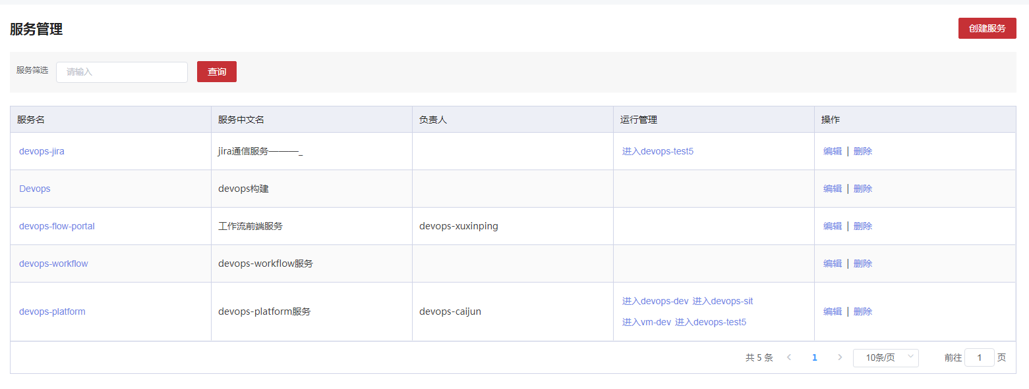3.1.6.2.2 创建

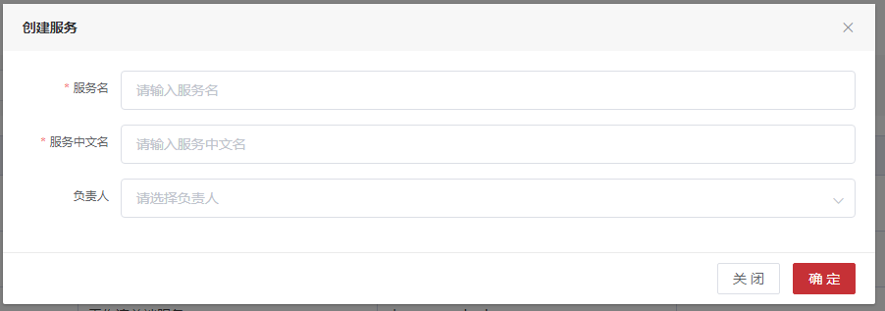3.1.6.2.3 编辑

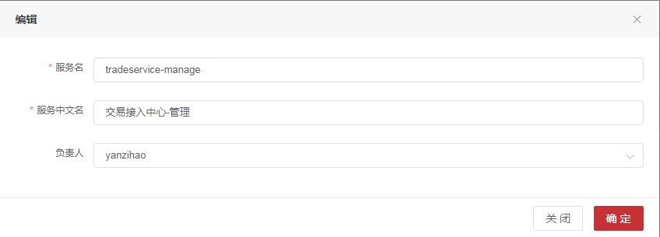3.1.6.2.4 服务版本

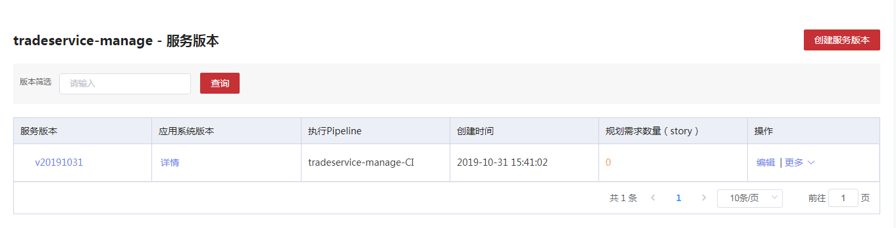3.1.6.2.4.1 创建服务版本

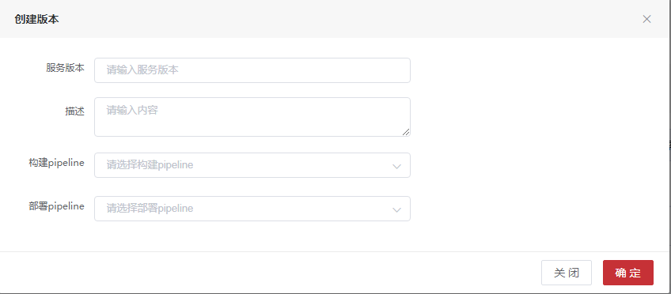3.1.6.2.4.2 编辑服务版本

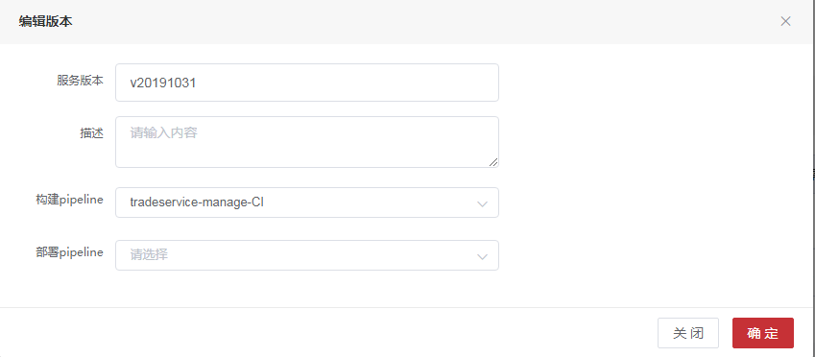3.1.6.3 表字段

3.1.6.3.1**数据表名：t_application_service 注释： 服务表**

|  |  |  |  |
| --- | --- | --- | --- |
| 字段 | 数据类型 | 注释 | 类型 |
| service_id | int(11) | 主键唯一标识 | 主键 |
| application_id | int(11) | 应用id |  |
| service_name | varchar(255) | 服务名 |  |
| service_alias | varchar(255) | 服务别名 |  |
| del_flag | int(1) | 0未删除,1已删除 |  |
| service_type | int(3) | 服务类型 |  |
| principal_id | int(11) | 负责人id |  |
| principal | varchar(100) | 负责人名称 |  |
| create_time | datetime | 创建时间 |  |
| jira_service_id | int(11) | jira服务ID |  |

3.1.6.3.2**数据表名：t_service_version 注释： 服务版本**

|  |  |  |  |
| --- | --- | --- | --- |
| 字段 | 数据类型 | 注释 | 类型 |
| version_id | int(11) | 版本id | 主键 |
| service_id | int(11) | 服务id |  |
| service_name | varchar(255) | 服务名称 |  |
| version_name | varchar(255) | 版本名称 |  |
| version_type | int(1) | 版本类型:1发布版，2过程版 |  |
| deploy_pipeline | int(11) | 部署pipelineId |  |
| deploy_name | varchar(255) | 部署pipeline名称 |  |
| release_pipeline | int(11) | 发布pipelineId |  |
| release_name | varchar(255) | 发布pipeline名称 |  |
| creation_time | datetime | 创建时间 |  |
| release_time | datetime | 发布时间 |  |
| description | varchar(2048) | 版本描述 |  |
| status | int(1) | 发布状态：0废弃版本,1未发布,2进行中,3已发布,4失败 |  |
| deploy_status | int(1) | 部署状态：0废弃部署,1未部署,2进行中,3已部署,4失败 |  |
| service_branch | varchar(255) | 分支名 |  |

3.1.6.3.3**数据表名：t_service_version_info 注释： 服务版本信息**

|  |  |  |  |
| --- | --- | --- | --- |
| 字段 | 数据类型 | 注释 | 类型 |
| info_id | int(11) | 唯一标识 | 主键 |
| release_id | int(11) | 发布版本id |  |
| beta_id | int(11) | 过程版本id |  |

3.1.6.3.4**数据表名：t_sonar_scan 注释： sonar扫描结果表**

|  |  |  |  |
| --- | --- | --- | --- |
| 字段 | 数据类型 | 注释 | 类型 |
| scan_id | int(11) | ID | 主键 |
| service_id | int(11) | 服务名 |  |
| service_name | varchar(255) | 服务id |  |
| version_id | int(11) | 服务版本id |  |
| version_name | varchar(255) | 服务版本名称 |  |
| build_number | int(11) | 构建次数 |  |
| CREATED_TIME | datetime | 创建时间 |  |
| complexity | int(11) | 复杂度 |  |
| coverage | float(8,2) | 覆盖率 |  |
| test_execution_time | datetime | 测试时长 |  |
| tests | int(11) | 测试次数 |  |
| test_errors | int(11) | 测试错误数 |  |
| test_success_density | float(8,2) | 成功比例 |  |
| duplicated_lines_density | float(8,2) | 重复率 |  |
| ncloc_language_distribution | int(11) | 有效代码行数 |  |
| comment_lines_density | float(8,2) | 注释率 |  |
| blocker_violations | int(11) | 阻断 |  |
| critical_violations | int(11) | 严重 |  |
| major_violations | int(11) | 主要 |  |
| minor_violations | int(11) | 次要 |  |
| vulnerabilities | int(11) | 漏洞数 |  |
| new_vulnerabilities | int(11) | 新的漏洞 |  |
| code_smells | int(11) | 坏味道数 |  |
| bugs | int(11) | bug数 |  |
| new_bugs | int(11) | 新增bug数 |  |
| project_id | varchar(255) | scan扫描项目id |  |

3.1.6.4 API接口

##### 3.1.6.4.1服务增加

|  |  |  |  |  |
| --- | --- | --- | --- | --- |
| 服务增加 | | | | |
| 接口描述 | 服务增加 | | | |
| URL | /applicationservice/add | | | |
| 请求方式 | post | | | |
| 请求类型 | application/json | | | |
| 返回类型 | */* | | | |
| 参数名 | 数据类型 | 参数类型 | 是否必填 | 说明 |
| service | body | ApplicationService | Y | 服务类 |
| 状态码 | 描述 | 说明 | | |
| 200 | OK | OK | | |
| 201 | Created | Created | | |
| 401 | Unauthorized | Unauthorized | | |
| 403 | Forbidden | Forbidden | | |
| 404 | Not Found | Not Found | | |
| 示例 | | | | |
| 请求参数 | {"applicationId":"应用id格式为(int32)","createTime":"创建时间格式为(date-time)","delFlag":"0未删除,1已删除格式为(int32)","jiraServiceId":"jira服务ID格式为(int32)","principal":"负责人","principalId":"负责人id格式为(int32)","runRecords":[{"bocAppId":"boc应用id","createTime":"创建时间格式为(date-time)","detailed":"物理环境配置明细","envId":"环境id格式为(int32)","envName":"环境名","ips":"IP多个用，分割","recordId":"id格式为(int32)","serviceId":"服务id格式为(int32)","serviceName":"服务名","status":"状态格式为(int32)"}],"serviceAlias":"服务别名","serviceId":"主键唯一标识格式为(int32)","serviceName":"服务名","serviceType":"服务类型格式为(int32)"} | | | |
| 返回值 | {"code":"格式为(int32)","data":"","message":"","success":"","timestamp":"格式为(int64)"} | | | |

##### 3.1.6.4.2服务代码分支列表

|  |  |  |  |  |
| --- | --- | --- | --- | --- |
| 服务代码分支列表 | | | | |
| 接口描述 | 服务代码分支列表 | | | |
| URL | /applicationservice/codeBranch | | | |
| 请求方式 | get | | | |
| 请求类型 | application/json | | | |
| 返回类型 | */* | | | |
| 参数名 | 数据类型 | 参数类型 | 是否必填 | 说明 |
| releaseList[0].taskId | integer | query | N | null |
| releaseList[0].taskName | string | query | N | null |
| releaseList[0].taskTrigger | string | query | N | null |
| releaseList[0].taskType | string | query | N | null |
| releaseList[0].pipelineName | string | query | N | null |
| releaseList[0].pipelineParam | string | query | N | null |
| releaseList[0].applicationId | integer | query | N | null |
| releaseList[0].serviceId | integer | query | N | null |
| releaseList[0].serviceName | string | query | N | null |
| releaseList[0].lastBuildTime | string | query | N | null |
| releaseList[0].lastBuildTakes | integer | query | N | null |
| releaseList[0].lastBuildStatus | string | query | N | null |
| releaseList[0].buildTimes | integer | query | N | null |
| releaseList[0].buildUser | integer | query | N | null |
| releaseList[0].taskStatus | string | query | N | null |
| releaseList[0].createUser | integer | query | N | null |
| releaseList[0].createTime | string | query | N | null |
| releaseList[0].updateUser | integer | query | N | null |
| releaseList[0].updateTime | string | query | N | null |
| releaseList[0].pipelineFile | string | query | N | null |
| deployList[0].taskId | integer | query | N | null |
| deployList[0].taskName | string | query | N | null |
| deployList[0].taskTrigger | string | query | N | null |
| deployList[0].taskType | string | query | N | null |
| deployList[0].pipelineName | string | query | N | null |
| deployList[0].pipelineParam | string | query | N | null |
| deployList[0].applicationId | integer | query | N | null |
| deployList[0].serviceId | integer | query | N | null |
| deployList[0].serviceName | string | query | N | null |
| deployList[0].lastBuildTime | string | query | N | null |
| deployList[0].lastBuildTakes | integer | query | N | null |
| deployList[0].lastBuildStatus | string | query | N | null |
| deployList[0].buildTimes | integer | query | N | null |
| deployList[0].buildUser | integer | query | N | null |
| deployList[0].taskStatus | string | query | N | null |
| deployList[0].createUser | integer | query | N | null |
| deployList[0].createTime | string | query | N | null |
| deployList[0].updateUser | integer | query | N | null |
| deployList[0].updateTime | string | query | N | null |
| deployList[0].pipelineFile | string | query | N | null |
| serviceId | integer | query | N | 主键唯一标识 |
| applicationId | integer | query | N | 应用id |
| serviceName | string | query | N | 服务名 |
| versionType | integer | query | N | 服务版本类型:1 release,2 beta |
| versionId | integer | query | N | app版本id |
| releaseId | integer | query | N | 服务releaseId |
| 状态码 | 描述 | 说明 | | |
| 200 | OK | OK | | |
| 401 | Unauthorized | Unauthorized | | |
| 403 | Forbidden | Forbidden | | |
| 404 | Not Found | Not Found | | |
| 示例 | | | | |
| 请求参数 | {"deployList[0].updateUser":0,"deployList[0].pipelineName":"string","deployList[0].taskType":"string","deployList[0].lastBuildTakes":0,"deployList[0].taskStatus":"string","deployList[0].createTime":"string","deployList[0].taskId":0,"deployList[0].createUser":0,"deployList[0].buildUser":0,"deployList[0].pipelineParam":"string","releaseList[0].lastBuildTakes":0,"releaseList[0].taskId":0,"deployList[0].taskName":"string","deployList[0].pipelineFile":"string","deployList[0].serviceId":0,"releaseId":0,"releaseList[0].createUser":0,"releaseList[0].serviceName":"string","releaseList[0].createTime":"string","deployList[0].serviceName":"string","deployList[0].lastBuildTime":"string","releaseList[0].updateUser":0,"serviceId":0,"releaseList[0].buildTimes":0,"releaseList[0].lastBuildStatus":"string","versionType":0,"releaseList[0].applicationId":0,"releaseList[0].updateTime":"string","releaseList[0].buildUser":0,"releaseList[0].pipelineFile":"string","releaseList[0].pipelineName":"string","serviceName":"string","releaseList[0].lastBuildTime":"string","releaseList[0].taskStatus":"string","versionId":0,"releaseList[0].taskName":"string","deployList[0].buildTimes":0,"releaseList[0].pipelineParam":"string","releaseList[0].taskType":"string","releaseList[0].taskTrigger":"string","deployList[0].taskTrigger":"string","deployList[0].applicationId":0,"deployList[0].lastBuildStatus":"string","releaseList[0].serviceId":0,"applicationId":0,"deployList[0].updateTime":"string"} | | | |
| 返回值 | {"body":"","statusCode":"","statusCodeValue":"格式为(int32)"} | | | |

##### 3.1.6.4.3根据应用ID查询服务列表

|  |  |  |  |  |
| --- | --- | --- | --- | --- |
| 根据应用ID查询服务列表 | | | | |
| 接口描述 | 根据应用ID查询服务列表 | | | |
| URL | /applicationservice/findApplicationId | | | |
| 请求方式 | get | | | |
| 请求类型 | application/json | | | |
| 返回类型 | */* | | | |
| 参数名 | 数据类型 | 参数类型 | 是否必填 | 说明 |
| releaseList[0].taskId | integer | query | N | null |
| releaseList[0].taskName | string | query | N | null |
| releaseList[0].taskTrigger | string | query | N | null |
| releaseList[0].taskType | string | query | N | null |
| releaseList[0].pipelineName | string | query | N | null |
| releaseList[0].pipelineParam | string | query | N | null |
| releaseList[0].applicationId | integer | query | N | null |
| releaseList[0].serviceId | integer | query | N | null |
| releaseList[0].serviceName | string | query | N | null |
| releaseList[0].lastBuildTime | string | query | N | null |
| releaseList[0].lastBuildTakes | integer | query | N | null |
| releaseList[0].lastBuildStatus | string | query | N | null |
| releaseList[0].buildTimes | integer | query | N | null |
| releaseList[0].buildUser | integer | query | N | null |
| releaseList[0].taskStatus | string | query | N | null |
| releaseList[0].createUser | integer | query | N | null |
| releaseList[0].createTime | string | query | N | null |
| releaseList[0].updateUser | integer | query | N | null |
| releaseList[0].updateTime | string | query | N | null |
| releaseList[0].pipelineFile | string | query | N | null |
| deployList[0].taskId | integer | query | N | null |
| deployList[0].taskName | string | query | N | null |
| deployList[0].taskTrigger | string | query | N | null |
| deployList[0].taskType | string | query | N | null |
| deployList[0].pipelineName | string | query | N | null |
| deployList[0].pipelineParam | string | query | N | null |
| deployList[0].applicationId | integer | query | N | null |
| deployList[0].serviceId | integer | query | N | null |
| deployList[0].serviceName | string | query | N | null |
| deployList[0].lastBuildTime | string | query | N | null |
| deployList[0].lastBuildTakes | integer | query | N | null |
| deployList[0].lastBuildStatus | string | query | N | null |
| deployList[0].buildTimes | integer | query | N | null |
| deployList[0].buildUser | integer | query | N | null |
| deployList[0].taskStatus | string | query | N | null |
| deployList[0].createUser | integer | query | N | null |
| deployList[0].createTime | string | query | N | null |
| deployList[0].updateUser | integer | query | N | null |
| deployList[0].updateTime | string | query | N | null |
| deployList[0].pipelineFile | string | query | N | null |
| serviceId | integer | query | N | 主键唯一标识 |
| applicationId | integer | query | N | 应用id |
| serviceName | string | query | N | 服务名 |
| versionType | integer | query | N | 服务版本类型:1 release,2 beta |
| versionId | integer | query | N | app版本id |
| releaseId | integer | query | N | 服务releaseId |
| 状态码 | 描述 | 说明 | | |
| 200 | OK | OK | | |
| 401 | Unauthorized | Unauthorized | | |
| 403 | Forbidden | Forbidden | | |
| 404 | Not Found | Not Found | | |
| 示例 | | | | |
| 请求参数 | {"deployList[0].updateUser":0,"deployList[0].pipelineName":"string","deployList[0].taskType":"string","deployList[0].lastBuildTakes":0,"deployList[0].taskStatus":"string","deployList[0].createTime":"string","deployList[0].taskId":0,"deployList[0].createUser":0,"deployList[0].buildUser":0,"deployList[0].pipelineParam":"string","releaseList[0].lastBuildTakes":0,"releaseList[0].taskId":0,"deployList[0].taskName":"string","deployList[0].pipelineFile":"string","deployList[0].serviceId":0,"releaseId":0,"releaseList[0].createUser":0,"releaseList[0].serviceName":"string","releaseList[0].createTime":"string","deployList[0].serviceName":"string","deployList[0].lastBuildTime":"string","releaseList[0].updateUser":0,"serviceId":0,"releaseList[0].buildTimes":0,"releaseList[0].lastBuildStatus":"string","versionType":0,"releaseList[0].applicationId":0,"releaseList[0].updateTime":"string","releaseList[0].buildUser":0,"releaseList[0].pipelineFile":"string","releaseList[0].pipelineName":"string","serviceName":"string","releaseList[0].lastBuildTime":"string","releaseList[0].taskStatus":"string","versionId":0,"releaseList[0].taskName":"string","deployList[0].buildTimes":0,"releaseList[0].pipelineParam":"string","releaseList[0].taskType":"string","releaseList[0].taskTrigger":"string","deployList[0].taskTrigger":"string","deployList[0].applicationId":0,"deployList[0].lastBuildStatus":"string","releaseList[0].serviceId":0,"applicationId":0,"deployList[0].updateTime":"string"} | | | |
| 返回值 | {"body":"","statusCode":"","statusCodeValue":"格式为(int32)"} | | | |

##### 3.1.6.4.4按照应用id或versionID查找服务

|  |  |  |  |  |
| --- | --- | --- | --- | --- |
| 按照应用id或versionID查找服务 | | | | |
| 接口描述 | 按照应用id或versionID查找服务 | | | |
| URL | /applicationservice/findByApplicationIdOrVersionID | | | |
| 请求方式 | get | | | |
| 请求类型 | application/json | | | |
| 返回类型 | */* | | | |
| 参数名 | 数据类型 | 参数类型 | 是否必填 | 说明 |
| releaseList[0].taskId | integer | query | N | null |
| releaseList[0].taskName | string | query | N | null |
| releaseList[0].taskTrigger | string | query | N | null |
| releaseList[0].taskType | string | query | N | null |
| releaseList[0].pipelineName | string | query | N | null |
| releaseList[0].pipelineParam | string | query | N | null |
| releaseList[0].applicationId | integer | query | N | null |
| releaseList[0].serviceId | integer | query | N | null |
| releaseList[0].serviceName | string | query | N | null |
| releaseList[0].lastBuildTime | string | query | N | null |
| releaseList[0].lastBuildTakes | integer | query | N | null |
| releaseList[0].lastBuildStatus | string | query | N | null |
| releaseList[0].buildTimes | integer | query | N | null |
| releaseList[0].buildUser | integer | query | N | null |
| releaseList[0].taskStatus | string | query | N | null |
| releaseList[0].createUser | integer | query | N | null |
| releaseList[0].createTime | string | query | N | null |
| releaseList[0].updateUser | integer | query | N | null |
| releaseList[0].updateTime | string | query | N | null |
| releaseList[0].pipelineFile | string | query | N | null |
| deployList[0].taskId | integer | query | N | null |
| deployList[0].taskName | string | query | N | null |
| deployList[0].taskTrigger | string | query | N | null |
| deployList[0].taskType | string | query | N | null |
| deployList[0].pipelineName | string | query | N | null |
| deployList[0].pipelineParam | string | query | N | null |
| deployList[0].applicationId | integer | query | N | null |
| deployList[0].serviceId | integer | query | N | null |
| deployList[0].serviceName | string | query | N | null |
| deployList[0].lastBuildTime | string | query | N | null |
| deployList[0].lastBuildTakes | integer | query | N | null |
| deployList[0].lastBuildStatus | string | query | N | null |
| deployList[0].buildTimes | integer | query | N | null |
| deployList[0].buildUser | integer | query | N | null |
| deployList[0].taskStatus | string | query | N | null |
| deployList[0].createUser | integer | query | N | null |
| deployList[0].createTime | string | query | N | null |
| deployList[0].updateUser | integer | query | N | null |
| deployList[0].updateTime | string | query | N | null |
| deployList[0].pipelineFile | string | query | N | null |
| serviceId | integer | query | N | 主键唯一标识 |
| applicationId | integer | query | N | 应用id |
| serviceName | string | query | N | 服务名 |
| versionType | integer | query | N | 服务版本类型:1 release,2 beta |
| versionId | integer | query | N | app版本id |
| releaseId | integer | query | N | 服务releaseId |
| 状态码 | 描述 | 说明 | | |
| 200 | OK | OK | | |
| 401 | Unauthorized | Unauthorized | | |
| 403 | Forbidden | Forbidden | | |
| 404 | Not Found | Not Found | | |
| 示例 | | | | |
| 请求参数 | {"deployList[0].updateUser":0,"deployList[0].pipelineName":"string","deployList[0].taskType":"string","deployList[0].lastBuildTakes":0,"deployList[0].taskStatus":"string","deployList[0].createTime":"string","deployList[0].taskId":0,"deployList[0].createUser":0,"deployList[0].buildUser":0,"deployList[0].pipelineParam":"string","releaseList[0].lastBuildTakes":0,"releaseList[0].taskId":0,"deployList[0].taskName":"string","deployList[0].pipelineFile":"string","deployList[0].serviceId":0,"releaseId":0,"releaseList[0].createUser":0,"releaseList[0].serviceName":"string","releaseList[0].createTime":"string","deployList[0].serviceName":"string","deployList[0].lastBuildTime":"string","releaseList[0].updateUser":0,"serviceId":0,"releaseList[0].buildTimes":0,"releaseList[0].lastBuildStatus":"string","versionType":0,"releaseList[0].applicationId":0,"releaseList[0].updateTime":"string","releaseList[0].buildUser":0,"releaseList[0].pipelineFile":"string","releaseList[0].pipelineName":"string","serviceName":"string","releaseList[0].lastBuildTime":"string","releaseList[0].taskStatus":"string","versionId":0,"releaseList[0].taskName":"string","deployList[0].buildTimes":0,"releaseList[0].pipelineParam":"string","releaseList[0].taskType":"string","releaseList[0].taskTrigger":"string","deployList[0].taskTrigger":"string","deployList[0].applicationId":0,"deployList[0].lastBuildStatus":"string","releaseList[0].serviceId":0,"applicationId":0,"deployList[0].updateTime":"string"} | | | |
| 返回值 | {"code":"格式为(int32)","data":"","message":"","success":"","timestamp":"格式为(int64)"} | | | |

##### 3.1.6.4.5修改服务

|  |  |  |  |  |
| --- | --- | --- | --- | --- |
| 修改服务 | | | | |
| 接口描述 | 修改服务 | | | |
| URL | /applicationservice/update | | | |
| 请求方式 | put | | | |
| 请求类型 | application/json | | | |
| 返回类型 | */* | | | |
| 参数名 | 数据类型 | 参数类型 | 是否必填 | 说明 |
| service | body | ApplicationService | Y | 服务类 |
| 状态码 | 描述 | 说明 | | |
| 200 | OK | OK | | |
| 201 | Created | Created | | |
| 401 | Unauthorized | Unauthorized | | |
| 403 | Forbidden | Forbidden | | |
| 404 | Not Found | Not Found | | |
| 示例 | | | | |
| 请求参数 | {"applicationId":"应用id格式为(int32)","createTime":"创建时间格式为(date-time)","delFlag":"0未删除,1已删除格式为(int32)","jiraServiceId":"jira服务ID格式为(int32)","principal":"负责人","principalId":"负责人id格式为(int32)","runRecords":[{"bocAppId":"boc应用id","createTime":"创建时间格式为(date-time)","detailed":"物理环境配置明细","envId":"环境id格式为(int32)","envName":"环境名","ips":"IP多个用，分割","recordId":"id格式为(int32)","serviceId":"服务id格式为(int32)","serviceName":"服务名","status":"状态格式为(int32)"}],"serviceAlias":"服务别名","serviceId":"主键唯一标识格式为(int32)","serviceName":"服务名","serviceType":"服务类型格式为(int32)"} | | | |
| 返回值 | {"code":"格式为(int32)","data":"","message":"","success":"","timestamp":"格式为(int64)"} | | | |

##### 3.1.6.4.5服务名称查询

|  |  |  |  |  |
| --- | --- | --- | --- | --- |
| 服务名称查询 | | | | |
| 接口描述 | 服务名称查询 | | | |
| URL | /applicationservice/{applicationId} | | | |
| 请求方式 | get | | | |
| 请求类型 | application/json | | | |
| 返回类型 | */* | | | |
| 参数名 | 数据类型 | 参数类型 | 是否必填 | 说明 |
| applicationId | integer | path | Y | applicationId |
| pageNumber | integer | query | N | 页号 |
| pageSize | integer | query | N | 页面大小 |
| sort | string | query | N | 排序字段 |
| order | string | query | N | 排序方式 asc/desc |
| name | string | query | N | 服务名称 |
| 状态码 | 描述 | 说明 | | |
| 200 | OK | OK | | |
| 401 | Unauthorized | Unauthorized | | |
| 403 | Forbidden | Forbidden | | |
| 404 | Not Found | Not Found | | |
| 示例 | | | | |
| 请求参数 | {"name":"string","pageSize":0,"pageNumber":0,"sort":"string","applicationId":0,"order":"string"} | | | |
| 返回值 | {"code":"格式为(int32)","data":"","message":"","success":"","timestamp":"格式为(int64)"} | | | |

##### 3.1.6.4.6删除服务

|  |  |  |  |  |
| --- | --- | --- | --- | --- |
| 删除服务 | | | | |
| 接口描述 | 删除服务 | | | |
| URL | /applicationservice/{id} | | | |
| 请求方式 | delete | | | |
| 请求类型 | application/json | | | |
| 返回类型 | */* | | | |
| 参数名 | 数据类型 | 参数类型 | 是否必填 | 说明 |
| id | integer | path | Y | id |
| 状态码 | 描述 | 说明 | | |
| 200 | OK | OK | | |
| 204 | No Content | No Content | | |
| 401 | Unauthorized | Unauthorized | | |
| 403 | Forbidden | Forbidden | | |
| 示例 | | | | |
| 请求参数 | {"id":0} | | | |
| 返回值 | {"code":"格式为(int32)","data":"","message":"","success":"","timestamp":"格式为(int64)"} | | | |

ServiceVersionController

##### 3.1.6.4.7创建服务beta版本

|  |  |  |  |  |
| --- | --- | --- | --- | --- |
| 创建服务beta版本 | | | | |
| 接口描述 | 创建服务beta版本 | | | |
| URL | /serviceversion/addBetaVersion | | | |
| 请求方式 | post | | | |
| 请求类型 | application/json | | | |
| 返回类型 | */* | | | |
| 参数名 | 数据类型 | 参数类型 | 是否必填 | 说明 |
| version | body | ServiceBetaVersionVo | Y | version |
| 状态码 | 描述 | 说明 | | |
| 200 | OK | OK | | |
| 201 | Created | Created | | |
| 401 | Unauthorized | Unauthorized | | |
| 403 | Forbidden | Forbidden | | |
| 404 | Not Found | Not Found | | |
| 示例 | | | | |
| 请求参数 | {"betaVersion":{"completeNumber":"完成需求数量格式为(int32)","creationTime":"创建时间格式为(date-time)","deployName":"部署pipeline名称","deployPipeline":"部署pipelineId格式为(int32)","deployStatus":"部署状态：0废弃部署,1未部署,2进行中,3已部署,4失败格式为(int32)","description":"版本描述","isRefresh":"是否刷新","jiraServiceId":"jira服务ID格式为(int32)","plansNumber":"规划需求数量格式为(int32)","queryType":"查詢類型","releaseName":"发布pipeline名称","releasePipeline":"发布pipelineId格式为(int32)","releaseTime":"发布时间格式为(date-time)","serviceBranch":"分支名","serviceId":"服务id格式为(int32)","serviceName":"服务名称","status":"发布状态：0废弃版本,1未发布,2进行中,3已发布,4失败格式为(int32)","versionDetail":[{}],"versionId":"版本id格式为(int32)","versionName":"版本名称","versionType":"版本类型:1发布版，2过程版格式为(int32)"},"releaseId":"release版本id格式为(int32)"} | | | |
| 返回值 | {"code":"格式为(int32)","data":"","message":"","success":"","timestamp":"格式为(int64)"} | | | |

##### 3.1.6.4.8创建服务Release版本

|  |  |  |  |  |
| --- | --- | --- | --- | --- |
| 创建服务Release版本 | | | | |
| 接口描述 | 创建服务Release版本 | | | |
| URL | /serviceversion/addReleaseVersion | | | |
| 请求方式 | post | | | |
| 请求类型 | application/json | | | |
| 返回类型 | */* | | | |
| 参数名 | 数据类型 | 参数类型 | 是否必填 | 说明 |
| version | body | ServiceVersion | Y | version |
| 状态码 | 描述 | 说明 | | |
| 200 | OK | OK | | |
| 201 | Created | Created | | |
| 401 | Unauthorized | Unauthorized | | |
| 403 | Forbidden | Forbidden | | |
| 404 | Not Found | Not Found | | |
| 示例 | | | | |
| 请求参数 | {"completeNumber":"完成需求数量格式为(int32)","creationTime":"创建时间格式为(date-time)","deployName":"部署pipeline名称","deployPipeline":"部署pipelineId格式为(int32)","deployStatus":"部署状态：0废弃部署,1未部署,2进行中,3已部署,4失败格式为(int32)","description":"版本描述","isRefresh":"是否刷新","jiraServiceId":"jira服务ID格式为(int32)","plansNumber":"规划需求数量格式为(int32)","queryType":"查詢類型","releaseName":"发布pipeline名称","releasePipeline":"发布pipelineId格式为(int32)","releaseTime":"发布时间格式为(date-time)","serviceBranch":"分支名","serviceId":"服务id格式为(int32)","serviceName":"服务名称","status":"发布状态：0废弃版本,1未发布,2进行中,3已发布,4失败格式为(int32)","versionDetail":[{}],"versionId":"版本id格式为(int32)","versionName":"版本名称","versionType":"版本类型:1发布版，2过程版格式为(int32)"} | | | |
| 返回值 | {"code":"格式为(int32)","data":"","message":"","success":"","timestamp":"格式为(int64)"} | | | |

##### 3.1.6.4.9删除服务版本

|  |  |  |  |  |
| --- | --- | --- | --- | --- |
| 删除服务版本 | | | | |
| 接口描述 | 删除服务版本 | | | |
| URL | /serviceversion/deleteVersion | | | |
| 请求方式 | delete | | | |
| 请求类型 | application/json | | | |
| 返回类型 | */* | | | |
| 参数名 | 数据类型 | 参数类型 | 是否必填 | 说明 |
| version | body | ServiceVersion | Y | version |
| 状态码 | 描述 | 说明 | | |
| 200 | OK | OK | | |
| 204 | No Content | No Content | | |
| 401 | Unauthorized | Unauthorized | | |
| 403 | Forbidden | Forbidden | | |
| 示例 | | | | |
| 请求参数 | {"completeNumber":"完成需求数量格式为(int32)","creationTime":"创建时间格式为(date-time)","deployName":"部署pipeline名称","deployPipeline":"部署pipelineId格式为(int32)","deployStatus":"部署状态：0废弃部署,1未部署,2进行中,3已部署,4失败格式为(int32)","description":"版本描述","isRefresh":"是否刷新","jiraServiceId":"jira服务ID格式为(int32)","plansNumber":"规划需求数量格式为(int32)","queryType":"查詢類型","releaseName":"发布pipeline名称","releasePipeline":"发布pipelineId格式为(int32)","releaseTime":"发布时间格式为(date-time)","serviceBranch":"分支名","serviceId":"服务id格式为(int32)","serviceName":"服务名称","status":"发布状态：0废弃版本,1未发布,2进行中,3已发布,4失败格式为(int32)","versionDetail":[{}],"versionId":"版本id格式为(int32)","versionName":"版本名称","versionType":"版本类型:1发布版，2过程版格式为(int32)"} | | | |
| 返回值 | {"code":"格式为(int32)","data":"","message":"","success":"","timestamp":"格式为(int64)"} | | | |

##### 3.1.6.4.10单服务部署

|  |  |  |  |  |
| --- | --- | --- | --- | --- |
| 单服务部署 | | | | |
| 接口描述 | 单服务部署 | | | |
| URL | /serviceversion/deployOne | | | |
| 请求方式 | post | | | |
| 请求类型 | application/json | | | |
| 返回类型 | */* | | | |
| 参数名 | 数据类型 | 参数类型 | 是否必填 | 说明 |
| vo | body | ServiceJobV4Vo | Y | vo |
| 状态码 | 描述 | 说明 | | |
| 200 | OK | OK | | |
| 201 | Created | Created | | |
| 401 | Unauthorized | Unauthorized | | |
| 403 | Forbidden | Forbidden | | |
| 404 | Not Found | Not Found | | |
| 示例 | | | | |
| 请求参数 | {"againFalg":"是否重启拉取代码","appJobId":"应用jobID, 应用版本作业格式为(int32)","ciPipelineId":"CI 的 pipelineID 关联Pipeline， CD时传值，CI不传值格式为(int32)","detailId":"ID格式为(int32)","envId":"环境ID格式为(int32)","pipelineId":"pipelineID 关联Pipeline格式为(int32)","releaseSatus":"发布状态格式为(int32)","serviceId":"服务id格式为(int32)","serviceJobId":"Id格式为(int32)","serviceName":"服务名称","serviceReleaseId":"服务版本releaseID格式为(int32)","serviceVersionId":"服务版本ID格式为(int32)","serviceVersionName":"服务版本名称","stageParams":[{"paramFlag":"参数标志","paramId":"参数Id格式为(int32)","paramName":"参数名","paramType":"参数类型格式为(int32)","paramValue":"参数值","stageId":"关联Stage格式为(int32)"}]} | | | |
| 返回值 | {"body":"","statusCode":"","statusCodeValue":"格式为(int32)"} | | | |

##### 3.1.6.4.11根据applicationVersionId和服务ID列表查找

|  |  |  |  |  |
| --- | --- | --- | --- | --- |
| 根据applicationVersionId和服务ID列表查找 | | | | |
| 接口描述 | 根据applicationVersionId和服务ID列表查找 | | | |
| URL | /serviceversion/findByApplicationVersionId | | | |
| 请求方式 | get | | | |
| 请求类型 | application/json | | | |
| 返回类型 | */* | | | |
| 参数名 | 数据类型 | 参数类型 | 是否必填 | 说明 |
| baseEntities[0].id | string | query | N | IssueId |
| baseEntities[0].key | string | query | N | Issue的key |
| baseEntities[0].type | string | query | N | Issue类型:Epic/Story/Task/Bug |
| baseEntities[0].name | string | query | N | Issue名称 |
| baseEntities[0].epicLink | string | query | N | Issue故事/BUG/任务关联的Epic |
| baseEntities[0].status | string | query | N | Issue中文状态 |
| baseEntities[0].createDate | string | query | N | Issue的创建日期 |
| baseEntities[0].devServiceId | integer | query | N | 平台服务id |
| baseEntities[0].devServiceName | string | query | N | null |
| baseEntities[0].devServiceVersion | string | query | N | null |
| baseEntities[0].enableCheck | boolean | query | N | 是否可选择 |
| baseEntities[0].unableStatus | string | query | N | 不可用状态说明 |
| baseEntities[0].serviceId | integer | query | N | 服务id |
| serviceVersionId | integer | query | N | 服务版本id |
| applicationVersionId | integer | query | N | 应用版本id |
| applicationVersionName | string | query | N | 应用版本名称 |
| queryType | string | query | N | deploy:部署,release:发布 |
| testId | string | query | N | 提测ID |
| 状态码 | 描述 | 说明 | | |
| 200 | OK | OK | | |
| 401 | Unauthorized | Unauthorized | | |
| 403 | Forbidden | Forbidden | | |
| 404 | Not Found | Not Found | | |
| 示例 | | | | |
| 请求参数 | {"baseEntities[0].type":"string","baseEntities[0].epicLink":"string","baseEntities[0].createDate":"string","baseEntities[0].key":"string","baseEntities[0].devServiceName":"string","serviceVersionId":0,"baseEntities[0].enableCheck":true,"applicationVersionName":"string","baseEntities[0].devServiceVersion":"string","baseEntities[0].name":"string","queryType":"string","baseEntities[0].devServiceId":0,"baseEntities[0].unableStatus":"string","baseEntities[0].id":"string","baseEntities[0].status":"string","testId":"string","baseEntities[0].serviceId":0,"applicationVersionId":0} | | | |
| 返回值 | {"code":"格式为(int32)","data":"","message":"","success":"","timestamp":"格式为(int64)"} | | | |

##### 3.1.6.4.12根据ServiceID查找服务版本列表

|  |  |  |  |  |
| --- | --- | --- | --- | --- |
| 根据ServiceID查找服务版本列表 | | | | |
| 接口描述 | 根据ServiceID查找服务版本列表 | | | |
| URL | /serviceversion/findByServiceVersion | | | |
| 请求方式 | get | | | |
| 请求类型 | application/json | | | |
| 返回类型 | */* | | | |
| 参数名 | 数据类型 | 参数类型 | 是否必填 | 说明 |
| versionId | integer | query | N | 版本id |
| serviceId | integer | query | N | 服务id |
| versionName | string | query | N | 版本名称 |
| versionType | integer | query | N | 版本类型:1发布版，2过程版 |
| queryType | string | query | N | release:发布,deploy:部署 |
| 状态码 | 描述 | 说明 | | |
| 200 | OK | OK | | |
| 401 | Unauthorized | Unauthorized | | |
| 403 | Forbidden | Forbidden | | |
| 404 | Not Found | Not Found | | |
| 示例 | | | | |
| 请求参数 | {"versionType":0,"versionId":0,"serviceId":0,"versionName":"string","queryType":"string"} | | | |
| 返回值 | {"code":"格式为(int32)","data":"","message":"","success":"","timestamp":"格式为(int64)"} | | | |

##### 3.1.6.4.13查询release版本下的beta版本

|  |  |  |  |  |
| --- | --- | --- | --- | --- |
| 查询release版本下的beta版本 | | | | |
| 接口描述 | 查询release版本下的beta版本 | | | |
| URL | /serviceversion/getBetaVersion | | | |
| 请求方式 | get | | | |
| 请求类型 | application/json | | | |
| 返回类型 | */* | | | |
| 参数名 | 数据类型 | 参数类型 | 是否必填 | 说明 |
| versionId | integer | query | N | 版本id |
| serviceId | integer | query | N | 服务id |
| versionName | string | query | N | 版本名称 |
| versionType | integer | query | N | 版本类型:1发布版，2过程版 |
| queryType | string | query | N | release:发布,deploy:部署 |
| 状态码 | 描述 | 说明 | | |
| 200 | OK | OK | | |
| 401 | Unauthorized | Unauthorized | | |
| 403 | Forbidden | Forbidden | | |
| 404 | Not Found | Not Found | | |
| 示例 | | | | |
| 请求参数 | {"versionType":0,"versionId":0,"serviceId":0,"versionName":"string","queryType":"string"} | | | |
| 返回值 | {"code":"格式为(int32)","data":"","message":"","success":"","timestamp":"格式为(int64)"} | | | |

##### 3.1.6.4.14获取单条版本

|  |  |  |  |  |
| --- | --- | --- | --- | --- |
| 获取单条版本 | | | | |
| 接口描述 | 获取单条版本 | | | |
| URL | /serviceversion/getOneVersion | | | |
| 请求方式 | get | | | |
| 请求类型 | application/json | | | |
| 返回类型 | */* | | | |
| 参数名 | 数据类型 | 参数类型 | 是否必填 | 说明 |
| versionId | integer | query | N | 版本id |
| serviceId | integer | query | N | 服务id |
| versionName | string | query | N | 版本名称 |
| versionType | integer | query | N | 版本类型:1发布版，2过程版 |
| queryType | string | query | N | release:发布,deploy:部署 |
| 状态码 | 描述 | 说明 | | |
| 200 | OK | OK | | |
| 401 | Unauthorized | Unauthorized | | |
| 403 | Forbidden | Forbidden | | |
| 404 | Not Found | Not Found | | |
| 示例 | | | | |
| 请求参数 | {"versionType":0,"versionId":0,"serviceId":0,"versionName":"string","queryType":"string"} | | | |
| 返回值 | {"code":"格式为(int32)","data":"","message":"","success":"","timestamp":"格式为(int64)"} | | | |

##### 3.1.6.4.15获取版本发布详情

|  |  |  |  |  |
| --- | --- | --- | --- | --- |
| 获取版本发布详情 | | | | |
| 接口描述 | 获取版本发布详情 | | | |
| URL | /serviceversion/getReleaseInfo | | | |
| 请求方式 | get | | | |
| 请求类型 | application/json | | | |
| 返回类型 | */* | | | |
| 参数名 | 数据类型 | 参数类型 | 是否必填 | 说明 |
| versionId | integer | query | N | versionId |
| 状态码 | 描述 | 说明 | | |
| 200 | OK | OK | | |
| 401 | Unauthorized | Unauthorized | | |
| 403 | Forbidden | Forbidden | | |
| 404 | Not Found | Not Found | | |
| 示例 | | | | |
| 请求参数 | {"versionId":0} | | | |
| 返回值 | {"body":"","statusCode":"","statusCodeValue":"格式为(int32)"} | | | |

##### 3.1.6.4.16服务ci和cd的pipeline停止

|  |  |  |  |  |
| --- | --- | --- | --- | --- |
| 服务ci和cd的pipeline停止 | | | | |
| 接口描述 | 服务ci和cd的pipeline停止 | | | |
| URL | /serviceversion/pipelineStop | | | |
| 请求方式 | post | | | |
| 请求类型 | application/json | | | |
| 返回类型 | */* | | | |
| 参数名 | 数据类型 | 参数类型 | 是否必填 | 说明 |
| vo | body | ServiceJobV4Vo | Y | vo |
| 状态码 | 描述 | 说明 | | |
| 200 | OK | OK | | |
| 201 | Created | Created | | |
| 401 | Unauthorized | Unauthorized | | |
| 403 | Forbidden | Forbidden | | |
| 404 | Not Found | Not Found | | |
| 示例 | | | | |
| 请求参数 | {"againFalg":"是否重启拉取代码","appJobId":"应用jobID, 应用版本作业格式为(int32)","ciPipelineId":"CI 的 pipelineID 关联Pipeline， CD时传值，CI不传值格式为(int32)","detailId":"ID格式为(int32)","envId":"环境ID格式为(int32)","pipelineId":"pipelineID 关联Pipeline格式为(int32)","releaseSatus":"发布状态格式为(int32)","serviceId":"服务id格式为(int32)","serviceJobId":"Id格式为(int32)","serviceName":"服务名称","serviceReleaseId":"服务版本releaseID格式为(int32)","serviceVersionId":"服务版本ID格式为(int32)","serviceVersionName":"服务版本名称","stageParams":[{"paramFlag":"参数标志","paramId":"参数Id格式为(int32)","paramName":"参数名","paramType":"参数类型格式为(int32)","paramValue":"参数值","stageId":"关联Stage格式为(int32)"}]} | | | |
| 返回值 | {"body":"","statusCode":"","statusCodeValue":"格式为(int32)"} | | | |

##### 3.1.6.4.17批量发布

|  |  |  |  |  |
| --- | --- | --- | --- | --- |
| 批量发布 | | | | |
| 接口描述 | 批量发布 | | | |
| URL | /serviceversion/releaseBatch | | | |
| 请求方式 | post | | | |
| 请求类型 | application/json | | | |
| 返回类型 | */* | | | |
| 参数名 | 数据类型 | 参数类型 | 是否必填 | 说明 |
| vo | body | ServiceJobV4Vo | Y | vo |
| 状态码 | 描述 | 说明 | | |
| 200 | OK | OK | | |
| 201 | Created | Created | | |
| 401 | Unauthorized | Unauthorized | | |
| 403 | Forbidden | Forbidden | | |
| 404 | Not Found | Not Found | | |
| 示例 | | | | |
| 请求参数 | {"againFalg":"是否重启拉取代码","appJobId":"应用jobID, 应用版本作业格式为(int32)","ciPipelineId":"CI 的 pipelineID 关联Pipeline， CD时传值，CI不传值格式为(int32)","detailId":"ID格式为(int32)","envId":"环境ID格式为(int32)","pipelineId":"pipelineID 关联Pipeline格式为(int32)","releaseSatus":"发布状态格式为(int32)","serviceId":"服务id格式为(int32)","serviceJobId":"Id格式为(int32)","serviceName":"服务名称","serviceReleaseId":"服务版本releaseID格式为(int32)","serviceVersionId":"服务版本ID格式为(int32)","serviceVersionName":"服务版本名称","stageParams":[{"paramFlag":"参数标志","paramId":"参数Id格式为(int32)","paramName":"参数名","paramType":"参数类型格式为(int32)","paramValue":"参数值","stageId":"关联Stage格式为(int32)"}]} | | | |
| 返回值 | {"body":"","statusCode":"","statusCodeValue":"格式为(int32)"} | | | |

##### 3.1.6.4.18单服务发布

|  |  |  |  |  |
| --- | --- | --- | --- | --- |
| 单服务发布 | | | | |
| 接口描述 | 单服务发布 | | | |
| URL | /serviceversion/releaseOne | | | |
| 请求方式 | post | | | |
| 请求类型 | application/json | | | |
| 返回类型 | */* | | | |
| 参数名 | 数据类型 | 参数类型 | 是否必填 | 说明 |
| vo | body | ServiceJobV4Vo | Y | vo |
| 状态码 | 描述 | 说明 | | |
| 200 | OK | OK | | |
| 201 | Created | Created | | |
| 401 | Unauthorized | Unauthorized | | |
| 403 | Forbidden | Forbidden | | |
| 404 | Not Found | Not Found | | |
| 示例 | | | | |
| 请求参数 | {"againFalg":"是否重启拉取代码","appJobId":"应用jobID, 应用版本作业格式为(int32)","ciPipelineId":"CI 的 pipelineID 关联Pipeline， CD时传值，CI不传值格式为(int32)","detailId":"ID格式为(int32)","envId":"环境ID格式为(int32)","pipelineId":"pipelineID 关联Pipeline格式为(int32)","releaseSatus":"发布状态格式为(int32)","serviceId":"服务id格式为(int32)","serviceJobId":"Id格式为(int32)","serviceName":"服务名称","serviceReleaseId":"服务版本releaseID格式为(int32)","serviceVersionId":"服务版本ID格式为(int32)","serviceVersionName":"服务版本名称","stageParams":[{"paramFlag":"参数标志","paramId":"参数Id格式为(int32)","paramName":"参数名","paramType":"参数类型格式为(int32)","paramValue":"参数值","stageId":"关联Stage格式为(int32)"}]} | | | |
| 返回值 | {"body":"","statusCode":"","statusCodeValue":"格式为(int32)"} | | | |

##### 3.1.6.4.19分页查询服务版本

|  |  |  |  |  |
| --- | --- | --- | --- | --- |
| 分页查询服务版本 | | | | |
| 接口描述 | 分页查询服务版本 | | | |
| URL | /serviceversion/selectPage | | | |
| 请求方式 | get | | | |
| 请求类型 | application/json | | | |
| 返回类型 | */* | | | |
| 参数名 | 数据类型 | 参数类型 | 是否必填 | 说明 |
| versionId | integer | query | N | 版本id |
| serviceId | integer | query | N | 服务id |
| versionName | string | query | N | 版本名称 |
| versionType | integer | query | N | 版本类型:1发布版，2过程版 |
| queryType | string | query | N | release:发布,deploy:部署 |
| pageNumber | integer | query | N | 页号 |
| pageSize | integer | query | N | 页面大小 |
| sort | string | query | N | 排序字段 |
| order | string | query | N | 排序方式 asc/desc |
| 状态码 | 描述 | 说明 | | |
| 200 | OK | OK | | |
| 401 | Unauthorized | Unauthorized | | |
| 403 | Forbidden | Forbidden | | |
| 404 | Not Found | Not Found | | |
| 示例 | | | | |
| 请求参数 | {"versionType":0,"versionId":0,"pageNumber":0,"pageSize":0,"sort":"string","serviceId":0,"versionName":"string","queryType":"string","order":"string"} | | | |
| 返回值 | {"code":"格式为(int32)","data":"","message":"","success":"","timestamp":"格式为(int64)"} | | | |

##### 3.1.6.4.20修改服务版本

|  |  |  |  |  |
| --- | --- | --- | --- | --- |
| 修改服务版本 | | | | |
| 接口描述 | 修改服务版本 | | | |
| URL | /serviceversion/updateVersion | | | |
| 请求方式 | put | | | |
| 请求类型 | application/json | | | |
| 返回类型 | */* | | | |
| 参数名 | 数据类型 | 参数类型 | 是否必填 | 说明 |
| version | body | ServiceVersion | Y | version |
| 状态码 | 描述 | 说明 | | |
| 200 | OK | OK | | |
| 201 | Created | Created | | |
| 401 | Unauthorized | Unauthorized | | |
| 403 | Forbidden | Forbidden | | |
| 404 | Not Found | Not Found | | |
| 示例 | | | | |
| 请求参数 | {"completeNumber":"完成需求数量格式为(int32)","creationTime":"创建时间格式为(date-time)","deployName":"部署pipeline名称","deployPipeline":"部署pipelineId格式为(int32)","deployStatus":"部署状态：0废弃部署,1未部署,2进行中,3已部署,4失败格式为(int32)","description":"版本描述","isRefresh":"是否刷新","jiraServiceId":"jira服务ID格式为(int32)","plansNumber":"规划需求数量格式为(int32)","queryType":"查詢類型","releaseName":"发布pipeline名称","releasePipeline":"发布pipelineId格式为(int32)","releaseTime":"发布时间格式为(date-time)","serviceBranch":"分支名","serviceId":"服务id格式为(int32)","serviceName":"服务名称","status":"发布状态：0废弃版本,1未发布,2进行中,3已发布,4失败格式为(int32)","versionDetail":[{}],"versionId":"版本id格式为(int32)","versionName":"版本名称","versionType":"版本类型:1发布版，2过程版格式为(int32)"} | | | |
| 返回值 | {"code":"格式为(int32)","data":"","message":"","success":"","timestamp":"格式为(int64)"} | | | |

sonar-scan-controller

##### 3.1.6.4.21添加Sonar扫扫描结果

|  |  |  |  |  |
| --- | --- | --- | --- | --- |
| 添加Sonar扫扫描结果 | | | | |
| 接口描述 | 添加Sonar扫扫描结果 | | | |
| URL | /sonarscan/addScan | | | |
| 请求方式 | post | | | |
| 请求类型 | application/json | | | |
| 返回类型 | */* | | | |
| 参数名 | 数据类型 | 参数类型 | 是否必填 | 说明 |
| vo | body | SonarScanVo | Y | vo |
| 状态码 | 描述 | 说明 | | |
| 200 | OK | OK | | |
| 201 | Created | Created | | |
| 401 | Unauthorized | Unauthorized | | |
| 403 | Forbidden | Forbidden | | |
| 404 | Not Found | Not Found | | |
| 示例 | | | | |
| 请求参数 | {"buildNumber":"构建次数格式为(int32)","componentKey":"组件键","scanId":"ID格式为(int32)","serviceId":"服务名格式为(int32)","serviceName":"服务id","versionId":"服务版本id格式为(int32)","versionName":"服务版本名称"} | | | |
| 返回值 | {"body":"","statusCode":"","statusCodeValue":"格式为(int32)"} | | | |

##### 3.1.6.4.22获取scan 质量及构建统计信息

|  |  |  |  |  |
| --- | --- | --- | --- | --- |
| 获取scan 质量及构建统计信息 | | | | |
| 接口描述 | 获取scan 质量及构建统计信息 | | | |
| URL | /sonarscan/scanQuality | | | |
| 请求方式 | get | | | |
| 请求类型 | application/json | | | |
| 返回类型 | */* | | | |
| 参数名 | 数据类型 | 参数类型 | 是否必填 | 说明 |
| releaseId | integer | query | N | releaseId |
| 状态码 | 描述 | 说明 | | |
| 200 | OK | OK | | |
| 401 | Unauthorized | Unauthorized | | |
| 403 | Forbidden | Forbidden | | |
| 404 | Not Found | Not Found | | |
| 示例 | | | | |
| 请求参数 | {"releaseId":0} | | | |
| 返回值 | {"body":"","statusCode":"","statusCodeValue":"格式为(int32)"} | | | |

sonar-scan-controller

##### 3.1.6.4.23添加Sonar扫扫描结果

|  |  |  |  |  |
| --- | --- | --- | --- | --- |
| 添加Sonar扫扫描结果 | | | | |
| 接口描述 | 添加Sonar扫扫描结果 | | | |
| URL | /sonarscan/addScan | | | |
| 请求方式 | post | | | |
| 请求类型 | application/json | | | |
| 返回类型 | */* | | | |
| 参数名 | 数据类型 | 参数类型 | 是否必填 | 说明 |
| vo | body | SonarScanVo | Y | vo |
| 状态码 | 描述 | 说明 | | |
| 200 | OK | OK | | |
| 201 | Created | Created | | |
| 401 | Unauthorized | Unauthorized | | |
| 403 | Forbidden | Forbidden | | |
| 404 | Not Found | Not Found | | |
| 示例 | | | | |
| 请求参数 | {"buildNumber":"构建次数格式为(int32)","componentKey":"组件键","scanId":"ID格式为(int32)","serviceId":"服务名格式为(int32)","serviceName":"服务id","versionId":"服务版本id格式为(int32)","versionName":"服务版本名称"} | | | |
| 返回值 | {"body":"","statusCode":"","statusCodeValue":"格式为(int32)"} | | | |

##### 3.1.6.4.24获取scan 质量及构建统计信息

|  |  |  |  |  |
| --- | --- | --- | --- | --- |
| 获取scan 质量及构建统计信息 | | | | |
| 接口描述 | 获取scan 质量及构建统计信息 | | | |
| URL | /sonarscan/scanQuality | | | |
| 请求方式 | get | | | |
| 请求类型 | application/json | | | |
| 返回类型 | */* | | | |
| 参数名 | 数据类型 | 参数类型 | 是否必填 | 说明 |
| releaseId | integer | query | N | releaseId |
| 状态码 | 描述 | 说明 | | |
| 200 | OK | OK | | |
| 401 | Unauthorized | Unauthorized | | |
| 403 | Forbidden | Forbidden | | |
| 404 | Not Found | Not Found | | |
| 示例 | | | | |
| 请求参数 | {"releaseId":0} | | | |
| 返回值 | {"body":"","statusCode":"","statusCodeValue":"格式为(int32)"} | | | |

3.1.7 代码仓库

3.1.7.1 功能概述

代码仓库是对各服务的代码仓库地址的管理功能。

3.1.7.2 页面

3.1.7.2.1 分页查询

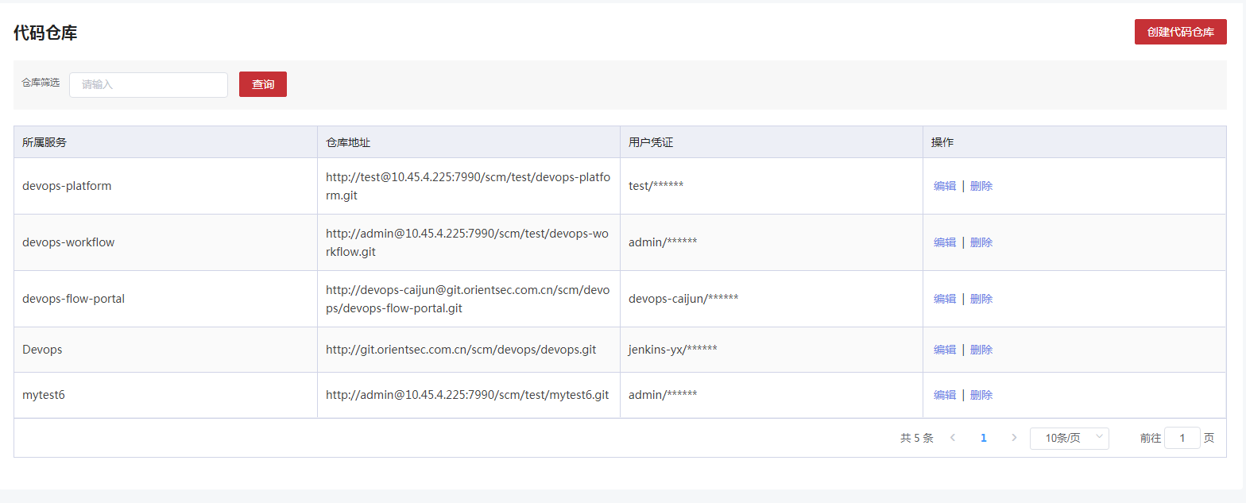3.1.7.2.2 申请代码仓库

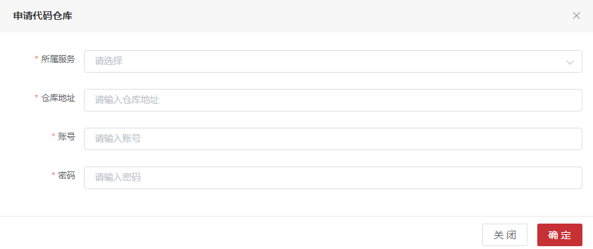3.1.7.2.3 编辑

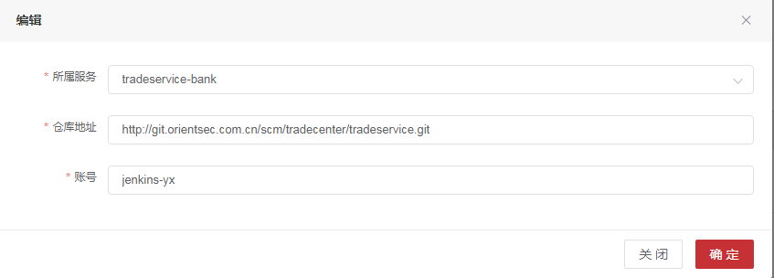3.1.7.3 表字段

3.1.7.3.1 **数据表名：code_warehouse 注释： 代码仓库**

|  |  |  |  |
| --- | --- | --- | --- |
| 字段 | 数据类型 | 注释 | 类型 |
| warehouse_id | int(11) | 代码仓库唯一标识 | 主键 |
| application_id | int(11) | 应用系统id |  |
| service_id | int(11) | 服务id |  |
| service_name | varchar(255) | 服务名 |  |
| warehouse_address | varchar(255) | 仓库地址 |  |
| user_name | varchar(255) | 用户名 |  |
| password | varchar(255) | 用户密码 |  |
| user_proof | varchar(255) | 用户凭证 |  |
| del_flag | int(1) | 删除标志，0未删除，1已删除 |  |

3.1.7.4 API接口

##### 3.1.7.4.1增加代码仓库

|  |  |  |  |  |
| --- | --- | --- | --- | --- |
| 增加代码仓库 | | | | |
| 接口描述 | 增加代码仓库 | | | |
| URL | /codeWarehouse/add | | | |
| 请求方式 | post | | | |
| 请求类型 | application/json | | | |
| 返回类型 | */* | | | |
| 参数名 | 数据类型 | 参数类型 | 是否必填 | 说明 |
| codeWarehouse | body | CodeWarehouse | Y | 代码仓库实体类 |
| 状态码 | 描述 | 说明 | | |
| 200 | OK | OK | | |
| 201 | Created | Created | | |
| 401 | Unauthorized | Unauthorized | | |
| 403 | Forbidden | Forbidden | | |
| 404 | Not Found | Not Found | | |
| 示例 | | | | |
| 请求参数 | {"applicationId":"应用系统id格式为(int32)","delFlag":"删除标志，0未删除，1已删除格式为(int32)","password":"用户密码","serviceId":"服务id格式为(int32)","serviceName":"服务名","userName":"用户名","userProof":"用户凭证","warehouseAddress":"仓库地址","warehouseId":"代码仓库唯一标识格式为(int32)"} | | | |
| 返回值 | {"code":"格式为(int32)","data":"","message":"","success":"","timestamp":"格式为(int64)"} | | | |

##### 3.1.7.4.2按照id删除代码仓库

|  |  |  |  |  |
| --- | --- | --- | --- | --- |
| 按照id删除代码仓库 | | | | |
| 接口描述 | 按照id删除代码仓库 | | | |
| URL | /codeWarehouse/delete | | | |
| 请求方式 | delete | | | |
| 请求类型 | application/json | | | |
| 返回类型 | */* | | | |
| 参数名 | 数据类型 | 参数类型 | 是否必填 | 说明 |
| codeWarehouse | body | CodeWarehouse | Y | codeWarehouse |
| 状态码 | 描述 | 说明 | | |
| 200 | OK | OK | | |
| 204 | No Content | No Content | | |
| 401 | Unauthorized | Unauthorized | | |
| 403 | Forbidden | Forbidden | | |
| 示例 | | | | |
| 请求参数 | {"applicationId":"应用系统id格式为(int32)","delFlag":"删除标志，0未删除，1已删除格式为(int32)","password":"用户密码","serviceId":"服务id格式为(int32)","serviceName":"服务名","userName":"用户名","userProof":"用户凭证","warehouseAddress":"仓库地址","warehouseId":"代码仓库唯一标识格式为(int32)"} | | | |
| 返回值 | {"code":"格式为(int32)","data":"","message":"","success":"","timestamp":"格式为(int64)"} | | | |

##### 3.1.7.4.3过滤并组装服务git地址

|  |  |  |  |  |
| --- | --- | --- | --- | --- |
| 过滤并组装服务git地址 | | | | |
| 接口描述 | 过滤并组装服务git地址 | | | |
| URL | /codeWarehouse/filterAssembleUrl | | | |
| 请求方式 | get | | | |
| 请求类型 | application/json | | | |
| 返回类型 | */* | | | |
| 参数名 | 数据类型 | 参数类型 | 是否必填 | 说明 |
| serviceId | integer | query | Y | serviceId |
| 状态码 | 描述 | 说明 | | |
| 200 | OK | OK | | |
| 401 | Unauthorized | Unauthorized | | |
| 403 | Forbidden | Forbidden | | |
| 404 | Not Found | Not Found | | |
| 示例 | | | | |
| 请求参数 | {"serviceId":0} | | | |
| 返回值 | {"body":"","statusCode":"","statusCodeValue":"格式为(int32)"} | | | |

##### 3.1.7.4.4判断服务代码tag是否存在

|  |  |  |  |  |
| --- | --- | --- | --- | --- |
| 判断服务代码tag是否存在 | | | | |
| 接口描述 | 判断服务代码tag是否存在 | | | |
| URL | /codeWarehouse/isTag | | | |
| 请求方式 | get | | | |
| 请求类型 | application/json | | | |
| 返回类型 | */* | | | |
| 参数名 | 数据类型 | 参数类型 | 是否必填 | 说明 |
| serviceId | integer | query | Y | serviceId |
| tag | string | query | Y | tag |
| 状态码 | 描述 | 说明 | | |
| 200 | OK | OK | | |
| 401 | Unauthorized | Unauthorized | | |
| 403 | Forbidden | Forbidden | | |
| 404 | Not Found | Not Found | | |
| 示例 | | | | |
| 请求参数 | {"tag":"string","serviceId":0} | | | |
| 返回值 | {"body":"","statusCode":"","statusCodeValue":"格式为(int32)"} | | | |

##### 3.1.7.4.5替换目标url

|  |  |  |  |  |
| --- | --- | --- | --- | --- |
| 替换目标url | | | | |
| 接口描述 | 替换目标url | | | |
| URL | /codeWarehouse/replaceTargetUrl | | | |
| 请求方式 | get | | | |
| 请求类型 | application/json | | | |
| 返回类型 | */* | | | |
| 参数名 | 数据类型 | 参数类型 | 是否必填 | 说明 |
| serviceId | integer | query | Y | serviceId |
| 状态码 | 描述 | 说明 | | |
| 200 | OK | OK | | |
| 401 | Unauthorized | Unauthorized | | |
| 403 | Forbidden | Forbidden | | |
| 404 | Not Found | Not Found | | |
| 示例 | | | | |
| 请求参数 | {"serviceId":0} | | | |
| 返回值 | {"body":"","statusCode":"","statusCodeValue":"格式为(int32)"} | | | |

##### 3.1.7.4.6按照id修改代码仓库

|  |  |  |  |  |
| --- | --- | --- | --- | --- |
| 按照id修改代码仓库 | | | | |
| 接口描述 | 按照id修改代码仓库 | | | |
| URL | /codeWarehouse/update | | | |
| 请求方式 | patch | | | |
| 请求类型 | application/json | | | |
| 返回类型 | */* | | | |
| 参数名 | 数据类型 | 参数类型 | 是否必填 | 说明 |
| codeWarehouse | body | CodeWarehouse | Y | 仓库代码实体类 |
| 状态码 | 描述 | 说明 | | |
| 200 | OK | OK | | |
| 204 | No Content | No Content | | |
| 401 | Unauthorized | Unauthorized | | |
| 403 | Forbidden | Forbidden | | |
| 示例 | | | | |
| 请求参数 | {"applicationId":"应用系统id格式为(int32)","delFlag":"删除标志，0未删除，1已删除格式为(int32)","password":"用户密码","serviceId":"服务id格式为(int32)","serviceName":"服务名","userName":"用户名","userProof":"用户凭证","warehouseAddress":"仓库地址","warehouseId":"代码仓库唯一标识格式为(int32)"} | | | |
| 返回值 | {"code":"格式为(int32)","data":"","message":"","success":"","timestamp":"格式为(int64)"} | | | |

##### 3.1.7.4.7按照所属服务名查找代码仓库

|  |  |  |  |  |
| --- | --- | --- | --- | --- |
| 按照所属服务名查找代码仓库 | | | | |
| 接口描述 | 按照所属服务名查找代码仓库 | | | |
| URL | /codeWarehouse/{applicationId} | | | |
| 请求方式 | get | | | |
| 请求类型 | application/json | | | |
| 返回类型 | */* | | | |
| 参数名 | 数据类型 | 参数类型 | 是否必填 | 说明 |
| pageNumber | integer | query | N | 页号 |
| pageSize | integer | query | N | 页面大小 |
| sort | string | query | N | 排序字段 |
| order | string | query | N | 排序方式 asc/desc |
| applicationId | integer | path | Y | applicationId |
| name | string | query | N | 所属服务名 |
| 状态码 | 描述 | 说明 | | |
| 200 | OK | OK | | |
| 401 | Unauthorized | Unauthorized | | |
| 403 | Forbidden | Forbidden | | |
| 404 | Not Found | Not Found | | |
| 示例 | | | | |
| 请求参数 | {"name":"string","pageSize":0,"pageNumber":0,"sort":"string","applicationId":0,"order":"string"} | | | |
| 返回值 | {"code":"格式为(int32)","data":{"current":"格式为(int64)","pages":"格式为(int64)","records":[{"applicationId":"应用系统id格式为(int32)","delFlag":"删除标志，0未删除，1已删除格式为(int32)","password":"用户密码","serviceId":"服务id格式为(int32)","serviceName":"服务名","userName":"用户名","userProof":"用户凭证","warehouseAddress":"仓库地址","warehouseId":"代码仓库唯一标识格式为(int32)"}],"searchCount":"","size":"格式为(int64)","total":"格式为(int64)"},"message":"","success":"","timestamp":"格式为(int64)"} | | | |

3.1.8 制品库

3.1.8.1 功能概述

制品库是应用系统下服务成功构建后存放docker镜像或者二进制包的地方，在本项目中采用artifactory作为制品库工具支撑，在DevOps平台进行制品库管理，在创建制品库时，需要调用artifactory接口创建制品库，artifactory制品库中存放制品的默认目录结构如下图：

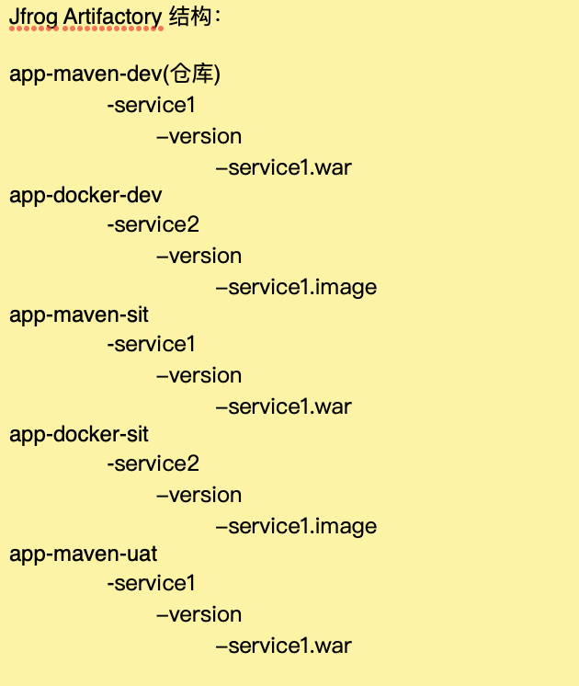

制品库一般按技术类型和制品成熟度进行管理。这里我们涉及到的技术类型包括maven和docker，制品成熟度一般为开发制品库、测试制品库、发布制品库，因此在一个应用系统下，一般默认创建6个制品仓库，命名方式为：应用系统名-技术类型-制品成熟度-reop，如果有其它技术类型的，则用户可以再手动创建所需技术类型的制品库。

制品库创建成功后，在Pipeline流水线定义时，就可以选择构建制品存放在指定制品库。

3.1.8.2 页面

3.1.8.2.1 分页查询

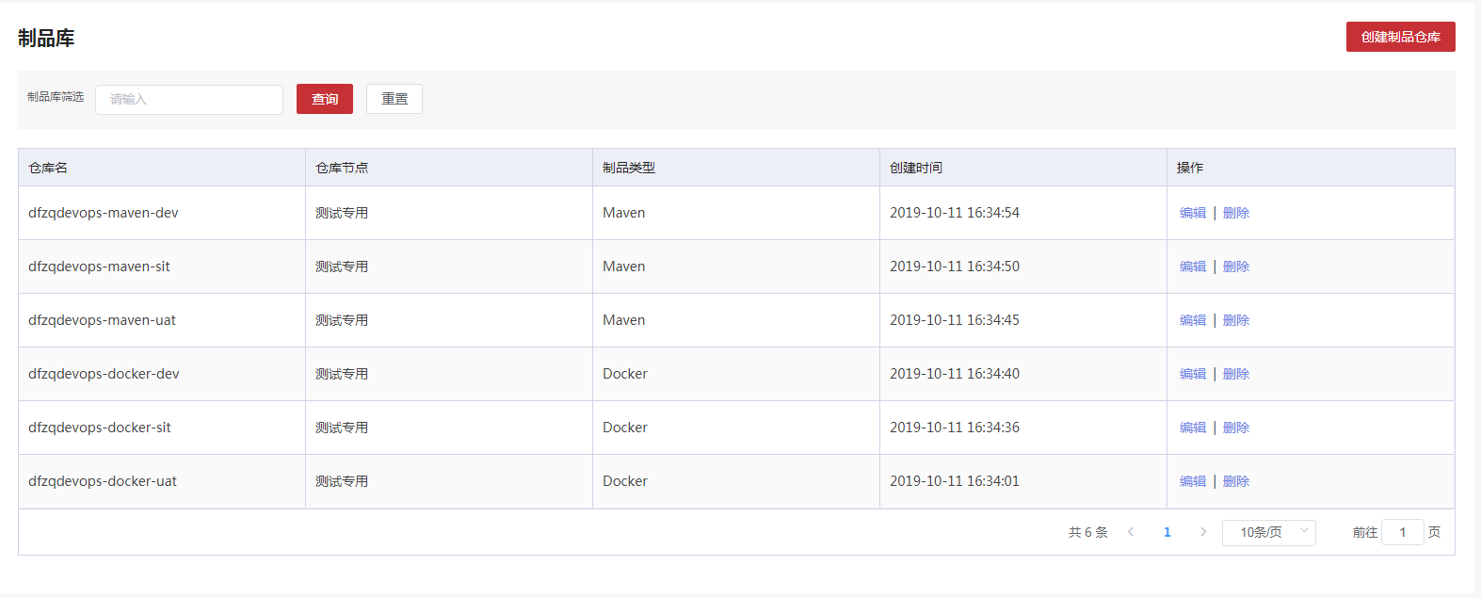3.1.8.2.2 创建

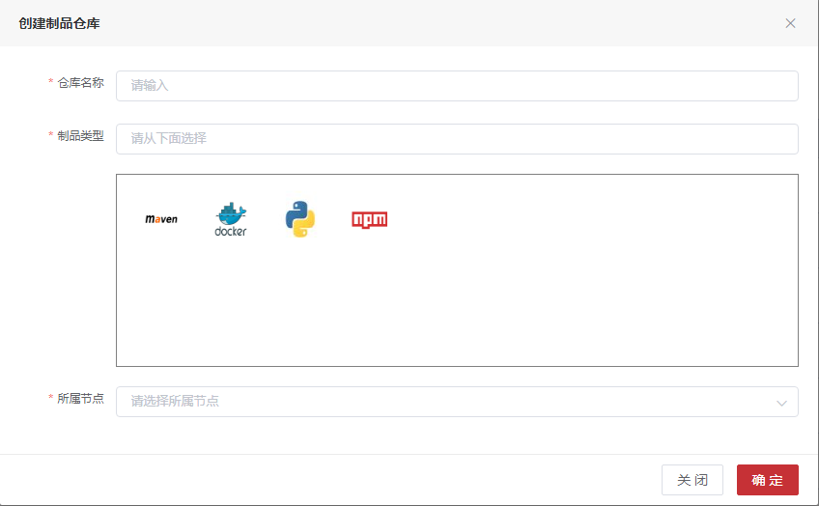3.1.8.2.3编辑

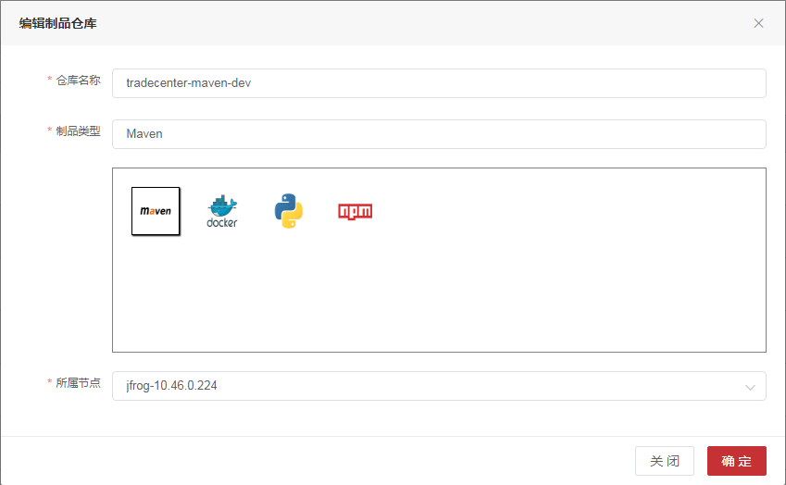3.1.8.3 表字段

3.1.8.3.1**数据表名：t_product_warehouse 注释： 制品库**

|  |  |  |  |
| --- | --- | --- | --- |
| 字段 | 数据类型 | 注释 | 类型 |
| warehouse_id | int(11) | 唯一标识 | 主键 |
| application_id | int(11) | 应用id |  |
| warehouse_name | varchar(255) | 仓库名 |  |
| product_type | int(11) | 制品类型 |  |
| node_id | int(11) | 节点id |  |
| environment_type | int(11) | 环境类型,1DEV环境,2SIT环境,3UAT环境 |  |
| create_time | datetime | 创建时间 |  |
| create_person | varchar(255) | 创建人 |  |
| del_flag | int(1) | 0未删除,1已删除 |  |

3.1.8.4 API 接口

##### 3.1.8.4.1添加制品库

|  |  |  |  |  |
| --- | --- | --- | --- | --- |
| 添加制品库 | | | | |
| 接口描述 | 添加制品库 | | | |
| URL | /productwarehouse/add | | | |
| 请求方式 | post | | | |
| 请求类型 | application/json | | | |
| 返回类型 | */* | | | |
| 参数名 | 数据类型 | 参数类型 | 是否必填 | 说明 |
| warehouse | body | ProductWarehouse | Y | 制品库实体类 |
| 状态码 | 描述 | 说明 | | |
| 200 | OK | OK | | |
| 201 | Created | Created | | |
| 401 | Unauthorized | Unauthorized | | |
| 403 | Forbidden | Forbidden | | |
| 404 | Not Found | Not Found | | |
| 示例 | | | | |
| 请求参数 | {"abbreviation":"应用英文名称","applicationId":"应用id格式为(int32)","createPerson":"创建人","createTime":"创建时间格式为(date-time)","delFlag":"0未删除,1已删除格式为(int32)","environmentType":"环境类型格式为(int32)","isMapping":"是否映射jfrog已存在的仓库","nodeId":"节点id格式为(int32)","nodeName":"节点名称","productType":"制品类型格式为(int32)","typeName":"制品类型名称","warehouseId":"唯一标识格式为(int32)","warehouseName":"仓库名"} | | | |
| 返回值 | {"code":"格式为(int32)","data":"","message":"","success":"","timestamp":"格式为(int64)"} | | | |

##### 3.1.8.4.2根据id修改制品库

|  |  |  |  |  |
| --- | --- | --- | --- | --- |
| 根据id修改制品库 | | | | |
| 接口描述 | 根据id修改制品库 | | | |
| URL | /productwarehouse/update | | | |
| 请求方式 | put | | | |
| 请求类型 | application/json | | | |
| 返回类型 | */* | | | |
| 参数名 | 数据类型 | 参数类型 | 是否必填 | 说明 |
| warehouse | body | ProductWarehouse | Y | 制品库实体类 |
| 状态码 | 描述 | 说明 | | |
| 200 | OK | OK | | |
| 201 | Created | Created | | |
| 401 | Unauthorized | Unauthorized | | |
| 403 | Forbidden | Forbidden | | |
| 404 | Not Found | Not Found | | |
| 示例 | | | | |
| 请求参数 | {"abbreviation":"应用英文名称","applicationId":"应用id格式为(int32)","createPerson":"创建人","createTime":"创建时间格式为(date-time)","delFlag":"0未删除,1已删除格式为(int32)","environmentType":"环境类型格式为(int32)","isMapping":"是否映射jfrog已存在的仓库","nodeId":"节点id格式为(int32)","nodeName":"节点名称","productType":"制品类型格式为(int32)","typeName":"制品类型名称","warehouseId":"唯一标识格式为(int32)","warehouseName":"仓库名"} | | | |
| 返回值 | {"code":"格式为(int32)","data":"","message":"","success":"","timestamp":"格式为(int64)"} | | | |

##### 3.1.8.4.3根据应用id和仓库名分页查询

|  |  |  |  |  |
| --- | --- | --- | --- | --- |
| 根据应用id和仓库名分页查询 | | | | |
| 接口描述 | 根据应用id和仓库名分页查询 | | | |
| URL | /productwarehouse/{applicationId} | | | |
| 请求方式 | get | | | |
| 请求类型 | application/json | | | |
| 返回类型 | */* | | | |
| 参数名 | 数据类型 | 参数类型 | 是否必填 | 说明 |
| applicationId | integer | path | Y | applicationId |
| pageNumber | integer | query | N | 页号 |
| pageSize | integer | query | N | 页面大小 |
| sort | string | query | N | 排序字段 |
| order | string | query | N | 排序方式 asc/desc |
| name | string | query | N | 仓库名 |
| 状态码 | 描述 | 说明 | | |
| 200 | OK | OK | | |
| 401 | Unauthorized | Unauthorized | | |
| 403 | Forbidden | Forbidden | | |
| 404 | Not Found | Not Found | | |
| 示例 | | | | |
| 请求参数 | {"name":"string","pageSize":0,"pageNumber":0,"sort":"string","applicationId":0,"order":"string"} | | | |
| 返回值 | {"code":"格式为(int32)","data":"","message":"","success":"","timestamp":"格式为(int64)"} | | | |

##### 3.1.8.4.4根据id删除制品库

|  |  |  |  |  |
| --- | --- | --- | --- | --- |
| 根据id删除制品库 | | | | |
| 接口描述 | 根据id删除制品库 | | | |
| URL | /productwarehouse/{warehouseId} | | | |
| 请求方式 | delete | | | |
| 请求类型 | application/json | | | |
| 返回类型 | */* | | | |
| 参数名 | 数据类型 | 参数类型 | 是否必填 | 说明 |
| warehouseId | integer | path | Y | warehouseId |
| 状态码 | 描述 | 说明 | | |
| 200 | OK | OK | | |
| 204 | No Content | No Content | | |
| 401 | Unauthorized | Unauthorized | | |
| 403 | Forbidden | Forbidden | | |
| 示例 | | | | |
| 请求参数 | {"warehouseId":0} | | | |
| 返回值 | {"code":"格式为(int32)","data":"","message":"","success":"","timestamp":"格式为(int64)"} | | | |

3.1.9 环境管理

3.1.9.1 功能概述

环境是指应用系统下部署服务的物理/虚拟机或docker资源空间的指向，一般是几台机器IP的集合或是K8S下的一个namespace，通过环境和资源空间关联关系的管理来为用户识别环境资源。

在DevOps创建docker资源类型的环境时，需要在BOC创建应用与之关联；创建物理/虚拟机资源的环境时，需要将机器ip、机器信息录入与之关联。

3.1.9.2 页面

3.1.9.2.1 分页查询

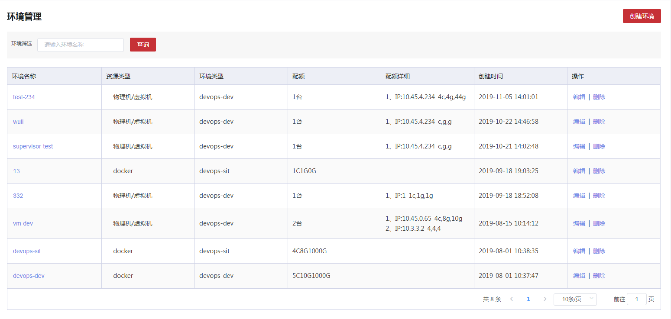3.1.9.2.2 创建

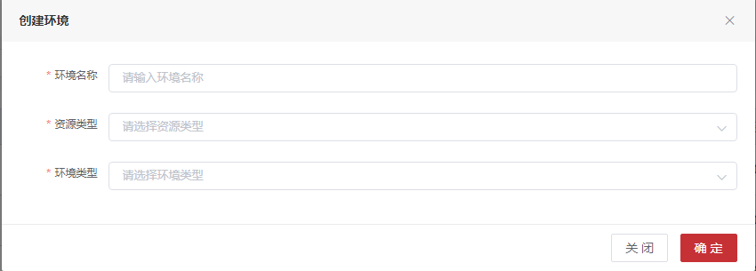3.1.9.2.3 编辑

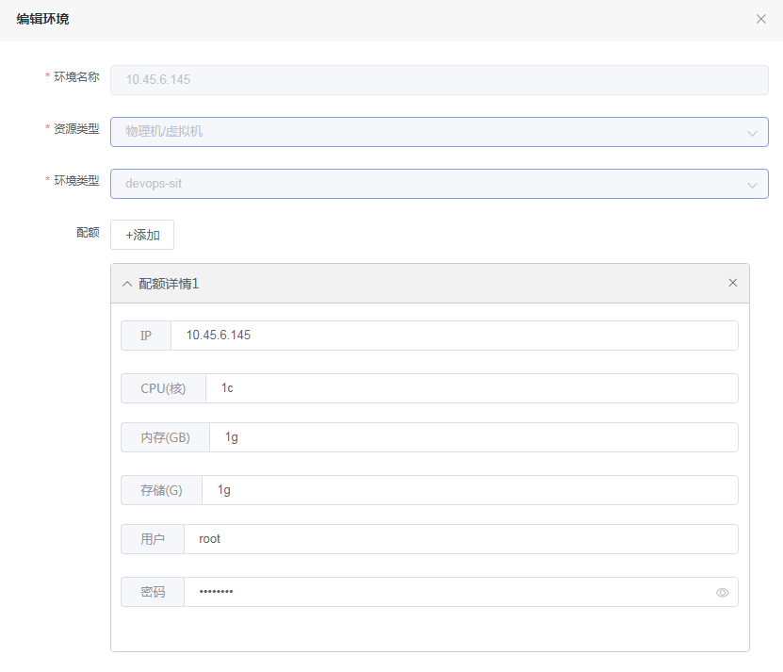3.1.9.3 表字段

3.1.9.3.1**数据表名：environment 注释： 环境表**

|  |  |  |  |
| --- | --- | --- | --- |
| 字段 | 数据类型 | 注释 | 类型 |
| environment_id | int(11) | 唯一标识 | 主键 |
| application_id | int(11) | 应用系统id |  |
| environment_name | varchar(255) | 环境名称 |  |
| resource_type | int(3) | 资源类型 |  |
| create_time | datetime | 创建时间 |  |
| update_time | datetime | 修改时间 |  |
| create_person | varchar(255) | 创建人 |  |
| update_person | varchar(255) | 修改人 |  |
| del_flag | int(1) | 1未删除，0已删除 |  |
| boc_app_id | varchar(255) | boc应用id |  |
| description | varchar(2048) | 描述 |  |
| env_type | int(1) | 环境类型 |  |

3.1.9.3.2**数据表名：t_container_quota 注释： 容器配额**

|  |  |  |  |
| --- | --- | --- | --- |
| 字段 | 数据类型 | 注释 | 类型 |
| container_id | int(11) | 容器配额id | 主键 |
| env_id | int(11) | 环境id |  |
| cpu | int(11) | 配额的CPU量 |  |
| memory | int(11) | 配额的MEM量 |  |
| pods | int(11) | 配额的实例量 |  |
| requestStorage | int(11) | 配额的存储量 |  |
| defaultCpu | varchar(255) | 默认实例的CPU量 |  |
| defaultMem | varchar(255) | 默认实例的MEM量 |  |
| env_type | int(11) | 环境类型 |  |

3.1.9.3.3**数据表名：quota_detail 注释： 配额明细**

|  |  |  |  |
| --- | --- | --- | --- |
| 字段 | 数据类型 | 注释 | 类型 |
| detail_id | int(11) | 唯一标识 | 主键 |
| environment_id | int(11) | 环境id |  |
| ip | varchar(15) | ip |  |
| user_name | varchar(50) | 用户名 |  |
| password | varchar(50) | 密码 |  |
| quota | varchar(255) | 配额 |  |

3.1.9.4 API 接口

##### 3.1.9.4.1增加物理环境

|  |  |  |  |  |
| --- | --- | --- | --- | --- |
| 增加物理环境 | | | | |
| 接口描述 | 增加物理环境 | | | |
| URL | /environment/add | | | |
| 请求方式 | post | | | |
| 请求类型 | application/json | | | |
| 返回类型 | */* | | | |
| 参数名 | 数据类型 | 参数类型 | 是否必填 | 说明 |
| environment | body | Environment | Y | 环境实体类 |
| 状态码 | 描述 | 说明 | | |
| 200 | OK | OK | | |
| 201 | Created | Created | | |
| 401 | Unauthorized | Unauthorized | | |
| 403 | Forbidden | Forbidden | | |
| 404 | Not Found | Not Found | | |
| 示例 | | | | |
| 请求参数 | {"applicationId":"应用系统id格式为(int32)","bocAppId":"boc应用id","containerQuota":{"containerId":"容器配额id格式为(int32)","cpu":"配额的CPU量格式为(int32)","defaultcpu":"默认实例的CPU量","defaultmem":"默认实例的MEM量","envId":"环境id格式为(int32)","memory":"配额的MEM量格式为(int32)","pods":"配额的实例量格式为(int32)","requeststorage":"配额的存储量格式为(int32)"},"createPerson":"创建人","createTime":"创建时间格式为(date-time)","delFlag":"0未删除，1已删除格式为(int32)","description":"描述","envType":"环境类型id格式为(int32)","environmentId":"唯一标识格式为(int32)","environmentName":"环境名称","quotaDetails":[{"detailId":"唯一标识格式为(int32)","environmentId":"环境id格式为(int32)","ip":"ip","password":"密码","quota":"配额","userName":"用户名"}],"resourceType":"资源类型格式为(int32)","typeName":"环境类型名称","updatePerson":"修改人","updateTime":"修改时间格式为(date-time)"} | | | |
| 返回值 | {"code":"格式为(int32)","data":"","message":"","success":"","timestamp":"格式为(int64)"} | | | |

##### 3.1.9.4.2根据应用ID和类型获取环境列表

|  |  |  |  |  |
| --- | --- | --- | --- | --- |
| 根据应用ID和类型获取环境列表 | | | | |
| 接口描述 | 根据应用ID和类型获取环境列表 | | | |
| URL | /environment/findByapplicationIdAndtype | | | |
| 请求方式 | get | | | |
| 请求类型 | application/json | | | |
| 返回类型 | */* | | | |
| 参数名 | 数据类型 | 参数类型 | 是否必填 | 说明 |
| environmentId | integer | query | N | 唯一标识 |
| applicationId | integer | query | N | 应用系统id |
| environmentName | string | query | N | 环境名称 |
| resourceType | integer | query | N | 资源类型 |
| 状态码 | 描述 | 说明 | | |
| 200 | OK | OK | | |
| 401 | Unauthorized | Unauthorized | | |
| 403 | Forbidden | Forbidden | | |
| 404 | Not Found | Not Found | | |
| 示例 | | | | |
| 请求参数 | {"environmentId":0,"applicationId":0,"environmentName":"string","resourceType":0} | | | |
| 返回值 | {"body":"","statusCode":"","statusCodeValue":"格式为(int32)"} | | | |

##### 3.1.9.4.3根据应用ID获取容器环境列表

|  |  |  |  |  |
| --- | --- | --- | --- | --- |
| 根据应用ID获取容器环境列表 | | | | |
| 接口描述 | 根据应用ID获取容器环境列表 | | | |
| URL | /environment/getContainers | | | |
| 请求方式 | get | | | |
| 请求类型 | application/json | | | |
| 返回类型 | */* | | | |
| 参数名 | 数据类型 | 参数类型 | 是否必填 | 说明 |
| environmentId | integer | query | N | 唯一标识 |
| applicationId | integer | query | N | 应用系统id |
| environmentName | string | query | N | 环境名称 |
| resourceType | integer | query | N | 资源类型 |
| 状态码 | 描述 | 说明 | | |
| 200 | OK | OK | | |
| 401 | Unauthorized | Unauthorized | | |
| 403 | Forbidden | Forbidden | | |
| 404 | Not Found | Not Found | | |
| 示例 | | | | |
| 请求参数 | {"environmentId":0,"applicationId":0,"environmentName":"string","resourceType":0} | | | |
| 返回值 | {"body":"","statusCode":"","statusCodeValue":"格式为(int32)"} | | | |

##### 3.1.9.4.4根据ip查询配额

|  |  |  |  |  |
| --- | --- | --- | --- | --- |
| 根据ip查询配额 | | | | |
| 接口描述 | 根据ip查询配额 | | | |
| URL | /environment/selectByQuotaDetail | | | |
| 请求方式 | get | | | |
| 请求类型 | application/json | | | |
| 返回类型 | */* | | | |
| 参数名 | 数据类型 | 参数类型 | 是否必填 | 说明 |
| detailId | integer | query | N | 唯一标识 |
| environmentId | integer | query | N | 环境id |
| ip | string | query | N | ip |
| 状态码 | 描述 | 说明 | | |
| 200 | OK | OK | | |
| 401 | Unauthorized | Unauthorized | | |
| 403 | Forbidden | Forbidden | | |
| 404 | Not Found | Not Found | | |
| 示例 | | | | |
| 请求参数 | {"detailId":0,"environmentId":0,"ip":"string"} | | | |
| 返回值 | {"body":"","statusCode":"","statusCodeValue":"格式为(int32)"} | | | |

##### 3.1.9.4.5按照id修改环境

|  |  |  |  |  |
| --- | --- | --- | --- | --- |
| 按照id修改环境 | | | | |
| 接口描述 | 按照id修改环境 | | | |
| URL | /environment/update | | | |
| 请求方式 | patch | | | |
| 请求类型 | application/json | | | |
| 返回类型 | */* | | | |
| 参数名 | 数据类型 | 参数类型 | 是否必填 | 说明 |
| environment | body | Environment | Y | 环境实体类 |
| 状态码 | 描述 | 说明 | | |
| 200 | OK | OK | | |
| 204 | No Content | No Content | | |
| 401 | Unauthorized | Unauthorized | | |
| 403 | Forbidden | Forbidden | | |
| 示例 | | | | |
| 请求参数 | {"applicationId":"应用系统id格式为(int32)","bocAppId":"boc应用id","containerQuota":{"containerId":"容器配额id格式为(int32)","cpu":"配额的CPU量格式为(int32)","defaultcpu":"默认实例的CPU量","defaultmem":"默认实例的MEM量","envId":"环境id格式为(int32)","memory":"配额的MEM量格式为(int32)","pods":"配额的实例量格式为(int32)","requeststorage":"配额的存储量格式为(int32)"},"createPerson":"创建人","createTime":"创建时间格式为(date-time)","delFlag":"0未删除，1已删除格式为(int32)","description":"描述","envType":"环境类型id格式为(int32)","environmentId":"唯一标识格式为(int32)","environmentName":"环境名称","quotaDetails":[{"detailId":"唯一标识格式为(int32)","environmentId":"环境id格式为(int32)","ip":"ip","password":"密码","quota":"配额","userName":"用户名"}],"resourceType":"资源类型格式为(int32)","typeName":"环境类型名称","updatePerson":"修改人","updateTime":"修改时间格式为(date-time)"} | | | |
| 返回值 | {"code":"格式为(int32)","data":"","message":"","success":"","timestamp":"格式为(int64)"} | | | |

##### 3.1.9.4.6按照name查询环境

|  |  |  |  |  |
| --- | --- | --- | --- | --- |
| 按照name查询环境 | | | | |
| 接口描述 | 按照name查询环境 | | | |
| URL | /environment/{applicationId} | | | |
| 请求方式 | get | | | |
| 请求类型 | application/json | | | |
| 返回类型 | */* | | | |
| 参数名 | 数据类型 | 参数类型 | 是否必填 | 说明 |
| applicationId | integer | path | Y | applicationId |
| pageNumber | integer | query | N | 页号 |
| pageSize | integer | query | N | 页面大小 |
| sort | string | query | N | 排序字段 |
| order | string | query | N | 排序方式 asc/desc |
| name | string | query | N | 环境名 |
| 状态码 | 描述 | 说明 | | |
| 200 | OK | OK | | |
| 401 | Unauthorized | Unauthorized | | |
| 403 | Forbidden | Forbidden | | |
| 404 | Not Found | Not Found | | |
| 示例 | | | | |
| 请求参数 | {"name":"string","pageSize":0,"pageNumber":0,"sort":"string","applicationId":0,"order":"string"} | | | |
| 返回值 | {"code":"格式为(int32)","data":{"current":"格式为(int64)","pages":"格式为(int64)","records":[{"applicationId":"应用系统id格式为(int32)","bocAppId":"boc应用id","containerQuota":{"containerId":"容器配额id格式为(int32)","cpu":"配额的CPU量格式为(int32)","defaultcpu":"默认实例的CPU量","defaultmem":"默认实例的MEM量","envId":"环境id格式为(int32)","memory":"配额的MEM量格式为(int32)","pods":"配额的实例量格式为(int32)","requeststorage":"配额的存储量格式为(int32)"},"createPerson":"创建人","createTime":"创建时间格式为(date-time)","delFlag":"0未删除，1已删除格式为(int32)","description":"描述","envType":"环境类型id格式为(int32)","environmentId":"唯一标识格式为(int32)","environmentName":"环境名称","quotaDetails":[{"detailId":"唯一标识格式为(int32)","environmentId":"环境id格式为(int32)","ip":"ip","password":"密码","quota":"配额","userName":"用户名"}],"resourceType":"资源类型格式为(int32)","typeName":"环境类型名称","updatePerson":"修改人","updateTime":"修改时间格式为(date-time)"}],"searchCount":"","size":"格式为(int64)","total":"格式为(int64)"},"message":"","success":"","timestamp":"格式为(int64)"} | | | |

##### 3.1.9.4.7按照id删除环境

|  |  |  |  |  |
| --- | --- | --- | --- | --- |
| 按照id删除环境 | | | | |
| 接口描述 | 按照id删除环境 | | | |
| URL | /environment/{id} | | | |
| 请求方式 | delete | | | |
| 请求类型 | application/json | | | |
| 返回类型 | */* | | | |
| 参数名 | 数据类型 | 参数类型 | 是否必填 | 说明 |
| id | integer | path | Y | id |
| 状态码 | 描述 | 说明 | | |
| 200 | OK | OK | | |
| 204 | No Content | No Content | | |
| 401 | Unauthorized | Unauthorized | | |
| 403 | Forbidden | Forbidden | | |
| 示例 | | | | |
| 请求参数 | {"id":0} | | | |
| 返回值 | {"code":"格式为(int32)","data":"","message":"","success":"","timestamp":"格式为(int64)"} | | | |

3.1.10 版本构建

3.1.10.1功能概述

应用系统的版本管理是在软件做一次发布时，对软件的需求、代码、制品和质量进行记录、跟踪、维护和控制的过程。应用系统在发布版本时，要记录应用系统本次发布所开发的需求、编译构建的代码，在版本发布完成后形成当前版本的制品信息和质量信息。应用系统的版本包括两种类型，分别是上线版本和测试版本，在一次上线版本形成之前，会发布多个测试版本进行测试，最终测试全部通过并确定上线后，最后的测试版本即封版为上线版本。

从应用系统的架构角度，应用系统由一个或多个服务组成，应用系统的版本是这些服务版本的合集，每个服务都是独立可发布的，所以应用系统版本和服务的版本是一对多的映射关系。

从应用系统版本发布的流程角度，版本有紧急版本和正常版本之分，他们的发布流程是有差别的，正常版本的流程一般为研发、sit测试、uat测试和上线，紧急版本的流程为研发、sit测试、和上线。

在DevOps平台周边相关集成平台和工具之间，DevOps平台的版本创建时要同步到Jira上，在Jira上创建需求做版本规划时，应将需求和版本进行关联，在DevOps平台则可以查看版本需求和需求提测等相关操作。

3.1.10.2 页面

3.1.10.2.1 版本构建查询

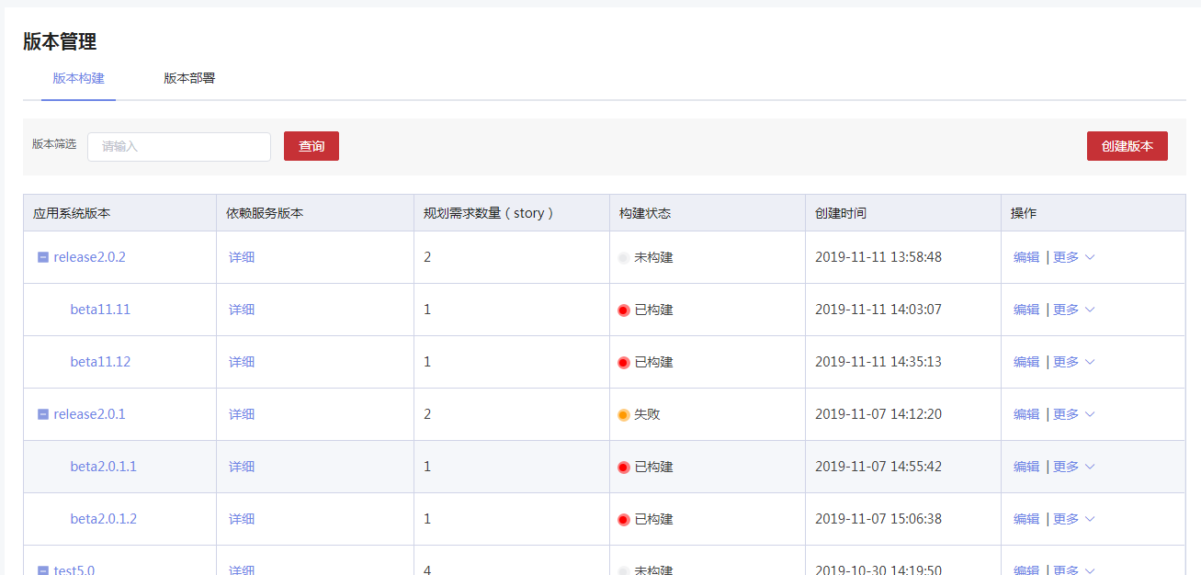3.1.10.2.2 版本部署查询

3.1.10.2.3 release 版本创建

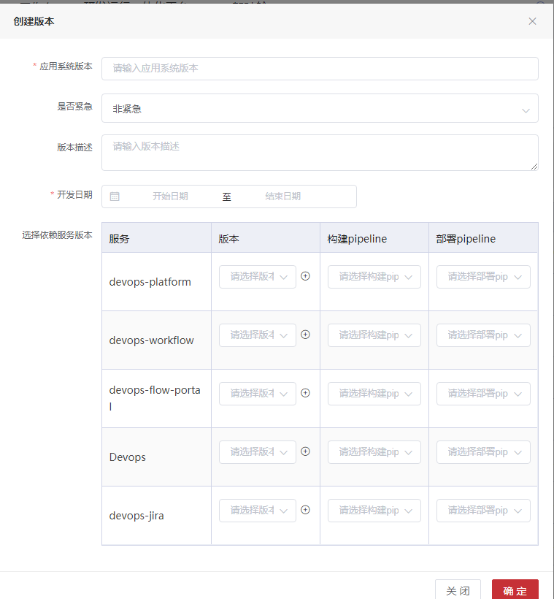3.1.10.2.4 bate 创建

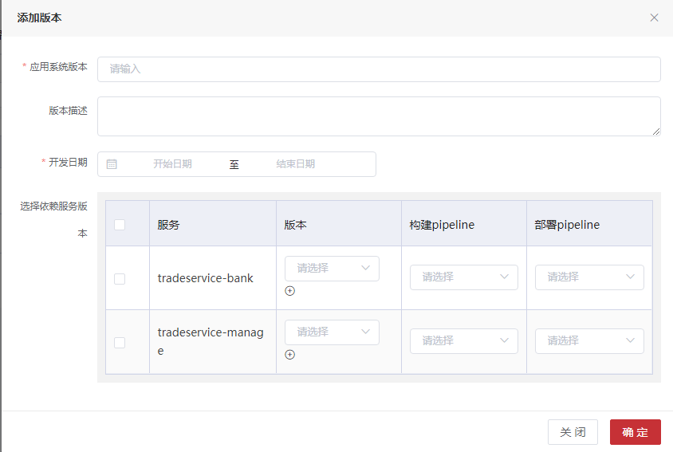3.1.10.2.5 编辑

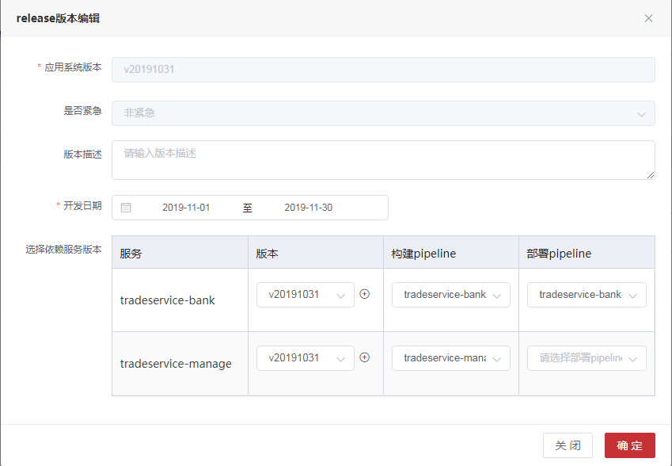3.1.10.3 表字段

**数据表名：t_application_version 注释： 应用版本**

|  |  |  |  |
| --- | --- | --- | --- |
| 字段 | 数据类型 | 注释 | 类型 |
| version_id | int(11) | 唯一标识 | 主键 |
| application_id | int(11) | 应用id |  |
| version_type | int(1) | 版本类型,1发布版,2过度版 |  |
| version_name | varchar(255) | 版本名称 |  |
| deploy_pipeline | int(11) | 部署pipeline的id |  |
| release_pipeline | int(11) | 发布pipeline的id |  |
| develop_time | date | 开发日期 |  |
| deploy_time | date | 部署日期 |  |
| creation_person | varchar(255) | 创建人 |  |
| creation_time | datetime | 创建时间 |  |
| release_person | varchar(255) | 发布人 |  |
| release_time | datetime | 发版时间 |  |
| description | varchar(2048) | 版本描述 |  |
| status | int(1) | 发布状态：0废弃版本,1未发布,2进行中,3已发布,4失败 |  |
| jira_version_id | int(11) | jira应用版本id |  |
| deploy_status | int(1) | 部署状态：0废弃部署,1未部署,2进行中,3已部署,4失败 |  |
| urgent | int(1) | 0不紧急,1紧急 |  |
| test_flag | int(1) | 提测标志:0未提测,1sit提测,2uat提测 |  |

**数据表名：t_application_version_detail 注释： 应用版本明细**

|  |  |  |  |
| --- | --- | --- | --- |
| 字段 | 数据类型 | 注释 | 类型 |
| id | int(11) | 唯一标识 | 主键 |
| service_version_id | int(11) | 服务版本id |  |
| application_version_id | int(11) | 应用版本id |  |
| status | int(1) | 0作废,1正常 |  |

**数据表名：t_application_version_info 注释： 应用版本明细**

|  |  |  |  |
| --- | --- | --- | --- |
| 字段 | 数据类型 | 注释 | 类型 |
| info_id | int(11) | 唯一标识 | 主键 |
| release_id | int(11) | 发布版本id |  |
| beta_id | int(11) | 过渡版本id |  |

3.1.10.4 API接口

application-version-controller

3.1.10.4.1应用下版本耗时

|  |  |  |  |  |
| --- | --- | --- | --- | --- |
| 应用下版本耗时 | | | | |
| 接口描述 | 应用下版本耗时 | | | |
| URL | /applicationVersion/CICDTimeConsuming | | | |
| 请求方式 | get | | | |
| 请求类型 | application/json | | | |
| 返回类型 | */* | | | |
| 参数名 | 数据类型 | 参数类型 | 是否必填 | 说明 |
| appId | integer | query | N | appId |
| type | string | query | N | type |
| 状态码 | 描述 | 说明 | | |
| 200 | OK | OK | | |
| 401 | Unauthorized | Unauthorized | | |
| 403 | Forbidden | Forbidden | | |
| 404 | Not Found | Not Found | | |
| 示例 | | | | |
| 请求参数 | {"type":"string","appId":0} | | | |
| 返回值 | {"body":"","statusCode":"","statusCodeValue":"格式为(int32)"} | | | |

3.1.10.4.2增加应用系统版本

|  |  |  |  |  |
| --- | --- | --- | --- | --- |
| 增加应用系统版本 | | | | |
| 接口描述 | 增加应用系统版本 | | | |
| URL | /applicationVersion/add | | | |
| 请求方式 | post | | | |
| 请求类型 | application/json | | | |
| 返回类型 | */* | | | |
| 参数名 | 数据类型 | 参数类型 | 是否必填 | 说明 |
| version | body | ApplicationVersion | Y | 应用系统版本类 |
| 状态码 | 描述 | 说明 | | |
| 200 | OK | OK | | |
| 201 | Created | Created | | |
| 401 | Unauthorized | Unauthorized | | |
| 403 | Forbidden | Forbidden | | |
| 404 | Not Found | Not Found | | |
| 示例 | | | | |
| 请求参数 | {"applicationId":"应用id格式为(int32)","completeNumber":"完成需求数量格式为(int32)","creationPerson":"创建人","creationTime":"创建时间格式为(date-time)","deployPipeline":"部署pipeline的id格式为(int32)","deployStatus":"部署状态：0废弃部署,1未部署,2进行中,3已部署,4失败格式为(int32)","deployTime":"部署日期格式为(date-time)","description":"版本描述","details":[{"applicationVersionId":"应用版本id格式为(int32)","creationTime":"创建时间格式为(date-time)","deployList":[{"applicationId":"格式为(int32)","buildTimes":"格式为(int32)","buildUser":"格式为(int32)","createTime":"格式为(date-time)","createUser":"格式为(int32)","lastBuildStatus":"格式为(byte)","lastBuildTakes":"格式为(int32)","lastBuildTime":"格式为(date-time)","pipelineFile":"","pipelineName":"","pipelineParam":"","serviceId":"格式为(int32)","serviceName":"","taskId":"格式为(int32)","taskName":"","taskStatus":"格式为(byte)","taskTrigger":"格式为(byte)","taskType":"格式为(byte)","updateTime":"格式为(date-time)","updateUser":"格式为(int32)"}],"deployName":"部署pipeline名称","deployPipeline":"部署pipelineId格式为(int32)","deployStatus":"部署状态：0废弃部署,1未部署,2进行中,3已部署,4失败格式为(int32)","id":"唯一标识格式为(int32)","jiraServiceId":"jira服务id格式为(int32)","releaseId":"releaseId格式为(int32)","releaseList":[{"applicationId":"格式为(int32)","buildTimes":"格式为(int32)","buildUser":"格式为(int32)","createTime":"格式为(date-time)","createUser":"格式为(int32)","lastBuildStatus":"格式为(byte)","lastBuildTakes":"格式为(int32)","lastBuildTime":"格式为(date-time)","pipelineFile":"","pipelineName":"","pipelineParam":"","serviceId":"格式为(int32)","serviceName":"","taskId":"格式为(int32)","taskName":"","taskStatus":"格式为(byte)","taskTrigger":"格式为(byte)","taskType":"格式为(byte)","updateTime":"格式为(date-time)","updateUser":"格式为(int32)"}],"releaseName":"发布pipeline名称","releasePipeline":"发布pipelineId格式为(int32)","releaseSatus":"发布状态：0废弃版本,1未发布,2进行中,3已发布,4失败格式为(int32)","serviceId":"服务id格式为(int32)","serviceName":"服务名称","serviceVersionId":"服务版本id格式为(int32)","serviceVersionName":"服务版本名称","standbyParam":"备用参数","status":"状态格式为(int32)","versionList":[{}]}],"developTime":"开发日期格式为(date-time)","jiraVersionId":"jira版本ID格式为(int32)","plansNumber":"规划需求数量格式为(int32)","queryType":"查询类型","releasePerson":"发布人","releasePipeline":"发布pipeline的id格式为(int32)","releaseTime":"发版时间格式为(date-time)","serviceVersions":[{}],"status":"发布状态：0废弃版本,1未发布,2进行中,3已发布,4失败格式为(int32)","testFlag":"提测标志:0未提测,1sit提测,2uat提测格式为(int32)","urgent":"0非紧急,1紧急格式为(int32)","versionId":"唯一标识格式为(int32)","versionName":"版本名称","versionType":"版本类型,2过渡版，1发布版格式为(int32)"} | | | |
| 返回值 | {"code":"格式为(int32)","data":"","message":"","success":"","timestamp":"格式为(int64)"} | | | |

3.1.10.4.3增加bate版本

|  |  |  |  |  |
| --- | --- | --- | --- | --- |
| 增加bate版本 | | | | |
| 接口描述 | 增加bate版本 | | | |
| URL | /applicationVersion/addBateVersion | | | |
| 请求方式 | post | | | |
| 请求类型 | application/json | | | |
| 返回类型 | */* | | | |
| 参数名 | 数据类型 | 参数类型 | 是否必填 | 说明 |
| vo | body | ApplicationBetaVersionVo | Y | vo |
| 状态码 | 描述 | 说明 | | |
| 200 | OK | OK | | |
| 201 | Created | Created | | |
| 401 | Unauthorized | Unauthorized | | |
| 403 | Forbidden | Forbidden | | |
| 404 | Not Found | Not Found | | |
| 示例 | | | | |
| 请求参数 | {"releaseId":"发布版本ID格式为(int32)","type":"releaseId类型：null或者不传devops,jira是jiraVersionID","version":{"applicationId":"应用id格式为(int32)","completeNumber":"完成需求数量格式为(int32)","creationPerson":"创建人","creationTime":"创建时间格式为(date-time)","deployPipeline":"部署pipeline的id格式为(int32)","deployStatus":"部署状态：0废弃部署,1未部署,2进行中,3已部署,4失败格式为(int32)","deployTime":"部署日期格式为(date-time)","description":"版本描述","details":[{"applicationVersionId":"应用版本id格式为(int32)","creationTime":"创建时间格式为(date-time)","deployList":[{"applicationId":"格式为(int32)","buildTimes":"格式为(int32)","buildUser":"格式为(int32)","createTime":"格式为(date-time)","createUser":"格式为(int32)","lastBuildStatus":"格式为(byte)","lastBuildTakes":"格式为(int32)","lastBuildTime":"格式为(date-time)","pipelineFile":"","pipelineName":"","pipelineParam":"","serviceId":"格式为(int32)","serviceName":"","taskId":"格式为(int32)","taskName":"","taskStatus":"格式为(byte)","taskTrigger":"格式为(byte)","taskType":"格式为(byte)","updateTime":"格式为(date-time)","updateUser":"格式为(int32)"}],"deployName":"部署pipeline名称","deployPipeline":"部署pipelineId格式为(int32)","deployStatus":"部署状态：0废弃部署,1未部署,2进行中,3已部署,4失败格式为(int32)","id":"唯一标识格式为(int32)","jiraServiceId":"jira服务id格式为(int32)","releaseId":"releaseId格式为(int32)","releaseList":[{"applicationId":"格式为(int32)","buildTimes":"格式为(int32)","buildUser":"格式为(int32)","createTime":"格式为(date-time)","createUser":"格式为(int32)","lastBuildStatus":"格式为(byte)","lastBuildTakes":"格式为(int32)","lastBuildTime":"格式为(date-time)","pipelineFile":"","pipelineName":"","pipelineParam":"","serviceId":"格式为(int32)","serviceName":"","taskId":"格式为(int32)","taskName":"","taskStatus":"格式为(byte)","taskTrigger":"格式为(byte)","taskType":"格式为(byte)","updateTime":"格式为(date-time)","updateUser":"格式为(int32)"}],"releaseName":"发布pipeline名称","releasePipeline":"发布pipelineId格式为(int32)","releaseSatus":"发布状态：0废弃版本,1未发布,2进行中,3已发布,4失败格式为(int32)","serviceId":"服务id格式为(int32)","serviceName":"服务名称","serviceVersionId":"服务版本id格式为(int32)","serviceVersionName":"服务版本名称","standbyParam":"备用参数","status":"状态格式为(int32)","versionList":[{}]}],"developTime":"开发日期格式为(date-time)","jiraVersionId":"jira版本ID格式为(int32)","plansNumber":"规划需求数量格式为(int32)","queryType":"查询类型","releasePerson":"发布人","releasePipeline":"发布pipeline的id格式为(int32)","releaseTime":"发版时间格式为(date-time)","serviceVersions":[{}],"status":"发布状态：0废弃版本,1未发布,2进行中,3已发布,4失败格式为(int32)","testFlag":"提测标志:0未提测,1sit提测,2uat提测格式为(int32)","urgent":"0非紧急,1紧急格式为(int32)","versionId":"唯一标识格式为(int32)","versionName":"版本名称","versionType":"版本类型,2过渡版，1发布版格式为(int32)"}} | | | |
| 返回值 | {"body":"","statusCode":"","statusCodeValue":"格式为(int32)"} | | | |

3.1.10.4.4按照id删除应用系统版本

|  |  |  |  |  |
| --- | --- | --- | --- | --- |
| 按照id删除应用系统版本 | | | | |
| 接口描述 | 按照id删除应用系统版本 | | | |
| URL | /applicationVersion/deleteDeploy/{versionId} | | | |
| 请求方式 | delete | | | |
| 请求类型 | application/json | | | |
| 返回类型 | */* | | | |
| 参数名 | 数据类型 | 参数类型 | 是否必填 | 说明 |
| versionId | integer | path | Y | versionId |
| 状态码 | 描述 | 说明 | | |
| 200 | OK | OK | | |
| 204 | No Content | No Content | | |
| 401 | Unauthorized | Unauthorized | | |
| 403 | Forbidden | Forbidden | | |
| 示例 | | | | |
| 请求参数 | {"versionId":0} | | | |
| 返回值 | {"body":"","statusCode":"","statusCodeValue":"格式为(int32)"} | | | |

3.1.10.4.5批量部署

|  |  |  |  |  |
| --- | --- | --- | --- | --- |
| 批量部署 | | | | |
| 接口描述 | 批量部署 | | | |
| URL | /applicationVersion/deployBatch | | | |
| 请求方式 | post | | | |
| 请求类型 | application/json | | | |
| 返回类型 | */* | | | |
| 参数名 | 数据类型 | 参数类型 | 是否必填 | 说明 |
| vo | body | ApplicationJobV4Vo | Y | vo |
| 状态码 | 描述 | 说明 | | |
| 200 | OK | OK | | |
| 201 | Created | Created | | |
| 401 | Unauthorized | Unauthorized | | |
| 403 | Forbidden | Forbidden | | |
| 404 | Not Found | Not Found | | |
| 示例 | | | | |
| 请求参数 | {"appJobId":"Id格式为(int32)","applicationId":"应用系统id格式为(int32)","applicationName":"应用系统名称","envId":"环境ID格式为(int32)","processId":"流程id","serviceJobs":[{"againFalg":"是否重启拉取代码","appJobId":"应用jobID, 应用版本作业格式为(int32)","ciPipelineId":"CI 的 pipelineID 关联Pipeline， CD时传值，CI不传值格式为(int32)","detailId":"ID格式为(int32)","envId":"环境ID格式为(int32)","pipelineId":"pipelineID 关联Pipeline格式为(int32)","releaseSatus":"发布状态格式为(int32)","serviceId":"服务id格式为(int32)","serviceJobId":"Id格式为(int32)","serviceName":"服务名称","serviceReleaseId":"服务版本releaseID格式为(int32)","serviceVersionId":"服务版本ID格式为(int32)","serviceVersionName":"服务版本名称","stageParams":[{"paramFlag":"参数标志","paramId":"参数Id格式为(int32)","paramName":"参数名","paramType":"参数类型格式为(int32)","paramValue":"参数值","stageId":"关联Stage格式为(int32)"}]}],"sitID":"提测单id","stotys":[{"createDate":"Issue的创建日期格式为(date-time)","devServiceId":"平台服务id格式为(int32)","devServiceName":"","devServiceVersion":"","enableCheck":"是否可选择","epicLink":"Issue故事/BUG/任务关联的Epic","id":"IssueId","key":"Issue的key","name":"Issue名称","serviceId":"服务id格式为(int32)","status":"Issue中文状态","type":"Issue类型:Epic/Story/Task/Bug","unableStatus":"不可用状态说明"}],"uatID":"uatID","versionId":"应用版本id格式为(int32)","versionName":"应用版本名称"} | | | |
| 返回值 | {"body":"","statusCode":"","statusCodeValue":"格式为(int32)"} | | | |

3.1.10.4.6根据应用ID和版本ID查找bate版本

|  |  |  |  |  |
| --- | --- | --- | --- | --- |
| 根据应用ID和版本ID查找bate版本 | | | | |
| 接口描述 | 根据应用ID和版本ID查找bate版本 | | | |
| URL | /applicationVersion/getBateVersion | | | |
| 请求方式 | get | | | |
| 请求类型 | application/json | | | |
| 返回类型 | */* | | | |
| 参数名 | 数据类型 | 参数类型 | 是否必填 | 说明 |
| versionId | integer | query | N | 版本ID |
| applicationId | integer | query | N | 应用id |
| versionName | string | query | N | 版本名称 |
| jiraVersionId | integer | query | N | jira应用版本ID |
| status | integer | query | N | 版本状态：1未发布，2已发布，3作废 |
| queryType | string | query | N | release:发布,deploy:部署 |
| 状态码 | 描述 | 说明 | | |
| 200 | OK | OK | | |
| 401 | Unauthorized | Unauthorized | | |
| 403 | Forbidden | Forbidden | | |
| 404 | Not Found | Not Found | | |
| 示例 | | | | |
| 请求参数 | {"jiraVersionId":0,"versionId":0,"applicationId":0,"versionName":"string","status":0,"queryType":"string"} | | | |
| 返回值 | {"body":"","statusCode":"","statusCodeValue":"格式为(int32)"} | | | |

3.1.10.4.7获取版本发布详情

|  |  |  |  |  |
| --- | --- | --- | --- | --- |
| 获取版本发布详情 | | | | |
| 接口描述 | 获取版本发布详情 | | | |
| URL | /applicationVersion/getReleaseInfo | | | |
| 请求方式 | get | | | |
| 请求类型 | application/json | | | |
| 返回类型 | */* | | | |
| 参数名 | 数据类型 | 参数类型 | 是否必填 | 说明 |
| versionId | integer | query | N | versionId |
| 状态码 | 描述 | 说明 | | |
| 200 | OK | OK | | |
| 401 | Unauthorized | Unauthorized | | |
| 403 | Forbidden | Forbidden | | |
| 404 | Not Found | Not Found | | |
| 示例 | | | | |
| 请求参数 | {"versionId":0} | | | |
| 返回值 | {"body":"","statusCode":"","statusCodeValue":"格式为(int32)"} | | | |

3.1.10.4.8根据bete版本ID查找release版本

|  |  |  |  |  |
| --- | --- | --- | --- | --- |
| 根据bete版本ID查找release版本 | | | | |
| 接口描述 | 根据bete版本ID查找release版本 | | | |
| URL | /applicationVersion/getReleaseVersion | | | |
| 请求方式 | post | | | |
| 请求类型 | application/json | | | |
| 返回类型 | */* | | | |
| 参数名 | 数据类型 | 参数类型 | 是否必填 | 说明 |
| vo | body | ApplicationVersionVo | Y | vo |
| 状态码 | 描述 | 说明 | | |
| 200 | OK | OK | | |
| 201 | Created | Created | | |
| 401 | Unauthorized | Unauthorized | | |
| 403 | Forbidden | Forbidden | | |
| 404 | Not Found | Not Found | | |
| 示例 | | | | |
| 请求参数 | {"applicationId":"应用id格式为(int32)","jiraVersionId":"jira应用版本ID格式为(int32)","queryType":"release:发布,deploy:部署","status":"版本状态：1未发布，2已发布，3作废格式为(int32)","versionId":"版本ID格式为(int32)","versionName":"版本名称"} | | | |
| 返回值 | {"body":"","statusCode":"","statusCodeValue":"格式为(int32)"} | | | |

3.1.10.4.9按照versionId查找

|  |  |  |  |  |
| --- | --- | --- | --- | --- |
| 按照versionId查找 | | | | |
| 接口描述 | 按照versionId查找 | | | |
| URL | /applicationVersion/getVersionId | | | |
| 请求方式 | get | | | |
| 请求类型 | application/json | | | |
| 返回类型 | */* | | | |
| 参数名 | 数据类型 | 参数类型 | 是否必填 | 说明 |
| versionId | string | query | Y | 版本名称 |
| 状态码 | 描述 | 说明 | | |
| 200 | OK | OK | | |
| 401 | Unauthorized | Unauthorized | | |
| 403 | Forbidden | Forbidden | | |
| 404 | Not Found | Not Found | | |
| 示例 | | | | |
| 请求参数 | {"versionId":"string"} | | | |
| 返回值 | {"code":"格式为(int32)","data":"","message":"","success":"","timestamp":"格式为(int64)"} | | | |

3.1.10.4.10初始化增加bate版本

|  |  |  |  |  |
| --- | --- | --- | --- | --- |
| 初始化增加bate版本 | | | | |
| 接口描述 | 初始化增加bate版本 | | | |
| URL | /applicationVersion/initializeBetaVersion | | | |
| 请求方式 | post | | | |
| 请求类型 | application/json | | | |
| 返回类型 | */* | | | |
| 参数名 | 数据类型 | 参数类型 | 是否必填 | 说明 |
| vo | body | ApplicationBetaVersionVo | Y | vo |
| 状态码 | 描述 | 说明 | | |
| 200 | OK | OK | | |
| 201 | Created | Created | | |
| 401 | Unauthorized | Unauthorized | | |
| 403 | Forbidden | Forbidden | | |
| 404 | Not Found | Not Found | | |
| 示例 | | | | |
| 请求参数 | {"releaseId":"发布版本ID格式为(int32)","type":"releaseId类型：null或者不传devops,jira是jiraVersionID","version":{"applicationId":"应用id格式为(int32)","completeNumber":"完成需求数量格式为(int32)","creationPerson":"创建人","creationTime":"创建时间格式为(date-time)","deployPipeline":"部署pipeline的id格式为(int32)","deployStatus":"部署状态：0废弃部署,1未部署,2进行中,3已部署,4失败格式为(int32)","deployTime":"部署日期格式为(date-time)","description":"版本描述","details":[{"applicationVersionId":"应用版本id格式为(int32)","creationTime":"创建时间格式为(date-time)","deployList":[{"applicationId":"格式为(int32)","buildTimes":"格式为(int32)","buildUser":"格式为(int32)","createTime":"格式为(date-time)","createUser":"格式为(int32)","lastBuildStatus":"格式为(byte)","lastBuildTakes":"格式为(int32)","lastBuildTime":"格式为(date-time)","pipelineFile":"","pipelineName":"","pipelineParam":"","serviceId":"格式为(int32)","serviceName":"","taskId":"格式为(int32)","taskName":"","taskStatus":"格式为(byte)","taskTrigger":"格式为(byte)","taskType":"格式为(byte)","updateTime":"格式为(date-time)","updateUser":"格式为(int32)"}],"deployName":"部署pipeline名称","deployPipeline":"部署pipelineId格式为(int32)","deployStatus":"部署状态：0废弃部署,1未部署,2进行中,3已部署,4失败格式为(int32)","id":"唯一标识格式为(int32)","jiraServiceId":"jira服务id格式为(int32)","releaseId":"releaseId格式为(int32)","releaseList":[{"applicationId":"格式为(int32)","buildTimes":"格式为(int32)","buildUser":"格式为(int32)","createTime":"格式为(date-time)","createUser":"格式为(int32)","lastBuildStatus":"格式为(byte)","lastBuildTakes":"格式为(int32)","lastBuildTime":"格式为(date-time)","pipelineFile":"","pipelineName":"","pipelineParam":"","serviceId":"格式为(int32)","serviceName":"","taskId":"格式为(int32)","taskName":"","taskStatus":"格式为(byte)","taskTrigger":"格式为(byte)","taskType":"格式为(byte)","updateTime":"格式为(date-time)","updateUser":"格式为(int32)"}],"releaseName":"发布pipeline名称","releasePipeline":"发布pipelineId格式为(int32)","releaseSatus":"发布状态：0废弃版本,1未发布,2进行中,3已发布,4失败格式为(int32)","serviceId":"服务id格式为(int32)","serviceName":"服务名称","serviceVersionId":"服务版本id格式为(int32)","serviceVersionName":"服务版本名称","standbyParam":"备用参数","status":"状态格式为(int32)","versionList":[{}]}],"developTime":"开发日期格式为(date-time)","jiraVersionId":"jira版本ID格式为(int32)","plansNumber":"规划需求数量格式为(int32)","queryType":"查询类型","releasePerson":"发布人","releasePipeline":"发布pipeline的id格式为(int32)","releaseTime":"发版时间格式为(date-time)","serviceVersions":[{}],"status":"发布状态：0废弃版本,1未发布,2进行中,3已发布,4失败格式为(int32)","testFlag":"提测标志:0未提测,1sit提测,2uat提测格式为(int32)","urgent":"0非紧急,1紧急格式为(int32)","versionId":"唯一标识格式为(int32)","versionName":"版本名称","versionType":"版本类型,2过渡版，1发布版格式为(int32)"}} | | | |
| 返回值 | {"body":"","statusCode":"","statusCodeValue":"格式为(int32)"} | | | |

3.1.10.4.11初始化release版本

|  |  |  |  |  |
| --- | --- | --- | --- | --- |
| 初始化release版本 | | | | |
| 接口描述 | 初始化release版本 | | | |
| URL | /applicationVersion/initializeReleaseVersion | | | |
| 请求方式 | post | | | |
| 请求类型 | application/json | | | |
| 返回类型 | */* | | | |
| 参数名 | 数据类型 | 参数类型 | 是否必填 | 说明 |
| version | body | ApplicationVersion | Y | version |
| 状态码 | 描述 | 说明 | | |
| 200 | OK | OK | | |
| 201 | Created | Created | | |
| 401 | Unauthorized | Unauthorized | | |
| 403 | Forbidden | Forbidden | | |
| 404 | Not Found | Not Found | | |
| 示例 | | | | |
| 请求参数 | {"applicationId":"应用id格式为(int32)","completeNumber":"完成需求数量格式为(int32)","creationPerson":"创建人","creationTime":"创建时间格式为(date-time)","deployPipeline":"部署pipeline的id格式为(int32)","deployStatus":"部署状态：0废弃部署,1未部署,2进行中,3已部署,4失败格式为(int32)","deployTime":"部署日期格式为(date-time)","description":"版本描述","details":[{"applicationVersionId":"应用版本id格式为(int32)","creationTime":"创建时间格式为(date-time)","deployList":[{"applicationId":"格式为(int32)","buildTimes":"格式为(int32)","buildUser":"格式为(int32)","createTime":"格式为(date-time)","createUser":"格式为(int32)","lastBuildStatus":"格式为(byte)","lastBuildTakes":"格式为(int32)","lastBuildTime":"格式为(date-time)","pipelineFile":"","pipelineName":"","pipelineParam":"","serviceId":"格式为(int32)","serviceName":"","taskId":"格式为(int32)","taskName":"","taskStatus":"格式为(byte)","taskTrigger":"格式为(byte)","taskType":"格式为(byte)","updateTime":"格式为(date-time)","updateUser":"格式为(int32)"}],"deployName":"部署pipeline名称","deployPipeline":"部署pipelineId格式为(int32)","deployStatus":"部署状态：0废弃部署,1未部署,2进行中,3已部署,4失败格式为(int32)","id":"唯一标识格式为(int32)","jiraServiceId":"jira服务id格式为(int32)","releaseId":"releaseId格式为(int32)","releaseList":[{"applicationId":"格式为(int32)","buildTimes":"格式为(int32)","buildUser":"格式为(int32)","createTime":"格式为(date-time)","createUser":"格式为(int32)","lastBuildStatus":"格式为(byte)","lastBuildTakes":"格式为(int32)","lastBuildTime":"格式为(date-time)","pipelineFile":"","pipelineName":"","pipelineParam":"","serviceId":"格式为(int32)","serviceName":"","taskId":"格式为(int32)","taskName":"","taskStatus":"格式为(byte)","taskTrigger":"格式为(byte)","taskType":"格式为(byte)","updateTime":"格式为(date-time)","updateUser":"格式为(int32)"}],"releaseName":"发布pipeline名称","releasePipeline":"发布pipelineId格式为(int32)","releaseSatus":"发布状态：0废弃版本,1未发布,2进行中,3已发布,4失败格式为(int32)","serviceId":"服务id格式为(int32)","serviceName":"服务名称","serviceVersionId":"服务版本id格式为(int32)","serviceVersionName":"服务版本名称","standbyParam":"备用参数","status":"状态格式为(int32)","versionList":[{}]}],"developTime":"开发日期格式为(date-time)","jiraVersionId":"jira版本ID格式为(int32)","plansNumber":"规划需求数量格式为(int32)","queryType":"查询类型","releasePerson":"发布人","releasePipeline":"发布pipeline的id格式为(int32)","releaseTime":"发版时间格式为(date-time)","serviceVersions":[{}],"status":"发布状态：0废弃版本,1未发布,2进行中,3已发布,4失败格式为(int32)","testFlag":"提测标志:0未提测,1sit提测,2uat提测格式为(int32)","urgent":"0非紧急,1紧急格式为(int32)","versionId":"唯一标识格式为(int32)","versionName":"版本名称","versionType":"版本类型,2过渡版，1发布版格式为(int32)"} | | | |
| 返回值 | {"body":"","statusCode":"","statusCodeValue":"格式为(int32)"} | | | |

3.1.10.4.12批量发布

|  |  |  |  |  |
| --- | --- | --- | --- | --- |
| 批量发布 | | | | |
| 接口描述 | 批量发布 | | | |
| URL | /applicationVersion/releaseBatch | | | |
| 请求方式 | post | | | |
| 请求类型 | application/json | | | |
| 返回类型 | */* | | | |
| 参数名 | 数据类型 | 参数类型 | 是否必填 | 说明 |
| vo | body | ApplicationJobV4Vo | Y | vo |
| 状态码 | 描述 | 说明 | | |
| 200 | OK | OK | | |
| 201 | Created | Created | | |
| 401 | Unauthorized | Unauthorized | | |
| 403 | Forbidden | Forbidden | | |
| 404 | Not Found | Not Found | | |
| 示例 | | | | |
| 请求参数 | {"appJobId":"Id格式为(int32)","applicationId":"应用系统id格式为(int32)","applicationName":"应用系统名称","envId":"环境ID格式为(int32)","processId":"流程id","serviceJobs":[{"againFalg":"是否重启拉取代码","appJobId":"应用jobID, 应用版本作业格式为(int32)","ciPipelineId":"CI 的 pipelineID 关联Pipeline， CD时传值，CI不传值格式为(int32)","detailId":"ID格式为(int32)","envId":"环境ID格式为(int32)","pipelineId":"pipelineID 关联Pipeline格式为(int32)","releaseSatus":"发布状态格式为(int32)","serviceId":"服务id格式为(int32)","serviceJobId":"Id格式为(int32)","serviceName":"服务名称","serviceReleaseId":"服务版本releaseID格式为(int32)","serviceVersionId":"服务版本ID格式为(int32)","serviceVersionName":"服务版本名称","stageParams":[{"paramFlag":"参数标志","paramId":"参数Id格式为(int32)","paramName":"参数名","paramType":"参数类型格式为(int32)","paramValue":"参数值","stageId":"关联Stage格式为(int32)"}]}],"sitID":"提测单id","stotys":[{"createDate":"Issue的创建日期格式为(date-time)","devServiceId":"平台服务id格式为(int32)","devServiceName":"","devServiceVersion":"","enableCheck":"是否可选择","epicLink":"Issue故事/BUG/任务关联的Epic","id":"IssueId","key":"Issue的key","name":"Issue名称","serviceId":"服务id格式为(int32)","status":"Issue中文状态","type":"Issue类型:Epic/Story/Task/Bug","unableStatus":"不可用状态说明"}],"uatID":"uatID","versionId":"应用版本id格式为(int32)","versionName":"应用版本名称"} | | | |
| 返回值 | {"body":"","statusCode":"","statusCodeValue":"格式为(int32)"} | | | |

3.1.10.4.13版本封版

|  |  |  |  |  |
| --- | --- | --- | --- | --- |
| 版本封版 | | | | |
| 接口描述 | 版本封版 | | | |
| URL | /applicationVersion/sealEdition | | | |
| 请求方式 | post | | | |
| 请求类型 | application/json | | | |
| 返回类型 | */* | | | |
| 参数名 | 数据类型 | 参数类型 | 是否必填 | 说明 |
| vo | body | SealEditionVo | Y | vo |
| 状态码 | 描述 | 说明 | | |
| 200 | OK | OK | | |
| 201 | Created | Created | | |
| 401 | Unauthorized | Unauthorized | | |
| 403 | Forbidden | Forbidden | | |
| 404 | Not Found | Not Found | | |
| 示例 | | | | |
| 请求参数 | {"appBateVersionId":"选择beta版的id格式为(int32)","appSealEditionVos":[{"appBetaVersion":"应用Beta版id格式为(int32)","appBetaVersionName":"应用Beta版名称","serviceSealEditionS":[{"cdPipeline":"cdPipeline格式为(int32)","cdPipelineName":"cdPipelineName","ciPipeline":"ciPipeline格式为(int32)","ciPipelineName":"ciPipelineName","relaseVersionId":"relaseVersionId格式为(int32)","relaseVersionName":"relaseVersionName","serviceId":"服务id格式为(int32)","serviceName":"服务名","serviceVersionId":"serviceVersionId格式为(int32)","serviceVersionName":"serviceVersionName"}]}],"appVersion":"应用relase封版Id格式为(int32)","appVersionName":"应用relase封版名称","applicationId":"应用系统id格式为(int32)","nextVersion":"应用下一版本"} | | | |
| 返回值 | {"body":"","statusCode":"","statusCodeValue":"格式为(int32)"} | | | |

3.1.10.4.14按照版本名称查找

|  |  |  |  |  |
| --- | --- | --- | --- | --- |
| 按照版本名称查找 | | | | |
| 接口描述 | 按照版本名称查找 | | | |
| URL | /applicationVersion/selectPage | | | |
| 请求方式 | get | | | |
| 请求类型 | application/json | | | |
| 返回类型 | */* | | | |
| 参数名 | 数据类型 | 参数类型 | 是否必填 | 说明 |
| versionId | integer | query | N | 版本ID |
| applicationId | integer | query | N | 应用id |
| versionName | string | query | N | 版本名称 |
| jiraVersionId | integer | query | N | jira应用版本ID |
| status | integer | query | N | 版本状态：1未发布，2已发布，3作废 |
| queryType | string | query | N | release:发布,deploy:部署 |
| pageNumber | integer | query | N | 页号 |
| pageSize | integer | query | N | 页面大小 |
| sort | string | query | N | 排序字段 |
| order | string | query | N | 排序方式 asc/desc |
| 状态码 | 描述 | 说明 | | |
| 200 | OK | OK | | |
| 401 | Unauthorized | Unauthorized | | |
| 403 | Forbidden | Forbidden | | |
| 404 | Not Found | Not Found | | |
| 示例 | | | | |
| 请求参数 | {"versionId":0,"pageNumber":0,"jiraVersionId":0,"pageSize":0,"sort":"string","applicationId":0,"versionName":"string","status":0,"queryType":"string","order":"string"} | | | |
| 返回值 | {"body":"","statusCode":"","statusCodeValue":"格式为(int32)"} | | | |

3.1.10.4.15获取release版本列表

|  |  |  |  |  |
| --- | --- | --- | --- | --- |
| 获取release版本列表 | | | | |
| 接口描述 | 获取release版本列表 | | | |
| URL | /applicationVersion/selectReleaseVersion | | | |
| 请求方式 | get | | | |
| 请求类型 | application/json | | | |
| 返回类型 | */* | | | |
| 参数名 | 数据类型 | 参数类型 | 是否必填 | 说明 |
| applicationId | integer | query | N | ID |
| applicationName | string | query | N | 应用名称 |
| typeId | integer | query | N | 应用系统类型id |
| jiraApplicationId | integer | query | N | jira应用系统id |
| envId | integer | query | N | 租户ID |
| 状态码 | 描述 | 说明 | | |
| 200 | OK | OK | | |
| 401 | Unauthorized | Unauthorized | | |
| 403 | Forbidden | Forbidden | | |
| 404 | Not Found | Not Found | | |
| 示例 | | | | |
| 请求参数 | {"typeId":0,"jiraApplicationId":0,"envId":0,"applicationId":0,"applicationName":"string"} | | | |
| 返回值 | {"body":"","statusCode":"","statusCodeValue":"格式为(int32)"} | | | |

3.1.10.4.16按照id修改应用系统版本

|  |  |  |  |  |
| --- | --- | --- | --- | --- |
| 按照id修改应用系统版本 | | | | |
| 接口描述 | 按照id修改应用系统版本 | | | |
| URL | /applicationVersion/update | | | |
| 请求方式 | patch | | | |
| 请求类型 | application/json | | | |
| 返回类型 | */* | | | |
| 参数名 | 数据类型 | 参数类型 | 是否必填 | 说明 |
| version | body | ApplicationVersion | Y | 应用系统版本类 |
| 状态码 | 描述 | 说明 | | |
| 200 | OK | OK | | |
| 204 | No Content | No Content | | |
| 401 | Unauthorized | Unauthorized | | |
| 403 | Forbidden | Forbidden | | |
| 示例 | | | | |
| 请求参数 | {"applicationId":"应用id格式为(int32)","completeNumber":"完成需求数量格式为(int32)","creationPerson":"创建人","creationTime":"创建时间格式为(date-time)","deployPipeline":"部署pipeline的id格式为(int32)","deployStatus":"部署状态：0废弃部署,1未部署,2进行中,3已部署,4失败格式为(int32)","deployTime":"部署日期格式为(date-time)","description":"版本描述","details":[{"applicationVersionId":"应用版本id格式为(int32)","creationTime":"创建时间格式为(date-time)","deployList":[{"applicationId":"格式为(int32)","buildTimes":"格式为(int32)","buildUser":"格式为(int32)","createTime":"格式为(date-time)","createUser":"格式为(int32)","lastBuildStatus":"格式为(byte)","lastBuildTakes":"格式为(int32)","lastBuildTime":"格式为(date-time)","pipelineFile":"","pipelineName":"","pipelineParam":"","serviceId":"格式为(int32)","serviceName":"","taskId":"格式为(int32)","taskName":"","taskStatus":"格式为(byte)","taskTrigger":"格式为(byte)","taskType":"格式为(byte)","updateTime":"格式为(date-time)","updateUser":"格式为(int32)"}],"deployName":"部署pipeline名称","deployPipeline":"部署pipelineId格式为(int32)","deployStatus":"部署状态：0废弃部署,1未部署,2进行中,3已部署,4失败格式为(int32)","id":"唯一标识格式为(int32)","jiraServiceId":"jira服务id格式为(int32)","releaseId":"releaseId格式为(int32)","releaseList":[{"applicationId":"格式为(int32)","buildTimes":"格式为(int32)","buildUser":"格式为(int32)","createTime":"格式为(date-time)","createUser":"格式为(int32)","lastBuildStatus":"格式为(byte)","lastBuildTakes":"格式为(int32)","lastBuildTime":"格式为(date-time)","pipelineFile":"","pipelineName":"","pipelineParam":"","serviceId":"格式为(int32)","serviceName":"","taskId":"格式为(int32)","taskName":"","taskStatus":"格式为(byte)","taskTrigger":"格式为(byte)","taskType":"格式为(byte)","updateTime":"格式为(date-time)","updateUser":"格式为(int32)"}],"releaseName":"发布pipeline名称","releasePipeline":"发布pipelineId格式为(int32)","releaseSatus":"发布状态：0废弃版本,1未发布,2进行中,3已发布,4失败格式为(int32)","serviceId":"服务id格式为(int32)","serviceName":"服务名称","serviceVersionId":"服务版本id格式为(int32)","serviceVersionName":"服务版本名称","standbyParam":"备用参数","status":"状态格式为(int32)","versionList":[{}]}],"developTime":"开发日期格式为(date-time)","jiraVersionId":"jira版本ID格式为(int32)","plansNumber":"规划需求数量格式为(int32)","queryType":"查询类型","releasePerson":"发布人","releasePipeline":"发布pipeline的id格式为(int32)","releaseTime":"发版时间格式为(date-time)","serviceVersions":[{}],"status":"发布状态：0废弃版本,1未发布,2进行中,3已发布,4失败格式为(int32)","testFlag":"提测标志:0未提测,1sit提测,2uat提测格式为(int32)","urgent":"0非紧急,1紧急格式为(int32)","versionId":"唯一标识格式为(int32)","versionName":"版本名称","versionType":"版本类型,2过渡版，1发布版格式为(int32)"} | | | |
| 返回值 | {"code":"格式为(int32)","data":"","message":"","success":"","timestamp":"格式为(int64)"} | | | |

3.1.10.4.17批量修改版本uat的testFlag

|  |  |  |  |  |
| --- | --- | --- | --- | --- |
| 批量修改版本uat的testFlag | | | | |
| 接口描述 | 批量修改版本uat的testFlag | | | |
| URL | /applicationVersion/updateUatFlag | | | |
| 请求方式 | post | | | |
| 请求类型 | application/json | | | |
| 返回类型 | */* | | | |
| 参数名 | 数据类型 | 参数类型 | 是否必填 | 说明 |
| list | body | ApplicationVersion | Y | list |
| 状态码 | 描述 | 说明 | | |
| 200 | OK | OK | | |
| 201 | Created | Created | | |
| 401 | Unauthorized | Unauthorized | | |
| 403 | Forbidden | Forbidden | | |
| 404 | Not Found | Not Found | | |
| 示例 | | | | |
| 请求参数 | {"applicationId":"应用id格式为(int32)","completeNumber":"完成需求数量格式为(int32)","creationPerson":"创建人","creationTime":"创建时间格式为(date-time)","deployPipeline":"部署pipeline的id格式为(int32)","deployStatus":"部署状态：0废弃部署,1未部署,2进行中,3已部署,4失败格式为(int32)","deployTime":"部署日期格式为(date-time)","description":"版本描述","details":[{"applicationVersionId":"应用版本id格式为(int32)","creationTime":"创建时间格式为(date-time)","deployList":[{"applicationId":"格式为(int32)","buildTimes":"格式为(int32)","buildUser":"格式为(int32)","createTime":"格式为(date-time)","createUser":"格式为(int32)","lastBuildStatus":"格式为(byte)","lastBuildTakes":"格式为(int32)","lastBuildTime":"格式为(date-time)","pipelineFile":"","pipelineName":"","pipelineParam":"","serviceId":"格式为(int32)","serviceName":"","taskId":"格式为(int32)","taskName":"","taskStatus":"格式为(byte)","taskTrigger":"格式为(byte)","taskType":"格式为(byte)","updateTime":"格式为(date-time)","updateUser":"格式为(int32)"}],"deployName":"部署pipeline名称","deployPipeline":"部署pipelineId格式为(int32)","deployStatus":"部署状态：0废弃部署,1未部署,2进行中,3已部署,4失败格式为(int32)","id":"唯一标识格式为(int32)","jiraServiceId":"jira服务id格式为(int32)","releaseId":"releaseId格式为(int32)","releaseList":[{"applicationId":"格式为(int32)","buildTimes":"格式为(int32)","buildUser":"格式为(int32)","createTime":"格式为(date-time)","createUser":"格式为(int32)","lastBuildStatus":"格式为(byte)","lastBuildTakes":"格式为(int32)","lastBuildTime":"格式为(date-time)","pipelineFile":"","pipelineName":"","pipelineParam":"","serviceId":"格式为(int32)","serviceName":"","taskId":"格式为(int32)","taskName":"","taskStatus":"格式为(byte)","taskTrigger":"格式为(byte)","taskType":"格式为(byte)","updateTime":"格式为(date-time)","updateUser":"格式为(int32)"}],"releaseName":"发布pipeline名称","releasePipeline":"发布pipelineId格式为(int32)","releaseSatus":"发布状态：0废弃版本,1未发布,2进行中,3已发布,4失败格式为(int32)","serviceId":"服务id格式为(int32)","serviceName":"服务名称","serviceVersionId":"服务版本id格式为(int32)","serviceVersionName":"服务版本名称","standbyParam":"备用参数","status":"状态格式为(int32)","versionList":[{}]}],"developTime":"开发日期格式为(date-time)","jiraVersionId":"jira版本ID格式为(int32)","plansNumber":"规划需求数量格式为(int32)","queryType":"查询类型","releasePerson":"发布人","releasePipeline":"发布pipeline的id格式为(int32)","releaseTime":"发版时间格式为(date-time)","serviceVersions":[{}],"status":"发布状态：0废弃版本,1未发布,2进行中,3已发布,4失败格式为(int32)","testFlag":"提测标志:0未提测,1sit提测,2uat提测格式为(int32)","urgent":"0非紧急,1紧急格式为(int32)","versionId":"唯一标识格式为(int32)","versionName":"版本名称","versionType":"版本类型,2过渡版，1发布版格式为(int32)"} | | | |
| 返回值 | {"body":"","statusCode":"","statusCodeValue":"格式为(int32)"} | | | |

3.1.10.4.18按照id删除应用系统版本

|  |  |  |  |  |
| --- | --- | --- | --- | --- |
| 按照id删除应用系统版本 | | | | |
| 接口描述 | 按照id删除应用系统版本 | | | |
| URL | /applicationVersion/{id} | | | |
| 请求方式 | delete | | | |
| 请求类型 | application/json | | | |
| 返回类型 | */* | | | |
| 参数名 | 数据类型 | 参数类型 | 是否必填 | 说明 |
| id | integer | path | Y | id |
| 状态码 | 描述 | 说明 | | |
| 200 | OK | OK | | |
| 204 | No Content | No Content | | |
| 401 | Unauthorized | Unauthorized | | |
| 403 | Forbidden | Forbidden | | |
| 示例 | | | | |
| 请求参数 | {"id":0} | | | |
| 返回值 | {"code":"格式为(int32)","data":"","message":"","success":"","timestamp":"格式为(int64)"} | | | |

ApplicationVersionInfoController

3.1.10.4.19获取release版本详情

|  |  |  |  |  |
| --- | --- | --- | --- | --- |
| 获取release版本详情 | | | | |
| 接口描述 | 获取release版本详情 | | | |
| URL | /applicationversioninfo/releaseInfo | | | |
| 请求方式 | post | | | |
| 请求类型 | application/json | | | |
| 返回类型 | */* | | | |
| 参数名 | 数据类型 | 参数类型 | 是否必填 | 说明 |
| vo | body | ApplicationVersionVo | Y | vo |
| 状态码 | 描述 | 说明 | | |
| 200 | OK | OK | | |
| 201 | Created | Created | | |
| 401 | Unauthorized | Unauthorized | | |
| 403 | Forbidden | Forbidden | | |
| 404 | Not Found | Not Found | | |
| 示例 | | | | |
| 请求参数 | {"applicationId":"应用id格式为(int32)","jiraVersionId":"jira应用版本ID格式为(int32)","queryType":"release:发布,deploy:部署","status":"版本状态：1未发布，2已发布，3作废格式为(int32)","versionId":"版本ID格式为(int32)","versionName":"版本名称"} | | | |
| 返回值 | {"body":"","statusCode":"","statusCodeValue":"格式为(int32)"} | | | |

3.1.10.4.20修改CD版本状态

|  |  |  |  |  |
| --- | --- | --- | --- | --- |
| 修改CD版本状态 | | | | |
| 接口描述 | 修改CD版本状态 | | | |
| URL | /applicationversioninfo/updateDeployStatus | | | |
| 请求方式 | post | | | |
| 请求类型 | application/json | | | |
| 返回类型 | */* | | | |
| 参数名 | 数据类型 | 参数类型 | 是否必填 | 说明 |
| job | body | ApplicationJobV4 | Y | job |
| 状态码 | 描述 | 说明 | | |
| 200 | OK | OK | | |
| 201 | Created | Created | | |
| 401 | Unauthorized | Unauthorized | | |
| 403 | Forbidden | Forbidden | | |
| 404 | Not Found | Not Found | | |
| 示例 | | | | |
| 请求参数 | {"appJobId":"格式为(int32)","applicationId":"格式为(int32)","createTime":"格式为(date-time)","serviceJobV4s":[{"appJobId":"格式为(int32)","buildNumber":"格式为(int32)","ciPipelineId":"格式为(int32)","createTime":"创建时间格式为(date-time)","jobName":"","message":"","pipelineId":"格式为(int32)","serviceBranch":"","serviceId":"格式为(int32)","serviceJobId":"格式为(int32)","serviceName":"","serviceVersionId":"格式为(int32)","serviceVersionName":"","stageParams":[{"paramFlag":"参数标志","paramId":"参数Id格式为(int32)","paramName":"参数名","paramType":"参数类型格式为(int32)","paramValue":"参数值","stageId":"关联Stage格式为(int32)"}],"status":"格式为(int32)"}],"status":"格式为(int32)","versionId":"格式为(int32)","versionName":""} | | | |
| 返回值 | {"body":"","statusCode":"","statusCodeValue":"格式为(int32)"} | | | |

##### 3.1.10.4.20修改CI版本状态

|  |  |  |  |  |
| --- | --- | --- | --- | --- |
| 修改CI版本状态 | | | | |
| 接口描述 | 修改CI版本状态 | | | |
| URL | /applicationversioninfo/updateReleaseStatus | | | |
| 请求方式 | post | | | |
| 请求类型 | application/json | | | |
| 返回类型 | */* | | | |
| 参数名 | 数据类型 | 参数类型 | 是否必填 | 说明 |
| job | body | ApplicationJobV4 | Y | job |
| 状态码 | 描述 | 说明 | | |
| 200 | OK | OK | | |
| 201 | Created | Created | | |
| 401 | Unauthorized | Unauthorized | | |
| 403 | Forbidden | Forbidden | | |
| 404 | Not Found | Not Found | | |
| 示例 | | | | |
| 请求参数 | {"appJobId":"格式为(int32)","applicationId":"格式为(int32)","createTime":"格式为(date-time)","serviceJobV4s":[{"appJobId":"格式为(int32)","buildNumber":"格式为(int32)","ciPipelineId":"格式为(int32)","createTime":"创建时间格式为(date-time)","jobName":"","message":"","pipelineId":"格式为(int32)","serviceBranch":"","serviceId":"格式为(int32)","serviceJobId":"格式为(int32)","serviceName":"","serviceVersionId":"格式为(int32)","serviceVersionName":"","stageParams":[{"paramFlag":"参数标志","paramId":"参数Id格式为(int32)","paramName":"参数名","paramType":"参数类型格式为(int32)","paramValue":"参数值","stageId":"关联Stage格式为(int32)"}],"status":"格式为(int32)"}],"status":"格式为(int32)","versionId":"格式为(int32)","versionName":""} | | | |
| 返回值 | {"body":"","statusCode":"","statusCodeValue":"格式为(int32)"} | | | |

application-version-detail-controller

##### 3.1.10.4.21 添加修改应用版本详情

|  |  |  |  |  |
| --- | --- | --- | --- | --- |
| 添加修改应用版本详情 | | | | |
| 接口描述 | 添加修改应用版本详情 | | | |
| URL | /versionDetail/addAndUpdate | | | |
| 请求方式 | post | | | |
| 请求类型 | application/json | | | |
| 返回类型 | */* | | | |
| 参数名 | 数据类型 | 参数类型 | 是否必填 | 说明 |
| vo | body | ApplicationVersionDetailVo | Y | vo |
| 状态码 | 描述 | 说明 | | |
| 200 | OK | OK | | |
| 201 | Created | Created | | |
| 401 | Unauthorized | Unauthorized | | |
| 403 | Forbidden | Forbidden | | |
| 404 | Not Found | Not Found | | |
| 示例 | | | | |
| 请求参数 | {"applicationVersionId":"应用版本id格式为(int32)","deployName":"部署pipeline名称","deployPipeline":"部署pipelineId格式为(int32)","deployStatus":"部署状态：0废弃部署,1未部署,2进行中,3已部署,4失败格式为(int32)","id":"唯一标识格式为(int32)","releaseName":"发布pipeline名称","releasePipeline":"发布pipelineId格式为(int32)","releaseSatus":"发布状态：0废弃版本,1未发布,2进行中,3已发布,4失败格式为(int32)","serviceId":"服务id格式为(int32)","serviceName":"服务名称","serviceVersionId":"服务版本id格式为(int32)","serviceVersionName":"服务版本名称","status":"状态格式为(int32)"} | | | |
| 返回值 | {"body":"","statusCode":"","statusCodeValue":"格式为(int32)"} | | | |

##### 3.1.10.4.22删除应用版本详情

|  |  |  |  |  |
| --- | --- | --- | --- | --- |
| 删除应用版本详情 | | | | |
| 接口描述 | 删除应用版本详情 | | | |
| URL | /versionDetail/deleteVersionDetail | | | |
| 请求方式 | delete | | | |
| 请求类型 | application/json | | | |
| 返回类型 | */* | | | |
| 参数名 | 数据类型 | 参数类型 | 是否必填 | 说明 |
| vo | body | ApplicationVersionDetailVo | Y | vo |
| 状态码 | 描述 | 说明 | | |
| 200 | OK | OK | | |
| 204 | No Content | No Content | | |
| 401 | Unauthorized | Unauthorized | | |
| 403 | Forbidden | Forbidden | | |
| 示例 | | | | |
| 请求参数 | {"applicationVersionId":"应用版本id格式为(int32)","deployName":"部署pipeline名称","deployPipeline":"部署pipelineId格式为(int32)","deployStatus":"部署状态：0废弃部署,1未部署,2进行中,3已部署,4失败格式为(int32)","id":"唯一标识格式为(int32)","releaseName":"发布pipeline名称","releasePipeline":"发布pipelineId格式为(int32)","releaseSatus":"发布状态：0废弃版本,1未发布,2进行中,3已发布,4失败格式为(int32)","serviceId":"服务id格式为(int32)","serviceName":"服务名称","serviceVersionId":"服务版本id格式为(int32)","serviceVersionName":"服务版本名称","status":"状态格式为(int32)"} | | | |
| 返回值 | {"body":"","statusCode":"","statusCodeValue":"格式为(int32)"} | | | |

##### 3.1.10.4.22过滤应用版本所关联的服务列表

|  |  |  |  |  |
| --- | --- | --- | --- | --- |
| 过滤应用版本所关联的服务列表 | | | | |
| 接口描述 | 过滤应用版本所关联的服务列表 | | | |
| URL | /versionDetail/filterRelationService | | | |
| 请求方式 | post | | | |
| 请求类型 | application/json | | | |
| 返回类型 | */* | | | |
| 参数名 | 数据类型 | 参数类型 | 是否必填 | 说明 |
| vo | body | AppDetailVo | Y | vo |
| 状态码 | 描述 | 说明 | | |
| 200 | OK | OK | | |
| 201 | Created | Created | | |
| 401 | Unauthorized | Unauthorized | | |
| 403 | Forbidden | Forbidden | | |
| 404 | Not Found | Not Found | | |
| 示例 | | | | |
| 请求参数 | {"appVersionId":"应用版本ID格式为(int32)","serviceIds":[{}]} | | | |
| 返回值 | {"body":"","statusCode":"","statusCodeValue":"格式为(int32)"} | | | |

##### 3.1.10.4.23根据AppVersionId和serviceId列表查找应用版本详情

|  |  |  |  |  |
| --- | --- | --- | --- | --- |
| 根据AppVersionId和serviceId列表查找应用版本详情 | | | | |
| 接口描述 | 根据AppVersionId和serviceId列表查找应用版本详情 | | | |
| URL | /versionDetail/findByApplicationVersionId | | | |
| 请求方式 | post | | | |
| 请求类型 | application/json | | | |
| 返回类型 | */* | | | |
| 参数名 | 数据类型 | 参数类型 | 是否必填 | 说明 |
| vo | body | VersionDetailVo | Y | vo |
| 状态码 | 描述 | 说明 | | |
| 200 | OK | OK | | |
| 201 | Created | Created | | |
| 401 | Unauthorized | Unauthorized | | |
| 403 | Forbidden | Forbidden | | |
| 404 | Not Found | Not Found | | |
| 示例 | | | | |
| 请求参数 | {"applicationVersionId":"应用版本id格式为(int32)","applicationVersionName":"应用版本名称","baseEntities":[{"createDate":"Issue的创建日期格式为(date-time)","devServiceId":"平台服务id格式为(int32)","devServiceName":"","devServiceVersion":"","enableCheck":"是否可选择","epicLink":"Issue故事/BUG/任务关联的Epic","id":"IssueId","key":"Issue的key","name":"Issue名称","serviceId":"服务id格式为(int32)","status":"Issue中文状态","type":"Issue类型:Epic/Story/Task/Bug","unableStatus":"不可用状态说明"}],"queryType":"deploy:部署,release:发布","serviceVersionId":"服务版本id格式为(int32)","testId":"提测ID"} | | | |
| 返回值 | {"body":"","statusCode":"","statusCodeValue":"格式为(int32)"} | | | |

##### 3.1.10.4.24根据应用版本ID和serviceIDs获取服务版本列表

|  |  |  |  |  |
| --- | --- | --- | --- | --- |
| 根据应用版本ID和serviceIDs获取服务版本列表 | | | | |
| 接口描述 | 根据应用版本ID和serviceIDs获取服务版本列表 | | | |
| URL | /versionDetail/getByAppVersionIdServiceIds | | | |
| 请求方式 | post | | | |
| 请求类型 | application/json | | | |
| 返回类型 | */* | | | |
| 参数名 | 数据类型 | 参数类型 | 是否必填 | 说明 |
| vo | body | AppDetailVo | Y | vo |
| 状态码 | 描述 | 说明 | | |
| 200 | OK | OK | | |
| 201 | Created | Created | | |
| 401 | Unauthorized | Unauthorized | | |
| 403 | Forbidden | Forbidden | | |
| 404 | Not Found | Not Found | | |
| 示例 | | | | |
| 请求参数 | {"appVersionId":"应用版本ID格式为(int32)","serviceIds":[{}]} | | | |
| 返回值 | {"body":"","statusCode":"","statusCodeValue":"格式为(int32)"} | | | |

## 3.2 paas-basic-pipeline 模块设计

### 3.2.1pipeline 任务模板

#### 3.2.1.1功能概述

Pipeline任务模板是平台集成jenkins时，为了使用户能够可视化的自定义Pipeline而设计的任务模板格式，任务模板内容对应jenkins的jenkinsfile脚本，在脚本中可设置希望通过用户界面传递进来的jenkinsfile参数，参数支持用户自定义参数和系统参数两种，并支持多种参数类型，每种类型的参数输入会展示不同形式的输入方式。本功能实现对Pipeline模板的添加、编辑、删除和列表显示功能。

#### 3.2.1.2页面

3.2.1.2.1 分页查询

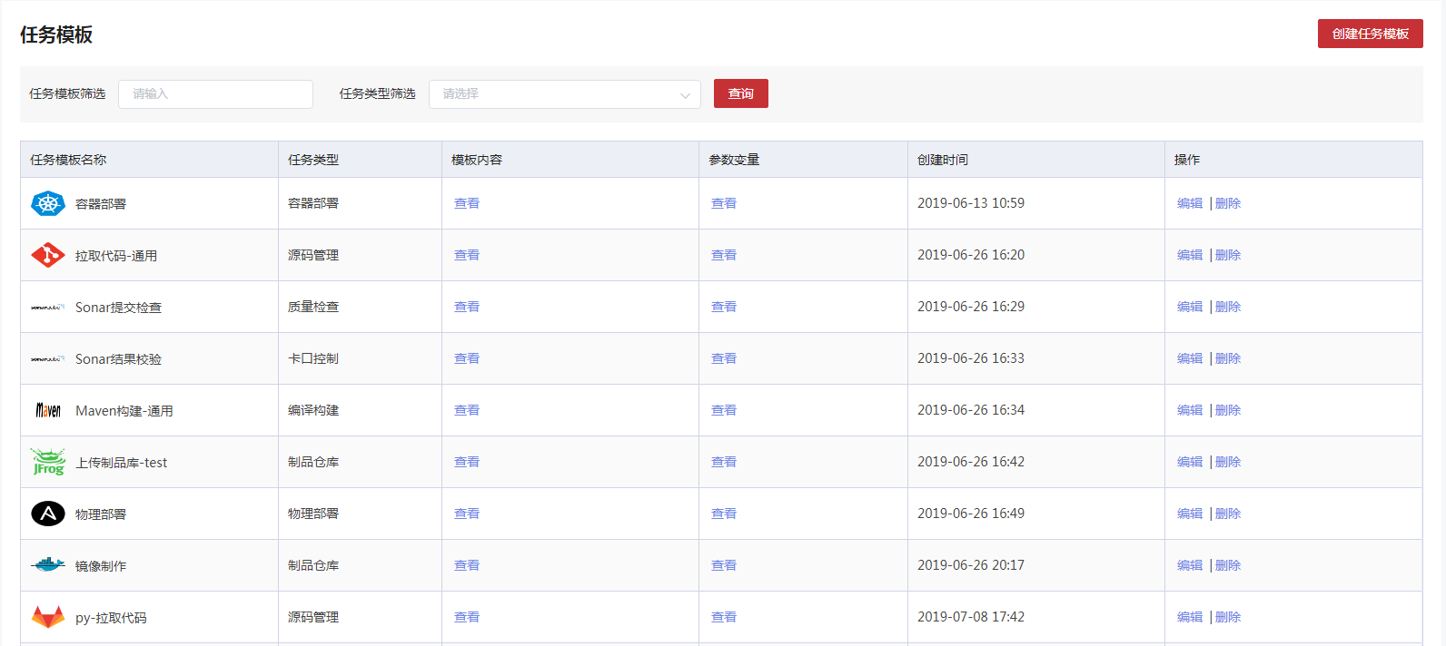

3.2.1.2.2 创建

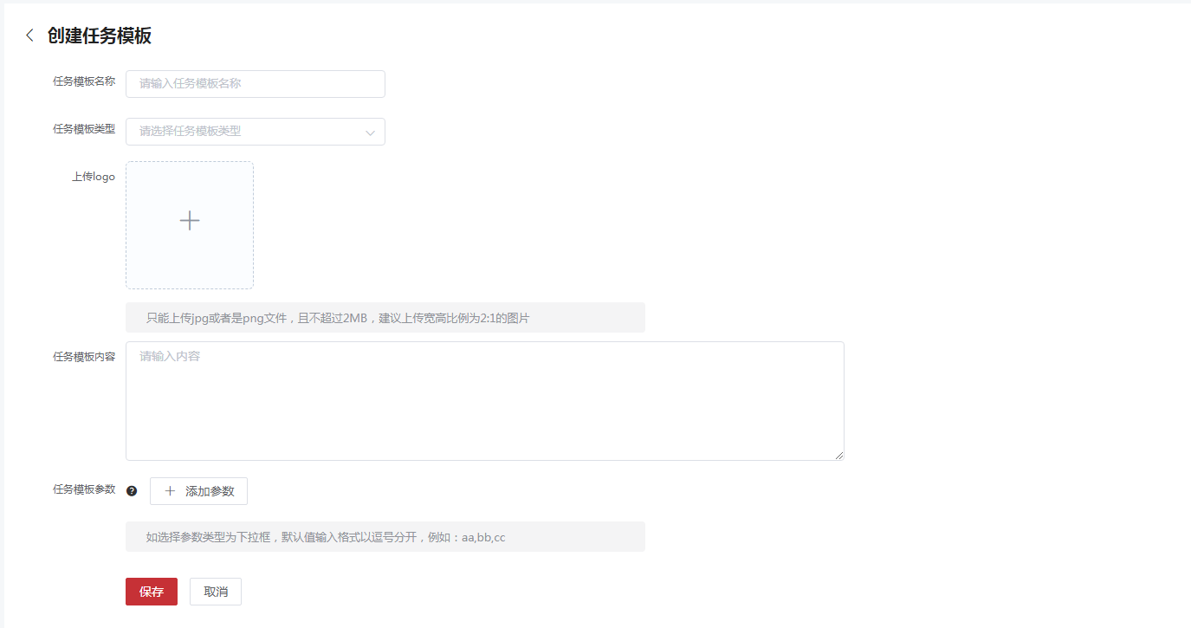3.2.1.2.3 编辑

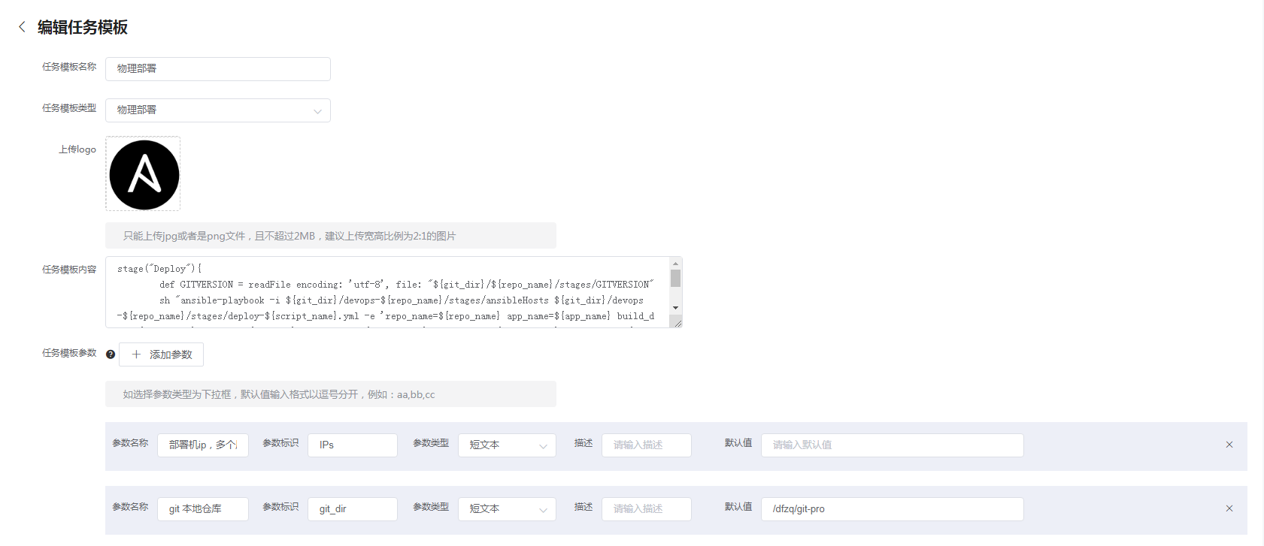

#### 3.2.1.3表字段

**3.2.1.1.3.1 数据表名：t_pipeline_file 注释： 流水线文件表**

|  |  |  |  |
| --- | --- | --- | --- |
| 字段 | 数据类型 | 注释 | 类型 |
| file_id | int(11) | 唯一标识 | 主键 |
| file_name | varchar(255) | 文件名称 |  |
| file_data | mediumblob | 文件二进制数据 |  |
| del_flag | int(1) | 状态0未删除，1删除 |  |

**3.2.1.1.3.2数据表名：t_pipeline_system_param 注释： 流水线系统参数**

|  |  |  |  |
| --- | --- | --- | --- |
| 字段 | 数据类型 | 注释 | 类型 |
| id | int(11) | 唯一标识 | 主键 |
| parameter_name | varchar(255) | 参数名 |  |
| parameter_flag | varchar(255) | 参数标志 |  |
| del_flag | int(1) | 状态0未删除，1删除 |  |

**3.2.1.1.3.3 数据表名：t_pipeline_task_template 注释： 流水线任务模板**

|  |  |  |  |
| --- | --- | --- | --- |
| 字段 | 数据类型 | 注释 | 类型 |
| template_id | int(11) | 唯一标识 | 主键 |
| template_name | varchar(255) | 任务模板名 |  |
| template_type | int(3) | 任务类型 |  |
| file_id | int(11) | 文件id |  |
| template_content | varchar(2048) | 任务模板类容 |  |
| creation_time | datetime | 创建时间 |  |
| del_flag | int(1) | 状态0未删除，1删除 |  |
| creation_person | varchar(50) | 创建人 |  |
| application_id | int(11) | 应用ID |  |

**3.2.1.1.3.4数据表名：t_pipeline_task_template_param 注释： 流水线任务模板参数**

|  |  |  |  |
| --- | --- | --- | --- |
| 字段 | 数据类型 | 注释 | 类型 |
| id | int(11) | 唯一标识 | 主键 |
| template_id | int(11) | 任务模板id |  |
| parameter_name | varchar(255) | 参数名 |  |
| parameter_flag | varchar(255) | 参数标志 |  |
| parameter_type | int(3) | 参数类型 |  |
| data_type | int(1) | 数据类型,0模板参数,1系统参数 |  |
| del_flag | int(1) | 状态0未删除，1删除 |  |
| parameter_default | text | 参数默认值 |  |
| param_describe | varchar(1024) | 参数描述 |  |

#### 3.2.1.4 API 接口

3.2.1.1.4.1 pipeline-task-template-controller

###### 3.2.1.1.4.1.1按照名称查找流水线任务模板

|  |  |  |  |  |
| --- | --- | --- | --- | --- |
| 按照名称查找流水线任务模板 | | | | |
| 接口描述 | 按照名称查找流水线任务模板 | | | |
| URL | /v4/pipelineTaskTemplate | | | |
| 请求方式 | get,post | | | |
| 请求类型 |  | | | |
| 返回类型 | */* | | | |
| 参数名 | 数据类型 | 参数类型 | 是否必填 | 说明 |
| applicationId | integer | query | N | 应用ID |
| creationPerson | string | query | N | 创建人 |
| creationTime | string | query | N | 创建时间 |
| delFlag | integer | query | N | 删除标识 |
| fileId | integer | query | N | log文件id |
| pageNo | integer | query | N | 当前第几页 |
| pageSize | integer | query | N | 每页显示行数 |
| paramList[0].dataType | integer | query | N | 数据类型 |
| paramList[0].delFlag | integer | query | N | 删除标识 |
| paramList[0].id | integer | query | N | 唯一标识 |
| paramList[0].paramDescribe | string | query | N | 参数描述 |
| paramList[0].parameterDefault | string | query | N | 参数默认值 |
| paramList[0].parameterFlag | string | query | N | 参数标识 |
| paramList[0].parameterName | string | query | N | 参数名 |
| paramList[0].parameterType | integer | query | N | 参数类型 |
| paramList[0].templateId | integer | query | N | 模板id |
| startRow | integer | query | N | 当前开始行 |
| templateContent | string | query | N | 模板类容 |
| templateId | integer | query | N | 唯一标识 |
| templateName | string | query | N | 模板名称 |
| templateType | integer | query | N | 模板类型 |
| 状态码 | 描述 | 说明 | | |
| 200 | OK | OK | | |
| 401 | Unauthorized | Unauthorized | | |
| 403 | Forbidden | Forbidden | | |
| 404 | Not Found | Not Found | | |
| 示例 | | | | |
| 请求参数 | {"paramList[0].parameterFlag":"string","templateType":0,"paramList[0].paramDescribe":"string","creationTime":"string","paramList[0].parameterName":"string","startRow":0,"paramList[0].delFlag":0,"paramList[0].parameterDefault":"string","pageSize":0,"delFlag":0,"paramList[0].templateId":0,"templateId":0,"paramList[0].id":0,"templateName":"string","pageNo":0,"paramList[0].parameterType":0,"creationPerson":"string","templateContent":"string","applicationId":0,"paramList[0].dataType":0,"fileId":0} | | | |
| 返回值 | {"body":"","statusCode":"","statusCodeValue":"格式为(int32)"} | | | |

3.2.1.1.4.1.2根据id查找流水线任务模板

|  |  |  |  |  |
| --- | --- | --- | --- | --- |
| 根据id查找流水线任务模板 | | | | |
| 接口描述 | 根据id查找流水线任务模板 | | | |
| URL | /v4/pipelineTaskTemplate/{id} | | | |
| 请求方式 | get,put,delete | | | |
| 请求类型 |  | | | |
| 返回类型 | */* | | | |
| 参数名 | 数据类型 | 参数类型 | 是否必填 | 说明 |
| id | integer | path | Y | id |
| 状态码 | 描述 | 说明 | | |
| 200 | OK | OK | | |
| 401 | Unauthorized | Unauthorized | | |
| 403 | Forbidden | Forbidden | | |
| 404 | Not Found | Not Found | | |
| 示例 | | | | |
| 请求参数 | {"id":0} | | | |
| 返回值 | {"body":"","statusCode":"","statusCodeValue":"格式为(int32)"} | | | |

###### 3.2.1.1.4.2pipeline-task-template-param-controller

3.2.1.1.4.2.1删除流水线任务模板参数

|  |  |  |  |  |
| --- | --- | --- | --- | --- |
| 删除流水线任务模板参数 | | | | |
| 接口描述 | 删除流水线任务模板参数 | | | |
| URL | /v4/pipelineTaskTemplateParam | | | |
| 请求方式 | delete | | | |
| 请求类型 |  | | | |
| 返回类型 | */* | | | |
| 参数名 | 数据类型 | 参数类型 | 是否必填 | 说明 |
| param | body | PipelineTaskTemplateParam | Y | param |
| 状态码 | 描述 | 说明 | | |
| 200 | OK | OK | | |
| 204 | No Content | No Content | | |
| 401 | Unauthorized | Unauthorized | | |
| 403 | Forbidden | Forbidden | | |
| 示例 | | | | |
| 请求参数 | {"dataType":"数据类型格式为(int32)","delFlag":"删除标识格式为(int32)","id":"唯一标识格式为(int32)","paramDescribe":"参数描述","parameterDefault":"参数默认值","parameterFlag":"参数标识","parameterName":"参数名","parameterType":"参数类型格式为(int32)","templateId":"模板id格式为(int32)"} | | | |
| 返回值 | {"body":"","statusCode":"","statusCodeValue":"格式为(int32)"} | | | |

3.2.1.1.4.2.2根据id查找流水线任务模板参数

|  |  |  |  |  |
| --- | --- | --- | --- | --- |
| 根据id查找流水线任务模板参数 | | | | |
| 接口描述 | 根据id查找流水线任务模板参数 | | | |
| URL | /v4/pipelineTaskTemplateParam/{id} | | | |
| 请求方式 | get | | | |
| 请求类型 |  | | | |
| 返回类型 | */* | | | |
| 参数名 | 数据类型 | 参数类型 | 是否必填 | 说明 |
| id | integer | query | N | id |
| 状态码 | 描述 | 说明 | | |
| 200 | OK | OK | | |
| 401 | Unauthorized | Unauthorized | | |
| 403 | Forbidden | Forbidden | | |
| 404 | Not Found | Not Found | | |
| 示例 | | | | |
| 请求参数 | {"id":0} | | | |
| 返回值 | {"body":"","statusCode":"","statusCodeValue":"格式为(int32)"} | | | |

###### 3.2.1.1.4.3 pipeline-system-param-controller

3.2.1.1.4.3.1查询所有的流水线系统参数

|  |  |  |  |  |
| --- | --- | --- | --- | --- |
| 查询所有的流水线系统参数 | | | | |
| 接口描述 | 查询所有的流水线系统参数 | | | |
| URL | /v4/pipelineSystemParam | | | |
| 请求方式 | get | | | |
| 请求类型 |  | | | |
| 返回类型 | */* | | | |
| 参数名 | 数据类型 | 参数类型 | 是否必填 | 说明 |
| 状态码 | 描述 | 说明 | | |
| 200 | OK | OK | | |
| 401 | Unauthorized | Unauthorized | | |
| 403 | Forbidden | Forbidden | | |
| 404 | Not Found | Not Found | | |
| 示例 | | | | |
| 请求参数 | {} | | | |
| 返回值 | {"body":"","statusCode":"","statusCodeValue":"格式为(int32)"} | | | |

3.2.1.1.4.3.2查询所有的流水线系统参数

|  |  |  |  |  |
| --- | --- | --- | --- | --- |
| 查询所有的流水线系统参数 | | | | |
| 接口描述 | 查询所有的流水线系统参数 | | | |
| URL | /v4/pipelineSystemParam/{id} | | | |
| 请求方式 | get | | | |
| 请求类型 |  | | | |
| 返回类型 | */* | | | |
| 参数名 | 数据类型 | 参数类型 | 是否必填 | 说明 |
| id | integer | path | Y | id |
| 状态码 | 描述 | 说明 | | |
| 200 | OK | OK | | |
| 401 | Unauthorized | Unauthorized | | |
| 403 | Forbidden | Forbidden | | |
| 404 | Not Found | Not Found | | |
| 示例 | | | | |
| 请求参数 | {"id":0} | | | |
| 返回值 | {"body":"","statusCode":"","statusCodeValue":"格式为(int32)"} | | | |

###### 3.2.1.1.4.4 pipeline-file-controller

3.2.1.1.4.4.1上传文件

|  |  |  |  |  |
| --- | --- | --- | --- | --- |
| 上传文件 | | | | |
| 接口描述 | 上传文件 | | | |
| URL | /v4/pipelineFile | | | |
| 请求方式 | post | | | |
| 请求类型 | multipart/form-data | | | |
| 返回类型 | */* | | | |
| 参数名 | 数据类型 | 参数类型 | 是否必填 | 说明 |
| fileUpload | file | formData | Y | fileUpload |
| 状态码 | 描述 | 说明 | | |
| 200 | OK | OK | | |
| 201 | Created | Created | | |
| 401 | Unauthorized | Unauthorized | | |
| 403 | Forbidden | Forbidden | | |
| 404 | Not Found | Not Found | | |
| 示例 | | | | |
| 请求参数 | {"fileUpload":null} | | | |
| 返回值 | {"body":"","statusCode":"","statusCodeValue":"格式为(int32)"} | | | |

3.2.1.1.4.4.2按照id查找文件

|  |  |  |  |  |
| --- | --- | --- | --- | --- |
| 按照id查找文件 | | | | |
| 接口描述 | 按照id查找文件 | | | |
| URL | /v4/pipelineFile/{fileId} | | | |
| 请求方式 | get,delete | | | |
| 请求类型 |  | | | |
| 返回类型 | */* | | | |
| 参数名 | 数据类型 | 参数类型 | 是否必填 | 说明 |
| fileId | integer | path | Y | fileId |
| 状态码 | 描述 | 说明 | | |
| 200 | OK | OK | | |
| 401 | Unauthorized | Unauthorized | | |
| 403 | Forbidden | Forbidden | | |
| 404 | Not Found | Not Found | | |
| 示例 | | | | |
| 请求参数 | {"fileId":0} | | | |
| 返回值 | {"body":"","statusCode":"","statusCodeValue":"格式为(int32)"} | | | |

### 3.2.2 pipeline

#### 3.2.2.1功能概述

Pipeline是一个流程，这个流程定义了完成一个CI/CD的所有步骤，每个步骤就是我们平台配置中Pipeline任务模板定义的内容，我们可以从中选择需要的步骤来定义我们自己的自动化流程。

Pipeline默认要支持的步骤包括Bitbucket代码下载、Sonar代码检查、Maven编译构建、上传Artifactory制品仓库、关联Apollo配置信息、Docker容器部署、非容器部署，各个任务功能要求描述如下：

1. Bitbucket代码下载

* 可以拉取选择分支下载代码进行构建
* 在选择分支上为当前版本打tag
* 基于选择版本tag下载代码进行构建

1. Sonar代码检查

* 根据设置的Sonar规划扫描代码
* 将Sonar扫描结果按版本进行存储，具体质量数据请参考度量分析

1. Maven编译构建

* 根据设置的编译脚本进行编译构建
* 构建成功生成二进制包后，可进行重命名操作

1. 上传Artifactory制品仓库

* 可选择存储到哪个制品仓库
* 可根据生成制品包的服务和版本创建仓库目录存储

1. 关联Apollo配置信息

* 部署时可由人工判断是否要更新配置文件appid
* 可根据部署的服务、版本和环境生成最终启动实例运行的Apollo配置信息appid

1. Docker容器部署

* 可选择部署到哪个环境下

1. 非容器部署

* 可选择部署到哪个环境下哪个ip地址，并能够标记ip用途（比如web、mysql、redis等）

Pipeline执行策略应支持提交代码自动触发、定时触发、人工触发三种方式，并且应支持分布式的编译执行，确保在大规模使用情况下，并发执行的性能不受影响。

#### 3.2.2.2页面

3.2.2.2.1分页查询

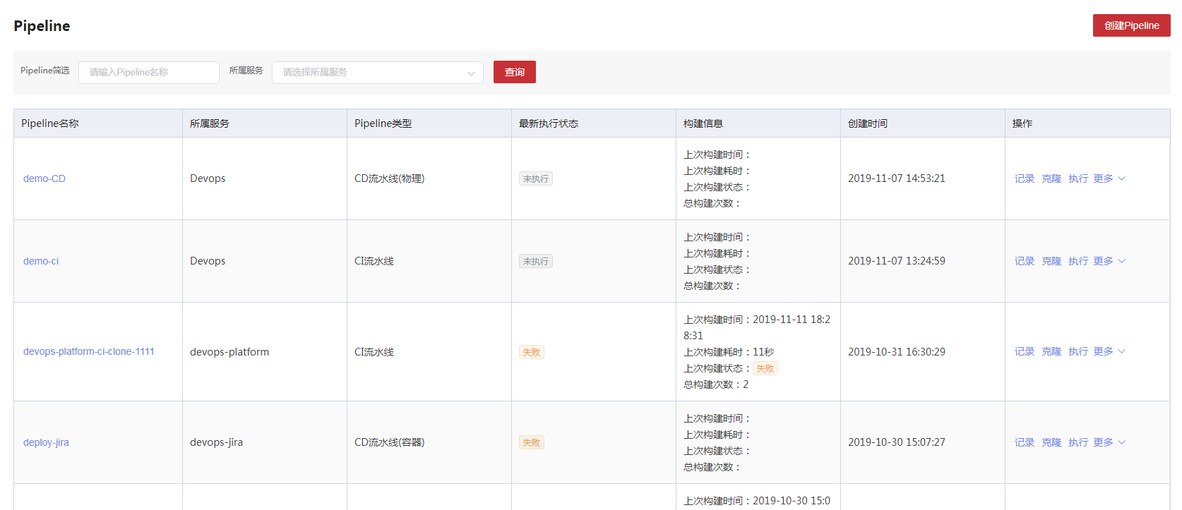

3.2.2.2.2 创建



3.2.2.2.3 编辑

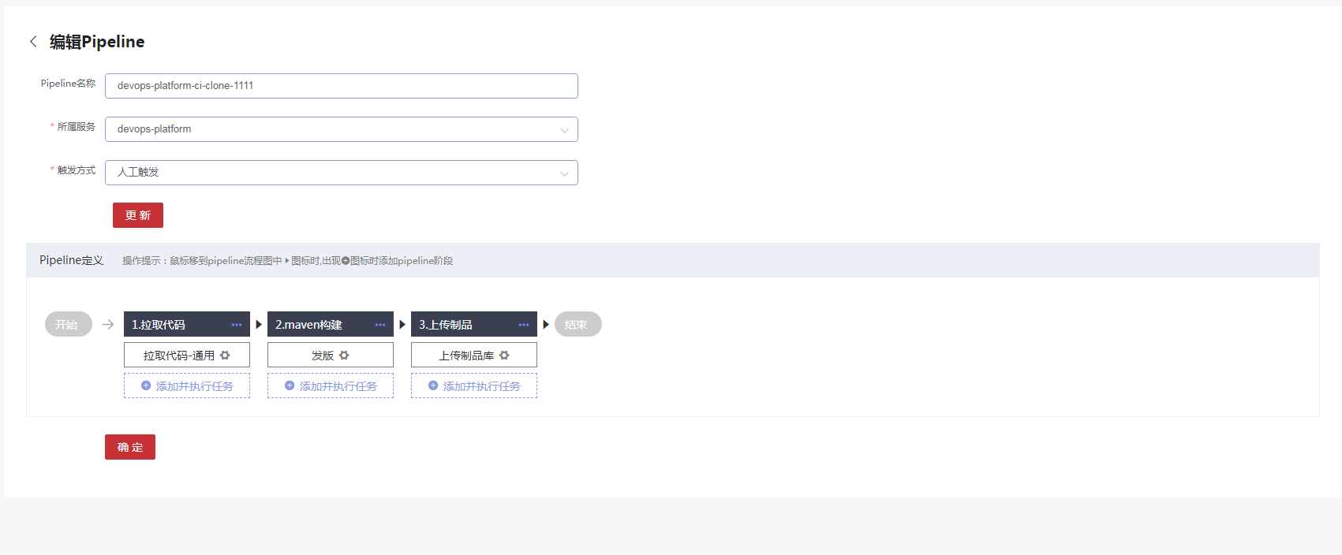

3.2.2.2.4 执行记录

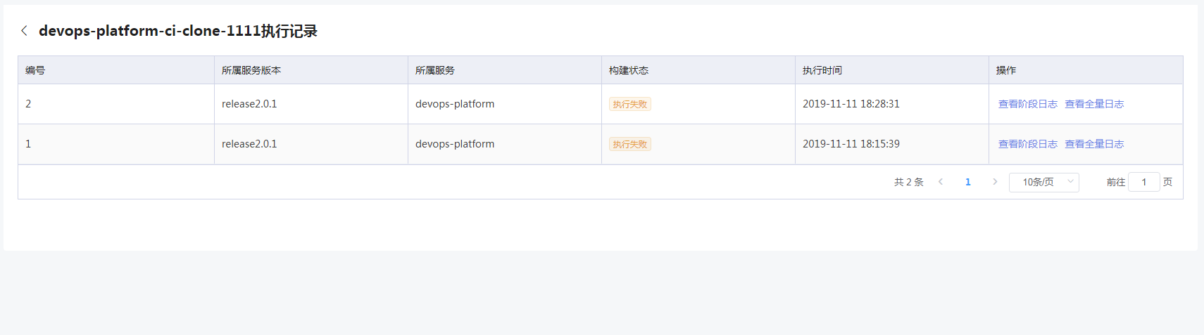

3.2.2.2.4.1 阶段日志

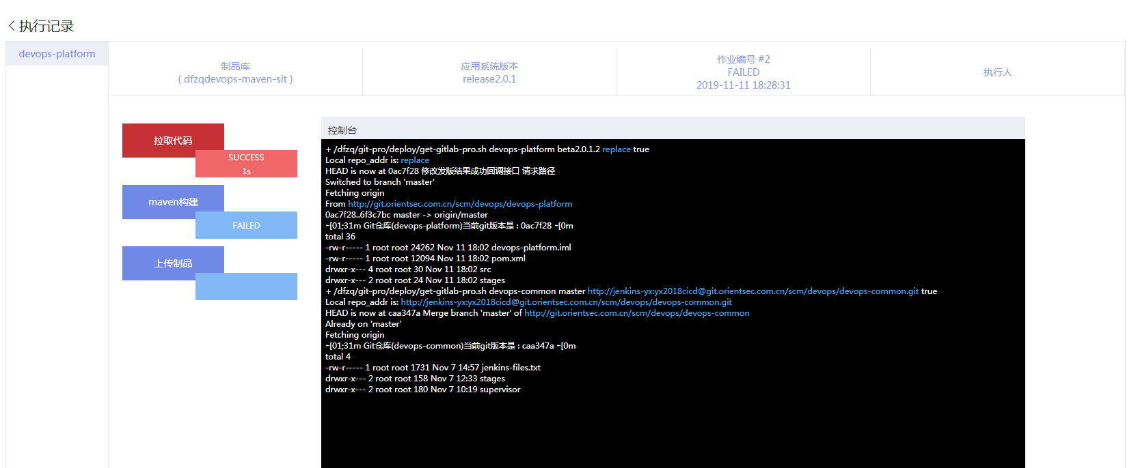

3.2.2.2.4.2 全量日志

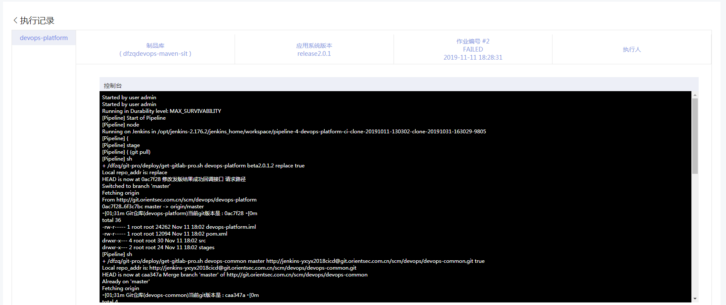

#### 3.2.2.3表字段

**3.2.2.3.1 数据表名：t_application_post_job 注释： 应用版本作业表**

|  |  |  |  |
| --- | --- | --- | --- |
| 字段 | 数据类型 | 注释 | 类型 |
| app_job_id | int(11) | 唯一标识 | 主键 |
| application_id | int(11) | 应用系统id |  |
| version_id | int(11) | 应用版本id |  |
| version_name | varchar(255) | 应用版本名称 |  |
| status | int(1) | 作业状态: 0废弃 1成功 2执行中 3失败 |  |
| create_time | datetime | 创建时间 |  |
| job_type | int(1) | job类型，1：CI流水线；2：CD流水线(物理)；3：CD流水线(容器)；4：CICD流水线 |  |

**3.2.2.3.2数据表名：t_pipeline_phase 注释： Pipeline阶段表**

|  |  |  |  |
| --- | --- | --- | --- |
| 字段 | 数据类型 | 注释 | 类型 |
| phase_id | int(11) | ID | 主键 |
| phase_name | varchar(255) | 阶段名称 |  |
| phase_status | tinyint(4) | 阶段状态，1：正常；0：废弃 |  |
| task_id | int(11) | 关联Pipeline |  |
| phase_order | tinyint(4) | 阶段顺序 |  |

**3.2.2.3.3数据表名：t_pipeline_stage 注释： Pipeline任务表(Stage)**

|  |  |  |  |
| --- | --- | --- | --- |
| 字段 | 数据类型 | 注释 | 类型 |
| stage_id | int(11) | ID | 主键 |
| template_id | int(11) | 任务模板Id |  |
| template_name | varchar(255) | 任务模板名 |  |
| template_content | text | 任务模板内容 |  |
| template_type | int(3) | 任务类型 |  |
| phase_id | int(11) | 关联阶段Id |  |
| create_time | datetime | 创建时间 |  |
| stage_status | tinyint(4) | 状态，1：正常；0：废弃 |  |

**3.2.2.3.4数据表名：t_pipeline_stage_param 注释： Pipeline任务参数表**

|  |  |  |  |
| --- | --- | --- | --- |
| 字段 | 数据类型 | 注释 | 类型 |
| param_id | int(11) | ID | 主键 |
| stage_id | int(11) | 关联Stage |  |
| param_name | varchar(255) | 参数名 |  |
| param_flag | varchar(255) | 参数标志 |  |
| param_type | int(3) | 参数类型 |  |
| param_value | text | 参数值 |  |
| select_value | text | 选择器值 |  |

**3.2.2.3.5数据表名：t_pipeline_task 注释： Pipeline主表**

|  |  |  |  |
| --- | --- | --- | --- |
| 字段 | 数据类型 | 注释 | 类型 |
| task_id | int(11) | ID | 主键 |
| task_name | varchar(255) | Pipeline名称 |  |
| task_trigger | tinyint(4) | 触发类型，1：自动触发；2：定时触发；3：人工触发 |  |
| task_type | tinyint(4) | Pipeline类型，1：CI流水线；2：CD流水线(物理)；3：CD流水线(容器)；4：CICD流水线 |  |
| pipeline_name | varchar(255) | Pipeline 任务名 |  |
| pipeline_file | text | Pipeline 脚本 |  |
| pipeline_param | text | Pipeline 参数 |  |
| application_id | int(11) | 应用Id |  |
| service_id | int(11) | 服务Id |  |
| service_name | varchar(255) | 服务名 |  |
| last_build_time | datetime | 上次构建时间 |  |
| last_build_takes | int(11) | 上次构建耗时（单位毫秒） |  |
| last_build_status | tinyint(4) | 上次构建状态，1：成功；0：失败 |  |
| build_times | int(11) | 总构建次数 |  |
| build_user | int(11) | 执行人 |  |
| task_status | tinyint(4) | Pipeline状态，1：正常；0：废弃 |  |
| create_user | int(11) | 创建人 |  |
| create_time | datetime | 创建时间 |  |
| update_user | int(11) | 更新人 |  |
| update_time | datetime | 更新时间 |  |
| build_status | int(1) | 最新构建状态:0:失败,1:成功,2:未执行,3：执行中 |  |

**3.2.2.3.6数据表名：t_pipeline_task_template 注释： 流水线任务模板**

|  |  |  |  |
| --- | --- | --- | --- |
| 字段 | 数据类型 | 注释 | 类型 |
| template_id | int(11) | 唯一标识 | 主键 |
| template_name | varchar(255) | 任务模板名 |  |
| template_type | int(3) | 任务类型 |  |
| file_id | int(11) | 文件id |  |
| template_content | varchar(2048) | 任务模板类容 |  |
| creation_time | datetime | 创建时间 |  |
| del_flag | int(1) | 状态0未删除，1删除 |  |
| creation_person | varchar(50) | 创建人 |  |
| application_id | int(11) | 应用ID |  |

**3.2.2.3.7数据表名：t_pipeline_task_template_param 注释： 流水线任务模板参数**

|  |  |  |  |
| --- | --- | --- | --- |
| 字段 | 数据类型 | 注释 | 类型 |
| id | int(11) | 唯一标识 | 主键 |
| template_id | int(11) | 任务模板id |  |
| parameter_name | varchar(255) | 参数名 |  |
| parameter_flag | varchar(255) | 参数标志 |  |
| parameter_type | int(3) | 参数类型 |  |
| data_type | int(1) | 数据类型,0模板参数,1系统参数 |  |
| del_flag | int(1) | 状态0未删除，1删除 |  |
| parameter_default | text | 参数默认值 |  |
| param_describe | varchar(1024) | 参数描述 |  |

**3.2.2.3.8数据表名：t_pipeline_task_timer 注释： Pipeline 定时任务**

|  |  |  |  |
| --- | --- | --- | --- |
| 字段 | 数据类型 | 注释 | 类型 |
| timer_id | int(11) | ID | 主键 |
| pipeline_id | int(11) | pipeline_id 关联 t_pipeline_task |  |
| timer_week_rate | varchar(255) | 构建频率，周一周二... 1,2,3 |  |
| timer_type | tinyint(4) | 触发类型，1:单次触发，2:重复触发 |  |
| timer_trigger_time | varchar(64) | 单次触发时间 |  |
| timer_trigger_start_time | varchar(64) | 重复触发开始时间 |  |
| timer_trigger_end_time | varchar(64) | 重复触发结束时间 |  |
| timer_trigger_interval | int(11) | 重复触发时间间隔 |  |
| timer_status | int(1) | 状态:0停用,1启用 |  |
| timer_cron | varchar(64) | cron表达式 |  |
| bean_name | varchar(255) | 执行类bean name |  |
| method_name | varchar(255) | 执行方法名 |  |
| params | varchar(255) | 参数 |  |

**3.2.2.3.9数据表名：t_pipeline_task_timer_log 注释： 定时任务日志**

|  |  |  |  |
| --- | --- | --- | --- |
| 字段 | 数据类型 | 注释 | 类型 |
| log_id | int(11) | 主键 | 主键 |
| timer_id | int(11) | 任务id |  |
| bean_name | varchar(255) | 模板名称 |  |
| method_name | varchar(255) | 方法名 |  |
| params | varchar(255) | 参数 |  |
| cron_expression | varchar(255) | cron |  |
| error | varchar(255) | 错误信息 |  |
| status | int(11) | 任务状态 |  |
| times | int(11) | 耗时 |  |
| create_time | timestamp | 创建时间 |  |

**3.2.2.3.10数据表名：t_service_post_job 注释： 服务版本作业表**

|  |  |  |  |
| --- | --- | --- | --- |
| 字段 | 数据类型 | 注释 | 类型 |
| service_job_id | int(11) | 唯一标识 | 主键 |
| app_job_id | int(11) | 应用jobID, 关联t_application_post_job |  |
| service_id | int(11) | 服务id |  |
| service_name | varchar(255) | 服务名称 |  |
| pipeline_id | int(11) | pipelineID 关联 t_pipeline_task |  |
| build_number | int(11) | 构建次数 |  |
| status | int(1) | 作业状态: 0废弃 1成功 2执行中 3失败 4异常 |  |
| create_time | datetime | 创建时间 |  |
| service_version_name | varchar(255) | 服务版本名称 |  |
| service_version_id | int(11) | 服务版本Id |  |
| service_branch | varchar(255) | 分支名 |  |
| message | varchar(1024) | 异常信息 |  |
| job_type | int(1) | job类型，1：CI流水线；2：CD流水线(物理)；3：CD流水线(容器)；4：CICD流水线 |  |
| consume_time | int(11) | 耗时 |  |

#### 3.2.2.4 API接口

##### 3.2.2.4.1 service-job-v-4-controller

###### 3.2.2.4.1.1根据服务id或appJobId或pieplineID分页查询

|  |  |  |  |  |
| --- | --- | --- | --- | --- |
| 根据服务id或appJobId或pieplineID分页查询 | | | | |
| 接口描述 | 根据服务id或appJobId或pieplineID分页查询 | | | |
| URL | /servicepostjob/applicationPostJob | | | |
| 请求方式 | get,delete | | | |
| 请求类型 |  | | | |
| 返回类型 | */* | | | |
| 参数名 | 数据类型 | 参数类型 | 是否必填 | 说明 |
| appJobId | integer | query | N | 应用jobID, 应用版本作业 |
| ciPipelineId | integer | query | N | CI 的 pipelineID 关联Pipeline， CD时传值，CI不传值 |
| pageNo | integer | query | N | 当前第几页 |
| pageSize | integer | query | N | 每页显示行数 |
| pipelineId | integer | query | N | pipelineID 关联Pipeline |
| serviceId | integer | query | N | 服务id |
| serviceJobId | integer | query | N | Id |
| serviceName | string | query | N | 服务名称 |
| serviceVersionId | integer | query | N | 服务版本Id |
| serviceVersionName | string | query | N | 服务版本名称 |
| stageParams[0].applicationId | integer | query | N | 应用系统id |
| stageParams[0].paramFlag | string | query | N | 参数标志 |
| stageParams[0].paramId | integer | query | N | 参数Id |
| stageParams[0].paramName | string | query | N | 参数名 |
| stageParams[0].paramType | integer | query | N | 参数类型 |
| stageParams[0].paramValue | string | query | N | 参数值 |
| stageParams[0].selectValue | string | query | N | 选择器值 |
| stageParams[0].stageId | integer | query | N | 关联Stage |
| startRow | integer | query | N | 当前开始行 |
| type | string | query | N | 查找类型：CI,CD |
| 状态码 | 描述 | 说明 | | |
| 200 | 操作成功 | 操作成功 | | |
| 400 | 参数错误 | 参数错误 | | |
| 401 | Unauthorized | Unauthorized | | |
| 403 | Forbidden | Forbidden | | |
| 404 | 无数据 | 无数据 | | |
| 500 | 操作失败 | 操作失败 | | |
| 示例 | | | | |
| 请求参数 | {"startRow":0,"serviceVersionId":0,"appJobId":0,"stageParams[0].stageId":0,"ciPipelineId":0,"stageParams[0].paramType":0,"serviceJobId":0,"pageSize":0,"stageParams[0].paramId":0,"serviceName":"string","type":"string","stageParams[0].paramValue":"string","pipelineId":0,"stageParams[0].selectValue":"string","pageNo":0,"stageParams[0].applicationId":0,"serviceVersionName":"string","stageParams[0].paramName":"string","serviceId":0,"stageParams[0].paramFlag":"string"} | | | |
| 返回值 | {"body":"","statusCode":"","statusCodeValue":"格式为(int32)"} | | | |

###### 3.2.2.4.1.2 cd耗时

|  |  |  |  |  |
| --- | --- | --- | --- | --- |
| cd耗时 | | | | |
| 接口描述 | cd耗时 | | | |
| URL | /servicepostjob/cdTimeConsuming | | | |
| 请求方式 | post | | | |
| 请求类型 | application/json | | | |
| 返回类型 | */* | | | |
| 参数名 | 数据类型 | 参数类型 | 是否必填 | 说明 |
| param | body | Map«string,object» | Y | param |
| 状态码 | 描述 | 说明 | | |
| 200 | 操作成功 | 操作成功 | | |
| 201 | Created | Created | | |
| 400 | 参数错误 | 参数错误 | | |
| 401 | Unauthorized | Unauthorized | | |
| 403 | Forbidden | Forbidden | | |
| 404 | 无数据 | 无数据 | | |
| 500 | 操作失败 | 操作失败 | | |
| 示例 | | | | |
| 请求参数 | {} | | | |
| 返回值 | {"body":"","statusCode":"","statusCodeValue":"格式为(int32)"} | | | |

###### 3.2.2.4.1.3 ci耗时

|  |  |  |  |  |
| --- | --- | --- | --- | --- |
| ci耗时 | | | | |
| 接口描述 | ci耗时 | | | |
| URL | /servicepostjob/ciTimeConsuming | | | |
| 请求方式 | post | | | |
| 请求类型 | application/json | | | |
| 返回类型 | */* | | | |
| 参数名 | 数据类型 | 参数类型 | 是否必填 | 说明 |
| param | body | Map«string,object» | Y | param |
| 状态码 | 描述 | 说明 | | |
| 200 | 操作成功 | 操作成功 | | |
| 201 | Created | Created | | |
| 400 | 参数错误 | 参数错误 | | |
| 401 | Unauthorized | Unauthorized | | |
| 403 | Forbidden | Forbidden | | |
| 404 | 无数据 | 无数据 | | |
| 500 | 操作失败 | 操作失败 | | |
| 示例 | | | | |
| 请求参数 | {} | | | |
| 返回值 | {"body":"","statusCode":"","statusCodeValue":"格式为(int32)"} | | | |

###### 3.2.2.4.1.4 最近构建历史记录

|  |  |  |  |  |
| --- | --- | --- | --- | --- |
| 最近构建历史记录 | | | | |
| 接口描述 | 最近构建历史记录 | | | |
| URL | /servicepostjob/historyJob | | | |
| 请求方式 | get | | | |
| 请求类型 |  | | | |
| 返回类型 | */* | | | |
| 参数名 | 数据类型 | 参数类型 | 是否必填 | 说明 |
| appId | integer | query | Y | appId |
| pageNo | integer | query | N | 当前第几页 |
| pageSize | integer | query | N | 每页显示行数 |
| startRow | integer | query | N | 当前开始行 |
| 状态码 | 描述 | 说明 | | |
| 200 | 操作成功 | 操作成功 | | |
| 400 | 参数错误 | 参数错误 | | |
| 401 | Unauthorized | Unauthorized | | |
| 403 | Forbidden | Forbidden | | |
| 404 | 无数据 | 无数据 | | |
| 500 | 操作失败 | 操作失败 | | |
| 示例 | | | | |
| 请求参数 | {"pageSize":0,"startRow":0,"pageNo":0,"appId":0} | | | |
| 返回值 | {"body":"","statusCode":"","statusCodeValue":"格式为(int32)"} | | | |

###### 3.2.2.4.1.5最新的服务发布作业记录

|  |  |  |  |  |
| --- | --- | --- | --- | --- |
| 最新的服务发布作业记录 | | | | |
| 接口描述 | 最新的服务发布作业记录 | | | |
| URL | /servicepostjob/newestServiceJob | | | |
| 请求方式 | post | | | |
| 请求类型 | application/json | | | |
| 返回类型 | */* | | | |
| 参数名 | 数据类型 | 参数类型 | 是否必填 | 说明 |
| jobV4 | body | ServiceJobV4Vo | Y | jobV4 |
| 状态码 | 描述 | 说明 | | |
| 200 | 操作成功 | 操作成功 | | |
| 201 | Created | Created | | |
| 400 | 参数错误 | 参数错误 | | |
| 401 | Unauthorized | Unauthorized | | |
| 403 | Forbidden | Forbidden | | |
| 404 | 无数据 | 无数据 | | |
| 500 | 操作失败 | 操作失败 | | |
| 示例 | | | | |
| 请求参数 | {"appJobId":"应用jobID, 应用版本作业格式为(int32)","ciPipelineId":"CI 的 pipelineID 关联Pipeline， CD时传值，CI不传值格式为(int32)","pipelineId":"pipelineID 关联Pipeline格式为(int32)","serviceId":"服务id格式为(int32)","serviceJobId":"Id格式为(int32)","serviceName":"服务名称","serviceVersionId":"服务版本Id格式为(int32)","serviceVersionName":"服务版本名称","stageParams":[{"applicationId":"应用系统id格式为(int32)","paramFlag":"参数标志","paramId":"参数Id格式为(int32)","paramName":"参数名","paramType":"参数类型格式为(int32)","paramValue":"参数值","selectValue":"选择器值","stageId":"关联Stage格式为(int32)"}],"type":"查找类型：CI,CD"} | | | |
| 返回值 | {"body":"","statusCode":"","statusCodeValue":"格式为(int32)"} | | | |

###### 3.2.2.4.1.6根据serviceJobId查找

|  |  |  |  |  |
| --- | --- | --- | --- | --- |
| 根据serviceJobId查找 | | | | |
| 接口描述 | 根据serviceJobId查找 | | | |
| URL | /servicepostjob/selectByAppJobId | | | |
| 请求方式 | post | | | |
| 请求类型 | application/json | | | |
| 返回类型 | */* | | | |
| 参数名 | 数据类型 | 参数类型 | 是否必填 | 说明 |
| jobVo | body | ServiceJobV4 | Y | jobVo |
| 状态码 | 描述 | 说明 | | |
| 200 | 操作成功 | 操作成功 | | |
| 201 | Created | Created | | |
| 400 | 参数错误 | 参数错误 | | |
| 401 | Unauthorized | Unauthorized | | |
| 403 | Forbidden | Forbidden | | |
| 404 | 无数据 | 无数据 | | |
| 500 | 操作失败 | 操作失败 | | |
| 示例 | | | | |
| 请求参数 | {"appJob":"","appJobId":"格式为(int32)","buildInfo":{"durationMillis":"格式为(int32)","endTimeMillis":"格式为(int64)","id":"","name":"","pauseDurationMillis":"格式为(int32)","queueDurationMillis":"格式为(int32)","stages":[{"durationMillis":"格式为(int32)","error":"","execNode":"","id":"","name":"","pauseDurationMillis":"格式为(int32)","phaseId":"格式为(int32)","phaseName":"","phaseOrder":"格式为(int32)","stageFlowNodes":[{"durationMillis":"格式为(int32)","execNode":"","id":"格式为(int32)","name":"","pauseDurationMillis":"格式为(int32)","startTimeMillis":"格式为(int32)","status":""}],"startTimeMillis":"格式为(int64)","status":""}],"startTimeMillis":"格式为(int64)","status":"","taskId":"格式为(int32)"},"buildNumber":"格式为(int32)","ciPipelineId":"格式为(int32)","consumeTime":"格式为(int32)","createTime":"创建时间格式为(date-time)","jobName":"","jobType":"格式为(int32)","message":"","pipelineId":"格式为(int32)","serviceBranch":"","serviceId":"格式为(int32)","serviceJobId":"格式为(int32)","serviceName":"","serviceVersionId":"格式为(int32)","serviceVersionName":"","stageParams":[{"applicationId":"应用系统id格式为(int32)","paramFlag":"参数标志","paramId":"参数Id格式为(int32)","paramName":"参数名","paramType":"参数类型格式为(int32)","paramValue":"参数值","selectValue":"选择器值","stageId":"关联Stage格式为(int32)"}],"status":"格式为(int32)"} | | | |
| 返回值 | {"body":"","statusCode":"","statusCodeValue":"格式为(int32)"} | | | |

###### 3.2.2.4.1.7根据serviceVersionId停止pipeline

|  |  |  |  |  |
| --- | --- | --- | --- | --- |
| 根据serviceVersionId停止pipeline | | | | |
| 接口描述 | 根据serviceVersionId停止pipeline | | | |
| URL | /servicepostjob/serviceVersionIdPipelineStop | | | |
| 请求方式 | post | | | |
| 请求类型 | application/json | | | |
| 返回类型 | */* | | | |
| 参数名 | 数据类型 | 参数类型 | 是否必填 | 说明 |
| jobV4 | body | ServiceJobV4Vo | Y | jobV4 |
| 状态码 | 描述 | 说明 | | |
| 200 | 操作成功 | 操作成功 | | |
| 201 | Created | Created | | |
| 400 | 参数错误 | 参数错误 | | |
| 401 | Unauthorized | Unauthorized | | |
| 403 | Forbidden | Forbidden | | |
| 404 | 无数据 | 无数据 | | |
| 500 | 操作失败 | 操作失败 | | |
| 示例 | | | | |
| 请求参数 | {"appJobId":"应用jobID, 应用版本作业格式为(int32)","ciPipelineId":"CI 的 pipelineID 关联Pipeline， CD时传值，CI不传值格式为(int32)","pipelineId":"pipelineID 关联Pipeline格式为(int32)","serviceId":"服务id格式为(int32)","serviceJobId":"Id格式为(int32)","serviceName":"服务名称","serviceVersionId":"服务版本Id格式为(int32)","serviceVersionName":"服务版本名称","stageParams":[{"applicationId":"应用系统id格式为(int32)","paramFlag":"参数标志","paramId":"参数Id格式为(int32)","paramName":"参数名","paramType":"参数类型格式为(int32)","paramValue":"参数值","selectValue":"选择器值","stageId":"关联Stage格式为(int32)"}],"type":"查找类型：CI,CD"} | | | |
| 返回值 | {"body":"","statusCode":"","statusCodeValue":"格式为(int32)"} | | | |

##### 3.2.2.4.2 application-job-v-4-controller

###### 3.2.2.4.2.1根据应用id和版本名称分页查询

|  |  |  |  |  |
| --- | --- | --- | --- | --- |
| 根据应用id和版本名称分页查询 | | | | |
| 接口描述 | 根据应用id和版本名称分页查询 | | | |
| URL | /v4/applicationPostJob | | | |
| 请求方式 | get,delete | | | |
| 请求类型 |  | | | |
| 返回类型 | */* | | | |
| 参数名 | 数据类型 | 参数类型 | 是否必填 | 说明 |
| appJobId | integer | query | N | Id |
| applicationId | integer | query | N | 应用系统id |
| pageNo | integer | query | N | 当前第几页 |
| pageSize | integer | query | N | 每页显示行数 |
| serviceJobs[0].appJobId | integer | query | N | 应用jobID, 应用版本作业 |
| serviceJobs[0].ciPipelineId | integer | query | N | CI 的 pipelineID 关联Pipeline， CD时传值，CI不传值 |
| serviceJobs[0].pipelineId | integer | query | N | pipelineID 关联Pipeline |
| serviceJobs[0].serviceId | integer | query | N | 服务id |
| serviceJobs[0].serviceJobId | integer | query | N | Id |
| serviceJobs[0].serviceName | string | query | N | 服务名称 |
| serviceJobs[0].serviceVersionId | integer | query | N | 服务版本Id |
| serviceJobs[0].serviceVersionName | string | query | N | 服务版本名称 |
| serviceJobs[0].stageParams[0].applicationId | integer | query | N | 应用系统id |
| serviceJobs[0].stageParams[0].paramFlag | string | query | N | 参数标志 |
| serviceJobs[0].stageParams[0].paramId | integer | query | N | 参数Id |
| serviceJobs[0].stageParams[0].paramName | string | query | N | 参数名 |
| serviceJobs[0].stageParams[0].paramType | integer | query | N | 参数类型 |
| serviceJobs[0].stageParams[0].paramValue | string | query | N | 参数值 |
| serviceJobs[0].stageParams[0].selectValue | string | query | N | 选择器值 |
| serviceJobs[0].stageParams[0].stageId | integer | query | N | 关联Stage |
| serviceJobs[0].type | string | query | N | 查找类型：CI,CD |
| startRow | integer | query | N | 当前开始行 |
| type | string | query | N | 查找类型：CI,CD |
| versionId | integer | query | N | 应用版本id |
| versionName | string | query | N | 应用版本名称 |
| 状态码 | 描述 | 说明 | | |
| 200 | 操作成功 | 操作成功 | | |
| 400 | 参数错误 | 参数错误 | | |
| 401 | Unauthorized | Unauthorized | | |
| 403 | Forbidden | Forbidden | | |
| 404 | 无数据 | 无数据 | | |
| 500 | 操作失败 | 操作失败 | | |
| 示例 | | | | |
| 请求参数 | {"serviceJobs[0].serviceVersionId":0,"serviceJobs[0].pipelineId":0,"pageSize":0,"serviceJobs[0].serviceId":0,"serviceJobs[0].stageParams[0].stageId":0,"type":"string","versionName":"string","serviceJobs[0].stageParams[0].selectValue":"string","serviceJobs[0].serviceJobId":0,"pageNo":0,"serviceJobs[0].stageParams[0].paramId":0,"serviceJobs[0].stageParams[0].paramType":0,"serviceJobs[0].stageParams[0].applicationId":0,"serviceJobs[0].serviceName":"string","startRow":0,"appJobId":0,"serviceJobs[0].stageParams[0].paramFlag":"string","serviceJobs[0].ciPipelineId":0,"serviceJobs[0].stageParams[0].paramValue":"string","versionId":0,"serviceJobs[0].stageParams[0].paramName":"string","serviceJobs[0].serviceVersionName":"string","applicationId":0,"serviceJobs[0].appJobId":0,"serviceJobs[0].type":"string"} | | | |
| 返回值 | {"body":"","statusCode":"","statusCodeValue":"格式为(int32)"} | | | |

###### 3.2.2.4.2.2获取版本列表对应得成功失败的记录

|  |  |  |  |  |
| --- | --- | --- | --- | --- |
| 获取版本列表对应得成功失败的记录 | | | | |
| 接口描述 | 获取版本列表对应得成功失败的记录 | | | |
| URL | /v4/applicationPostJob/getFailSuccess | | | |
| 请求方式 | post | | | |
| 请求类型 | application/json | | | |
| 返回类型 | */* | | | |
| 参数名 | 数据类型 | 参数类型 | 是否必填 | 说明 |
| list | body | {} | Y | list |
| 状态码 | 描述 | 说明 | | |
| 200 | 操作成功 | 操作成功 | | |
| 201 | Created | Created | | |
| 400 | 参数错误 | 参数错误 | | |
| 401 | Unauthorized | Unauthorized | | |
| 403 | Forbidden | Forbidden | | |
| 404 | 无数据 | 无数据 | | |
| 500 | 操作失败 | 操作失败 | | |
| 示例 | | | | |
| 请求参数 | {} | | | |
| 返回值 | {"body":"","statusCode":"","statusCodeValue":"格式为(int32)"} | | | |

###### 3.2.2.4.3根据AppJobId查找

|  |  |  |  |  |
| --- | --- | --- | --- | --- |
| 根据AppJobId查找 | | | | |
| 接口描述 | 根据AppJobId查找 | | | |
| URL | /v4/applicationPostJob/selectByAppJobId | | | |
| 请求方式 | get | | | |
| 请求类型 |  | | | |
| 返回类型 | */* | | | |
| 参数名 | 数据类型 | 参数类型 | 是否必填 | 说明 |
| appJobId | integer | query | N | Id |
| applicationId | integer | query | N | 应用系统id |
| serviceJobs[0].appJobId | integer | query | N | 应用jobID, 应用版本作业 |
| serviceJobs[0].ciPipelineId | integer | query | N | CI 的 pipelineID 关联Pipeline， CD时传值，CI不传值 |
| serviceJobs[0].pipelineId | integer | query | N | pipelineID 关联Pipeline |
| serviceJobs[0].serviceId | integer | query | N | 服务id |
| serviceJobs[0].serviceJobId | integer | query | N | Id |
| serviceJobs[0].serviceName | string | query | N | 服务名称 |
| serviceJobs[0].serviceVersionId | integer | query | N | 服务版本Id |
| serviceJobs[0].serviceVersionName | string | query | N | 服务版本名称 |
| serviceJobs[0].stageParams[0].applicationId | integer | query | N | 应用系统id |
| serviceJobs[0].stageParams[0].paramFlag | string | query | N | 参数标志 |
| serviceJobs[0].stageParams[0].paramId | integer | query | N | 参数Id |
| serviceJobs[0].stageParams[0].paramName | string | query | N | 参数名 |
| serviceJobs[0].stageParams[0].paramType | integer | query | N | 参数类型 |
| serviceJobs[0].stageParams[0].paramValue | string | query | N | 参数值 |
| serviceJobs[0].stageParams[0].selectValue | string | query | N | 选择器值 |
| serviceJobs[0].stageParams[0].stageId | integer | query | N | 关联Stage |
| serviceJobs[0].type | string | query | N | 查找类型：CI,CD |
| type | string | query | N | 查找类型：CI,CD |
| versionId | integer | query | N | 应用版本id |
| versionName | string | query | N | 应用版本名称 |
| 状态码 | 描述 | 说明 | | |
| 200 | 操作成功 | 操作成功 | | |
| 400 | 参数错误 | 参数错误 | | |
| 401 | Unauthorized | Unauthorized | | |
| 403 | Forbidden | Forbidden | | |
| 404 | 无数据 | 无数据 | | |
| 500 | 操作失败 | 操作失败 | | |
| 示例 | | | | |
| 请求参数 | {"serviceJobs[0].stageParams[0].paramType":0,"serviceJobs[0].serviceVersionId":0,"serviceJobs[0].stageParams[0].applicationId":0,"serviceJobs[0].serviceName":"string","serviceJobs[0].pipelineId":0,"appJobId":0,"serviceJobs[0].stageParams[0].paramFlag":"string","serviceJobs[0].serviceId":0,"serviceJobs[0].stageParams[0].stageId":0,"type":"string","versionName":"string","serviceJobs[0].ciPipelineId":0,"serviceJobs[0].stageParams[0].paramValue":"string","serviceJobs[0].stageParams[0].selectValue":"string","versionId":0,"serviceJobs[0].stageParams[0].paramName":"string","serviceJobs[0].serviceJobId":0,"serviceJobs[0].stageParams[0].paramId":0,"serviceJobs[0].serviceVersionName":"string","applicationId":0,"serviceJobs[0].appJobId":0,"serviceJobs[0].type":"string"} | | | |
| 返回值 | {"body":"","statusCode":"","statusCodeValue":"格式为(int32)"} | | | |

###### 3.2.2.4.4根据AppJobId查找作业记录

|  |  |  |  |  |
| --- | --- | --- | --- | --- |
| 根据AppJobId查找作业记录 | | | | |
| 接口描述 | 根据AppJobId查找作业记录 | | | |
| URL | /v4/applicationPostJob/selectByPrimaryKey | | | |
| 请求方式 | get | | | |
| 请求类型 |  | | | |
| 返回类型 | */* | | | |
| 参数名 | 数据类型 | 参数类型 | 是否必填 | 说明 |
| appJobId | integer | query | Y | appJobId |
| 状态码 | 描述 | 说明 | | |
| 200 | 操作成功 | 操作成功 | | |
| 400 | 参数错误 | 参数错误 | | |
| 401 | Unauthorized | Unauthorized | | |
| 403 | Forbidden | Forbidden | | |
| 404 | 无数据 | 无数据 | | |
| 500 | 操作失败 | 操作失败 | | |
| 示例 | | | | |
| 请求参数 | {"appJobId":0} | | | |
| 返回值 | {"body":"","statusCode":"","statusCodeValue":"格式为(int32)"} | | | |

##### 3.2.2.5.3 phase-v-4-controller

###### 3.2.2.5.3.1新增修改 Pipeline phase 阶段

|  |  |  |  |  |
| --- | --- | --- | --- | --- |
| 新增修改 Pipeline phase 阶段 | | | | |
| 接口描述 | 新增修改 Pipeline phase 阶段 | | | |
| URL | /v4/phase | | | |
| 请求方式 | post,delete | | | |
| 请求类型 | application/json | | | |
| 返回类型 | */* | | | |
| 参数名 | 数据类型 | 参数类型 | 是否必填 | 说明 |
| phaseV4Vo | body | PhaseV4Vo | Y | phaseV4Vo |
| 状态码 | 描述 | 说明 | | |
| 200 | 操作成功 | 操作成功 | | |
| 201 | Created | Created | | |
| 400 | 参数错误 | 参数错误 | | |
| 401 | Unauthorized | Unauthorized | | |
| 403 | Forbidden | Forbidden | | |
| 404 | Not Found | Not Found | | |
| 500 | 操作失败 | 操作失败 | | |
| 示例 | | | | |
| 请求参数 | {"phaseId":"阶段Id格式为(int32)","phaseName":"阶段名称","phaseOrder":"阶段顺序格式为(int32)","taskId":"关联Pipeline格式为(int32)"} | | | |
| 返回值 | {"body":"","statusCode":"","statusCodeValue":"格式为(int32)"} | | | |

###### 3.2.2.5.3.2查询 Pipeline 下的 phase 列表

|  |  |  |  |  |
| --- | --- | --- | --- | --- |
| 查询 Pipeline 下的 phase 列表 | | | | |
| 接口描述 | 查询 Pipeline 下的 phase 列表 | | | |
| URL | /v4/phase/list | | | |
| 请求方式 | get | | | |
| 请求类型 |  | | | |
| 返回类型 | */* | | | |
| 参数名 | 数据类型 | 参数类型 | 是否必填 | 说明 |
| phaseId | integer | query | N | 阶段Id |
| phaseName | string | query | N | 阶段名称 |
| phaseOrder | integer | query | N | 阶段顺序 |
| taskId | integer | query | N | 关联Pipeline |
| 状态码 | 描述 | 说明 | | |
| 200 | 操作成功 | 操作成功 | | |
| 400 | 参数错误 | 参数错误 | | |
| 401 | Unauthorized | Unauthorized | | |
| 403 | Forbidden | Forbidden | | |
| 404 | Not Found | Not Found | | |
| 500 | 操作失败 | 操作失败 | | |
| 示例 | | | | |
| 请求参数 | {"phaseId":0,"phaseName":"string","phaseOrder":0,"taskId":0} | | | |
| 返回值 | {"code":"格式为(int32)","data":"","entity":"","message":"","state":""} | | | |

###### 3.2.2.5.3.3修改 Pipeline phase 顺序

|  |  |  |  |  |
| --- | --- | --- | --- | --- |
| 修改 Pipeline phase 顺序 | | | | |
| 接口描述 | 修改 Pipeline phase 顺序 | | | |
| URL | /v4/phase/sort | | | |
| 请求方式 | post | | | |
| 请求类型 | application/json | | | |
| 返回类型 | */* | | | |
| 参数名 | 数据类型 | 参数类型 | 是否必填 | 说明 |
| phaseV4Vos | body | PhaseV4Vo | Y | phaseV4Vos |
| 状态码 | 描述 | 说明 | | |
| 200 | 操作成功 | 操作成功 | | |
| 201 | Created | Created | | |
| 400 | 参数错误 | 参数错误 | | |
| 401 | Unauthorized | Unauthorized | | |
| 403 | Forbidden | Forbidden | | |
| 404 | Not Found | Not Found | | |
| 500 | 操作失败 | 操作失败 | | |
| 示例 | | | | |
| 请求参数 | {"phaseId":"阶段Id格式为(int32)","phaseName":"阶段名称","phaseOrder":"阶段顺序格式为(int32)","taskId":"关联Pipeline格式为(int32)"} | | | |
| 返回值 | {"body":"","statusCode":"","statusCodeValue":"格式为(int32)"} | | | |

##### 3.2.2.5.4 pipeline-v-4-controller

###### 3.2.2.5.4.1单个构建 Pipeline

|  |  |  |  |  |
| --- | --- | --- | --- | --- |
| 单个构建 Pipeline | | | | |
| 接口描述 | 单个构建 Pipeline | | | |
| URL | /v4/pipeline/build | | | |
| 请求方式 | post | | | |
| 请求类型 | application/json | | | |
| 返回类型 | */* | | | |
| 参数名 | 数据类型 | 参数类型 | 是否必填 | 说明 |
| taskVo | body | TaskV4Vo | Y | taskVo |
| 状态码 | 描述 | 说明 | | |
| 200 | 操作成功 | 操作成功 | | |
| 201 | Created | Created | | |
| 400 | 参数错误 | 参数错误 | | |
| 401 | Unauthorized | Unauthorized | | |
| 403 | Forbidden | Forbidden | | |
| 404 | Not Found | Not Found | | |
| 500 | 操作失败 | 操作失败 | | |
| 示例 | | | | |
| 请求参数 | {"applicationId":"应用Id格式为(int32)","pageNo":"当前第几页格式为(int32)","pageSize":"每页显示行数格式为(int32)","serviceId":"服务Id格式为(int32)","serviceName":"服务名称","startRow":"当前开始行格式为(int32)","taskId":"任务Id格式为(int32)","taskName":"任务名称","taskTrigger":"触发类型，1：自动触发；2：定时触发；3：人工触发格式为(int32)","taskType":"Pipeline类型，1：CI流水线；2：CD流水线；3：CICD流水线格式为(int32)","timerV4Vo":{"pipelineId":"pipeline_id 关联 t_pipeline_task格式为(int32)","timerCron":"cron表达式","timerId":"ID格式为(int32)","timerStatus":"状态格式为(int32)","timerTriggerEndTime":"重复触发结束时间","timerTriggerInterval":"重复触发时间间隔格式为(int32)","timerTriggerStartTime":"重复触发开始时间","timerTriggerTime":"单次触发时间","timerType":"触发类型，1:单次触发，2:重复触发格式为(int32)","timerWeekRate":"构建频率，周一周二... 1,2,3"}} | | | |
| 返回值 | {"code":"格式为(int32)","data":"","entity":"","message":"","state":""} | | | |

###### 3.2.2.5.4.2版本一键部署

|  |  |  |  |  |
| --- | --- | --- | --- | --- |
| 版本一键部署 | | | | |
| 接口描述 | 版本一键部署 | | | |
| URL | /v4/pipeline/build/batch | | | |
| 请求方式 | post | | | |
| 请求类型 | application/json | | | |
| 返回类型 | */* | | | |
| 参数名 | 数据类型 | 参数类型 | 是否必填 | 说明 |
| applicationJobV4Vo | body | ApplicationJobV4Vo | Y | applicationJobV4Vo |
| 状态码 | 描述 | 说明 | | |
| 200 | 操作成功 | 操作成功 | | |
| 201 | Created | Created | | |
| 400 | 参数错误 | 参数错误 | | |
| 401 | Unauthorized | Unauthorized | | |
| 403 | Forbidden | Forbidden | | |
| 404 | Not Found | Not Found | | |
| 500 | 操作失败 | 操作失败 | | |
| 示例 | | | | |
| 请求参数 | {"appJobId":"Id格式为(int32)","applicationId":"应用系统id格式为(int32)","serviceJobs":[{"appJobId":"应用jobID, 应用版本作业格式为(int32)","ciPipelineId":"CI 的 pipelineID 关联Pipeline， CD时传值，CI不传值格式为(int32)","pipelineId":"pipelineID 关联Pipeline格式为(int32)","serviceId":"服务id格式为(int32)","serviceJobId":"Id格式为(int32)","serviceName":"服务名称","serviceVersionId":"服务版本Id格式为(int32)","serviceVersionName":"服务版本名称","stageParams":[{"applicationId":"应用系统id格式为(int32)","paramFlag":"参数标志","paramId":"参数Id格式为(int32)","paramName":"参数名","paramType":"参数类型格式为(int32)","paramValue":"参数值","selectValue":"选择器值","stageId":"关联Stage格式为(int32)"}],"type":"查找类型：CI,CD"}],"type":"查找类型：CI,CD","versionId":"应用版本id格式为(int32)","versionName":"应用版本名称"} | | | |
| 返回值 | {"code":"格式为(int32)","data":"","entity":"","message":"","state":""} | | | |

###### 3.2.2.5.4.3获取pipeline构建全量日志

|  |  |  |  |  |
| --- | --- | --- | --- | --- |
| 获取pipeline构建全量日志 | | | | |
| 接口描述 | 获取pipeline构建全量日志 | | | |
| URL | /v4/pipeline/build/getPipelinelogText | | | |
| 请求方式 | get | | | |
| 请求类型 |  | | | |
| 返回类型 | */* | | | |
| 参数名 | 数据类型 | 参数类型 | 是否必填 | 说明 |
| buildNumber | integer | query | N | buildNumber |
| taskId | integer | query | Y | taskId |
| 状态码 | 描述 | 说明 | | |
| 200 | 操作成功 | 操作成功 | | |
| 400 | 参数错误 | 参数错误 | | |
| 401 | Unauthorized | Unauthorized | | |
| 403 | Forbidden | Forbidden | | |
| 404 | Not Found | Not Found | | |
| 500 | 操作失败 | 操作失败 | | |
| 示例 | | | | |
| 请求参数 | {"buildNumber":0,"taskId":0} | | | |
| 返回值 | {"code":"格式为(int32)","data":"","entity":"","message":"","state":""} | | | |

###### 3.2.2.5.4.4获取webhook url

|  |  |  |  |  |
| --- | --- | --- | --- | --- |
| 获取webhook url | | | | |
| 接口描述 | 获取webhook url | | | |
| URL | /v4/pipeline/build/getWebHookUrl | | | |
| 请求方式 | get | | | |
| 请求类型 |  | | | |
| 返回类型 | */* | | | |
| 参数名 | 数据类型 | 参数类型 | 是否必填 | 说明 |
| taskId | integer | query | Y | taskId |
| 状态码 | 描述 | 说明 | | |
| 200 | 操作成功 | 操作成功 | | |
| 400 | 参数错误 | 参数错误 | | |
| 401 | Unauthorized | Unauthorized | | |
| 403 | Forbidden | Forbidden | | |
| 404 | Not Found | Not Found | | |
| 500 | 操作失败 | 操作失败 | | |
| 示例 | | | | |
| 请求参数 | {"taskId":0} | | | |
| 返回值 | {"code":"格式为(int32)","data":"","entity":"","message":"","state":""} | | | |

###### 3.2.2.5.4.5查询Pipeline 执行记录

|  |  |  |  |  |
| --- | --- | --- | --- | --- |
| 查询Pipeline 执行记录 | | | | |
| 接口描述 | 查询Pipeline 执行记录 | | | |
| URL | /v4/pipeline/build/log | | | |
| 请求方式 | get | | | |
| 请求类型 |  | | | |
| 返回类型 | */* | | | |
| 参数名 | 数据类型 | 参数类型 | 是否必填 | 说明 |
| buildNumber | integer | query | N | 构建序号，第几次构建 |
| jobName | string | query | N | 任务名称 |
| stageNodeId | integer | query | N | 阶段执行节点Id |
| 状态码 | 描述 | 说明 | | |
| 200 | 操作成功 | 操作成功 | | |
| 400 | 参数错误 | 参数错误 | | |
| 401 | Unauthorized | Unauthorized | | |
| 403 | Forbidden | Forbidden | | |
| 404 | Not Found | Not Found | | |
| 500 | 操作失败 | 操作失败 | | |
| 示例 | | | | |
| 请求参数 | {"jobName":"string","buildNumber":0,"stageNodeId":0} | | | |
| 返回值 | {"code":"格式为(int32)","data":"","entity":"","message":"","state":""} | | | |

###### 3.2.2.5.4.6执行webhook

|  |  |  |  |  |
| --- | --- | --- | --- | --- |
| 执行webhook | | | | |
| 接口描述 | 执行webhook | | | |
| URL | /v4/pipeline/build/pipelineWebHook/{taskId} | | | |
| 请求方式 | post | | | |
| 请求类型 | application/json | | | |
| 返回类型 | */* | | | |
| 参数名 | 数据类型 | 参数类型 | 是否必填 | 说明 |
| taskId | integer | path | Y | taskId |
| 状态码 | 描述 | 说明 | | |
| 200 | 操作成功 | 操作成功 | | |
| 201 | Created | Created | | |
| 400 | 参数错误 | 参数错误 | | |
| 401 | Unauthorized | Unauthorized | | |
| 403 | Forbidden | Forbidden | | |
| 404 | Not Found | Not Found | | |
| 500 | 操作失败 | 操作失败 | | |
| 示例 | | | | |
| 请求参数 | {"taskId":0} | | | |
| 返回值 | {"code":"格式为(int32)","data":"","entity":"","message":"","state":""} | | | |

###### 3.2.2.5.4.7流水线执行阶段查看日志

|  |  |  |  |  |
| --- | --- | --- | --- | --- |
| 流水线执行阶段查看日志 | | | | |
| 接口描述 | 流水线执行阶段查看日志 | | | |
| URL | /v4/pipeline/stage/log | | | |
| 请求方式 | get | | | |
| 请求类型 |  | | | |
| 返回类型 | */* | | | |
| 参数名 | 数据类型 | 参数类型 | 是否必填 | 说明 |
| buildNumber | integer | query | N | 构建序号，第几次构建 |
| jobName | string | query | N | 任务名称 |
| stageNodeId | integer | query | N | 阶段执行节点Id |
| 状态码 | 描述 | 说明 | | |
| 200 | 操作成功 | 操作成功 | | |
| 400 | 参数错误 | 参数错误 | | |
| 401 | Unauthorized | Unauthorized | | |
| 403 | Forbidden | Forbidden | | |
| 404 | Not Found | Not Found | | |
| 500 | 操作失败 | 操作失败 | | |
| 示例 | | | | |
| 请求参数 | {"jobName":"string","buildNumber":0,"stageNodeId":0} | | | |
| 返回值 | {"code":"格式为(int32)","data":"","entity":"","message":"","state":""} | | | |

###### 3.2.2.5.4.8流水线构建停止

|  |  |  |  |  |
| --- | --- | --- | --- | --- |
| 流水线构建停止 | | | | |
| 接口描述 | 流水线构建停止 | | | |
| URL | /v4/pipeline/stop | | | |
| 请求方式 | post | | | |
| 请求类型 | application/json | | | |
| 返回类型 | */* | | | |
| 参数名 | 数据类型 | 参数类型 | 是否必填 | 说明 |
| ServiceJobV4Vo | body | ServiceJobV4Vo | Y | ServiceJobV4Vo |
| 状态码 | 描述 | 说明 | | |
| 200 | 操作成功 | 操作成功 | | |
| 201 | Created | Created | | |
| 400 | 参数错误 | 参数错误 | | |
| 401 | Unauthorized | Unauthorized | | |
| 403 | Forbidden | Forbidden | | |
| 404 | Not Found | Not Found | | |
| 500 | 操作失败 | 操作失败 | | |
| 示例 | | | | |
| 请求参数 | {"appJobId":"应用jobID, 应用版本作业格式为(int32)","ciPipelineId":"CI 的 pipelineID 关联Pipeline， CD时传值，CI不传值格式为(int32)","pipelineId":"pipelineID 关联Pipeline格式为(int32)","serviceId":"服务id格式为(int32)","serviceJobId":"Id格式为(int32)","serviceName":"服务名称","serviceVersionId":"服务版本Id格式为(int32)","serviceVersionName":"服务版本名称","stageParams":[{"applicationId":"应用系统id格式为(int32)","paramFlag":"参数标志","paramId":"参数Id格式为(int32)","paramName":"参数名","paramType":"参数类型格式为(int32)","paramValue":"参数值","selectValue":"选择器值","stageId":"关联Stage格式为(int32)"}],"type":"查找类型：CI,CD"} | | | |
| 返回值 | {"code":"格式为(int32)","data":"","entity":"","message":"","state":""} | | | |

##### 3.2.2.5.5 stage-v-4-controller

###### 3.2.2.5.5.1 新增修改 Pipeline stage 任务

|  |  |  |  |  |
| --- | --- | --- | --- | --- |
| 新增修改 Pipeline stage 任务 | | | | |
| 接口描述 | 新增修改 Pipeline stage 任务 | | | |
| URL | /v4/stage | | | |
| 请求方式 | post,delete | | | |
| 请求类型 | application/json | | | |
| 返回类型 | */* | | | |
| 参数名 | 数据类型 | 参数类型 | 是否必填 | 说明 |
| stageV4Vo | body | StageV4Vo | Y | stageV4Vo |
| 状态码 | 描述 | 说明 | | |
| 200 | 操作成功 | 操作成功 | | |
| 201 | Created | Created | | |
| 400 | 参数错误 | 参数错误 | | |
| 401 | Unauthorized | Unauthorized | | |
| 403 | Forbidden | Forbidden | | |
| 404 | Not Found | Not Found | | |
| 500 | 操作失败 | 操作失败 | | |
| 示例 | | | | |
| 请求参数 | {"phaseId":"关联阶段Id格式为(int32)","stageId":"Stage Id格式为(int32)","templateId":"任务模板Id格式为(int32)"} | | | |
| 返回值 | {"body":"","statusCode":"","statusCodeValue":"格式为(int32)"} | | | |

##### 3.2.2.5.6 stage-param-v-4-controller

###### 3.2.2.5.6.1 批量保存参数值

|  |  |  |  |  |
| --- | --- | --- | --- | --- |
| 批量保存参数值 | | | | |
| 接口描述 | 批量保存参数值 | | | |
| URL | /v4/stage/param/batch | | | |
| 请求方式 | post | | | |
| 请求类型 | application/json | | | |
| 返回类型 | */* | | | |
| 参数名 | 数据类型 | 参数类型 | 是否必填 | 说明 |
| stageParamV4Vos | body | StageParamV4Vo | Y | stageParamV4Vos |
| 状态码 | 描述 | 说明 | | |
| 200 | 操作成功 | 操作成功 | | |
| 201 | Created | Created | | |
| 400 | 参数错误 | 参数错误 | | |
| 401 | Unauthorized | Unauthorized | | |
| 403 | Forbidden | Forbidden | | |
| 404 | Not Found | Not Found | | |
| 500 | 操作失败 | 操作失败 | | |
| 示例 | | | | |
| 请求参数 | {"applicationId":"应用系统id格式为(int32)","paramFlag":"参数标志","paramId":"参数Id格式为(int32)","paramName":"参数名","paramType":"参数类型格式为(int32)","paramValue":"参数值","selectValue":"选择器值","stageId":"关联Stage格式为(int32)"} | | | |
| 返回值 | {"body":"","statusCode":"","statusCodeValue":"格式为(int32)"} | | | |

###### 3.2.2.5.6.2根据 stage 获取参数列表

|  |  |  |  |  |
| --- | --- | --- | --- | --- |
| 根据 stage 获取参数列表 | | | | |
| 接口描述 | 根据 stage 获取参数列表 | | | |
| URL | /v4/stage/param/list | | | |
| 请求方式 | get | | | |
| 请求类型 |  | | | |
| 返回类型 | */* | | | |
| 参数名 | 数据类型 | 参数类型 | 是否必填 | 说明 |
| applicationId | integer | query | N | 应用系统id |
| paramFlag | string | query | N | 参数标志 |
| paramId | integer | query | N | 参数Id |
| paramName | string | query | N | 参数名 |
| paramType | integer | query | N | 参数类型 |
| paramValue | string | query | N | 参数值 |
| selectValue | string | query | N | 选择器值 |
| stageId | integer | query | N | 关联Stage |
| 状态码 | 描述 | 说明 | | |
| 200 | 操作成功 | 操作成功 | | |
| 400 | 参数错误 | 参数错误 | | |
| 401 | Unauthorized | Unauthorized | | |
| 403 | Forbidden | Forbidden | | |
| 404 | Not Found | Not Found | | |
| 500 | 操作失败 | 操作失败 | | |
| 示例 | | | | |
| 请求参数 | {"paramType":0,"selectValue":"string","paramFlag":"string","paramName":"string","applicationId":0,"paramId":0,"paramValue":"string","stageId":0} | | | |
| 返回值 | {"body":"","statusCode":"","statusCodeValue":"格式为(int32)"} | | | |

###### 3.2.2.5.6.3根据 stage 获取参数列表

|  |  |  |  |  |
| --- | --- | --- | --- | --- |
| 根据 stage 获取参数列表 | | | | |
| 接口描述 | 根据 stage 获取参数列表 | | | |
| URL | /v4/stage/param/listParam | | | |
| 请求方式 | post | | | |
| 请求类型 | application/json | | | |
| 返回类型 | */* | | | |
| 参数名 | 数据类型 | 参数类型 | 是否必填 | 说明 |
| stageParamV4Vos | body | StageParamV4Vo | Y | stageParamV4Vos |
| 状态码 | 描述 | 说明 | | |
| 200 | 操作成功 | 操作成功 | | |
| 201 | Created | Created | | |
| 400 | 参数错误 | 参数错误 | | |
| 401 | Unauthorized | Unauthorized | | |
| 403 | Forbidden | Forbidden | | |
| 404 | Not Found | Not Found | | |
| 500 | 操作失败 | 操作失败 | | |
| 示例 | | | | |
| 请求参数 | {"applicationId":"应用系统id格式为(int32)","paramFlag":"参数标志","paramId":"参数Id格式为(int32)","paramName":"参数名","paramType":"参数类型格式为(int32)","paramValue":"参数值","selectValue":"选择器值","stageId":"关联Stage格式为(int32)"} | | | |
| 返回值 | {"body":"","statusCode":"","statusCodeValue":"格式为(int32)"} | | | |

###### 3.2.2.5.6.4根据taskId查找

|  |  |  |  |  |
| --- | --- | --- | --- | --- |
| 根据taskId查找 | | | | |
| 接口描述 | 根据taskId查找 | | | |
| URL | /v4/stage/param/selectParams/{taskId} | | | |
| 请求方式 | get | | | |
| 请求类型 |  | | | |
| 返回类型 | */* | | | |
| 参数名 | 数据类型 | 参数类型 | 是否必填 | 说明 |
| taskId | integer | path | Y | taskId |
| 状态码 | 描述 | 说明 | | |
| 200 | 操作成功 | 操作成功 | | |
| 400 | 参数错误 | 参数错误 | | |
| 401 | Unauthorized | Unauthorized | | |
| 403 | Forbidden | Forbidden | | |
| 404 | Not Found | Not Found | | |
| 500 | 操作失败 | 操作失败 | | |
| 示例 | | | | |
| 请求参数 | {"taskId":0} | | | |
| 返回值 | {"body":"","statusCode":"","statusCodeValue":"格式为(int32)"} | | | |

##### 3.2.2.5.7 task-v-4-controller

###### 3.2.2.5.7.1根据应用applicationId和taskName分页查询

|  |  |  |  |  |
| --- | --- | --- | --- | --- |
| 根据应用applicationId和taskName分页查询 | | | | |
| 接口描述 | 根据应用applicationId和taskName分页查询 | | | |
| URL | /v4/task | | | |
| 请求方式 | get,post,delete | | | |
| 请求类型 |  | | | |
| 返回类型 | */* | | | |
| 参数名 | 数据类型 | 参数类型 | 是否必填 | 说明 |
| applicationId | integer | query | N | 应用Id |
| pageNo | integer | query | N | 当前第几页 |
| pageSize | integer | query | N | 每页显示行数 |
| serviceId | integer | query | N | 服务Id |
| serviceName | string | query | N | 服务名称 |
| startRow | integer | query | N | 当前开始行 |
| taskId | integer | query | N | 任务Id |
| taskName | string | query | N | 任务名称 |
| taskTrigger | integer | query | N | 触发类型，1：自动触发；2：定时触发；3：人工触发 |
| taskType | integer | query | N | Pipeline类型，1：CI流水线；2：CD流水线；3：CICD流水线 |
| timerV4Vo.pipelineId | integer | query | N | pipeline_id 关联 t_pipeline_task |
| timerV4Vo.timerCron | string | query | N | cron表达式 |
| timerV4Vo.timerId | integer | query | N | ID |
| timerV4Vo.timerStatus | integer | query | N | 状态 |
| timerV4Vo.timerTriggerEndTime | string | query | N | 重复触发结束时间 |
| timerV4Vo.timerTriggerInterval | integer | query | N | 重复触发时间间隔 |
| timerV4Vo.timerTriggerStartTime | string | query | N | 重复触发开始时间 |
| timerV4Vo.timerTriggerTime | string | query | N | 单次触发时间 |
| timerV4Vo.timerType | integer | query | N | 触发类型，1:单次触发，2:重复触发 |
| timerV4Vo.timerWeekRate | string | query | N | 构建频率，周一周二... 1,2,3 |
| 状态码 | 描述 | 说明 | | |
| 200 | 操作成功 | 操作成功 | | |
| 400 | 参数错误 | 参数错误 | | |
| 401 | Unauthorized | Unauthorized | | |
| 403 | Forbidden | Forbidden | | |
| 404 | 无数据 | 无数据 | | |
| 500 | 操作失败 | 操作失败 | | |
| 示例 | | | | |
| 请求参数 | {"timerV4Vo.timerTriggerInterval":0,"startRow":0,"pageSize":0,"timerV4Vo.pipelineId":0,"timerV4Vo.timerTriggerStartTime":"string","serviceName":"string","timerV4Vo.timerCron":"string","taskTrigger":0,"timerV4Vo.timerTriggerTime":"string","taskType":0,"timerV4Vo.timerStatus":0,"pageNo":0,"timerV4Vo.timerType":0,"taskName":"string","timerV4Vo.timerWeekRate":"string","applicationId":0,"serviceId":0,"timerV4Vo.timerTriggerEndTime":"string","taskId":0,"timerV4Vo.timerId":0} | | | |
| 返回值 | {"body":"","statusCode":"","statusCodeValue":"格式为(int32)"} | | | |

###### 3.2.2.5.7.2克隆 Pipeline

|  |  |  |  |  |
| --- | --- | --- | --- | --- |
| 克隆 Pipeline | | | | |
| 接口描述 | 克隆 Pipeline | | | |
| URL | /v4/task/clone | | | |
| 请求方式 | post | | | |
| 请求类型 | application/json | | | |
| 返回类型 | */* | | | |
| 参数名 | 数据类型 | 参数类型 | 是否必填 | 说明 |
| taskVo | body | TaskV4Vo | Y | taskVo |
| 状态码 | 描述 | 说明 | | |
| 200 | 操作成功 | 操作成功 | | |
| 201 | Created | Created | | |
| 400 | 参数错误 | 参数错误 | | |
| 401 | Unauthorized | Unauthorized | | |
| 403 | Forbidden | Forbidden | | |
| 404 | Not Found | Not Found | | |
| 500 | 操作失败 | 操作失败 | | |
| 示例 | | | | |
| 请求参数 | {"applicationId":"应用Id格式为(int32)","pageNo":"当前第几页格式为(int32)","pageSize":"每页显示行数格式为(int32)","serviceId":"服务Id格式为(int32)","serviceName":"服务名称","startRow":"当前开始行格式为(int32)","taskId":"任务Id格式为(int32)","taskName":"任务名称","taskTrigger":"触发类型，1：自动触发；2：定时触发；3：人工触发格式为(int32)","taskType":"Pipeline类型，1：CI流水线；2：CD流水线；3：CICD流水线格式为(int32)","timerV4Vo":{"pipelineId":"pipeline_id 关联 t_pipeline_task格式为(int32)","timerCron":"cron表达式","timerId":"ID格式为(int32)","timerStatus":"状态格式为(int32)","timerTriggerEndTime":"重复触发结束时间","timerTriggerInterval":"重复触发时间间隔格式为(int32)","timerTriggerStartTime":"重复触发开始时间","timerTriggerTime":"单次触发时间","timerType":"触发类型，1:单次触发，2:重复触发格式为(int32)","timerWeekRate":"构建频率，周一周二... 1,2,3"}} | | | |
| 返回值 | {"body":"","statusCode":"","statusCodeValue":"格式为(int32)"} | | | |

###### 3.2.2.5.7.3 获取应用下有效的pipeline数量

|  |  |  |  |  |
| --- | --- | --- | --- | --- |
| 获取应用下有效的pipeline数量 | | | | |
| 接口描述 | 获取应用下有效的pipeline数量 | | | |
| URL | /v4/task/count | | | |
| 请求方式 | get | | | |
| 请求类型 |  | | | |
| 返回类型 | */* | | | |
| 参数名 | 数据类型 | 参数类型 | 是否必填 | 说明 |
| appId | integer | query | Y | appId |
| 状态码 | 描述 | 说明 | | |
| 200 | 操作成功 | 操作成功 | | |
| 400 | 参数错误 | 参数错误 | | |
| 401 | Unauthorized | Unauthorized | | |
| 403 | Forbidden | Forbidden | | |
| 404 | Not Found | Not Found | | |
| 500 | 操作失败 | 操作失败 | | |
| 示例 | | | | |
| 请求参数 | {"appId":0} | | | |
| 返回值 | {"body":"","statusCode":"","statusCodeValue":"格式为(int32)"} | | | |

###### 3.2.2.5.7.4根据应用ID获取最新执行的10条pipeline构建记录

|  |  |  |  |  |
| --- | --- | --- | --- | --- |
| 根据应用ID获取最新执行的10条pipeline构建记录 | | | | |
| 接口描述 | 根据应用ID获取最新执行的10条pipeline构建记录 | | | |
| URL | /v4/task/newestExecutionPipeline/{appId} | | | |
| 请求方式 | get | | | |
| 请求类型 |  | | | |
| 返回类型 | */* | | | |
| 参数名 | 数据类型 | 参数类型 | 是否必填 | 说明 |
| appId | integer | path | Y | appId |
| 状态码 | 描述 | 说明 | | |
| 200 | 操作成功 | 操作成功 | | |
| 400 | 参数错误 | 参数错误 | | |
| 401 | Unauthorized | Unauthorized | | |
| 403 | Forbidden | Forbidden | | |
| 404 | 无数据 | 无数据 | | |
| 500 | 操作失败 | 操作失败 | | |
| 示例 | | | | |
| 请求参数 | {"appId":0} | | | |
| 返回值 | {"body":"","statusCode":"","statusCodeValue":"格式为(int32)"} | | | |

###### 3.2.2.5.7.5根据服务获取流水线

|  |  |  |  |  |
| --- | --- | --- | --- | --- |
| 根据服务获取流水线 | | | | |
| 接口描述 | 根据服务获取流水线 | | | |
| URL | /v4/task/service | | | |
| 请求方式 | get | | | |
| 请求类型 |  | | | |
| 返回类型 | */* | | | |
| 参数名 | 数据类型 | 参数类型 | 是否必填 | 说明 |
| applicationId | integer | query | N | 应用Id |
| pageNo | integer | query | N | 当前第几页 |
| pageSize | integer | query | N | 每页显示行数 |
| serviceId | integer | query | N | 服务Id |
| serviceName | string | query | N | 服务名称 |
| startRow | integer | query | N | 当前开始行 |
| taskId | integer | query | N | 任务Id |
| taskName | string | query | N | 任务名称 |
| taskTrigger | integer | query | N | 触发类型，1：自动触发；2：定时触发；3：人工触发 |
| taskType | integer | query | N | Pipeline类型，1：CI流水线；2：CD流水线；3：CICD流水线 |
| timerV4Vo.pipelineId | integer | query | N | pipeline_id 关联 t_pipeline_task |
| timerV4Vo.timerCron | string | query | N | cron表达式 |
| timerV4Vo.timerId | integer | query | N | ID |
| timerV4Vo.timerStatus | integer | query | N | 状态 |
| timerV4Vo.timerTriggerEndTime | string | query | N | 重复触发结束时间 |
| timerV4Vo.timerTriggerInterval | integer | query | N | 重复触发时间间隔 |
| timerV4Vo.timerTriggerStartTime | string | query | N | 重复触发开始时间 |
| timerV4Vo.timerTriggerTime | string | query | N | 单次触发时间 |
| timerV4Vo.timerType | integer | query | N | 触发类型，1:单次触发，2:重复触发 |
| timerV4Vo.timerWeekRate | string | query | N | 构建频率，周一周二... 1,2,3 |
| 状态码 | 描述 | 说明 | | |
| 200 | 操作成功 | 操作成功 | | |
| 400 | 参数错误 | 参数错误 | | |
| 401 | Unauthorized | Unauthorized | | |
| 403 | Forbidden | Forbidden | | |
| 404 | 无数据 | 无数据 | | |
| 500 | 操作失败 | 操作失败 | | |
| 示例 | | | | |
| 请求参数 | {"timerV4Vo.timerTriggerInterval":0,"startRow":0,"pageSize":0,"timerV4Vo.pipelineId":0,"timerV4Vo.timerTriggerStartTime":"string","serviceName":"string","timerV4Vo.timerCron":"string","taskTrigger":0,"timerV4Vo.timerTriggerTime":"string","taskType":0,"timerV4Vo.timerStatus":0,"pageNo":0,"timerV4Vo.timerType":0,"taskName":"string","timerV4Vo.timerWeekRate":"string","applicationId":0,"serviceId":0,"timerV4Vo.timerTriggerEndTime":"string","taskId":0,"timerV4Vo.timerId":0} | | | |
| 返回值 | {"body":"","statusCode":"","statusCodeValue":"格式为(int32)"} | | | |