SIGCHI Conference Proceedings Format
1st Author Name  Affiliation  Address  e-mail address  Optional phone number | 2nd Author Name  Affiliation  Address  e-mail address  Optional phone number | 3rd Author Name  Affiliation  Address  e-mail address  Optional phone number
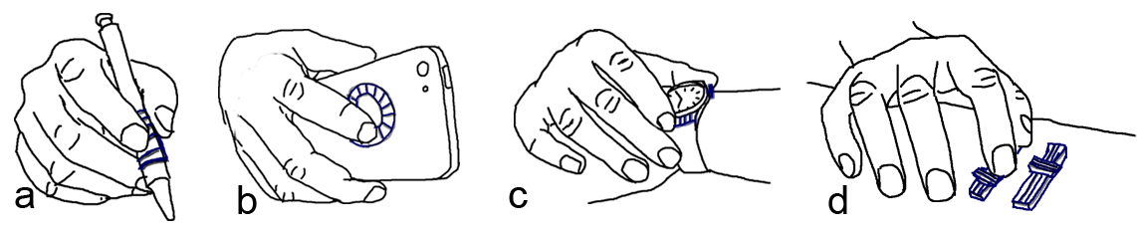
Figure 1: Scenarios of using on hand motion sensors (ring, watch, wrist band) to enhance the use of everyday things. (a) swiping on a textured pad while holding a pen. (b) swiping on a dial pad on the back of a mobile device. (c) pushing a button or swiping on a textured pad on a smart watch. (d) sliding on sliders on a table.

ABSTRACT
Paste the appropriate copyright/license statement here. ACM now supports three different publication options:
- ACM copyright: ACM holds the copyright on the work. This is the historical approach.
- License: The author(s) retain copyright, but ACM receives an exclusive publication license.
- Open Access: The author(s) wish to pay for the work to be open access. The additional fee must be paid to ACM.
This text field is large enough to hold the appropriate release statement assuming it is single-spaced in TimesNewRoman 8 point font. Please do not change or modify the size of this text box.
Every submission will be assigned their own unique DOI string to be included here.
On-body motion sensors embedded in wearable devices, such as wrist band, watches and rings, add new dimensions to the way we feel everyday things. Motion sensors have the ability to digitalize our tactile feelings and transmit the information to computers. This paper discuss how to leverage the functions of on-hand motion sensors to enhance the use of everyday things, such as adding rich tapping and swiping gestures with common and natural actions while using them. The system does not require extra electronic components, but works with existing ordinary objects alone, or with low-cost 3D printed, easily attachable widgets that help providing identifiable touch signals and passive tactile feedback. User studies show that xxx.

Author Keywords
Wearable devices; Gestural input; 3D printed widgets; Everyday objects;

ACM Classification Keywords
H.5.m. Inform

INTRODUCTION
The emerging wearable devices are bringing us into a new era of ubiquitous computing. To fulfill functions like activity tracking and gestural input, many wearable devices such as pedometers, smart watches and rings have embedded motion sensors inside. Beyond their original functions, these on-hand motion sensors can transmit the sensory vibration feedback of our hands to computers. Knowing that fingers receive vibrotactile feedback when moving relatively upon stimulus surfaces, we can use this feedback to turn physical objects into tangible interfaces, which introduce enhanced ways for us to interact with everyday things.

Existing solutions for interacting with physical objects include those using embedded motion or acoustic sensors, or both on mobile phones [17, 14, 33], and those putting extra sensors on human body [7, 28], on objects [6, 21, 23, 24], or on a third-party place [2, 11]. They usually face three major problems, namely availability of extra sensors, human body discomfort caused by improper sensor installations, and limited expression capability of gestures (e.g., designers usually assign one-to-one gesture-command mappings to avoid confusing users). Those wearable devices in forms of watches and rings, on the other hand, provide more accessible and acceptable solutions for the first two problems.

To solve the third problem, extending gestural input’s expression capabilities, which in our case are finger actions on objects that generate vibrotactile feedback, we propose two solutions. The first is to leverage the form factors and configurations of existing objects around us. For example, we may flip upon desk edges to commit a click command. We may also swipe on keyboards as shortcut for deleting a whole paragraph. The second is to bring attachable 3D printed widgets that help providing identifiable and passive vibrotactile feedbacks to ordinary objects. We call these widgets as VIBE-dget. The widgets are designed with raised lines on surfaces, similar to those tangible graphic displays that are used by people with limited or no vision. To generate various vibrotactile patterns with the raised lines, we consider several geometry properties including density, shapes, height, size and duration (Figure x). These parameter changes can be easily made with 3D model software. Besides various vibrotactile patterns, we design the widgets in forms of pads, buttons, dial pads, sliders, and scrolls (Figure x). As shown in Figure 1, users may swipe index fingers on pad widgets attached to stylus pens to input for tablets and smart phones. Users may enable back of mobile device interaction with their index fingers on dial pads to adjust audio volume for one handed operation. Users may also attach swipe pads, buttons, and sliders on tabletops to operate corresponding commands. VIBE-dgets can be used to solve the input challenge on smart watches that are lack of physical buttons.
Our solution to interact with everyday objects via wearable motion sensors brings several benefits. The system does not require extra electronic components on objects, but works with existing ordinary objects alone, or with low-cost 3D printed, easily attachable widgets. The way users interact with the objects, like swiping, not only provides identifiable motion signals for system recognition, but also generates unique passive tactile feedbacks. These feedbacks are especially useful to make user gestures deterministic.

The paper made contributions from three aspects.
- We enrich interactions with everyday objects by using “Vibro widgets”, which are non-electronic, fast printed, low cost, easy to attach and dynamic in form factors, working with emerging and existing on-hand motion sensors.
- Design factors are examined for building textures on the widgets, which can be used to guide other designers.
- We carried out user studies to confirm the performance of the system for several different daily tasks.
The rest of the paper is organized as following. We first reviewed related literature. We then introduced the widgets that are designed. Followed by the algorithm to make the system work, and interaction scenarios that are enabled with the system. After that, we described three user studies, and finally the conclusion.

RELATED WORK
Our work is related to interaction with physical objects for gestural input. In this section, we first review the literature on how previous research enables us to leverage physical objects for interactive input and output, which is also called tangible interfaces. We then talk about enhanced operations and new user experiences with ordinary objects such as stylus, keyboards. Lastly, we review the use of motion sensors embedded in wearable devices for gestural input.

Mechanisms to Interact with Physical Objects
Instead of conventional touchscreens, researchers have been exploring other input and output methodologies such as using physical objects. The benefits include enhancing interactions with more concrete haptic feedback and more real visual representations. Laput et.al [14] designed a set of passive primitives as blocks to build users’ familiar physical mechanism, which worked as tangible input channel leveraging smartphone’s existing acoustic functionality. The idea of using objects’ passive acoustic feedback as input channel was also explored in the work like Lamello [22], Scratch Input [8] and Acoustic Barcode [9]. Similar to passive acoustic feedback, passive vibrations was also used for designing interaction with physical objects, such as Textured Pad [13] that uses a piezo-electric microphone. In our work, we chose passive vibrations which can be captured by accelerometers as our design factor instead of acoustic feedback because motion sensors are more in common use on wearable devices, compared with microphones.
Other mechanisms were also investigated for using physical objects. Ashbrook et.al [1] and Hwang et.al [10] used magnetometer to track changes of magnetic field generated by motion of controller widgets. Liang et.al [15] used magnetic building blocks to enable real-time constructions. TZee [26], WonderLens [16], and Magic Lens [18] investigated using optical glasses that works with existing displays for tangible input and output. Chan et.al [4], Yu et.al [32] and Wolf et.al [27] leveraged capacitive sensing functionality with existing capacitive touch screen and touch pad. Besides, attached capacitive sensors are often used to detect touches on physical objects [6, 23, 24]. Infrared sensors [3] and camera based vision tracking [2, 11] were used very often as well. In Augmented Reality (AR) applications, cameras are used to track and make real-world environment like wall, desk, and floor interactive. The other emerging trend is building tangible shape-changing interfaces with external actuators [31] and smart materials [19]. In a recent work, Yao et.al [30] demonstrated how to use live natto cells to build bio actuators.

Enhanced Operations with Ordinary Objects
With the knowledge on different mechanisms that have been applied to interact with physical objects, this section focus on what enhanced operations and new user experiences have been brought to ordinary objects. Bonfire [11] switches tables to interactive surfaces and used them as extended displays. OmniTouch [7] also used camera projector setup to switch human arm and hand to operation platform. Graspables [24] made an interactive soap to detect how users grasp it. Multi-touch pen [23] attached capacitive sensors to a normal pen and switched writing modes based on how users grip the device. Zhang et.al [34] and Taylor et.al [25] designed swiping gestures on or above keyboards. Yang et.al [29] added a display to mouse to provide auxiliary information. McGrath et.al [17] used embedded motion sensors of mobile devices to enable tapping detection on the devices’ edges. Sato et.al [21] used a novel capacitive sensing technique to detect touch patterns on normal objects, like doorknob, table, water and even human body.
These scenarios require sensors to be instrumented on the objects, thus are not easy to expand to work on others. Yang et.al [28] took another approach that attached optical mouse sensor and camera to a finger, to support always-available interactions. However, this on-body sensor might cause discomfort as it is placed on fingertips. To keep normal hand function, Kienzle et.al [12] used ring form factor to track 2d location of a fingertip on surfaces like desk and leg. Our solution also took benefits from ring and watch form factors, but created richer gestures by using 3D printed widgets.

Use of Wearable Motion Sensors for Interactions
Motion sensors such as accelerometers and gyroscopes are widely embedded with finger wore rings and wrist wore watches and bands, which provide new opportunities to create gestural interactions. Ring [20] is a commercial product that supports customize gestures based on finger strokes in the air. It does not support interaction with physical objects so far as we know. Chen et.al [5] used motions of smart watch to enhance the touch input to mobile phones and vise versa. We expand the idea to enhance the use of everyday things.

Interact with 3D Printed Widgets
Motion
//the following is not done yet

SENSOR DETECTIONS / to be revised
Developing upon the method described in McGrath et.al [17], we used the acceleration data for gesture detection. We record the acceleration data on each sensor and use a linear SVM model to capture events.

Feature Selection and Data Collection
There are two types of tapping event, which is defined based on whether the finger flips away directly after it bumps. Figure xx plots the acceleration data for the two types of tapping events with the sampling rate at ~66.6 Hz (~15ms per frame). A tap event usually occurs in 150 – 300ms according to McGrath et.al [17], and we observed some users take slightly longer to perform the gesture, thus we capture a ~450ms window of the signal.
Besides adding the common measurements for brutal force signals as our features, such as mean, standard deviation, skewness and kurtosis on each axis, and on each sensor, we noticed on the signal that there are two acceleration spikes during the event. The sensor on dominant moving finger has stronger spikes. Taking a tap with thumb on index finger as an example, the first spike of the thumb signal happens when the thumb moves towards the index finger and the second one happens when the thumb bumps the index finger and is forced to stop moving. The two signal spikes are in opposite direction and normally, the second spike has larger magnitude than the first one because of the bumping force. Thus we make another two features, one by first finding the largest and second largest spikes on the sensor whichever has stronger signal, and return 1 if the two spikes are in opposite direction and -1 if otherwise, the other one by detecting the moving direction (defined as atan(1st axis, 2nd axis)) of both sensors when the first spike occurs.
In total, there are 31 features, including spike direction comparison (1), moving direction on the 1st signal spike (3 axis * 2 sensors), mean (3 axis * 2 sensor), stand deviation (3 axis * 2 sensors), skewness (3 axis * 2 sensor) and kurtosis (3 axis * 2 sensors).
Similar to McGrath et.al [17], the same 20 participants performed tapping gestures when seeing prompt. The recording lasted for 1.5 seconds such that the participants had enough time to respond. We then subtracted 450ms action signal from the 1.5s raw signal. Each participant was asked to perform tapping on each finger segments 5 times, with both tapping types. In total we got 2800 (20*14*5*2) positive training data. After this, the participants were asked to perform arbitrary finger and hand motions, including no motions. We collected the data in the same way and got 3000 negative training data.

Recognition
To simplify the classification model, we did not distinguish the two types of tapping as different classes, but treat them as one. The goal is to train a classifier that can recognize whether a piece of incoming signal is a tapping event or not. We used linear SVM method to do the task. All the features were normalized. To pick the best values for parameter C and gamma, we used 10-fold cross validation to evaluate various C and gamma values. In the end, we chose C as 1.0 and gamma as 1.0, which had best performance with xx.xx% (stdv = xx.xx%) accuracy. Then we saved the model with the chosen parameters.
To evaluate the model in real-time, we test every ~450ms (30 frames) incoming signal and count for the right and wrong predictions. With 10 participants testing for 50 tapping gestures and 50 arbitrary movements, we got xx.xx% (stdv = xx.x%) accuracy for positive predictions and xx.xx% (stdv = xx.x%) for negative predictions.
As noted, the false positive error rate is slightly high. To improve the performance, we took account of the tap position detection described in the previous section and used heuristic based approach. The heuristics include: 1,

VIBE Design Parameters
Through a multi-part study, we explore the characteristics of blimp patterns that are recognizable by our algorithm. We first explore the minimally recognizable blimp height, and then consider inter-blimp density, uniformity and length with respect to accuracy. The outcome of these studies provides some guidelines on the characteristics of blimp parameters to use for the remainder of the work. In study 2, we examine the use of VIBEs for accurate and efficient parameter manipulation.

Study 1A: Blimp height
We explore the minimally allowable height of a blimp on VIBE-dgets.
Study factors: heights (X) × finger-tip or nail use (2) × ring or watch (2) giving a X×2×2 factorial design. The task consisted of asking the user to flick over a blimp. The system recorded matching accuracy for each blimp.
Task: flick over one blimp. Record recognition accuracy.
Procedure: ….
Participants: we recruited N=10.
Results: we find that highest recognition is achieved with a blimp of 0.5 mm and beyond this size accuracy recognition is not affected, or affected very slightly.

Figure Study 1A: Notice that after blimp height of 0.5 mm accuracy does not change much, suggesting that our blimps can go as low as 0.5 mm in height to be detectable.

Study 2A: Inter-blimp density, uniformity, length
We next explore the density thresholds for recognizing inter-blimp density. We also consider the overall length of a VIBE-dget as well as the degree of uniformity in blimp height toward accurate recognition.
Task: flick over a VIBE-dget. Record recognition accuracy.
Participants: we recruited N=10.
Study factors: we examine the effect of three parameters on accuracy. These include inter-blimp density (4 levels), inter-blimp length (3 levels), and blimp height uniformity (3 levels) for a 4 ×3 × 3 factorial design. We do the task using the ring as well as the watch, but using the finger nail.
Results:
Density | Length | Uniformity

Study 2: Parameter Manipulation
The prior study allows us to define certain parameters for our blimps for good enough accuracy. We now turn our attention to tasks in which a finger could introduce some effects in an application. We choose parameter manipulation as a canonical task, as it matches the affordance of the gesture and also is universally used for flicking, panning, zooming, menu navigation, selection of values from a multi-item control. Given that such tasks are designed for action in which the user is grasping an object, we investigate the effect of grasp style (tripod, i.e. pen or palm, i.e. smartphone) on performance accuracy. We also investigate the accuracy levels for this task.
Task: the task consisted of moving a virtual cursor onto a given target. We record time to complete, number of overshoot/undershoots. Selection is achieved after the cursor dwells on the target for 200 ms, just enough time to disambiguate from incidental activations during cursor movement.

Factors: we evaluate effectiveness of VIBE-dgets based on ‘best’ derived parameter values from the previous study. We include as factors grasp style (4 levels) × amount of distance traveled by cursor (3 levels) × sensor location (ring vs. watch) [WE NEED TO THINK OF THE MOST RELEVANT FACTORS ONCE THE PREVIOUS STUDY IS DONE]
Results:

VIBE-DGET DESIGN GUIDELINES
Based on our results, we propose the following guidelines to apply in the design of VIBE-DGETS. [Teng: we need to think carefully about how to fill this table and I would like you to start filling it, even before running the studies, so that you know what your studies should provide you as output. You need to think clearly about what will be the most crucial guidelines and include those first, then include the less important ones, then check if the studies will give these or not.]

VIBE-dgets
Based on the above two studies and our derived guidelines, we design a suite of VIBE-dgets each with their unique affordances.

Design Example: Textures
M
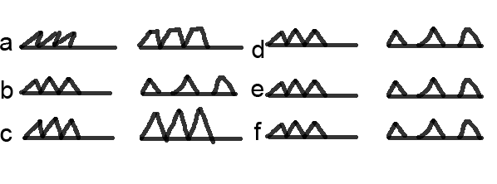
Figure x. Texture patterns

Design Example: Form Factors
M
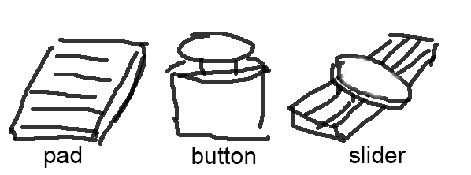
Figure x. Form factors and their working mechanisms
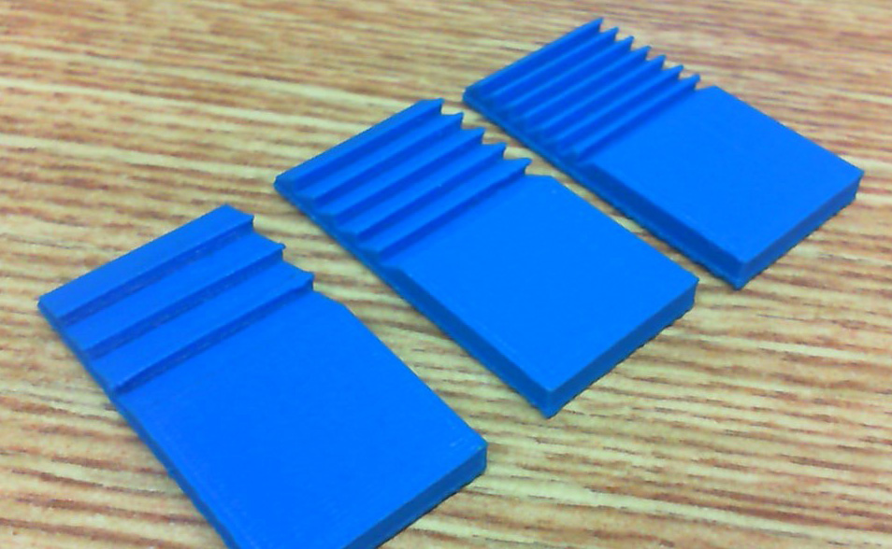
Figure x. Printed samples

DEMO APPLICATIONS
We demonstrate novel applications and scenarios with VIBE-dgets.

Pen
In this application, a VIBE-dget with three different blimp patterns allow the manipulation of three parameters, ink thickness, ink color and line format.

Tools
With

Driving
With

Keyboard
In this application, the user can flick their finger over the keyboard to issue a given command. A traditional keyboard has 3 different blimp patterns, such as left-to-right, right-to-left, and diagonal movement for effective cursor manipulation, for example, to delete a word, a sentence or an entire paragraph (right-to-left with different lengths), to scroll up/down (up-to-down on keyboard) and to pan a map (diagonal).

Phone
With

Tactile Pad for Blind
With

USER FEEDBACK
W

Let Users Design Their Own Widgets
With

Subjective Feedbacks
With

Discussion
[Teng: we need to include sub-sections here for what we plan to discuss].

CONCLUSION AND FUTURE WORK
Conclusions

REFERENCES
- Ashbrook, D., Baudisch, P., and White, S. Nenya: subtle and eyes-free mobile input with a magnetically-tracked finger ring. In Proc. CHI 2011. ACM Press (2011), 2043-2046.
- Avrahami, D., Wobbrock, J.O., and Izadi, S. Portico: tangible interaction on and around a tablet. In Proc. UIST 2011. ACM Press (2011), 347-356.
- Butler, A., Izadi, S., and Hodges, S. 2008. SideSight: multi-"touch" interaction around small devices. In Proc. UIST 2008. ACM Press (2008), 201-204.
- Chan, L., Müller, S., Roudaut, A., and Baudisch, P. CapStones and ZebraWidgets: sensing stacks of building blocks, dials and sliders on capacitive touch screens. In Proc. CHI 2012. ACM Press (2012), 2189-2192.
- Chen, X., Grossman, T., Wigdor, D. J., and Fitzmaurice, G. Duet: exploring joint interactions on a smart phone and a smart watch. In Proc. CHI 2014. ACM Press (2014), 159-168.
- Cheng, L., Liang, H., Wu, C., and Chen, M. iGrasp: grasp-based adaptive keyboard for mobile devices. In Proc. CHI 2013. ACM Press (2013), 3037-3046.
- Harrison, C., Benko, H., and Wilson, A. D. OmniTouch: wearable multitouch interaction everywhere. In Proc. UIST 2011. ACM Press (2011), 441-450.
- Harrison, C., and Hudson, S. E. Scratch input: creating large, inexpensive, unpowered and mobile finger input surfaces. In Proc. UIST 2008. ACM Press (2008), 205-208.
- Harrison, C., Xiao, R., and Hudson, S. E. Acoustic barcodes: passive, durable and inexpensive notched identification tags. In Proc. UIST 2012. ACM Press (2012), 563-568.
- Hwang, H., Ahn, M., and Wohn, K. MagGetz: customizable passive tangible controllers on and around conventional mobile devices. In Proc. UIST 2013. ACM Press (2013), 411-416.
- Kane, S.K., Avrahami, D., Wobbrock, J.O., Harrison, B., Rea, A.D., Philipose, M., and LaMarca, A. Bonfire: a nomadic system for hybrid laptop-tabletop interaction. In Proc. UIST 2009. ACM Press (2009), 129-138.
- Kienzle, W., and Hinckley, K. LightRing: always-available 2D input on any surface. In Proc. UIST 2014. ACM Press (2014), 157-160.
- Kim, J., Sunwoo, J., Son, Y., Lee, D., and Cho, I. A gestural input through finger writing on a textured pad. In Proc. CHI 2007 Ext. Abstracts, ACM Press (2007), 2495-2500.
- Laput, G., Brockmeyer, E., Hudson, S. E., and Harrison, C. Acoustruments: Passive, Acoustically-Driven, Interactive Controls for Handheld Devices. In Proc. CHI 2015. ACM Press (2015), 2161-2170.
- Liang, R.-H., Chan, L., Tseng, H.-Y., Kuo, H.-C., Huang, D.-Y., Yang, D.-N, and Chen, B.-Y. 2014. GaussBricks: magnetic building blocks for constructive tangible interactions on portable displays. In Proc. CHI 2014. ACM Press (2014), 3153-3162.
- Liang, R.-H., Shen, C., Chan, Y.-C., Chou, G.-T., Chan, L., Yang, D.-N., Chen, M. Y., and Chen, B.-Y. WonderLens: Optical Lenses and Mirrors for Tangible Interactions on Printed Paper. In Proc. CHI 2015. ACM Press (2015), 1281-1284.
- McGrath, W., and Li, Y. Detecting tapping motion on the side of mobile devices by probabilistically combining hand postures. In Proc. UIST 2014, ACM Press (2014), 215-219.
- Papas, M., Houit, T., Nowrouzezahrai, D., Gross, M., and Jarosz, W. The magic lens: Refractive steganography. ACM TOG 31, 6 (Nov. 2012).
- Park, Y.-W., Park, J., and Nam, T.-J. The Trial of Bendi in a Coffeehouse: Use of a Shape-Changing Device for a Tactile-Visual Phone Conversation. In Proc. CHI 2015. ACM Press (2015), 2181-2190.
- Ring, Logbar Inc. http://logbar.jp/ring/en
- Sato, M., Poupyrev, I., and Harrison, C. Touché: enhancing touch interaction on humans, screens, liquids, and everyday objects. In Proc. CHI 2012. ACM Press (2012), 483-492.
- Savage, V., Head, A., Hartmann, B., Goldman, D.B., Mysore, G., and Li, W. Lamello: Passive Acoustic Sensing for Tangible Input Components. In Proc. CHI 2015. ACM Press (2015), 1277-1280.
- Song, H., Benko, H., Guimbretiere, F., Izadi, S., Cao, X., and Hinckley, K. Grips and gestures on a multi-touch pen. In Proc. CHI 2011. ACM Press (2011), 1323-1332.
- Taylor, B.T., and J. V. Michael Bove. Graspables: grasp-recognition as a user interface. In Proc. CHI 2009. ACM Press (20009), 917-926.
- Taylor, S., Keskin, C., Hilliges, O., Izadi, S., and Helmes, J. Type-hover-swipe in 96 bytes: a motion sensing mechanical keyboard. In Proc. CHI 2014. ACM Press (2014), 1695-1704.
- Williams, C., Yang, X. D., Partridge, G., Millar, J., Major, A., and Irani, P. TZee: exploiting the lighting properties of multi-touch tabletops for tangible 3d interactions. In Proc. CHI 2011. ACM Press (2011), 1363-1372.
- Wolf, K., Schneegass, S., Henze, N., Weber, D., Schwind, V., Knierim, P., Mayer, S., Dingler, T., Abdelrahman, Y., Kubitza, T., Funk, M., Mebus, A., and Schmidt, A. TUIs in the Large: Using Paper Tangibles with Mobile Devices. In Proc. CHI 2015 Ext. Abstracts. ACM Press (2015), 1579-1584.
- Yang, X.-D., Grossman, T., Wigdor, D., and Fitzmaurice, G. Magic finger: always-available input through finger instrumentation. In Proc. UIST 2012. ACM Press (2012), 147-156.
- Yang, X.-D., Mak, E., McCallum, D., Irani, P., Cao, X., and Izadi, S. LensMouse: augmenting the mouse with an interactive touch display. In Proc. CHI 2010. ACM Press (2010), 2431-2440.
- Yao, L., Ou, J., Cheng, C.-Y., Steiner, H., Wang, W., Wang, G., and Ishii, H. bioLogic: Natto Cells as Nanoactuators for Shape Changing Interfaces. In Proc. CHI 2015. ACM Press (2015), 1-10.
- Yao, L., Niiyama, R., Ou, J., Follmer, S., Silva, C. D., and Ishii, H. PneUI: pneumatically actuated soft composite materials for shape changing interfaces. In Proc. UIST 2013. ACM Press (2013), 13-22.
- Yu, N.-H., Chan, L.-W., Lau, S., Tsai, S.-S., Hsiao, I.-C., Tsai, D.-J., Hsiao, F.-I., Cheng, L.-P., Chen, M., Huang, P., and Hung, Y.-P. TUIC: enabling tangible interaction on capacitive multi-touch displays. In Proc. CHI 2011. ACM Press (2011), 2995-3004.
- Zhang, C., Guo, A., Zhang, D., Southern, C., Arriaga, R., and Abowd, G. BeyondTouch: Extending the Input Language with Built-in Sensors on Commodity Smartphones. In Proc. IUI 2015. ACM Press (2015), 67-77.
- Zhang, H., and Li, Y. GestKeyboard: enabling gesture-based interaction on ordinary physical keyboard. In Proc. CHI 2014. ACM Press (2014), 1675-1684.

The columns on the last page should be of approximately equal length.
Remove these two lines from your final version.

