SIGCHI Conference Proceedings Format
1st Author Name  Affiliation  Address  e-mail address  Optional phone number | 2nd Author Name  Affiliation  Address  e-mail address  Optional phone number | 3rd Author Name  Affiliation  Address  e-mail address  Optional phone number
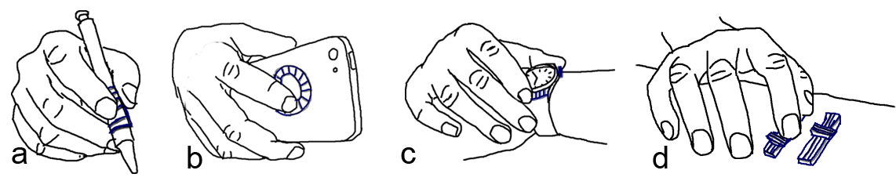
Figure 1: Scenarios of using on hand motion sensors (ring, watch, wrist band) to enhance the use of everyday things. (a) swiping on a textured pad while holding a pen. (b) swiping on a dial pad on the back of a mobile device. (c) pushing a button or swiping on a textured pad on a smart watch. (d) sliding on sliders on a table.

ABSTRACT
Paste the appropriate copyright/license statement here. ACM now supports three different publication options:
- ACM copyright: ACM holds the copyright on the work. This is the historical approach.
- License: The author(s) retain copyright, but ACM receives an exclusive publication license.
- Open Access: The author(s) wish to pay for the work to be open access. The additional fee must be paid to ACM.
This text field is large enough to hold the appropriate release statement assuming it is single-spaced in TimesNewRoman 8 point font. Please do not change or modify the size of this text box.
Every submission will be assigned their own unique DOI string to be included here.
On-body motion sensors embedded in wearable devices, such as wrist band, watches and rings, add new dimensions to the way we feel everyday things. Motion sensors have the ability to digitalize our tactile feelings and transmit the information to computers. This paper discuss how to leverage the functions of on-hand motion sensors to enhance the use of everyday things, such as adding rich tapping and swiping gestures with common and natural actions while using them. The system does not require extra electronic components to ordinary objects, but works with low-cost 3D printed, easily attached widgets that helps providing identifiable touch signals and passive tactile feedback. Users can easily use the widgets by attaching them on ordinary objects. User studies show that xxx.

Author Keywords
Wearable devices; Gestural input; 3D printed widgets; Everyday objects;

ACM Classification Keywords
H.5.m. Inform

INTRODUCTION
The emerging wearable devices are bringing us into a new era of ubiquitous computing. To fulfill functions like activity tracking and gestural input, many wearable devices have embedded motion sensors inside, such as pedometers, smart watches and rings. Beyond their original set functions, these on/near hand motion sensors help transmitting sensory feedback of our hands to computers. For instance, accelerometers can detect vibrations as fingers do, which can then be used by computers to predict what users might hold. These sensor potentials provide opportunities to digitalize our tactile feelings while hands are touching objects and thus enhance the way we interact with everyday things. In other words, ordinary objects can be used to create rich gestural interfaces with the help from wearable devices.
Though the idea of interacting with ordinary physical objects for gestural input is not new, existing solutions including those using embedded motion [17] or acoustic [14] sensors, or both [33] on mobile phones, and those putting extra sensors on human body [7, 28], on objects [6, 21, 23, 24], or on a third-party place [2, 11] usually face three major problems. First, sensors might not be always available to ordinary objects. The portability, complex and cost of the sensors for objects impede their popularizing process. Second, users usually prefer bare hand interaction. Improper installation of sensors on human body cause discomfort. Third, the expression capability of hand gestures on physical objects is limited. Tapping and swiping are the two most common used gestures. Information such as positions [12], action speed and even contact area can be added to generate rich gestures. However, they are lack of passive tactile feedback, which makes it hard for users to memorize all those gesture set and their meanings.
To solve the availability and comfort problems, we consider using existing and emerging wearable devices in forms of watches and rings. They are more acceptable to users as they fit the way we used to wear devices. Meanwhile, most of the devices are equipped with motion sensors such as accelerometers and gyroscopes, which are getting more accurate and reliable nowadays. With the embedded sensors, wireless transmitters and raising computing powers, these devices provide the opportunity to make interacting with everyday things achievable.
To solve the third problem, extending gestural input’s expression capabilities, we propose two solutions. The first is to leverage the form factors and configurations of existing objects in our life. For example, we may use desk edges as buttons. Flipping upon the edges commits a click action. We may also find objects with textures that can provide passive tactile feedback while fingers are swiping on them, such as keyboards and xxxx (Figure xx). The second is to bring 3D printed widgets that can be easily attached to ordinary objects. We designed the widgets in two ways. The first is providing various physical platforms for finger actions. We designed widgets in the forms of pads, buttons, dial pads, sliders, and scrolls (Figure x). For example, Figure 1 demonstrates several use scenarios of the widgets. Users may swipe their index finger on a pad widget attached to a pen, to interact with their mobile phone or tablet. Users may enable back of mobile device interaction with their index finger on a dial pad to increase or decrease audio volume for one handed operation. Users may also attach swipe pads, buttons, and sliders on button-less smart watches and tables if using touch screens of the devices are not convenient. The second is providing various textures on the widgets, which not only help providing identifiable motion signals when fingers are moving on them, but also providing various passive tactile feedbacks, to make users’ gestures more deterministic. Thus a simple swipe gesture can generate rich meanings with different textured widgets. We designed the textures from several factors, including density, peak shapes, height, size and duration (Figure x).
The paper made contributions from three aspects.
- We enrich interactions with everyday objects by using “Vibro widgets”, which are non-electronic, fast printed, low cost, easy to attach and dynamic in form factors, working with emerging and existing on-hand motion sensors.
- Design factors are examined for building textures on the widgets, which can be used to guide other designers.
- We carried out user studies to confirm the performance of the system for several different daily tasks.
The rest of the paper is organized as following. We first reviewed related literature. We then introduced the widgets that are designed. Followed by the algorithm to make the system work, and interaction scenarios that are enabled with the system. After that, we described three user studies, and finally the conclusion.

RELATED WORK
Our work is related to interaction with physical objects for gestural input. In this section, we first review the literature on how previous research enables us to leverage physical objects for interactive input and output, which is also called tangible interfaces. We then talk about enhanced operations and new user experiences with ordinary objects such as stylus, keyboards. Lastly, we review the use of motion sensors embedded in wearable devices for gestural input.

Mechanisms to Interact with Physical Objects
Instead of conventional touchscreens, researchers have been exploring other input and output methodologies such as using physical objects. The benefits include enhancing interactions with more concrete haptic feedback and more real visual representations. Laput et.al [14] designed a set of passive primitives as blocks to build users’ familiar physical mechanism, which worked as tangible input channel leveraging smartphone’s existing acoustic functionality. The idea of using objects’ passive acoustic feedback as input channel was also explored in the work like Lamello [22], Scratch Input [8] and Acoustic Barcode [9]. Similar to passive acoustic feedback, passive vibrations was also used for designing interaction with physical objects, such as Textured Pad [13] that uses a piezo-electric microphone. In our work, we chose passive vibrations which can be captured by accelerometers as our design factor instead of acoustic feedback because motion sensors are more in common use on wearable devices, compared with microphones.
Other mechanisms were also investigated for using physical objects. Ashbrook et.al [1] and Hwang et.al [10] used magnetometer to track changes of magnetic field generated by motion of controller widgets. Liang et.al [15] used magnetic building blocks to enable real-time constructions. TZee [26], WonderLens [16], and Magic Lens [18] investigated using optical glasses that works with existing displays for tangible input and output. Chan et.al [4], Yu et.al [32] and Wolf et.al [27] leveraged capacitive sensing functionality with existing capacitive touch screen and touch pad. Besides, attached capacitive sensors are often used to detect touches on physical objects [6, 23, 24]. Infrared sensors [3] and camera based vision tracking [2, 11] were used very often as well. In Augmented Reality (AR) applications, cameras are used to track and make real-world environment like wall, desk, and floor interactive. The other emerging trend is building tangible shape-changing interfaces with external actuators [31] and smart materials [19]. In a recent work, Yao et.al [30] demonstrated how to use live natto cells to build bio actuators.

Enhanced Operations with Ordinary Objects
With the knowledge on different mechanisms that have been applied to interact with physical objects, this section focus on what enhanced operations and new user experiences have been brought to ordinary objects. Bonfire [11] switches tables to interactive surfaces and used them as extended displays. OmniTouch [7] also used camera projector setup to switch human arm and hand to operation platform. Graspables [24] made an interactive soap to detect how users grasp it. Multi-touch pen [23] attached capacitive sensors to a normal pen and switched writing modes based on how users grip the device. Zhang et.al [34] and Taylor et.al [25] designed swiping gestures on or above keyboards. Yang et.al [29] added a display to mouse to provide auxiliary information. McGrath et.al [17] used embedded motion sensors of mobile devices to enable tapping detection on the devices’ edges. Sato et.al [21] used a novel capacitive sensing technique to detect touch patterns on normal objects, like doorknob, table, water and even human body.
These scenarios require sensors to be instrumented on the objects, thus are not easy to expand to work on others. Yang et.al [28] took another approach that attached optical mouse sensor and camera to a finger, to support always-available interactions. However, this on-body sensor might cause discomfort as it is placed on fingertips. To keep normal hand function, Kienzle et.al [12] used ring form factor to track 2d location of a fingertip on surfaces like desk and leg. Our solution also took benefits from ring and watch form factors, but created richer gestures by using 3D printed widgets.

Use of Wearable Motion Sensors for Interactions
Motion sensors such as accelerometers and gyroscopes are widely embedded with finger wore rings and wrist wore watches and bands, which provide new opportunities to create gestural interactions. Ring [20] is a commercial product that supports customize gestures based on finger strokes in the air. It does not support interaction with physical objects so far as we know. Chen et.al [5] used motions of smart watch to enhance the touch input to mobile phones and vise versa. We expand the idea to enhance the use of everyday things.

Interact with 3D Printed Widgets
Motion
//the following is not done yet

SENSOR DETECTIONS / to be revised
Developing upon the method described in McGrath et.al [17], we used the acceleration data for gesture detection. We record the acceleration data on each sensor and use a linear SVM model to capture events.

Feature Selection and Data Collection
There are two types of tapping event, which is defined based on whether the finger flips away directly after it bumps. Figure xx plots the acceleration data for the two types of tapping events with the sampling rate at ~66.6 Hz (~15ms per frame). A tap event usually occurs in 150 – 300ms according to McGrath et.al [17], and we observed some users take slightly longer to perform the gesture, thus we capture a ~450ms window of the signal.
Besides adding the common measurements for brutal force signals as our features, such as mean, standard deviation, skewness and kurtosis on each axis, and on each sensor, we noticed on the signal that there are two acceleration spikes during the event. The sensor on dominant moving finger has stronger spikes. Taking a tap with thumb on index finger as an example, the first spike of the thumb signal happens when the thumb moves towards the index finger and the second one happens when the thumb bumps the index finger and is forced to stop moving. The two signal spikes are in opposite direction and normally, the second spike has larger magnitude than the first one because of the bumping force. Thus we make another two features, one by first finding the largest and second largest spikes on the sensor whichever has stronger signal, and return 1 if the two spikes are in opposite direction and -1 if otherwise, the other one by detecting the moving direction (defined as atan(1st axis, 2nd axis)) of both sensors when the first spike occurs.
In total, there are 31 features, including spike direction comparison (1), moving direction on the 1st signal spike (3 axis * 2 sensors), mean (3 axis * 2 sensor), stand deviation (3 axis * 2 sensors), skewness (3 axis * 2 sensor) and kurtosis (3 axis * 2 sensors).
Similar to McGrath et.al [17], the same 20 participants performed tapping gestures when seeing prompt. The recording lasted for 1.5 seconds such that the participants had enough time to respond. We then subtracted 450ms action signal from the 1.5s raw signal. Each participant was asked to perform tapping on each finger segments 5 times, with both tapping types. In total we got 2800 (20*14*5*2) positive training data. After this, the participants were asked to perform arbitrary finger and hand motions, including no motions. We collected the data in the same way and got 3000 negative training data.

Recognition
To simplify the classification model, we did not distinguish the two types of tapping as different classes, but treat them as one. The goal is to train a classifier that can recognize whether a piece of incoming signal is a tapping event or not. We used linear SVM method to do the task. All the features were normalized. To pick the best values for parameter C and gamma, we used 10-fold cross validation to evaluate various C and gamma values. In the end, we chose C as 1.0 and gamma as 1.0, which had best performance with xx.xx% (stdv = xx.xx%) accuracy. Then we saved the model with the chosen parameters.
To evaluate the model in real-time, we test every ~450ms (30 frames) incoming signal and count for the right and wrong predictions. With 10 participants testing for 50 tapping gestures and 50 arbitrary movements, we got xx.xx% (stdv = xx.x%) accuracy for positive predictions and xx.xx% (stdv = xx.x%) for negative predictions.
As noted, the false positive error rate is slightly high. To improve the performance, we took account of the tap position detection described in the previous section and used heuristic based approach. The heuristics include: 1,

DESIGN THE WIDGETS
//

Defining Design Parameter Boundaries
//user studies to define the range of parameters

Design Example: Textures
M
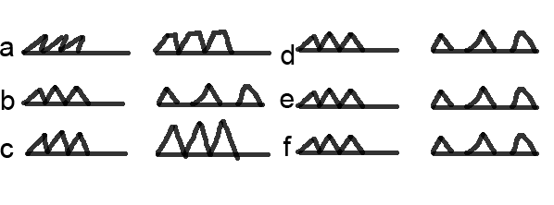
Figure x. Texture patterns

Design Example: Form Factors
M
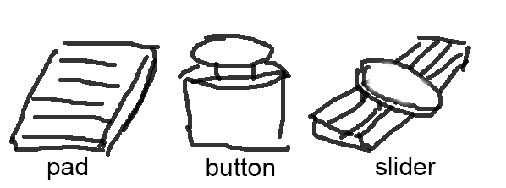
Figure x. Form factors and their working mechanisms
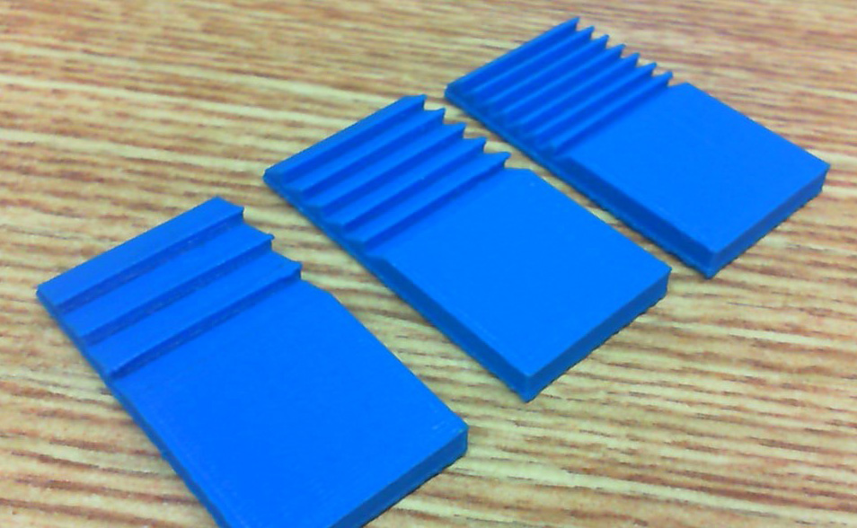
Figure x. Printed samples

DEMO APPLICATIONS

Pen
With

Tools
With

Driving
With

Keyboard
With

Phone
With

Tactile Pad for Blind
With

USER EVALUATIONS
W

Let Users Design Their Own Widgets
With

Subjective Feedbacks
With

CONCLUSION AND FUTURE WORK
Conclusions

REFERENCES
- Ashbrook, D., Baudisch, P., and White, S. Nenya: subtle and eyes-free mobile input with a magnetically-tracked finger ring. In Proc. CHI 2011. ACM Press (2011), 2043-2046.
- Avrahami, D., Wobbrock, J.O., and Izadi, S. Portico: tangible interaction on and around a tablet. In Proc. UIST 2011. ACM Press (2011), 347-356.
- Butler, A., Izadi, S., and Hodges, S. 2008. SideSight: multi-"touch" interaction around small devices. In Proc. UIST 2008. ACM Press (2008), 201-204.
- Chan, L., Müller, S., Roudaut, A., and Baudisch, P. CapStones and ZebraWidgets: sensing stacks of building blocks, dials and sliders on capacitive touch screens. In Proc. CHI 2012. ACM Press (2012), 2189-2192.
- Chen, X., Grossman, T., Wigdor, D. J., and Fitzmaurice, G. Duet: exploring joint interactions on a smart phone and a smart watch. In Proc. CHI 2014. ACM Press (2014), 159-168.
- Cheng, L., Liang, H., Wu, C., and Chen, M. iGrasp: grasp-based adaptive keyboard for mobile devices. In Proc. CHI 2013. ACM Press (2013), 3037-3046.
- Harrison, C., Benko, H., and Wilson, A. D. OmniTouch: wearable multitouch interaction everywhere. In Proc. UIST 2011. ACM Press (2011), 441-450.
- Harrison, C., and Hudson, S. E. Scratch input: creating large, inexpensive, unpowered and mobile finger input surfaces. In Proc. UIST 2008. ACM Press (2008), 205-208.
- Harrison, C., Xiao, R., and Hudson, S. E. Acoustic barcodes: passive, durable and inexpensive notched identification tags. In Proc. UIST 2012. ACM Press (2012), 563-568.
- Hwang, H., Ahn, M., and Wohn, K. MagGetz: customizable passive tangible controllers on and around conventional mobile devices. In Proc. UIST 2013. ACM Press (2013), 411-416.
- Kane, S.K., Avrahami, D., Wobbrock, J.O., Harrison, B., Rea, A.D., Philipose, M., and LaMarca, A. Bonfire: a nomadic system for hybrid laptop-tabletop interaction. In Proc. UIST 2009. ACM Press (2009), 129-138.
- Kienzle, W., and Hinckley, K. LightRing: always-available 2D input on any surface. In Proc. UIST 2014. ACM Press (2014), 157-160.
- Kim, J., Sunwoo, J., Son, Y., Lee, D., and Cho, I. A gestural input through finger writing on a textured pad. In Proc. CHI 2007 Ext. Abstracts, ACM Press (2007), 2495-2500.
- Laput, G., Brockmeyer, E., Hudson, S. E., and Harrison, C. Acoustruments: Passive, Acoustically-Driven, Interactive Controls for Handheld Devices. In Proc. CHI 2015. ACM Press (2015), 2161-2170.
- Liang, R.-H., Chan, L., Tseng, H.-Y., Kuo, H.-C., Huang, D.-Y., Yang, D.-N, and Chen, B.-Y. 2014. GaussBricks: magnetic building blocks for constructive tangible interactions on portable displays. In Proc. CHI 2014. ACM Press (2014), 3153-3162.
- Liang, R.-H., Shen, C., Chan, Y.-C., Chou, G.-T., Chan, L., Yang, D.-N., Chen, M. Y., and Chen, B.-Y. WonderLens: Optical Lenses and Mirrors for Tangible Interactions on Printed Paper. In Proc. CHI 2015. ACM Press (2015), 1281-1284.
- McGrath, W., and Li, Y. Detecting tapping motion on the side of mobile devices by probabilistically combining hand postures. In Proc. UIST 2014, ACM Press (2014), 215-219.
- Papas, M., Houit, T., Nowrouzezahrai, D., Gross, M., and Jarosz, W. The magic lens: Refractive steganography. ACM TOG 31, 6 (Nov. 2012).
- Park, Y.-W., Park, J., and Nam, T.-J. The Trial of Bendi in a Coffeehouse: Use of a Shape-Changing Device for a Tactile-Visual Phone Conversation. In Proc. CHI 2015. ACM Press (2015), 2181-2190.
- Ring, Logbar Inc. http://logbar.jp/ring/en
- Sato, M., Poupyrev, I., and Harrison, C. Touché: enhancing touch interaction on humans, screens, liquids, and everyday objects. In Proc. CHI 2012. ACM Press (2012), 483-492.
- Savage, V., Head, A., Hartmann, B., Goldman, D.B., Mysore, G., and Li, W. Lamello: Passive Acoustic Sensing for Tangible Input Components. In Proc. CHI 2015. ACM Press (2015), 1277-1280.
- Song, H., Benko, H., Guimbretiere, F., Izadi, S., Cao, X., and Hinckley, K. Grips and gestures on a multi-touch pen. In Proc. CHI 2011. ACM Press (2011), 1323-1332.
- Taylor, B.T., and J. V. Michael Bove. Graspables: grasp-recognition as a user interface. In Proc. CHI 2009. ACM Press (20009), 917-926.
- Taylor, S., Keskin, C., Hilliges, O., Izadi, S., and Helmes, J. Type-hover-swipe in 96 bytes: a motion sensing mechanical keyboard. In Proc. CHI 2014. ACM Press (2014), 1695-1704.
- Williams, C., Yang, X. D., Partridge, G., Millar, J., Major, A., and Irani, P. TZee: exploiting the lighting properties of multi-touch tabletops for tangible 3d interactions. In Proc. CHI 2011. ACM Press (2011), 1363-1372.
- Wolf, K., Schneegass, S., Henze, N., Weber, D., Schwind, V., Knierim, P., Mayer, S., Dingler, T., Abdelrahman, Y., Kubitza, T., Funk, M., Mebus, A., and Schmidt, A. TUIs in the Large: Using Paper Tangibles with Mobile Devices. In Proc. CHI 2015 Ext. Abstracts. ACM Press (2015), 1579-1584.
- Yang, X.-D., Grossman, T., Wigdor, D., and Fitzmaurice, G. Magic finger: always-available input through finger instrumentation. In Proc. UIST 2012. ACM Press (2012), 147-156.
- Yang, X.-D., Mak, E., McCallum, D., Irani, P., Cao, X., and Izadi, S. LensMouse: augmenting the mouse with an interactive touch display. In Proc. CHI 2010. ACM Press (2010), 2431-2440.
- Yao, L., Ou, J., Cheng, C.-Y., Steiner, H., Wang, W., Wang, G., and Ishii, H. bioLogic: Natto Cells as Nanoactuators for Shape Changing Interfaces. In Proc. CHI 2015. ACM Press (2015), 1-10.
- Yao, L., Niiyama, R., Ou, J., Follmer, S., Silva, C. D., and Ishii, H. PneUI: pneumatically actuated soft composite materials for shape changing interfaces. In Proc. UIST 2013. ACM Press (2013), 13-22.
- Yu, N.-H., Chan, L.-W., Lau, S., Tsai, S.-S., Hsiao, I.-C., Tsai, D.-J., Hsiao, F.-I., Cheng, L.-P., Chen, M., Huang, P., and Hung, Y.-P. TUIC: enabling tangible interaction on capacitive multi-touch displays. In Proc. CHI 2011. ACM Press (2011), 2995-3004.
- Zhang, C., Guo, A., Zhang, D., Southern, C., Arriaga, R., and Abowd, G. BeyondTouch: Extending the Input Language with Built-in Sensors on Commodity Smartphones. In Proc. IUI 2015. ACM Press (2015), 67-77.
- Zhang, H., and Li, Y. GestKeyboard: enabling gesture-based interaction on ordinary physical keyboard. In Proc. CHI 2014. ACM Press (2014), 1675-1684.

The columns on the last page should be of approximately equal length.
Remove these two lines from your final version.

