**2021 MCM**

**Problem A: Fungi**

**fungi是fungus的复数**

The **carbon cycle** describes the process of the exchange of carbon throughout the **geochemical cycle** of the Earth, and is a vital component for life on the planet. Part of the carbon cycle includes the decomposition of compounds, allowing carbon to be renewed and used in other forms. One key component of this part of the process is the decomposition of plant material and woody fibers.

碳循环描述了地球化学循环中碳的交换过程，是地球上生命的重要组成部分。碳循环的一部分包括化合物的分解，使碳得以更新并以其他形式使用。这一过程的一个关键组成部分是植物材料和木质纤维的分解。

Some of the key agents in decomposing woody fibers are **fungi**. The authors of a recent research article on wood decomposition by fungi identified fungi traits that determine decomposition rates and also noted links between certain traits**[1]**. In particular, the slow growing strains of fungi tend to be better able to survive and grow in the presence of environmental changes with respect to moisture and temperature, while the faster growing strains tend to be less robust to the same changes. A synopsis of this article can be found below on page 3.

分解木质纤维的关键是真菌。最新的研究确定了与木质纤维分解速率有关的真菌性状，并指出了这些性状之间的关系。尤其是，生长缓慢的真菌更易于在湿度、温度变化的环境下存活和生长；而生长较快的真菌对相同的环境变化抵抗力较弱。

These researchers examined a large number of traits associated with different fungi and their role in the decomposition of ground litter (dead plant material) and woody fibers. For this MCM Problem you should focus on just two traits of a fungus: the growth rate of the fungus and the fungus’ tolerance to moisture. Your primary goal is to model the decomposition of woody fibers in a given patch of land, and do so in the presence of multiple types of fungi breaking down woody fibers in the same area.

这些研究人员检查了大量与不同真菌相关的性状，以及它们在地面凋落物(死植物物质)和木质纤维分解中的作用。对于这个MCM问题，你应该只关注真菌的两个特性: 真菌的生长速度和耐湿性。您的主要目标是在给定的土地上模拟木本纤维的分解，并且在同一地区存在分解木本纤维的多种类型的真菌时这样做。

As you explore the relationship of the two traits of interest, growth rate and **moisture tolerance**, with the rate of decomposition, several questions may arise to include: Using these two traits, how do the different fungi interact and decompose ground litter in a fixed patch of land in different environments? Within these different environments, how will the decomposition be impacted over time as conditions vary? How do environmental changes and the variation in environmental change impact the long-term dynamics with respect to decomposition, as well as competition between fungi in a given environment? The estimation for the decomposition rates, given the growth rate, is shown in **Figure 1**. The estimation of the decomposition rates, given the relative moisture tolerance, is shown in **Figure 2**.

当你探索的关系感兴趣的两个特质,增长率和湿度耐受性,与分解的速率,可能出现几个问题,包括:使用这两个特征, 在不同环境中不同的真菌如何相互作用并在固定块土地上分解地面的垃圾?在这些不同的环境中，随着时间的推移条件的变化，分解将如何受到影响?环境的变化和环境变化中的变化是怎样的在给定的环境中，对真菌分解和竞争的长期动态有影响吗?对于分解速率的估计，给定的增长率，如图1所示。分解速率的估计，给定相对湿度的耐受性，如图2所示。

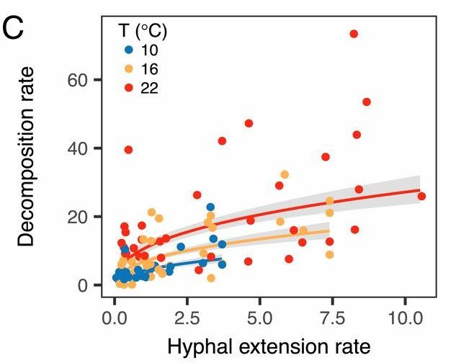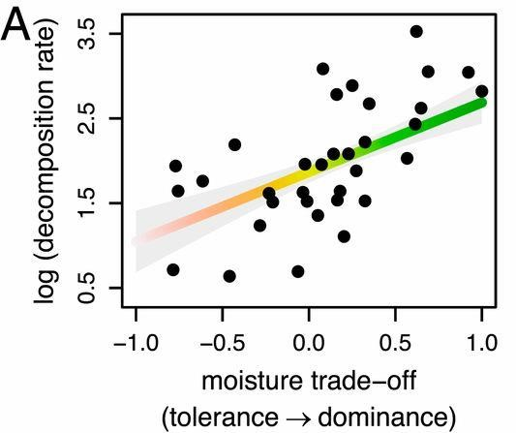

**Figure 1:** The relationship between the hyphal **extension**  **rate** (mm/day) of various fungi and the resulting wood decomposition rate (% mass loss over 122 days) at various temperatures. (Figure 1C in **[1]**).

图1：各种真菌的菌丝扩张率（mm/day）与由此产生的木材分解速率（122天以上的质量损失）在不同的温度下的关系。

**Figure 2:** The relationship between the moisture tolerance (difference of each isolate’s competitive ranking and their **moisture niche width**, both scaled to [0,1]) of various fungi and the resulting wood decomposition rate (% mass loss over 122 days, log transformed). (Figure 4A in **[1]**).

图2：各种真菌的水分耐受性（每个分离物的竞争排名的差异及其水分生态位宽度的差异，均缩放至 [0，1]）与由此产生的木材分解率（122 天内质量损失百分比）之间的关系。

**Requirement:** Your paper should explore and address the following aspects.

* Build a mathematical model that describes the breakdown of ground litter and woody fibers through fungal activity in the presence of multiple species of fungi.

建立一个数学模型，通过真菌活性在多种真菌存在的情况下描述地面凋落物和木质纤维的分解

* In your model, incorporate the interactions between different species of fungi, which have different growth rates and different moisture tolerances as shown in Figures 1 and 2.

在你的模型中，包括不同种类真菌之间的相互作用，它们具有不同的生长速度和不同的耐湿性，如图1和2所示

* Provide an analysis of the model and describe the interactions between the different types of fungi. The dynamics of the interactions should be characterized and described including both short- and long-term trends. Your analysis should examine the sensitivity to rapid fluctuations in the environment, and you should determine the overall impact of changing atmospheric trends to assess the impact of variation of local weather patterns.

对模型进行分析，并描述不同类型真菌之间的相互作用。应该描述和描述相互作用的动态变化情况，包括短期和长期趋势。您的分析应检查环境中快速波动的敏感性，并应确定大气变化的总体影响来评估本地天气模式变化影响的趋势

* Include predictions about the relative advantages and disadvantages for each species and combinations of species likely to persist, and do so for different environments including arid, semi-arid, temperate, arboreal, and tropical rain forests.

包括对每个物种和可能持续存在的物种组合的相对优势和劣势的预测，以及对不同环境的预测，包括干旱、半干旱、温带、乔木和热带雨林。

* Describe how the diversity of fungal communities of a system impacts the overall efficiency of a system with respect to the breakdown of ground litter. Predict the importance and role of **biodiversity** in the presence of different degrees of variability in the local environment.

描述系统真菌群落的多样性如何影响地面凋落物分解系统的整体效率。预测在当地环境中存在不同程度的变化时生物多样性的重要性和作用。

Include a two-page article of your results. Your article should be appropriate for inclusion in an introductory college level biology textbook to discuss recent developments in our understanding of the roles fungi play in ecological systems.

包括一篇两页的结果文章。你的文章应该适合列入一个介绍大学水平的生物教科书讨论在我们对真菌在生态系统中扮演的角色的理解中最近发展。

Your PDF solution of no more than 25 total pages should include:

* One-page Summary Sheet.
* Table of Contents.
* Your complete solution.
* Two-page Article.
* References list.

**Note:** The MCM Contest now has a 25 page limit. All aspects of your submission count toward the 25 page limit (Summary Sheet, Table of Contents, Reference List and any Appendices).

**Reference:**

**[1]** Nicky Lustenhouwer, Daniel S. Maynard, Mark A. Bradford, Daniel L. Lindner, Brad Oberle, Amy E. Zanne, and Thomas W. Crowther, "A trait-based understanding of wood decomposition by fungi," Proceedings of the National Academy of Sciences of the United States, May 13, 2020. <https://www.pnas.org/content/pnas/117/21/11551.full.pdf>

**Research Article Synopsis**

We provide a brief synopsis below of the research article by Lustenhouwer, *et al* **[1]**. The original full article is available at [https://www.pnas.org/content/pnas/117/21/11551.full.pdf.](https://www.pnas.org/content/pnas/117/21/11551.full.pdf) Note that you **do not** need to read the original article to complete this MCM Problem.

下面我们提供了Lustenhouwer等人[1]的研究文章的简要摘要。全文原文可在https://www.pnas.org/content/pnas/117/21/11551.full.pdf上找到。注意，您不需要阅读原始文章来完成这个MCM问题。

The decomposition of organic material is a critical component of the **carbon cycle**. Large scale modeling of the carbon cycle as well as global climate models are becoming more refined and are incorporating more small scale details. One important detail is the rate associated with the decay of organic material by microbial and fungal communities. The focus of the paper is the different decay rates associated with different types of **fungi**.

有机物的分解是碳循环的一个关键组成部分。碳循环的大规模模型和全球气候模型正变得越来越精确并且合并了更多的小尺度细节。一个重要的细节是有机物被微生物和真菌群落分解的速率。这篇论文的重点是不同类型的真菌的不同衰减速率。

The authors of the paper explored several different traits of fungi to determine the effects of the decomposition of wood. They did so by measuring how much mass was lost in wood blocks after introducing different types of fungi into the blocks. The researchers examined a large number of different traits associated with each fungus and attempted to determine the role these traits play in the decomposition of the wood blocks.

本文作者探索了真菌的几种不同特性，以确定木材分解的影响。他们通过将不同类型的真菌引入木块后，测量木块的质量损失。研究人员检查了与每种真菌相关的大量不同特征，试图确定这些特征在木块分解过程中所起的作用。

For example, one important trait is the **hyphal extension rate**. The **hyphae** are the cells that branch out and form the filaments and structure of a fungus, and the different kind of hyphae play different roles in the life cycle of a fungus. The hyphal extension rate is essentially the growth rate of a fungus. Another trait examined was the density of the hyphae in a given volume.

例如，一个重要的特征是菌丝扩展速率。菌丝是形成真菌的丝和结构的细胞，不同种类的菌丝在真菌的生命周期中扮演不同的角色。菌丝扩展速率实质上是真菌的生长速度。研究的另一个特性是给定体积内菌丝的密度。

These two traits are associated with a number of properties of a fungus. For example, it was found that if the hyphal extension rate was larger (faster growth), the fungus was more likely to decompose wood faster. Likewise, if the filaments were denser it was more likely that the decomposition of wood was slower. Additionally, these two traits are also associated with how a

fungus reacts to different environmental conditions.

这两种特性与真菌的许多特性有关。例如，菌丝扩展速率越大(生长速度越快)，真菌分解木材的速度越快。同样地，如果细丝密度更大，木材的分解速度也更慢。此外，这两种特性也与真菌对不同环境条件的反应有关。

In particular the researchers found that fungi that were better able to adapt to a more varied range of moisture conditions tended to also decompose wood slower. Fungi that grew faster and outcompeted other fungi tended to decompose wood faster. Figures 1 and 2 in the MCM Problem A statement show these relationships.

特别是，研究人员发现，能够更好地适应更多样的湿度条件的真菌，往往分解木材的速度也较慢。生长速度快且胜过其他真菌的真菌往往会更快地分解木材。MCM问题A语句中的图1和图2显示了这些关系。

Woody materials break down through multiple stages, and the fungi that were examined in the research article are most relevant with respect to the decay of woody materials in the middle of their decay cycle. The results may differ for other stages of decay. For the purpose of this modeling exercise, you can focus on the results for the middle stage and assume it is consistent for other stages of decomposition. Another consideration is that local environmental conditions can vary greatly over an area and impact the overall dynamics as well.

木质材料的分解经历了多个阶段，而在这篇研究文章中所研究的真菌与木质材料在其衰变周期的中间阶段的衰变最为相关。其他衰变阶段的结果可能有所不同。对于这个建模练习的目的，您可以将重点放在中间阶段的结果上，并假设它与分解的其他阶段是一致的。另一个需要考虑的问题是，当地的环境条件在一个地区可能会有很大的差异，同时也会影响整体的动态变化。

**Glossary:**

**Biodiversity:** Broadly, the variety of life in the world. On a smaller scale, the variety of life in a particular habitat or ecosystem.

生物多样性:广义上说，是指世界上生命的多样性。在较小的范围内，指的是某一特定栖息地或生态系统中的生命种类。

**Carbon Cycle:** The continuous process (or series of processes) by which carbon is exchanged between organisms and the environment, and then reused throughout the planet.

碳循环:碳在生物体和环境之间进行交换，然后在整个地球上重复利用的连续过程(或一系列过程)。

**Competitive Ranking:** A measure of the ability for a fungus to out-compete other fungi in a series of pair wise tests in similar conditions.

竞争排名:在一系列类似条件下的配对测试中，衡量一种真菌在竞争中胜过其他真菌的能力。

**Earth’s Biosphere:** The lithosphere (crust and upper mantle of the earth), the hydrosphere (all of the water on the earth’s surface), and the atmosphere (the envelope of gases surrounding the earth) of the earth.

地球的生物圈:地球的岩石圈(地壳和上地幔)、水圈(地球表面所有的水)和大气(包围地球的气体)。

**Fungus (plural: fungi):** Any member of the group of eukaryotic (cells that have a nucleus enclosed within a nuclear envelope) organisms. Examples are yeasts, molds, and mushrooms.

真菌(复数:真菌):真核生物(有一个被核膜包裹着的细胞核的细胞)生物群中的任何成员。例如酵母、霉菌和蘑菇。

**Geochemical Cycle:** The various pathways and steps by which elements are exchanged through and between the **Earth’s biosphere.**

地球化学循环:元素在地球生物圈内或在生物圈之间交换的各种途径和步骤。

**Hyphae:** The cells that form the filaments within a fungal community.

菌丝:在真菌群落中形成丝的细胞。

**Hyphal Extension Rate:** The rate of growth of a fungus.

菌丝扩张率:真菌生长的速度。

**Moisture Niche Width:** The difference between the maximum and minimum moisture levels in which half of a fungal community can maintain its fastest growth rate.

水分生态位宽度:最大和最小水分水平之间的差异，使一半的真菌群落能保持其最快的生长速度。

**Moisture Tolerance:** The difference between a fungus’ **competitive ranking** and its **moisture niche width**.

湿度耐受性:真菌的竞争性排名与其湿度生态位宽度之间的区别。