**关于真菌分解作用及相关环境问题的探究**

**Abstract**

**Key words:**

**Contents**

# Introduction

## Background

生态系统是一个开放的系统, 无论是物质还是能量，都是同外界进行着不断的循环和交换，而物质和能量的循环就需要生产者和分解者共同努力才能完成，生产者将物质和能量聚集在系统中, 而分解者将物质和能量释放出来，这对整个生态系统维持平衡和发展至关重要。生态系统中的真菌多样性极为丰富, 它在保持生态系统多样性的稳定方面具有及为重要的作用，系统地研究真菌的分解模型，并分析其在生态系统中的作用，对于研究整个生态系统的发展具有十分深远的意义和影响。

Ecosystem is an open system, both material and energy are constantly circulating and exchanging with the outside world. The cycle of matter and energy requires the joint efforts of producers and decomposers. Producers gather matter and energy in the system, while decomposers release them, which is crucial to the balance and development of the entire ecosystem. The diversity of fungi in the ecosystem is very rich and it plays an important role in maintaining the stability of the diversity of the ecosystem.It is of great significance and influence to study the development of the whole ecosystem to systematically study the decomposition models of fungi and analyze their roles in the ecosystem.

## Restatement of the Problems

* Build a mathematical model that describes the breakdown of ground litter and woody fibers through fungal activity in the presence of multiple species of fungi.
* In your model, incorporate the interactions between different species of fungi, which have different growth rates and different moisture tolerances.
* Provide an analysis of the model and describe the interactions between the different types of fungi.
* Include predictions about the relative advantages and disadvantages for each species and combinations of species likely to persist, and do so for different environments.
* Describe how the diversity of fungal communities of a system impacts the overall efficiency of a system with respect to the breakdown of ground litter. Predict the importance and role of biodiversity in the presence of different degrees of variability in the local environment.

# Analysis of the Problems

## Analysis of the Problem 1

本问需要建立“分解速率模型”，其中重点在于描述在多种真菌存在的情况下地面凋落物和木质纤维的分解情况。在建立模型的过程中，需要考虑woody plant species,site,years decayed,mesh,sampling side,extension rate,温度、湿度、群落间重叠度和时间等可能会影响分解过程的自变量对分解速率的影响，并将decomposition rate作为因变量进行拟合。

We need to establish a "decomposition rate model", which focuses on describing the breakdown of ground litter and woody fibers through fungal activity in the presence of multiple species of fungi. In the process of building the model, we need to consider the influence of woody plant species, site, years decayed, mesh, sampling side, extension rate, temperature, humidity overlap degree, time and other independent variables that may affect the decomposition process on the decomposition rate, and take the decomposition rate as the dependent variable for fitting.

## Analysis of the Problem 2

根据附件中Nicky Lustenhouwer等人的研究成果[1],可知菌丝延伸率the hyphal extension rate和竞争性差异moisture trade-off都与分解速率decomposition rate有着一定的关系，存在着相互作用。在本问中需要建立对这两种相互作用进行合并处理的模型，并在保持真菌分解速率不变的情况下，利用两者之间的函数关系对模型进行优化。

According to the research results of Nicky Lustenhouwer et al. in the attachment, it can be concluded that both the hyphal extension rate and the moisture trade-off are related to the decomposition rate, and there are specific interactions between them. To solve this question, we need to establish a model to combine these two interactions, and optimize the model by using the functional relationship between them while keeping the decomposition rate unchanged.

## Analysis of the Problem 3

在同一生存环境下，空间和资源都是有限的，因此不同类型真菌之间的相互作用通常表现为竞争关系，即不同种群间的竞争。在本问中需要建立以logistic模型和Lotka-Voltrra模型为基础的动态相互作用模型，并通过对增长率、抑制程度、环境容纳量等系数的控制来实现温度、湿度等大气环境对不同类型真菌之间的相互作用的影响。

In the same living environment, space and resources are limited, so the interaction between different types of fungi is usually manifested as competition relationship, that is, competition between different populations. In this question, a dynamic interaction model based on Logistic model and Lotka-Voltrra model should be established, and the influence of atmospheric environment such as temperature and humidity on the interaction between different types of fungi should be realized by controlling the growth rate, the degree of inhibition, the environmental tolerance and other coefficients.

# Assumptions

⚫ The curve between two adjacent known points of the graph to be filled is represented by a straight line.

# Symbol Description

|  |  |
| --- | --- |
| Symbol | Description |
| y | decomposition rate |
|  | the value of the i-th influencing factor |
| h | the hyphal extension rate |
| m | moisture trade-off |
|  |  |

# Model Establishment and Solution of Problem

## Problem 1

## **Decomposition rate model**

通过查阅相关资料并进行分析，我们得到影响分解速率的因素主要有温度、湿度、群落间重叠度、氧气浓度、光照强度、时间、woody plant species,site,years decayed,mesh,sampling side,extension rate等。所以我们可以以上述影响因素为自变量，选用decomposition rate作为描述地面凋落物和木质纤维的分解情况的因变量，建立分解速率模型。

By consulting relevant data and analyzing, it can be found that the main factors affecting the decomposition rate include temperature, humidity, overlap degree between communities, oxygen concentration, illumination intensity, time, woody plant species, site, years decayed, mesh, sampling side, extension rate, etc. Therefore, we can take the above influencing factors as independent variables, and choose the decomposition rate as the dependent variable to describe the breakdown of ground litter and woody fibers, and start to establish the decomposition rate model.

假设共有k个自变量，首先对各个自变量进行量化、归一化、无量纲化处理，其中类别变量需要哑元化处理。则在已知N组k个自变量的数据的情况下，选取decomposition rate关于各个自变量的近似方程如下：

It is assumed that there are k independent variables. Firstly, each independent variable is quantified, normalized and dimensionless, and the category variable needs dummy element processing. Then, in the case of known data of N groups of k independent variables, the decomposition rate's approximate equation of each independent variable is selected as follows:

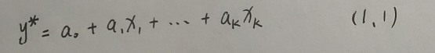

其中为y的近似值；

为第i个影响因素的值，即第i个自变量；

为假设的系数，。

Where,

is the approximate value of y;

is the value of the i-th influencing factor, namely the i-th independent variable;

is the assumed coefficient,.

在已知N组k个自变量的数据的情况下，将实测值与利用计算值的离差的平方和最小作为“优化判据”，令：

In the case of known data of N groups of k independent variables, the minimum sum of squares of the deviation between the measured value and the calculated value is taken as the "optimization criterion". Let:

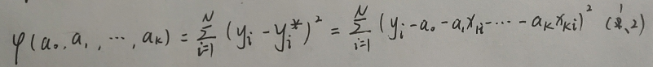（全部i改为n）

其中，

（yn）为第n组数据下的decomposition rate；

（yn*）为第n组数据下的decomposition rate的近似值；

（xin）为第n组数据下的第i个自变量；

Where,

（yn）is the decomposition rate under the data of the nth group;

（yn*）is the approximate value of the decomposition rate under data of the nth group;

（xin）is the ith independent variable under the data of the nth group.

下面利用最小二乘法确定式(1.1)中的全部系数：

通过求多元函数极值的方法，在式(1.2)中对求偏导并令其等于零，使得达到最小值。求得k+1个偏导如下：

The least square method is used to determine all the coefficients in Equation (1.1) :

Through the method of finding the extreme value of the multivariate function, take the partial derivative in Equation (1.2) and make it equal to zero, so as to reach the minimum value. For k + 1 partial derivatives are as follows:

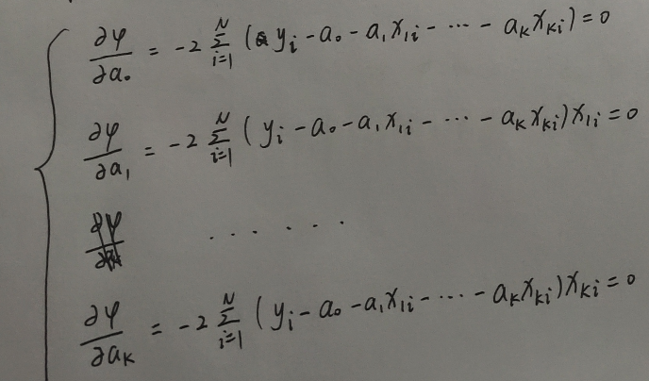

（全部i改为n）

对上述等式进行变换，得到：

By transforming the above equation, we get:

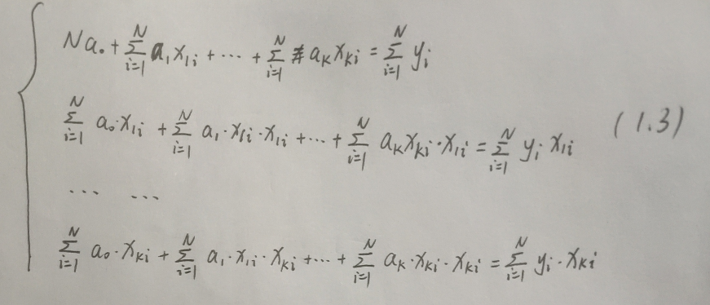（全部i改为n）

再进行简化处理，得到：

After further simplification, we can get:

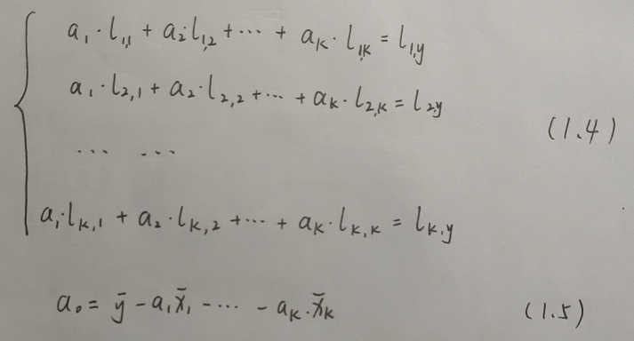

Where，

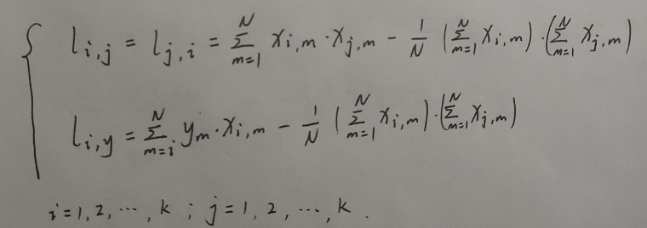

通过上述转化可知，只要相关变量满足方程组(1.4)和等式(1.5)，就能取得最小值。所以我们可以通过求解方程组(1.4)和等式(1.5)来确定全部系数。进而可得decomposition rate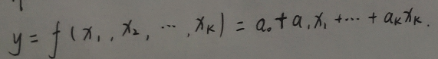

According to the above transformation, as long as the relevant variables satisfy the equation (1.4) and equation (1.5), the minimum value of  can be obtained. So we can determine all the coefficients by solving equations (1.4) and equations (1.5). Then, the decomposition rate can be obtained as follows



## **Solution of Question 1**

## Problem 2

## **Interaction model**

通过观察和分析Nicky Lustenhouwer等人的研究成果中得到的两张图像（图1）,并利用与附件相关的两篇论文中的数据对图像进行复现，可以发现菌丝延伸率the hyphal extension rate与分解速率decomposition rate近似呈对数关系，竞争性差异moisture trade-off与分解速率decomposition rate的对数近似呈线性关系。

By observing and analyzing the two images (Fig. 1) obtained from the research results of Nicky Lustenhouwer et al., and using the data in the two papers related to the attachment to reproduce the images, it can be found that the hyphal extension rate is approximately in logarithmic relation with the decomposition rate, and the moisture trade-off is approximately in a linear relationship with the logarithm of the decomposition rate.

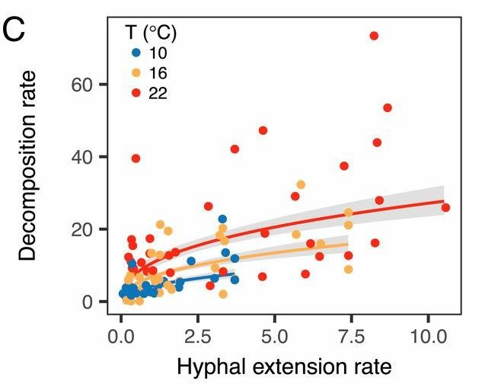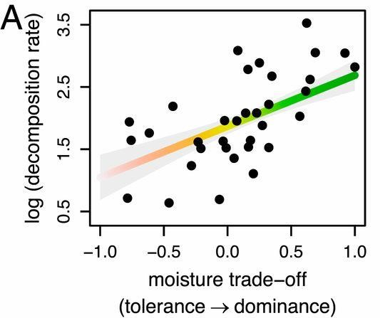

因此假设分解速率为定值Y，则可以选取菌丝延伸率the hyphal extension rate与分解速率decomposition rate的近似关系函数和竞争性差异moisture trade-off与分解速率decomposition rate的近似关系函数如下：

Therefore, assuming the decomposition rate as a constant value Y, the approximate relationship function between the hyphal extension rate and the decomposition rate and the approximate relationship function between the moisture trade-off and the decomposition rate can be selected as follows:

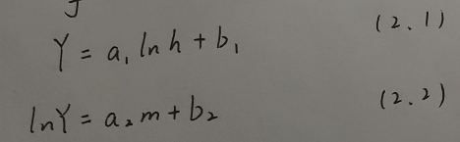

Where，

h is the hyphal extension rate;

m is moisture trade-off;

, ,  and  are assumed coefficients.

将近似关系函数式(2.1)和近似关系函数式(2.2)关联后，可以得到关于竞争性差异moisture trade-off和菌丝延伸率the hyphal extension rate的关系：

After the correlation between the approximate relation function formula (2.1) and the approximate relation function formula (2.2), the relationship between the moisture trade-off and the hyphal extension rate can be obtained:

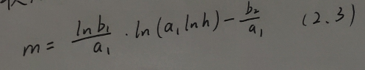

再将菌丝延伸率the hyphal extension rat和竞争性差异moisture trade-off对分解速率decomposition rate的影响以线性关系进行组合，则有

Then, the influences of the hyphal extension rat and moisture trade-off on decomposition rate are combined in a linear relationship, and the results are as follows



根据式(2.3)表述的竞争性差异moisture trade-off和菌丝延伸率the hyphal extension rate的关系，对两种因素的影响进行合并，将式(2.4)转化为分解速率decomposition rate关于菌丝延伸率the hyphal extension rate的表达式：

According to the relationship between moisture trade-off and the hyphal extension rate described in Equation (2.3), the effects of the two factors can be combined, and then the equation (2.4) can be converted into the expression of the decomposition rate about the hyphal extension rate:

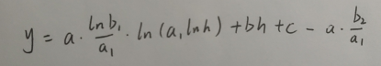

再对上式进行简化，得到

Then simplify the above equation, and get

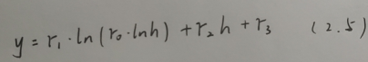

Where  are coefficients.

## **Solution of Question 2**