## Problem 3

## **Dynamic interaction model**

所谓“竞争”，是指种内或种间的两个或更多个个体间，由于它们的需求或多或少地超过了共同资源的供应而产生的一种生存斗争现象，所以在这些竞争着的个体间相互施加着不利的影响。在本问中不同类型的真菌在同一环境中争夺空间和资源以求得生存，因此他们之间的相互作用通常表现为竞争关系，即不同种群间的竞争。我们建立的模型需要解决：在同一初始环境下，不同类型真菌之间会发生什么类型的群落演化。

"Competition" refers to the struggle for existence between two or more individuals within or between species, whose demands more or less exceed the supply of common resources, thus exerting adverse effects on each other among these competing individuals. In this question, different types of fungi compete for space and resources to survive in the same environment, so the interaction between them is usually manifested as competition, that is, competition between different populations.Our model needs to address what types of community evolution occur between different types of fungi under the same initial environment.

**(1)Logistic model and Lotka-Volterra model**

在一开始营养供给充足的条件下，两种或多种真菌不会发生竞争，但当更适宜环境的真菌数量远远大于弱势方时，弱势真菌会缺少营养，有可能导致真菌死亡。也就是说，当不同类型的真菌为争夺同一食物来源和生存空间相互竞争时，常见的结局是，竞争力弱的灭绝，竞争力强的达到环境容许的最大容量。使用种群竞争模型可以描述不同类型的真菌相互竞争的过程，分析产生各种群落演化结局的条件。

At the beginning, the two or more fungal populations do not compete with each other under the condition of adequate nutrient supply. However, when the number of fungi more suitable for the environment is much larger than that of the weaker species, the weaker species will lack nutrients and may die. That is, when different types of fungi compete for the same food source and space, the common outcome is that the less competitive ones go extinct and the more competitive ones reach the maximum capacity that the environment allows. The population competition model can be used to describe the process of competition between different types of fungi and to analyze the conditions that produce the evolutionary outcomes of various communities.

当存在甲、乙两种真菌时，在空间和资源有限的情况下，一种真菌数量的增长会抑制另一种真菌的增长。用几个参数来表示两种真菌在竞争过程中服从的规律[2]如下：

When fungus 1 and fungus 2 are present, an increase in the number of one inhibits the growth of the other, given limited space and resources. Several parameters are used to represent the rules[2] that the two fungi obey in the process of competition as follows:

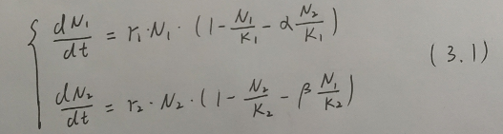

其中，

为两种真菌的规模（用数量表示）

为两种真菌的环境最大容纳量

为两种真菌的增长率

为乙对甲的竞争系数

为甲对乙的竞争系数

Where,

and are the size (expressed in number) of the two fungi;

and are the maximum environmental tolerance of the two fungi;

and are the growth rate of the two fungi;

is the coefficient of competition of 1 to 2;

is the coefficient of competition of 2 to 1.

这里引入的竞争系数和表示一种真菌所占用的空间和资源可以供另一种真菌生存的数量。因此可以通过、和之间的关系来体现甲乙两种真菌之间的抑制关系，经过分析可得两者之间的抑制关系如下：

The coefficients of competition introduced here-and represent the amount of one fungus that can be supported by the space and resources occupied by another fungus.Therefore, the inhibition relationship between fungi 1 and 2 can be reflected by the relationship betweenand. Through analysis, the inhibition relationship between the two fungi can be obtained as follows:

当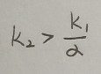时，真菌2可以抑制真菌1；

当时，真菌2不能抑制真菌1；

当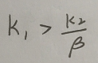时，真菌1可以抑制真菌2；

当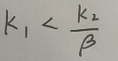时，真菌1不能抑制真菌2。

When, Fungus 2 can inhibit Fungus 1;

When,Fungus 2 can’t inhibit Fungus 1;

When,Fungus 1 can inhibit Fungus 2;

When,Fungus 1 can’t inhibit Fungus 2.

**(2)**模型奇点及类型分析**Model singularity and type analysis**

在竞争的过程中，当(3.1)中的两式都为零时，真菌1和真菌2都停止增长，系统达到相对稳定。易知其在第一象限的奇点为和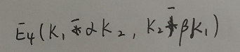。

In the process of competition, when both Equations in (3.1) are zero, both Fungi 1 and Fungi 2 stop growing, and the system is relatively stable. It's easy to know that its singularity in the first quadrant is and.

a)奇点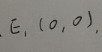对应的线性方程组为

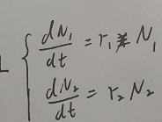

该线性方程组的系数矩阵特征方程为，故为不稳定点。

a)The linear equations corresponding to the singularity  are



The coefficient matrix characteristic equation of the linear equations is, so  is the unstable point.

b)对奇点做如下平移变换：

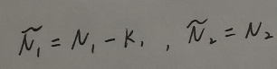

则其对应的线性方程组为

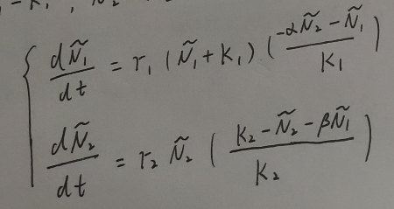

相应的系数矩阵特征方程为，故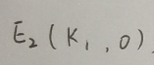为鞍点。

b) Transform the singularity as follows:



The corresponding linear system of equations are:



The characteristic equation of the corresponding coefficient matrix is, so is the saddle point.

c）同理可得对应的线性方程组的系数矩阵特征方程为。

则当时，为鞍点；当时，为稳定结点。

c) Similarly, the coefficient matrix characteristic equation of the linear system corresponding to  can be obtained as .

So when , is the saddle point; when , is the stable node.

d）对奇点作如下平移变换：



则其对应的线性方程组为

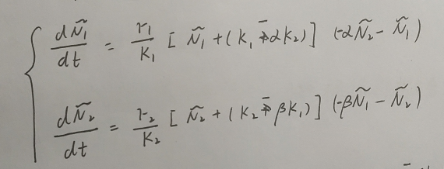

相应的特征方程为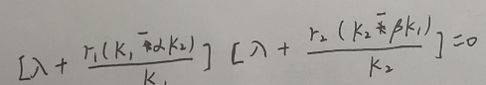，故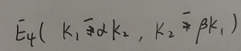为稳定点。

d) Transform the singularity as follows:



The corresponding linear system of equations are:



The corresponding characteristic equation is, so  is the stable point.

**(3)稳定性分析Stability analysis**

根据一次近似理论[3]可知和是不稳定的解，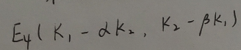是渐进稳定解。而对于的性质，则需要分三种情况来讨论。

According to the first approximation theory [3], it can be known that and are unstable solutions, and is asymptotically stable solution. As for the property of , we need to discuss it in three cases.

When, is unstable;

when,is asymptotically stable;

when, the Liapunov function is as follows:

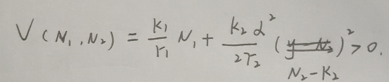

Then the following expression can be obtained:

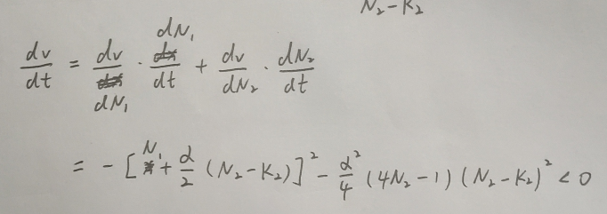

According to Liapunov's fundamental theorem, the corresponding solution to is asymptotically stable.

1. **The balance of the two fungi**

根据上述的稳定性分析，可知在不同的抑制关系下会出现如下表所示的四种结果。

According to the above stability analysis, four results as shown in the following table can be seen under different inhibition relationships.

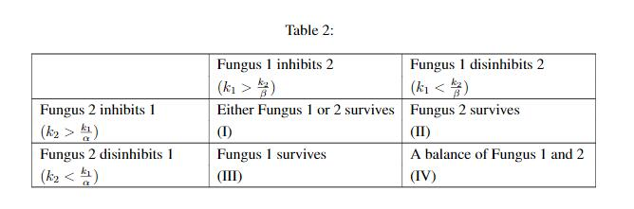

(表3.1)

利用平衡线表示上述四种结果，则(Ⅲ)和(Ⅱ)中真菌1和真菌2的平衡线没有交点，系统不可能达到平衡，两者中总有一方被淘汰；(Ⅰ)虽然存在一个平衡点，但微小的波动就会导致系统状态偏离平衡点；(Ⅳ)是一个稳定的平衡，当时间足够长时，任何初始状态都会逐渐趋近平衡点，使系统达到平衡状态。

The above four results are represented by balance lines. It can be find that under the situation (Ⅲ) and (Ⅱ) balance lines of fungus 1 and fungus 2 have no intersection, so the system can't achieve balance and one side of the two will be eliminated;Under the situation (Ⅰ) although there is a balance, but tiny fluctuations will lead to the system state deviation from equilibrium; situation (Ⅳ) is a stable equilibrium, when the time is long enough, any initial state is gradually reaching balance, make the system to reach equilibrium.

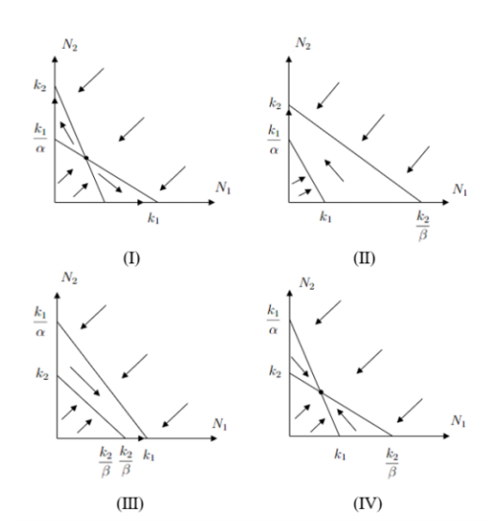(图3.1)

当大气环境变化时，会引起相关系数的变化，进而影响模型和长短期趋势，使图3.1所示的四种情况发生变化。结合表3.1可知情况(Ⅰ)对环境的快速波动最为敏感，而快速波动决定着从平衡点开始移动的方向，影响着最终真菌1和真菌2中的哪一方被淘汰，即当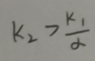且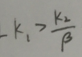时，所达到的平衡状态对大气环境的波动是非常敏感的。情况(Ⅰ)(Ⅱ)和(Ⅲ)对的改变具有一定的调节能力，短期内会受波动影响，但随着时间的推移，这种影响会逐渐消除。

When the atmospheric environment changes, it will cause changes in the correlation coefficient, which will affect the model and the long-term and short-term trends, resulting in changes in the four situations shown in Figure 3.1.Combined with Table 3.1, it can be seen that situation (Ⅰ) is most sensitive to the rapid fluctuation of the environment, and the rapid fluctuation determines the direction in which moves from the equilibrium point and affects which one of Fungus 1 and Fungus 2 is eliminated in the end. That is to say, when and, the equilibrium state reached is very sensitive to the fluctuation of the atmospheric environment. Situation (Ⅰ) (Ⅱ) and (Ⅲ) has a certain ability to adjust the change of . In the short term, it will be affected by the fluctuation, but with the passage of time, this influence will be gradually eliminated.

## **Solution of Question 3**

## Problem 4

## **Species and environment prediction model**

在第三问的基础上，利用如下Lotka-Volterra model的另一种表达形式：

On the basis of Problem 3, another expression of Lotka-Volterra model is used as follows:

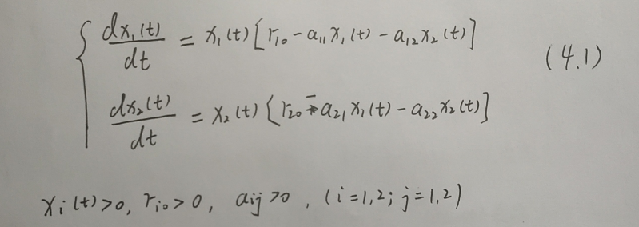

其中，

为t时刻真菌1和真菌2的规模（用数量刻画）；

为种群内的增长率；

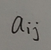为种群内的竞争系数（i=j时）或种群间的竞争系数（i≠j时）。

Where，

and  are the scale of fungi 1 and 2 at time t (described by number);

 is the growth rate within the population;

is the competition coefficient within the population (when i=j) or the competition coefficient between the populations (when i≠j).

现设表示t时刻外部因素对个体的影响量，表示t时刻外部因素对环境的影响量。假设真菌种群没有迁移且同质并引入随机干扰，即有：

Let  represent the amount of external factors influencing individuals at time t, and  represent the amount of external factors influencing the environment at time t. Assuming that the fungal population does not migrate and is homogeneous and introduces random disturbance, then:

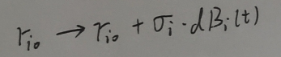

Where，

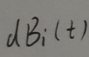is the interference of external variables;

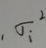 is Brown's exercise intensity.

在式（4.1）中引入如下的随机种群动力系统：

The following stochastic population dynamic system is introduced into Equation (4.1) :

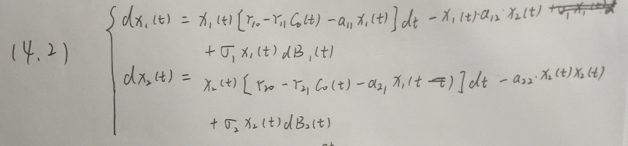

Where，

；

 is the influence intensity of external factors on the dynamical system.

Through transformation, we can get:

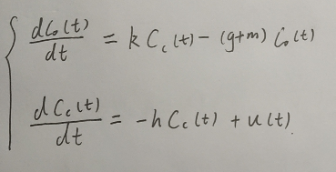（4.3）

The initial values of the two influences are

其中，

k,g,m,h均为正常数，

为t时刻种群从环境吸收的外部影响量，

为t时刻种群对外部环境的自我消化量；

为t时刻原环境对外部因素的自我消化量；

表示外部干扰对环境的输入率。

Where，

k,g,m,h are all normal numbers;

is the amount of external influence absorbed by the population from the environment at time t;

is the self-digesting amount of the population to the external environment at time t;

 is the self-digesting amount of the primary environment to external factors at time t;

 is the input rate of external disturbance to the environment.

对由（4.2）和（4.3）组成的动力干扰种群模型进行分析，并作如下定义：

The dynamic disturbance population model composed of (4.2) and (4.3) is analyzed, and the relevant symbols are defined as follows:

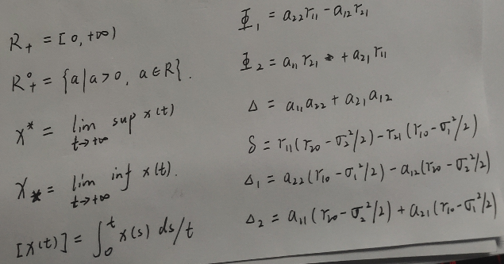

那么可以得到如下结论：

当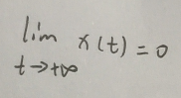a.s.真菌种群x(t)灭绝；

当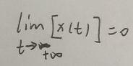a.s.真菌种群x(t)非平均持久；

当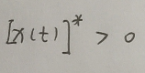a.s.真菌种群x(t)弱平均持久；

当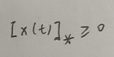a.s.真菌种群x(t)强平均持久。

Then we can get the following conclusion:

When a.s. fungal population x (t) will extinct;

when a.s. fungal population x (t) is not average persistent;

when a.s. fungal population x (t) is weakly average persistent;

when  a.s. fungal population x (t) is strongly average persistent.

通过Chen Shasha等人的证明[4]，上述4种结果对应下列4种动力干扰情况：

According to the proof of Chen Shasha et al. [4], the above four results correspond to the following four dynamic interference situations:

a)若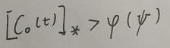，那么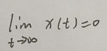，即种群灭绝

a) If, then, that is, the population will be extinct.

Where，

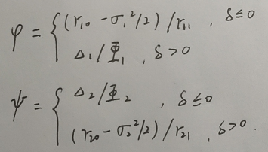

b)If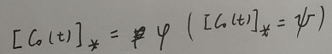，then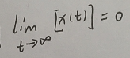,that is, the population is not average persistent;

c)If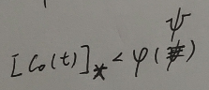,then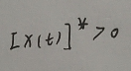,that is, the population is weakly average persistent;

d)If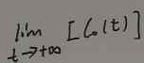is bounded and satisfies the following conditions:

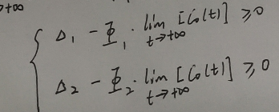

Then we can get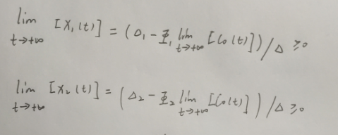,that is, the population is strongly average persistent.