# Assumptions

To simplify the problem, we make the following basic assumptions, each of which is properly justified.

* Nutrients such as ground litter and woody fibers are only broken down by fungi and not broken down or consumed by other organisms.
* The maximum environmental capacity of the fungal community is constant over a period of time and only depends on the size of space and the amount of resources.
* After a fungus has been eliminated from the competition, it is likely to reappear if environmental conditions change.
* Even when different communities are not in direct contact, they are competing and interacting with each other all the time.

# Symbol Description

|  |  |
| --- | --- |
| Symbol | Description |
| y | decomposition rate |
|  | the value of the i-th influencing factor |
| h | the hyphal extension rate |
| m | moisture trade-off |
| N | the size (expressed in number) of fungi |
| K | the maximum environmental tolerance of fungi |
| r | the growth rate of fungi |

## **Solution of Question 1**

（只需改动最后一小部分）

Using the least square method, we can get the function expression of Mass loss regarding Extension rate under different Years decayed conditions as follows:

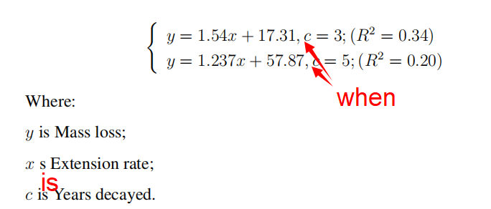

R^2 is the coefficient of determination.

由于对“分解速率”产生影响的自变量有很多，且自变量的种类也不同，因此真实情况比较复杂。本模型用线性方程来进行拟合，在简化问题的同时，也综合考虑了各个变量对分解速率的影响。且使用该模型时，结果的误差会随着数据的增多而减小。因此为了后续模型的研究，我们团队选择用线性方程来建立模型。

The real situation is complicated by the fact that there are many and different types of independent variables that affect the decomposition rate. In this model, linear equations are used for fitting. While simplifying the problem, the influence of various variables on the decomposition rate is also taken into consideration. And when using this model, the error of the result will decrease with the increase of data. Therefore, for the follow-up model research, our team chose to build the model with linear equations.

## **Solution of Question 2**

利用上述模型，我们可以拟合得到在不同温度下分解速率decomposition rate和菌丝延伸率the hyphal extension rate的关系：

Using the above model, we can fit the relationship between decomposition rate and hyphal extension rate at different temperatures:

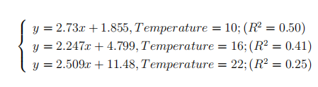（同solution1 +when）

以及分解速率decomposition rate和moisture trade-off的关系为：

And the relationship between the decomposition rate and moisture trade-off is as follows:



再将菌丝延伸率the hyphal extension rat和竞争性差异moisture trade-off对分解速率decomposition rate的影响以线性关系结合，则可以得到三者之间的关系表达式：

Then, the effects of the hyphal extension rat and moisture trade-off on decomposition rate are combined with a linear relationship, and the relationship expression among the three can be obtained:

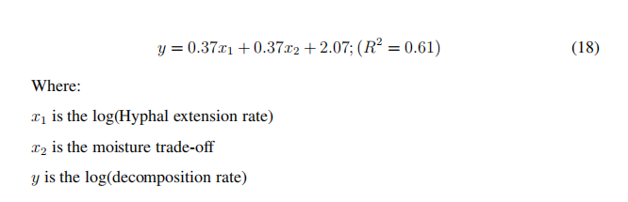

将三者的关系表达式用图像表示如下：

The relation expression of the three is represented by images:

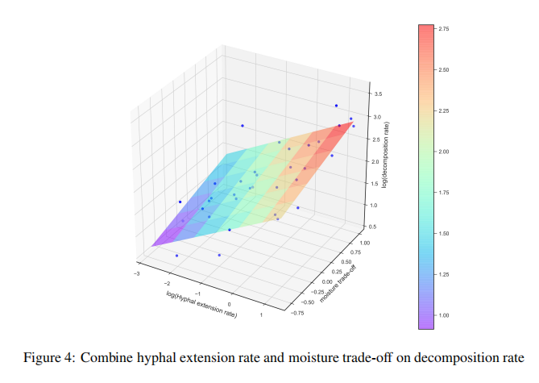

通过对Decomposition rate -- Hyphal extension rate关系图像的拟合，我们发现以“对数关系”拟合的效果远不如“线性关系”拟合的效果好。因此，我们将式(2.1)和(2.3)改进为如下(2.1*)和(2.3*)

Through the fitting of the image of Decomposition rate -- Hyphal extension rate, we find that the fitting effect with "logarithmic relationship" is far less good than that with "linear relationship". Therefore, Equations (2.1) and (2.3) are improved to Equations (2.1*) and (2.3*).

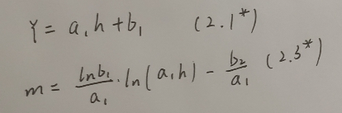

将Hyphal extension rate和moisture trade-off合并后得到下式：

After combining Hyphal Extension Rate and Moisture Trade-Off, the following formula can be obtained:

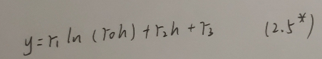

拟合后的结果符合预期效果且误差较小。

The results obtained by this method accord with the expected effect and the error is small.