# Analysis of the Problems

## Analysis of the Problem 1

本问需要建立“分解速率模型”，其中重点在于描述在多种真菌存在的情况下地面凋落物和木质纤维的分解情况。在建立模型的过程中，需要考虑woody plant species,site,years decayed,mesh,sampling side,extension rate,温度、湿度、群落间重叠度和时间等可能会影响分解过程的自变量对分解速率的影响，并将decomposition rate作为因变量进行拟合。

We need to establish a "decomposition rate model", which focuses on describing the breakdown of ground litter and woody fibers through fungal activity in the presence of multiple species of fungi. In the process of building the model, we need to consider the influence of woody plant species, site, years decayed, mesh, sampling side, extension rate, temperature, humidity overlap degree, time and other independent variables that may affect the decomposition process on the decomposition rate, and take the decomposition rate as the dependent variable for fitting.

## Analysis of the Problem 2

根据附件中Nicky Lustenhouwer等人的研究成果[1],可知菌丝延伸率the hyphal extension rate和竞争性差异moisture trade-off都与分解速率decomposition rate有着一定的关系，存在着相互作用。在本问中需要建立对这两种相互作用进行合并处理的模型，并在保持真菌分解速率不变的情况下，利用两者之间的函数关系对模型进行优化。

According to the research results of Nicky Lustenhouwer et al. in the attachment, it can be concluded that both the hyphal extension rate and the moisture trade-off are related to the decomposition rate, and there are specific interactions between them. To solve this question, we need to establish a model to combine these two interactions, and optimize the model by using the functional relationship between them while keeping the decomposition rate unchanged.

## Analysis of the Problem 3

在同一生存环境下，空间和资源都是有限的，因此不同类型真菌之间的相互作用通常表现为竞争关系，即不同种群间的竞争。在本问中需要建立以logistic模型和Lotka-Voltrra模型为基础的动态相互作用模型，并通过对增长率、抑制程度、环境容纳量等系数的控制来实现温度、湿度等大气环境对不同类型真菌之间的相互作用的影响。

In the same living environment, space and resources are limited, so the interaction between different types of fungi is usually manifested as competition relationship, that is, competition between different populations. In this question, a dynamic interaction model based on Logistic model and Lotka-Voltrra model should be established, and the influence of atmospheric environment such as temperature and humidity on the interaction between different types of fungi should be realized by controlling the growth rate, the degree of inhibition, the environmental tolerance and other coefficients.

## Analysis of the Problem 4

本问需要预测可能出现的物种组合的相对优势和相对劣势，并对不同环境进行合理预测。因此可以在第三问建立的模型的基础上考虑“动态波动”的影响，加入随机干扰因素并引入随机种群模型，从而模拟不同环境对真菌种群的影响。

This question needs to predict the relative advantages and disadvantages of possible species combinations and make reasonable predictions for different environments. Therefore, the influence of "dynamic fluctuations" can be considered on the basis of the model established in problem 3. We can add random disturbance factors and introduce a random population model to simulate the effects of different environments on the fungal population.

## Analysis of the Problem 5

为了描述系统真菌群落的多样性如何影响地面凋落物分解系统的整体效率，需要在第三问的动态相互作用模型的基础上考虑真菌群落间不同的相互作用（不只有竞争关系）共同存在时情况的变化，分析真菌种类数和分解效率的关系，并通过设置初始条件模拟局部环境的可变性。

In order to describe how the diversity of fungal communities of a system impacts the overall efficiency of a system with respect to the breakdown of ground litter, it is necessary to consider the changes when different interactions (not only competition) between fungal communities coexist on the basis of the dynamic interaction model of the third question, analyze the relationship between the number of fungal species and decomposition efficiency, and simulate the variability of local environment by setting initial conditions.

# Problem 5

## **Fungal diversity model**

生态系统中种群间的相互作用十分复杂，其类型可以大致分为三大类：第一，中性作用，即种群之间没有相互作用。事实上，生物与生物之间是普遍联系的，没有相互作用是相对的。第二，正相互作用，正相互作用按其作用程度分为偏利共生、原始协作和互利共生三类。第三，负相互作用，包括竞争、捕食、寄生和偏害等。问题三中只考虑了不同类型真菌间的竞争关系，没有考虑其他的相互作用，而在真实环境中，不同类型的真菌之间的相互作用不仅有竞争关系，还可能有正相互作用和其他的负相互作用。因此，本模型需要全面地考虑各种相互作用对分解速率的影响。

The interaction between populations in an ecosystem is very complex, and its types can be roughly divided into three categories: first, neutral interaction, that is, there is no interaction between populations. In fact, living things are universally related to each other, and no interaction is relative. Secondly, positive interaction, which can be divided into three categories: partial symbiosis, original collaboration and mutualism. Third, negative interactions, including competition, predation, parasitism and bias, etc. In the third question, only the competition between different types of fungi is considered, and other interactions are not considered. In the real environment, the interaction between different types of fungi not only contains competition, but also may have positive interactions and other negative interactions. Therefore, this model needs to comprehensively consider the effects of various interactions on the decomposition rate.

以甲、乙和丙三种真菌种群为例，为了模拟真实环境中各种相互作用共存的情况，假设真菌甲和真菌乙之间存在着正相互作用（如一方产生的物质对另一方有利等情况），同时又存在着负相互作用（如竞争生存资源等情况），这里将甲乙的关系简单地称为竞争合作关系。假设丙和甲、丙和乙之间都存在着负相互作用（如丙能分泌对甲、乙有害的物质等情况）。则可得如下几个方程式：

Using fungal populations A, B and C as examples, in order to simulate the real environment in the coexistence of a variety of interaction, assuming that there is a positive interaction between fungus A and fungus B (such as the material produced by one party is good for the other and so on), and at the same time, there is a negative interaction (such as competition for survival resources and so on). Here, the relationship between A and B is simply called the competitive and cooperative relationship.

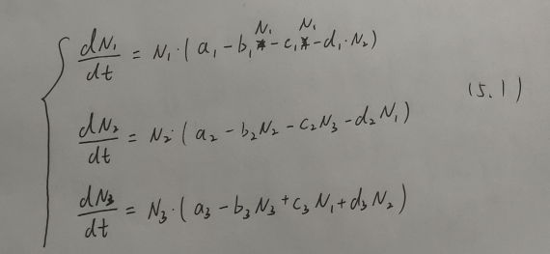

Where,,  and  are the scales of fungus A, B and C, respectively.

其中的参数满足如下几个等式：

The parameters satisfy the following equations:

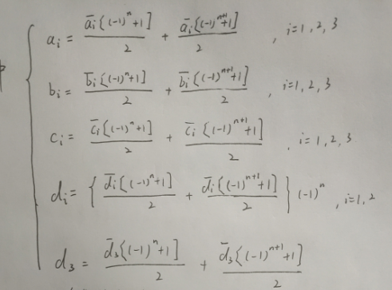

其中，

，各系数均为正数；

为第i种真菌种群内的竞争系数；

为第i种真菌种群内的增长率；

为其他种类的真菌对第i种真菌的竞争（或合作）系数。

Where,

, all the coefficients are positive.

 is the competition coefficient within the population of the ith species.

 is the growth rate within the population of the ith species.

 and  are the competition (or cooperation) coefficients of other species of fungi against the ith species of fungi.

故可知是系统（5.1）的一个正不变集[5].再结合问题三和问题四中的模型稳定性分析，可知若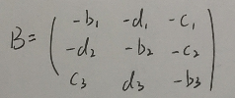存在一个正对角矩阵，使得是正定的，且满足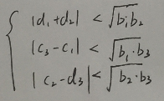，则正平衡点E是全局渐进稳定的。所以整体分解速率为

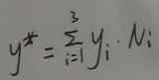

其中，为第i种真菌的分解速率。

Therefore,  is a positive invariant set of system (5.1)[5].Combined with the model stability analysis in problem 3 and problem 4, it can be seen that if  has a positive diagonal matrix, such that  is positive definite and satisfies , then the positive equilibrium E is globally asymptotically stable. So the overall rate of decomposition is ,where, is the decomposition rate of the ith fungus.

## **Solution of Question 5**

考虑到局部环境可能存在不同程度的可变性，我们可以通过对系统(5.1)设定不同的初始条件来实现不同的可变性。

（插入PDF中的模拟图）

由模拟结果可知，当初始条件满足全局渐进稳定性条件时，多样性真菌群落具有较强的“抗干扰能力”和“恢复力”，局部环境的变化一般对整体分解效率的影响较小。但是当初始条件不满足全局渐进稳定，即真菌群落的多样性被大幅度破坏时，整体分解效率会发生改变且仍不稳定，若局部环境再次发生变化，尤其是温度、湿度发生变化，会直接影响优势真菌，使整体分解效率大幅度减小。

Considering that the local environment may have varying degrees of variability, we can achieve different variability by setting different initial conditions for the system (5.1).

（插入PDF中的模拟图）

According to the simulation results, when the initial conditions meet the global asymptotic stability conditions, the diverse fungal communities have strong "anti-interference ability" and "resilience", and the local environmental changes generally have little effect on the overall decomposition efficiency. However, when the initial conditions do not meet the global gradual stability, that is, the diversity of the fungal community is greatly destroyed, the overall decomposition efficiency will change and remain unstable. If the local environment changes again, especially the change of temperature and humidity, the dominant fungi will be directly affected, and the overall decomposition efficiency will be greatly reduced.