

2026 OFFICIAL BASKETBALL RULES
BASKETBALL RULES & BASKETBALL EQUIPMENT


Valid as of 1st October 2026




是 Ba 吗？

2026 官方篮球规则
篮球规则与篮球器材


有效期至2026年10月1日
由 批准在



Official Basketball Rules 2026

As approved by

FIBA Central Board
Berlin, Germany, 23rd April 2026

Valid as of 1st October 2026

2026年官方篮球规则

经批准

国际篮联中央理事会
德国柏林，2026年4月23日

有效期至2026年10月1日

TABLE OF CONTENTS
TABLE OF DIAGRAMS 4
RULE ONE – THE GAME 5
Article 1 Definitions 5
RULE TWO – COURT AND EQUIPMENT 6
Article 2 Court 6
Article 3 Equipment 11
RULE THREE – TEAMS 12
Article 4 Teams 12
Article 5 Players: Injury and assistance 14
Article 6 Captain: Duties and powers 14
Article 7 Head coach and first assistant coach: Duties and powers 15
RULE FOUR – PLAYING REGULATIONS 16
Article 8 Playing time, tied score and overtime 16
Article 9 Start and end of a quarter, overtime or the game 16
Article 10 Status of the ball 17
Article 11 Location of a player and a referee 18
Article 12 Jump ball and alternating possession 18
Article 13 How the ball is played 20
Article 14 Control of the ball 20
Article 15 Player in the act of shooting 20
Article 16 Goal: When made and its value 21
Article 17 Throw-in 22
Article 18 Time-out 24
Article 19 Substitution 26
Article 20 Game lost by forfeit 27
Article 21 Game lost by default 28
RULE FIVE – VIOLATIONS 29
Article 22 Violations 29
Article 23 Player out-of-bounds and ball out-of-bounds 29
Article 24 Dribbling 29
Article 25 Travelling 30
Article 26 3 seconds 31
Article 27 Closely guarded player 32
Article 28 8 seconds 32
Article 29 Shot clock 32
Article 30 Ball returned to the backcourt 35
Article 31 Goaltending and basket interference 35
RULE SIX – FOULS 37
Article 32 Fouls 37
Article 33 Contact: General principles 37
Article 34 Personal foul 42
Article 35 Double foul 43
Article 36 Technical foul 43
July 2026 OFFICIAL BASKETBALL RULES 2026 Page 3 of 107

目录
图表清单 4
规则一——比赛 5
第一条 定义 5
第二条——场地与器材 6
第二条 场地 6
第三条 器材 11
规则三——球队 12
第四条 球队 12
第五条 队员：受伤和协助 14
第六条 队长：职责和权力 14
第七条 主教练和第一助理教练：职责和权力 15
规则四——比赛规则 16
第八条 比赛时间、比分相等和决胜期 16
第九条 一节、决胜期或比赛的开始和结束 16
第十条 球的状态 17
第十一条 队员和裁判员的位置 18
第十二条 跳球与交替拥有 18
第十三条 如何打球 20
第十四条 控制球 20
第十五条 投篮动作 20
第十六条 中篮和它的得分值 21
第十七条 掷球入界 22
第十八条 暂停 24
第十九条 替换 26
第二十条 比赛因弃权告负 27
第二十一条 比赛因缺少队员告负 28
规则五——违例 29
第二十二条 违例 29
第二十三条 队员出界和球出界 29
第二十四条 运球 29
第二十五条 带球走 30
第二十六条 3秒钟 31
第二十七条 被严密防守的队员 32
第二十八条 8秒钟 32
第二十九条 进攻计时钟 32
第三十条 球回后场 35
第三十一条 干涉得分与干扰得分 35
规则六——犯规 37
第三十二条 犯规 37
第三十三条 接触：一般原则 37
第三十四条 侵人犯规 42
第三十五条 双方犯规 43
第三十六条 技术犯规 43

2026年7月 官方篮球规则 2026

第3页

共107页

Article 37 Disruptive foul 45
Article 38 Flagrant foul 46
Article 39 Disqualifying foul 47
Article 40 Fighting 48
RULE SEVEN – GENERAL PROVISIONS 50
Article 41 Foul limits by a player/head coach and game disqualifications 50
Article 42 Team fouls: Penalty 50
Article 43 Special situations 51
Article 44 Free throws 51
Article 45 Correctable errors 53
RULE EIGHT – REFEREES, TABLE OFFICIALS, COMMISSIONER: DUTIES AND POWERS 57
Article 46 Referees, table officials and commissioner 57
Article 47 Crew chief: Duties and powers 57
Article 48 Referees: Duties and powers 58
Article 49 Scorer and assistant scorer: Duties 59
Article 50 Timer: Duties 60
Article 51 Shot clock operator: Duties 61
APPENDIX A – REFEREES’ SIGNALS 63
APPENDIX B – THE SCORESHEET 71
APPENDIX C – PROTEST PROCEDURE 81
APPENDIX D – CLASSIFICATION OF TEAMS 82
APPENDIX E – MEDIA TIME-OUTS 96
APPENDIX F – INSTANT REPLAY SYSTEM 97
INDEX TO THE RULES 100

TABLE OF DIAGRAMS
Diagram 1 Full size court 7
Diagram 2 Court and floor 8
Diagram 3 Restricted area 9
Diagram 4 2-point/3-point goal area 10
Diagram 5 Scorer's table and substitution chairs 10
Diagram 6 Cylinder principle 38
Diagram 7 Players' positions during free throws 52
Diagram 8 Referees' signals 70
Diagram 9 Scoresheet 71
Diagram 10 Top of the scoresheet 72
Diagram 11 Teams on the scoresheet (before the game) 73
Diagram 12 Teams on the scoresheet (after the game) 74
Diagram 13 Running score 79
Diagram 14 Summing up 80
Diagram 15 Bottom of the scoresheet 80


第三十七条 破坏性犯规 45
第三十八条 恶意犯规 46
第三十九条 取消比赛资格的犯规 47
第四十条 打架 48
规则七——一般规定 50
第四十一条 队员/主教练的犯规次数限制和比赛取消资格 50
第四十二条 全队犯规：处罚 50
第四十三条 特殊情况 51
第四十四条 罚球 51
第四十五条 可纠正的失误 53
规则八——裁判员、记录台人员和技术代表：职责和权力 57
第四十六条 裁判员、记录台人员和技术代表 57
第四十七条 主裁判：职责和权力 57
第四十八条 裁判员：职责和权力 58
第四十九条 记录员和助理记录员：职责 59
第五十条 计时员：职责 60
第五十一条 进攻计时钟操作员：职责 61
附录A 裁判员手势 63
附录 B – 记录表 71
附录C 抗议程序 81
附录D 球队名次排列 82
附录E 媒体暂停 96
附录F 即时回放系统 97
规则索引 100

图表清单
图 1 全尺寸场地示意图 7
图 2 场地与地板 8
图3 限制区 9
图4 2分/3分投篮区域 10
图5 记录台和替换椅 10
图 6 圆柱体原则 38
图7 罚球时队员的站位 52
图8 主裁判手势示意图 70
图9 记录表 71
图10 记录表顶部 72
图11 比赛前记录表上的参赛球队 73
图12 赛后记录表上的参赛球队示意图 74
图 13 实时比分 79
图 14 总结 80
图15 记录表底部 80

Throughout the Official Basketball Rules the text applies
equally to all genders and shall be read accordingly.

RULE ONE – THE GAME

Article 1 Definitions
1.1 Basketball game
Basketball is played by 2 teams of five players each. The aim of each team is to score in the opponents' basket and to prevent the other team from scoring.
The game is conducted by the referees, table officials and a commissioner, if present. Whenever the role of "commissioner" is referenced, it also applies to the role of “technical delegate”.
1.2 Participants’ responsibilities
All participants in the game, table officials, commissioners, if present, all team members entitled to play, head coaches, and other accompanying delegation members should play a positive role in the smooth running of the game and are expected to always demonstrate ethical behaviour. Should they become aware of an inaccuracy (correctable error) in scorekeeping involving the score, fouls, time-outs as well as the timekeeping and shot clock operations, they are expected to notify the referees immediately to ensure and facilitate the error being corrected in accordance with these rules.
1.3 Basket: opponents'/own
The basket that is attacked by a team is the opponents' basket and the basket which is defended by a team is its own basket.
1.4 Winner of a game
The team that has scored the greater number of points atthe end of playing time shall be the winner.

本条款适用于《官方篮球规则》全文。
对所有性别一视同仁，并应据此进行解读。

规则一——比赛

第一条 定义
1.1 篮球比赛
篮球比赛由两支各由5名队员组成的球队进行。每支球队的目标是将球投进对方篮筐，并阻止对方球队得分。
比赛由主裁判、记录台人员以及技术代表（如在场）共同进行。凡提及“技术代表”一职时，亦适用于“技术代表”这一称谓。
1.2 参与者的责任
比赛中的所有参与者——包括记录台人员、技术代表（如在场）、所有具备参赛资格的队员、主教练及其他随行代表团成员——均应在比赛顺利进行方面发挥积极作用，并始终秉持职业道德规范。若他们发现计分、犯规、暂停以及计时与进攻计时钟操作方面存在可纠正的误差，应立即通知主裁判，以确保并协助根据本规则纠正该错误。
1.3 篮筐：对方/己方
某队进攻的篮筐为对方篮筐，而某队防守的篮筐为其本队篮筐。
1.4 比赛的胜者
比赛结束时得分较多的球队即为获胜方。

RULE TWO – COURT AND EQUIPMENT

Article 2 Court
2.1 Court
The court shall have a flat, hard surface free from obstructions (Diagram 1) with dimensions of 28 m in length by 15 m in width measured from the inner edge of the boundary line.
2.2 Floor
The floor shall include the court area surrounded by a further boundary lane free from obstructions with a minimum of 2 m in width (Diagram 2). Therefore, the floor shall have dimensions of a minimum of 32 m in length and a minimum of 19 m in width.
2.3 Backcourt
A team's backcourt consists of its team's own basket, the inbounds part of the backboard and that part of the court limited by the endline behind its own basket, the sidelines and the centre line.
2.4 Frontcourt
A team's frontcourt consists of the opponents' basket, the inbounds part of the backboard and that part of the court limited by the endline behind the opponents' basket, the sidelines and the inner edge of the centre line nearest to the opponents' basket.
2.5 Lines
All lines shall be of a solid colour, 5 cm in width, clearly visible and in high contrast with the colour(s) of the playing court and the further boundary lane.
The colours of the boundary lines and other court markings may differ, however, the following principle must apply:
• All boundary lines, including sidelines, end lines, throw-in lines and team bench area lines must be of the same colour.
• The colour of each pair of other court markings must match on both half-courts. These include:
_ Restricted areas, including free throw lines and free-throw rebound places _ Free throw semi-circles
_ 3-point lines
_ No-charge semi-circles
• The centre line and the centre circle may be of a different colour than the boundary lines and other court markings. The centre line and the centre circle, between each other, may be of the same colour or of different colours.
2.5.1 Boundary line
The court shall be limited by the boundary line, consisting of the endlines and the sidelines. These lines are not part of the court.
Any obstruction, including seated head coach, first assistant coach, substitutes, excluded players and accompanying delegation members shall be at least 2 m from the court.

规则二——场地与器材

第二条 场地
2.1 场地
球场应具有一片平整、坚硬且无障碍的场地（图1），其尺寸自界线内缘起算，长28米，宽15米。
2.2 地面
场地应包括被一条无障碍的附加边界道环绕的球场区域，该边界道的最小宽度为2米（图2）。因此，场地的最小尺寸应为长32米、宽19米。
2.3 后场
一支球队的后场由该球队的篮筐、篮板的入界部分、以及以本队篮筐后方端线、边线和中线为边界的球场区域组成。
2.4 前场
一队的前场由对手的篮筐、篮板的界内部分以及由对手篮筐后方的端线、边线和中线最靠近对手篮筐的内侧边缘所限定的球场区域组成。
2.5 线
所有标线均应采用纯色，宽度为5厘米，清晰可见，且与比赛场地及其他边界区域的颜色形成高对比度。
界线及其他场地标记的颜色可有所不同，但须遵循以下原则：
• 所有界线，包括边线、端线、掷球入界线及球队席区域线，均须采用相同颜色。
• 其他对场地标记的颜色必须在两个半场上保持一致。这些标记包括：限制区，包括罚球线及罚球抢篮板球位置——罚球半圆
3分线
无撞人半圆
• 中线和中圈的颜色可与界线及其他场地标记色不同。中线和中圈之间的颜色可相同，亦可不同。
2.5.1 界线
球场由端线及边线构成的边界线所限定。这些线条均不属于球场的一部分。
包括坐着的主教练、助理教练、替补队员、被罚出场的队员及随行代表团成员在内的任何障碍物，均须与球场保持至少2米的距离。

2.5.2 Centre line, centre circle, and free-throw semi-circles
The centre line shall be marked parallel to the endlines from the midpoint of the sidelines. It shall extend 0.15 m beyond each sideline. The centre line is part of the backcourt.
The centre circle shall be marked in the centre of the court and have a radius of 1.80 m measured to the outer edge of the circumference.
The free-throw semi-circles shall be marked on the court with a radius of 1.80 m measured to the outer edge of the circumferencerenceference and with their centres at the mid-point of the free-throw lines (Diagram 3).

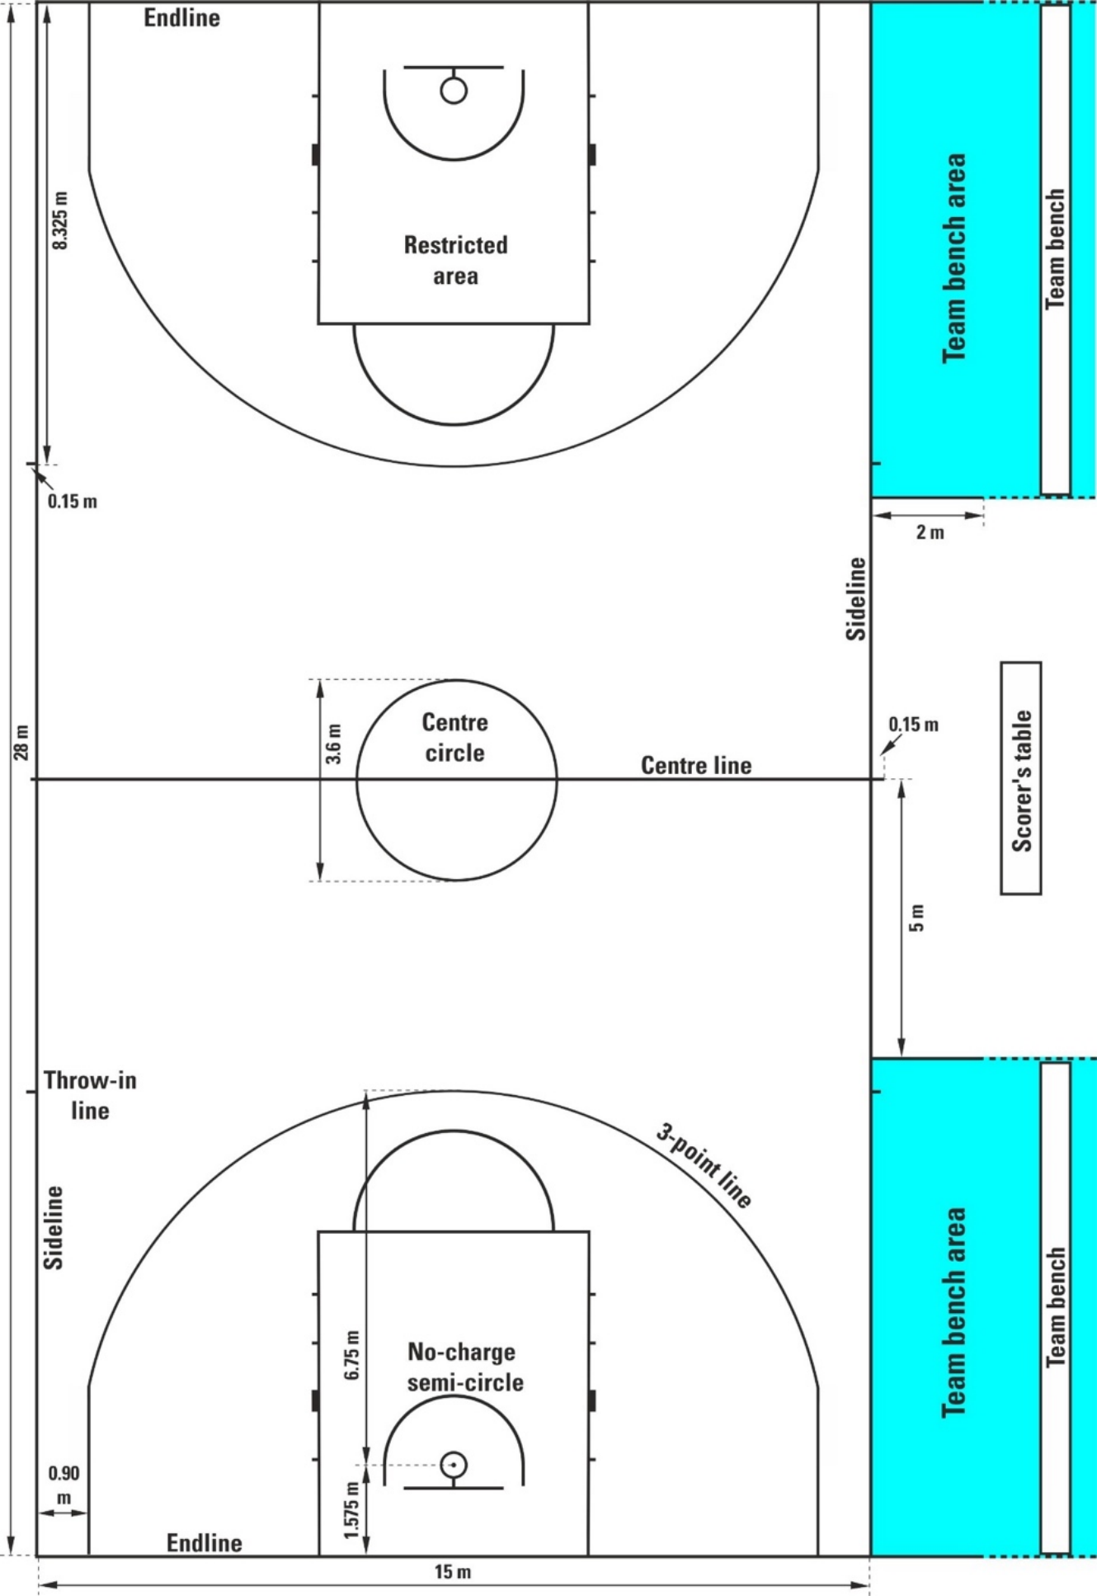
Diagram 1 Full size court

2.5.2 中线、中心圆及罚球半圆
中线应从边线的中点起，与端线平行标出。中线应每侧超出边线0.15米。中线属于后场的一部分。
中心圆应标记于球场中央，其半径为1.80米，以圆周外缘为基准测量。
罚球半圆应在场地上标出，其半径为1.80米（以圆周外缘为基准测量），圆心位于罚球线中点处（图3）。

图 1 全场

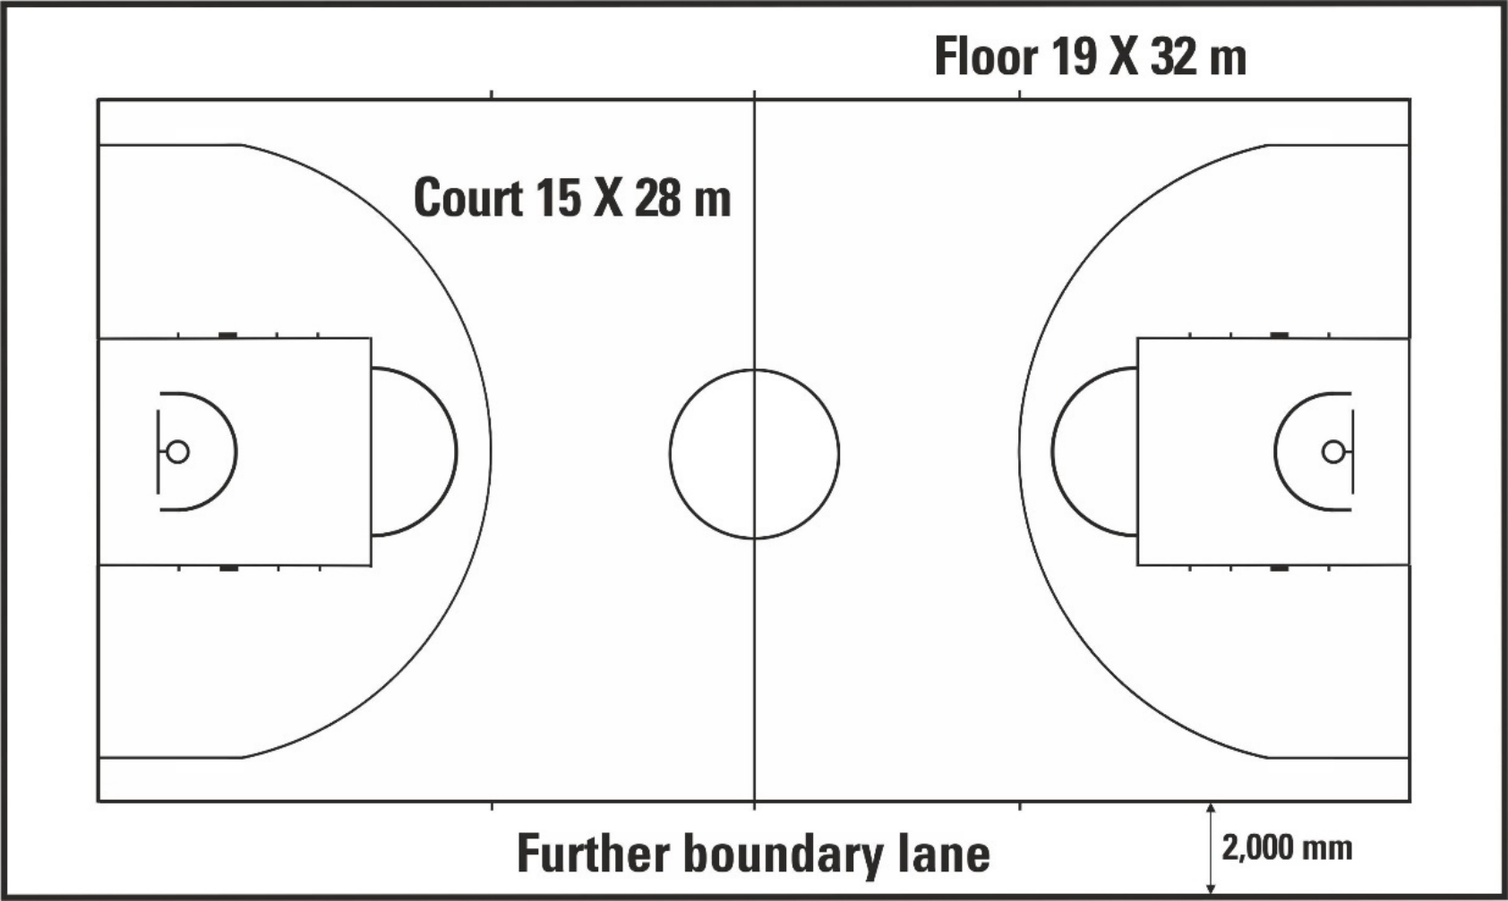
Diagram 2 Court and floor
2.5.3 Free-throw lines, restricted areas and free-throw rebound places
The free-throw line shall be marked parallel to each endline. It shall have its furthest edge 5.80 m from the inner edge of the endline and shall be 3.60 m long. Its mid-point shall lie on the imaginary line joining the mid-point of the 2 endlines.
The restricted areas shall bethe rectangular areas marked on the court limited by the endlines, the extended free-throw lines and the lines which originate at the endlines, their outer edges being 2.45 m from the mid-point of the endlines and terminating at the outer edge of the extended free-throw lines. These lines, excluding the endlines, are part of the restricted area.
Free-throw rebound places along the restricted areas, reserved for players during free throws, shall be marked as in Diagram 3.
2.5.4 3-point goal area
The team's 3-point goal area (Diagram 1 and Diagram 4) shall bethe entire court area, except for the area near the opponents' basket, limited by and including:
• The 2 parallel lines extending from and perpendicular to the endline, with the outer edge 0.90 m from the inner edge of the sidelines.
• An arc of radius 6.75 m measured from the point on the court beneath the exact centre of the opponents' basket to the outer edge of the arc. The distance of the point on the court from the inner edge of the midpoint of the endline is 1.575 m. The arc is joined to the parallel lines.
The 3-point line is not part of the 3-point goal area.
2.5.5 Team bench areas
The team bench areas shall be marked outside the court limited by 2 lines as in Diagram 1.
There must be 16 seats available in each team bench area for the head coach, the substitutes, the excluded players, and the accompanying delegation members, including assistant coaches. Any other persons shall be located at least 2 m behind the team bench.

图 2 场地与地面
2.5.3 罚球线、限制区及罚球抢篮板球位置
罚球线应与每条端线平行标记。其最远边缘距端线内缘5.80米，长度为3.60米。其中点应位于连接两条端线中点的假想线上。
限制区应为场地上标明的矩形区域，其边界由端线、延伸罚球线以及从端线延伸出的界线构成；这些边界的外缘距端线中点2.45米，并终止于延伸罚球线的外缘。除端线外，上述界线均属于限制区的一部分。
罚球区内的罚球抢篮板球位置，应如附图3所示进行标记。

2.5.4 3分投篮区域
球队的3分投篮区域（图1及图4）应为整个球场区域，但不包括靠近对方篮筐的区域，该区域由以下界线限定并包含以下部分：
• 两条自端线延伸且与端线垂直的平行线，其外边缘距边线内边缘0.90米。
• 以对手篮筐正中心下方场地上的点为起点，测量半径为6.75米的圆弧，直至该圆弧的外缘。该场地点与端线中点内缘的距离为1.575米。此圆弧与平行线相接。
三分线不属于3分投篮区域的一部分。
2.5.5 球队席区域
球队席区域应在球场外用两条线标出，具体如图1所示。
每支球队的球队席区域内，必须为主教练、替补队员、被罚出场的队员以及随行代表团成员（包括助理教练）预留16个座位。其他人员须位于球队席后方至少2米处。

2.5.6 Throw-in lines
The four throw-in lines, 2 of them on each sideline, of 0.15 m in length shall be marked outside the court, with the outer edge of the lines 8.325 m from the inner edge of the nearest endline.
2.5.7 No-charge semi-circle areas
The no-charge semi-circle areas shall be marked on the court, limited by:
• A semi-circle line with a radius of 1.30 m measured from the point on the court beneath the exact centre of the basket to the outer edge of the semi-circle. The semi-circle line is joined to:
• The 2 parallel lines perpendicular to the endline, the outer edge 1.30 m from the point on the court beneath the exact centre of the basket, 0.375 m in length and ending 1.20 m from the inner edge of the endline.
The no-charge semi-circle areas are completed by imaginary lines.nes joining the ends of the parallel lines directly below the front edges of the backboards.
The no-charge semi-circle lines are part of the no-charge semi-circle areas.

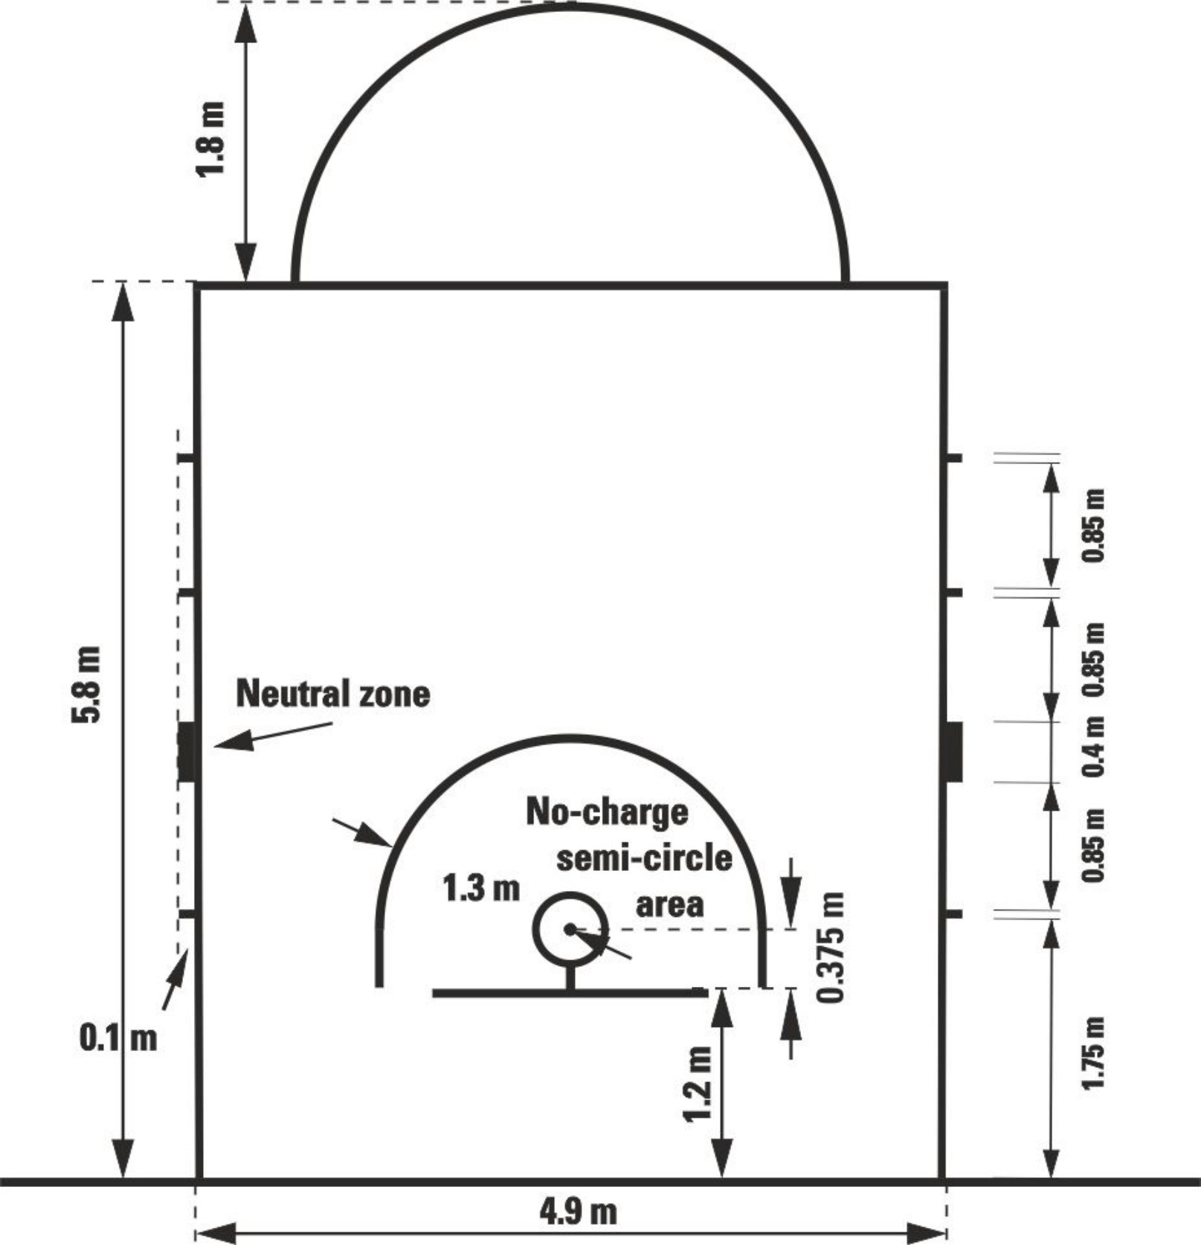
Diagram 3 Restricted area

2.5.6 掷球入界线
应在场区外标出4条掷球入界线（每条边线各设2条），每条线长0.15米，且各线的外缘距最近端线内缘8.325米。
2.5.7 无撞人半圆区域
场地内应标出无撞人半圆区域，其边界由以下要素限定：
• 一条半径为 1.30 米的半圆弧线，该半径从篮筐正中心下方场地上的点起，延伸至该半圆弧线的外缘。此半圆弧线与以下部分相连：
• 两条与端线垂直的平行线，其外缘距篮筐正下方场地上的点 1.30 米，长度为 0.375 米，末端距端线内缘 1.20 米。
无撞人半圆区域由连接篮板前缘正下方平行线末端的虚线构成。
无撞人半圆弧线属于无撞人半圆区域的一部分。

图 3 限制区

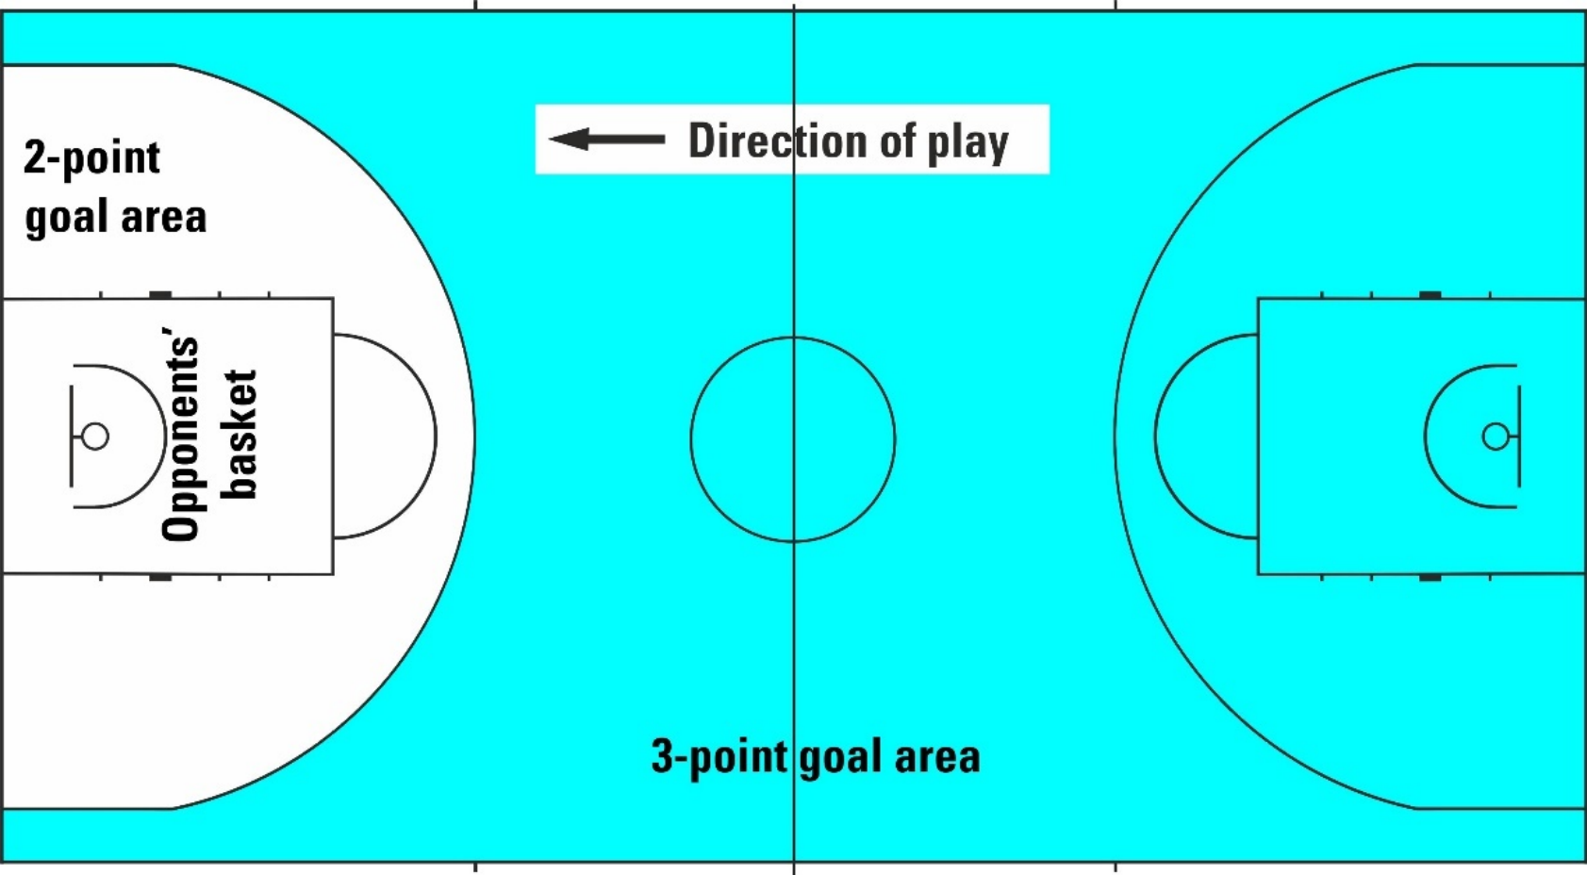

Diagram 4 2-point/3-point goal area
2.5.7 Position of the scorer's table and substitution chairs (Diagram 5)
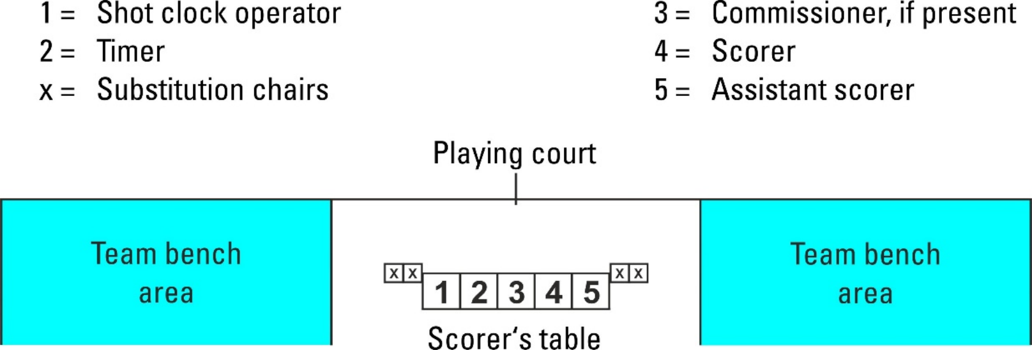
The scorer's table and its chairs must be placed on a platform. The announcer and/or statisticians (if present) can be seated at the side of and/or behind the scorer’s table.
Diagram 5 Scorer's table and substitution chairs

Page 10 of 107 OFFICIAL BASKETBALL RULES 2026 July 2026

/

图 4 2分/3分投篮区域

2.6 记录台及替换椅的摆放位置（图5）
记录员工作台及其座椅必须放置在平台上。解说员和/或统计人员（如在场）可坐在记录员工作台侧面和/或后方。
图5 记录台和替换椅

第 10 页，共 107 页 官方篮球规则 2026 2026年7月

Article 3 Equipment
The following equipment shall be required:
• Backstop units, consisting of:
_ Backboards
_ Baskets comprising (pressure release) rings and nets
_ Backboard support structures including padding.
• Basketballs
• Game clock
• Scoreboard
• Shot clock
• Stopwatch or suitable (visible) device (not the game clock) for timing time-outs
• 2 separate, distinctly different and loud signals, one of each for the _ shot clock operator,
_ timer.
• Scoresheet
• Player / head coach foul markers
• Team foul markers
• Alternating possession arrow
• Floor
• Court
• Adequate lighting.
For a more detailed description of basketball equipment, seethe Appendix on Basketball Equipment.

第三条 器材
下列器材应为必备条件：
• 篮板装置，由以下部件组成：
篮板
由（压力释放式）篮圈和球网构成的球篮
篮板支撑结构，包括衬垫。
• 篮球
• 比赛计时钟。
• 记分牌。
• 进攻计时钟。
• 用于计时暂停时间的秒表或其他合适的（可见）装置（非比赛计时钟）。
• 两种独立、截然不同且响亮的信号，分别由进攻计时钟操作员和计时员使用。
• 记录表。
• 队员/主教练犯规标志牌。
• 全队犯规标志。
• 交替拥有箭头。
• 地板。
• 场地。
• 充足的照明。
如需了解更多关于篮球器材的详细信息，请参阅附录《篮球器材》。

RULE THREE – TEAMS

Article 4 Teams
4.1 Definition
4.1.1 A team member is eligible to play when authorised to play for a team according to the regulations, including regulations governing age limits, of the organising body of the competition.
4.1.2 A team member is entitled to play when entered on the scoresheet before the start of the game and as long as the player has neither been disqualified nor committed 5 fouls.
4.1.3 During playing time, a team member is:
• A player when on the court and entitled to play.
• A substitute when not on the court but entitled to play.
• An excluded player when having committed 5 fouls, is no longer entitled to play.
4.1.4 During any interval of play, all team members entitled to play are considered players.
4.2 Rule
4.2.1 Each team shall consist of:
• No more than 12 team members entitled to play, including a captain.
• A head coach.
• A maximum of 8 accompanying delegation members, including assistant coaches who may sit on the team bench. In case a team has assistant coaches, the first assistant coach shall be entered on the scoresheet.
4.2.2 During playing time, five team members from each team shall be on the court and may be substituted.
4.2.3 During playing time, a substitute becomes a player and a player becomes a substitute when:
• The referee beckons the substitute to enter the court.
• During a time-out, a substitute requests the substitution from the timer.
During an interval of play between quarters and overtimes, a player becomes a substitute when the respective interval ends.
4.3 Uniforms
4.3.1 The uniform of all team members shall consist of:
• Shirts of the same dominant colour front and back as the shorts. If shirts have sleeves, they must end above the elbow. Long sleeved shirts are not permitted. All players must tuck their shirts into their playing shorts. 'All-in-ones' are permitted.
• Shorts of the same dominant colour front and back as the shirts. The shorts must end above the knee.
• Socks of the same dominant colour for all team members.

规则三——球队

第四条 球队
4.1 定义
4.1.1 队员若根据赛事主办方的相关规定（包括关于年龄限制的条款）获准代表某支球队参赛，则具备参赛资格。
4.1.2 队员只要在比赛开始前被记入记录表，且该队员既未被取消参赛资格，也未犯下5次犯规，即有权参赛。
4.1.3 在比赛期间，队员的角色是：
• 队员在场上且具备参赛资格时。
• 未上场但仍有参赛资格的替补队员。
• 若一名队员累计犯规达5次，则被排除在比赛之外，且不再具备参赛资格。
4.1.4 在比赛的任何间歇期间，所有具备参赛资格的队员均被视为队员。

4.2 规则
4.2.1 每支球队应由以下人员组成：
• 可参赛队员不得超过12人，其中包括一名队长。
• 一名主教练。
• 随队代表成员最多可为8人，其中包括可坐在球队席上的助理教练。若某支球队设有助理教练，则首位助理教练须记录于记录表中。
4.2.2 比赛期间，每支球队应有5名队员在场上，并可进行替补。
4.2.3 在比赛期间，替补队员成为正式队员，而正式队员在以下情况下成为替补队员：
• 主裁判示意替补队员进入场地。
• 在暂停间，替补队员需向计时员申请换人。
在节与节之间以及决胜期之间的比赛间歇期，当相应间歇期结束时，一名队员将成为替补队员。
4.3 制服
4.3.1 所有球队成员的制服均应包含以下组成部分：
• 球衣的正面与背面应采用与短裤相同的主色调。若球衣带有袖子，则袖口须位于肘部以上；禁止穿着长袖球衣。所有队员均须将球衣塞入比赛短裤内。允许穿着“All-in-ones”球衣。
• 短裤的正反两面颜色与衬衫相同。短裤长度须及膝以上。
• 所有球队成员均穿着相同主色调的袜子。

4.3.2 Each team member shall wear a shirt numbered on the front and back with plain numbers, of a colour contrasting with the colour of the shirt.
The numbers shall be clearly visible and:
• Those on the back shall be at least 16 cm high.
• Those on the front shall be at least 8 cm high.
• The numbers shall be at least 2 cm wide.
• Teams may only use numbers 0 and 00 and from 1 to 99.
• Players on the same team shall not wear the same number.
• Any advertising or logo shall be at least 4 cm away from the numbers.
4.3.3 Teams must have a minimum of 2 sets of shirts and:
• The first team named in the schedule (home team) shall wear light-coloured shirts (preferably white).
• The second team named in the schedule (visiting team) shall wear dark-coloured shirts.
• However, if the 2 teams agree, they may interchange the colours of the shirts.
4.4 Other equipment
4.4.1 All equipment used by players must be appropriate for the game. Any equipment that is designed to increase a player's height or reach or in any other way give an unfair advantage is not permitted.
4.4.2 Players shall not wear equipment (objects) that may cause injury to other players.
• The following are not permitted:
_ Finger, hand, wrist, elbow or forearm guards, helmets, casts or braces made of leather, plastic, pliable (soft) plastic, metal or any other hard substance, even if covered with soft padding.
_ Objects that could cut or cause abrasions (fingernails must be closely cut). _ Hair accessories and jewellery.
• The following are permitted:
_ Upper arm, thigh or lower leg protective equipment if sufficiently padded.
_ Arm and leg garments, including undershirts and undershorts, made of compression material.
_ Headgear. It shall not cover any part of the face entirely or partially (eyes, nose, lips etc.) and shall not be dangerous to the player wearing it and/or to other players. The headgear shall not have opening/closing elements around the face and/or neck and shall not have any parts extruding from its surface.
_ Knee, shoulder and ankle braces.
_ Protector covering an injured nose, even if made of a hard material.
_ Non-coloured transparent mouth guard.
_ Spectacles, if they do not pose a danger to other players.
_ Wristbands and headbands, maximum of 10 cm wide textile material.
_ Taping of arms, shoulders, legs etc.
All players on the team must have all their arm and leg compression garments including undershirts and undershorts, headgear, wristbands, headbands and tapings of the same solid colour.
4.4.3 During the game a player may wear shoes of any colour combination. No flashing lights, reflective material or other adornments are permitted.

4.3.2 每位队员均应在上衣正面及背面佩戴印有简洁数字的号码衫，其颜色应与上衣颜色形成对比。
数字应清晰可见，且：
• 背面的部分高度应至少为 16 cm。
• 前沿部分的高度应至少为 8 cm。
• 这些孔洞的宽度应至少为 2 cm。
• 球队仅可使用数字 0、00 以及 1 至 99。
• 同一队内的队员不得穿着相同的号码。
• 所有广告或标识与数字的间距不得少于 4 cm。
4.3.3 每支球队至少需配备两套队服，并满足以下条件：
• 赛程表中所列的第一支球队（主队）应穿着浅色球衣（首选白色）。
• 赛程表中列出的第二支球队（客队）应穿着深色球衣。
• 然而，若双方球队达成一致，可互换球衣颜色。
4.4 其他器材
4.4.1 队员使用的所有装备均须适用于比赛。任何旨在增加队员身高或触及范围，或以其他任何方式赋予不公平优势的装备均不被允许使用。
4.4.2 队员不得穿戴可能对其他队员造成伤害的装备（物品）。
• 以下行为均不被允许：
手指、手掌、腕部、肘部或前臂护具，以及由皮革、塑料、柔韧（软质）塑料、金属或任何其他硬质材料制成的头盔、固定支具或支撑装
置，即使表面覆盖有柔软衬垫。
可能造成切割或擦伤的物品（指甲须修剪整齐）；发饰及珠宝饰品。
• 以下行为是被允许的：
若防护装备已配备足够缓冲层，则可使用上臂、大腿或小腿防护装备。由加压材料制成的上下肢服装，包括内衣和短裤。
_头罩：不得完全或部分覆盖面部任何部位（如眼睛、鼻子、嘴唇等），且不得对佩戴该头罩的队员及/或其他队员构成危险。头罩在面部及/
或颈部周围不得设有开合部件，且其表面不得有任何突出部分。膝部、肩部及踝部支具。
用于覆盖受伤鼻部的防护罩，即使其材质为硬质材料。
无彩色透明护齿器。
护目镜，前提是不对其他队员构成危险。
腕带与头带，所用纺织材料宽度不得超过 10 cm。
对手臂、肩部、腿部等进行贴扎。
球队所有队员必须穿着全套手臂与腿部加压衣（包括内层背心与内层短裤）、头戴防护装备、佩戴腕带、头带，并使用同色胶带进行固定。
4.4.3 比赛期间，队员可穿着任意颜色搭配的鞋类，但禁止使用闪光装置、反光材料或其他装饰物。

4.4.4 During the game, a player may not display any commercial, promotional, or charitable name, mark, logo, or other identification, including, but not limited to, on the player’s body, in the hair, or otherwise.
4.4.5 Any other equipment not specifically mentioned in this article must be approved by the FIBA Technical Commission.

Article 5 Players: Injury and assistance
5.1 In the event of injury to a player(s), the referees may stop the game.
5.2 If the ball is live when an injury occurs, the referee shall not blow the whistle until the team in control of the ball has shot for a goal, lost control of the ball, withheld the ball from play, or the ball has become dead, unless neither team shall be placed at a disadvantage. If it is necessary to protect an injured player, the referees may stop the game immediately.
5.3 If an injured player cannot continue to play immediately (within approximately 15 seconds) or if a player receives treatment or any assistance from the player’s own head coach, assistant coaches, substitutes, excluded players, and/or accompanying delegation members, that player must be substituted unless the team is reduced to fewer than 5 players on the court.
5.4 The head coach, assistant coaches, substitutes, excluded players, and accompanying delegation members may enter the court, only with the permission of a referee, to attend to an injured player before the player is substituted.
5.5 When the ball has become dead, a doctor may enter the court without the permission of a referee if, in the doctor's judgment, the injured player requires immediate medical treatment.
5.6 During the game, any player who is bleeding or has an open wound must be substituted. The player may return to the court only after the bleeding has stopped and the affected area or open wound has been completely and securely covered.
5.7 If the injured player or any player who is bleeding or has an open wound recovers during a time-out taken by either team before the timer’s signal for the substitution, that player may continue to play.
5.8 Players who have been designated by the head coach to start the game or who receive treatment between free throws may be substituted in the event of an injury. In this case, the opponents are also entitled to substitute the same number of players, if they wish.

Article 6 Captain: Duties and powers
6.1 The captain (CAP) is a player designated by the head coach to represent the team on the court. The captain may communicate in a courteous manner withh the referees during the game to obtain information only when the ball is dead and the game clock is stopped.
6.2 The captain shall inform the crew chief no later than 15 minutes following the end of the game if the team is protesting against the result of the game and shall sign the scoresheet in the 'Captain's signature' case of protest' column.

4.4.4 比赛期间，队员不得在其身体、头发或其他部位展示任何商业、促销或慈善相关的名称、标志、徽标或其他识别标识，包括但不限于上述内容。
4.4.5 本文未特别提及的其他器材，均须经国际篮联技术委员会批准。

第五条 队员：受伤和协助
5.1 若队员受伤，主裁判可暂停比赛。
5.2 若受伤发生时球仍为活球，主裁判不得鸣哨，除非控制球的球队已尝试投篮、失去对球的控制、将球弃置场外或球已变为死球，且此举不会使任何一方处于不利境地。若需保护受伤队员，主裁判可立即终止比赛。
5.3 若受伤队员无法立即继续比赛（约15秒内），或该队员接受其主教练、助理教练、替补队员、被换下队员及/或随行代表成员的治疗或任何协助时，该队员必须被替换下场，除非场上队员人数少于5人。
5.4 主教练、助理教练、替补队员、被排除参赛的队员及随行代表成员，仅在获得主裁判许可的情况下，方可进入场地，在受伤队员被替换前对其进行关注。
5.5 当球已停时，若医生经判断认为受伤队员需要立即接受医疗救治，则可在未经主裁判许可的情况下进入场地。
5.6 比赛期间，任何出现出血或存在开放性伤口的队员必须被替换下场。该队员仅在出血停止且受伤部位或开放性伤口已完全且牢固地包扎后，方可重返场地。
5.7 若受伤队员或任何正在出血或带有开放性伤口的队员，在任一方球队在计时员发出换人信号前所进行的暂停间恢复健康，则该队员可继续参赛。
5.8 经主教练指定首发或可在罚球期间接受治疗的队员，若发生受伤，可被替换下场。在此情况下，若对手队愿意，亦有权替换同等数量的队员。

第六条 队长：职责和权力
6.1 队长（CAP）是由主教练指定代表球队上场的队员。比赛期间，队长可与裁判（简称）以礼貌的方式交流，但仅可在球已停且比赛计时钟已停止时获取信息。
6.2 若球队对比赛结果提出申诉，队长应在比赛结束后15分钟内通知队长，并须在“队长申诉时签名”栏内签署记录表。

Article 7 Head coach and first assistant coach: Duties and powers
7.1 At least 40 minutes before the game is scheduled to start, each head coach or the team’s representative shall give the scorer a list with the names and corresponding numbers of the team members who are eligible to play in the game, as well as the name of the captain of the team, the head coach and the first assistant coach. All team members whose names are entered on the scoresheet are entitled to play, even if they arrive after the start of the game.
7.2 At least 10 minutes before the game is scheduled to start, each head coach shall confirm the names and corresponding numbers of the team members and the names of the head coach and first assistant coach by signing the scoresheet. At the same time, the head coach shall indicate the 5 players to start the game. The head coach of team 'A' shall be the first to provide this information.
7.3 The head coaches, assistant coaches, substitutes, excluded players and accompanying delegation members are the only persons permitted to sit and remain within their team bench area. During playing time all substitutes, excluded players and accompanying delegation members shall remain seated.
7.4 The head coach or the first assistant coach may go to the scorer’s table during the game to obtain statistical information only when the ball becomes dead and the game clock is stopped.
7.5 The head coach may communicate in a courteous manner with the referees during the game to obtain information only when the ball is dead and the game clock is stopped.
7.6 Either the head coach or the first assistant coach, but only one of them at any given time, is permitted to remain standing during the game. They may address the players verbally during the game provided they remain within their team bench area. The first assistant coach shall not communicate with the referees.
7.7 The name of the first assistant coach, if any, must be entered on the scoresheet before the start of the game (a signature is not necessary). The first assistant coach shall assume all duties and powers of the head coach if, for any reason, the head coach is unable to continue.
7.8 If the captain leaves the court, the head coach shall inform the referee of the number of the player who shall act as captain on the court.
7.9 The captain shall act as player head coach if there is no head coach, or if the head coach is unable to continue and there is no first assistant coach entered on the scoresheet (or the latter is unable to continue). If the captain must leave the court, that captain may continue to act as player head coach. If the captain must leave following a disqualifying foul or is unable to act as player head coach because of injury, the substitute captain may act as player head coach.
7.10 The head coach shall designate the free-throw shooter of the team in all cases where the free-throw shooter is not determined by the rules.

第七条 主教练和第一助理教练：职责和权力
7.1 比赛开始前至少40分钟，每位主教练或球队代表应向记录员提供一份名单，列明球队中符合参赛条件的队员姓名及其对应号码，以及球队队长、主教练和第一助理教练的姓名。凡姓名已列入记录表的队员均有权参赛，即使他们在比赛开始后抵达。
7.2 比赛开始前至少10分钟，每位主教练应通过签署记录表，确认队员姓名及对应号码，以及主教练与助理主教练的姓名。同时，主教练须指定本场比赛的5名首发队员。A 队主教练应率先提供上述信息。
7.3 主教练、助理教练、替补队员、被罚出场的队员及随行代表团成员是仅被允许坐在本队球队席区域内的人员。比赛期间，所有替补队员、被罚出场的队员及随行代表团成员均须保持坐姿。
7.4 主教练或第一助理教练仅在球停且比赛计时停止时，方可前往记录台获取统计信息。
7.5 主教练可在比赛期间以礼貌的方式与裁判（简称）沟通，但仅可在球已停且比赛计时已停止时获取信息。
7.6 比赛期间，主教练或第一助理教练中仅允许其中一人保持站立姿势。他们可在比赛期间对队员进行口头指示，但须始终留在所属球队的球队席区域内。第一助理教练不得与裁判（简称）交流。
7.7 若设有第一助理教练，其姓名须在比赛开始前填写于记录表中（无需签名）。若因任何原因主裁判无法继续履职，第一助理教练应代行主教练的全部职责与权限。
7.8 若队长离场，主教练须将在场上担任队长的队员编号告知主裁判。
7.9 若未设主教练，或主教练无法继续履职且记录表中未列有第一助理教练（或该助理教练亦无法继续履职），则队长应担任队员主教练。若队长必须离场，该队长仍可继续担任队员主教练。若队长因被取消参赛资格而必须离场，或因伤无法担任队员主教练，则由替补队长担任队员主教练。
7.10 在规则未规定罚球手人选的所有情况下，主教练均应指定球队内的罚球手人选。

RULE FOUR – PLAYING REGULATIONS

Article 8 Playing time, tied score and overtime
8.1 The game shall consist of 4 quarters of 10 minutes each.
8.2 There shall be an interval of play of 20 minutes before the game is scheduled to start.
8.3 There shall be intervals of play of 2 minutes between the first and second quarter (first half), between the third and fourth quarter (second half), and before each overtime.
8.4 There shall be a half-time interval of play of 15 minutes.
8.5 An interval of play starts:
• 20 minutes before the game is scheduled to start.
• When the game clock signal sounds for the end of the quarter or overtime.
8.6 An interval of play ends:
• At the start of the first quarter when the ball leaves the hand(s) of the crew chief on the toss for the jump ball in the centre circle.
• At the start of all other quarters and overtime when the ball is at the disposal of the thrower-in.
8.7 If the score is tied at the end of the fourth quarter, the game shall continue with as many overtimes of 5 minutes each as necessary to break the tie.
If the aggregated score of both games for a 2-game home and away total points series competition system is tied at the end of the second game, this game shall continue with as many overtimes of 5 minutes each as necessary to break the tie.
8.8 If a foul is committed near the end of a quarter and overtime, the referee shall determine the remaining playing time. A minimum of 0.1 second shall be shown on the game clock.
8.9 If a technical, flagrant or disqualifying foul is committed during an interval of play, any eventual free throw(s) shall be administered before the start of the following quarter or overtime.

Article 9 Start and end of a quarter, overtime or the game
9.1 The first quarter starts when the ball leaves the hand(s) of the crew chief on the toss for the jump ball in the centre circle.
9.2 All other quarters or overtime start when the ball is at the disposal of the thrower-in.
9.3 The game cannot start if one or both teams are not on the court with five players ready to play.
9.4 For all games, the first team named in the schedule (home team) shall have its team bench and warm-up half-court before the game on the left side of the scorer’s table, when facing the court from the scorer’s table.
However, if both teams agree, they may exchange the team benches and/or warm- up half-courts for the first half.

规则四——比赛规则

第八条 比赛时间、比分相等和决胜期
8.1 比赛共分为4节，每节10分钟。
8.2 比赛开始前，应设有20分钟的比赛间歇期。
8.3 第一节与第二节（上半场）、第三节与第四节（下半场）之间，以及每场决胜期开始前，均须设有2分钟的比赛间歇期。
8.4 半场比赛时间应为15分钟。
8.5 比赛休息期间开始：
• 比赛开始前20分钟。
• 当比赛计时钟发出本节或决胜期结束信号时。
8.6 比赛休息期间结束：
• 在第一节开始时，当球从场地负责人手中抛出，用于中圈内的跳球时。
• 在所有其他节及决胜期开始时，若球处于掷球入界队员可掌控的状态。
8.7 若第四节结束时比分相等，比赛应继续进行必要数量的每场5分钟的决胜期，以打破平局。
若采用两回合主客场总积分制时，两场比赛的总比分在第二场结束时仍为平局，则本场将继续进行必要次数的每场5分钟的决胜期，直至分出胜负。
8.8 若犯规发生在节末或决胜期阶段，主裁判应确定剩余比赛时间。比赛计时钟上显示的剩余时间不得低于0.1秒。
8.9 若在比赛间歇期间发生技术性、恶劣性或导致取消资格的犯规，则所有最终罚球均应在下一节或决胜期开始前执行。

第九条 一节、决胜期或比赛的开始和结束
9.1 第一节比赛始于掷球裁判在中圈掷跳球时，球离开掷球裁判的手部。
9.2 其他所有节次或决胜期均始于球处于掷球入界队员可掌控之时。
9.3 若一方或双方队员未在场上且未备有5名待命队员，则比赛不得开始。
9.4 在所有比赛中，赛程表上列出的第一支球队（主队）在比赛前，应从记录台面向球场一侧，将球队席及热身半场区设于记录台的左侧。
然而，若双方球队均同意，可在上半场交换球队席及/或热身半场场地。

9.5 Teams shall exchange their warm-up half-courts and baskets for the second half.
9.6 In all overtime periods, the teams shall continue to play towards the same baskets as in the fourth quarter.
9.7 A quarter, overtime or game shall end when the game clock signal sounds for the end of the quarter or overtime. When the backboard is equipped with red lighting around its perimeter, the lighting takes precedence over the game clock signal sound.

Article 10 Status of the ball
10.1 The ball can be either live or dead.
10.2 The ball becomes live when:
• During the jump ball, the ball leaves the hand(s) of the crew chief on the toss.
• During a free throw, the ball is at the disposal of the free-throw shooter.
• During a throw-in, the ball is at the disposal of the thrower-in.
10.3 The ball becomes dead when:
• Any goal or free throw is made.
• A referee blows the whistle while the ball is live.
• It is apparent that the ball shall not enter the basket on a free throw which is to be followed by:
_ Another free throw(s).
_ A further penalty (free throw(s) and/or possession).
• The game clock signal sounds for the end of the quarter or overtime.
• The shot clock signal sounds while a team is in control of the ball.
• The ball in flight on a shot for a goal is touched by a player from either team after: _ A referee blows the whistle.
_ The game clock signal sounds for the end of the quarter or overtime.
_ The shot clock signal sounds.
10.4 The ball does not become dead and the goal counts if made when:
• The ball is in flight on a shot for a goal and:
_ A referee blows the whistle.
_ The game clock signal sounds for the end of the quarter or overtime.
_ The shot clock signal sounds.
• The ball is in flight on a free throw and a referee blows the whistle for any rule infraction other than by the free-throw shooter.
• The ball is in the control of a shooter for a goal who finishes the shot with a continuous motion which started before a foul is committed by any opponent player or by any person permitted to sit on the opponents’ team bench.
This provision does not apply, and the goal shall not count if after a referee blows the whistle an entirely new act of shooting is made.

9.5 各队应在下半场交换各自的热身半场及篮筐。
9.6 在所有决胜期中，各队将继续使用与第四节相同的篮筐进行比赛。
9.7 当比赛计时钟发出本节或决胜期结束信号时，本节、决胜期或整场比赛即告结束。若篮板四周装有红色照明灯，则该照明灯信号优先于比赛计时钟信号音。

第十条 球的状态
10.1 球可以是活球或死球。
10.2 当满足以下条件时，球变为活球：
• 在跳球过程中，球从队长手中抛出。
• 在罚球时，球由罚球手掌控。
• 在掷球入界时，球由掷球人控制。
10.3 当满足以下条件时，球变为死球：
• 任何进球或罚球均已执行。
• 主裁判在球处于活球状态时吹哨。
• 显然，在以下情况下的罚球中，球不得进入篮筐：
另一次罚球。
另处一处罚（罚球及/或控球权）。
• 比赛计时钟信号在节末或决胜期结束时响起。
• 当某支球队控制球时，击球计时信号会响起。
• 在投篮过程中，球在飞行中被任一队的一名队员触到后，主裁判吹哨。比赛计时信号在节末或决胜期结束时响起。
计时信号响起。
10.4 当满足以下条件时，球不会变为死球，且若进球则该进球有效：
• 球在投篮过程中处于飞行状态，且：
主裁判吹响了哨子。
比赛计时钟信号在节末或决胜期结束时响起。
计时信号响起。
• 罚球时球已腾空，若出现非罚球手所犯的任何违规行为，裁判（简称）应鸣哨。
• 当球由准备攻门的队员控制时，若该队员以连续动作完成投篮，且该连续动作始于任何对方队员或任何获准坐在对方队员球队席上的人员犯规之前，则此情况适用本条规定。
本条款不适用；若主裁判吹哨后，队员又完成一次全新的投篮动作，则该球无效。

Article 11 Location of a player and a referee
11.1 The location of a player is determined by where that player is touching the floor.
While airborne, the player shall retain the same status as when that player last touched the floor. This includes the boundary line, the centre line, the 3-point line, the free-throw line, the lines delimiting the restricted area and the lines delimiting the no- charge semi-circle area.
11.2 The location of a referee is determined in the same manner as that of a player. When the ball touches a referee, it isthe same as touching the floor atthe referee's location.

Article 12 Jump ball and alternating possession

12.1  12.1.1  12.1.2  12.2  12.2.1  12.2.2  12.2.3  12.2.4  12.2.5  12.2.6  12.2.7  12.2.8 | Jump ball definition  A jump ball occurs when a referee tosses the ball between any 2 opponents.  A held ball occurs when one or more players from opposing teams have one or both hands firmly on the ball so that neither player can gain control without undue roughness.  Jump ball procedure  Each jumper shall stand with both feet inside the half of the centre circle nearest to the player’s own basket with one foot close to the centre line.  Teammates may not occupy adjacent positions around the circle if an opponent wishes to occupy one of those positions.  The referee shall then toss the ball vertically upwards between the 2 opponents, higher than either of them can reach by jumping.  The ball must be tapped with the hand(s) of at least one of the jumpers after it has started its downward flight.  Neither jumper shall leave the jumper’s position until the ball has been legally tapped. Neither jumper may catch the ball or tap it more than twice until it has touched one of the non-jumpers or the court.  If the ball is not tapped by at least one of the jumpers, the jump ball shall be repeated. No part of a non-jumper's body may be on or over the circle line (cylinder) before the ball has been tapped.  An infraction of Article 12.2.1, 12.2.4, 12.2.5, 12.2.6, and 12.2.8 is a violation.
12.3 | Penalty  The ball shall be awarded to the opponents for a throw-in from the place nearest to the infraction, except from directly behind the backboard.
12.4 | Jump ball situations  A jump ball situation occurs when:  • A held ball is called.  • The ball goes out-of-bounds and the referees are in doubt or disagree on which of the opponents last touched the ball.

第十一条 队员和裁判员的位置
11.1 队员的位置由其与地面的接触点决定。
队员在腾空状态下，应保持与该队员上次触地时相同的状态。这包括边界线、中线、三分线、罚球线、限定限制区的界线以及限定无撞人半圆区域的界线。
11.2 主裁判的位置确定方式与队员相同。当球触及主裁判时，其效果等同于球触及主裁判所在位置的地板。

第十二条 跳球与交替拥有
12.1 跳球定义
12.1.1 跳球是指主裁判将球抛向任意两名队员之间时进行的动作。
12.1.2 争球是指对方球队的一名或多名队员用一只手或双手牢固地握住球，使得任何一方队员都无法在不施加不当粗暴动作的情况下控制球。
12.2 跳球程序
12.2.1 每位跳球队员应双脚均立于靠近己方篮筐的中圈半区内，其中一脚靠近中线。

若对手欲占据圆环上的某一相邻位置，队友则不得占据该相邻位置。
12.2.2
12.2.3 主裁判随后应将球垂直向上抛掷于两名队员之间，抛掷高度须超过其中任何一方可通过跳跃达到的高度。
12.2.4 球在开始向下飞行后，必须由至少一名跳球手用一只手或双手拍球。
12.2.5 双方跳球者均不得离开跳球者所处位置，直至球被合法拍球。在球接触非跳12.2.6
球者或场地之前，双方跳球者均不得接球或拍球超过两次。
12.2.7 若至少一名跳球手未对球进行拍球，则需重新进行跳球。在球被拍球前，非
12.2.8
跳球手身体的任何部分均不得位于或越过圆圈线（圆柱体）。
违反第12.2.1条、12.2.4条、12.2.5条、12.2.6条及12.2.8条的行为即构成违例。

12.3 罚则
球应判给对方，由其在距违犯地点最近处掷球入界，但直接位于篮板正后方的情况除外。
12.4 跳球情况
以下情况发生时，即构成跳球：
• 裁判判罚争球。
• 球飞出界，且裁判对哪一方队员最后触球存在疑问或意见不一。

• A double free-throw violation occurs during an unsuccessful last free throw.
• A live ball lodges between the ring and the backboard except:
_ Between free throws.
_ After the last free throw followed by a throw-in from the throw-in line in the team’s frontcourt, opposite the scorer’s table.
• The ball becomes dead when neither team has control of the ball nor is entitledd to the ball.
• After the cancellation of equal penalties against both teams, if there are no other foul penalties remaining for administration and neither team had control of the ball nor was entitled to the ball before the first foul or violation.
• All quarters other than the first quarter and all overtime periods are to start.
12.5 Alternating possession definition
Alternating possession is a method of causing the ball to become live with a throw-in rather than a jump ball.
12.6 Alternating possession procedure
12.6.1 In all jump ball situations teams shall alternate possession of the ball for a throw-in from the place nearest to where the jump ball situation occurs, except directly behind the backboard.
12.6.2 The team that does not gain the first team control of a live ball after the jump ball shall be entitled to the first alternating possession throw-in.
12.6.3 The team entitled to the next alternating possession at the end of any quarter or overtime shall start the next quarter or overtime with a throw-in from the centre line extended, opposite the scorer’s table, unless there are further free throws and a possession penalty to be administered.
12.6.4 The team entitled to the alternating possession throw-in shall be indicated by the alternating possession arrow in the direction of the opponents’ basket. The direction of the alternating possession arrow shall be reversed immediately when the alternating possession throw-in ends.
12.6.5 A violation by a team during its alternating possession throw-in causes that team to lose the alternating possession throw-in. The direction of the alternating possession arrow shall be reversed immediately, indicating that the opponents of the violating team shall be entitled to the alternating possession throw-in at the next jump ball situation. The game shall then be resumed by awarding the ball to the opponents of the violating team for a throw-in from the place of the original throw-in.
12.6.6 A foul by either team:
• Before the start of a quarter other than the first quarter or an overtime, or
• During the alternating possession throw-in,
does not cause the team entitled to the throw-in to lose that alternating possession.

• 在最后一次罚球未命中时，会发生一次双罚球违例。
• 活球应位于篮筐与篮板之间，但以下情况除外：
_罚球之间。
在最后一次罚球之后，球队于前场掷球线处（与记录台相对）进行掷球入界。
• 当双方球队均不控制球，且均无权拥有该球时，该球即变为死球。
• 在双方球队被取消同等罚则后，若再无其他可判处的犯规罚则，且双方在首次犯规或违例前均未控制球，亦均无权拥有该球。
• 除第一节以外的所有节以及所有决胜期均须开始。
12.5 交替拥有定义
交替拥有是一种通过掷球入界而非跳球，使球恢复为活球的方法。
12.6 交替拥有程序
12.6.1 在所有跳球情况下，各队应从距跳球发生地点最近处进行掷球入界时交替拥有球权，但直接位于篮板后方时除外。
12.6.2 在跳球后未能率先获得对活球的控制权的球队，有权获得首次交替拥有掷球入界机会。
12.6.3 在任何节末或决胜期结束时，有权获得下一次交替拥有的球队，应从中线向与记录台相对的方向掷球入界开始下一节或决胜期，除非另有罚球及进攻犯规处罚待执行。
12.6.4 有权进行交替拥有掷球入界的球队，应在指向对方篮筐的方向上标出交替拥有箭头。当交替拥有掷球入界结束时，交替拥有箭头的指向应立即反转。
12.6.5 某队在交替拥有掷球入界期间发生违例，则该队将失去此次交替拥有掷球入界机会。交替拥有箭头方向须立即反向，表明该违例队的对手在下一跳球情况下有权获得交替拥有掷球入界机会。比赛随后应通过将球权判给该违例队的对手，从原掷球入界地点进行掷球入界来恢复比赛。
12.6.6 任一方犯规：
• 在除第一节或决胜期之外的其他节开始之前，或
• 在交替拥有时的掷球入界中，并不导致拥有掷球入界权的球队失去该交替拥有权。

Article 13 How the ball is played
13.1 Definition
During the game, the ball is played with the hand(s) only and may be passed, thrown, tapped, rolled or dribbled in any direction, subject to the restrictions of these rules.
13.2 Rule
A player shall not run with the ball, deliberately touch the ball, kick or block it with any part of the leg or strike it with the fist.
However, to accidentally come into contact with or touch the ball with any part of the leg is not a violation.
An infraction of Article 13.2 is a violation.

13.3 Penalty
The ball shall be awarded to the opponents for a throw-in from the place nearest to the infraction, except from directly behind the backboard.

Article 14 Control of the ball
14.1 Definition
14.1.1 Team control starts when a player of that team is in control of a live ball by holding or dribbling it or has a live ball at a player’s disposal.
14.1.2 Team control continues when:
• A player of that team is in control of a live ball.
• The ball is being passed between teammates.
14.1.3 Team control ends when:
• An opponent gains control.
• The ball becomes dead.
• The ball has left the player's hand(s) on a shot for a goal or for a free throw.

Article 15 Player in the act of shooting
15.1 Definition
15.1.1 A shot for a goal or a free throw occurs when the ball is held in a player’s hand(s) and is then thrown into the air towards the opponents' basket.
A tap for a goal occurs when the ball is directed with the hand(s) towards the opponents' basket.
A dunk for a goal occurs when the ball is forced downwards into the opponents' basket with one or both hands.
15.1.2 The act of shooting on jump shots or other moving shots:
• Starts when the player begins to move the shoulders and the ball upwards towards the opponents’ basket.
• Ends when the ball has left the player’s hand(s), or if an entirely new act of shooting is made and, in the case of an airborne shooter, both feet have returned to the floor.

第十三条 如何打球
13.1 定义
比赛期间，球仅可用手操作，并可在本规则限制范围内向任何方向传球、投掷、拍球、滚球或运球。
13.2 规则
队员不得持球奔跑、故意触球、用腿部任何部位踢或挡球，或以拳头击球。然而，若用腿部任何部位意外接触或触碰球，则不构成违例。
违反第13.2条即构成违例。

13.3 处罚
球权应判给对方，由对方从距违犯地点最近处掷球入界，但直接从篮板正后方掷球的情况除外。

第十四条 控制球
14.1 定义
14.1.1 球队控制始于该队队员通过拉人或运球控制活球，或该队员可支配活球之时。
14.1.2 球队控制在以下情况下继续：
• 该队的一名队员正在控制一个活球。
• 球正在队员之间传球。
14.1.3 球队控制在以下情况下结束：
• 对手获得控制权。
• 球变为死球。
• 在投篮或罚球时，球已离开队员的手。

第十五条 投篮动作
15.1 定义
15.1.1 当球被队员握在手中，随后将球投向对方篮筐时，即构成一次进球投篮或罚球。
当球被用手（或双手）朝向对方篮筐击出时，即构成一次进球拍球。
当队员用一只手或双手将球用力压入对方篮筐时，即构成一次扣篮得分。

15.1.2 跳投或其他动态投篮的投篮动作：
• 当队员开始移动肩膀并将球向上运向对方篮筐时，此动作即开始。
• 当球已离开队员的手（s），或若执行了全新的投篮动作，且对于空中投篮者，双脚均已落回地面时，该动作即告结束。

15.1.3 The act of shooting in a continuous movement on drives to the basket:
• Starts when the player has gathered the ball and it comes to rest in the player’s hand(s), upon completion of a dribble or a catch in the air, and the player continues the shooting motion preceding the release of the ball for a goal.
• Ends when the ball has left the player’s hand(s), or if an entirely new act of shooting is made and, in the case of an airborne shooter, both feet have returned to the floor.
A continuous movement in the act of shooting on drives to the basket is an action of the player in the team’s frontcourt, typically starting between the offensive 3-point line and the basket, in which the player gathers the ball upon completion of a dribble or catches the ball while progressing, and then continues the shooting motion towards the basket, usually upwards.
15.1.4 For a player to be in the act of shooting, the player must be in the frontcourt.
An exception is made that a player may be anywhere on the court during the last action before:
• the expiration of a game clock for the end of the quarter or overtime; or
• the expiration of a shot clock at any time of the game.
In such cases, the act of shooting starts when the player has gathered the ball and it comes to rest in the player's hand(s).
15.1.5 There is no relationship between the number of legal steps taken and the act of shooting
15.1.6 During the act of shooting the player might have the arm(s) held by an opponent, thus being prevented from scoring. In this case it is not essential that the ball leaves the player's hand(s).
15.1.7 When a player is in the act of shooting on jump shots or other moving shots and after being fouled,
• passes the ball off or
• if the ball is moved upwardd in a direction away from the basket or
• if the player is not facing the basket when the ball is moved in an upward motion, that player is no longer considered to have been in the act of shooting.
15.1.8 When a player is in the act of shooting on a drive to the basket and after being fouled passes the ball off that player is no longer considered to have been in the act of shooting.

Article 16 Goal: When made and its value
16.1 Definition
16.1.1 A goal is scored when a live ball enters the basket from above and remains within or passes through the basket entirely.
16.1.2 The ball is within the basket when the slightest part of the ball is within the basket and below the level of the ring.

15.1.3 在向篮筐推进的连续动作中完成的投篮动作：
• 当队员已接住球且球静止于其手中，或完成运球或空中接球后，队员继续投篮动作并在释放球以得分时，本回合即开始。
• 当球已离开队员的手（s），或若执行了全新的投篮动作，且对于空中投篮者，其双脚均已落回地面时，该回合即告结束。
在篮下突破投篮动作中，队员在前场进行的连续动作是指：该队员通常从进攻端三分线至篮筐之间开始，在完成运球后接球，或行进中接球，随后继续向篮筐方向完成投篮动作——通常朝上投篮。
15.1.4 一名队员要处于投篮动作中，该队员必须位于前场。
例外情况是：队员在最后一次动作前可位于球场任意位置：
• 本节末或决胜期结束时比赛计时钟的归零；或
• 比赛过程中任意时刻进攻计时钟的到期。
在此类情况下，投篮动作始于队员接球且球静止于其手中时。

15.1.5 合法步数与投篮动作之间不存在关联。
15.1.6 在投篮动作过程中，队员的手臂可能被对手抓住，从而无法得分。在此情况下，球是否离开队员的手并非必要条件。
15.1.7 当一名队员正在执行跳投或其他移动投篮动作，且在被犯规后，
• 传球或
• 若球沿远离篮筐的方向向上移动，或
• 若队员在球向上移动时未面向篮筐，则该队员不再被视为处于投篮动作中。
15.1.8 当一名队员在向篮筐推进的投篮动作中遭犯规后，若将该球传给该队员以外的其他队员，则不再被视为处于投篮动作中。

第十六条 中篮和它的得分值
16.1 定义
16.1.1 当活球从上方进入篮筐，并完全位于篮筐内或穿过篮筐时，即算得进球。
16.1.2 当球的任何微小部分进入篮筐且位于篮筐平面以下时，即判定球已入筐。

16.2 Rule
16.2.1 A goal is credited to the team attacking the opponents’ basket into which the ball has entered as follows:
• A goal released from a free throw counts 1 point.
• A goal released from the 2-point goal area counts 2 points.
• A goal released from the 3-point goal area counts 3 points.
After the ball has touched the ring on a last free throw and is legally touched by any player before it enters the basket, the goal counts 2 points.
16.2.2 If a player accidentally scores a goal in the team’s own basket, the goal counts 2 points and shall be entered on the scoresheet as scored by the captain of the opponents’ team on the court.
16.2.3 If a player deliberately scores a goal in the team’s own basket, it is a violation and the goal shall not count.
16.2.4 If a player causes the entire ball to pass through the basket from below, it is a violation.
16.2.5 The game clock or the shot clock must show 0.3 (3 tenths of a second) or more for a player to gain control of the ball on a throw-in or on a rebound after the last free throw to attempt a shot for a goal. If the game clock or the shot clock shows 0.2 or 0.1 the only type of a valid goal that can be made is by tapping or directly dunking the ball, provided that the hand(s) of the player are no longer touching the ball when the game clock or the shot clock shows 0.0.

Article 17 Throw-in
17.1 Definition
17.1.1 A throw-in occurs when the ball is passed on to the court by the out-of-bounds thrower-in.
17.1.2 A throw-in:
• Starts when the ball is at the disposal of the thrower-in.
• Ends when:
_ The ball touches or is legally touched by any player on the court.
_ The team of the thrower-in commits a violation.
_ A live ball lodges between the ring and the backboard during a throw-in.
17.2 Procedure
17.2.1 A referee must hand or place the ball at the disposal of the thrower-in. The referee may also toss or bounce pass the ball provided that:
• The referee is no more than 4 m away from the thrower-in.
• The thrower-in is at the correct place as designated by the referee.
17.2.2 The player shall take the throw-in from the place nearest to the infraction or where the game was stopped, except from directly behind the backboard.
17.2.3 At the start of all quarters other than the first quarter and all overtime periods, the throw-in shall be administered from the centre line.ne extended, opposite the scorer's table.
The thrower-in shall have one foot on either side of the centre line extended, opposite the scorer’s table, and shall be entitled to pass the ball to a teammate at any place on the court.

16.2 规则
16.2.1 当球进入对方篮筐时，进攻方球队得一分，具体规则如下：
• 罚球命中得1分。
• 从两分球区射入的进球计为2分。
• 从3分投篮区域内发射的球计为3分。
若球在最后一次罚球时已触碰到篮圈，且在进入篮筐前被任何队员合法触到，则该得分计为2分。
16.2.2 若队员意外在己方篮筐内得分，则该得分计为2分，并须以对手队队长在场上得分的形式记录于记录表中。
16.2.3 若队员故意在己方球筐内得分，则构成违例，该得分无效。
16.2.4 若一名队员导致整球从下方穿过篮筐，则构成违例。
16.2.5 当一名队员在掷球入界或最后一次罚球后的篮板球中试图投篮时，比赛计时钟或进攻计时钟必须显示0.3秒（即十分之三秒）或更长时间，该队员方可获得控制球权。若比赛计时钟或进攻计时钟显示0.2秒或0.1秒，则唯一有效的得分方式仅为拍球或直接扣篮，且须满足：当比赛计时钟或进攻计时钟显示0.0秒时，该队员的手部已不再接触球。

第十七条 掷球入界
17.1 定义
17.1.1 当掷球入界者将球传至场内时，即构成掷球入界。
17.1.2 掷球入界：
• 当球处于掷球入界者的控制之下时，比赛开始。
• 终止条件为：
球与场上任何队员发生接触，或被队员合法触碰。
掷球入界方球队犯下违例。
在一次掷球入界过程中，活球卡在篮筐与篮板之间。
17.2 程序
17.2.1 主裁判必须将球递予或放置于掷球入界队员可使用的位置。主裁判亦可抛球或弹球传球，但须满足以下条件：
• 主裁判与掷球入界者之间的距离不得超过4米。
• 掷球入界者已位于主裁判指定的正确位置。
17.2.2 队员应从最靠近违犯地点或比赛被暂停地点处执行掷球入界，但不得从篮板正后方执行。
17.2.3 除第一节及所有决胜期外，每节比赛开始时，掷球入界均应从与记录台相对的中线延伸线处进行。掷球人须将一脚置于与记录台相对的中线延伸线两侧，并有权将球传给场上任意位置的队友。

17.2.4 When the game clock shows 2:00 minutes or less in the fourth quarter and in each overtime, following a time-out taken by the team entitled to the possession of the ball from its backcourt, the head coach of that team has the right to decide whether the game shall be resumed with a throw-in from the throw-in line in the team’s frontcourt or from the team’s backcourt at the place nearest to where the game was stopped. If the head coach decides to resume the game with a frontcourt throw-in and the original throw-in is in the backcourt, from
• At the endline after a successful goal or a successful last free throw, the head coach shall decide whether the throw-in shall take place from the throw-in line on the table side or on the opposite side.
• After a foul, violation (including an out-of-bounds violation), or a jump ball situation, the throw-in shall take place in the frontcourt from the throw-in line on the same side of the court (table side or opposite side) as the original throw-in.
17.2.5 Following a personal foul committed by a player of the team in control of a live ball, or of the team entitled to the ball, the game shall be resumed with a throw-in from the place nearest to the infraction.
17.2.6 Following a technical foul, the game shall be resumed with a throw-in from the place nearest to where the ball was located when the technical foul was committed, unless otherwise stated in these rules.
17.2.7 Following a disruptive, flagrant, or disqualifying foul, the game shall be resumed with a throw-in from the throw-in line in the team’s frontcourt, opposite the scorer’s table, unless otherwise stated in these rules.
17.2.8 Following a fight, the game shall be resumed as stated in Article 40.
17.2.9 Whenever the ball enters the basket, but the goal or the last free throw is not valid, the game shall be resumed with a throw-in from the free-throw line extended.
17.2.10 Following a successful goal or a successful last free throw:
• Any player of the non-scoring team shall take the throw-in from any place behind that team’s endline. This is also applicable after a referee hands or places the ball at the disposal of the thrower-in after a time-out or after any interruption of the game following a successful goal or a successful last free throw.
• The thrower-in from behind the endline may move laterally along the endline and/or backward, and the ball may be passed between teammates, but the 5-second count starts when the ball is at the disposal of the first player out-of-bounds.
17.3 Rule
17.3.1 The thrower-in shall not:
• Take more than 5 seconds to release the ball.
• Step onto the court while having the ball in the hand(s).
• Cause the ball to touch out-of-bounds after it has been released on the throw-in.
• Touch the ball before it has touched another player on the court.
• Cause the ball to enter the baskett directly.
• Move from the designated throw-in place behind the boundary line laterally in one or both directions, exceeding a total distance of 1 m before releasing the ball. However, the player is permitted to move directly backwards from the boundary line as far as circumstances allow.

17.2.4 当比赛计时钟在第四节及每场决胜期中显示剩余时间≤2分钟，且拥有球权的球队自后场获得暂停后，该球队的主教练有权决定：比赛是否应从球队前场的掷球入界线起，或从球队后场中距比赛暂停点最近处起，以掷球入界方式继续进行。若主教练决定以前场掷球入界继续比赛，而原掷球入界位于后场，
• 在成功进球或成功执行最后一次罚球后，当球抵达边线时，主教练应决定掷球入界是从场边桌侧的掷球线进行，还是从对侧的掷球线进行。
• 在发生犯规、违例（包括界外违例）或跳球情况后，若球位于边线或端线附近，则掷球入界应在前场进行，且掷球线位于与首次掷球相同的球场一侧（桌侧或对侧）。
17.2.5 若控制活球的球队或拥有球权的球队的队员犯下侵人犯规，比赛应从距违犯地点最近处以掷球入界方式重新开始。
17.2.6 发生技术犯规后，比赛应从距实施该技术犯规时球所在位置最近处以掷球入界方式恢复，除非本规则另有规定。
17.2.7 若发生破坏性、恶劣性或导致判罚的犯规，比赛应从球队前场中与记录台相对的掷球入界线处重新进行，除非本规则另有规定。
17.2.8 发生争执后，比赛应按照第40条的规定继续进行。
17.2.9 每当球进入篮筐，但进球或最后一次罚球无效时，比赛应从罚球线延伸处以掷球入界方式重新开始。
17.2.10 在成功进球或成功执行最后一次罚球后：
• 非得分方球队的任何队员，均可从该球队端线后方任意位置进行掷球入界。此规定亦适用于以下情形：暂停结束后，或进球或成功执行最后一次罚球后比赛任何中断期间，主裁判将球递交或放置于掷球人可支配范围内时。
• 从端线后方掷球的队员可沿端线横向移动和/或向后移动，且球可在队友之间传球，但当球处于首位出界队员的可控范围时，5秒计时即开始。

17.3 规则
17.3.1 掷球入界者不得：
• 释放球的时间超过5秒。
• 手持球时步入球场。
• 在掷球入界后，使球触及界外。
• 在球接触场上其他队员之前触球。
• 使球直接进入篮筐。
• 从界线后方的指定掷球入界位置向一侧或两侧移动，在释放球前总移动距离不得超过1米。但队员可在实际情况允许的情况下，从界线处直接向后移动。

17.3.2 During the throw-in other player(s) shall not:
• Have any part of their bodies over the boundary line before the ball has been thrown in across the boundary line.
• Be closer than 1 m to the thrower-in when the throw-in place has less than 2 m distance between the boundary line and any out-of-bounds obstructions.
17.3.3 When the game clock shows 2:00 minutes or less in the fourth quarter and in each overtime and there is a throw-in, the referee shall use an ‘illegal boundary line crossing’ signal as a warning to the defensive player before administering the throw- in.
If a defensive player then:
• Moves any part of the body over the boundary line to interfere with a throw-in, or
• Is closer than 1 m to the thrower-in when the throw-in place has less than 2 m distance,
it is a violation and shall lead to a technical foul.
An infraction of Article 17.3 is a violation.

17.4 Penalty
The ball shall be awarded to the opponents for a throw-in from the place of the original throw-in.

Article 18 Time-out
18.1 Definition
A time-out is an interruption of the game requested by the head coach or first assistant coach.
18.2 Rule
18.2.1 Each time-out shall last one minute.
18.2.2 A time-out may be granted during a time-out opportunity.
18.2.3 A time-out opportunity starts when:
• For both teams, the ball becomes dead, the game clock is stopped and the referee has ended communication with the scorer's table.
• For both teams, the ball becomes dead following a successful last free throw.
• For the non-scoring team, a goal is scored.
18.2.4 A time-out opportunity ends when the ball is at the disposal of a player for a throw-in or for a first free throw.
18.2.5 Each team may be granted:
• 2 time-outs during the first half.
• 3 time-outs during the second half with a maximum of 2 of these time-outs when the game clock shows 2:00 minutes or less in the fourth quarter.
• 1 time-out during each overtime.
18.2.6 Unused time-outs may not be carried over to the next half or overtime.

17.3.2 在掷球入界期间，其他队员不得：
• 在球被掷入界内之前，其身体任何部位是否已越过界线？
• 当掷球入界地点的边界线与任何界外障碍物之间的距离小于2米时，与掷球入界者保持的距离不得小于1米。
17.3.3 当比赛计时钟在第四节及每场决胜期中显示剩余时间≤2分钟，且出现掷球入界时，主裁判应在执行掷球入界前，向防守队员发出“非法越界线”信号作为警告。
若防守队员随后：
• 将身体任何部位移至界线外，从而干扰掷球入界，或
• 当掷球入界点与掷球人之间的距离小于2米时，该距离应小于1米。

这构成违例，并将导致技术性犯规。
违反第17.3条即构成违例。

17.4 处罚
球应判给对方，并从原掷球入界地点进行掷球入界。

第十八条 暂停
18.1 定义
暂停是指主教练或首席助理教练要求对比赛进行的中断。
18.2 规则
18.2.1 每次暂停时间均为1分钟。
18.2.2 在暂停机会期间，可给予一次暂停。
18.2.3 暂停机会在以下情况下触发：
• 对于双方球队而言，球变为死球，比赛计时钟停止运行，且主裁判已与记录员做结束沟通。
• 对于双方球队而言，在最后一次罚球命中后，球权即转为死球。
• 对于未得分的球队，则计入一球。
18.2.4 暂停机会在球由队员可用于掷球入界或首次罚球时结束。
18.2.5 每支球队均可获得以下资源：
• 上半场共使用两次暂停。
• 下半场可使用3次暂停，若比赛计时钟显示第四节剩余时间≤2分钟，则此类暂停次数最多不得超过2次。
• 每场决胜期中执行一次暂停。
18.2.6 未使用的暂停时间可能不得延续至下一半场或决胜期。

18.2.7 A time-out is charged against the team whose head coach or first assistant coach first made a request unless the time-out is granted following a goal scored by the opponents and without an infraction having been committed.
18.2.8 A time-out shall not be permitted to the scoring team when the game clock shows 2:00 minutes or less in the fourth quarter and in each overtime and following a successful goal, unless a referee has interrupted the game.
18.3 Procedure
18.3.1 Only a head coach or first assistant coach has the right to request a time-out. The coach shall establish visual contact with the scorer’s table or shall go to the scorer’s table and ask clearly for a time-out, making the proper conventional sign with the hands.
18.3.2 A time-out request may be cancelled only before the timer's signal has sounded for such a request.
18.3.3 The time-out period:
• Starts when the referee blows the whistle and gives the time-out signal.
• Ends when the referee blows the whistle and beckons the teams back onto the court.
18.3.4 When a time-out opportunity starts, the timer shall sound the signal to notify the referees that a team has requested a time-out.
If a goal is scored against a team which has requested a time-out, the timer shall immediately stop the game clock and sound the signal.
18.3.5 During the time-out and during an interval of play before the start of the second and fourth quarters or each overtime, the players may leave the court and sit on the team bench and any person permitted to sit on the team bench may enter the court, provided they remain within the vicinity of their team bench area.
18.3.6 If the request for a time-out is made by either team after the ball is at the disposal of the free-throw shooter for the first free throw, the time-out shall be granted if:
• The last free throw is successful.
• The last free throw, if not successful, is followed by a throw-in.
• A foul is committed between free throws. In this case, the set of free throws shall be completed and the time-out shall be permitted before the new foul penalty is administered, unless otherwise stated in these rules.
• A foul is committed before the ball becomes live after the last free throw. In this case, the time-out shall be permitted before the new foul penalty is administered.
• A violation is committed before the ball becomes live after the last free throw. In this case, the time-out shall be permitted before the throw-in is administered.
In the event of consecutive sets of free throws and/or possession of the ball resulting from more than one foul penalty, each set shall be treated separately.

18.2.7 暂停权由主教练或首席助理教练首次提出请求的球队获得，除非在对手得分后 且未发生违犯的情况下准予该暂停。
18.2.8 当比赛计时钟显示第四节及每场决胜期中剩余时间≤2分钟，或进球成功后，记录方不得获得暂停机会，除非主裁判已中断比赛。
18.3 程序
18.3.1 只有主教练或首席助理教练才有权请求暂停。教练应与记录台建立视觉接触，或走向记录台，清晰地请求暂停，并用手做出适当的约定手势。
18.3.2 暂停请求仅可在计时员发出相应请求信号之前取消。
18.3.3 暂停时间：
• 自主裁判吹哨并发出暂停信号时开始。
• 比赛在主裁判吹哨并示意各队返回场地时结束。
18.3.4 当暂停机会启动时，计时员应发出信号，通知主裁判某队已请求暂停。

若对已请求暂停的球队攻入一球，计时员应立即停止比赛计时钟并鸣响信号。
18.3.5 在暂停间，以及第二节、第四节或每节决胜期开始前的比赛间歇期内，队员可离开球场并坐在球队席上；任何获准坐在球队席上的人员，只要仍留在其所属球队席区域附近，均可进入球场。
18.3.6 若任一球队在球已处于罚球手可处置状态后进行暂停请求，则满足下列条件时，应准予暂停：
• 最后一次罚球命中。
• 若最后一次罚球未命中，则随后将进行掷球入界。
• 在罚球期间发生犯规时，除非本规则另有规定，否则应完成该罚球组，并可在判罚新的犯规处罚前允许一次暂停。
• 若最后一次罚球后球尚未进入活球状态时发生犯规，则可在判罚新的犯规处罚前允许一次暂停。
• 若最后一次罚球后，球尚未进入活球状态时即发生违例，则可在执行掷
球入界前允许一次暂停。
若连续进行罚球回合，以及/或因一次以上犯规处罚而获得控球权，则每个罚球回合均应分别处理。

Article 19 Substitution
19.1 Definition
A substitution is an interruption of the game requested by the substitute to become a player.
19.2 Rule
19.2.1 A team may substitute a player(s) during a substitution opportunity.
19.2.2 A substitution opportunity starts when:
• For both teams, the ball becomes dead, the game clock is stopped and the referee has ended communication with the scorer's table.
• For both teams, the ball becomes dead following a successful last free throw.
• For the non-scoring team, a goal is scored when the game clock shows 2:00 minutes or less in the fourth quarter and in each overtime.
19.2.3 A substitution opportunity ends when the ball is atthe disposal of a player for a throw- in or for a first free throw.
19.2.4 A player who has become a substitute and a substitute who has become a player cannot, respectively, re-enter the game or leave the game until the ball becomes dead again after a game clock running period, unless:
• The team is reduced to fewer than five players on the court.
• The player entitled to the free-throws, as the result of the correction of an error, is on the team bench after having been legally substituted.
19.2.5 A substitution shall not be permitted to the scoring team when the game clock is stopped following a successful goal when the game clock shows 2:00 minutes or less in the fourth quarter and in each overtime, unless a referee has interrupted the game.
19.2.6 If a player receives any treatment or any assistance, that player must be substituted unless the team is reduced to fewer than 5 players on the court.
19.3 Procedure
19.3.1 Only a substitute has the right to request a substitution. The substitute (not the head coach or the first assistant coach) shall go to the scorer’s table and ask clearly for a substitution, making the proper conventional sign with the hands, or sit on the substitution chair, ready to play immediately.
19.3.2 A substitution request may be cancelled only before the timer's signal has sounded for such a request.
19.3.3 When a substitution opportunity starts, the timer shall sound the signal to notify the referees that a request for a substitution has been made.
19.3.4 The substitute shall remain outside the boundary line until the referee blows the whistle, gives the substitution signal and beckons the substitute to enter the court.
19.3.5 The substituted player is permitted to go directly to the team bench without reporting either to the timer or the referee.
19.3.6 Substitutions shall be completed as quickly as possible. A player who has committed five fouls or has been disqualified must be substituted immediately (taking no more than 30 seconds). If there is a delay of the game, a time-out may be charged against the offending team. If the team has no time-out remaining, a technical foul for delaying the game may be charged against the head coach, entered as a 'B'.

第十九条 替换
19.1 定义
替换是指替补队员为成为队员而请求的中断比赛行为。
19.2 规则
19.2.1 球队可在替换机会期间替换一名或多名队员。
19.2.2 替换机会在以下情况下产生：
• 对于双方球队而言，球变为死球，比赛计时钟停止运行，且主裁判已与记录台结束沟通。
• 对于双方球队而言，在成功完成最后一次罚球后，球权即转为死球。
• 对于非得分方球队，当比赛计时钟在第四节及每场决胜期中显示时间≤ 2:00时，即判定进球。
19.2.3 替换机会在球由队员用于掷球或首次罚球时结束。
19.2.4 已成为替补队员的队员与已成为正式队员的替补队员，在比赛计时钟运行时段结束后，除非球再次进入死球状态，否则均不得重新进入比赛或退出比赛。
• 球队在场上队员人数减少至少于5人。
• 因纠正失误而有权获得罚球机会的队员，在依法替换后，应置于球队席上。
19.2.5 当比赛计时钟在第四节比赛时间显示为2:00或更少时，以及每场决胜期中，若进球后比赛计时钟已停止，则不得允许得分方进行替换，除非主裁判已中断比赛。
19.2.6 若队员接受任何治疗或协助，则该队员必须被替换下场，除非场上队员人数少于5人。
19.3 程序
19.3.1 只有替补队员才有权要求换人。替补队员（不包括主教练或首席助理教练）应前往记录台前，清晰地向裁判提出换人请求，同时用双手做出相应的约定手势，或坐在替换椅上，随时准备上场。
19.3.2 替换请求仅可在计时员发出相应请求信号之前被取消。
19.3.3 当出现替换机会时，计时员应发出信号，以通知主裁判已提出替换请求。
19.3.4 替补队员应始终留在边线外，直至主裁判吹哨、发出替换信号并示意替补队员进入场地。
19.3.5 替补队员可直接前往球队席，既无需向计时员报告，也无需向主裁判报告。
19.3.6 换人操作应尽可能迅速完成。已犯5次犯规或被取消资格的队员必须立即换下（耗时不超过30秒）。若比赛出现延误，可对涉事球队判罚暂停。若该球队已无可用暂停次数，则可对主教练判罚一次因延误比赛而判处的技术犯规，记作“B”罚。

19.3.7 If a substitution is requested during a time-out or during an interval of play other than the half-time interval, the substitute must report to the timer before entering the game.
19.3.8 If the free-throw shooter must be substituted because of
• being injured, or
• having committed 5 fouls, or
• having been disqualified,
The free throw(s) must be attempted by the substitute who may not be substituted again until after having played in the next game clock running period.
19.3.9 If the request for a substitution is made by either team after the ball is at the disposal of the free-throw shooter for the first free throw, the substitution shall be granted if:
• The last free throw is successful.
• The last free throw, if not successful, is followed by a throw-in.
• A foul is committed between free throws. In this case, the free throw(s) shall be completed and the substitution shall be permitted before the new foul penalty is administered, unless otherwise stated in these rules.
• A foul is committed before the ball becomes live after the last free throw. In this case, the substitution shall be permitted before the new foul penalty is administered.
• A violation is committed before the ball becomes live after the last free throw. In this case, the substitution shall be permitted before the throw-in is administered.
In the event of consecutive sets of free throws and/or possession of the ball resulting from more than one foul penalty, each set shall be treated separately.

Article 20 Game lost by forfeit
20.1 Rule
A team shall lose the game by forfeit if:
• The team is not present or is unable to field 5 players ready to play 15 minutes after the game is scheduled to start.
• Its actions prevent the game from being played.
• It refuses to play after being instructed to do so by the crew chief.

20.2 Penalty
20.2.1 The game shall be awarded to the opponents and the score shall be 20 to 0. Furthermore, the forfeiting team shall receive 0 classification points.
20.2.2 For a 2-game (home and away) total points series (aggregate score) and for Play- Offs (best of 3), the team that forfeits in the first, second, or third game shall lose the series or Play-Offs by 'forfeit'. This does not apply to Play-Offs (best of 5 and best of 7).
20.2.3 If in a tournament, a team forfeits for the second time, the team shall be disqualified from the tournament and the results of all games played by that team shall be nullified.

19.3.7 若在暂停间或半场休息以外的比赛间歇期要求换人，替补队员在进入比赛前必须向计时员报到。
19.3.8 若罚球手因以下原因必须被替换下场：
• 受伤，或
• 已犯下5次犯规，或
• 若队员被取消资格，则其罚球必须由替补队员尝试，且该替补队员在参加下一节比赛计时后，方可再次被替换上场。
19.3.9 若任一球队在首次罚球球已处于罚球手可支配状态后提出换人请求，则满足下列条件时，应准予换人：
• 最后一次罚球命中。
• 若最后一次罚球未命中，则随后将进行掷球入界。
• 在罚球期间发生犯规时，除非本规则另有规定，否则应完成该罚球，并允许进行换人，之后方可判罚新的犯规处罚。
• 若最后一次罚球后，球尚未进入活球状态时即发生犯规，则可在判罚新的犯规处罚前允许换人。
• 在最后一次罚球后，球尚未进入活球状态时即发生违例。此种情况下，可在执行掷球入界前允许换人。
若连续进行罚球回合，以及/或因一次以上犯规处罚而获得球权时，每个罚球回合均应分别处理。

第二十条 比赛因弃权告负
20.1 规则
若出现下列情形，某队应以弃权方式判负：
• 若比赛预定开始时间后，球队未到场或无法派出5名队员准备进行15分钟的比赛。
• 其行为会导致比赛无法进行。
• 在得到队长指示后，该队仍拒绝参赛。

20.2 处罚
20.2.1 比赛判给对方，比分为20比0。此外，被判负的球队不得获得任何分类积分。
20.2.2 在两场比赛（主客场）的总得分系列赛中（累计得分），以及在季后赛（三局两胜制）中，若某队在第一、第二或第三场比赛中弃权，则该队将以“弃权”结果输掉该系列赛或季后赛。此规定不适用于季后赛（五局三胜制及七局四胜制）。
20.2.3 若某队在锦标赛中第二次弃权，则该队将被取消参赛资格，且该队所参加的所有比赛结果均被作废。

Article 21 Game lost by default
21.1 Rule
A team shall lose a game by default if during the game, the team has fewer than 2 players on the court ready to play.

21.2 Penalty
21.2.1 If the team to which the game is awarded is ahead, the score shall stand as at the time when the game was stopped. If the team to which the game shall be awarded is not ahead, the score shall be 2 to 0 in its favour. The defaulting team shall receive 1 classification point.
21.2.2 For a 2-games (home and away) total points series (aggregate score), the team that defaults in the first or in the second game shall lose the series by 'default'.

第二十一条 比赛因缺少队员告负
21.1 规则
若比赛期间，某队场上准备参赛的队员少于2名，则该队应判负。

21.2 处罚
21.2.1 若被判输的一方已领先，则应以比赛暂停时的比分为准；若被判输的一方未领先，则其以2比0获胜。违规方将获得1个分类积分。
21.2.2 在两场（主客场）总比分系列赛中，若某队在第一场或第二场中先“弃权”，则该队将以“弃权”判定方式输掉系列赛。

RULE FIVE – VIOLATIONS

Article 22 Violations
22.1 Definition
A violation is an infraction of the rules.

22.2 Penalty
The ball shall be awarded to the opponents for a throw-in from the place nearest to the infraction, except from directly behind the backboard, unless otherwise stated in these rules.

Article 23 Player out-of-bounds and ball out-of-bounds
23.1 Definition
23.1.1 A player is out-of-bounds when any part of the body is in contact with the floor, or any object other than a player above, on or outside the boundary line.
23.1.2 The ball is out-of-bounds when it touches:
• A player or any other person who is out-of-bounds.
• The floor or any object above, on or outside the boundary line.
• The backboard supports, the back of the backboards or any object above the court.
23.2 Rule
23.2.1 The ball is caused to go out-of-bounds by the last player to touch or be touched by the ball before it goes out-of-bounds, even if the ball then goes out-of-bounds by touching something other than a player.
23.2.2 If the ball is out-of-bounds because of touching or being touched by a player who is on or outside the boundary line, this player causes the ball to go out-of-bounds.
23.2.3 If a player moves out-of-bounds or to the player’s backcourt during a held ball, a jump ball situation occurs.

Article 24 Dribbling
24.1 Definition
24.1.1 A dribble is the movement of a live ball caused by a player in control of that ball who throws, taps, rolls or bounces the ball on the court.
24.1.2 A dribble starts when a player, having gained control of a live ball on the court throws, taps, rolls or bounces it on the court and touches it again before it touches another player.
During a dribble the player may not place any part of the hand under the ball and carry it from one point to another or bring the ball to a pause and then continue to dribble. During a dribble the ball may be thrown into the air provided the ball touches the court or another player before the player who threw it touches it again with the hand.

规则五——违例

第二十二条 违例
22.1 定义
违例是对规则的违反。

22.2 处罚
球应判给对方队员从距违犯地点最近处掷球入界，但篮板正后方除外，除非本规则另有规定。

第二十三条 队员出界和球出界
23.1 定义
23.1.1 当一名队员的身体任何部位与地板接触，或与边界线上方、上方或外侧的其他物体接触时，该队员即处于界外状态。
23.1.2 当球触碰到以下部位时，该球即判为界外：
• 一名队员或任何其他处于界外的人员。
• 场地或边界线上方、上或外侧的任何物体。
• 篮板支撑物、篮板背面或场地上方任何物体。
23.2 规则
23.2.1 若球在界外前被最后一名接触或被最后一名队员接触的队员导致出界，即使该球随后是通过接触非队员物体而出界，亦按此规则处理。
23.2.2 若球因与位于边界线内或外的队员接触或被该队员触碰而变为界外，则该队员应对球变为界外负责。
23.2.3 若队员在争球期间移动至界外或进入本队后场，则将触发跳球情况。

第二十四条 运球
24.1 定义
24.1.1 运球是指由控制活球的队员在球场上通过抛球、拍球、滚动或弹跳球而引发的活球移动动作。
24.1.2 运球始于一名队员在场上获得活球控制后，通过抛球、拍球、滚动或弹跳的方式在场上处理该球，并在球接触其他队员前再次触球。
队员在运球时，不得将手部任何部分置于球下方，亦不得将球从一处运至另一处，或将球停驻片刻后再继续运球。在运球过程中，若球在投球队员再次用手触及球之前已接触场地或另一名队员，则可将球抛向空中。

There is no limit to the number of steps a player may take when the ball is not in contact with the hand.
A dribble ends when the player touches the ball with both hands simultaneously or permits the ball to come to rest in one or both hands.
24.1.3 A player who accidentally loses and then regains control of a live ball on the court has fumbled the ball.
24.1.4 The following are not dribbles:
• Successive shots for a goal.
• Fumbling the ball at the start or at the end of a dribble.
• Attempts to gain control of the ball by tapping it from the vicinity of other players.
• Tapping the ball from the control of another player.
• Deflecting a pass and gaining control of the ball.
• Tossing the ball from hand to hand and allowing it to come to rest in one or both hands before touching the court, provided that no travelling violation is committed.
• Throwing the ball against the backboard and regaining control of the ball.
24.2 Rule
A player shall not dribble for a second time after the player’s first dribble has ended unless the player has lost control of a live ball on the court because of one of the following:
• A shot for a goal.
• The ball is touched by an opponent.
• On a pass or fumble the ball touches or is touched by another player.

Article 25 Travelling
25.1 Definition
25.1.1 Travelling is the illegal movement of one foot or both feet beyond the limits outlined in this article, in any direction, while holding a live ball on the court.
25.1.2 A pivot is the legal movement in which a player who is holding a live ball on the court steps once or more than once in any direction with the same foot, while the other foot, called the pivot foot, is kept at its point of contact with the court.
25.2 Rule
25.2.1 Establishing a pivot foot by a player who catches a live ball on the court:
• A player who catches the ball while standing with both feet on the court: _ The moment one foot is lifted, the other foot becomes the pivot foot.
_ To start a dribble, the pivot foot may not be lifted before the ball is released from the hand(s).
_ To pass or shoot for a goal, the player may jump off a pivot foot, but neither foot may be returned to the court before the ball is released from the hand(s).
• A player who catches the ball while progressing, or upon completion of a dribble,
may take two steps in coming to a stop, passing or shooting the ball:
_ After receiving the ball, a player shall release the ball to start the dribble before the second step.
_ The first step occurs when one foot or both feet touch the court after gaining control of the ball.

当球未与手接触时，队员可踏出的步数不受限制。
运球结束的条件是：队员同时用双手触球，或允许球停在一只或两只手中。
24.1.3 若一名队员在场上意外失去对活球的控制，随后又重新获得控制，则该队员被判定犯有掉球犯规。
24.1.4 以下情况均不属于轻推：
• 连续投篮攻入一球。
• 在运球开始或结束时掉球。
• 从其他队员附近拍球以试图控制球的尝试。
• 从另一名队员控制球的位置拍球。
• 拨开传球并夺取球权。
• 将球从一只手抛至另一只手，并使其在一只或两只手中静止后触地，前提是未发生移动违例。
• 将球投向篮板，并重新夺回对球的控制。
24.2 规则
队员在其首次运球结束后，不得进行第二次运球，除非该队员因下列任一原因而在场上失去对活球的控制：
• 投篮。
• 球被对手触碰。
• 在传球或掉球时，球与另一名队员发生接触或被该队员触碰。

第二十五条 带球走
25.1 定义
25.1.1 移动是指持活球时，任一脚或双脚向任何方向超出本条规定的界限的非法动作。
25.1.2 中枢脚是指一名正在场上持活球的队员，使用同一只脚向任意方向踏出一次或多次，而另一只脚（称为中枢脚）始终保持在与场地接触点的位置，这一合法动作。
25.2 规则
25.2.1 队员在场上接住活球时确立中枢脚：
• 一名队员双脚均站在场地上接球时：
一旦一只脚抬起，另一只脚便成为中枢脚。
开始运球时，中枢脚在球从手中释放前不得抬起。
队员若要传球或投篮，可从中枢脚起跳，但在球从手中释放前，任何一脚均不得放回场内。
• 队员在推进过程中或完成运球后接球时，可在停止、传球或投篮前移动两步：
队员接球后，应在第二步前将球释放以开始运球。
第一步发生在获得对球的控制后，其中一只脚或双脚触地。

_ The second step occurs after the first step when the other foot touches the court or both feet touch the court simultaneously.
_ If the player who comes to a stop on the first step has both feet on the court or they touch the court simultaneously, that player may pivot using either foot as the pivot foot. If the player then jumps with both feet, no foot may return to the court before the ball is released from the hand(s).
_ If a player lands on one foot, only that foot may be used as the pivot foot.
_ If a player jumps off one foot on the first step, that player may land on both
feet simultaneously for the second step. In this case, the player may not pivot with either foot. If one foot or both feet then leave the court, no foot may return to the court before the ball is released from the hand(s).
_ If both feet are off the court and the player lands on both feet simultaneously,
the moment one foot is lifted the other foot becomes the pivot foot.
_ A player may not touch the court consecutively with the same foot or both
feet after ending the dribble or gaining control of the ball.
25.2.2 A player falling, lying or sitting on the court:
• It is legal when a player falls and slides on the court while holding the ball or, while lying or sitting on the court, gains control of the ball.
• It is a violation if the player then rolls or attempts to stand up while holding the ball.

Article 26 3 seconds
26.1 Rule
26.1.1 A player shall not remain in the opponents' restricted area for more than 3 consecutive seconds while the team is in control of a live ball in the frontcourt and the game clock is running.
26.1.2 Allowances must be made for a player who:
• Attempts to leave the restricted area.
• Is in the restricted area when that player or the teammate is in the act of shooting and the ball is leaving or has just left the player's hand(s) on the shot for a goal.
• Dribbles in the restricted area to shoot for a goal after having been there for less than three consecutive seconds.
26.1.3 To be established outside the restricted area, both feet of the player must be placed on the court outside the restricted area.

第二步发生在第一步之后，此时另一只脚触地，或两只脚同时触地。
若队员在第一步停步时，双脚均位于场地上或同时触地，则该队员可任选一脚作为中枢脚进行旋转。若该队员随后用双脚起跳，则在球从手中
释放前，任何脚均不得重新触地。
若队员以单脚着地，则仅该脚可用作中枢脚；若队员在第一步时以单脚起跳，则该队员可双脚着地。
在第二步时，双脚不得同时移动。此种情况下，队员不得用任一脚进行旋转。若单脚或双脚任一脚或双脚均离开场地，则在球从手中释放前，任何脚均不得重新进入场地。
若队员双脚均已离开场地，且双脚同时着地，则当其中一只脚抬起时，另一只脚即刻成为中枢脚。队员不得连续使用同一只脚或双脚触碰场地。
在结束运球或获得对球的控制后，用脚。
25.2.2 队员在球场上跌倒、躺卧或坐卧：
• 当队员在拉人时于场地上摔倒并打滑，或当队员在场上躺卧或坐立时获得对球的控制，此类行为均属合法。
• 若队员在持球时滚动或试图站立，则构成违例。

第二十六条 3秒钟
26.1 规则
26.1.1 当球队在前场控制活球且比赛计时钟运行时，队员不得在对方限制区内连续停留超过3秒。
26.1.2 对于符合下列条件的队员，必须给予相应宽容：
• 试图离开限制区。
• 当该队员或其队友处于投篮动作中，且球正离开或刚离开该队员用于得分的手部时，若此时该队员处于限制区内，则构成犯规。
• 在限制区内运球，且在该区域内连续停留时间不足3秒后，尝试投篮得分。
26.1.3 若要在限制区外建立，队员的两脚均须置于限制区外的场地上。

Article 27 Closely guarded player
27.1 Definition
A player who is holding a live ball on the court is closely guarded when an opponent is in an active legal guarding position at a distance of no more than 1 m.
27.2 Rule
A closely guarded player must pass, shoot or dribble the ball within 5 seconds.

Article 28 8 seconds
28.1 Rule
28.1.1 Whenever:
• A player in the backcourt gains control of a live ball, or
• On a throw-in, the ball touches or is legally touched by any player in the backcourt and the team of that thrower-in remains in control of the ball in its backcourt
court,
That team must cause the ball to go into its frontcourt within 8 seconds.
28.1.2 The team has caused the ball to go into its frontcourt whenever:
• The ball, not in control of any player, touches the frontcourt.
• The ball touches or is legally touched by an offensive player who has both feet completely in contact with the frontcourt.
• The ball touches or is legally touched by a defensive player who has part of the body in contact with the backcourt.
• The ball touches a referee who has part of the body in contact with thehe frontcourt of the team in control of the ball.
• During a dribble from the backcourt to the frontcourt, the ball and both feet of the dribbler are completely in contact with the frontcourt.
28.1.3 The 8-second period shall continue with anytime remaining when the same team that previously had control of the ball is awarded a throw-in in the backcourt when:
• A ball having been caused to go out-of-bounds.
• A player of the same team having been injured.
• A technical foul is committed by that team.
• A jump ball situation.
• A double foul.
• A cancellation of equal penalties against both teams.

Article 29 Shot clock
29.1 Rule
29.1.1 Whenever:
• A player gains control of a live ball on the court,
• On a throw-in, the ball touches or is legally touched by any player on the court and the team of the thrower-in remains in control of the ball,
that team must attempt a shot for a goal within 24 seconds.

第二十七条 被严密防守的队员
27.1 定义
当一名队员在场上持握活球时，若对手处于距离不超过1米的有效合法防守位置，则该持球队员受到严密防守。
27.2 规则
被严密防守的队员必须在5秒内完成传球、投篮或运球。

第二十八条 8秒钟
28.1 规则
28.1.1 每当：
• 后场队员获得活球控制权，或
• 在掷球入界时，若球与后场中的任何队员发生接触或被该队员合法触碰，且掷球队员所属球队仍保持对该球在后场的控制，则继续执行此规定。
在该场地内，该球队必须在8秒内使球进入其前场。
28.1.2 当以下任一情况发生时，该球队均使球进入其前场：
• 球未由任何队员控制，且已触及前场。
• 球被一名双脚完全接触前场的进攻队员触及，或经其合法触及。
• 球与一名身体部分接触后场的防守队员发生接触，或经合法方式被该防守队员触碰。
• 球触碰到一名主裁判，且该裁判的部分身体与控制球的球队的前场有接触。
• 在从后场向前场运球时，球及运球者的双脚均完全与前场接触。
28.1.3 当先前控制球的同一队在后场获得掷球入界时，若仍有时间剩余，则8秒时限仍继续有效，具体情形如下：
• 球已导致出界。
• 同一队的一名队员已受伤。
• 该球队犯下了技术犯规。
• 争球情况。
• 双方犯规。
• 取消对双方球队的同等处罚。

第二十九条 进攻计时钟
29.1 规则
29.1.1 每当：
• 一名队员在场上获得对活球的控制权，
• 在掷球入界时，球与场上任何队员发生接触或被合法接触，且掷球队员所在球队仍控制该球。
该球队必须在 24 秒内尝试投篮以得分。

To constitute a shot for a goal within 24 seconds:
• The ball must leave the player's hand(s) before the shot clock signal sounds, and
• After the ball has left the player's hand(s), the ball must touch the ring or enter the basket.
29.1.2 When a shot for a goal is attempted near the end of the shot clock period and the shot clock signal sounds while the ball is in the air:
• If the ball enters the basket, no violation has occurred, the signal shall be disregarded and the goal shall count.
• If the ball touches the ring but does not enter the basket, no violation has occurred, the signal shall be disregarded and the game shall continue.
• If the ball misses the ring, a violation has occurred. However, if the opponents gain immediate and clear control of the ball, the signal shall be disregarded and the game shall continue.
When the backboard is equipped with yellow lighting along its perimeter at the top, the lighting takes precedence over the shot clock signal sound.
All restrictions related to goaltending and basket interference shall apply.
29.2 Procedure
29.2.1 After a jump ball at the start of the first quarter or after a throw-in from the centre line at the start of the other quarters or each overtime, if a player gains control of a live ball on the court, regardless of whether in the backcourt or frontcourt, the shot clock shall be started with 24 seconds.
29.2.2 The shot clock shall be reset whenever the game is stopped by a referee:
• For a foul or violation (except for an out-of-bounds violation) by the team not in control of the ball.
• For any valid reason caused by the team not in control of the ball.
• For any valid reason not caused by either team.
In these situations, the possession of the ball shall be awarded to the same team that previously had control of the ball. If the throw-in is then administered in that team’s:
• Backcourt, the shot clock shall be reset to 24 seconds.
• Frontcourt, the shot clock shall be reset as follows:
_ If 14 seconds or more are displayed on the shot clock at the time when the game is stopped, the shot clock shall not be reset but shall continue from the time it was stopped.
_ If 13 seconds or less are displayed on the shot clock at the time when the
game was stopped, the shot clock shall be reset to 14 seconds.
However, if the game is stopped by a referee for any valid reason not connected with either team or the reset of the shot clock would place the opponents at a disadvantage, the shot clock shall continue from the time it was stopped.
29.2.3 The shot clock shall be reset whenever a throw-in is awarded to the opponents’team after the game is stopped by a referee for a foul or violation (including an out-of- bounds violation) by the team in control of the ball.
The shot clock shall also be reset if the new offensive team is awarded a throw-in according to the alternating possession procedure.

在24秒内完成一次进球投篮：
• 球必须在击球计时信号响起前离开队员的手，并且
• 球离开队员手后，球必须触碰到篮筐或进入篮筐。
29.1.2 当在进攻计时钟期临近结束时尝试投篮得分，且球在飞行中时进攻计时钟信号响起：
• 若球进入篮筐，且未发生违例，则应忽略该手势，该进球有效。
• 若球触碰到篮圈但未进入篮筐，则不构成违例，该手势应被忽略，比赛继续进行。
• 若球未进入篮筐，则构成违例。但若对方立即且明显地获得对球的控制，则应忽略该手势，比赛继续进行。
当篮板顶部边缘装有黄色照明灯时，该照明灯的信号优先于进攻计时钟信号音。
所有与干涉得分及干扰得分相关的限制均适用。
29.2 程序
29.2.1 在第一节开始时的跳球后，或在其他各节比赛或每节决胜期开始时从中线进行掷球入界后，若队员在场上获得对活球的控制权——无论该球位于后场还是前场——则进攻计时钟应从24秒开始运行。
29.2.2 每当主裁判暂停比赛时，击球计时钟均应重新设定：
• 对于非控球方队员的犯规或违例（界外违例除外）。
• 因非控球方造成的任何正当理由。
• 对于任何非由任何一方球队造成的正当理由。
在上述情况下，球权应判给先前控制球的同一队。若随后在该队内执行掷球入界：
• 在后场，进攻计时钟应重置为24秒。
• 在前场，进攻计时钟应按以下方式重置：
若比赛暂停时进攻计时钟上显示的时间为14秒或以上，则进攻计时钟不得重置，而应从暂停时起继续计时。
若比赛暂停时进攻计时钟上显示的时间为13秒或更少，则该进攻计时钟应重置为14秒。
然而，若主裁判因与双方球队无关的任何正当理由而暂停比赛，且暂停比赛将使对方处于不利境地，则计时钟应从暂停时起继续运行。
29.2.3 当控制球的球队因犯规或违例（包括越界违例）被主裁判暂停比赛后，若判给对方球队掷球入界权，则须重新设定进攻计时钟。
若根据交替拥有规则，新进攻方被判罚掷球入界，则进攻计时钟器亦应重置。

If the throw-in is then administered in that team’s:
• Backcourt, the shot clock shall be reset to 24 seconds.
• Frontcourt, the shot clock shall be reset to 14 seconds.
29.2.4 Whenever the game is stopped by a referee for a technical foul committed by the team in control of the ball, the game shall be resumed with a throw-in from the place nearest to where the game was stopped. The shot clock shall not be reset but shall continue from the time it was stopped.
29.2.5 When the game clock shows 2:00 minutes or less in the fourth quarter or overtime, following a time-out taken by the team entitled to the possession of the ball from its backcourt, the head coach of that team has the right to decide whether the game shall be resumed with a throw-in from the throw-in line in the team’s frontcourt or from the team’s backcourt at the place nearest to where the game was stopped.
After the time-out, the throw-in shall be administered as follows:
• If as a result of the ball having gone out-of-bounds and if from the team's: _ Backcourt, the shot clock shall continue from the time it was stopped.
_ Frontcourt: If the shot clock shows 13 seconds or less it shall continue from the time it was stopped. If the shot clock shows 14 seconds or more, it shall be reset to 14 seconds.
• If as a result of a foul or violation (except for an out-of-bounds violation) and if from the team's:
_ Backcourt, the shot clock shall be reset to 24 seconds.
_ Frontcourt, the shot clock shall be reset to 14 seconds.
• If the time-out is taken by the team which has new control of the ball, and if from the team's:
_ Backcourt, the shot clock shall be reset to 24 seconds.
_ Frontcourt, the shot clock shall be reset to 14 seconds.
29.2.6 When the team is awarded a throw-in from the throw-in line in the team’s frontcourt, opposite the scorer’s table, as part of the penalty for a disruptive, flagrant, or disqualifying foul, the shot clock shall be reset to 14 seconds.
29.2.7 After the ball has touched the ring of the opponents’ basket, the shot clock shall be reset to:
• 24 seconds, if the opponents’ team gains control of the ball.
• 14 seconds, if the team which regains control of the ball is the same team that was in control of the ball before the ball touched the ring.
29.2.8 If the shot clock signal sounds in error while a team has control of the ball or neither team has control of the ball, the signal shall be disregarded and the game shall continue.
However, if the team in control of the ball has been placed at a disadvantage, the game shall be stopped, the shot clock shall be corrected and possession of the ball shall be awarded to that team.

若随后对该队执行掷球入界：
• 在后场，进攻计时钟应重置为24秒。
• 在前场，进攻计时钟应重置为14秒。
29.2.4 当主裁判因控制球一方犯下技术犯规而暂停比赛时，比赛应从距暂停地点最近处以掷球入界方式恢复进行。射钟时间不得重新起算，而应从暂停时起继续计算。
29.2.5 当比赛计时钟在第四节或决胜期中显示剩余时间≤2分钟时，若拥有球权的球队从其后场获得暂停，则该球队的主教练有权决定：比赛是否应从球队前场的掷球线处，或从球队后场距比赛暂停点最近的位置处，以掷球入界方式继续进行。暂停结束后，掷球入界应按以下方式执行：
• 若球已出界，且该球来自本队：
在后场，进攻计时钟应从其被暂停时起继续运行。
前场：若进攻计时钟显示剩余时间≤13秒，则从计时钟停止时继续计时；
若显示剩余时间≥14秒，则将计时钟重置为14秒。
• 若因犯规或违例（界外违例除外）导致，且该球队：在后场，进攻计时钟应重置为24秒。
在前场，进攻计时钟应重置为14秒。
• 若暂停由获得新控球权的球队使用，且该球队满足以下条件：在后场，进攻计时钟应重置为24秒。
在前场，进攻计时钟应重置为14秒。

29.2.6 当球队因实施扰乱比赛、粗暴犯规或导致禁赛的犯规，被判从位于球队前场、与记录台相对的掷球线处进行掷球入界时，其进攻计时钟应重置为14秒。
29.2.7 当球已触碰到对方篮筐环后，进攻计时钟应重置为：
• 若对方球队获得控制球，则计时为24秒。
• 若重新控制球的球队，与球触及篮圈前控制球的球队为同一球队，则计时为14秒。
29.2.8 若球权在某队控制下或双方均未控制球时，进攻计时钟信号被误触发，则该信号应被忽略，比赛继续进行。
然而，若控制球的球队处于不利境地，则应暂停比赛，修正进攻计时钟，并将控球权判给该球队。

Article 30 Ball returned to the backcourt
30.1 Definition
30.1.1 A team is in control of a live ball in its frontcourt when:
• A player of that team is touching the frontcourt with both feet while holding, catching or dribbling the ball in the frontcourt, or
• The ball is passed between the players of that team in the frontcourt.
30.1.2 A team in control of a live ball in the frontcourt has illegally returned the ball to its backcourt, if a player of that team is the last to touch the ball in the frontcourt and the ball is then first touched by a player of that team:
• Who has part of the body in contact with the backcourt, or
• After the ball has touched the backcourt of that team.
This restriction applies to all situations in a team's frontcourt, including throw-ins. However, it does not apply to a player who jumps from the frontcourt, establishes new team control while still airborne and then lands with the ball in the team’s backcourt.
30.2 Rule
A team which is in control of a live ball in its frontcourt may not cause the ball to be illegally returned to its backcourt.

30.3 Penalty
The ball shall be awarded to the opponents for a throw-in in its frontcourt from the place nearest to the infraction, except from directly behind the backboard.

Article 31 Goaltending and basket interference
31.1 Definition
31.1.1 A shot for a goal or a free throw:
• Starts when the ball leaves the hand(s) of a player in the act of shooting.
• Ends when the ball:
_ Enters the basket directly from above and remains within the basket or
passes through the basket entirely.
_ No longer has the possibility to enter the basket.
_ Touches the ring.
_ Touches the floor.
_ Becomes dead.
31.2 Rule
31.2.1 Goaltending occurs during a shot for a goal when a player touches the ball while it is completely above the level of the ring and:
• It is on its downward flight to the basket, or
• After it has touched the backboard.
31.2.2 Goaltending occurs during a shot for a free throw when a player touches the ball while it is in flight to the basket and before it touches the ring.

第三十条 球回后场
30.1 定义
30.1.1 当满足以下条件时，球队即控制其前场内的活球：
• 该球队的队员在拉人、接球或运球于前场时，用双脚触碰到前场，或
• 球在该队队员于前场之间进行传球。
30.1.2 若某队在前场控制活球时，该队的一名队员成为前场中最后触球的人，随后该队的一名队员首次触球，则该队已将球非法地传回后场：
• 谁的身体某部位与后场发生接触，或
• 球已触及该队后场后。
本限制适用于球队前场中的所有情况，包括掷球入界。但以下情形除外：队员从前场起跳，在腾空状态下建立新的球队控制，随后落地时球位于球队后场。
30.2 规则
在己方前场控制活球的球队，不得使球被非法地回传至己方后场。

30.3 点球
球应判给对方在对方前场、距违犯地点最近处进行掷球入界，但直接位于篮板正后方时除外。

第三十一条 干涉得分与干扰得分
31.1 定义
31.1.1 投篮或罚球：
• 始于球离开正在投篮动作中的队员的手时。
• 结束于球：
从上方直接进入篮筐，并始终留在篮筐内，或完全穿过篮筐。
已不再有机会进入篮筐。
触及篮圈。
触及地面。
成为死球。
31.2 规则
31.2.1 干涉得分发生在投篮过程中，当一名队员在球完全位于篮圈水平面之上时触球，并且：
• 它正朝着篮筐方向下行，或者
• 在它触碰到篮板之后。
31.2.2 干涉得分发生在罚球投篮过程中，即队员在球飞向篮筐途中 且尚未触碰到篮筐前，触碰到该球。

31.2.3 The goaltending restrictions apply until the ball:
• No longer has the possibility to enter the basket.
• Has touched the ring.
31.2.4 Basket interference occurs when:
• After a shot for a goal or the last free throw a player touches the basket or the backboard while the ball is in contact with the ring.
• After a free throw followed by an additional free throw(s), a player touches the ball, the basket or the backboard while the ball has still a possibility to enter the basket.
• A player reaches through the basket from below and touches the ball.
• A defensive player touches the ball or the basket while the ball is within the basket, thus preventing the ball from passing through the basket.
• A player causes the basket to vibrate or grasps the basket (ring and/or net) in such a way that causes the ball to take an unnatural bounce or to change direction, thus the ball is prevented from entering the basket or is caused to enter the basket.
• A player grasps the basket and plays the ball.
31.2.5 When:
• A referee has blown the whistle while the ball was:
_ In the hands of a player in the act of shooting, or
_ In flight on a shot for a goal or on a last free throw, or
• The game clock signal has sounded for the end of the quarter or overtime,
no player shall touch the ball after it has touched the ring while it still has the possibility to enter the basket.
All restrictions related to goaltending and basket interference shall apply.

31.3 Penalty
31.3.1 If the violation is committed by an offensive player, no points can be awarded. The ball shall be awarded to the opponents for a throw-in from the free-throw line extended, unless otherwise stated in these rules.
31.3.2 If the violation is committed by a defensive player, the offensive team shall be awarded:
• 1 point, if the ball was released for a free throw.
• 2 points, if the ball was released from the 2-point goal area.
• 3 points, if the ball was released from the 3-point goal area.
The awarding of the points is considered as if the ball had entered the basket.
31.3.3 If the violation is committed by a defensive player during a last free throw, 1 point shall be awarded to the offensive team, followed by a category 2 technical foul penalty charged against the defensive player.

31.2.3 干扰得分限制在以下情况之前持续生效：
• 已无法再进入篮筐。
• 已触及篮圈。
31.2.4 干扰得分发生在以下情况：
• 在尝试进球或执行最后一次罚球后，队员在球与篮圈接触时触碰到篮筐或篮板。
• 在一次罚球及随后的附加罚球之后，若队员在球仍有可能进入篮筐时触碰到球、篮筐或篮板，则构成犯规。
• 一名队员从下方穿过篮筐并触球。
• 防守队员在球位于篮筐内时触碰到球或篮筐，从而阻止球穿过篮筐。
• 一名队员导致篮筐振动，或以某种方式抓握篮筐（篮圈和/或篮网），致使球产生非正常弹跳或改变方向，从而阻止球进入篮筐，或促使球进入篮筐。
• 一名队员抓住篮筐并运球。
31.2.5 当：
• 主裁判在球处于以下位置时吹响了哨子：
——在正在投篮动作中的队员手中，或
在投篮或最后一次罚球时处于飞行状态，或 • 当比赛计时钟响起表明本节或决胜期结束时，若队员在球已触筐且仍有可能进入篮筐的情况下，不得再触碰该球。
所有与干涉得分及干扰得分相关的限制均适用。

31.3 点球
31.3.1 若违例由进攻方队员犯下，则不得判给分数。球应判给对方队员，从延长罚球线起进行掷球入界，除非本规则另有规定。
31.3.2 若该违例由防守队员犯下，进攻方球队应获判：
• 若罚球时球被释放，则判给1分。
• 若球从两分球区发出，则得2分。
• 若球从三分区释放，则得3分。
得分时，应视同球已入筐。
31.3.3 若防守队员在最后一次罚球期间犯下该违例，则进攻方得1分，随后对涉事防守队员判罚一次第二类技术犯规。

RULE SIX – FOULS

Article 32 Fouls
32.1 Definition
32.1.1 A foul is an infraction of the rules concerning illegal personal contact with an opponent and/or unsportsmanlike behaviour.
32.1.2 Any number of fouls may be called against a team. Irrespective of the penalty, each foul shall be charged, entered on the scoresheet against the offender and penalised accordingg to these rules.
32.1.3 If a foul is committed after the ball has become dead when
• the game clock signal sounds for the end of the quarter or each overtime, • an infraction is committed,
it shall be disregarded unless it is a technical, flagrant or disqualifying foul.

Article 33 Contact: General principles
33.1 Cylinder principle
The cylinder principle is defined as the space within an imaginary cylinder occupied by a player on the court. The dimensions, and the distance between the player’s feet, shall vary according to the height and size of the player. It includes the space above the player and is limited to the boundaries of the cylinder of the defensive player or the offensive player without the ball which are:
• The front by the palms of the hands,
• The rear by the buttocks, and
• The sides by the outer edge of the arms and legs.
The hands and arms may be extended in front of the torso no further than the position of the feet and knees, with the arms bent atthe elbows so that the forearms and hands are raised in the legal guarding position.
The defensive player may not enter the cylinder of the offensive player with the ball and cause illegal contact when the offensive player is attempting a normal basketball play within the cylinder. The boundaries of the cylinder of the offensive player with the ball are:
• The front by the feet, bent knees, and arms holding the ball above the hips, and
• The rear by the buttocks, and
• The sides by the outer edge of elbows and legs.
The offensive player with the ball must be allowed enough space for a normal basketball play within the cylinder. A normal basketball play includes starting a dribble, pivoting, shooting and passing.
The offensive player cannot spread the legs or arms outside of the cylinder and cause illegal contact with the defensive player to gain additional space.

规则六——犯规

第三十二条 犯规
32.1 定义
32.1.1 犯规是指违反关于与对手发生非法身体接触和/或违背体育道德行为的规则。
32.1.2 一支球队可被判处任意数量的犯规。无论处罚如何，每起犯规均须被记录、载入针对犯规者的记录表，并依照本规则予以处罚。
32.1.3 若球已停赛后发生犯规，则
• 比赛计时钟信号在每节比赛结束或每节决胜期结束时响起。• 若发生违犯，除非属于技术性、恶劣性或导致禁赛的犯规，否则该违犯应不予考虑。

第三十三条 接触：一般原则
33.1 圆柱体原则
圆柱体原则定义为：场上队员所占据的、以假想圆柱体为边界的空间。该圆柱体的尺寸以及队员双脚之间的距离，应根据队员的身高与体型进行调整。此空间包含队员头顶区域，且仅限于防守队员或未持球进攻队员所对应圆柱体的边界范围，具体边界如下：
• 手掌前侧，
• 位于臀部后方，以及
• 位于臂部与腿部外缘的侧边。
手与手臂可向前伸至躯干前方，其伸展范围不得超过足部与膝部的位置，且肘部弯曲，使前臂与手部处于合法防守位置。
当进攻队员在持球圆柱区内进行常规篮球动作时，防守队员不得进入该进攻队员的圆柱区，并引发非法接触。进攻队员持球圆柱区的边界如下：
• 双脚前伸，膝盖与手臂弯曲，将球举至髋部上方，并
• 位于臀部后方，以及
• 位于肘部与腿部外缘的侧边。
持球的进攻队员必须被允许在圆柱形区域内拥有足够空间以进行常规篮球动作。常规篮球动作包括运球启动、转身、投篮及传球。
进攻队员不得将双腿或双臂伸入圆柱形区域之外，并由此与防守队员发生违规接触以获取额外空间。

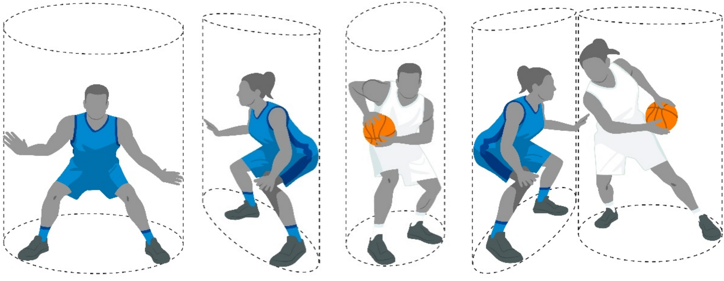
Diagram 6 Cylinder principle

33.2 Principle of verticality
During the game, each player has the right to occupy any position (cylinder) on the court not already occupied by an opponent.
This principle protects the space on the court which the player occupies and the space above when jumping vertically within that space.
When the player leaves the vertical position (cylinder) and body contact occurs with an opponent who had already established that player’s own vertical position (cylinder), the player who left the vertical position (cylinder) is responsible for the contact. The defensive player must not be penalised for leaving the court vertically (within the cylinder) or having the hands and arms extended above and within that player’s own cylinder.
The offensive player, whether on the court or airborne, shall not cause contact with the defensive player in a legal guarding position by:
• Using the arms to create more space (pushing off).
• Spreading the legs or arms during or immediately after a shot for a goal.
33.3 Legal guarding position
A defensive player has established an initial legal guarding positionn when
• facing the opponent, and
• having both feet on the court.
The legal guarding position extends vertically above (within the cylinder) from the court to the ceiling. The defensive player may raise the arms and hands above the head or jump vertically but that player must maintain them in a vertical position inside the imaginary cylinder.
33.4 Guarding a player who controls the ball
When guarding a player who controls (holding or dribbling) the ball, the elements of time and distance do not apply.
The player with the ball must expect to be guarded and must be prepared to stop or change direction whenever an opponent takes an initial legal guarding position in front of that offensive player, even if this is done within a fraction of a second.
The guarding (defensive) player must establish an initial legal guarding position without causing contact before establishing the defensive position.

图 6 圆柱体原则

33.2 垂直性原则
比赛期间，每位队员均有权占据场上未被对手占据的任何位置（圆柱体）。
该原则保护队员在球场上所占用的空间，以及该空间内垂直跳跃时上方的空间。
当一名队员离开垂直位置（圆柱体），并与已确立自身垂直位置（圆柱体）
的对手发生身体接触时，离开垂直位置（圆柱体）的队员应对该接触负责。防守队员若以垂直方式（在圆柱体内）离开场地，或将双手及手臂伸展至自身圆柱体上方及内部，均不得受到处罚。
进攻队员，无论是在场上还是在空中，均不得通过以下方式与处于合法防守位置的防守队员发生身体接触：
• 利用手臂创造更多空间（推人）。
• 在投篮过程中或投篮后即刻张开双腿或双臂。
33.3 合法防守位置
当防守队员已建立初始合法防守位置时
• 面对对手，并且
• 双脚均踩在球场上。
合法防守位置从球场垂直延伸至天花板上方（位于圆柱体内）。防守队员可将双臂及双手举过头顶或垂直跳跃，但该队员必须将上述动作保持在虚拟圆柱体内的垂直姿态。
33.4 防守控制球权的队员
当防守控制球（持球或运球）的队员时，时间与距离要素不再适用。
持球队员必须预期会被防守，并且当对手在进攻队员前方采取首个合法防守位置时，无论该动作仅在瞬间完成，该队员都必须做好停止或改变方向的准备。
防守队员在建立防守位置前，必须先确立一个初始合法防守位置，且不得引发身体接触。

Once the defensive player has established an initial legal guarding position, that player may move to guard the opponent, but may not extend the arms, shoulders, hips or legs to prevent the dribbler from passing by.
When judging a charge/block situation involving a player with the ball, a referee shall use the following principles:
• The defensive player must establish an initial legal guarding position by facing the player with the ball and having both feet on the court.
• The defensive player may remain stationary, jump vertically, move laterally or backward to maintain the initial legal guarding position.
• When moving to maintain the initial legal guarding position, one foot or both feet may be off the court for an instant, as long as the movement is lateral or backward, but not toward the player with the ball.
• Contact must occur on the torso, in which case the defensive player would be considered as having been at the place of contact first.
• Having established a legal guarding position, the defensive player may turn within the cylinder to avoid injury.
In any of the above situations, the contact shall be considered as having been caused by the player with the ball.
33.5 Guarding a player who does not control the ball
A player who does not control the ball is entitled to move freely on the court and take any position not already occupied by another player.
When guarding a player who does not control the ball, the elements of time and distance shall apply. A defensive player cannot take a position so near and/or so quickly in the path of a moving opponent that the latter does not have sufficient time or distance either to stop or change direction.
The distance is directly proportional to the speed of the opponent, but never less than
1 normal step.
If a defensive player does not respect the elements of time and distance in taking an initial legal guarding position and contact with an opponent occurs, that player is responsible for the contact.
Once a defensive player has established an initial legal guarding position, that player may move to guard the opponent. The player may not prevent the opponent from passing by extending the arms, shoulders, hips or legs in the opponent’s path. The player may turn within the cylinder to avoid injury.
33.6 A player who is in the air
A player who has jumped into the air from a place on thee court has the right to land again at the same place.
He has the right to land on another place on the court provided that the landing place and the direct path between the take-off and landing place is not already occupied by an opponent(s) at the time of take-off.
If a player has taken off and landed but momentum causes contact with an opponent who has taken a legal guarding position beyond the landing place, the jumper is responsible for the contact.
An opponent may not move into the path of a player after that player has jumped into the air.

一旦防守队员已确立初始合法防守位置，该队员可移动以盯防对方队员，但不得伸展手臂、肩膀、臀部或腿部以阻止运球者通过。
在判罚涉及持球队员的冲撞/阻挡情况时，主裁判应遵循以下原则：
• 防守队员必须通过面向持球队员且双脚均位于场地上，确立初始合法防守位置。
• 防守队员可保持静止、垂直跳跃、横向移动或向后移动，以维持初始合法防守位置。
• 当移动以维持初始合法防守位置时，只要移动方向为横向或向后，且非朝向持球队员，队员的一脚或双脚均可短暂离开球场。
• 接触必须发生在躯干部位，若如此，则该防守队员将被视为首先处于接触点。
• 在确立合法防守位置后，防守队员可在圆柱形区域内转身，以避免受伤。在上述任一情况下，该接触均应被视为由持球队员引起。
33.5 防守未持球的队员
未持球的队员有权在球场上自由移动，并占据其他队员尚未占据的任何位置。
在防守未持球的队员时，应适用时间和距离要素。防守队员不得在移动对手的路径上，以过近或过快的速度占据位置，以致该对手既无足够时间也无足够距离来停止或改变方向。
距离与对手的速度成正比，但始终不小于
1 个正常步骤。
若防守队员在采取初始合法防守位置时未遵守时间与距离要素，且与对手发生接触，则该队员应对此次接触负责。
一旦防守队员已确立初始合法防守位置，该队员即可移动以盯防对方队员。该队员不得通过伸展手臂、肩膀、臀部或腿部进入对方队员的运动路径来阻碍其传球。该队员可在圆柱形区域内转身以避免受伤。
33.6 处于空中的队员
从球场某处跳起的队员，有权再次在同一位置着地。
只要起跳时着陆点及从起跳点至着陆点的直接路径上尚未被对手占据，他即有权在球场上的其他位置着陆。
若队员起跳并落地，但因惯性与已在落地点以外采取合法防守位置的对手发生接触，则该跳起队员应对此次接触负责。
若队员已跃起，对手不得进入该队员的移动路径。

Moving under a player who is in the air and causing contact is usually a flagrant foul and in certain circumstances may be a disqualifying foul.
33.7 Screening: Legal and illegal
Screening is an attempt to delay or prevent an opponent without the ball from reaching a desired position on the court.
Legal screening is when the player who is screening an opponent:
• Was stationary (inside that player’s cylinder) when contact occurred.
• Had both feet on the court when contact occurred.
Illegal screening is when the player who is screening an opponent:
• Was moving when contact occurred.
• Did not give sufficient distance when setting a screen outside the field of vision of a stationary opponent when contact occurred.
• Did not respect the elements of time and distance of an opponent in motion when contact occurred.
If the screen is set within the field of vision of a stationary opponent (front or lateral), the screener may establish the screen as close as possible to the opponent, provided there is no contact.
If the screen is set outside the field of vision of a stationary opponent, the screener must permit the opponent to take one normal step towards the screen without making contact.
If the opponent is in motion, the elements of time and distance shall apply. The screener must leave enough space so that the player who is being screened is able to avoid the screen by stopping or changing direction.
The distance required is never less than 1 and never more than 2 normal steps.
A player who is legally screened is responsible for any contact with the player who has set the screen.
33.8 Charging
Charging is illegal personal contact, with or without the ball, by pushing or moving into an opponent’s torso.
33.9 Blocking
Blocking is illegal personal contact which impedes the progress of an opponent with or without the ball.
A player who is attempting to screen is committing a blocking foul if contact occurs when moving, and the opponent is stationary or retreating.
If a player disregards the ball, faces an opponent and shifts position as the opponent shifts, that player is primarily responsible for any contact that occurs, unless other factors are involved.
The expression 'unless other factors are involved' refers to deliberate pushing, charging or holding of the player who is being screened.
It is legal for a player to extend the arm(s) or elbow(s) outside of the cylinder when taking a position on the court but they must be moved inside the cylinder.linder when an opponent attempts to pass by. If the arm(s) or elbow(s) are outside the cylinder and contact occurs, it is blocking or holding.

在处于空中的队员下方移动并造成身体接触，通常构成恶意犯规，且在特定情况下可能构成禁赛犯规。
33.7 掩护：合法与非法
掩护是指试图延缓或阻止持球或无球对手到达球场上的预定位置。
合法掩护是指正在对对手进行掩护的队员：
• 在发生接触时，该队员处于静止状态（位于该队员的圆柱形区域内）。
• 发生接触时，双脚均位于场地上。
非法掩护是指正在掩护对手的队员：
• 发生接触时正在移动。
• 在发生接触时，未在静止对手的视野外设置掩护时提供足够的距离。
• 在发生接触时，未考虑运动中对手的时间与距离因素。

若掩护设置在静止对手（正面或侧面）的视线范围内，掩护者可将掩护位置尽可能靠近对手，前提是双方未发生身体接触。
若掩护设置于静止对手视野之外，掩护者必须允许对手向掩护方向迈出1步常规步，且不得发生接触。
若对方正在移动，则须考虑时间与距离因素。掩护者必须留出足够空间，使被掩护的队员能够通过停止或改变方向来避开该掩护。
所需步数始终不小于 1 步，且始终不大于 2 步标准步长。
合法执行掩护的队员，对其与设置掩护的队员发生任何接触均承担责任。

33.8 充电
推人是指无论是否持球，通过推或侵入对手躯干而进行的非法身体接触。
33.9 阻挡
阻挡是指非法的身体接触行为，无论对方是否持球，均会阻碍其比赛进程。
当一名试图进行掩护的队员在移动过程中发生身体接触，且对方队员处于静止或后退状态时，该队员即构成阻挡犯规。
若一名队员忽视球，面对对方队员，并在对方移动时同步调整位置，则该队员对由此产生的任何身体接触负主要责任，除非存在其他影响因素。
“除非涉及其他因素”这一表述，是指对被阻挡的队员故意推人、冲撞或拉人。
队员在场上就位时，将手臂或肘部伸至圆柱体外是合法的，但当对手试图传球时，这些肢体必须移回圆柱体内。若手臂或肘部位于圆柱体外且发生接触，则构成阻挡或拉入。

33.10 No-charge semi-circle areas
The no-charge semi-circle areas are marked on the court for the purpose of designating a specific area for the interpretation of charge/block situations under the basket.
On drives into the no-charge semi-circle area, any contact caused by an airborne offensive player with a defensive player inside the no-charge semi-circle shall not be called as a team control foul, unless the offensive player is illegally using the hands, arms, legs or body. This rule applies when:
• The offensive player is in control of the ball while airborne, and
• The offensive player attempts a shot for a goal or passes the ball, and
• The defensive player has one foot or both feet in contact with the no-charge semi-circle area.
33.11 Contacting an opponent with the hand(s) and/or arm(s)
The touching of an opponent with the hand(s) is, in itself, not necessarily a foul.
The referees shall decide whether the player who caused the contact has gained an advantage. If contact caused by a player in any way restricts the freedom of movement of an opponent, such contact is a foul.
Illegal use of the hand(s) or extended arm(s) occurs when the defensive player is in a guarding position, places the hand(s) or the arm(s) upon and remains in contact with an opponent with or without the ball, to impede the opponent’s progress.
To repeatedly touch or 'jab' an opponent with or without the ball is a foul, as it may lead to rough play.
It is a foul by an offensive player with the ball to:
• 'Hook' or wrap an arm or an elbow around a defensive player to obtain an advantage.
• 'Push off'the defensive player to prevent an opponent from playing or attempting to play the ball, or to create more space.
• Use an extended forearm or hand, while dribbling, to prevent an opponent from gaining control of the ball.
It is a foul by an offensive player without the ball to 'push off' to:
• Get free to catch the ball.
• Prevent the defensive player from playing or attempting to play the ball.
• Create more space.
33.12 Post play
The principle of verticality (cylinder principle) applies also to post play.
The offensive player in the post position and the defensive player must respect each other's rights to a vertical position (cylinder).
It is a foul by an offensive or defensive player in the post position to shoulder or hip the opponent out of position or to interfere with the opponent’s freedom of movement using extended arms, shoulders, hips, legs or other parts of the body.
33.13 Illegal guarding from the rear
Illegal guarding from the rear is personal contact by the defensive player with an opponent from behind. The fact that the defensive player is attempting to play the ball does not justify contact with an opponent from the rear.

33.10 无撞人半圆区域
场上标有无撞人半圆区域，旨在为篮筐下触球/阻挡情况的判罚划定特定区域。
当进攻队员进入无冲撞半圆形区域进行推进时，若空中进攻队员与处于该半圆形区域内的防守队员发生身体接触，除非该进攻队员非法使用手、臂、腿或身体，否则此类接触均不得判为控制球队犯规。本规则适用于以下情形：
• 进攻队员在腾空状态下控制球，并且
• 进攻队员尝试投篮得分或传球，并且
• 防守队员的一只脚或双脚均与无撞人半圆区域接触。
33.11 用一只手或双手及/或手臂接触对手
用一只手或双手触碰到对手，这一行为本身并不必然构成犯规。
主裁判应判定引发接触的队员是否获得了优势。若队员的接触以任何方式限制了对方队员的自由移动，则该接触应判为犯规。
当防守队员处于防守位置时，将手或手臂置于对手身上，并与对手保持接触（无论是否持球），从而阻碍对手推进，即构成手或手臂的违规使用。
无论是否持球，反复触碰到或“jab”对方均构成犯规，因为这可能导致粗暴行为。
以下情况中，持球的进攻队员均构成犯规：
• “勾”或将手臂或肘部缠绕防守队员，以获取优势。
• 推开防守队员，以防止对手参与或试图参与控球，或创造更多空间。
• 在运球时，使用前臂或手掌的延伸部位，以阻止对手获得对球的控制。

若持球进攻队员进行“推离”动作，则构成犯规：
• 免费接球。
• 防止防守队员参与或试图参与控球。
• 创造更多空间。
33.12 赛后
垂直性原则（圆柱体原则）同样适用于立柱防守。
后场进攻队员与防守队员必须相互尊重对方对垂直位置（圆柱体区域）的权利。若进攻或防守队员在后场位置时，用肩膀或臀部将对方推离原位，或运用伸展的手臂、肩膀、臀部、腿部或身体其他部位干扰对方的自由移动，则构成犯规。
33.13 从后方进行非法防守
从后方进行的非法防守是指防守队员从后方与对手发生身体接触。即使防守队员试图参与控球，也不能成为从后方与对手发生接触的正当理由。

33.14 Holding
Holding is illegal personal contact with an opponent that interferes with an opponent’s freedom of movement. This contact (holding) can occur with any part of the body.
33.15 Pushing
Pushing is illegal personal contact with any part of the body where a player forcibly moves or attempts to move an opponent with or without the ball.
33.16 Fake being fouled
A fake is any action by a player to simulate being fouled or to make theatrical exaggerated movements to create an opinion of being fouled and therefore gaining an advantage.

Article 34 Personal foul
34.1 Definition
34.1.1 A personal foul is a player’s illegal contact with an opponent, whether the ball is live or dead.
A player shall not hold, block, push, charge, trip or impede the progress of an opponent by extending the hand, arm, elbow, shoulder, hip, leg, knee or foot, nor by bending the body into an 'abnormal' position (outside the cylinder), nor shall a player indulge in any rough or violent play.
34.1.2 A throw-infoul is a personal foul committed, when the game clock shows 2:00 minutes or less in the fourth quarter and in each overtime, by a defensive player on an opponent on the court when the ball is out-of-bounds for a throw-in and at the disposal of the thrower-in.

34.2 Penalty
A personal foul shall be charged against the offender.
34.2.1 If the foul is committed against a player not in the act of shooting:
• The game shall be resumed with a throw-in by the non-offending team from the place nearest to the infraction.
• If the offending team is in a team foul penalty situation, then Article 42 shall apply.
34.2.2 If the foul is committed against a player in the act of shooting, that player shall be awarded a number of free throws as follows:
• If the shot released from the goal area is successful, the goal shall count and, in addition, 1 free throw.
• If the shot released from the 2-point goal area is unsuccessful, 2 free throws.
• If the shot released from the 3-point goal area is unsuccessful, 3 free throws. 34.2.3 If the foul is committed as a throw-in foul:
• The player who was fouled shall be awarded only one free throw, regardless of whether the offending team is already in the team penalty situation. The game shall be resumed with a throw-in by the non-offending team from the place nearest to the infraction.

33.14 拉人
拉人是与对手进行的非法身体接触，会干扰对手的自由移动。此类接触（拉人）可涉及身体任何部位。
33.15 推人
推人是指队员利用身体任何部位，对对方（无论是否持球）进行强制推动或试图推动的非法身体接触行为。
33.16 假被犯规
假动作是指队员为模拟被犯规，或做出戏剧化、夸张的动作以营造已被犯规的假象，从而获得优势的任何行为。

第三十四条 侵人犯规
34.1 定义
34.1.1 侵人犯规是指队员与对手发生的非法接触，无论球是否处于活球状态。
队员不得通过伸出手、手臂、肘部、肩部、臀部、腿部、膝盖或脚部，或将身体弯曲至“异常”姿势（超出圆柱体范围），来拉人、阻挡、推人、冲撞、绊倒或阻碍对手的行动；亦不得进行任何粗暴或暴力的行为。
34.1.2 掷球入界犯规是指：当比赛计时钟显示第四节或每场决胜期中剩余时间不超过2分钟时，防守队员在球已处于掷球入界界外且处于掷球入界队员可掌控状态的情况下，对场上对方队员实施的侵人犯规。

34.2 罚则
对犯规者应判罚侵人犯规。
34.2.1 若犯规是针对未处于投篮动作中的队员实施的：
• 比赛应由未犯规方从距违犯地点最近处以掷球入界方式重新开始。
• 若犯规球队已处于全队犯规处罚情形，则适用第42条。
34.2.2 若犯规发生在队员投篮动作期间，则该队员应获判如下次数的罚球：
• 若从罚球区发出的投篮命中，则进球有效，并额外判罚一次罚球。
• 若从两分球区发出的投篮未命中，则判罚两次罚球。
• 若从3分投篮区域发出的投篮未命中，则判罚3次罚球。34.2.3 若该犯规系
掷球入界犯规所致：
• 被犯规的队员仅获罚一次罚球，无论犯规方是否已处于队罚状态。比赛
应由未犯规方从距违犯地点最近处以掷球入界方式继续进行。

Article 35 Double foul
35.1 Definition
35.1.1 A double foul is a situation in which 2 opponents commit personal, disruptive, flagrant or disqualifying fouls on each other at approximately the same time.
35.1.2 To consider 2 fouls as a double foul the following conditions must apply:
• Both fouls are player fouls.
• Both fouls involve physical contact.
• Both fouls are between the same 2 opponents fouling each other.
• Both fouls are either 2 personal or any combination of disruptive, flagrant and disqualifying fouls.

35.2 Penalty
A personal, disruptive, flagrant or disqualifying foul shall be charged against each offender. No free throws shall be awarded and the game shall be resumed as follows: If at approximately the same time as the double foul:
• A valid goal is scored, or a last free throw is scored, the ball shall be awarded to the non- scoring team for a throw-in from any place behind that team’s endline.
• A team had control of the ball or was entitled to the ball, the ball shall be awarded to this team for a throw-in from the place nearest to the infraction.
• Neither team had control of the ball nor was entitled to the ball, a jump ball situation occurs.

Article 36 Technical foul
36.1 Rules of conduct
36.1.1 The proper conduct of the game demands the full and loyal cooperation of the players, head coaches, assistant coaches, substitutes, excluded players and accompanying delegation members with the referees, table officials and commissioner, if present.
36.1.2 Each team shall do its best to secure victory, but this must be done in the spirit of sportsmanship and fair play.
36.1.3 Any deliberate or repeated non-cooperation or non-compliance with the spirit and intent of this rule shall be considered a technical foul.
36.1.4 The referees may prevent technical fouls by giving warnings or even overlooking minor infractions which are obviously unintentional and have no direct effect upon the game, unless there is repetition of the same infraction after the warning.
36.1.5 If an infraction is recognised after the ball becomes live, the game shall be stopped and a technical foul charged. The penalty shall be administered as if the technical foul had occurred at the time it was charged. Whatever occurred during the interval between the infraction and the game being stopped shall remain valid.
36.2 Definition
36.2.1 Technical fouls are divided into two categories, according to their nature and severity level. A category 1 technical foul shall count towards the game disqualification, a category 2 technical foul shall not count towards the game disqualification.

第三十五条 双方犯规
35.1 定义
35.1.1 双方犯规是指两名队员在几乎同一时间分别对对方做出个人犯规、破坏性犯规、鲁莽犯规或导致禁赛的犯规行为。
35.1.2 要将两次犯规判定为双方犯规，须满足以下条件：
• 这两次犯规均为队员犯规。
• 这两次犯规均涉及身体接触。
• 这两次犯规均发生在同一对相互犯规的队员之间。
• 这两次犯规均属于个人犯规，或是破坏性犯规、鲁莽犯规及取消资格犯规的任意组合。

35.2 处罚
对每位犯规者应判罚个人犯规、破坏性犯规、鲁莽犯规或取消参赛资格的犯规。
不得判罚罚球，比赛应按以下方式恢复：若与双方犯规发生时间大致相同：
• 若进球有效或完成最后一次罚球，球权应判给未得分方，由该方在己方端线后方任意位置进行掷球入界。
• 若一方球队控制球或有权拥有该球，则应将球判给该球队，并从距违犯地点最近处进行掷球入界。
• 双方球队均未控制球，亦无权争夺球权，此时便进入跳篮圈节。

第三十六条 技术犯规
36.1 行为准则
36.1.1 确保比赛顺利进行，需要全体队员、主教练、助理教练、替补队员、被禁赛队员及随行代表团成员与主裁判、记录台人员以及技术代表（如在场）充分且忠诚地配合。
36.1.2 每支球队均应竭尽全力争取胜利，但此举必须以体育精神和公平竞赛精神为前提。
36.1.3 任何故意或反复的不配合行为，或违反本规则宗旨与意图的行为，均应被视为技术犯规。
36.1.4 主裁判可通过给予警告，甚至忽略那些明显非故意且对比赛无直接影响的轻微违犯，来避免判罚技术犯规，除非在给予警告后该违犯再次发生。
36.1.5 若违犯行为在球已进入活球状态后被认定，则应立即停止比赛，并判罚一次技术犯规。处罚的适用方式应如同该技术犯规在判罚时即已发生。在违犯行为与比赛停止之间的间隔期内发生的一切情况仍继续有效。
36.2 定义
36.2.1 技术犯规根据其性质和严重程度分为两类：1类技术犯规应计入比赛取消资格，2类技术犯规则不计入比赛取消资格。

Category 1 technical fouls by a player may be non-contact or contact fouls of a behavioural nature including, but not limited to:
• Disrespectfully dealing and/or communicating with the referees, the commissio- ner, if present, the table officials, the opponents or persons permitted to sit on the team benches.
• Using language or gestures likely to offend or incite the spectators.
• Baiting, taunting or provoking an opponent, including a contact with the hands, arms, body or the ball which does not rise to the level of a flagrant or a disqualifying foul.
• Obstructing the vision of an opponent by waving/placing the hand(s) near the opponent’s eyes.
• Excessive swinging of elbows without contact.
• Fake being fouled.
Category 2 technical fouls by a player may be non-contact fouls of a behavioural or administrative nature including, but not limited to:
• Delaying the game by deliberately touching the ball after it passes through the basket or by preventing a throw-in or a free throw from being taken promptly or by coming on the court late to start the game or the second half.
• Hanging on the ring in such a way that the weight of the player is supported by the ring, unless a player grasps the ring momentarily following a dunk shot or is trying to prevent injury to any player.
• Goaltending during the last free throw by a defensive player. The offensive team shall be awarded 1 point, followed by the technical foul penalty charged against the defensive player.
36.2.2 A technical foul by any person permitted to sit on the team bench is a category 1 foul for disrespectfully communicating with or touching the referees, the commissioner, if present, the table officials or the opponents, or an infraction of a procedural or an administrative nature.
36.2.3 A player shall be disqualified for the remainder of the game (game disqualification) when charged with:
• two category 1 technical fouls, or
• two flagrant fouls, or
• one category 1 technical foul and one flagrant foul.
36.2.4 A head coach shall be disqualified for the remainder of the game (game disqualification) when charged with:
• two category 1 technical fouls ('C') as a result of personal unsportsmanlike behaviour.
• three category 1 technical fouls, either all of them ('B') or ('BD') or one of them ('C'), as a result of the unsportsmanlike behaviour of other persons permitted to sit on the team bench.
36.2.5 If a player or a head coach is disqualified under Articles 36.2.3 or 36.2.4, that technical foul shall be the only foul to be penalised, and no additional penalty for the game disqualification shall be administered.

队员犯下的第1类技术犯规可为非接触性犯规或具有行为性质的接触犯规，包括但不限于：
• 对主裁判、若在场时的技术代表、记录台人员、对手或获准坐在球队席上的人员，表现出不尊重态度或进行不当沟通。
• 使用可能冒犯或煽动观众的语言或手势。
• 挑衅、嘲弄或激怒对手，包括用手、手臂、身体或球进行接触，但该行为未达到恶意犯规或取消比赛资格犯规的标准。
• 通过将手挥动或置于对手眼睛附近，以遮挡对手的视线。
• 无接触情况下肘部过度摆动。
• 假被犯规。
队员犯下的第二类技术犯规可为涉及行为或管理性质的非接触性犯规，包括但不限于：
• 在球已穿过篮筐后故意触球、阻碍掷球入界或罚球及时执行，或延迟进入场地以开始比赛或下半场比赛，从而拖延比赛的行为。
• 队员以身体重量悬吊于篮圈上的方式保持平衡，除非该队员在扣篮后短暂握持篮圈，或正试图防止其他队员受伤。
• 防守队员在最后一次罚球时发生干涉得分。进攻方得1分，随后对防守队员判罚技术犯规。
36.2.2 任何获准坐在球队席的人员若与主裁判、技术代表（如在场）、记录台人员或对手进行不敬性交流或接触，或违反程序性或管理性规定，即构成第1类犯规。
36.2.3 若队员被判定犯有下列行为，则应在本场比赛剩余时间内被取消比赛资格（全场取消比赛资格）：
• 两次一级技术犯规，或
• 两次恶意犯规，或
• 一次1类技术犯规和一次恶意犯规。
36.2.4 若主教练被指控以下行为，则应在本场比赛剩余时间内被取消比赛资格（全场取消比赛资格）：
• 因个人不体育道德行为而累计两次1类技术犯规（“C”）。
• 因其他获准坐在球队席的人员出现不体育道德行为，而累计三次一级技术犯规，且这三次犯规均属于（“B”）或（“BD”），或其中一次属于（“C”）。
36.2.5 若队员或主教练根据第36.2.3条或第36.2.4条被取消比赛资格，则该技术犯规
应为唯一被处罚的犯规，且不得对取消比赛资格追加其他处罚。

36.3 Penalty
36.3.1 If a technical foul is committed:
• By a player, a technical foul, irrespective of the category, shall be charged as a player foul and shall count as onee of the team fouls.
• By any person permitted to sit on the team bench, a category 1 technical foul shall be charged against the head coach and shall not count as one of the team fouls.
36.3.2 The opponents shall be awarded 1 free throw. The game shall be resumed as follows:
• The free throw shall be administered immediately. After the free throw, the throw-in shall be administered by the team which had control of the ball or was entitled to the ball when the technical foul was committed, from the place nearest to where the ball was located when the game was stopped.
• The free throw shall also be administered immediately, regardless of whether the order of any other possible penalties for any other fouls has been determined or whether the administration of the penalties has been started. After the free throw for a technical foul, the game shall be resumed by the team which had control of the ball or was entitled to the ball when the technical foul was committed, from the place where the game was interrupted for the technical foul penalty.
• If a valid goal or a last free throw is scored, the game shall be resumed with a throw-in from any place behind the endline.
• If neither team has control of the ball nor is entitled to the ball, a jump ball situation occurs.
• With a jump ball in the centre circle at the start of the first quarter.

Article 37 Disruptive foul
37.1 Definition
37.1.1 A disruptive foul is a player’s illegal contact with an opponent which does not rise to the level of a flagrant foul, and which disrupts the flow of the game and places the opponent at a disadvantage. The criteria for disruptive fouls are the following:
• An unnecessary contact caused by the defensive player, not legitimately attempting to directly play the ball, to stop the progress of the offensive team in transition. This applies until the offensive player starts the act of shooting.
• An unnecessary contact caused by a defensive player anywhere on the court, not legitimately attempting to directly play the ball, to stop the game clock and/or shot clock, at the end of a quarter or overtime.
• An illegal contact caused by a player from behind or laterally on an opponent, who is progressing towards the opponent’s basket and with no opponents between the progressing player and the basket, and:
_ The progressing player is in control of the ball, or
_ The progressing player is attempting to gain control of the ball, or _ The ball has been released on a pass to the progressing player.
This applies until the offensive player starts the act of shooting.
37.1.2 The referee must interpret disruptive fouls consistently throughout the game and judge only the action.

36.3 处罚
36.3.1 若发生技术犯规：
• 队员犯技术犯规时，无论属于何种类别，均应记为队员犯规，并计入全队犯规次数。
• 任何获准坐在球队席上的人员，对主教练均可判罚一次一级技术犯规，且该犯规不计入全队犯规次数。
36.3.2 对方球队应获判1次罚球。比赛按以下方式恢复：
• 罚球应立即执行。罚球结束后，由在发生技术犯规时控制球或拥有球权的球队，从比赛暂停时球所在位置最近的地点执行掷球入界。
• 罚球亦应立即执行，无论是否已确定对其他犯规可能判处的其他处罚顺序，或是否已启动相关处罚程序。对于技术犯规后的罚球，比赛应由在实施该技术犯规时控制球或拥有球权的球队，从因该技术犯规处罚而中断比赛的地点重新开始。
• 若成功攻入一球或完成最后一次罚球，比赛应从端线后方的任意位置以掷球入界方式重新开始。
• 若双方均未控制球，且均无权争夺该球，则进入跳球阶段。
• 在第一节开始时，于中圈进行跳球。

第三十七条 破坏性犯规
37.1 定义
37.1.1 破坏性犯规是指队员与对手发生非法接触，该行为虽未达到恶意犯规的标准，但会破坏比赛进程并使对手处于不利境地。破坏性犯规的判定标准如下：
• 防守队员为阻止进攻方在转换进攻中的推进，而进行非正当直接争球动作时，若造成不必要的身体接触，则适用本条规定；该规定持续至进攻队员开始投篮动作为止。
• 在节末或决胜期结束时，防守队员在球场任何位置，若非正当尝试直接争夺球权，而是为阻止比赛计时钟及/或进攻计时钟而造成不必要的身体接触。
• 当一名队员从身后或侧面与正朝对方篮筐推进的对方发生非法接触，且该推进队员与篮筐之间无其他队员阻挡，并满足以下任一条件：_该推进队员已控制球；或_该推进队员正试图获得对球的控制；或_球已通过传
球释放至该推进队员手中。
此规定一直适用，直至进攻队员开始投篮动作。
37.1.2 主裁判在整个比赛过程中必须对破坏性犯规作出一致判罚，且仅对犯规动作进行判罚。

37.2 Penalty
37.2.1 A disruptive foul shall be charged against the offender and shall count as one of the team fouls.
37.2.2 Free throw(s) shall be awarded to the player who was fouled, followed by:
• A throw-in from the throw-in line in the team’s frontcourt, opposite the scorer’stable. The number of free throws shall be awarded as follows:
• If the foul is committed on a player not in the act of shooting: 2 free throws.
• If the foul is committed on a player in the act of shooting: the goal, if made, shall count and, in addition, 1 free throw.
• If the foul is committed on a player in the act of shooting and the goal is not made, 2 or 3 free throws.

Article 38 Flagrant foul
38.1 Definition
38.1.1 A flagrant foul is a player’s illegal contact with an opponent, which violates the spirit of sportsmanship and fair play, and by its nature and/or the severity level exceeds the limits of a personal or disruptive foul. The criteria for flagrant fouls are the following:
• Not a legitimate basketball play against an opponent, with or without a ball.
• Reckless, violent, or dangerous act, which causes or may cause injury to an opponent.
• Excessive, hard contact in an effort to play the ball or an opponent.
38.1.2 The referee must interpret flagrant fouls consistently throughout the game and judge only the action.

38.2 Penalty
38.2.1 A flagrant foul shall be charged against the offender and shall count as one of the team fouls.
38.2.2 Free throw(s) shall be awarded to the player who was fouled, followed by:
• A throw-in from the throw-in line in the team’s frontcourt, opposite the scorer’s table.
• A jump ball in the centre circle at the start of the first quarter.
The number of free throws shall be awarded as follows:
• If the foul is committed on a player not in the act of shooting: 2 free throws.
• If the foul is committed on a player in the act of shooting: the goal, if made, shall count and, in addition, 1 free throw.
• If the foul is committed on a player in the act of shooting and the goal is not made, 2 or 3 free throws.
38.2.3 A player shall be disqualified for the remainder of the game (game disqualification) when charged with:
• two flagrant fouls, or
• two category 1 technical fouls, or
• one category 1 technical foul and one flagrant foul.
38.2.4 If a player is disqualified under Article 38.2.3, that flagrant foul shall be the only foul to be penalised, and no additional penalty for the disqualification shall be administered.

37.2 处罚
37.2.1 破坏性犯规应由犯规者承担，并计入全队犯规次数。
37.2.2 罚球应由被犯规的队员获得，随后按以下顺序进行：
• 从球队前场中与记录台相对的掷球线处进行掷球入界。罚球次数按以下规定分配：
• 若犯规发生在未进行投篮动作的队员身上：则判罚两次罚球。
• 若犯规发生在队员投篮动作期间：若进球，则该进球有效，并额外获得1次罚球机会。
• 若犯规发生在队员投篮动作期间，且未命中进球，则判罚2或3次罚球。

第三十八条 恶意犯规
38.1 定义
38.1.1 恶意犯规是指队员与对手发生非法接触，违背体育精神和公平竞争原则，且根据其性质及/或严重程度，已超出个人犯规或扰乱性犯规的范畴。恶意犯规的判定标准如下：
• 并非针对对手进行的合法篮球动作，无论是否持球。
• 鲁莽、暴力或危险的行为，若已或可能给对方造成伤害。
• 为争夺球或对抗对手而进行的过度、剧烈身体接触。
38.1.2 主裁判在整个比赛过程中必须对恶意犯规作出一致判罚，且仅针对该动作进行判罚。

38.2 处罚
38.2.1 恶意犯规应由犯规者承担相应责任，并计入全队犯规次数。
38.2.2 罚球应判给被犯规的队员，随后执行以下操作：
• 从球队前场中与记录台相对的掷球线处进行掷球入界。
• 第一节开始时，在中圈进行跳球。
罚球次数按下列规定分配：
• 若犯规发生在未进行投篮动作的队员身上：则判罚两次罚球。
• 若犯规发生在队员投篮动作期间：若进球有效，则该进球应计入得分，并额外获得1次罚球机会。
• 若犯规发生在队员投篮动作期间，且未命中进球，则判罚2或3次罚球。
38.2.3 若队员被判定存在以下行为，则应在本场比赛剩余时间内被取消比赛资格（全场取消比赛资格）：
• 两次恶意犯规，或
• 两次一级技术犯规，或
• 一次1类技术犯规和一次恶意犯规。
38.2.4 若队员根据第38.2.3条被取消比赛资格，则该恶意犯规应为唯一被处罚的犯规，且不得对取消比赛资格另行施加处罚。

Article 39 Disqualifying foul
39.1 Definition
39.1.1 A disqualifying foul is any flagrant unsportsmanlike action by players, substitutes, head coaches, assistant coaches, excluded players and accompanying delegation members.
39.1.2 A head coach who has received a disqualifying foul shall be replaced by the first assistant coach as entered on the scoresheet. If no first assistant coach is entered on the scoresheet, the captain (CAP) shall replace the head coach.
39.2 Violence
39.2.1 Acts of violence may occur during the game, contrary to the spiritit of sportsmanship and fair play. These should be stopped immediately by the referees and, if necessary, by public order enforcement officers.
39.2.2 Whenever acts of violence occur involving players on the court or in its vicinity, the referees shall take the necessary action to stop them.
39.2.3 Any of the above persons who are guilty of flagrant acts of aggression on opponents or referees shall be disqualified. The crew chief must report the incident to the organising body of the competition.
39.2.4 Public order enforcement officers may enter the court only if requested to do so by the referees. However, should spectators enter the court with the obvious intention of committing acts of violence, the public order enforcement officers must intervene immediately to protect the teams and referees.
39.2.5 All areas beyond the floor or its vicinity, including entrances, exits, hallways, dressing rooms, etc., come under the jurisdiction of the organising body of the competition and the public order enforcement officers.
39.2.6 Physical actions by players or any person permitted to sit on the team bench, which could lead to damaging game equipment, must not be permitted by the referees. When behaviour of this nature is observed by the referees, the head coach of the offending team shall be given a warning.
Should the action(s) be repeated, a technical or even disqualifying foul shall immediately be called against the individual(s) involved.

39.3 Penalty
39.3.1 A disqualifying foul shall be charged against the offender.
39.3.2 Whenever the offender is disqualified according to the respective articles of these rules, the offender shall go to and remain in the team's dressing room for the duration of the game or shall leave the building.
39.3.3 Free throw(s) shall be awarded:
• To any opponent, as designated by the head coach in case of a non-contact foul.
• To the player who was fouled in case of a contact foul.
Followed by:
• A throw-in from the throw-in line in the team’s frontcourt, opposite the scorer’s table.
• A jump ball in the centre circle at the start of the first quarter.

第三十九条 取消比赛资格的犯规
39.1 定义
39.1.1 判罚犯规是指队员、替补队员、主教练、助理教练、被驱逐出场队员及其随行代表成员实施的任何严重违反体育道德的行为。
39.1.2 若主教练受到取消参赛资格的犯规处罚，则应由记录表上登记的首位助理教练接替其职务。若记录表上未登记首位助理教练，则由队长（CAP）接替主教练职务。
39.2 暴力
39.2.1 比赛过程中可能发生违背体育精神和公平竞争原则的暴力行为。此类行为应立即被主裁判制止，必要时可由公共秩序执法人员介入处理。
39.2.2 凡场上或场边队员发生暴力行为时，主裁判应采取必要措施予以制止。
39.2.3 上述人员中凡对对手或主裁判实施公然侵犯行为者，均应被取消参赛资格。赛事负责人须将此类事件上报至赛事组委会。
39.2.4 公共秩序执法人员仅可在主裁判要求时进入赛场。然而，若观众进入赛场时明显意图实施暴力行为，公共秩序执法人员必须立即介入，以保护参赛球队及主裁判。
39.2.5 场地之外或其周边区域，包括入口、出 口、走廊、更衣室等，均归赛事组委会及公共秩序执法人员管辖。
39.2.6 队员或获准坐在球队席上的任何人若做出可能导致比赛器材损坏的身体动作，主裁判均不得允许。若主裁判观察到此类行为，则应对该队主教练予以警告。
若该行为被重复发生，则应立即对涉事人员判罚技术犯规，甚至直接取消其参赛资格。

39.3 处罚
39.3.1 对违规者应判罚一次取消参赛资格的犯规。
39.3.2 若违规者根据本规则相应条款被取消参赛资格，则该违规者须在比赛期间进入并留在球队更衣室，或离开场馆。
39.3.3 罚球应判给：
• 对于任何对手，在发生非接触性犯规时，均由主教练指定。
• 针对在接触犯规中被犯规的队员。
随后是：
• 从球队前场中与记录台相对的掷球线处进行掷球入界。
• 第一节开始时，在中心圆区进行跳球。

39.3.4 The number of free throws shall be awarded as follows:
• If the foul is a non-contact foul: 2 free throws.
• If the foul is committed on a player not in the act of shooting: 2 free throws.
• If the foul is committed on a player in the act of shooting: the goal, if made, shall count and in addition, one free throw.
• If the foul is committed on a player in the act of shooting and the goal is not made: 2 or 3 free throws.
• If the foul is a disqualification of a head coach: 2 free throws.
• If the foul is a disqualification of a first assistant coach, substitute, excluded player or an accompanying delegation member, this foul is charged against the head coach as a technical foul: 2 free throws.
In addition, if a disqualification of a first assistant coach, substitute, excluded player or an accompanying delegation member after leaving the team bench area is for their active participation during any fight:
— For each single disqualifying foul of a first assistant coach, substitute and excluded player: 2 free throws. All disqualifying fouls shall be charged against each offender.
— For each single disqualifying foul of any accompanying delegation member:
2 free throws. All disqualifying fouls shall be charged against the head coach.
All free-throw penalties shall be executed, unless there are equal penalties on the opponent’s team to be cancelled.

Article 40 Fighting
40.1 Definition
Fighting is physical interaction between 2 or more opponent players and any person permitted to sit on the team benches.
This article only applies to the substitutes, head coaches, first assistant coaches, excluded players and accompanying delegation members who leave the confines of the team bench area during a fight or during any situation which may lead to a fight.
40.2 Rule
40.2.1 Substitutes, excluded players or accompanying delegation members who leave the team bench area during a fight, or during any situation which may lead to a fight, shall be disqualified.
40.2.2 Only the head coach and/or first assistant coach are permitted to leave the team bench area during a fight, or during any situation which may lead to a fight, to assist the referees in maintaining or restoring order. In this situation, they shall not be disqualified.
40.2.3 If a head coach and/or first assistant coach leave the team bench area and neither assist nor attempt to assist the referees in maintaining or restoring order, they shall be disqualified.

39.3.4 罚球次数按下列规定分配：
• 若该犯规为非接触性犯规：则判罚两次罚球。
• 若犯规发生在未进行投篮动作的队员身上：则判罚两次罚球。
• 若犯规发生在队员投篮动作期间：若进球，则该进球有效，并额外获得1次罚球机会。
• 若犯规发生在队员投篮动作期间，且未命中进球：则判罚2或3次罚球。
• 若该犯规导致主教练被取消比赛资格：则给予2次罚球机会。
• 若该犯规导致第一助理教练、替补队员、被禁赛队员或随行代表团成员被取消比赛资格，则此犯规将作为技术犯规判罚给主教练：判罚2次罚球。
此外，若第一助理教练、替补队员、被罚出场的队员或随行代表团成员在离开球队替补区后，因参与任何打架行为而被取消比赛资格：
— 对于第一助理教练、替补队员及被驱逐出场队员的每项单项取消比赛资格犯规：判罚2次罚球。所有取消比赛资格的犯规均应由违规者承担。
— 对于任何随同代表团成员发生的单项取消比赛资格犯规：
2次罚球。所有导致取消比赛资格的犯规均应由主教练承担。
所有罚球处罚均须执行，除非对方球队面临的处罚相同而予以取消。

第四十条 打架
40.1 定义
打架是指两名或更多对手队员与任何获准坐在球队席上的人员之间发生的肢体接触。
本条款仅适用于在打架期间，或在任何可能导致打架的情况下，离开球队席区域的替补队员、主教练、助理教练、被罚出场的队员及随行代表成员。
40.2 规则
40.2.1 替补队员、被禁赛队员或随队代表成员在打架期间，或在任何可能引发打架的情况下离开球队替补区时，均应被取消比赛资格。
40.2.2 只有在打架期间，或在任何可能导致打架的情况下，主教练和/或助理主教练才被允许离开球队替补区，以协助裁判维持或恢复秩序。在此情况下，他们不得被取消比赛资格。
40.2.3 若主教练和/或第一助理教练离开球队替补区，且既未协助也未尝试协助裁判维持或恢复秩序，则应被取消资格。

40.3 Penalty
40.3.1 Irrespective of the number of persons disqualified for leaving the team bench area, a single technical foul (‘B’) shall be charged against the head coach.
40.3.2 If players from both teams are disqualified under this article and there are no other foul penalties remaining for administration, the game shall be resumed as follows.
If at approximately the same time when the game was stopped because of the fighting:
• A valid goal or a last free throw is scored, the ball shall be awarded to the non- scoring team for a throw-in from any place behind that team’s endline.
• If a team had control of the ball or was entitled to the ball, the ball shall be awarded to that team for a throw-in from the place nearest to where the ball was located when the fight started.
• Neither team had control of the ball nor was entitled to the ball, a jump ball situation occurs.
40.3.3 All disqualifying fouls shall be entered on the scoresheet as described in Appendix B.8.6 and shall not count as team fouls.
40.3.4 All possible foul penalties against players on the court involved in a fight or any situation which leads to a fight, shall be dealt with in accordance with Article 43.
40.3.5 All possible disqualification foul penalties against the first assistant coach, substitute, excluded player or an accompanying delegation memberember involved actively in a fight or any situation which leads to a fight, shall be penalised in accordance with Article
39.3.4, sixth bullet.

40.3 处罚
40.3.1 无论有多少人被取消资格（因离开球队替补区），主教练均将被判一次技术犯规（“B”）。
40.3.2 若双方队员均根据本条被取消比赛资格，且无其他可判处的犯规处罚，比赛应按以下方式恢复：若比赛因打架而暂停时，双方队员大致处于同一时间：
• 若成功攻入一球或完成最后一次罚球，则球权应判给未得分方，由该方在己方端线后方任意位置进行掷球入界。
• 若一方球队控制球或有权拥有该球，则当比赛开始时，应将球判给该球队，并从距球所在位置最近处进行掷球入界。
• 双方球队均未控制球，亦无权争夺球权，此时便进入跳篮圈节。
40.3.3 所有导致取消比赛资格的犯规均应按照附录 B.8.6 的规定记录于记录表中，且不得计入全队犯规。
40.3.4 对于场上发生打架或任何可能导致打架的情况中的队员，所有可能适用的犯规处罚，均应按照第43条规定处理。
40.3.5 对于第一助理教练、替补队员、被驱逐出场队员或随行代表团成员若积极参与打架或引发打架的任何情形，所有可能适用的取消比赛资格处罚，均应按照第……条予以执行。
39.3.4 条第六项。

RULE SEVEN – GENERAL PROVISIONS

Article 41 Foul limits by a player/head coach and game disqualifications
41.1 A player who has committed five fouls shall be informed of it by a referee and must leave the game immediately.
41.2 A player head coach who has committed five fouls as a player is an excluded player but may continue as a head coach.
41.3 A foul by a player who has previously committed five fouls is an excluded player’s foul and it is charged and entered on the scoresheet against the head coach ('B').
41.4 A player who has committed two category 1 technical fouls or two flagrant fouls or one flagrant foul and one category 1 technical foul shall be informed of the game disqualification by the timer who shall raise the game disqualification (GD) marker.
41.5 A head coach who has committed 2 technical fouls ('C') because of personal unsportsmanlike behaviour or three technical fouls, either all of them ('B') or ('BD') or one of them ('C') shall be informed of the game disqualification by the timer who shall raise the game disqualification (GD) marker.
41.6 Any disqualified player, substitute, head coach, assistant coach, excluded player or accompanying delegation member must leave the game immediately (taking no more than 30 seconds) and shall go to and remain in the team's dressing room for the duration of the game or shall leave the building.

Article 42 Team fouls: Penalty
42.1 Definition
42.1.1 A team foul is a personal, technical, disruptive, flagrant, or disqualifying foul committed by a player. A team is in the team foul penalty situation after it has committed 4 team fouls in a quarter.
42.1.2 All team fouls committed in an interval of play shall be considered as being committed in the following quarter or overtime.
42.1.3 All team fouls committed in each overtime shall be considered as being committed in the fourth quarter.
42.2 Rule
42.2.1 When a team is in the team foul penalty situation, all following player personal fouls committed on a player not in the act of shooting shall be penalised by 2 free throws, instead of a throw-in. The player on whom the foul was committed shall attempt the free throws.
42.2.2 If a personal foul is committed by a player of the team in control of the live ball or of the team entitled to the ball, such a foul shall be penalised by a throw-in for the opponents.

规则七——一般规定
第四十一条 队员/主教练的犯规次数限制和比赛取消资格
41.1 一名已犯下5次犯规的队员，应由主裁判告知，并须立即离场。
41.2 曾作为队员犯过5次犯规的队员主教练属于被排除对象，但可继续担任主教练职务。
41.3 此前已犯过5次犯规的队员所犯的犯规，属于被排除队员的犯规，该犯规将被记录并填入记录表中，针对主教练（“B”）。
41.4 若一名队员累计犯下两次1类技术犯规或两次恶意犯规，或一次恶意犯规加一次1类技术犯规，则计时员应告知该队员将被取消比赛资格，并随即举起比赛取消资格（GD）标记。
41.5 若主教练因个人不体育道德行为累计犯下2次技术犯规（“C”），或累计犯下3次技术犯规——无论全部犯下 （“B”）、部分犯下 （“BD”），或仅其中一次犯下（“C”）——均须由计时员告知其比赛被取消资格，且计时员须举起比赛取消资格（GD）标记。
41.6 任何被取消比赛资格的队员、替补队员、主教练、助理教练、被罚出场的队员或随行代表团成员，必须立即离场（耗时不超过30秒），并在比赛期间前往球队更衣室停留，或离开场馆。

第四十二条 全队犯规：处罚
42.1 定义
42.1.1 全队犯规是指队员实施的侵人犯规、技术犯规、破坏性犯规、恶意犯规或导致取消比赛资格的犯规。当一支球队在一个节内累计犯下4次全队犯规时，即进入全队犯规处罚状态。
42.1.2 比赛间歇期内犯下的所有全队犯规，均应视为在随后的节或决胜期中犯下的犯规。
42.1.3 每场决胜期中发生的所有全队犯规，均视为在第四节内发生。
42.2 规则
42.2.1 当一支球队处于全队犯规处罚情形时，随后对未处于投篮动作中的队员所犯的所有队员犯规，均应判罚两次罚球，而非掷球入界。被犯规的队员应尝试执行罚球。
42.2.2 若控制活球一方或拥有球权的方之队员犯下侵人犯规，则该犯规应判给对方队员掷球入界。

Article 43 Special situations
43.1 Definition
In the same game clock stopped period which follows an infraction, special situations may arise when additional infraction(s) are or have been committed.
43.2 Procedure
43.2.1 All fouls shall be charged and all penalties identified.
43.2.2 The order in which all infractions occurred shall be determined.
43.2.3 All equal penalties on the teams and all double foul penalties shall be cancelled in the order in which they were committed. Once all foul penalties have been entered on the scoresheet and cancelled, they are considered as never having occurred.
43.2.4 If a technical foul is committed, that penalty shall be administered first, regardless of whether the order of the penalties has already been determined or whether the administration of the penalties has been started.
If the technical foul is entered on the scoresheet against the head coach for a disqualification of a first assistant coach, substitute, excluded player and accompanying delegation member, that penalty shall not be administered first. It shall be administered in the order in which all fouls and violations have occurred, unless they were cancelled.
43.2.5 The right to possession of the ball as part of the last penalty to be administered shall cancel any prior rights to possession of the ball.
43.2.6 Once the ball has become live on the first free throw or on a throw-in penalty, that penalty can no longer be used for cancelling any remaining penalties.
43.2.7 All remaining penalties shall be administered in the order in which they were committed.
43.2.8 If, after the cancellation of equal penalties on both teams, there are no other penalties remaining for administration, the game shall be resumed as follows.
If at approximately the same time as the first infraction:
• A valid goal or a last free throw is scored, the ball shall be awarded to the non- scoring team for a throw-in from any place behind that team’s endline.
• If a team had control of the ball or was entitled to the ball, the ball shall be awarded to this team for a throw-in from the place nearest to the first infraction.
• Neither team had control of the ball nor was entitled to the ball, a jump ball situation occurs.

Article 44 Free throws
44.1 Definition
44.1.1 A free throw is an opportunity given to a player to score 1 point, uncontested, from a position behind the free-throw line and inside the semi-circle.
44.1.2 A set of free throws is defined as all free throws and the possible following possession of the ball resulting from a single foul penalty.

第四十三条 特殊情况
43.1 定义
在因违犯而暂停比赛计时期间，若又发生或已发生其他违犯，则可能出现特殊情况。
43.2 操作流程
43.2.1 所有犯规均须被记录，且所有处罚均须被确定。
43.2.2 所有违犯事件发生的先后顺序应予确定。
43.2.3 所有对双方球队的相同罚则及所有双方犯规罚则，均应按其发生顺序予以取消。一旦所有犯规罚则均已记录于记录表并取消，则这些罚则即被视为从未发生。
43.2.4 若发生技术犯规，则无论处罚顺序是否已确定，或处罚程序是否已启动，均应先执行该项处罚。
若针对主教练的记录表上记入技术犯规，导致第一助理教练、替补队员、被驱逐出场队员及随行代表团成员被取消比赛资格，则该处罚不得优先执行。处罚应按所有犯规及违例发生的时间顺序依次执行，除非这些犯规或违例已被取消。
43.2.5 作为即将判罚的最后一记点球的一部分，对球的控制权应撤销此前任何对球的控制权。
43.2.6 一旦球在首次罚球或掷球入界罚命中变为活球，则该罚则不得再用于取消其余任何罚则。
43.2.7 所有剩余的罚球均应按其被判罚的顺序执行。
43.2.8 若在对双方球队处以同等处罚后，再无其他可判罚的处罚，比赛应按以下方式恢复进行。
若在与首次违犯大致相同的时间点：
• 若成功攻入一球或完成最后一次罚球，则球权应判给未得分方，由该方在己方端线后方任意位置进行掷球入界。
• 若一方球队控制球或有权拥有该球，则应将球判给该球队，并从距首次违犯地点最近处进行掷球入界。
• 双方球队均未控制球，亦无权争夺球权，此时即构成跳球情况。

第四十四条 罚球
44.1 定义
44.1.1 罚球是授予队员的一次机会，使其可在罚球线后方、半圆区域内，在不被争抢的情况下获得1分。
44.1.2 一次罚球回合定义为：由一次犯规判罚所引发的所有罚球以及可能随之进行的控球机会。

44.2 Rule
44.2.1 When a personal, disruptive, flagrant or disqualifying contact foul is committed, the free throw(s) shall be awarded as follows:
• The player who was fouled shall attempt the free throw(s).
• If that player is designated to be substituted, the free throw(s) shall be attempted before the substitution.
• If the player must leave the game due to injury, having committed 5 fouls or having been disqualified, the substitute shall attempt the free throw(s). If no substitute is available, any team-mate as designated by the head coach shall attempt the free throw(s).
44.2.2 When a technical or a disqualifying non-contact foul is committed, any member of the opponents’ team as designated by the head coach shall attempt the free throw(s).
44.2.3 The free-throw shooter shall:
• Take a position behind the free-throw line and inside the semi-circle.
• Use any method to shoot a free throw in such away that the ball enters the basket from above or the ball touches the ring.
• Release the ball within 5 seconds after it is placed at your disposal by the referee.
• Do not touch the free-throw line or enter the restricted area until the ball has entered the basket or has touched the ring.
• Do not fake a free throw.
44.2.4 The players in the free-throw rebound places shall be entitled to occupy alternating positions in these spaces, of 1 m in depth (Diagram 7).
During free throws these players shall not:
• Occupy free-throw rebound places to which they are not entitled.
• Enter the restricted area, the neutral zone or leave the free-throw rebound place until the ball has left the hand(s) of the free-throw shooter.
• Distract the free-throw shooter with their actions.
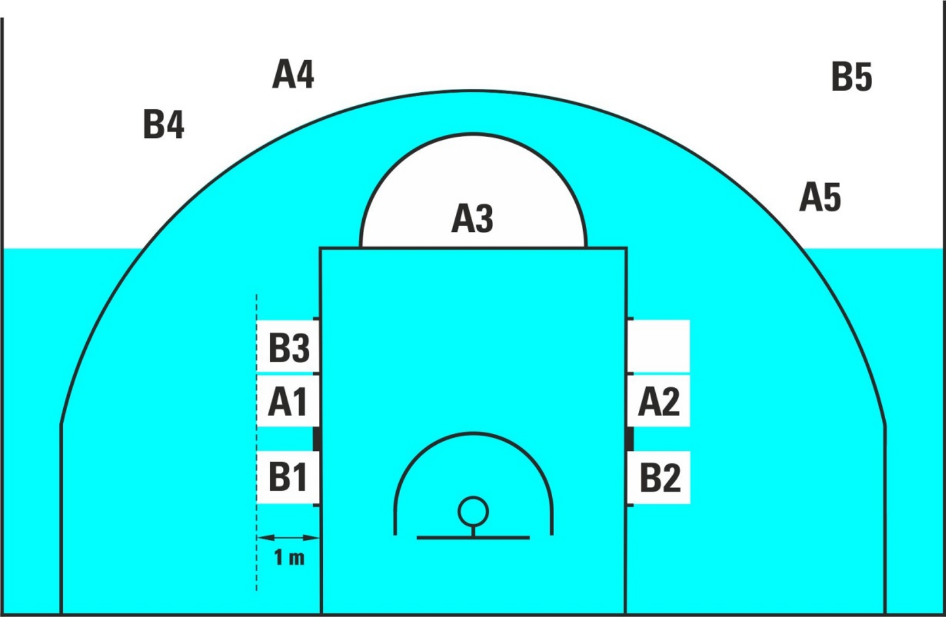
Diagram 7 Players ' positions during free throws

44.2 规则
44.2.1 当发生个人性、破坏性、鲁莽性或导致取消资格的接触犯规时，罚球应按下列规定发放：
• 被犯规的队员应尝试执行罚球。
• 若该队员被指定替换，则应在替换前尝试罚球。
• 若队员因受伤、已犯5次犯规或被取消参赛资格而必须离场，替补队员应尝试罚球；若无可用替补队员，则由主教练指定的任何队友尝试罚球。
44.2.2 当发生技术性犯规或导致禁赛的非接触性犯规时，对方球队中由主教练指定的任何队员均须尝试执行罚球。
44.2.3 罚球手应当：
• 站在罚球线后方、半圆区域内。
• 可采用任何方式执行罚球，只要球从上方进入篮筐或球触及篮圈。
• 在裁判将球置于可支配位置后5秒内将球释放。
• 在球进入篮筐或触及篮圈之前，不得触碰罚球线或进入限制区。
• 不要伪造罚球。
44.2.4 罚球抢篮板区域的队员有权在这些深度为1米的区域内交替占据位置（见图7）。

在罚球期间，这些队员不得：
• 占据他们无权占据的罚球线篮板球位置。
• 进入限制区、中立区或离开罚球抢篮板区域，直至球离开罚球手。
• 通过自身行为分散罚球手注意力。
图 7 罚球期间队员的站位

44.2.5 The players not in the free-throw rebound places shall remain behind the free-throw line extended and behind the 3-point goal line until the free throw ends.
44.2.6 During a free throw (or throws) to be followed by other set(s) of free throws or by a throw-in, all players shall remain behind the free-throw line extended and behind the 3-point goal line.
An infraction of Article 44.2.3, 44.2.4, 44.2.5 and 44.2.6 is a violation.

44.3 Penalty
44.3.1 If a free throw is successful and the violation is committed by the free-throw shooter, the point shall not count.
The ball shall be awarded to the opponents for a throw-in from the free-throw line extended, unless there is a further free throw(s) or possession penalty to be administered.
44.3.2 If a free throw is successful and the violation is committed by any player other than the free-throw shooter:
• The point shall count.
• The violation(s) shall be disregarded.
In the case of the last free throw, the ball shall be awarded to the opponents for a throw- in from any place behind that team’s endline.
44.3.3 If a free throw is not successfulul and the violation is committed by:
• A free-throw shooter or the teammate on the last free throw, the ball shall be awarded to the opponents for a throw-in from the free-throw line extended unless that team is entitled to further possession.
• An opponent of the free-throw shooter, a substitute free throw shall be awarded to the free-throw shooter.
• Both teams on the last free throw, a jump ball situation occurs.

Article 45 Correctable errors
45.1 Correctable errors – General procedures
45.1.1 A referee may stop the game immediately upon identification of a correctable error, unless either team is placed at a disadvantage.
45.1.2 Any fouls committed, time used and additional activity which may have occurred after the error has occurred and before its recognition shall remain valid.
45.1.3 After the correction of the error, the game shall be resumed from the place nearest to where it was stopped to correct the error. The ball shall be awarded to the team entitled to the ball at the time the game was stopped for the correction of the error.
45.2 Correctable errors category 1 – Definition
The below category 1 errors may be corrected by the referees if a rule is incorrectly applied.
• Awarding an unmerited free throw(s).
• Failing to award a merited free throw(s).
• Permitting the wrong player to attempt a free throw(s).
• Directing the wrong player to attempt a free throw(s).

44.2.5 未处于抢篮板球位置的队员，在罚球结束前，均应留在罚球线延长线及三分线后侧。
44.2.6 在进行罚球时，若后续还有其他罚球或掷球入界，所有队员均须留在已延伸的罚球线后方及3分投篮区域内。
违反第44.2.3条、第44.2.4条、第44.2.5条及第44.2.6条的行为即构成违例。

44.3 处罚
44.3.1 若罚球命中，而违例由罚球手犯下，则该分不予计入。
球应判给对方从延长罚球线起进行掷球入界，除非需判罚追加罚球或持球犯规处罚。
44.3.2 若罚球命中，且违例由罚球队员以外的任何队员犯下：
• 这一点应当计入。
• 该违例（或各项违例）应不予考虑。
对于最后一次罚球，球权应判给对方，由对方从该队端线后方任意位置进行掷球入界。
44.3.3 若罚球未命中，且违例由以下情况造成：
• 若投篮队员或最后一次罚球时的队友未能命中，球权应判给对方，由对方从罚球线延伸线处掷球入界，除非该队有权获得进一步控球权。
• 若罚球手有一名对手，则应判给罚球手一次罚球。
• 在最后一次罚球时，双方球队均出现了跳球情况。

第四十五条 可纠正的失误
45.1 可纠正的失误——一般程序
45.1.1 主裁判在发现可纠正的失误时，可立即终止比赛，除非任一球队已处于不利境地。
45.1.2 凡在失误发生后至该失误被确认前所犯下的任何犯规、所消耗的时间以及可能发生的其他活动，均仍有效。
45.1.3 纠正失误后，比赛应从距纠正失误时停止点最近的位置重新开始。球权应判给在比赛停止以纠正失误时拥有球权的球队。
45.2 可纠正的失误类别1——定义
若规则应用不当，主裁判可纠正下列第1类错误。
• 判罚不合理的罚球。
• 未能判罚应得的罚球。
• 允许错误的队员尝试罚球。
• 指示错误的队员尝试罚球。

• Erroneously awarding or cancelling a point (or points).
• Reporting a foul against the wrong player, head coach or team.
• Scorekeeping errors, including failing to record or erroneously recording:
_ Points.
_ A foul against the wrong player, head coach or team.
_ A time-out against the wrong team.
• Game clock errors, including malfunctions, in starting or stopping the game clock correctly or in setting the correct time on the game clock.
45.3 Correctable errors category 1 – General procedures
45.3.1 To be correctable, the errors must be identified by the referees, commissioner, if present or table officials as follows:
• If the error occurs before the game clock shows 2:00 minutes or less in the fourth quarter, the error must be corrected before 2:00 minutes or less are remaining on the game clock.
• If the error occurs before the game clock shows 2:00 minutes or less in the fourth quarter, but the referees stop the game for the first time with 2:00 minutes or less remaining on the game clock, the error must be corrected before the ball becomes live again.
• If the error occurs after the game clock shows 2:00 minutes or less in the fourth quarter or in an overtime, the error must be corrected before the ball becomes live after the first time the referees have stopped the game for any reason following the error.
45.3.2 These errors are no longer correctrectable after the ball becomes dead when the game clock sounds for the end of the game unless the error occurs after the last time the referees have stopped the game for any reason before the game clock signal sounds for the end of the game. In such a case, the error must be corrected immediately after the end of the game and the teams shall remain on the court or in their team bench areas.
45.3.3 Once an error that is still correctable has been identified, and:
• The team member involved in the correction of the error is on the team bench after being legally substituted, that team member must re-enter the court to participate in the correction of the error, at which point the given team member becomes a player.
• Upon completion of the correction, the player may remain in the game unless a legal substitution has been requested again, in which case the player may leave the court.
• If the team member has been excluded, disqualified, unable to play due to injury or cannot be identified, the head coach shall designate the team member to participate in the correction of the error.
45.4 Correctable errors category 1 – Special procedures
45.4.1 Awarding an unmerited free throw(s):
The free throw(s) attempted because of the error shall be cancelled, and the game shall be resumed as follows:
• If the game clock has not started after the error, the ball shall be awarded for a throw-in from the free-throw line extended to the team whose free throws had been cancelled.

• 错误地授予或撤销一分（或多分）。
• 向错误的队员、主教练或球队报告犯规。
• 计分错误，包括未记录或错误记录：
_得分。
对错误的队员、主教练或球队犯规。
对错误对手进行暂停。
• 比赛计时钟错误，包括计时钟故障、未能正确启动或停止比赛计时钟，或未能正确设置比赛计时钟时间。
45.3 可纠正的失误类别1——一般程序
45.3.1 若要成为可纠正的失误，相关失误必须由主裁判、若在场时的技术代表或记录台人员按以下方式予以识别：
• 若失误发生在第四节比赛计时钟显示剩余时间≤2:00之前，则必须在比赛计时钟剩余时间≤2:00之前纠正该失误。
• 若失误发生在第四节比赛计时钟显示剩余时间≤2:00之前，但主裁判首次因比赛计时钟剩余时间≤2:00而暂停比赛，则必须在球重新进入活球状态前纠正该失误。
• 若该失误发生在比赛计时钟显示第四节剩余时间≤2:00或决胜期中，则须在裁判（简称）因该失误后首次因任何原因暂停比赛前，将该项失误予以纠正。
45.3.2 若比赛计时钟响起终场信号时这些失误已无法纠正，除非该失误发生在主裁判因任何原因最后一次暂停比赛之后——即比赛计时钟终场信号响起之前。在此情况下，相关失误必须在比赛结束后立即予以纠正，且各参赛球队仍须留在场区内或各自的球队席区域内。
45.3.3 一旦已识别出仍可纠正的失误，且：
• 参与纠错的队员已在合法换人后位于球队席上，该队员必须重新进入场地参与纠错，此时该队员即成为队员。
• 完成纠正后，该队员可继续参与比赛，除非再次提出合法换人请求；若提出此类请求，该队员可离场。
• 若队员已被排除、被取消资格、因受伤无法参赛或无法确认身份，主教练应指定该队员参与纠错工作。

45.4 可纠正的失误类别1——特殊程序
45.4.1 判罚不合理的罚球：
因该失误而尝试的罚球（或罚球）应被取消，比赛按以下方式恢复：
• 若失误发生后比赛计时钟尚未启动，则应将球判给因罚球被取消而拥有掷球入界权的球队，掷球位置自罚球线向外延伸。

• If the game clock has already started after the error, the game shall be resumed
from the place nearest to where it was stopped to correct the error.
45.4.2 Failing to award a merited free throw(s):
• If there has been no change in possession of the ball after the error occurred, the game shall be resumed after the correction of the error as after any last free throw.
• If the same team scores a goal after having been erroneously awarded possession of the ball for a throw-in, the error shall be disregarded.
• If the game clock has already started, and there has been a change of possession after the correction of the error, the game shall be resumed from the place nearest to where it was stopped to correct the error.
45.4.3 Permitting the wrong player to attempt a free throw(s):
The free throw(s) attempted and the possession of the ball, if part of the penalty, shall be cancelled. The ball shall be awarded to the opponents for a throw-in from the free- throw line extended, unless the game has continued and was stopped for the correction of the error, in which case the game shall be resumed from the place nearest to where it was stopped to correct the error.
45.4.4 Directing the wrong player to attempt a free throw(s):
The free throw(s) attempted shall be cancelled and the correct player shall attempt a replacement free throw(s). The game shall continue as after any last free throw, unless the game has continued and was stopped for the correction of the error, in which case the game shall be resumed from the place nearest to where it was stopped to correct the error.
45.4.5 Erroneous awarding or cancelling of a point(s):
The points shall be awarded or cancelled. The scoresheet shall be corrected.
The game shall be resumed from the place nearest to where it was stopped to correct the error.
45.4.6 Reporting a foul against the wrong player, head coach or team:
The scoresheet shall be corrected. Any erroneously excluded or disqualified player or head coach shall re-enter the game. Any player or head coach who should have been excluded or disqualified shall be excluded or disqualified.
45.4.7 Scorekeeping errors failing to record or erroneously recording:
• Points.
• A foul against the wrong player, head coach or team.
• A time-out against the wrong team:
The scoresheet shall be corrected and any resulting action such as a player exclusion or re-entering the game shall be applied.
45.4.8 Game clock errors, including malfunctions, in starting or stopping the game clock correctly or errors in setting the correct time on the game clock:
The game clock shall be corrected with time added or deducted as necessary to correct the error.
45.5 Correctable error category 2 – Definition
The below category 2 error may be corrected by the referees if a rule is incorrectly applied: Shot clock errors, including malfunctions, in starting or stopping the shot clock correctly or errors in setting the correct time on the shot clock.

• 若比赛计时在出现错误后已启动，则比赛应从最接近比赛暂停位置处重新开始，以纠正该错误。
45.4.2 未能判罚应得的罚球：
• 若失误发生后球权未发生转移，则应在纠正该失误后，自最后一次罚球起恢复比赛。
• 若同一球队在因掷球入界而被错误地判给球权后得分，则该错误应不予考虑。
• 若比赛计时钟已启动，且在纠正失误后球权已发生转移，则比赛应从距纠正失误时停止点最近的位置重新开始。
45.4.3 允许错误的队员尝试罚球：
若犯规行为包含尝试罚球及持球行为，则上述行为均应被取消。球权应判给对方，由对方从罚球线延长线处掷球入界；但若比赛仍在进行中，仅为纠正该错误而暂停，则比赛应从距暂停地点最近处恢复进行。
45.4.4 指派错误的队员尝试罚球：
已尝试的罚球应被取消，由正确的队员尝试一次替代罚球。比赛应继续进行，如同进行完最后一次罚球后的状态；但若比赛已继续进行，却因纠正该错误而暂停，则比赛应从距暂停地点最近的位置重新开始，以纠正该错误。
45.4.5 错误地授予或撤销一分（或多分）：
得分应予授予或作废。记录表应予修正。
比赛应从距停止点最近的位置重新开始，以纠正错误。
45.4.6 向错误的队员、主教练或球队报告犯规：
记录表应予修正。任何被错误排除或取消资格的队员或主教练均须重新进入比赛；任何本应被排除或取消资格的队员或主教练均须被排除或取消资格。
45.4.7 记分错误：未记录或错误记录：
• 要点。
• 对错误队员、主教练或球队犯规。
• 对阵错误球队时暂停：
应修正该记录表，并执行由此产生的任何相应措施，例如队员禁赛或重新进入比赛。
45.4.8 比赛计时钟错误，包括启动或停止比赛计时钟时发生故障，或比赛计时钟上设置正确时间时出现错误：应根据需要，通过增加或减少时间，对比赛计时钟进行修正以纠正上述错误。
45.5 可纠正错误类别 2 – 定义
若裁判错误适用某条规则，下述第二类错误可由主裁判予以纠正：进攻计时钟相关错误，包括进攻计时钟的故障、启动或停止进攻计时钟时操作不当，以及在进攻计时钟上设置正确时间时出现错误。

45.6 Correctable errors category 2 – General procedures
45.6.1 To be correctable, the error must be identified by the referees, commissioner, if present or table officials
• when the ball is live immediately after the error and the referees stop the game to correct the error, or
• when the referees have stopped the game for the first time for any reason, and the team in control of or entitled to possession of the ball at the time of the error shall keep control of the ball or stay entitled to possession of the ball,
The shot clock shall be corrected to the correct time.
45.6.2 Shot clock errors are no longer correctable after:
• A change of possession of a live ball after the error.
• The team in control of the ball scores a valid goal.
• The ball becomes dead when the game clock sounds for the end of the game.

45.6 可纠正的失误类别2——一般程序
45.6.1 若要被视为可纠正的失误，该失误必须由主裁判、在场时的技术代表或记录台人员予以识别。
• 当失误发生后球仍处于活球状态，且主裁判暂停比赛以纠正该失误时，或
• 当主裁判因任何原因首次停止比赛时，在出现失误时控制球或拥有球权的球队，应当继续保持对球的控制，或继续保有对球的所有权。
进攻计时钟器应校正至正确时间。
45.6.2 以下情况下，抢球时间错误不再可纠正：
• 失误后活球的控制权转移。
• 控制球的球队攻入一个有效进球。
• 当比赛计时钟响起比赛结束信号时，球变为死球。

RULE EIGHT – REFEREES, TABLE OFFICIALS, COMMISSIONER: DUTIES AND POWERS

Article 46 Referees, table officials and commissioner
46.1 The referees shall be a crew chief and 1 or 2 umpire(s). They shall be assisted by the table officials and by a commissioner, if present.
46.2 The table officials shall be a scorer, an assistant scorer, a timer and a shot clock operator.
46.3 The commissioner, if present, shall sit between the scorer and the timer. The commissioner’s primary duty during the game is to supervise the work of the table officials and to assist the crew chief and umpire(s) in the smooth functioning of the game.
46.4 The referees of a given game should not be connected in any way with either team on the court.
46.5 The referees, the table officials and the commissioner, if present, shall conduct the game in accordance with these rules and have no authority to change them.
46.6 The referees' uniform shall consist of an referees’ shirt, long black trousers, black socks and black basketball shoes.
46.7 The referees and table officials shall be uniformly dressed.

Article 47 Crew chief: Duties and powers
The crew chief shall:
47.1 Inspect and approve all equipment to be used during the game.
47.2 Designate the official game clock, shot clock, stopwatch, and identify the table officials.
47.3 Select a game ball from at least 2 used balls provided by the home team. Should neither of these balls be suitable as the game ball, the best quality ball available shall be selected.
47.4 Not permit any player to wear objects that may cause injury to other players.
47.5 Administer a jump ball at the start of the first quarter and an alternating possession throw-in at the start of all other quarters and overtimes.
47.6 Have the power to stop a game when conditions warrant it.
47.7 Have the power to determine that a team shall forfeit the game.
47.8 Carefully examine the scoresheet at the end of playing time or at any time when necessary.
47.9 Approve and sign the scoresheet at the end of playing time which terminates the referees' administration and connection with the game. The referees' power shall start when they arrive on the court 20 minutes before the game is scheduled to start,

规则八——裁判员、记录台人员和技术代表：职责和权力

第四十六条 裁判员、记录台人员和技术代表
46.1 裁判组应由一名队长及一至两名副裁判员组成。他们可得到记录台人员以及在场的技术代表的协助。
46.2 记录台人员应包括一名记录员、一名助理记录员、一名计时员以及一名进攻计时钟操作员。
46.3 技术代表如在场，应坐在记录员与计时员之间。比赛期间，技术代表的主要职责是监督记录台人员的工作，并协助赛事主管及裁判确保比赛顺利进行。
46.4 特定比赛的裁判（简称）不得与场上任何一支球队存在任何形式的关联。
46.5 裁判、记录台人员及技术代表（如在场）均须依照本规则进行比赛，且均无权修改本规则。
46.6 裁判的服装应由裁判衫、黑色长裤、黑色球袜及黑色篮球鞋组成。
46.7 裁判与记录台人员应穿着统一的服装。

第四十七条 主裁判：职责和权力
主裁判应：
47.1 对比赛期间使用的所有器材进行检查并批准。
47.2 指定正式比赛计时钟、进攻计时钟及秒表，并识别记录台人员。
47.3 从主队提供的至少2个已使用过的球中选定比赛用球。若这两个球均不适合作为比赛用球，则应选用可用的最佳质量的球。
47.4 禁止任何队员佩戴可能对其他队员造成伤害的物品。
47.5 在第一节开始时执行跳球，并在所有其他节及决胜期开始时执行交替拥有掷球入界。
47.6 在条件允许时，有权中止比赛。
47.7 有权裁定某支球队应判负比赛。
47.8 在比赛时间结束时或必要时，务必仔细检查记录表。

47.9 在比赛时间结束时，批准并签署记录表，至此裁判的执法职责及其与比赛的关系即告终止。裁判的执法权自其在比赛预定开始前20分钟抵达球场时起生

and end when the game clock signal sounds for the end of the game as approved by the crew chief.
47.10 Enter on the reverse side of the scoresheet, in the dressing room before signing the scoresheet:
• Any forfeit or disqualifying foul,
• Any unsportsmanlike behaviour by team members, head coaches, assistant coaches and accompanying delegation members that occurs prior to the 20 minutes before the game is scheduled to start, or between the end of the game and the approval and signing of the scoresheet.
In such a case, the crew chief (or commissioner, if present) must send a detailed report to the organising body of the competition.
47.11 Make the final decision whenever necessary or when the referees disagree. To make a final decision the umpire(s), the commissioner, if present, and/or the table officials may be consulted.
47.12 For games where the Instant Replay System is used refer to Appendix F.
47.13 After being notified by the timer, blow the whistle before the first and third quarters when 3 minutes and 1.5 minutes remain until the start of the quarter. The crew chief shall also blow the whistle before the second and fourth quarters and each overtime when 30 seconds remain until the start of the quarter and overtime.
47.14 Have the power to make decisions on any point not specifically covered by these rules.

Article 48 Referees: Duties and powers
48.1 The referees shall have the power to make decisions on infractions of the rules committed either within or outside the boundary lines including the areas of the floor near to the scorer's table, the team benches and the areas immediately behind the boundary lines.
48.2 The referees shall blow their whistles when an infraction of the rules occurs, a quarter or overtime ends or the referees find it necessary to stop the game. The referees shall not blow their whistles after a successful goal, a successful free throw or when the ball becomes live.
48.3 When deciding on an infraction, the referees shall, in each instance, have regard for and consider the following fundamental principles:
• The spirit and intent of the rules and the need to uphold the integrity of the game.
• Consistency in application of the concept of 'advantage/disadvantage'. The referees should not seek to interrupt the flow of the game unnecessarily to penalise incidental personal contact which neither gives the player responsible an advantage nor places the opponent at a disadvantage.
• Consistency in the application of common sense to each game, bearing in mind the abilities of the players concerned and their attitude and conduct during the game.
• Consistency in the maintenance of a balance between game control and game flow, having a 'feeling' for what the participants are trying to do and calling what is right for the game.

效，直至经总裁判批准、比赛结束信号响起时终止。
47.10 在签署记录表前，于更衣室内将信息填写于记录表背面：
• 任何判罚或导致取消资格的犯规，
• 队员、主教练、助理教练及随行代表团成员在比赛开始前20分钟之前，或比赛结束后至记录表批准并签署之前，若出现任何不体育精神的行为
为。
在此情况下，赛事负责人（或若存在技术代表，则由其提交）必须向赛事组织机构提交一份详细报告。
47.11 在必要时或裁判之间出现分歧时，作出最终决定。为作出最终决定，可征询主裁判、若在场时的技术代表及/或记录台人员的意见。
47.12 对于使用即时回放系统的比赛，请参阅附录 F。
47.13 在计时员发出通知后，当每节比赛开始前还剩3分钟及1.5分钟时，主裁判须在第一节和第三节开始前鸣哨。场长亦须在第二节和第四节开始前，以及每节决胜期开始前，当剩余30秒时鸣哨。
47.14 对于本规则未明确涵盖的任何事项，均有权作出裁决。

第四十八条 裁判员：职责和权力
48.1 裁判（简称）有权对在界线内或界线外发生的规则违犯行为作出裁决，包括靠近记录台、球队休息区以及界线正后方的场地区域。
48.2 当出现规则违反、节或决胜期结束时，或主裁判认为有必要终止比赛时，主裁判应吹哨。主裁判在进球成功、罚球命中或球恢复活球状态后，不得吹哨。
48.3 在判定违犯时，裁判（简称）应在每个具体情况下，兼顾并考量以下基本原则：
• 规则的精神和意图，以及维护比赛公正性的需要。
• 在应用“优势/劣势”概念时保持一致性。主裁判不得为处罚偶发的身体接触而不必要地中断比赛流畅性，只要该接触既未给责任队员带来优势，也未使对方队员处于劣势。
• 在每场比赛中应用常识时保持一致性，同时充分考虑相关队员的能力及其在比赛中的态度与行为。
• 在维持比赛控制与比赛流畅性之间的平衡方面保持一致性，对参赛者的意图具备敏锐感知，并能做出符合比赛本质的判罚。

48.4 Should a protest be filed by one of the teams, the crew chief (or commissioner, if present) shall, upon receipt of the protest reasons, report in writing the incident to the organising body of the competition.
48.5 If a referee is injured or for any other reason cannot continue to perform the referee’s duties within 5 minutes of the incident, the game shall be resumed. The remaining referee(s) shall officiate for the remainder of the game alone unless there is the possibility of replacing the injured referee with a qualified substitute.lified substitute referee. After consulting the commissioner, if present, the remaining referee(s) shall decide upon the possible replacement.
48.6 For all international games, if verbal communication is necessary to make a decision clear, it shall be conducted in the English language.
48.7 Each referee has the power to make decisions within the limits of the referee’s duties but has no authority to disregard or question decisions made by the other referee.
48.8 The implementation and interpretation of the Official Basketball Rules by the referees, regardless of whether an explicit decision was made or not, is final and cannot be contested or disregarded, except in cases where a protest is allowed (see Appendix C).

Article 49 Scorer and assistant scorer: Duties
49.1 The scorer shall be provided with a scoresheet and shall keep a record of:
• Teams, by entering the names and numbers of the players who are to start the game and of all substitutes who enter the game. When there is an infraction of the rules regarding the five players to start the game, substitutions or numbers of players, the nearest referee must be notified immediately.
• Running summary of points scored, by entering the goals and the free throws made.
• Fouls charged against each player. The scorer shall enter the fouls charged against each head coach and must notify a referee immediately when a head coach should be disqualified. Similarly, the scorer must notify a referee immediately that a player should be disqualified, after having committed two category 1 technical fouls, or two flagrant fouls, or one category 1 technical and one flagrant foul.
• Time-outs. The scorer must notify the head coach through a referee when the head coach has no more time-out(s) left in a half or overtime.
• The next alternating possession, by operating the alternating possession arrow. The scorer shall reverse the direction of the alternating possession arrow immediately after the end of the first half as the teams shall exchange baskets for the second half.
• For each team the head coach’s challenge is granted. The scorer must notify the nearest referee immediately when a head coach erroneously requests a second challenge.
49.2 The assistant scorer shall operate the scoreboard and assist the scorer and timer. In case of any discrepancy between the scoreboard and the scoresheet which cannot be resolved, the scoresheet shall take precedence and the scoreboard shall be corrected accordingly.

48.4 若其中一方球队提出申诉，赛事负责人（或在场时的技术代表）在收到申诉理由后，应以书面形式将该事件报告给赛事组织方。
48.5 若主裁判在事件发生后5分钟内因受伤或其他原因无法继续履行裁判职责，则比赛应重新进行。其余主裁判应独自执裁剩余比赛，除非有可能用合格替补主裁判替换受伤主裁判。在征询技术代表（如在场）的意见后，其余主裁判应就可能的替换人选作出决定。
48.6 对于所有国际比赛，若需通过口头沟通以明确判定结果，则此类沟通应以英语进行。
48.7 每位裁判（简称）均有权在其职责范围内作出裁决，但无权无视或质疑另一位裁判（简称）作出的裁决。
48.8 主裁判对《职业篮球规则》的执行与解释，无论是否已作出明确裁定，均具有最终效力，不得被质疑或忽视，但允许提出申诉的情形除外（参见附录 C）。

第四十九条 记录员与助理记录员：职责
49.1 记录员应配备一份记录表，并记录以下内容：
• 各队须填写本场比赛首发队员及所有替补队员的姓名与号码。若违反关于首发5名队员、替补人数或队员数量的规则，须立即通知最近的主裁判。
• 通过记录进球数和罚球数，生成得分简要统计。
• 记录每位队员被判处的犯规次数。记录员须将每位主教练被判处的犯规情况登记入册，且当主教练被取消资格时，须立即通知主裁判。同理，若某队员已犯下两次1类技术犯规、两次恶意犯规，或一次1类技术犯规加一次恶意犯规，记录员亦须立即通知主裁判该队员应被取消资格。
• 暂停。当主教练在半场或决胜期中已无可用暂停时，记录员须通过主裁判通知主教练。
• 下一次交替拥有操作交替拥有箭头即可进行。上半场结束时，由于双方球队将在下半场交换得分机会，记录员应立即反转交替拥有箭头方向。
• 每支球队均享有主教练的二次挑战权。若主教练错误地提出二次挑战请求，记录员须立即通知最近的裁判（简称）。
49.2 助理记录员应操作记分牌，并协助记录员与计时员工作。若记分牌与记录表
之间出现无法解决的差异，应以记录表为准，并相应修正记分牌。

49.3 If an error is identified on the scoresheet:
• During the game, the timer must wait for the first dead ball before sounding the signal.
• The scorer shall consult the crew chief and correct errors on the scoresheet when the error is identified within the limits defined in Article 45 (Correctablele errors).
• If the error is not identified within the limits defined in Article 45 (Correctable errors), the error may no longer be corrected. The crew chief or the commissioner, if present, shall send a detailed report to the organising body of the competition.

Article 50 Timer: Duties
50.1 The timer shall be provided with a game clock and a stopwatch and shall:
• Measure playing time, time-outs and intervals of play.
• Ensure that the game clock signal sounds very loudly and automatically at the end of a quarter or overtime.
• Use any means possible to notify the referees immediately if the signal fails to sound or is not heard.
• Indicate the number of fouls committed by each player by raising the player foul marker in a manner visible to both head coaches.
• Indicate that a player or a coach has been disqualified, by raising the GD marker.
• Notify a referee immediately when 5 fouls have been charged against any player.
• Operate the team foul markers, each one positioned on either side of the scorer’s table nearest to the team bench. The team foul marker shall show the current number of team fouls and shall be fully in red, with no number visible, after the ball becomes live again after the fourth team foul in a quarter.
• Effect substitutions.
• Effect time-outs. The timer must notify the referees of the time-out opportunity when a team has requested a time-out.
• Sound the signal only when the ball becomes dead and before the ball becomes live again. The sound of the timer’s signal neither stops the game clock or the game nor causes the ball to become dead.
50.2 The timer shall measure playing time as follows:
• Start the game clock when:
_ During a jump ball, the ball is legally tapped by a jumper.
_ After an unsuccessful last free throw and the ball continues to be live, the
The ball touches or is touched by any player on the court.
_ During a throw-in, the ball touches or is legally touched by any player on the court.
• Stop the game clock when:
_ Time expires at the end of a quarter and overtime, if not stopped automatically by the game clock itself.
_ A referee blows the whistle while the ball is live.
_ A goal is scored against a team which has requested a time-out.
_ A goal is scored when the game clock shows 2:00 minutes or less in the fourth quarter and in each overtime.

49.3 若记录表上发现错误：
• 比赛期间，计时员必须等待首次出现死球后，方可发出手势信号。
• 当记录员在第45条（可纠正的失误）规定的范围内发现失误时，应咨询队长并纠正记录表上的错误。
• 若失误未在第45条（可纠正的失误）规定的时限内被发现，则该失误可能不再可纠正。赛事负责人或技术代表（如在场）应向赛事组织方提交一份详细报告。

第五十条 计时员：职责
50.1 计时员应配备比赛计时钟和秒表，并须满足以下要求：
• 记录比赛时间、暂停时间及比赛间歇时间。
• 确保比赛计时信号在每节比赛或决胜期结束时响亮且自动响起。
• 若手势未能发出或未被听到，应尽可能采取一切措施立即通知主裁判。
• 通过以两位主教练均能清晰地看到的方式抬起相应队员的犯规标志牌，标明每位队员所犯犯规的次数。
• 通过抬起 GD 标记，表明某位队员或教练已被判罚出局。
• 当任何队员被判5次犯规时，须立即通知主裁判。
• 操作全队犯规标志牌，每块标记牌分别置于记录台两侧最靠近球队席的位置。在每节比赛发生第四次全队犯规后，当球重新进入活球状态时，该全队犯规标志牌应显示当前全队犯规次数，且整体呈纯红色，且不得显示具体数字。
• 替换。
• 执行暂停。当某队请求暂停时，计时员必须将暂停机会通知主裁判。
• 仅在球变为死球且尚未重新变为活球时发出信号。计时员的信号声既不会停止比赛计时或比赛进程，也不会使球变为死球。
50.2 计时员应按下列方式测量比赛时间：
• 在以下情况下启动比赛计时钟：
在跳球过程中，跳球者可合法地拍球。
在最后一次罚球未命中且球仍为活球后，
球被触碰到，或被场上任何队员触碰。
在掷球入界过程中，球与场上任何队员发生接触，或被队员合法触碰。
• 在以下情况下暂停比赛计时：
若比赛计时钟未自动停止，则每节比赛及决胜期结束时时间即告结束。主裁判在球处于活球状态时吹哨。
若某队请求暂停，则该队可得分。
当比赛计时钟在第四节显示剩余时间≤2:00分钟，以及每场决胜期中，均算作进球。

_ The shot clock signal sounds while a team is in control of the ball.
_ The shot clock signal sounds while a team is in control of the ball and a referee calls a violation.
50.3 The timer shall measure a time-out as follows:
• Start the stopwatch immediately when the referee blows the whistle and gives the time-out signal.
• Sound the signal when 50 seconds of the time-out have elapsed.
• Sound the signal when the time-out has ended.
50.4 The timer shall measure an interval of play as follows:
• Start the stopwatch immediately when a previous quarter or overtime has ended.
• Notify the referees before the first and third quarters when 3 minutes and 1.5 minutes remain until the start of the quarter.
• Sound the signal before the second and fourth quarters and each overtime when 30 seconds remain until the start of the quarter or overtime.
• Sound the signal and simultaneously stop the stopwatch immediately when an interval of play has ended.

Article 51 Shot clock operator: Duties
The shot clock operator shall be provided with a shot clock which shall be:
51.1 Started or restarted when:
• On the court a team gains control of a live ball. After that, the mere touching of the ball by an opponent does not start a new shot clock period if the same team remains in control of the ball.
• On a throw-in, the ball touches or is legally touched by any player on the court.
51.2 Stopped, but not reset, with the remaining time visible, when the same team that
The player who previously had control of the ball is awarded a throw-in as the result of:
• A ball having gone out-of-bounds.
• A player of the same team having been injured.
• A technical foul committed by that team.
• A jump ball situation (not when the ball lodges between the ring and the backboard).
• A double foul.
• A cancellation of equal penalties on both teams.
Stopped, but also not reset, with the remaining time visible, when the same team that previously had control of the ball is awarded a frontcourt throw-in and 14 or more seconds are displayed on the shot clock as a result of a foul or violation.
51.3 Stopped and reset to 24 seconds, with no display visible, when:
• The ball legally enters the basket.
• The ball touches the ring of the opponents' basket and it is controlled by the team that was not in control of the ball before it touched the ring.
• The team is awarded a backcourt throw-in:
_ As the result of a foul or violation (except for an out-of-bounds violation).
_ As the result of a jump ball situation for the team that previously did not have control of the ball.

当某支球队控制球时，进攻计时信号会响起。
当某队控制球时，进攻计时信号响起，同时主裁判判罚违例。
50.3 计时员应按以下方式记录暂停时间：
• 当主裁判吹哨并发出暂停信号时，应立即启动秒表。
• 当暂停时间达到50秒时，发出手势信号。
• 计时结束时发出信号。
50.4 计时员应按以下方式测量比赛时间间隔：
• 在前一个节或决胜期结束时，立即启动秒表。
• 在第一节和第三节开始前，当距本节开始还有3分钟及1.5分钟时，须通知主裁判。
• 在第二节和第四节开始前，以及每节比赛或每节决胜期开始前30秒时，鸣响信号。
• 发出手势信号，并在比赛时段结束时立即停止秒表。

第五十一条 进攻计时钟操作员：职责
进攻计时钟操作员应配备一台进攻计时钟，该计时钟应符合以下要求：
51.1 在以下情况下启动或重新启动：
• 在场上，一支球队获得对活球的控制权。此后，若同一球队仍保持对球的控制，对手仅触及该球则不会启动新的进攻计时周期。
• 在掷球入界时，球与场上任何队员发生接触，或被队员合法触碰。
51.2 比赛暂停，但并未重置，且剩余时间仍清晰可见；此时，先前控制球的同一队因以下原因被判掷球入界：
• 球已出界。
• 同一队的一名队员已受伤。
• 该球队犯下的技术犯规。
• 跳球情况（并非球卡在篮圈与篮板之间时）。
• 双方犯规。
• 取消双方球队的同等处罚。
比赛暂停，但并未重置，剩余时间仍清晰可见；此时，先前控制球的同一队因犯规或违例而获得前场掷球入界机会，且进攻计时钟上显示有14秒或更长时间。
51.3 当满足以下条件时，进攻计时钟停止并复位为 24 秒，且此时屏幕无显示：
• 球合法地进入篮筐。
• 球触及对方篮筐，且由在接触篮筐前未控制球的球队控制。
• 该球队获得一次后场掷球入界机会：
作为犯规或违例（界外违例除外）的结果。
若此前未控制球的球队在跳球情况下获得该球权，则构成此犯规。

_ The game is stopped because of an action not connected with the team in control of the ball.
_ The game is stopped because of an action not connected with either team,
unless the opponents are placed at a disadvantage.
• The team is awarded free throw(s).
51.4 Stopped and reset to 14 seconds, with 14 seconds visible, when:
• The same team that previously had control of the ball is awarded a frontcourt throw-in and 13 seconds or less are displayed on the shot clock:
_ As the result of a foul or violation (except an out-of-bounds violation).
_ The game being stopped because of an action not connected with the team in control of the ball.
_ The game being stopped because of an action not connected with either
team, unless the opponents would be placed at a disadvantage.
• The team that previously did not have control of the ball shall be awarded a frontcourt throw-in as a result of a:
_ Personal foul or violation (including for an out-of-bounds violation), _ Jump ball situation.
• A team shall be awarded a throw-in from the throw-in line in its frontcourt, opposite the scorer’s table, as a result of a disruptive, flagrant or disqualifying foul.
• After the ball has touched the ring on an unsuccessful shot for a goal (including when the ball lodges between the ring and the backboard), an unsuccessful last free throw or on a pass, if the team which regains control of the ball is the same team that was in control of the ball before the ball touched the ring.
• The game clock shows 2:00 minutes or less in the fourth quarter or in each overtime following a time-out taken by the team that is entitled to the possession of the ball from its backcourt and the head coach decides that the game shall be resumed with a throw-in for the team from the throw-in line in the team’s frontcourt and 14 seconds or more are displayed on the shot clock at the time when the game clock was stopped.
51.5 Switched off, after the ball becomes dead and the game clock is stopped in any quarter or overtime when there is a new control of the ball for either team and there are less than 14 seconds on the game clock.
The shot clock signal neither stops the game clock or the game, nor causes the ball to become dead, unless a team is in control of the ball.

比赛因与控球方无关的动作而暂停。
比赛因与双方球队均无关的行为而暂停。
除非这会使对手处于不利境地。
• 该球队被判罚罚球。
51.4 当满足以下条件时，停止并复位为14秒，且显示14秒：
• 先前控制球的同一球队将获得一次前场掷球入界机会，且进攻计时钟上显示的时间为13秒或更短：
作为犯规或违例（界外违例除外）的结果。
比赛因与控球方无关的动作而暂停。
若比赛因与双方球队均无关的行为而暂停，除非此举会使对方处于不利境地。
• 此前未控制球的球队，若因以下情况，应被判罚一次前场掷球入界：
侵人犯规或违例（包括界外违例）、争球情况。
• 若球队因实施破坏性、恶劣或导致禁赛的犯规，则可在其前场、与记录台相对的位置，从掷球入界线获得一次掷球入界机会。
• 当球在一次未成功的投篮中触碰到篮筐后（包括球卡在篮筐与篮板之间时）、或在一次未成功的最后一次罚球后、或在一次传球后，若重新控制球的球队与球触碰到篮筐前控制球的球队为同一球队，则适用此规定。
• 当比赛计时钟在第四节或球队从后场获得控球权后进行的每场决胜期中显示剩余时间≤2分钟，且主教练决定由该球队从前场掷球线起以掷球入界方式继续比赛，且比赛计时钟暂停时进攻计时钟显示时间≥14秒，则执行此规定。
51.5 当比赛时钟在任何节或决胜期中停止，且任一球队重新获得控球权，同时比赛时钟剩余时间少于14秒时，本规则暂停执行。
进攻计时钟信号既不会停止比赛计时钟或比赛进程，也不会导致球变为死球，除非某支球队正在控制球。

APPENDIX A – REFEREES’ SIGNALS
A.1 The hand signals illustrated in these rules are the only valid referees’ signals.
A.2 While reporting to the scorer’s table it is strongly recommended to verbally support the communication (in international games in the English language).
A.3 It is important that the table officials are familiar with these signals.

Game clock signals

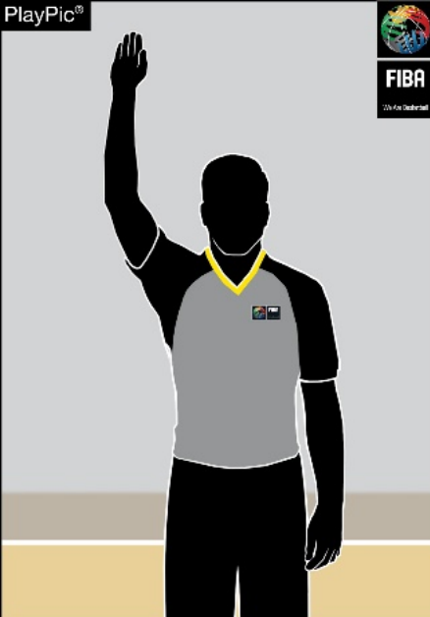STOP THE CLOCK

1

STOP THE CLOCK
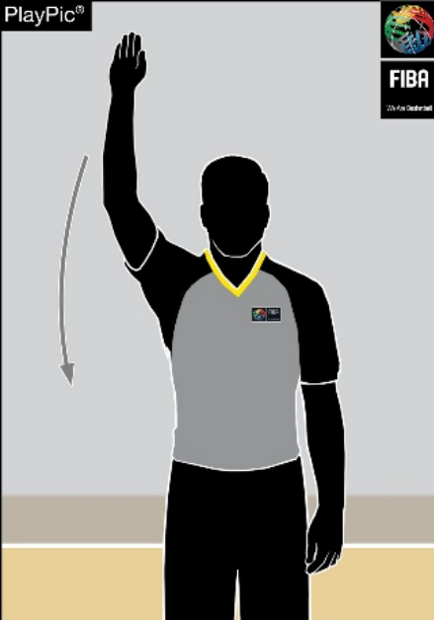FOR FOUL START THE CLOCK

3

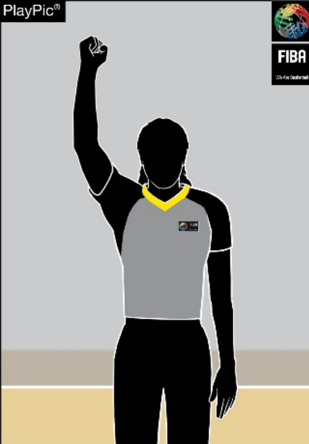

2

Open palm | One clenched fist Chop with hand
Scoring  1 POINT | 2 POINTS 3 POINTS
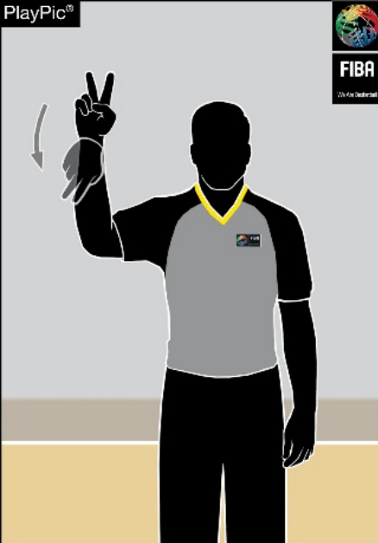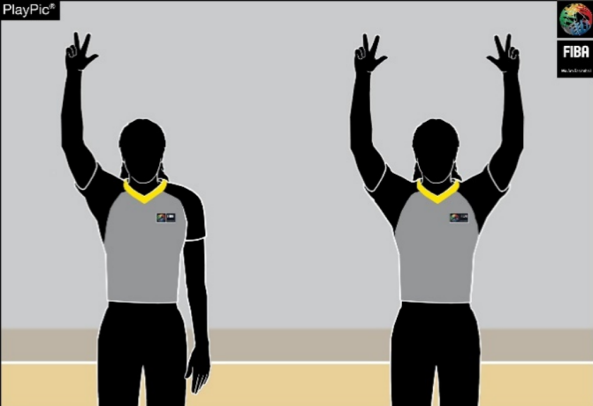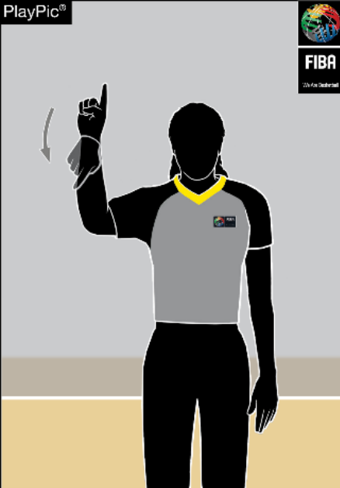

5

6

4

1 finger, 'flag' from 2 fingers, 'flag' from 3 fingers extended
wrist wrist One arm: Attempt
Both arms: Successful

附录A 裁判员手势
A.1 本规则中所列的手势信号，系主裁判唯一有效的信号。
A.2 在向记录台汇报时，强烈建议以口头方式辅助沟通（在国际比赛中建议使用英语）。
A.3 记录台人员熟悉这些手势至关重要。

比赛计时手势

暂停时间

2

暂停时间
因犯规 开始计时

3

1

张开手掌 一只紧握的拳头 用手切碎
计分

1 要点 2 要点

4

5

1 指，“旗”手势（来自 2 指），“旗”手势腕 腕

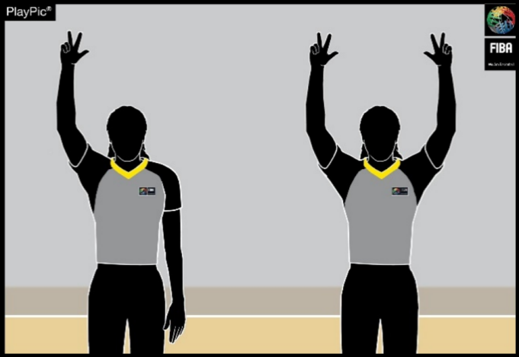
3 要点

（来自）伸出3根手指一组：尝试
6
两组均成功

Substitution and Time-out

SUBSTITUTION
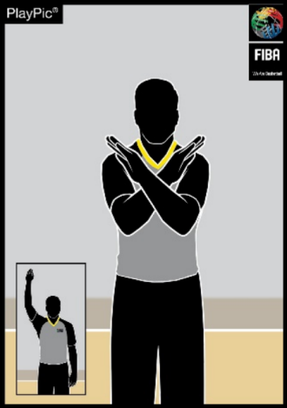
7
Cross forearms

BECKONING IN
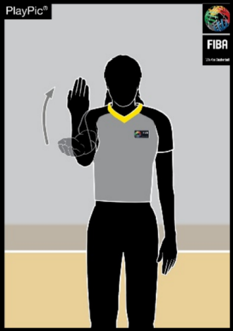
8
Open palm, wave towards the body
-

CHARGED TIME-OUT MEDIA TIME-OUT
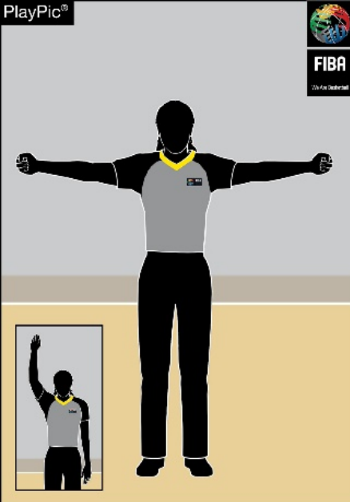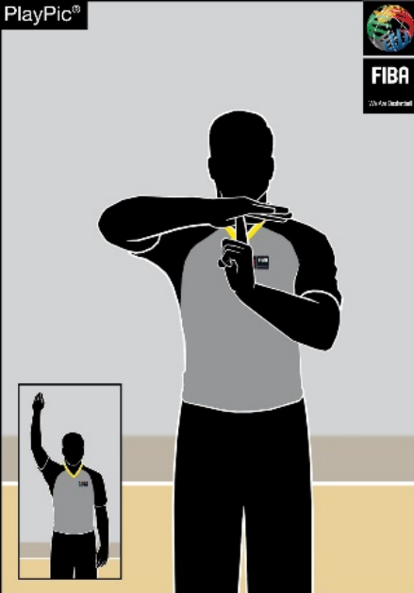

10

9

Form T,
Open arms with clenched fists
show index finger

Informative
CANCEL SCORE CANCEL PLAY
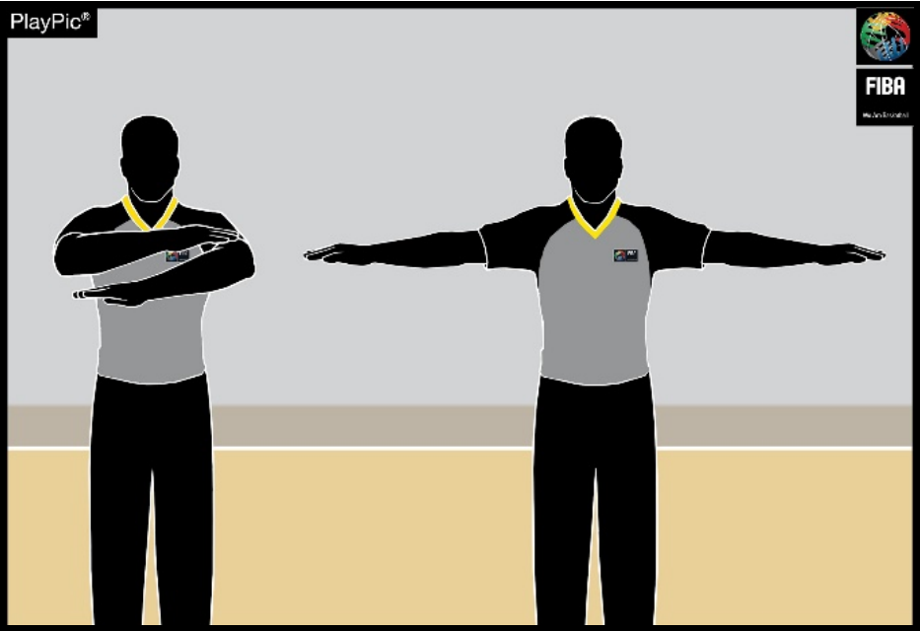
11
Scissor-like action with arms, once across chest
,

VISIBLE COUNT
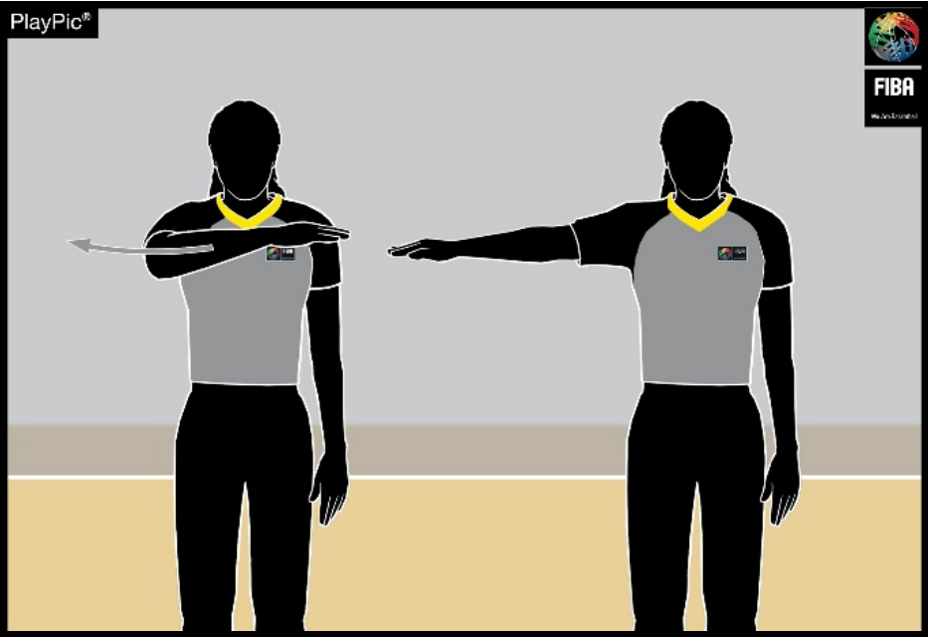
12
Counting while moving the palm

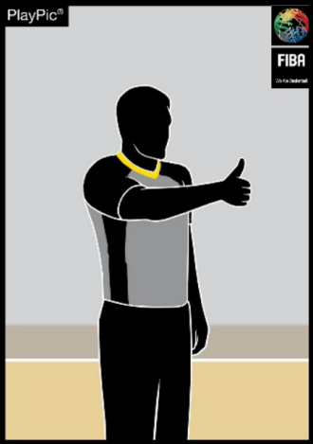
13
Thumb up
COMMUNICATION

SHOT CLOCK RESET
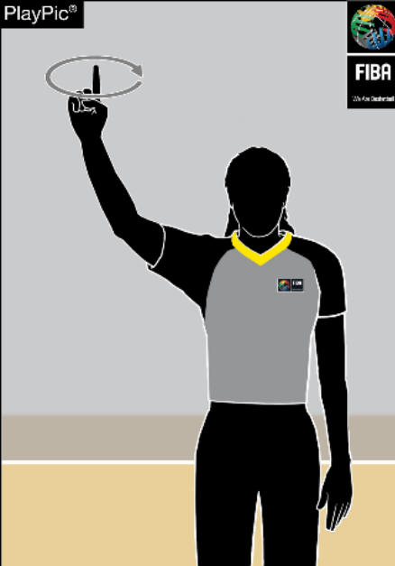

14

Rotate hand,
extend index finger

DIRECTION OF PLAY
AND/OR
OUT-OF-BOUNDS
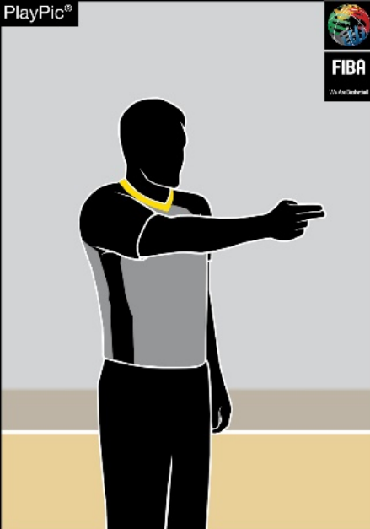

15

Point in the direction of
play, arm parallel to
sidelines

HELD BALL/JUMP BALL SITUATION
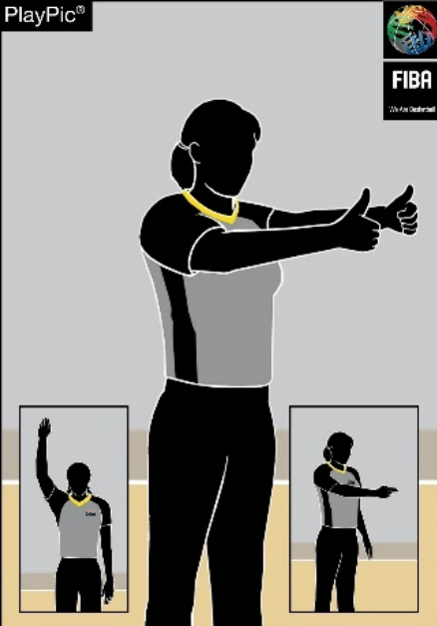

16

Thumbs up, then point
in the direction of play
using the alternating
possession arrow

替换和暂停
替换 贝肯宁-因 已触发超时 媒体暂停
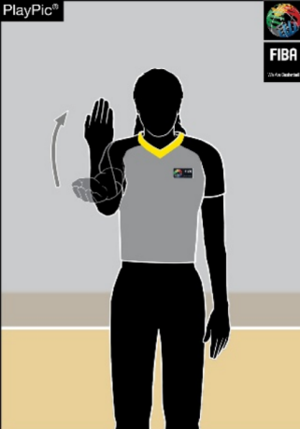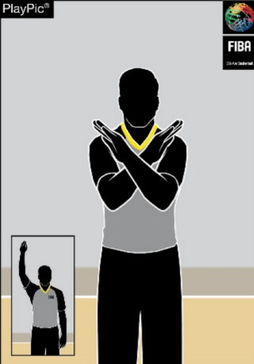

8

9

10

7

前臂交叉 掌心朝上，向身体方向挥手
具有参考价值
取消得分，取消比赛
11
双臂呈剪刀状动作，双臂已横跨胸前

双臂张开，双手紧握
呈 T 形，伸出食指

可见计数
12
手掌移动时计数

比赛方向及/或界

沟通 击球计时钟重置 外 争球/跳球情况
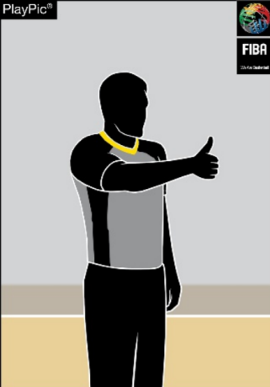

14

15

16

13

点赞 转动手，
伸出食指

指向比赛方向，手臂与边线平行

竖起大拇指，然后
用交替拥有箭头指
向比赛方向。

Violations
ILLEGAL DRIBBLE: ILLEGAL DRIBBLE:

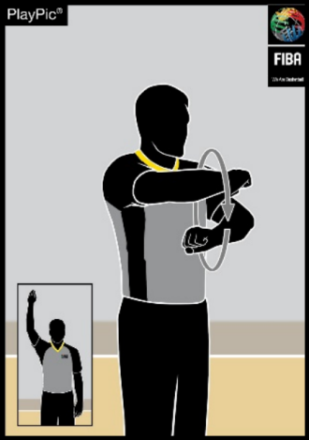
17
TRAVELLING

DOUBLE DRIBBLING
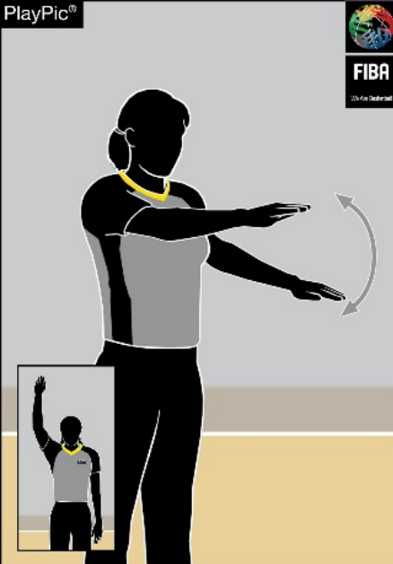

18

CARRYING THE BALL
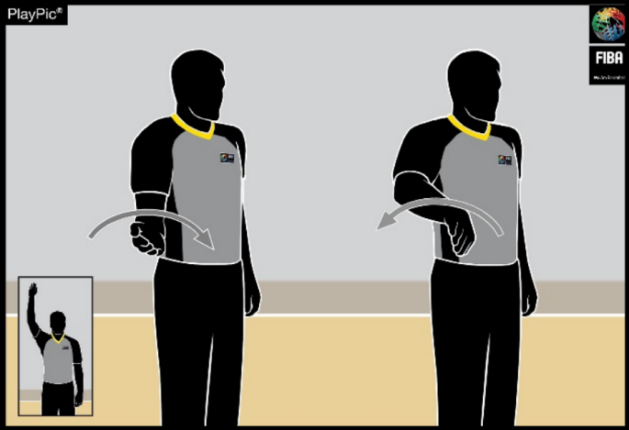
19

Rotate fists Patting motion with
palm

Half rotation with palm

3 SECONDS 5 SECONDS 8 SECONDS SHOT CLOCK
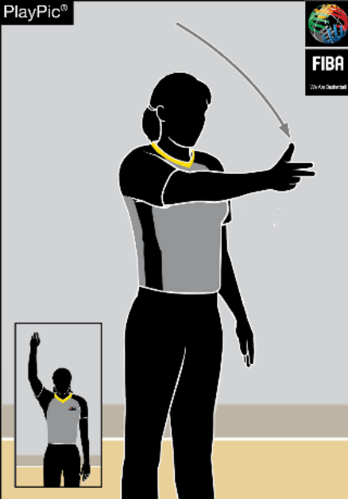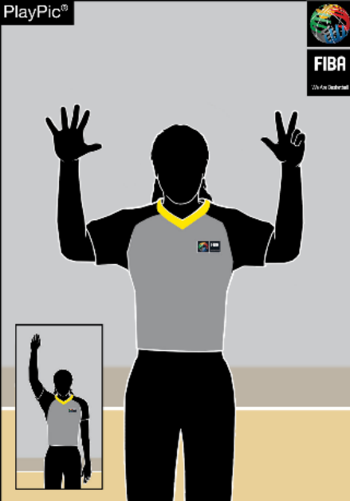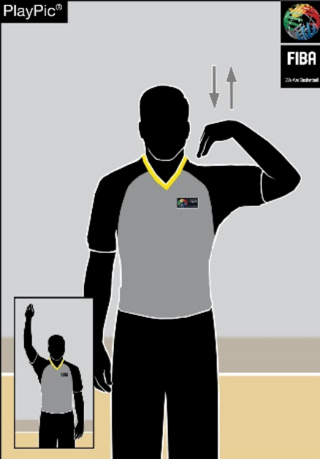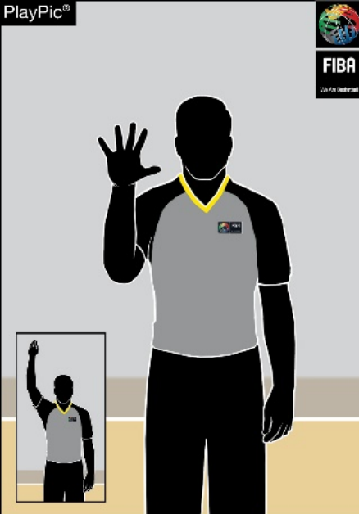

20

22

23

21

Wave arm, Show 5 fingers Show 8 fingers Fingers touch shoulder
show 3 fingers

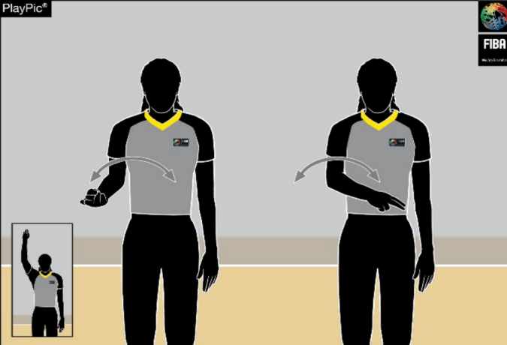BALL RETURNED TO BACKCOURT

24

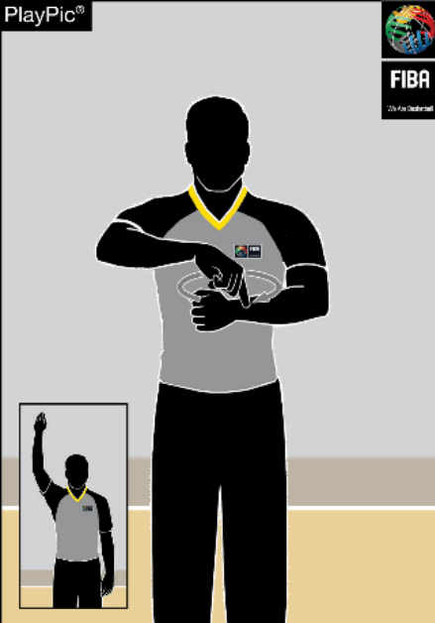DELIBERATE KICK OR BLOCK OF THE BALL

26

GOALTENDING/
BASKET INTERFERENCE

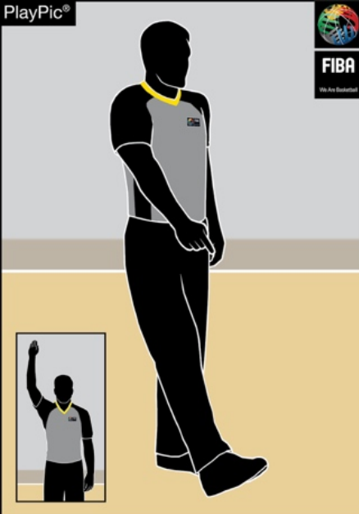

25

Wave arm in front of body Point to the foot Rotate finger, extend
index finger over the other hand in a circle

违例

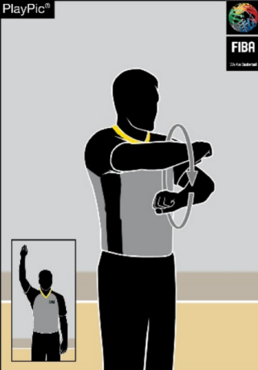T 嬉戏

17

18

非法运球：
双重运球

非法运球：
持球

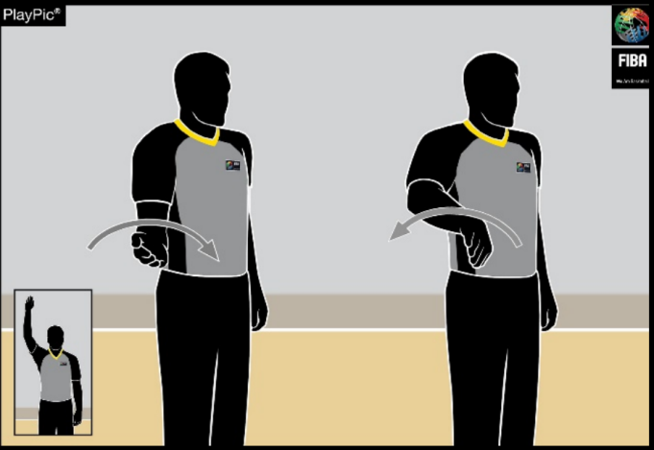
19

握拳轮转 用手掌拍打动作

半轮转（以手掌为支点）

3 秒 5 秒 8 秒 进攻计时钟

20

22

23

21

挥手，伸出三指

伸出五根手指 伸出8 根手指 手指触碰肩膀

球被回传至后场
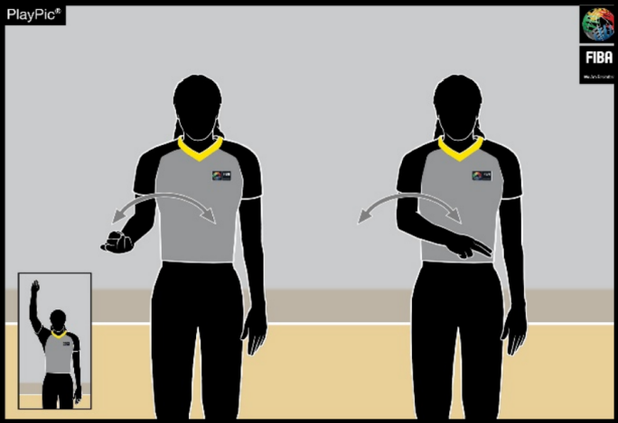
24
车身前部波浪形臂

故意踢球或挡球 干涉得分/干扰得分

25

26

指向脚部，旋转手指，伸展
用食指在另一只手
上画一个圆圈

Number of Players
No. 00 and 0
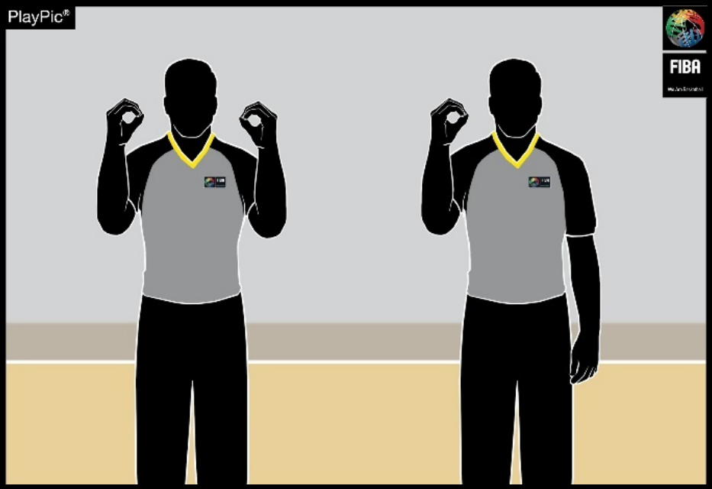
27
Both hands show Right hand shows
number 0 number 0
.

No. 1 - 5 No. 6 - 10 No. 11 - 15
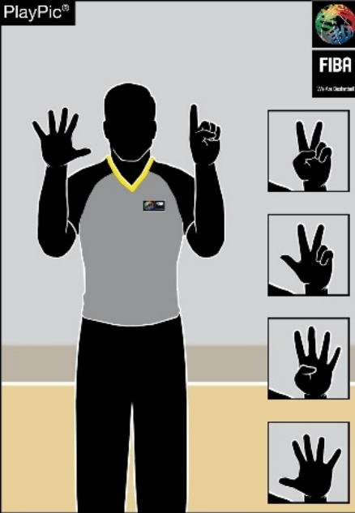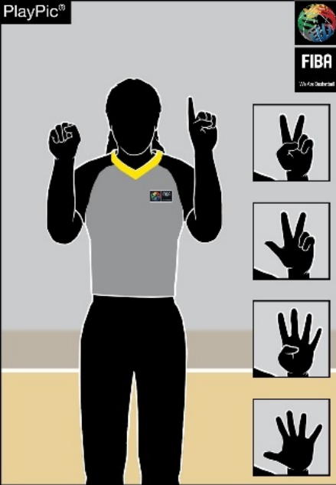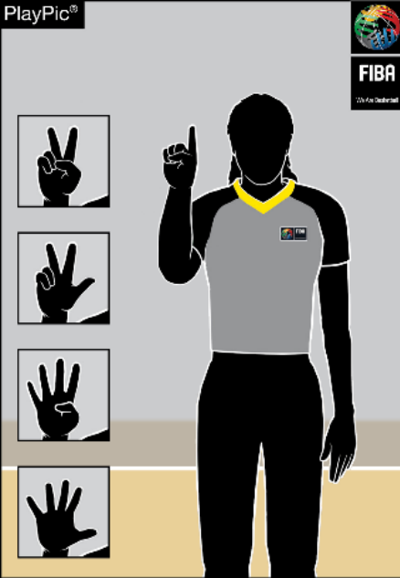

29

30

28

Right hand shows
Right hand shows number 1 to 5
number 5,
left hand shows
numbers 1 to 5

No 16
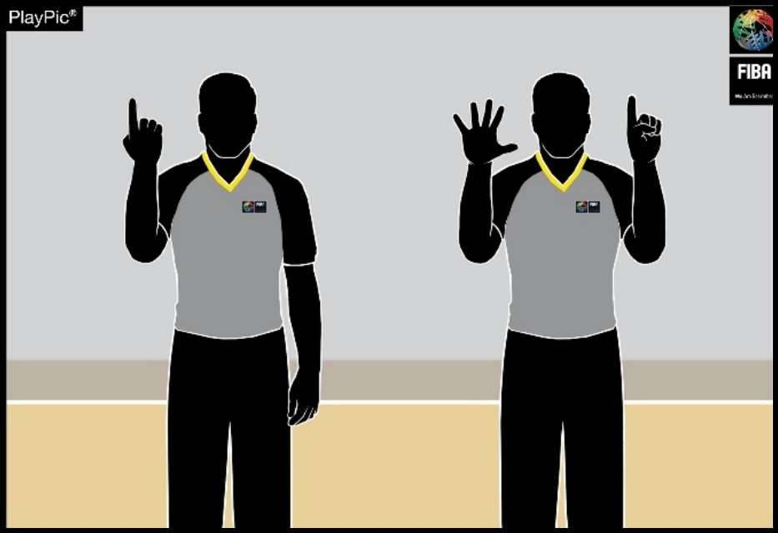
31
First reverse hand shows number 1 for the
.
decade digit _ then open hands show number 6
for the units’ digit

Right hand shows
clenched fist,
left hand shows
numbers 1 to 5

No 24
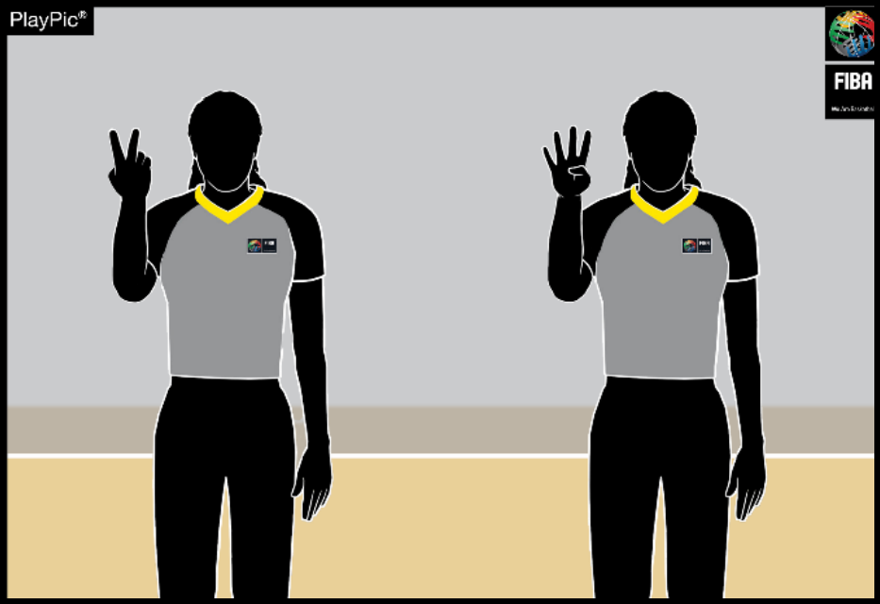
32
First reverse hand shows number 2 for the
.
decade digit _ then open hand shows number 4
for the units’ digit

队员人数
00号及0号
27
双手均显示数
右手显示数字 0
字 0

第 1–5 号

29

第 6–10 号

30

第 11–15 号

28

右侧显示数字 1至 5 | 右手显示数字5，左手显示数  字 1 至 5

第 16 号
31
首先，反向手势表示十位数字为 1；随后，
张开手势表示个位数字为 6。

右手握拳，左手
显示数字 1 至
5.

第 24 号
32
首先，反向手势显示十位数字为 2；接着，
开放手势显示个位数字为 4。

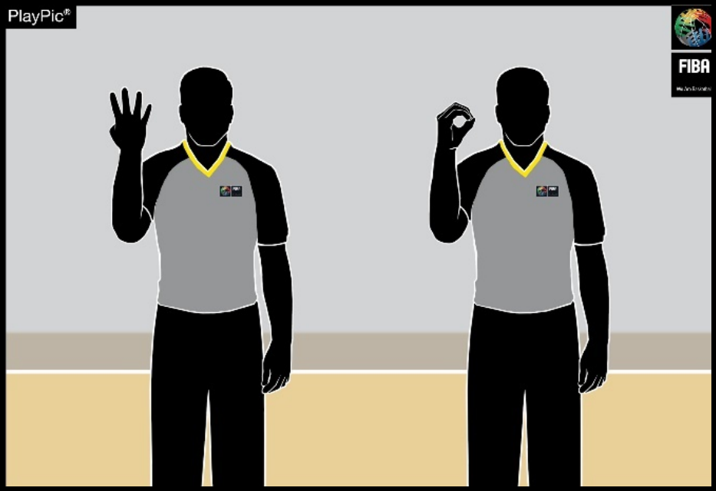
33
First reverse hand shows number 4 for the
No. 40
decade digit _ then open hand shows 0 for the
units’ digit

No. 62
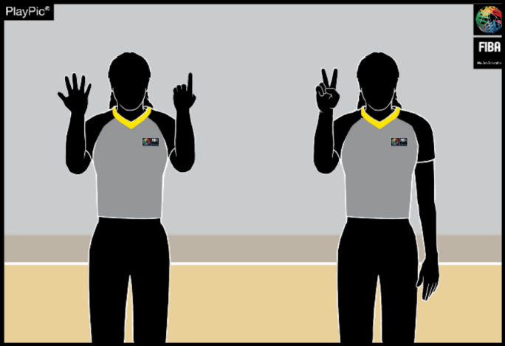
34
First reverse hands show number 6 for the
decade digit _ then open hand shows 2 for the
units’ digit

No 78
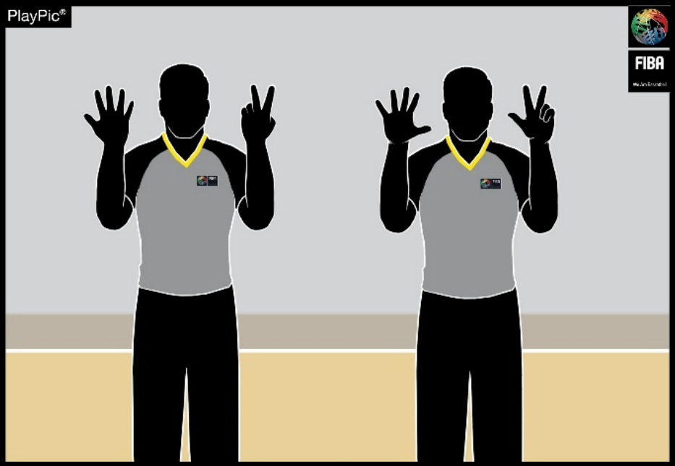
35
First reverse hands show number 7 for the
.
decade digit _ then open hands show number 8
for the units’ digit

No 99
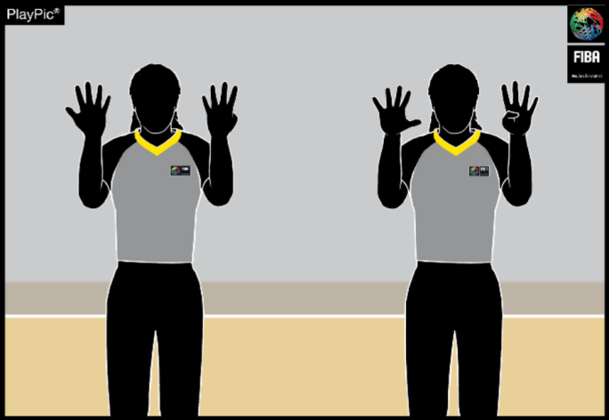
36
First reverse hands show number 9 for the
.
decade digit _ then open hands show number 9
for the units’ digit

Types of Fouls

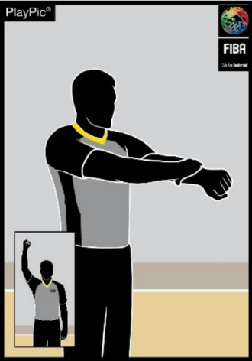
37
Grasp wrist downward
HOLDING

BLOCKING (DEFENSE),  ILLEGAL SCREEN  (OFFENSE) | PUSHING OR  CHARGING WITHOUT  THE BALL
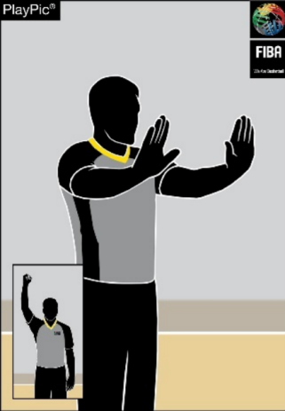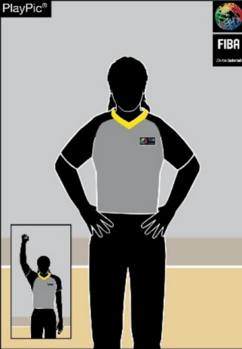

39

38

Both hands on hips Imitate push

HANDCHECKING
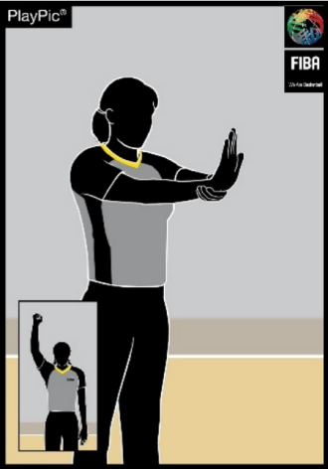
40
Grab palm and forward motion

第 40 号
33
首先，反向手型显示十位数字为数字4；接着，张开的手型显示个位数字为0。
第 78 号
35
首先，将双手反握，代表十位数字为 7；随
后，将双手张开，代表个位数字为 8。
犯规类型
阻挡（防守），非法拦截（进攻）

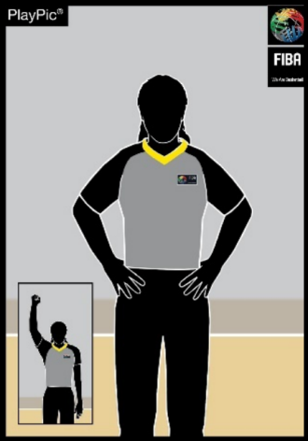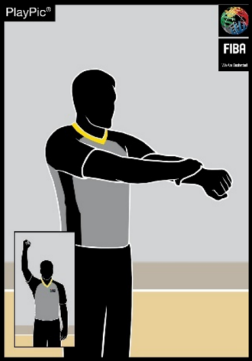
38
双手叉腰
37
握拳，手腕向下
拉人

第 62 号
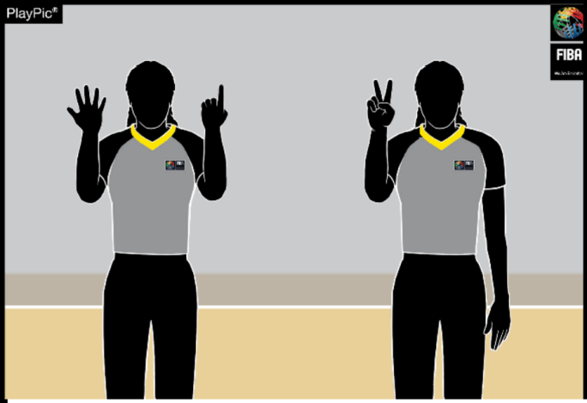

34
首先，反向手势显示十位数字为6；接着，张开的手势显示个位数字为2。
第 99 号
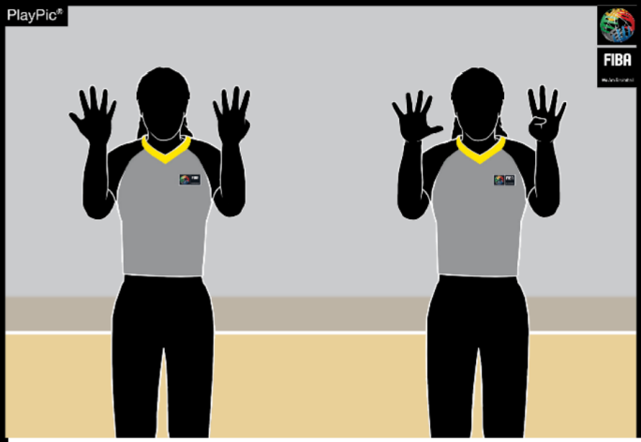

36
首先，将双手反握，代表十位数字为 9；随后，将双手张开，代表个位数字为 9。

无球状态下推人或冲撞
HANDCHECKING
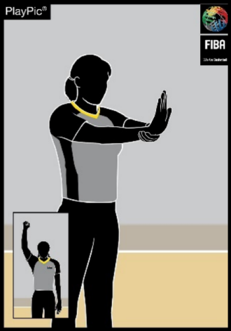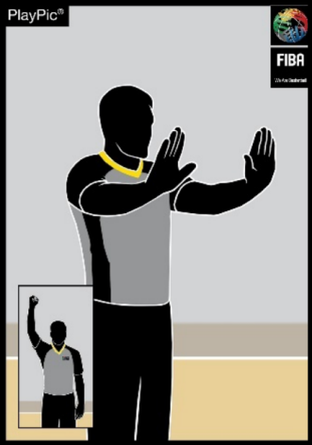
40
握住手掌并工作进程
39
模仿推人

ILLEGAL USE OF HANDS

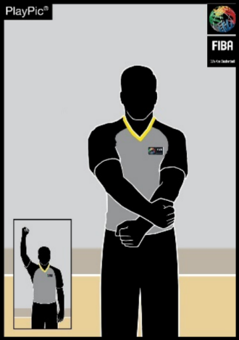
41
Strike wrist

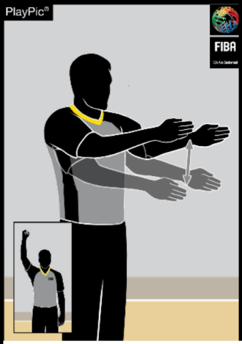
45
ILLEGAL CYLINDER
Move both arms with
open palms vertically
down and up

FOUL ON THE ACT OF
SHOOTING
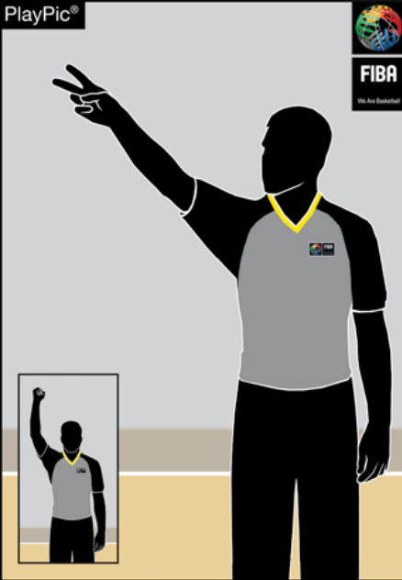
49
One arm with a
clenched fist, followed
by an indication of the
number of free throws

ILLEGAL CONTACT TO THE HAND
CHARGING
WITH THE BALL
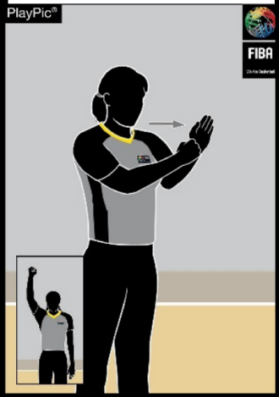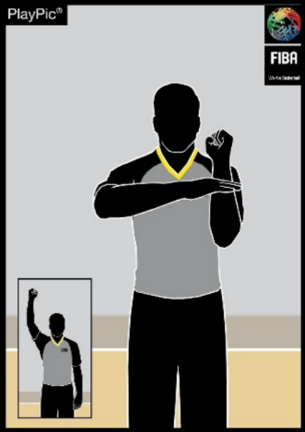
42
Clenched fist strike open palm
43
Strike the palm towards the other forearm

EXCESSIVE SWINGING OF ELBOW
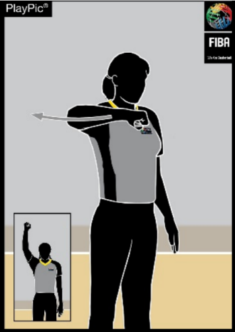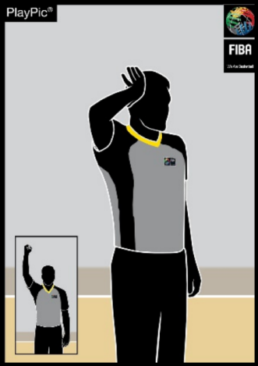
46
Swing elbow backwards
47
Imitate the contact to the head
HIT TO THE HEAD

FOUL NOT ON THE ACT
OF SHOOTING PASS-OFF AFTER FOUL
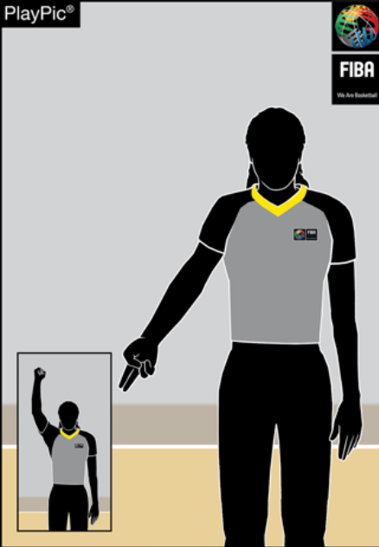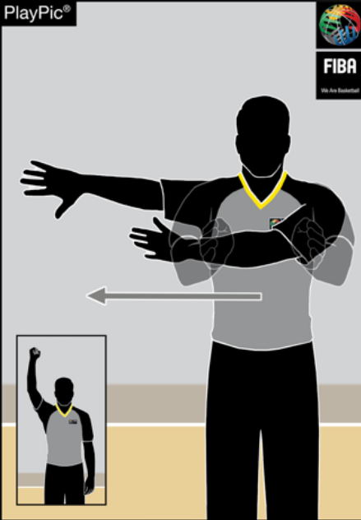

50

51

Move both arms with open palms to the side
One arm with
clenched fist,
followed by pointing
to the court

HOOKING
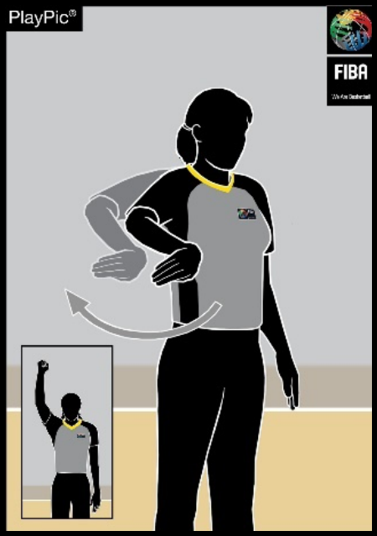
44
Move lower arm backwards

FOUL BY TEAM IN
CONTROL OF THE BALL
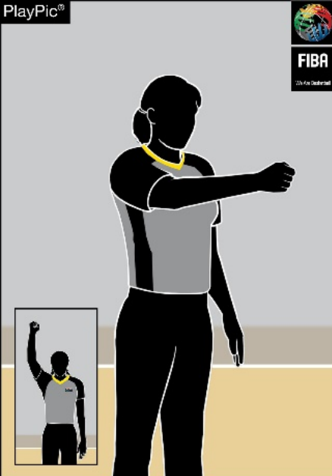

48

Point clenched fist
towards the basket of the
offending team

非法用手 控球 非法接触手部
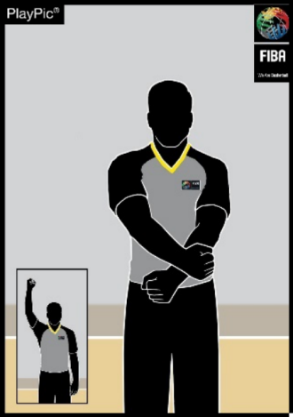
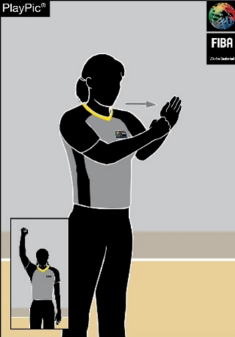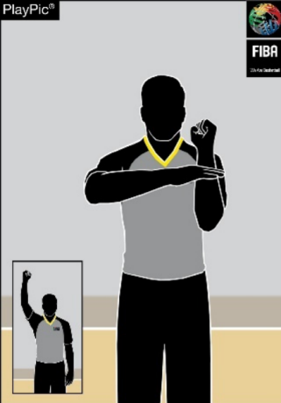

42

43

41
手掌朝前挥动另一只前臂
腕部挫伤 紧握的拳头
张开手掌
44
下移手臂
向后
勾人

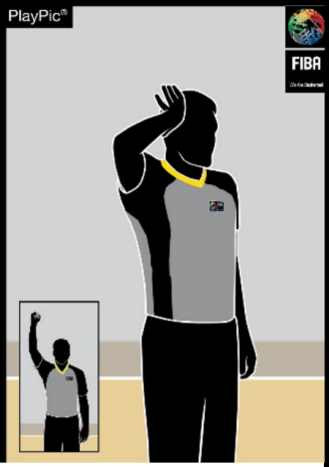控球方犯规
肘关节过度活动
头部撞击
非法气瓶
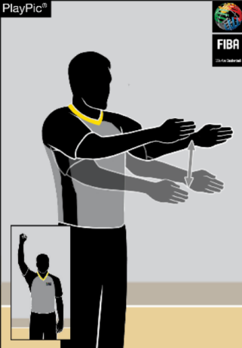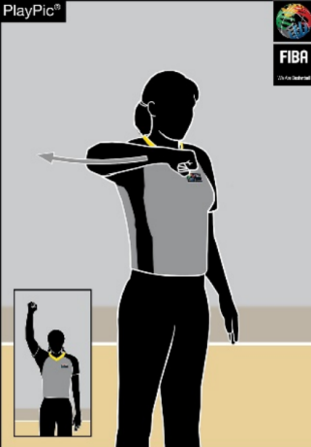

45

46

模仿接触
朝向头部
47

48

双臂张开，掌心朝
摆动肘部向后
将拳头指向对方球队的篮筐
下，垂 直 上 下 移动。
对以下行为犯规：
非针对行为本身的犯规
关于射击 犯规后中断投篮的传球
投篮

50

51

49

一侧手臂握拳，随后示意罚球次数
将双臂掌心朝外向两侧移动
一手握拳，随后指
向球场

Special Fouls / Warnings
DOUBLE FOUL TECHNICAL FOUL DISRUPTIVE FOUL FLAGRANT FOUL

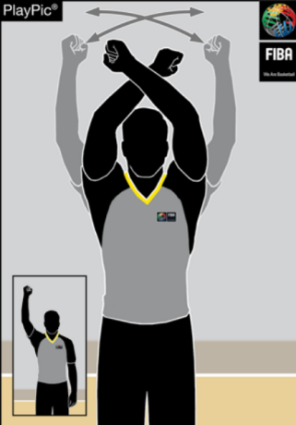

52

Wave clenched fists in both hands

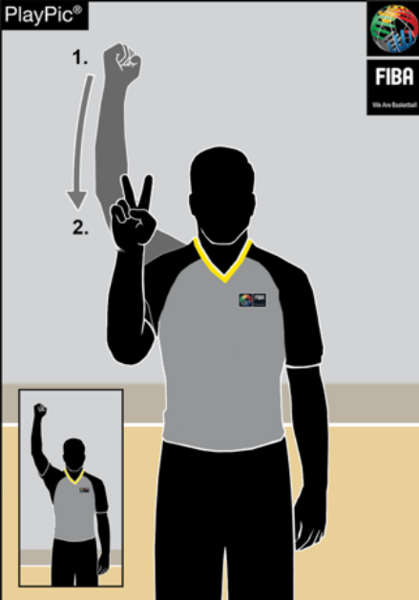

54

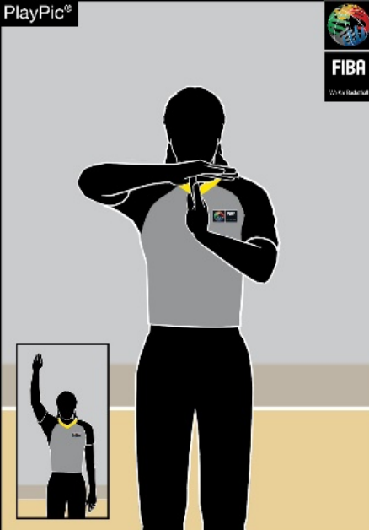Form T, showing palms One arm with clenched fist, followed by

53

showing 2 at face level

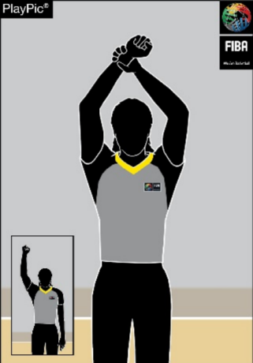

55

Grasp wrist upward

DISQUALIFYING FOUL FAKE A FOUL DELAY OF GAME
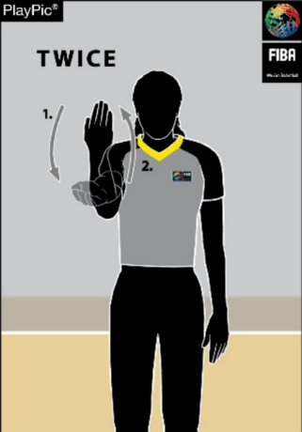

57

ILLEGAL BOUNDARY LINE CROSSING
ON A THROW-IN
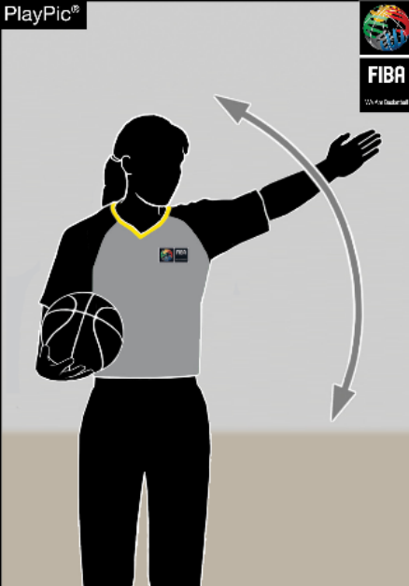

59

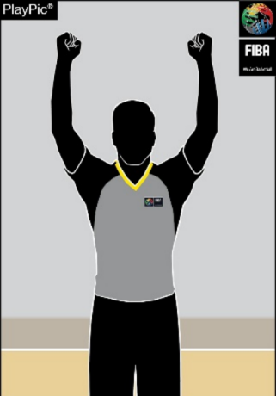Clenched fists in both hands

56

Instant replay system

IRS REVIEW
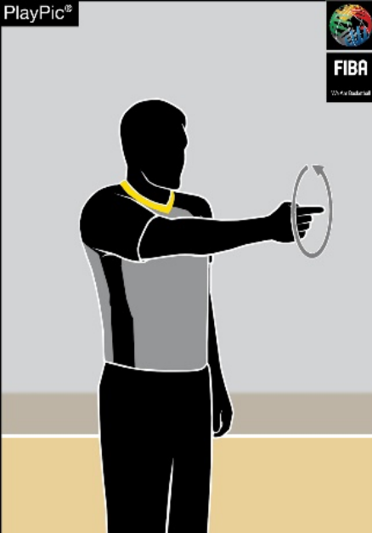

60

Rotate hand with
horizontally extended
index finger

Lower the forearm twice

HEAD COACH’S CHALLENGE
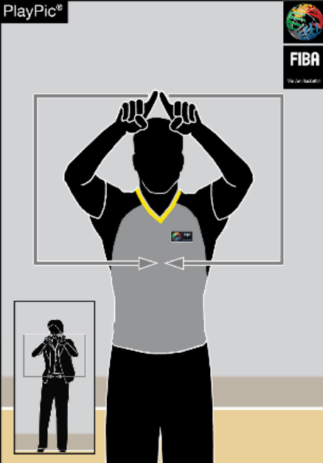
61
Referee confirms hed
coach’s challenge
request

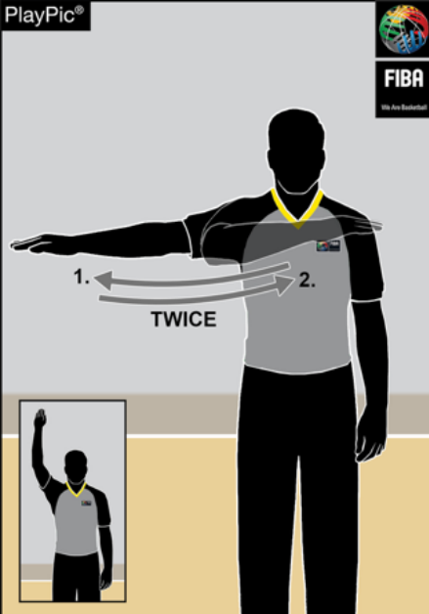Wave forearm horizontally twice

58

Wave arm parallel to boundary line (in the last 2 minutes of the fourth quarter and overtime)

特殊犯规/警告

双方犯规 技术犯规 破坏性犯规
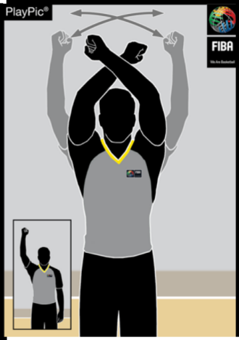
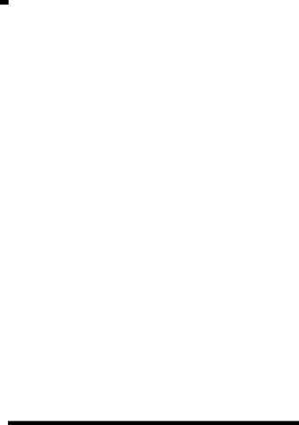
52

53

T 式姿势：双手掌心朝前，一只手臂握拳，随韦夫双手紧握拳头

54

后
在面部水平显示为 2

比赛延迟
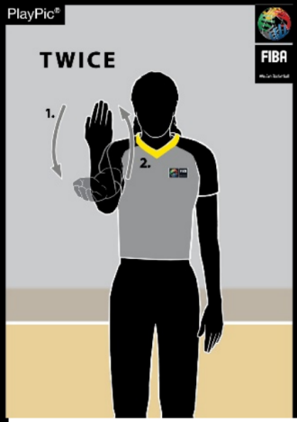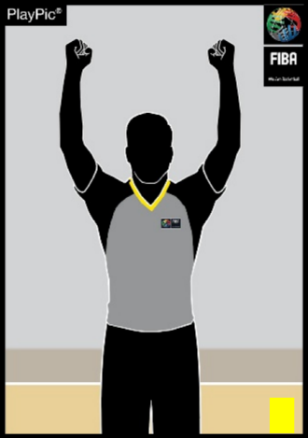
假犯规

58

将前臂下压两次
57
将前臂水平摆动两次
取消参赛资格犯规
56
紧握的拳头双手

即时回放系统
IRS 复审
主教练的挑战

61

60

将食指水平伸展，旋转
主裁判确认主教练的质疑请求
手掌

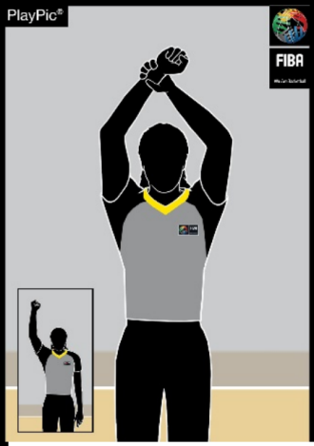
55
恶意犯规
将手腕向上握紧

掷球入界时非法越界线

59

手臂与边线平行挥动（于第四节最后2分钟及决胜期中）

Foul Penalty Administration – Reporting to Table

AFTER FOUL
WITHOUT FREE
THROW(S)
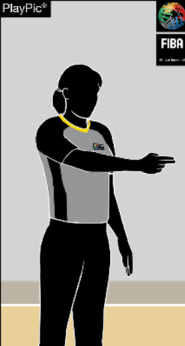

62

Point in the
direction of play, arm parallel to
sidelines

AFTER FOUL BY
TEAM IN
CONTROL
OF THE BALL
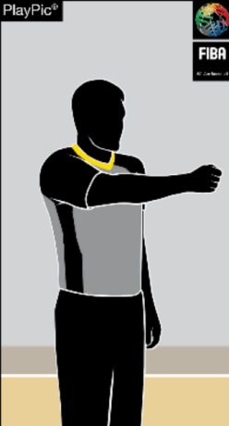

63

Clenched fist in
direction of play,
arm parallel to
sidelines

1 FREE
THROW 2 FREE THROWS 3 FREE THROWS
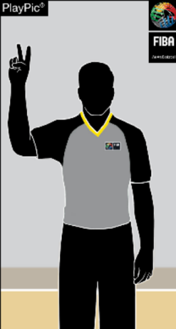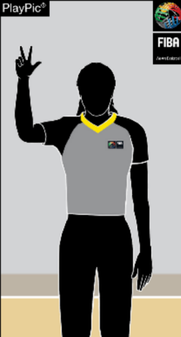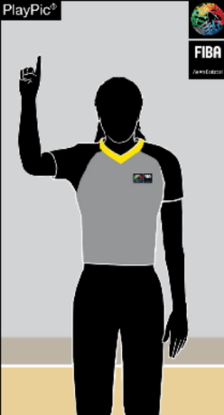

65

66

64

Hold up one finger
Hold up 2 fingers
Hold up 3 fingers

Administrating Free Throws – Active Referee (Lead)
1 FREE THROW 2 FREE THROWS 3 FREE THROWS
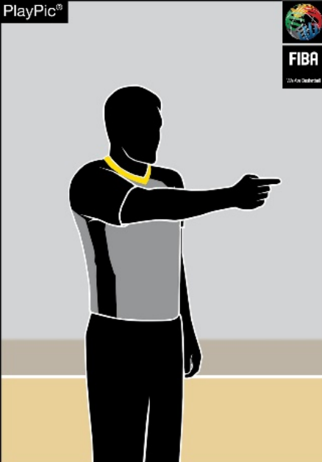

67

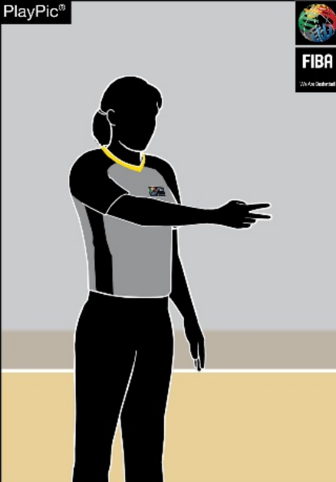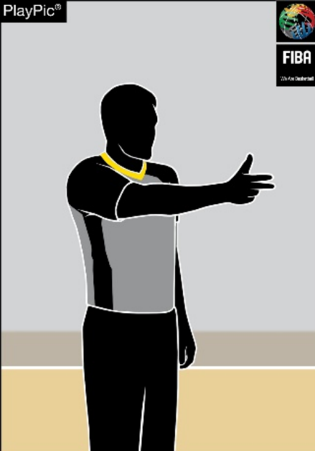1 finger horizontal 2 fingers horizontal 3 fingers horizontal

68

69

Administrating Free Throws – Passive Referee (Trail in 2PO & Centre in 3PO)
1 FREE THROW 2 FREE THROWS 3 FREE THROWS
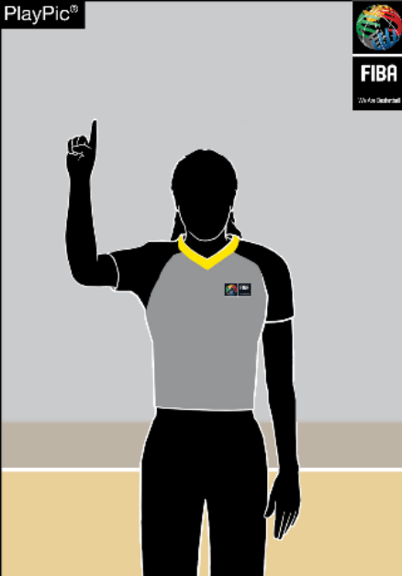

70

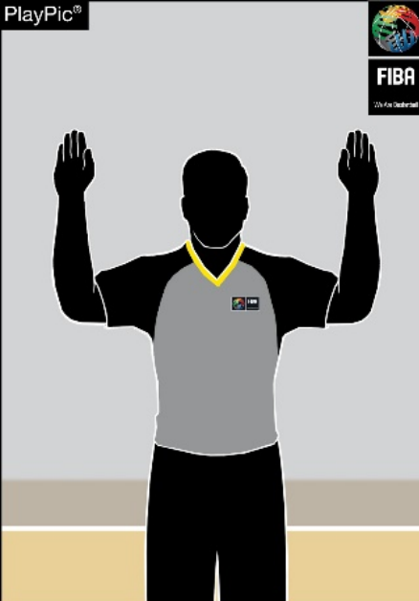Index finger Fingers together  on both hands | 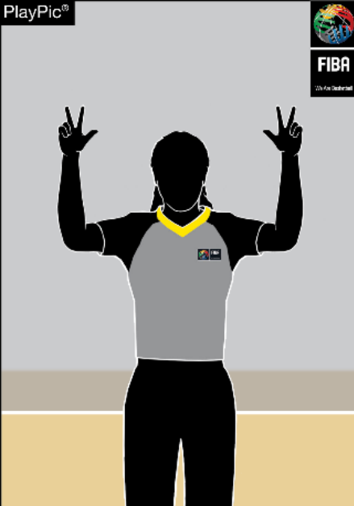3 fingers extended on both hands
  71
  72
Diagram 8 Referees' signals

犯规处罚处理——提交至表格

犯规后无掷球
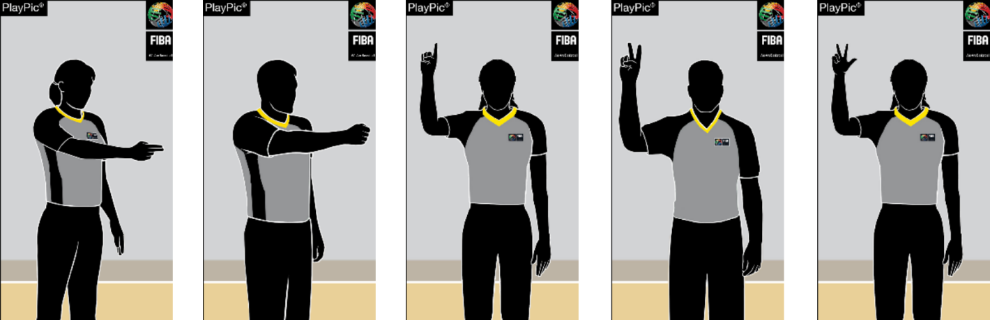
自由（S）

本队犯规后控制球

64

1 免费投掷

65

2 免费投掷

3 免费投掷
66

63

指向比赛方

62

向，手臂与地
面平行
边线

握紧拳头朝向比赛方向，手臂与边线平行

竖起一根手指

竖起两根手指

竖起三根手指

罚球判罚——执行裁判员（主裁判）
1 自由投掷 2次自由投掷 3次自由投

67

1指水平方向 两指水平放置 3 指水平放置

68

69

罚球判罚——非执行裁判员（2分球时位于侧翼，3分球时位于中锋位置）
1 自由投掷 2 免费投掷 3 免费投掷

71

72

70

食指 双手手指并拢 双手各伸出三指
图8 裁判手势

APPENDIX B – THE SCORESHEET
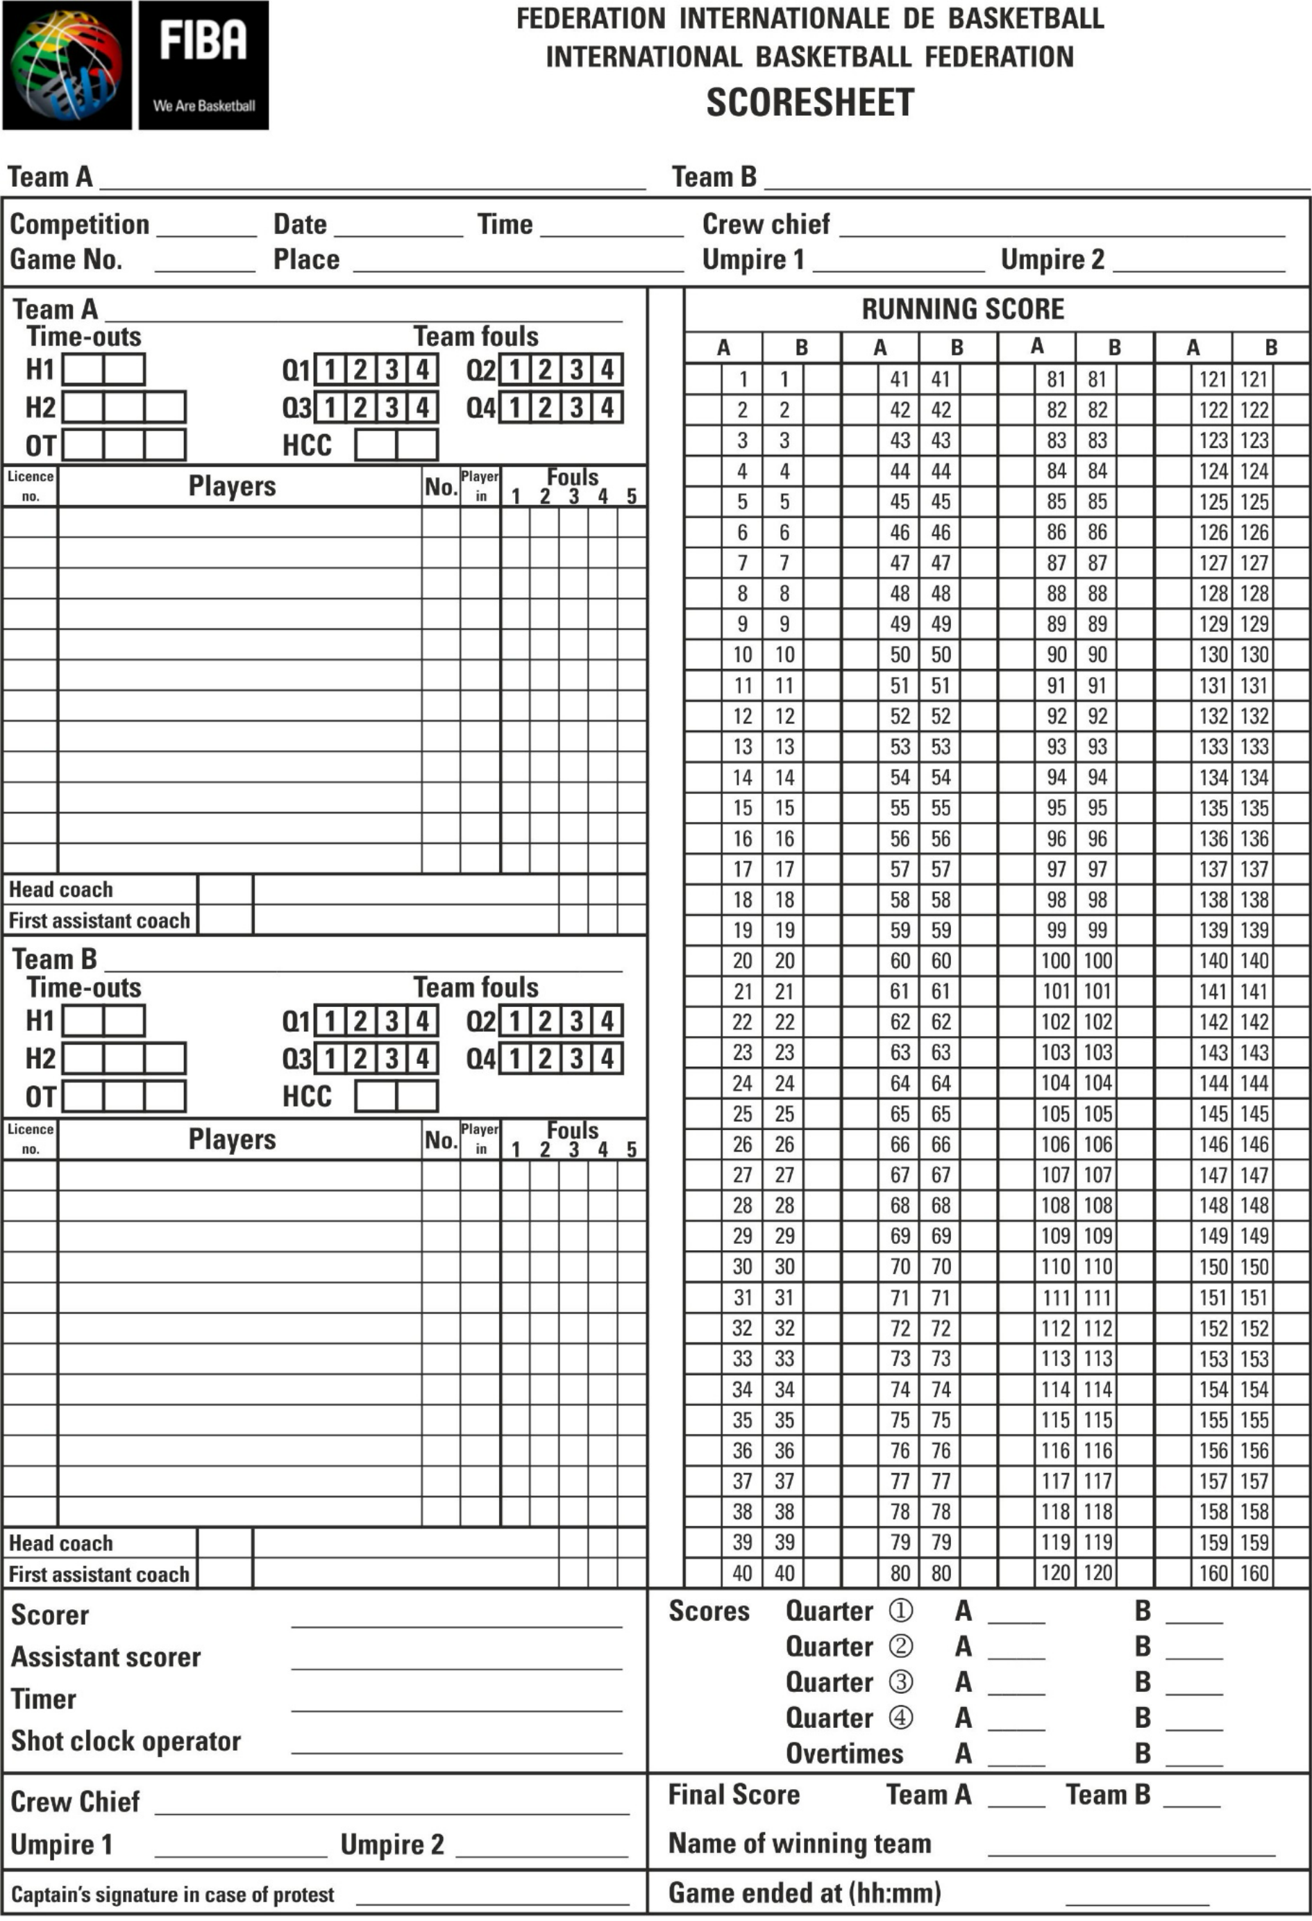
Diagram 9 Scoresheet

附录B 记录表
图 9 记录表

B.1 The scoresheet shown in Diagram 9 is the one approved by the FIBA Technical Commission.
B.2 It consists of one original and three copies, each to be of different coloured paper. The original on white paper is for FIBA. The first copy on blue paper is for the organising body of the competition, the second copy on pink paper is for the winning team, and the last copy, on yellow paper, is for the losing team.
Note: 1. The scorer shall use 2 different coloured pens, RED for the first and third quarters and BLUE or BLACK for the second and fourth quarters. For all overtime, all entries shall be made in BLUE or BLACK (same colour as for the second and fourth quarters).
2. The scoresheet may be prepared and completed electronically.
B.3 At least 40 minutes before the game is scheduled to start, the scorer shall prepare the scoresheet in the following manner:
B.3.1 The scorer shall enter the names of the 2 teams in the space at the top of the scoresheet. Team 'A' shall always be the local (home) team or for tournaments or games on a neutral court, the first team named in the schedule. The other team shall be team 'B'.
B.3.2 The scorer shall then enter:
• The name of the competition.
• The number of the game.
• The date, the time and the place of the game.
• The names of the crew chief and the umpire(s) and their nationality (IOC code).

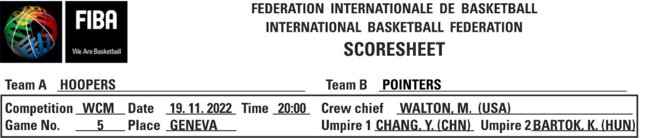
Diagram 10 Top of the scoresheet
B.3.3 Team 'A' shall occupy the upper part of the scoresheet, team 'B' the lower part.
B.3.3.1 In the first column, the scorer shall enter the licence number (last 3 digits) of each player, head coach and first assistant coach. For tournaments, the number of the licences shall only be entered for the first game played by the teams.
B.3.3.2 In the second column, the scorer shall enter each player's name and initials in the order of the shirt numbers, all in BLOCK CAPITAL letters, using the list of team members as provided by the head coach or the team’s representative. The captain of the team shall be entered with a (CAP) immediately after the name.
B.3.3.3 If a team presents fewer than 12 players, the scorer shall draw a line through the spaces for the player’s licence number, name, number, player in, in the line below the last entered player. If there are fewer than 11 players, the horizontal line shall be drawn horizontally until reaching the player fouls section and continue diagonally down to the bottom.

B.1 图9所示的记录表系经国际篮联技术委员会批准的版本。
B.2 本文件由1份正本及3份副本组成，每份副本均使用不同颜色的纸张。白色纸张上的正本供 FIBA 使用；蓝色纸张上的第一份副本供赛事主办机构使用；粉色纸张上的第二份副本供获胜球队使用；黄色纸张上的最后一份副本供失利球队使用。
注：1. 记录员应使用两种不同颜色的笔：第一和第三节使用红色，第二和第
四节使用蓝色或黑色。对于所有决胜期，所有记录均须使用蓝色或黑色（与第二和第四节使用的颜色相同）。
2. 记录表可以电子方式编制并填写。
B.3 在比赛开始前至少40分钟，记录员应按以下方式准备记录表：
B.3.1 记录员应在记录表顶部的空格内填写两支参赛球队的名称。球队 “A”始终应为主场球队；若为中立场地举行的赛事或比赛，则应为赛程表中列出的第一支球队。另一支球队应为球队 “B”。
B.3.2 记录员随后应记录如下：
• 比赛名称。
• 比赛编号。
• 比赛日期、时间及地点。
• 赛事总监及裁判（简称）的姓名及其国籍（IOC 代码）。
图10 记录表顶部
B.3.3 A 队应占据记录表的上部，B 队应占据记录表的下部。
B.3.3.1 在第一栏中，记录员应填写每位队员、主教练及助理主教练的许可证编号（最后三位数字）。对于赛事，仅需填写各队进行的第一场比赛的许可证编号。
B.3.3.2 在第二栏中，记录员应按照球衣号码顺序，使用主教练或球队代表提供的队员名单，以全大写字母形式填写每位队员的姓名及姓名首字母。球队队长姓名后须立即标注“ （CAP）”。
B.3.3.3 若某队参赛队员少于12名，记录员应在队员许可证号、姓名、号码、上场队员栏的相应空格下方，于最后一位已录入队员的下方绘制一条横线；若参赛队员少于11名，则该横线应水平延伸至“队员犯规”栏，随后斜向延伸至底部。

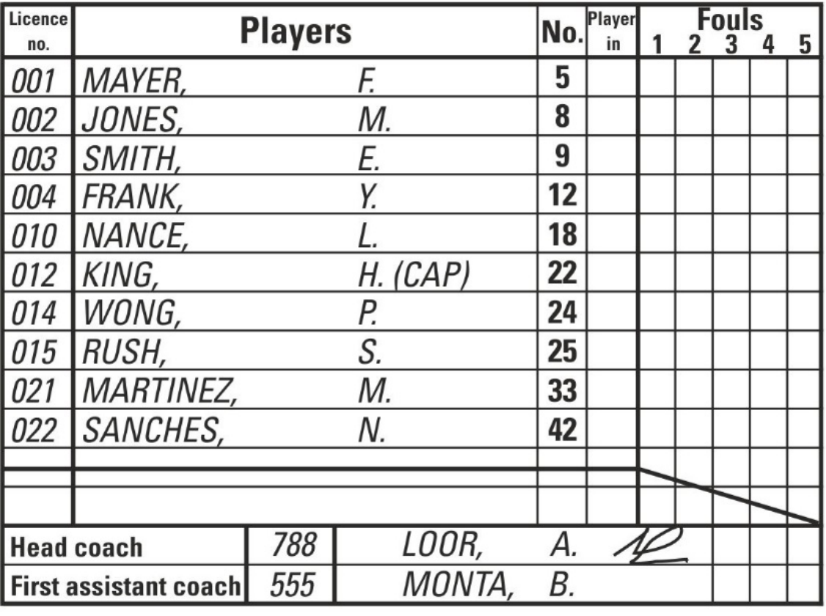
Diagram 11 Teams on the scoresheet (before the game)
B.3.4 At the bottom of each team's section, the scorer shall enter (in BLOCK CAPITALS)
letters) the names of the team's head coach and first assistant coach.
B.3.5 At the bottom of the scoresheet the scorer shall enter (in BLOCK CAPITAL letters) the
Names of the scorer, assistant scorer, timer and shot clock operator.
B.4 At least 10 minutes before the game is scheduled to start each head coach shall:
B.4.1 Confirm the agreement with the names and the corresponding numbers of the team members.
B.4.2 Confirm the names of the head coach and first assistant coach. If there is no head coach and no first assistant coach, the captain shall act as player head coach and shall be entered with a (CAP) behind the name.
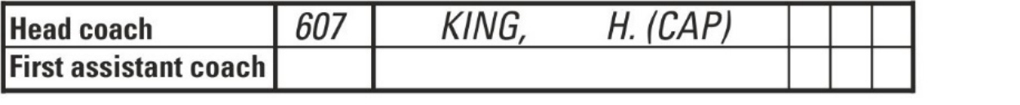
B.4.3 Enter a small 'x' beside the player's number in the 'Player in' column for the 5 players to start the game.
B.4.4 Sign the scoresheet.
The head coach of team 'A' shall be the first to provide the above information.
B.5 At the start of the game, the scorer shall circle the small 'x' of the 5 players in the 'Player in' column of each team to start the game.
B.6 During the game, the scorer shall draw a small 'x' (not circled) when the substitute enters the game for the first time as a player.
B.7 Time-outs
B.7.1 Time-outs granted shall be entered on the scoresheet below the team's name by entering the minute of the playing time of the quarter or overtime in the boxes next to H1 for the first half, next to H2 for the second half and next to OT for up to 3 overtimes.
B.7.2 At the end of each half and overtime, unused boxes shall be marked with 2 horizontal parallel lines. Should the team not be granted its first time-out before the game clock shows 2:00 minutes in the fourth quarter, the scorer shall mark 2 horizontal lines in the first box for the team’s second half.

图 11 记录表上的参赛球队（赛前）
B.3.4 在每支球队的栏目底部，记录员应以大写字母块形式填写该球队主教练及首席助理教练
的姓名。
B.3.5 在记录表底部，记录员应以大写字母块形式填写记录员、助理记录员、计时员及进攻计
时员的姓名。
B.4 在比赛开始前至少10分钟，每位主教练均应：
B.4.1 确认球队成员姓名及对应编号的一致性。
B.4.2 确认主教练与第一助理教练的姓名。若无主教练及第一助理教练，则由队长担任队员主教练，并在姓名后标注“ （CAP）”。
B.4.3 在“队员”栏中，为参与比赛的5名队员的号码旁输入一个小“x”。
B.4.4 在记录表上签字。
A 队的主教练应首先提供上述信息。
B.5 比赛开始时，记录员应在每队“队员”栏中为5名队员标出小“x”标记，以启动比
赛。
B.6 在比赛期间，当替补队员首次作为队员上场时，记录员应画一个小的“×”号（不可加圈）。
B.7 暂停时间
B.7.1 授予的暂停应记录在队员姓名下方的记录表中：对于上半场，在 H1 旁的方格内填写相应节次或决胜期的比赛分钟数；对于下半场，在 H2 旁的方格内填写；对于最多 3 次决胜期，则在 OT 旁的方格内填写。
B.7.2 每半场及决胜期结束时，未使用的方格应标以两条水平平行线。若球队在第四节比赛计时显示还剩2分钟时仍未获得首次暂停机会，记录员应在该球队下半场的第一个方格内标出两条水平线。

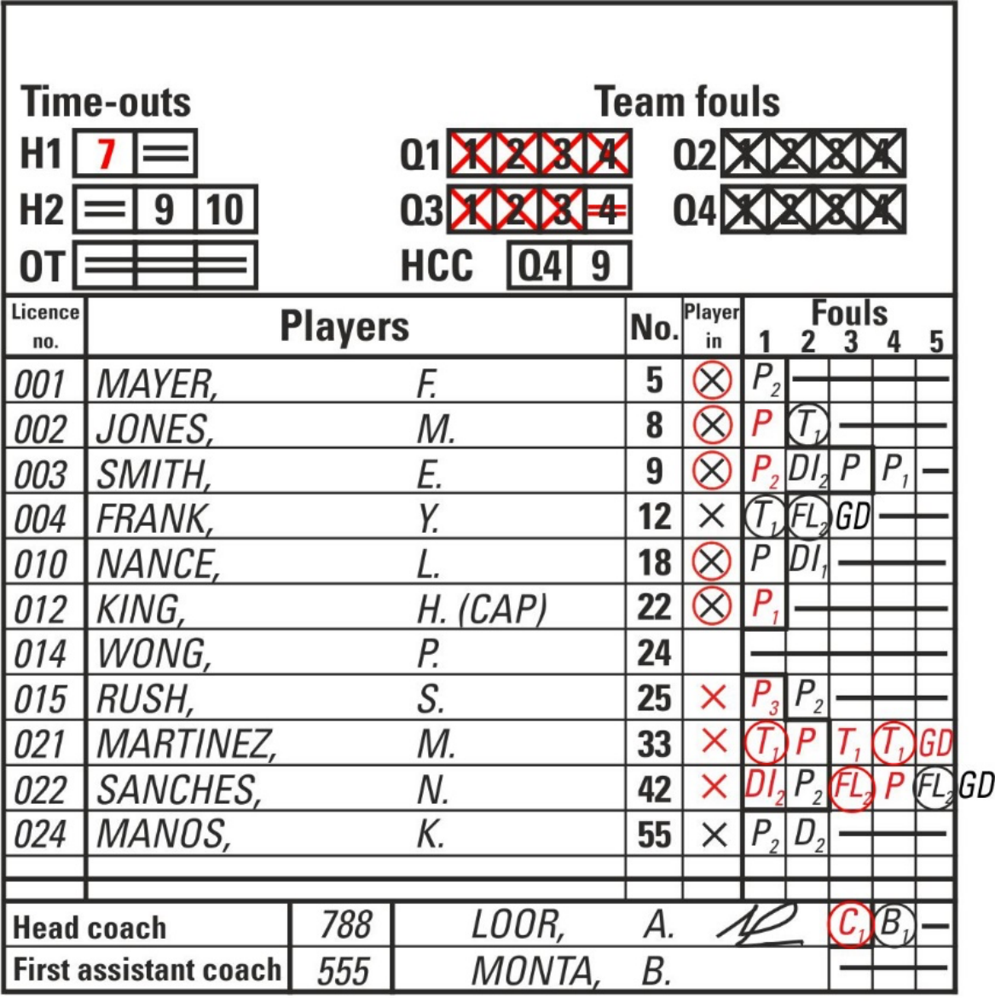
Diagram 12 Teams on the scoresheet (after the game)
B.8 Fouls
B.8.1 Player fouls may be personal, technical, disruptive, flagrant or disqualifying and shall be entered against the player.
B.8.2 Fouls committed by the head coach, first assistant coach, substitutes, excluded players and accompanying delegation members may be technical or disqualifying fouls and shall be entered against the head coach. The disqualifying fouls committed by persons entered on the scoresheet in a fight shall be entered against these persons.
B.8.3 Any foul counting towards game disqualification (GD) shall be entered with a circle.
B.8.4 Any foul involving a free throw(s) shall be entered with adding the corresponding
number of free throws (1, 2 or 3) beside the 'P', 'T', 'C', 'B', 'BD', 'DI', 'FL' or 'D'.
B.8.5 All equal penalties according to Article 43 shall be cancelled and entered with a small
A 'c' added beside the 'P', 'T', 'C', 'B', 'BD', 'DI', 'FL' or 'D'.
B.8.6 All fouls shall be entered as follows:
B.8.6.1 A personal foul shall be entered as a 'P'.
B.8.6.2 A category 1 technical foul against a player shall be entered as a ①.
B.8.6.3 A category 2 technical foul against a player shall be entered as a 'T'.
B.8.6.4 A second category 1 technical foul shall also be entered as a ①, followed by a 'GD' for the game disqualification in the following space.
B.8.6.5 A category 1 technical foul against the head coach for personal unsportsmanlike behaviour shall be entered as a  . A second similar technical foul shall also be
entered as a , followed by a 'GD' in the following space.

图12 赛后记录表中的球队分布图
B.8 犯规
B.8.1 队员犯规可分为侵人犯规、技术犯规、扰乱比赛犯规、恶劣犯规或导致取消比赛资格的犯规，且均应记入该队员的犯规记录。
B.8.2 主教练、助理教练、替补队员、被罚出场的队员及随行代表成员所犯的犯规，可为技术犯规或取消比赛资格犯规，且均应记入主教练名下。在比赛中，凡记录
表上所列人员所犯的取消比赛资格犯规，均应记入该人员名下。
B.8.3 任何可导致取消比赛资格（GD）的犯规均应以圆圈符号标注。B.8.4 任何涉及罚球（s）的犯规均应在标注相应内容后予以记录。
在“P”、“T”、“C”、“B”、“BD”、“DI”、“FL”或“D”旁标注罚球次数（1、2或3次）。B.8.5 根据第43条判处的所有相同处罚均予以撤销，并以小字重新记录。
在 ‘ P’、 ‘T’、 ‘C’、 ‘ B’、 ‘ BD’、 ‘ DI’、 ‘ FL’或 ‘ D’旁边添加 ‘c’。
B.8.6 所有犯规均应按以下方式记录：
B.8.6.1 侵人犯规应记为“P”。
B.8.6.2 对队员判处的第1类技术犯规，应记为① .
B.8.6.3 对队员判处的第2类技术犯规应记为“T”。
B.8.6.4 第二类第1类技术犯规亦应作为一项记录。①随后在下一栏中填写“GD”，表示该场比赛被取消比赛资格。
B.8.6.5 针对主教练因个人不体育道德行为而判处的第1类技术犯规，应计入一项若再次出现类似技术犯规，亦应予以判罚。
以 身份加入随后在下一空格中填写“GD”。

B.8.6.6 A category 1 technical foul against the head coach for any other reason shall be entered as or  . A third category 1 technical foul (one of them could be a ) shall be entered as either a , or followed by a 'GD' in the following space.
B.8.6.7 A disruptive foul against a player shall be entered as a 'DI'.
B.8.6.8 A flagrant foul against a player shall be entered as a 'F'.
B.8.6.9 A second flagrant foul shall also be entered as a , followed by a 'GD' in the next following space.
B.8.6.10 A category 1 technical foul against a player with an earlier flagrant foul or a flagrant foul against a player with an earlier category 1 technical foul shall also be entered as
a or ① followed by a 'GD' in the next following space.
B.8.6.11 A player head coach shall be disqualified when committing:
• A technical foul as a coach, entered as a and a flagrant foul or category 1 technical foul as a player, or
• A technical foul as a coach, entered as either a or , a technical foul as a coach, entered as a and a flagrant foul or category 1 technical foul as a player, or
• Two technical fouls as a coach, entered as either or and a flagrant or category 1 technical foul as a player.
After the last technical foul or a flagrant foul has been entered, it shall be followed by a 'GD' in the following space.
B.8.6.12 A disqualifying foul shall be entered as a 'D'.
B.8.6.13 A disqualifying foul against a first assistant coach, substitute or excluded player shall
be entered as a technical foul against the head coach with a .
B.8.6.14 A disqualifying foul against an accompanying delegation member shall be entered as
a technical foul against the head coach with a .
B.8.6.15 A disqualifying foul against a first assistant coach, substitute or an excluded player for leaving the team bench area in a fight, shall be entered as a technical foul against
The head coach with a .
B.8.6.16 A disqualifying foul against an accompanying delegation member for leaving the team bench area in a fight, shall be entered as a technical foul against the head coach with a 'B' followed by a 'D'. The 'BD' shall not count towards the three technical fouls for the head coach’s game disqualification.
B.8.6.17 A disqualifying foul against an accompanying delegation member for active involvement in a fight, shall be entered as a technical foul against the head coach with a followed with a 'BD'. The 'BD' shall not count towards the three technical fouls for the head coach’s game disqualification.
B.8.6.18 An 'F' shall be entered, after the 'D2 ' or 'D', in all remaining spaces of the disqualified head coach, first assistant coach, substitute or excluded player in a fight.
B.8.6.19 Examples of disqualifying fouls on a head coach, first assistant coach, substitute, excluded player or accompanying delegation member:
A disqualifying foul against a head coach shall be entered as follows:
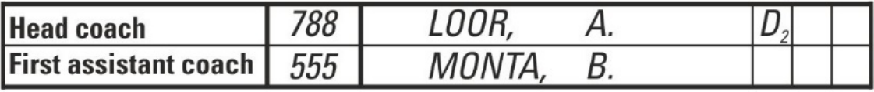

B.8.6.6 对于主教练因任何其他原因被判处的1类技术犯规，均应记录为 或第三类1级技术犯规（其中一项可为）应填写为以下任一形式：,  或 随后在下一空格中填写“GD”。
B.8.6.7 对队员实施的破坏性犯规应记为“DI”。
B.8.6.8 对队员实施的恶意犯规应记为 .
B.8.6.9 第二次恶意犯规也应记为一次随后在下一个空格处添加“GD”。
B.8.6.10 若某队员此前已犯有恶意犯规，或某队员此前已犯有第1类技术犯规，则对其再次犯有恶意犯规或第1类技术犯规时，亦应将其记录为
a 或① 随后在下一个空格处添加“GD”。
B.8.6.11 队员主教练若有下列行为，应被取消资格：
• 作为教练判处的技术犯规，以以下形式记录：以及作为队员时犯下的恶意犯规或一级技术犯规，或
• 作为教练判罚的技术犯规，以下任一方式记录：或，作为教练被判定为一次技术犯规，以一名队员身份进入比赛。以及作为队员时犯下的恶意犯规或一级技术犯规，或
• 作为教练累计两次技术犯规，均以下任一方式记录：或 以及作为队员时犯下的恶意犯规或一级技术犯规。
在记录到最后一次技术犯规或恶意犯规后，应在后续空格中填写“GD”。
B.8.6.12 导致取消比赛资格的犯规应记为“D”。
B.8.6.13 对第一助理教练、替补队员或被驱逐出场队员实施的取消比赛资格犯规，应记
为对主教练的技术犯规，并附带 .
B.8.6.14 对随团代表团成员实施的取消比赛资格犯规，应记为
对主教练判处的技术犯规 .
B.8.6.15 若第一助理教练、替补队员或被驱逐出场队员因在斗殴中离开球队替补区而受
到取消比赛资格的犯规，则该犯规应记为针对该人员的技术犯规。
主教练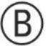 .
B.8.6.16 若随行代表团成员因在争抢中离开球队替补区而受到取消比赛资格的犯规处罚，则应将该行为记为对主教练的技术犯规。随后记一次“BD”。该
“BD”不计入主教练被取消比赛资格的三次技术犯规之内。
B.8.6.17 若随行代表团成员因积极参与斗殴而受到取消比赛资格的处罚，则应将该行为记为对主教练的技术犯规。随后记一次“BD”。该“BD”不计入主教练被取消比赛资格的三次技术犯规之内。
B.8.6.18 对于在比赛中被取消资格的主教练、第一助理教练、替补队员或被驱逐的队
员，应在“D2”或“D”之后，于所有剩余空格内填写“F”。
B.8.6.19对主教练、第一助理教练、替补队员、被罚出场的队员或随行代表团成员判罚取消参赛资格的犯规示例：
针对主教练的判罚性犯规应按以下方式记录：

A disqualifying foul against a first assistant coach shall be entered as follows:
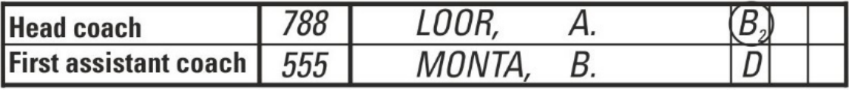
A disqualifying foul against a substitute shall be entered as follows:
and
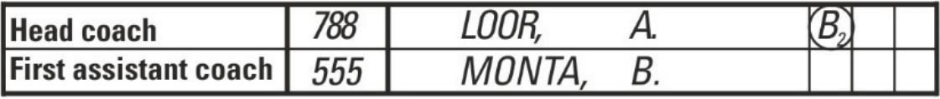
A disqualifying foul against an excluded player after the fifth foul shall be entered as follows:
and
A disqualifying foul against an accompanying delegation member shall be entered as follows:
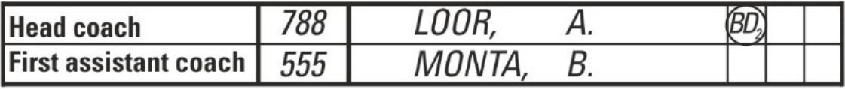
B.8.6.20 Examples of disqualifying fouls for leaving the team bench area in a fight on a head coach, first assistant coach, substitute, excluded player or accompanying delegation member:
Irrespective of the number of persons disqualified for leaving the team bench area, a single technical foul shall be charged against the head coach and entered with a 'B2 ' or 'D2 '.
A disqualifying foul against a head coach and a first assistant coach shall be entered as follows:
If only the head coach is disqualified:
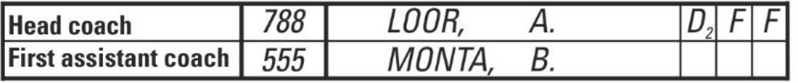
If only the first assistant coach is disqualified:
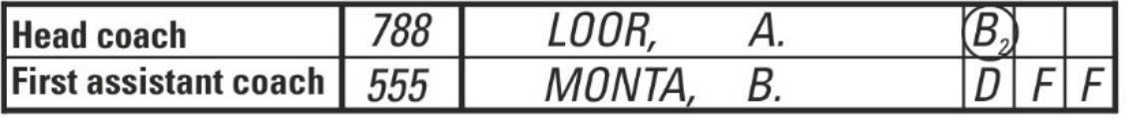
If both the head coach and the first assistant coach are disqualified:
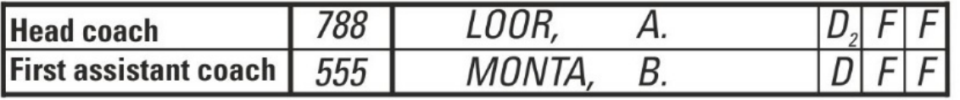
A disqualifying foul against a substitute shall be entered as follows:
If the substitute has fewer than 4 fouls, then a 'D' shall be entered, followed by an 'F' in all remaining foul spaces:
and

对第一助理教练的取消参赛资格犯规应按以下方式记录：
对替补队员判处的取消参赛资格犯规应按以下方式记录：
和
对已被驱逐的队员在第五次犯规后实施的取消参赛资格的犯规，应按以下方式记录：
和
对随团代表团成员实施的取消参赛资格的犯规，应按以下方式记录：
B.8.6.20在主教练、第一助理教练、替补队员、被罚出场的队员或随行代表团成员面前离开球队替补区时，可导致禁赛的犯规示例如下：
无论有多少人被判禁止离开球队替补区，主教练均将被判一次技术犯规，并记录为“ B2”或“D2”。
对主教练及助理教练的取消参赛资格犯规，应按如下方式记录：
如果仅主教练被取消资格：
若仅首位助理教练被取消资格：
若主教练与第一助理教练均被取消资格：
对替补队员的取消参赛资格犯规应按以下方式记录：
若替补队员犯有少于4次犯规，则应在“D”后，于其余所有犯规栏中均填入“F”：
和

If it is the substitute's fifth foul, then a 'D' shall be entered, followed by an 'F' in the column behind the last foul space:
and
A disqualifying foul against an excluded player shall be entered as follows:
As an excluded player has no more foul spaces, then a 'D' shall be entered, followed by an 'F', both in the column behind the last foul:
and
A disqualifying foul against an accompanying delegation member shall be charged againstnst the head coach and entered as follows:
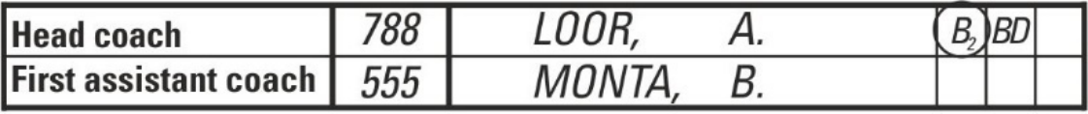
B.8.6.21 Examples of disqualifying fouls for the active involvement in a fight on a head coach, first assistant coach, substitute, excluded player or accompanying delegation member:
Irrespective of the number of persons disqualified for leaving the team bench area, a single technical foul shall be charged against the head coach and entered with a 'B2 ' or 'D2 '.
If the head coach is actively involved in the fight, the head coach shall be charged with one 'D' only, entered as 'D2 '.
A disqualifying foul against a head coach and a first assistant coach shall be entered as follows:
If only the head coach is disqualified:
If only the first assistant coach is disqualified:
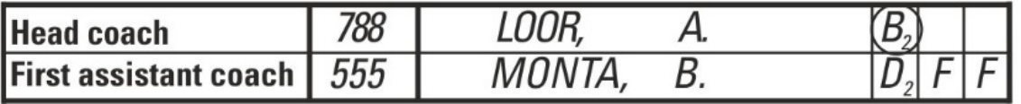
If both the head coach and the first assistant coach are disqualified:
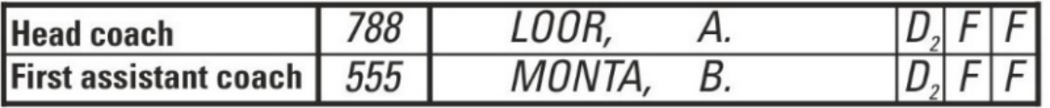
A disqualifying foul against a substitute shall be entered as follows:
If the substitute has fewer than 4 fouls, then a 'D2 ' shall be entered, followed by an 'F' in all remaining foul spaces:
and

若替补队员犯下第五次犯规，则应在“D”后，于最后一个犯规栏后的列中填写“F”：
和
对被罚出场的队员判处取消参赛犯规，应按以下方式记录：
若被罚出场的队员已无犯规空间，则应在最后一次犯规后一栏内依次填入“D”及“F”：
和
对随团成员判处的取消参赛资格犯规，应归责于主教练，并按下列方式记录：
B.8.6.21对主教练、助理教练、替补队员、被罚出场的队员或随行代表团成员主动参与斗殴而予以取消参赛资格的犯规示例：
无论有多少人被判禁止离开球队席区域，主教练均将被判一次技术犯规，并记录为“ B2”或“D2”。
若主教练积极参与比赛，则仅对其判罚一次“D”，记作“D2”。
对主教练及助理教练的取消参赛资格犯规，应按以下方式记录：
如果仅主教练被取消资格：

若仅首位助理教练被取消资格：
若主教练与第一助理教练均被取消资格：
对替补队员的取消参赛资格犯规应按以下方式记录：
若替补队员犯规次数少于4次，则先填入“D2”，随后在所有剩余的犯规栏位中均填入“F”：
和

If it is the substitute's fifth foul, then a 'D2 ' shall be entered, followed by an 'F' in the column behind the last foul space:
and
A disqualifying foul against an excluded player is entered as follows:
As an excluded player has no more foul spaces, then a 'D2 ' shall be entered, followed by an 'F', both in the column behind the last foul:
and
A disqualifying foul against an accompanying delegation member shall be charged against the head coach and entered as follows:
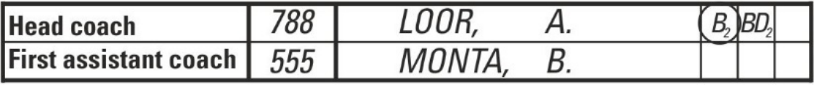
A disqualifying foul against two accompanying delegation members shall be charged against the head coach and entered as follows:
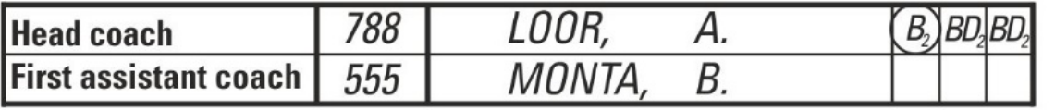
Note: Technical or disqualifying fouls according to Article 40 shall not count as team fouls.
B.8.7 At the end of the second quarter, the scorer shall draw a thick line between the used and unused spaces in the players’ and coach’s foul columns.
At the end of the game, the scorer shall obliterate the remaining spaces with a thick horizontal line.
B.9 Team fouls
B.9.1 For each quarter (Q1, Q2, Q3 and Q4), four spaces are provided on the scoresheet (immediately below the team's name and above the players' names) to enter the team fouls.
B.9.2 Whenever a player commits a personal, technical, disruptive, flagrant or disqualifying foul, the scorer shall enter the foul against the team of that player by marking a large 'X' in the designated spaces in turn.
B.9.3 At the end of each quarter, the scorer shall obliterate the remaininging spaces with 2 horizontal parallel lines.

若替补队员犯下第五次犯规，则应在记录栏中先输入“D2”，随后在最后一个犯规栏后的列中输入“F”：
和
针对被罚出场的队员的判罚性犯规应按以下方式记录：
当被罚出场的队员不再拥有犯规空间时，应在最后一个犯规栏的对应列中先输入“D2”，随后输入“F”：
和
对随团成员判处的取消参赛资格犯规，应记于主教练名下，并按下列方式登记：
对两名随行代表团成员判处的取消参赛资格犯规，应记入主教练名下，并按以下方式记录：
注：根据第40条判定的技术性犯规或导致禁赛的犯规，不得计入全队犯规。
B.8.7 第二节结束时，记录员应在队员及教练的犯规栏中，于已使用与未使用区域之间
画一条粗线。
比赛结束时，记录员应以一条粗横线划掉剩余空格。
B.9 全队犯规
B.9.1 对于每个节（Q1、Q2、Q3 及 Q4），记录表上均设有 4 个空格（位于球队名称正
下方、队员姓名正上方），用于记录球队的犯规次数。
B.9.2 当队员犯下个人犯规、技术犯规、破坏性犯规、鲁莽犯规或导致禁赛犯规时，记
录员应在指定位置依次用大号“X”标记，将该队员所属球队记为犯规方。B.9.3 每节结束时，记录员应用两条水平平行线划掉剩余空格。

B.10
B.10.1

B.10.2

B.10.3

B.11
B.11.1

B.11.2

B.11.3

B.11.4

B.11.5

B.11.6

B.11.7

The running score
The scorer shall keep a chronological running summary of the points scored by each team.
There are four main columns on the scoresheet for the running score.
Each main column is divided into 4 columns. The 2 on the left are for team 'A' and the 2 on the right for team 'B'. The centre columns are for the running score (160 points) for each team.
The scorer shall:
• First, draw a diagonal line ( for right-handed or \ for left- handed) for any valid goal scored and a filled circle (●) for any valid free throw scored, over the new total number of points as accumulated by the team that has just scored.
• Then, in the blank space on the same side of the new total number of points (beside the new / or \ or l), enter the number of the player who scored the goal or the free throw.
The running score: Additional instructions
A 3-point goal scored by a player shall be entered by drawing a circle around the player's number.
A goal accidentally scored by a player in their own basket shall be entered as having been scored by the captain of the opponents’ team on the court.
Points scored when the ball does not enter the basket (Article 31) shall be entered as having been scored by the player who attempted the shot.
At the end of each quarter or overtime, the scorer shall draw a thick circle () around the latest number of points scored by each team, followed by a thick horizontal line under those points and under the number of each player who scored those last points. At the start of each quarter or overtime, the scorer shall continue to keep a chronological running summary of the points scored from the point of interruption.
Whenever possible, the scorer should check the running score with the visual scoreboard. If there is a discrepancy, and the score is correct, the scorer shall immediately take steps to have the scoreboard corrected. If in doubt or if one of the teams raises an objection to the correction, the scorer shall inform the crew chief when the ball becomes dead and the game clock is stopped. The referees may correct any error in scorekeeping involving the score, number of fouls or number of time-outs under the provisions of the rules. The crew chief shall sign the corrections. Extensive corrections shall be documented on the reverse side of

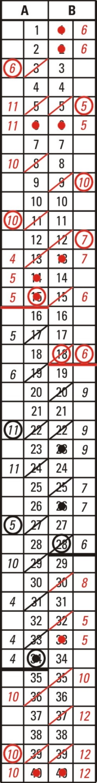

the scoresheet. Diagram 13
Running score

B.10
B.10.1

B.10.2

B.10.3

B.11
B.11.1

B.11.2

B.11.3

B.11.4

B.11.5

B.11.6

B.11.7

实时比分
记录员应按时间顺序持续汇总各队得分情况。
比赛计分表上共有4个主要栏目，用于记录实时比分。
每个主栏均分为4个子栏：左侧两个子栏用于记录“A 队”的得分，右侧两个子栏用于记录“B 队”的得分；中间栏则用于记录每支球队的实时比分（160分）。
记录员应：
• 首先，针对任意一次有效进球，画一条对角线（右手队员用“”，左手队员用“”）和一个实心圆点 (l) 对于任何有效投出的罚球，相对于刚刚得分的球队所累积的新总分。
• 然后，在新增点总数同一侧的空白处（位于新的 / 或 \ 或旁边）l) , 输入命中该进球或罚球得分的队员编号。
实时比分：附加说明
队员攻入的3分球，应在圈出该队员号码处进行记录。
队员在本方球筐内意外攻入的球，应记为由对方球队队长在场上攻入。
球未入筐时（第31条）的得分，应记入尝试投篮的队员已得分。
在每个节末或决胜期结束时，记录员应画一个粗圈（）显示各队最新得分，其下方及每位队员获得这些最终得分的分数下方均绘有一条粗横线。每节比赛或决胜期开始时，记录员应继续自比赛中断时起，按时间顺序持续记录已得分情况。
在可能的情况下，记录员应通过可视记分牌核对实时比分。若出现差异而比分确属正确，记录员应立即采取措施要求校正记分牌。若存疑，或任一参赛球队对校正提出异议时，当球权结束且比赛计时停止，记录员须告知场务主管。
主裁判可根据规则规定，对记分中涉及比分、犯规次数或暂停次数的任何错误进行更正。球队负责人须对更正内容签字确认。重大更正内容应在记录表背面予以记录。
记录表。

图 13
实时比分

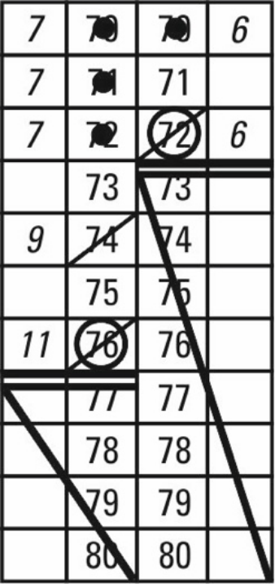
B.12 The running score: Summing up
B.12.1 At the end of each quarter and last overtime, the scorer shall enter the score of that quarter and of all overtimes in the proper section in the lower part of the scoresheet.
B.12.2 Immediately at the end of the game, the scorer shall enter the time in the ‘Game ended at (hh:mm)’ column.
B.12.3 At the end of the game, the scorer shall draw 2 thick horizontal lines under the final number of points scored by each team and the numbers of the players who scored those last points. The scorer shall also draw a diagonal line to the bottom of the column to obliterate the remaining numbers (running score) for each team.
B.12.4 At the end of the game, the scorer shall enter the final score and Diagram 14
the name of the winning team. Summing up
B.12.5 All table officials shall then sign the scoresheet next to their names.
B.12.6 The crew chief, after the scoresheet is signed by the umpire(s), shall be the last to approve and sign the scoresheet. This act terminates the referees’ administration and connection with the game.
Note: Should the captain (CAP) sign the scoresheet under protest (using the 'Captain's signature in case of protest' column), the table officials and the umpire(s) shall remain at the disposal of the crew chief until having permission to leave.
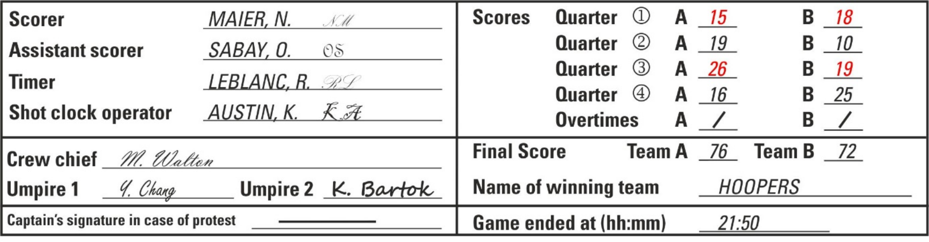
Diagram 15 Bottom of the scoresheet
B.13 Head coach’s challenge
B.13.1 For games where the Instant Replay System is used each team may be granted one head coach’s challenge (HCC). If granted, the HCC shall be entered on the scoresheet below the team’s name in the boxes next to the HCC. In the first box the scorer shall enter the quarter or overtime (Q1, Q2, Q3, Q4 or OT) and in the second box the minute of the playing time of the quarter or overtime.
B.13.2 At the end of the game, the scorer shall obliterate the unused boxes for the HCC with
2 horizontal parallel lines.

B.12 实时比分：汇总
B.12.1 每节比赛及最后一节决胜期结束时，记录员应在记录表底部的相应栏目中记录该节比赛及所有决胜期的比分。

B.12.2 比赛结束时，记录员应立即在“比赛结束时间（小时：分钟）”栏中填写时间。
B.12.3 比赛结束时，记录员应在每队最终得分及获得最后得分的队员编号下方各画两条粗横线；同时，记录员应在每队得分栏的底部画一条对角线，以擦除该队剩余的得分数字（实时比分）。

B.12.4 比赛结束时，记录员应填写最终比分及图14。
获胜球队的名称。
B.12.5 所有记录台人员随后应在其对应的记录表上签字。
名字。
B.12.6 赛事负责人应在主裁判签署记录表后，最后批准并签署该记录表。此行为即终止裁判组的管理工作及其与比赛的关系。

总结

注：若队长（CAP）在提出异议时签署记录表（使用“提出异议时的队长签名”栏），记录台人员及主裁判（复数）仍须由船队负责人保管，直至获准离场。
图 15 记录表底部
B.13 主教练的挑战
B.13.1 对于使用即时回放系统的比赛，每支球队可获准进行一次主教练挑战（HCC）。
若获准，则应在球队名称下方的记录表中，于 HCC 旁的方框内记录该挑战。第一个方框内，记录员应填写该回合或决胜期阶段（Q1、Q2、Q3、Q4或 OT）；第二个方框内，则填写该回合或决胜期阶段的比赛分钟数。
B.13.2 比赛结束时，记录员应 擦除 HCC 未使用的方格。
2 条水平平行线。

APPENDIX C – PROTEST PROCEDURE
C.1 A team may file a protest if its interests have been adversely affected by:
a) An error in scorekeeping, timekeeping, or shot clock operations, which the referees were authorised to correct as provided in these rules and had access to verifiable evidence available at the time of the decision to correct the error under Article 45 (Correctable errors) but failed to do so.
b) A decision to forfeit, cancel, postpone, not resume or not play the game.
c) A violation of the applicable eligibilitylity rules.
C.2 To be admissible, a protest shall comply with the following procedure:
a) The captain (CAP) of that team shall, no later than 15 minutes following the end of the game, inform the crew chief or the commissioner that the team is protesting against the result of the game and sign the scoresheet in the 'Captain's signature in case of protest' column.
b) The team shall submit the protest reasons to the crew chief or the commissioner in writing no later than 1 hour following the end of the game.
c) A fee of CHF 1,500 shall be applied to each protest and shall be paid in case the protest is rejected.
C.3 The crew chief or the commissioner shall, following receipt of the protest reasons, report in writing the incident which leads to the protest, to the FIBA representative or to the competent body. When receiving the protest reasons document, the crew chief orthe commissioner shall record on the document the time when the protest has been received.
C.4 The competent body shall issue any procedural requests which it deems appropriate and shall decide on the protest immediately, and in any case no later than 24 hours following the end of the game. The competent body shall use any reliable evidence and can take any appropriate decision, including without limitation partial or full replay of the game. The competent body may not decide to change the result of the game unless there is clear and conclusive evidence that, had it not been for the error that gave rise to the protest, the new result would have certainly materialised.
C.5 The decision of the competent body is also considered as a ‘field of play rule’ decision and is not subject to further review or appeal. Exceptionally, decisions on eligibility may be appealed as provided for in the applicable regulations.
C.6 Special rules for FIBA competitions or competitions which do not provide otherwise in their regulations:
a) In case the competition is in tournament format, the competent body for all protests shall be the Technical Committee (see FIBA Internal Regulations, Book 2).
b) In the case of home and away games, the competent body for protests relating to eligibility issues shall be the FIBA Disciplinary Panel. For all other issues giving rise to a protest, the competent body shall be FIBA acting through one or more persons with expertise in the implementation and interpretation of the Official Basketball Rules (see FIBA Internal Regulations, Book 2).

附录C 抗议程序
C.1 若某队利益因下列情形受到不利影响，该队可提出申诉：
a）在记分、计时或射钟操作中出现失误，主裁判根据本规则获得授权可予以纠正，且在作出纠正决定时依据第45条（可纠正的失误）可获取可验证证据，但未能采取纠正措施。
b）决定弃权、取消比赛、推迟比赛、不继续比赛或不进行比赛。
c）违反适用的资格规则。
C.2 异议若要被受理，须遵循以下程序：
a）该队队长（CAP）应在比赛结束后15分钟内，将本队对比赛结果提出申诉一事告知队长或技术代表，并在记录表的“队长申诉签名栏”内签名。
b）球队应在比赛结束后1小时内，以书面形式将抗议理由提交给队长或技术代表。
c）每份申诉均须缴纳1,500瑞士法郎的费用，若申诉被驳回，则须支付该费用。
C.3 赛事总监或技术代表在收到申诉理由后，应以书面形式将引发申诉的事件报告给国际篮联代表或相关主管部门。收到申诉理由文件时，赛事总监或技术代表应在该文件上记录收到申诉的时间。
C.4 主管机构应发布其认为适当的任何程序性要求，并应立即对申诉作出决定，且在任何情况下均不得迟于比赛结束后24小时。主管机构可采用任何可靠证据，并可作出任何适当决定，包括但不限于对比赛进行部分或全部重赛。除非存在明确且确凿的证据表明：若非引发申诉的失误，新的比赛结果必将最终实现，否则主管机构不得决定更改比赛结果。
C.5 主管机构的决定亦被视为“比赛规则”类决定，不得再接受复核或上诉。但在
特殊情况下，关于参赛资格的决定可根据适用法规的规定提出上诉。
C.6 FIBA 赛事或赛事规程中未作另行规定的赛事的特别规则：
a）若比赛采用锦标赛形式，所有申诉的管辖机构应为技术委员会（参见《国际篮联内部规章》第二册）。
b）对于主客场比赛，涉及参赛资格问题的申诉受理机构为国际篮联纪律委员会。对于其他所有引发申诉的事项，受理机构为国际篮联，由其一名或多名精通《国际篮球官方规则》实施与解释的专业人员代表行使职权（参见《国际篮联内部规章》第二册）。

APPENDIX D – CLASSIFICATION OF TEAMS
D.1 Procedure
D.1.1 Teams shall be classified according to their win-loss record, namely 2 classification points for each game won, 1 classification point for each game lost (including lost by default) and 0 classification points for a game lost by forfeit.
D.1.2 The procedure shall be used for all competitions with a round-robin system.
D.1.3 If two or more teams have the same win-loss record of all games,ames in the group, the game(s) between these 2 or more teams shall decide on the classification. If these 2 or more teams have the same win-loss record in the games between them, further criteria shall be used in the following order:
• Higher game points difference in the games between them.
• Higher number of game points scored in the games between them.
• Higher game points difference in all games in the group.
• Higher number of game points scored in all games in the group.
If, upon application of these criteria, a final decision cannot be reached at the conclusion of the group phase, the relevant FIBA ranking shall determine the final classification in National Teams Competitions. In all other competitions where no FIBA ranking exists, the final classification shall be determined by a draw.
D.1.4 If at any level of these criteria one or more team(s) are already classified, the procedure of D.1.3 shall be repeated from the start for all the remaining teams not classified yet.
D.2 Examples

D.2.1

Example 1
A vs. B 100 – 55
A vs. C 90 – 85
A vs. D 75 – 80

B vs. C
B vs. D
C vs. D

100 – 95
80 – 75
60 – 55

Team | Games  played | Wins | Losses | Classification  points | Game points | Game points  difference
A | 3 | 2 | 1 | 5 | 265 : 220 | + 45
B | 3 | 2 | 1 | 5 | 235 : 270 | - 35
C | 3 | 1 | 2 | 4 | 240 : 245 | - 5
D | 3 | 1 | 2 | 4 | 210 : 215 | - 5

 | Therefore: 1st | A – winner against B | 3rd | C - winner against D
 | 2nd | B | 4th | D
D.2.2 | Example 2
A vs. B 100 – 55 B vs. C 100 – 85
A vs. C 90 – 85 B vs. D 75 – 80
A vs. D 120 – 75 C vs. D 65 – 55

附录D 球队名次排列
D.1 操作流程
D.1.1球队应根据其胜负记录进行分级，即每胜一场得2分，每负一场得1分（包括因弃
权而负的比赛），每因弃权而负的比赛得0分。
D.1.2本程序适用于所有采用循环赛制的比赛。
D.1.3若两支或更多球队在小组所有比赛中的胜负记录相同，则这两支或更多球队之间
的比赛结果将决定最终排名。若这两支或更多球队在彼此之间的比赛中胜负记录相同，则按以下顺序采用进一步标准：
• 他们之间比赛的净胜分更高。
• 他们在相互对战中获得的比赛积分更多。
• 本组所有比赛中的总分差均较高。
• 本组所有比赛中累计得分更高。
若依据上述标准，在小组赛阶段结束时仍无法达成最终决定，则相关国际篮联排名将决定国家队赛事的最终排名。对于所有不存在国际篮联排名的其他赛事，最终排名则通过抽签决定。
D.1.4若在上述标准的任一级别中，一个或多个球队已被分类，则应对所有尚未分类的其余球队从头开始重复执行 D.1.3 节所述程序。
D.2 示例
D.2.1 示例 1
A 对 B：100 – 55 B 对 C 100 – 95
A 对 C：90 – 85 B 对 D 80 – 75
A 对比 D：75–80 C 对比 D 60 – 55

球队 | 运动  已播放 | 获胜次数 | 损失 | 分类  道岔 | 比赛积分 | 比赛积分差别
A | 3 | 2 | 1 | 5 | 265 : 220 | + 45
B | 3 | 2 | 1 | 5 | 235 : 270 | - 35
C | 3 | 1 | 2 | 4 | 240 : 245 | - 5
D | 3 | 1 | 2 | 4 | 210 : 215 | - 5

因此：第一 | A – 战胜 B | 第3 | C 战胜 D
第2 | B | 第4 | D

D.2.2 示例 2
A 对 B：100 – 55 B 对比 C：100 – 85
A 对 C：90 – 85 B 对比 D：75–80
A 对 D：120 – 75 C 对比 D：65 – 55

Team | Games  played | Wins | Losses | Classification  points | Game points | Game points  difference
A | 3 | 3 | 0 | 6 | 310 : 215 | + 95
B | 3 | 1 | 2 | 4 | 230 : 265 | - 35
C | 3 | 1 | 2 | 4 | 235 : 245 | - 10
D | 3 | 1 | 2 | 4 | 210 : 260 | - 50
Therefore: 1st A
Classification of the games between B, C, and D:

Team | Games  played | Wins | Losses | Classification  points | Game points | Game points  difference
B | 2 | 1 | 1 | 3 | 175 : 165 | + 10
C | 2 | 1 | 1 | 3 | 150 : 155 | - 5
D | 2 | 1 | 1 | 3 | 135 : 140 | - 5
Therefore: 2nd B, 3rd C - winner against D, 4th D

D.2.3

Example 3
A vs. B 85 – 90
A vs. C 55 – 100
A vs. D 75 – 120

B vs. C
B vs. D
C vs. D

100 – 95
75 – 85
65 – 55

Team | Games  played | Wins | Losses | Classification  points | Game points | Game points  difference
A | 3 | 0 | 3 | 3 | 215 : 310 | - 95
B | 3 | 2 | 1 | 5 | 265 : 265 | 0
C | 3 | 2 | 1 | 5 | 260 : 210 | + 50
D | 3 | 2 | 1 | 5 | 260 : 215 | + 45
Therefore: 4th A
Classification of the games between B, C, and D:

Team | Games  played | Wins | Losses | Classification  points | Game points | Game points  difference
B | 2 | 1 | 1 | 3 | 175 : 180 | - 5
C | 2 | 1 | 1 | 3 | 160 : 155 | +5
D | 2 | 1 | 1 | 3 | 140 : 140 | 0
Therefore: 1st C 2nd D 3rd B

D.2.4

Example 4
A vs. B 85 – 90
A vs. C 55 – 100
A vs. D 75 – 120

B vs. C
B vs. D
C vs. D

100 – 90
75 – 85
65 – 55

球队 | 运动  已播放 | 获胜次数 | 损失 | 分类  道岔 | 比赛积分 | 比赛积分差别
A | 3 | 3 | 0 | 6 | 310 : 215 | + 95
B | 3 | 1 | 2 | 4 | 230 : 265 | - 35
C | 3 | 1 | 2 | 4 | 235 : 245 | - 10
D | 3 | 1 | 2 | 4 | 210 : 260 | - 50
因此：第一项 A
B、C、D 组间比赛的分类：

球队 | 运动  已播放 | 获胜次数 | 损失 | 分类  道岔 | 比赛积分 | 比赛积分差别
B | 2 | 1 | 1 | 3 | 175 : 165 | + 10
C | 2 | 1 | 1 | 3 | 150 : 155 | - 5
D | 2 | 1 | 1 | 3 | 135 : 140 | - 5
因此：第二名 B, 第3 C 战胜 D，第4 D

D.2.3 示例 3
A 对 B：85–90 B 对 C 100 – 95
A 对 C：55–100 B 对 D 75 – 85
A 对比 D：75–120 C 对比 D 65 – 55

球队 | 运动  已播放 | 获胜次数 | 损失 | 分类  道岔 | 比赛积分 | 比赛积分差别
A | 3 | 0 | 3 | 3 | 215 : 310 | - 95
B | 3 | 2 | 1 | 5 | 265 : 265 | 0
C | 3 | 2 | 1 | 5 | 260 : 210 | + 50
D | 3 | 2 | 1 | 5 | 260 : 215 | + 45
因此：4th A
B、C、D 组间比赛的分类：

球队 | 运动  已播放 | 获胜次数 | 损失 | 分类  道岔 | 比赛积分 | 比赛积分差别
B | 2 | 1 | 1 | 3 | 175 : 180 | - 5
C | 2 | 1 | 1 | 3 | 160 : 155 | +5
D | 2 | 1 | 1 | 3 | 140 : 140 | 0
因此：第一题选 C，第二题选 D，第三题选 B

D.2.4 示例 4
A 对 B：85–90 B 对 C 100 – 90
A 对 C：55–100 B 对 D 75 – 85
A 对比 D：75–120 C 对比 D 65 – 55

Team | Games  played | Wins | Losses | Classification  points | Game points | Game points  difference
A | 3 | 0 | 3 | 3 | 215 : 310 | - 95
B | 3 | 2 | 1 | 5 | 265 : 260 | +5
C | 3 | 2 | 1 | 5 | 255 : 210 | + 45
D | 3 | 2 | 1 | 5 | 260 : 215 | + 45
Therefore: 4th A
Classification of the games between B, C, and D:

Team | Games  played | Wins | Losses | Classification  points | Game points | Game points  difference
B | 2 | 1 | 1 | 3 | 175 : 175 | 0
C | 2 | 1 | 1 | 3 | 155 : 155 | 0
D | 2 | 1 | 1 | 3 | 140 : 140 | 0
Therefore: 1st B 2nd C 3rd D

D.2.5 | Example 5  A vs. B  A vs. C  A vs. D  A vs. E  A vs. F  B vs. C  B vs. D  B vs. E | 100 – 55  85 – 90  120 – 75  80 – 100  85 – 80  100 – 95  80 – 75  75 – 80 | B vs. F  C vs. D  C vs. E  C vs. F  D vs. E  D vs. F  E vs. F | 110 – 90  55 – 60  90 – 75  105 – 75  70 – 45  65 – 60  75 – 80

Team | Games  played | Wins | Losses | Classification  points | Game points | Game points  difference
A | 5 | 3 | 2 | 8 | 470 : 400 | + 70
B | 5 | 3 | 2 | 8 | 420 : 440 | - 20
C | 5 | 3 | 2 | 8 | 435 : 395 | + 40
D | 5 | 3 | 2 | 8 | 345 : 360 | - 15
E | 5 | 2 | 3 | 7 | 375 : 395 | - 20
F | 5 | 1 | 4 | 6 | 385 : 440 | - 55
Therefore: 5th E 6th F
Classification of the games between A, B, C, and D:

Team | Games  played | Wins | Losses | Classification  points | Game points | Game points  difference
A | 3 | 2 | 1 | 5 | 305 : 220 | + 85
B | 3 | 2 | 1 | 5 | 235 : 270 | - 35
C | 3 | 1 | 2 | 4 | 240 : 245 | - 5
D | 3 | 1 | 2 | 4 | 210 : 255 | - 45

Therefore: 1st | A – winner against B | 3rd | D - winner against C
2nd | B | 4th | C

球队 | 运动  已播放 | 获胜次数 | 损失 | 分类  道岔 | 比赛积分 | 比赛积分差别
A | 3 | 0 | 3 | 3 | 215 : 310 | - 95
B | 3 | 2 | 1 | 5 | 265 : 260 | +5
C | 3 | 2 | 1 | 5 | 255 : 210 | + 45
D | 3 | 2 | 1 | 5 | 260 : 215 | + 45
因此：4th A
B、C、D 组间比赛的分类：

球队 | 运动  已播放 | 获胜次数 | 损失 | 分类  道岔 | 比赛积分 | 比赛积分差别
B | 2 | 1 | 1 | 3 | 175 : 175 | 0
C | 2 | 1 | 1 | 3 | 155 : 155 | 0
D | 2 | 1 | 1 | 3 | 140 : 140 | 0
因此：第一 B 第2 C 第3 D

D.2.5 | 示例 5  A 对 B  A 对 C  A 对 D  A 对 E  A 对 F B 对 C  B 对 D  B 对比 E | 100 – 55  85 – 90  120 – 75  80 – 100  85 – 80  100 – 95  80 – 75  75 – 80 | B 对 F C 对比 D  C 对 E C 对 F D 对 E  D 对 F E 对 F | 110 – 90  55 – 60  90 – 75  105 – 75  70 – 45  65 – 60  75 – 80

球队 | 运动  已播放 | 获胜次数 | 损失 | 分类  道岔 | 比赛积分 | 比赛积分差别
A | 5 | 3 | 2 | 8 | 470 : 400 | + 70
B | 5 | 3 | 2 | 8 | 420 : 440 | - 20
C | 5 | 3 | 2 | 8 | 435 : 395 | + 40
D | 5 | 3 | 2 | 8 | 345 : 360 | - 15
E | 5 | 2 | 3 | 7 | 375 : 395 | - 20
F | 5 | 1 | 4 | 6 | 385 : 440 | - 55
因此：第5 E 6 th F
A、B、C、D 组间比赛的分类：

球队 | 运动  已播放 | 获胜次数 | 损失 | 分类  道岔 | 比赛积分 | 比赛积分差别
A | 3 | 2 | 1 | 5 | 305 : 220 | + 85
B | 3 | 2 | 1 | 5 | 235 : 270 | - 35
C | 3 | 1 | 2 | 4 | 240 : 245 | - 5
D | 3 | 1 | 2 | 4 | 210 : 255 | - 45
因此：第一 A – 战胜 B 第3 D 战胜 C
第2 B 第4 C

D.2.6 | Example 6  A vs. B  A vs. C  A vs. D  A vs. E  A vs. F  B vs. C  B vs. D  B vs. E | 71 – 65  85 – 86  77 – 75  80 – 86  85 – 80  88 – 87  80 – 75  75 – 76 | B vs. F  C vs. D  C vs. E  C vs. F  D vs. E  D vs. F  E vs. F | 95 – 90  95 – 100  82 – 75  105 – 75  68 – 67  65 – 60  80 – 75

Team | Games  played | Wins | Losses | Classification  points | Game points | Game points  difference
A | 5 | 3 | 2 | 8 | 398 : 392 | +6
B | 5 | 3 | 2 | 8 | 403 : 399 | +4
C | 5 | 3 | 2 | 8 | 455 : 423 | + 32
D | 5 | 3 | 2 | 8 | 383 : 379 | +4
E | 5 | 3 | 2 | 8 | 384 : 380 | +4
F | 5 | 0 | 5 | 5 | 380 : 430 | - 50
Therefore: 6th F
Classification of the games between A, B, C, D, E:

Team | Games  played | Wins | Losses | Classification  points | Game points | Game points  difference
A | 4 | 2 | 2 | 6 | 313 : 312 | + 1
B | 4 | 2 | 2 | 6 | 308 : 309 | - 1
C | 4 | 2 | 2 | 6 | 350 : 348 | +2
D | 4 | 2 | 2 | 6 | 318 : 319 | - 1
E | 4 | 2 | 2 | 6 | 304 : 305 | - 1
Therefore: 1st C 2nd A
Classification of the games between B, D, and E:

Team | Games  played | Wins | Losses | Classification  points | Game points | Game points  difference
B | 2 | 1 | 1 | 3 | 155 : 151 | +4
D | 2 | 1 | 1 | 3 | 143 : 147 | - 4
E | 2 | 1 | 1 | 3 | 143 : 143 | 0
Therefore: 3rd B 4th E 5th D

D.2.7 | Example 7  A vs. B  A vs. C  A vs. D  A vs. E  A vs. F  B vs. C  B vs. D  B vs. E | 73 – 71  85 – 86  77 – 75  90 – 96  85 – 80  88 – 87  80 – 79  79 – 80 | B vs. F  C vs. D  C vs. E  C vs. F  D vs. E  D vs. F  E vs. F | 95 – 90  95 – 96  82 – 75  105 – 75  68 – 67  80 – 75  80 – 75

D.2.6 | 示例 6  A 对 B  A 对 C  A 对 D  A 对 E  A 对 F B 对 C  B 对 D  B 对比 E | 71 – 65  85 – 86  77 – 75  80 – 86  85 – 80  88 – 87  80 – 75  75 – 76 | B 对 F C 对比 D  C 对 E C 对 F D 对 E  D 对 F E 对 F | 95 – 90  95 – 100  82 – 75  105 – 75  68 – 67  65 – 60  80 – 75

球队 | 运动  已播放 | 获胜次数 | 损失 | 分类  道岔 | 比赛积分 | 比赛积分差别
A | 5 | 3 | 2 | 8 | 398 : 392 | +6
B | 5 | 3 | 2 | 8 | 403 : 399 | +4
C | 5 | 3 | 2 | 8 | 455 : 423 | + 32
D | 5 | 3 | 2 | 8 | 383 : 379 | +4
E | 5 | 3 | 2 | 8 | 384 : 380 | +4
F | 5 | 0 | 5 | 5 | 380 : 430 | - 50
因此：第六区
A、B、C、D、E 之间的比赛分类如下：

球队 | 运动  已播放 | 获胜次数 | 损失 | 分类  道岔 | 比赛积分 | 比赛积分差别
A | 4 | 2 | 2 | 6 | 313 : 312 | + 1
B | 4 | 2 | 2 | 6 | 308 : 309 | - 1
C | 4 | 2 | 2 | 6 | 350 : 348 | +2
D | 4 | 2 | 2 | 6 | 318 : 319 | - 1
E | 4 | 2 | 2 | 6 | 304 : 305 | - 1
因此：第一 C，第二 A
B、D、E 组间比赛的分类：

球队 | 运动  已播放 | 获胜次数 | 损失 | 分类  道岔 | 比赛积分 | 比赛积分差别
B | 2 | 1 | 1 | 3 | 155 : 151 | +4
D | 2 | 1 | 1 | 3 | 143 : 147 | - 4
E | 2 | 1 | 1 | 3 | 143 : 143 | 0
因此：第3名 B 第4 E 第5 D

D.2.7 | 示例 7  A 对 B  A 对 C  A 对 D  A 对 E  A 对 F B 对 C  B 对 D  B 对比 E | 73 – 71  85 – 86  77 – 75  90 – 96  85 – 80  88 – 87  80 – 79  79 – 80 | B 对 F C 对比 D  C 对 E C 对 F D 对 E  D 对 F E 对 F | 95 – 90  95 – 96  82 – 75  105 – 75  68 – 67  80 – 75  80 – 75

2026年7月

官方篮球规则 2026

第 85 页，

共 107 页

Team | Games  played | Wins | Losses | Classification  points | Game points | Game points  difference
A | 5 | 3 | 2 | 8 | 410 : 408 | +2
B | 5 | 3 | 2 | 8 | 413 : 409 | +4
C | 5 | 3 | 2 | 8 | 455 : 419 | + 36
D | 5 | 3 | 2 | 8 | 398 : 394 | +4
E | 5 | 3 | 2 | 8 | 398 : 394 | +4
F | 5 | 0 | 5 | 5 | 395 : 445 | - 50
Therefore: 6th F
Classification of the games betweenen A, B, C, D, E:

Team | Games  played | Wins | Losses | Classification  points | Game points | Game points  difference
A | 4 | 2 | 2 | 6 | 325 : 328 | - 3
B | 4 | 2 | 2 | 6 | 318 : 319 | - 1
C | 4 | 2 | 2 | 6 | 350 : 344 | +6
D | 4 | 2 | 2 | 6 | 318 : 319 | - 1
E | 4 | 2 | 2 | 6 | 318 : 319 | - 1
Therefore: 1st C 5th A
Classification of the games between B, D, and E:

Team | Games  played | Wins | Losses | Classification  points | Game points | Game points  difference
B | 2 | 1 | 1 | 3 | 159 : 159 | 0
D | 2 | 1 | 1 | 3 | 147 : 147 | 0
E | 2 | 1 | 1 | 3 | 147 : 147 | 0
Therefore: 2nd B, 3rd D - winner against E, 4th E
D.3 Forfeit
D.3.1 A team which, without valid reason, fails to show up for a scheduled game or withdraws from the court before the end of the game, shall lose the game by forfeit and receive 0 classification points.
D.3.2 If the team forfeits for a second time, the results of all games played by this team shall be nullified.
D.3.3 If the team forfeits for a second time in a competition played in groups, and the best placed team(s) from each group shall qualify for the next round of the competition, the results of all games played by the last placed team in the cross-over group shall also be nullified.
Example
Team 4A in Group A forfeits twice; therefore, all its games shall be nullified.

球队 | 运动  已播放 | 获胜次数 | 损失 | 分类  道岔 | 比赛积分 | 比赛积分差别
A | 5 | 3 | 2 | 8 | 410 : 408 | +2
B | 5 | 3 | 2 | 8 | 413 : 409 | +4
C | 5 | 3 | 2 | 8 | 455 : 419 | + 36
D | 5 | 3 | 2 | 8 | 398 : 394 | +4
E | 5 | 3 | 2 | 8 | 398 : 394 | +4
F | 5 | 0 | 5 | 5 | 395 : 445 | - 50
因此：第六区
A、B、C、D、E 之间的比赛分类如下：

球队 | 运动  已播放 | 获胜次数 | 损失 | 分类  道岔 | 比赛积分 | 比赛积分差别
A | 4 | 2 | 2 | 6 | 325 : 328 | - 3
B | 4 | 2 | 2 | 6 | 318 : 319 | - 1
C | 4 | 2 | 2 | 6 | 350 : 344 | +6
D | 4 | 2 | 2 | 6 | 318 : 319 | - 1
E | 4 | 2 | 2 | 6 | 318 : 319 | - 1
因此：1st C 5th A
B、D、E 组间比赛的分类：

球队 | 运动  已播放 | 获胜次数 | 损失 | 分类  道岔 | 比赛积分 | 比赛积分差别
B | 2 | 1 | 1 | 3 | 159 : 159 | 0
D | 2 | 1 | 1 | 3 | 147 : 147 | 0
E | 2 | 1 | 1 | 3 | 147 : 147 | 0
因此：第二名 B，第三名 D——战胜 E，第四名 E
D.3 弃权
D.3.1若某队无正当理由未能参加预定比赛，或在比赛结束前退出赛场，则该队应被判
负，并不得获得任何分类积分。
D.3.2若某队第二次弃权，则该队参加的所有比赛结果均告无效。
D.3.3若某队在分组赛中第二次弃权，且各小组中排名最高的球队晋级下一轮比赛，则
该轮交叉分组赛中末位球队所进行的所有比赛结果亦应作废。

样例
A 组第4A 队两次弃权，因此其所有比赛均告无效。

Final standings:

Group B | Wins | Losses | Classification  points
Team 1B | 6 | 0 | 12
Team 2B | 4 | 2 | 10
Team 3B | 1 | 5 | 7
Team 4B | 1 | 5 | 7

Group A | Wins | Losses | Classification  points
Team 1A | 4 | 0 | 8
Team 2A | 2 | 2 | 6
Team 3A | 0 | 4 | 4
Team 4A
Results of the games played between teams 3B and 4B: 3B vs 4B 88 – 71 4B vs 3B 76 – 75
Therefore: 3rd 3B 4th 4B
Revised final standings in Group B:

Group B | Wins | Losses | Classification  points
Team 1B | 4 | 0 | 8
Team 2B | 2 | 2 | 6
Team 3B | 0 | 4 | 4
D.4 Cross-group classifications
D.4. 1 To classify teams across groups (e.g., to determine the best second or third placed teams), the following criteria shall be used.
If all teams in all groups have played the same number of games, the teams in the same position in each group shall be placed in one group. The following criteria shall apply in the order listed below:
• Better win-loss record of all games played in their revised final group standings.
• Higher game points difference of all games in their revised final group standings.
• Higher number of game points scored in all games in their revised final group standings.
• If these criteria still cannot decide, the relevant FIBA ranking shall decide on the final classification.

Group B | Wins | Losses | Classification  points
Team 1B | 8 | 0 | 16
Team 2B | 6 | 2 | 14
Team 3B | 4 | 4 | 12
Team 4B | 2 | 6 | 10
Team 5B | 0 | 8 | 8

Group D | Wins | Losses | Classification  points
Team 1D | 7 | 1 | 15
Team 2D | 7 | 1 | 15
Team 3D | 4 | 4 | 12
Team 4D | 2 | 6 | 10
Team 5D | 0 | 8 | 8

Group A | Wins | Losses | Classification  points
Team 1A | 8 | 0 | 16
Team 2A | 6 | 2 | 14
Team 3A | 4 | 4 | 12
Team 4A | 2 | 6 | 10
Team 5A | 0 | 8 | 8

Group C | Wins | Losses | Classification  points
Team 1C | 8 | 0 | 16
Team 2C | 6 | 2 | 14
Team 3C | 3 | 5 | 11
Team 4C | 3 | 5 | 11
Team 5C | 0 | 8 | 8

最终排名：

B 组 | 获胜次数 | 损失 | 分类  道岔
1B 队 | 6 | 0 | 12
2B 队 | 4 | 2 | 10
3B 队 | 1 | 5 | 7
4B 队 | 1 | 5 | 7

A 组 | 获胜次数 | 损失 | 分类  道岔
1A 队 | 4 | 0 | 8
2A 队 | 2 | 2 | 6
3A 队 | 0 | 4 | 4
4A 队
3B 队与4B 队比赛结果：3B vs 4B 88 – 71 4B vs 3B 76 – 75
因此：3号三垒手 4号四垒手
B 组 revised 最终积分榜如下：

B 组 | 获胜次数 | 损失 | 分类  道岔
1B 队 | 4 | 0 | 8
2B 队 | 2 | 2 | 6
3B 队 | 0 | 4 | 4
D.4 跨组分类
D.4.1为对各小组内的球队进行分类（例如，以确定最佳亚军或季军球队），应采用以下标准。
若所有小组中的各队比赛场次相同，则各小组中处于相同排位的球队应被归入同一小组。下列标准应按下列顺序依次适用：
• 在其修订后的最终小组积分榜中，所有已进行比赛的胜负记录均有所改善。
• 在其修订后的最终小组积分榜中，所有比赛的总分差均更大。
• 在其修订后的最终小组积分榜中，所有比赛获得的总得分更高。
• 若上述标准仍无法作出判定，则由相关国际篮联排名决定最终分类。

B 组 | 获胜次数 | 损失 | 分类  道岔
1B 队 | 8 | 0 | 16
2B 队 | 6 | 2 | 14
3B 队 | 4 | 4 | 12
4B 队 | 2 | 6 | 10
5B 队 | 0 | 8 | 8

D 组 | 获胜次数 | 损失 | 分类  道岔
1D 球队 | 7 | 1 | 15
Team 2D | 7 | 1 | 15
3D 球队 | 4 | 4 | 12
4D 球队 | 2 | 6 | 10
5D 球队 | 0 | 8 | 8

A 组 | 获胜次数 | 损失 | 分类  道岔
1A 队 | 8 | 0 | 16
2A 队 | 6 | 2 | 14
3A 队 | 4 | 4 | 12
4A 队 | 2 | 6 | 10
5A 队 | 0 | 8 | 8

C 组 | 获胜次数 | 损失 | 分类  道岔
1C 队 | 8 | 0 | 16
2C 队 | 6 | 2 | 14
3C 球队 | 3 | 5 | 11
4C 球队 | 3 | 5 | 11
5C 队 | 0 | 8 | 8

To determine the best second placed team:

Group X | Wins | Losses | Classification  points | Game points | Game points  difference
Team 2D | 7 | 1 | 15 | 628 – 521
Team 2B | 6 | 2 | 14 | 551 – 488 | + 63
Team 2A | 6 | 2 | 14 | 531 – 506 | + 25
Team 2C | 6 | 2 | 14 | 525 – 500 | + 25
D.4.2 If after grouping the teams in the same position in each group, these teams have played a different number of games in their respective groups, then the games of the last placed team in the group or groups of the teams with the most games shall be nullified. This process shall be repeated across all groups until the number of games is the same across all groups. The following criteria shall apply in the order listed below:
• Better win-loss record of all games played in their revised final group standings.
• Higher game points difference of all games in their revised final group standings.
• Higher number of game points scored in all games in their revised final group standings.
• If these criteria still cannot decide, the relevant FIBA ranking shall decide on the final classification.
Note:
For the avoidance of doubt, the cancellation of games referred to above, for the purposes of cross-group classifications, shall not alter the initial standing of teams in a particular group.
Example

Group B | Wins | Losses | Classification  points
Team 1B | 4 | 1 | 9
Team 2B | 4 | 1 | 9
Team 3B | 4 | 1 | 9
Team 4B | 2 | 3 | 7
Team 5B | 1 | 4 | 6
Team 6B | 0 | 5 | 5

Group D | Wins | Losses | Classification  points
Team 1D | 3 | 1 | 7
Team 2D | 3 | 1 | 7
Team 3D | 2 | 2 | 6
Team 4D | 2 | 2 | 6
Team 5D | 0 | 4 | 4

Group A | Wins | Losses | Classification  points
Team 1A | 5 | 0 | 10
Team 2A | 4 | 1 | 9
Team 3A | 3 | 2 | 8
Team 4A | 2 | 3 | 7
Team 5A | 1 | 4 | 6
Team 6A | 0 | 5 | 5

Group C | Wins | Losses | Classification  points
Team 1C | 4 | 0 | 8
Team 2C | 3 | 1 | 7
Team 3C | 2 | 2 | 6
Team 4C | 1 | 3 | 5
Team 5C | 0 | 4 | 4

旨在确定最佳亚军球队：
X 组 | 获胜次数 | 损失 | 分类  道岔 | 比赛积分 | 比赛积分差别
Team 2D | 7 | 1 | 15 | 628 – 521
2B 队 | 6 | 2 | 14 | 551 – 488 | + 63
2A 队 | 6 | 2 | 14 | 531 – 506 | + 25
2C 队 | 6 | 2 | 14 | 525 – 500 | + 25
D.4.2若在各小组中按相同排名对球队进行分组后，这些球队在各自小组中已进行的比赛场数不同，则小组内排名垫底的球队或比赛场数最多的球队所在小组中的比赛均应取消。此操作应在所有小组中重复进行，直至各小组的比赛场数相同。下列标准应按以下顺序依次适用：
• 在其修订后的最终小组积分榜中，所有已进行比赛的胜负记录均有所改善。
• 在其修订后的最终小组积分榜中，所有比赛的总分差均更大。
• 在其修订后的最终小组积分榜中，所有比赛获得的总得分更高。
• 若上述标准仍无法作出判定，则由相关国际篮联排名决定最终分类。
笔记：
为避免疑问，上述为跨组分类目的而取消的比赛，不得改变各球队在特定小组中的初始排名。
样例

B 组 | 获胜次数 | 损失 | 分类  道岔
1B 队 | 4 | 1 | 9
2B 队 | 4 | 1 | 9
3B 队 | 4 | 1 | 9
4B 队 | 2 | 3 | 7
5B 队 | 1 | 4 | 6
6B 队 | 0 | 5 | 5

D 组 | 获胜次数 | 损失 | 分类  道岔
1D 球队 | 3 | 1 | 7
Team 2D | 3 | 1 | 7
3D 球队 | 2 | 2 | 6
4D 球队 | 2 | 2 | 6
5D 球队 | 0 | 4 | 4

A 组 | 获胜次数 | 损失 | 分类  道岔
1A 队 | 5 | 0 | 10
2A 队 | 4 | 1 | 9
3A 队 | 3 | 2 | 8
4A 队 | 2 | 3 | 7
5A 队 | 1 | 4 | 6
6A 队 | 0 | 5 | 5

C 组 | 获胜次数 | 损失 | 分类  道岔
1C 队 | 4 | 0 | 8
2C 队 | 3 | 1 | 7
3C 球队 | 2 | 2 | 6
4C 球队 | 1 | 3 | 5
5C 队 | 0 | 4 | 4

To determine the best third placed team, all third placed teams shall be put into one group:

Group X | Wins | Losses | Classification  points
Team 3B | 4 | 1 | 9
Team 3A | 3 | 2 | 8
Team 3D | 2 | 2 | 6
Team 3C | 2 | 2 | 6
However, teams 3B and 3A have played five games whereas teams 3D and 3C have played four games.
The games of the last placed teams in groups A and B must be annulled to level all third placed teams to four games, and a new table established.
The game results of Group A and B were as follows: Group A
Away Home | 2A | 3A | 4A | 5A | 6A
1A | 71 – 65 | 86 – 85 | 77 – 75 | 86 – 80 | 85 – 80
2A |  | 80 – 75 | 90 – 84 | 98 – 79 | 87 – 85
3A |  |  | 87 – 67 | 101 – 76 | 86 – 74
4A |  |  |  | 78 – 54 | 87 – 81
5A |  |  |  |  | 84 – 65
Group B

Away Home | 2B | 3B | 4B | 5B | 6B
1B | 81 – 76 | 85 – 86 | 77 – 75 | 90 – 80 | 85 – 69
2B |  | 90 – 85 | 96 – 79 | 81 – 73 | 87 – 85
3B |  |  | 87 – 67 | 101 – 76 | 86 – 74
4B |  |  |  | 78 – 54 | 87 – 81
5B |  |  |  |  | 84 – 65
Upon the cancellation of games between teams 6A and 6B, the revised standings of the group to determine the best third team are as follows:

Group X | Wins | Losses | Classification  points | Game points | Game points  difference
Team 3B | 3 | 1 | 7 | 359 – 323
Team 3A | 2 | 2 | 6 | 348 – 309 | + 39
Team 3D | 2 | 2 | 6 | 363 – 359 | +4
Team 3C | 2 | 2 | 6 | 302 – 298 | +4

为确定最佳第三名球队，将所有第三名球队归入同一组别：

X 组 | 获胜次数 | 损失 | 分类  道岔
3B 队 | 4 | 1 | 9
3A 队 | 3 | 2 | 8
3D 球队 | 2 | 2 | 6
3C 球队 | 2 | 2 | 6
然而，3B 队和 3A 队已进行了五场比赛，而 3D 队和 3C 队仅进行了四场比赛。
A 组和 B 组中排名垫底的球队的比赛须被取消，以使所有第三名球队的比赛场次均变为四场，并重新制定分组表。
A 组和 B 组的比赛结果如下：
A 组

离家 | 2A | 3A | 4A | 5A | 6A
1A | 71 – 65 | 86 – 85 | 77 – 75 | 86 – 80 | 85 – 80
2A |  | 80 – 75 | 90 – 84 | 98 – 79 | 87 – 85
3A |  |  | 87 – 67 | 101 – 76 | 86 – 74
4A |  |  |  | 78 – 54 | 87 – 81
5A |  |  |  |  | 84 – 65
B 组

离家 | 2B | 3B | 4B | 5B | 6B
1B | 81 – 76 | 85 – 86 | 77 – 75 | 90 – 80 | 85 – 69
2B |  | 90 – 85 | 96 – 79 | 81 – 73 | 87 – 85
3B |  |  | 87 – 67 | 101 – 76 | 86 – 74
4B |  |  |  | 78 – 54 | 87 – 81
5B |  |  |  |  | 84 – 65
在6A 组与6B 组比赛取消后，用于确定最佳第三名球队的分组最新排名如下：

X 组 | 获胜次数 | 损失 | 分类  道岔 | 比赛积分 | 比赛积分差别
3B 队 | 3 | 1 | 7 | 359 – 323
3A 队 | 2 | 2 | 6 | 348 – 309 | + 39
3D 球队 | 2 | 2 | 6 | 363 – 359 | +4
3C 球队 | 2 | 2 | 6 | 302 – 298 | +4

D.5 Classifications of teams in a Tournament of Phases
D.5.1 In a tournament where game results in a group are carried over from one phase to another, but a team is withdrawn from the tournament or forfeits for a second time a game for any reason, then the results of all games played by the withdrawn or forfeiting team shall be nullified from all relevant phases. The following criteria shall apply in the order listed below:
• Better win-loss record of all games played in their revised final group standings.
• Higher game points difference of all games in their revised final group standings.
• Higher number of game points scored in all games in their revised final group standings.
• If these criteria still cannot decide, the relevant FIBA ranking shall decide on the final classification.
Example
Round 1
Two groups of four teams each, playing home and away, with standings as follows:

Group B | Wins | Losses | Classification  points
Team 1B | 5 | 1 | 11
Team 2B | 4 | 2 | 10
Team 3B | 2 | 4 | 8
Team 4B | 1 | 5 | 7

Group A | Wins | Losses | Classification  points
Team 1A | 6 | 0 | 12
Team 2A | 4 | 2 | 10
Team 3A | 2 | 4 | 8
Team 4A | 0 | 6 | 6
Group A

Away Home | 1A | 2A | 3A | 4A
1A |  | 71 – 65 | 86 – 85 | 101 – 76
2A | 80 – 86 |  | 80 – 75 | 90 – 84
3A | 80 – 85 | 79 – 98 |  | 87 – 67
4A | 75 – 77 | 85 – 87 | 74 – 86
Group B

Away Home | 1B | 2B | 3B | 4B
1B |  | 71 – 65 | 86 – 85 | 101 – 76
2B | 81 – 76 |  | 80 – 75 | 90 – 84
3B | 80 – 92 | 98 – 79 |  | 87 – 67
4B | 75 – 77 | 85 – 100 | 86 – 65

D.5 分阶段锦标赛中球队的分类
D.5.1若某小组赛的比赛结果从一阶段延续至下一阶段，但某支球队退出赛事，或因任何原因第二次弃权，则该退出或弃权球队所进行的所有比赛结果，自所有相关阶段起均作废。下列标准应按以下顺序依次适用：
• 在其修订后的最终小组积分榜中，所有已进行比赛的胜负记录均有所改善。
• 在其修订后的最终小组积分榜中，所有比赛的净胜球均有所增加。
• 在其修订后的最终小组积分榜中，所有比赛获得的总得分更高。
• 若上述标准仍无法作出判定，则由相关国际篮联（FIBA）排名决定最终分类。
样例
第一轮
共分为两组，每组四支队伍，进行主客场对决，积分榜如下：

B 组 | 获胜次数 | 损失 | 分类  道岔
1B 队 | 5 | 1 | 11
2B 队 | 4 | 2 | 10
3B 队 | 2 | 4 | 8
4B 队 | 1 | 5 | 7

A 组 | 获胜次数 | 损失 | 分类  道岔
1A 队 | 6 | 0 | 12
2A 队 | 4 | 2 | 10
3A 队 | 2 | 4 | 8
4A 队 | 0 | 6 | 6
A 组

离家 | 1A | 2A | 3A | 4A
1A |  | 71 – 65 | 86 – 85 | 101 – 76
2A | 80 – 86 |  | 80 – 75 | 90 – 84
3A | 80 – 85 | 79 – 98 |  | 87 – 67
4A | 75 – 77 | 85 – 87 | 74 – 86
B 组

离家 | 1B | 2B | 3B | 4B
1B |  | 71 – 65 | 86 – 85 | 101 – 76
2B | 81 – 76 |  | 80 – 75 | 90 – 84
3B | 80 – 92 | 98 – 79 |  | 87 – 67
4B | 75 – 77 | 85 – 100 | 86 – 65

Round 2
The top three teams from Groups A and B go into Group C, carrying forward their results and classification points. The initial ranking shall be as follows:

Group C | Wins | Losses | Classification  points | Game points | Game points  difference
Team 1A | 6 | 0 | 12 | 506 – 461 | + 45
Team 1B | 5 | 1 | 11 | 503 – 462 | + 41
Team 2A | 4 | 2 | 10 | 500 – 480 | + 20
Team 2B | 4 | 2 | 10 | 495 – 489 | +6
Team 3A | 2 | 4 | 8 | 492 – 490 | +2
Team 3B | 2 | 4 | 8 | 490 – 490 | 0
If teams play home and away against teams not previously in their group with the following results:

Away Home | 1A | 1B | 2A | 2B | 3A | 3B
1A |  | 77 – 98 |  | 100 – 89 |  | 95 – 74
1B | 87 – 83 |  | 87 – 75 |  | 99 – 92
2A |  | 71 – 96 |  | 87 – 86 |  | 88 – 84
----2B | 65 – 76 |  | FORFEIT |  | FORFEIT
3A |  | 87 – 97 |  | 69 – 73 |  | 83 – 81
3B | 68 – 96 |  | 82 – 81 |  | 74 – 67
Since team 2B has forfeited twice, the results of all games involving team 2B (in both rounds) shall be nullified as follows:
Round 1 revised results:

Away Home | 1B | 2B | 3B | 4B
1B |  | 71 – 65 | 86 – 85 | 101 – 76
2B | 81 – 76 |  | 80 – 75 | 90 – 84
3B | 80 – 92 | 98 – 79 |  | 87 – 67
4B | 75 – 77 | 85 – 100 | 86 – 65

第二轮
A 组和 B 组的前三名球队晋级 C 组，并沿用其此前赛果及积分。初步排名顺序如下：

C 组 | 获胜次数 | 损失 | 分类  道岔 | 比赛积分 | 比赛积分差别
1A 队 | 6 | 0 | 12 | 506 – 461 | + 45
1B 队 | 5 | 1 | 11 | 503 – 462 | + 41
2A 队 | 4 | 2 | 10 | 500 – 480 | + 20
2B 队 | 4 | 2 | 10 | 495 – 489 | +6
3A 队 | 2 | 4 | 8 | 492 – 490 | +2
3B 队 | 2 | 4 | 8 | 490 – 490 | 0
若各队与此前未同组的其他球队进行主客场对决，且比赛结果如下：

离家 | 1A | 1B | 2A | 2B | 3A | 3B
1A |  | 77 – 98 |  | 100 – 89 |  | 95 – 74
1B | 87 – 83 |  | 87 – 75 |  | 99 – 92
2A |  | 71 – 96 |  | 87 – 86 |  | 88 – 84
----2B | 65 – 76 |  | 没收 |  | 没收
3A |  | 87 – 97 |  | 69 – 73 |  | 83 – 81
3B | 68 – 96 |  | 82 – 81 |  | 74 – 67
鉴于2B 队已两次弃权，2B 队参与的所有比赛（包括两轮赛事）的比赛结果均按以下规定作废：
第一轮修订结果：

离家 | 1B | 2B | 3B | 4B
1B |  | 71 – 65 | 86 – 85 | 101 – 76
2B | 81 – 76 |  | 80 – 75 | 90 – 84
3B | 80 – 92 | 98 – 79 |  | 87 – 67
4B | 75 – 77 | 85 – 100 | 86 – 65

Round 2 revised results:

Away Home | 1A | 1B | 2A | 2B | 3A | 3B
1A |  | 77 – 98 |  | 100 – 89 |  | 95 – 74
1B | 87 – 83 |  | 87 – 75 |  | 99 – 92
2A |  | 71 – 96 |  | 87 – 86 |  | 88 – 84
2B | 65 – 76 |  | FORFEIT |  | FORFEIT
3A |  | 87 – 97 |  | 69 – 73 |  | 83 – 81
3B | 68 – 96 |  | 82 – 81 |  | 74 – 67
Final standings:

Group C | Wins | Losses | Classification  points | Game points | Game points  difference
Team 1B | 10 | 0 | 20 | 916 – 801 | + 115
Team 1A | 8 | 2 | 18 | 857 – 788 | + 69
Team 2A | 5 | 5 | 15 | 815 – 785 | + 30
Team 3A | 4 | 6 | 14 | 825 – 837 | - 12
Team 3B | 3 | 7 | 13 | 780 – 841 | - 61
D.5.2 To classify teams eliminated at the tournament after the Group Phase, and the qualification for the Quarterfinals and/or the Quarterfinals, the four eliminated teams at each respective elimination phase shall be placed in one group. The following criteria shall apply in the order listed below:
• Higher group placing after all games played in the Group Phase.
• Better win-loss record of all games played in the Group Phase.
• Higher game points difference of all games played in the Group Phase.
• Higher number of game points scored in all games played in the Group Phase. If these criteria still cannot decide, the relevant FIBA ranking shall decide on the classification.
Example
The final standings of 16 teams, divided for the Group Phase into 4 groups of 4 teams, are as follows:

Group A | Wins | Losses | Classification  points | Game points | Game points  difference
Team A1 | 3 | 0 | 6 | 300 – 223 | + 77
Team A2 | 2 | 1 | 5 | 255 – 266 | - 11
Team A3 | 1 | 2 | 4 | 250 – 270 | - 20
Team A4 | 0 | 3 | 3 | 245 – 291 | - 46

第二轮修订结果：
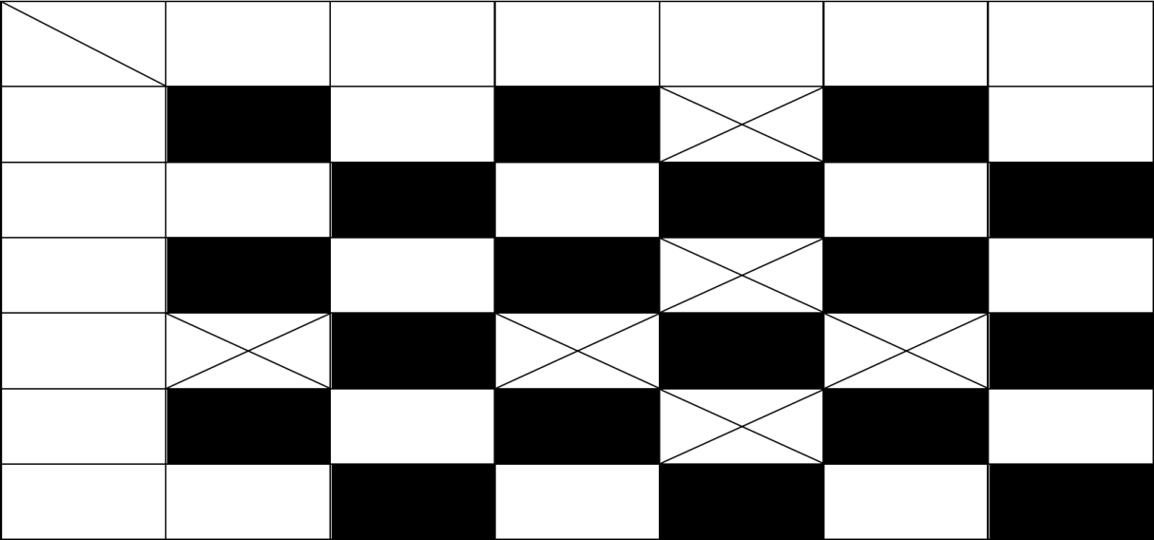
2B 3A 3B
100 – 89 95 – 74 99 – 92
87 – 86 88 – 84

没收
69 – 73 83 – 81
74 – 67
离家 1A
1A
1B 87 – 83 2A
2B 65 – 76 3A
3B 68 – 96
2A

87 – 75

没收

82 – 81
1B 77 – 98

71 – 96

87 – 97
最终排名：

C 组 | 获胜次数 | 损失 | 分类  道岔 | 比赛积分 | 比赛积分差别
1B 队 | 10 | 0 | 20 | 916 – 801 | + 115
1A 队 | 8 | 2 | 18 | 857 – 788 | + 69
2A 队 | 5 | 5 | 15 | 815 – 785 | + 30
3A 队 | 4 | 6 | 14 | 825 – 837 | - 12
3B 队 | 3 | 7 | 13 | 780 – 841 | - 61
D.5.2 为对小组赛阶段后被淘汰的球队，以及晋级八强赛和/或四分之一决赛的球队进行分类，每个相应淘汰阶段的4支被淘汰球队应被归入同一小组。下列标准应按以下顺序依次适用：
• 在小组赛全部比赛结束后，排名更高。
• 小组赛阶段所有比赛更好的胜负记录。
• 小组赛阶段所有比赛中的总分差更高。
• 在小组赛阶段进行的所有比赛中，总得分较高的球队。若上述标准仍无法确定排名，则由相关国际篮联排名决定最终分类。
样例
16支参赛球队在小组赛中被分为4个小组（每组4支），最终排名如下：

A 组 | 获胜次数 | 损失 | 分类  道岔 | 比赛积分 | 比赛积分差别
A1 队 | 3 | 0 | 6 | 300 – 223 | + 77
A2 队 | 2 | 1 | 5 | 255 – 266 | - 11
A3 球队 | 1 | 2 | 4 | 250 – 270 | - 20
A4 球队 | 0 | 3 | 3 | 245 – 291 | - 46

Group B | Wins | Losses | Classification  points | Game points | Game points  difference
Team B1 | 3 | 0 | 6 | 237 – 165 | + 72
Team B2 | 2 | 1 | 5 | 271 – 209 | + 62
Team B3 | 1 | 2 | 4 | 197 – 252 | - 55
Team B4 | 0 | 3 | 3 | 184 – 263 | - 79

Group C | Wins | Losses | Classification  points | Game points | Game points  difference
Team C1 | 3 | 0 | 6 | 283 – 225 | + 58
Team C2 | 2 | 1 | 5 | 249 – 225 | + 24
Team C3 | 1 | 2 | 4 | 232 – 251 | - 19
Team C4 | 0 | 3 | 3 | 212 – 275 | - 63

Group D | Wins | Losses | Classification  points | Game points | Game points  difference
Team D1 | 3 | 0 | 6 | 312 – 242 | + 70
Team D2 | 2 | 1 | 5 | 260 – 265 | - 5
Team D3 | 1 | 2 | 4 | 239 – 246 | - 7
Team D4 | 0 | 3 | 3 | 195 – 253 | - 58

Final classification of 4 teams (13th – 16th) eliminated after the Group Phase.
The teams placed 1st in each group of the Group Phase qualify directly for the Quarterfinals. The teams placed 4th in each group in the Group Phase are eliminated. The table of the teams’ final classification is as follows:

Final  classification | Classification  points | Game points | Game points  difference
13th Team A4 | 3 | 245 – 291 | - 46
14th Team D4 | 3 | 195 – 253 | - 58
15th Team C4 | 3 | 212 – 275 | - 63
16th Team B4 | 3 | 184 – 263 | - 79

Final classification of 4 teams (9th–12th) eliminated after the qualification for the quarterfinals.
The teams placed 2nd and 3rd in each group of the Group Phase shall play one elimination game as follows: A2 v B3, B2 v A3, C2 v D3, D2 v C3. The winning teams (example: A2, A3, D3, D2) qualify for the quarterfinals. The losing teams (example: B3, B2, C2, C3) are eliminated. The table of the team’s final classification is as follows:

Final  classification | Classification  points | Game points | Game points  difference
9th Team B2 | 5 | 271 – 209 | + 62
10th Team C2 | 5 | 249 – 225 | + 24
11th Team C3 | 4 | 232 – 251 | - 19
12th Team B3 | 4 | 197 – 252 | - 55

B 组 | 获胜次数 | 损失 | 分类  道岔 | 比赛积分 | 比赛积分差别
B1 队 | 3 | 0 | 6 | 237 – 165 | + 72
B2 球队 | 2 | 1 | 5 | 271 – 209 | + 62
B3 球队 | 1 | 2 | 4 | 197 – 252 | - 55
B4 球队 | 0 | 3 | 3 | 184 – 263 | - 79

C 组 | 获胜次数 | 损失 | 分类  道岔 | 比赛积分 | 比赛积分差别
C1 队 | 3 | 0 | 6 | 283 – 225 | + 58
C2 球队 | 2 | 1 | 5 | 249 – 225 | + 24
C3 球队 | 1 | 2 | 4 | 232 – 251 | - 19
C4 球队 | 0 | 3 | 3 | 212 – 275 | - 63

D 组 | 获胜次数 | 损失 | 分类  道岔 | 比赛积分 | 比赛积分差别
D1 队 | 3 | 0 | 6 | 312 – 242 | + 70
D2 队 | 2 | 1 | 5 | 260 – 265 | - 5
D3 队 | 1 | 2 | 4 | 239 – 246 | - 7
D4 球队 | 0 | 3 | 3 | 195 – 253 | - 58

小组赛阶段后，4支排名第13至第16位的球队被淘汰。各小组第一名直接晋级四分之一决赛；各小组第四名则被淘汰。各球队最终排名如下：
最后  分类 | 分类  道岔 | 比赛积分 | 比赛积分差别
第13队 A4组 | 3 | 245 – 291 | - 46
第14队 D4 | 3 | 195 – 253 | - 58
第15队 C4 | 3 | 212 – 275 | - 63
第16名 球队 B4 | 3 | 184 – 263 | - 79

在四分之一决赛资格赛结束后，4 支球队（第 9–12 名）被淘汰，完成最终分组排名。
在小组赛每个小组中分别获得第二名和第三名的球队，将进行一场淘汰赛，对阵顺序如下：A2 对阵 B3、B2 对阵 A3、C2 对阵 D3、D2 对阵 C3。获胜球队（示例：A2、A3、D3、D2）晋级四分之一决赛；失利球队（示例：B3、B2、
C2、C3）被淘汰。球队最终排名表如下：

最后分类 | 分类  道岔 | 比赛积分 | 比赛积分差别
第9队 B2组 | 5 | 271 – 209 | + 62
第10队 C2 | 5 | 249 – 225 | + 24
第11队 C3 | 4 | 232 – 251 | - 19
第12队 B3组 | 4 | 197 – 252 | - 55

Final classification of 4 teams (5th – 8th) eliminated after the quarterfinals.
The 4 winning teams of the elimination for the Quarterfinals games shall play one elimination game for the Semi-Finals as follows: A1 v D3, B1 v D2, C1 v A2, D1 v A3. The winning teams (example: A1, B1, C1, D1) qualify for the semi-finals. The losing teams (example: D3, D2, A2, A3) are eliminated. The table of the teams’ final classification is as follows:

Final  classification | Classification  points | Game points | Game points  difference
5th Team D2 | 5 | 260 – 265 | - 5
6th Team A2 | 5 | 255 – 266 | - 11
7th Team D3 | 4 | 239 – 246 | - 7
8th Team A3 | 4 | 250 – 270 | - 20
D.6 Home and away games (aggregate score)
D.6.1 For a 2-game home and away total points series (aggregated score) competition
system, the 2 games shall be considered as one game of 80 minutes duration.
D.6.2 If the score is tied at the end of the first game, no overtime shall be played.
D.6.3 If the aggregated score of both games is tied, the second game shall continue with as many overtimes of 5 minutes as necessary to break the tie.
D.6.4 The winner of the series shall be the team that:
• Is the winner of both games.
• Has scored the greater number of aggregated game points at the end of the second game, if both teams have won 1 game.
D.7 Examples
D.7.1 Example 1
A vs B 80 – 75
B vs A 72 – 73
Team A is the winner of the series (winner of both games)
D.7.2 Example 2
A vs B 80 – 75
B vs A 73 – 72
Team A is the winner of the series (aggregate score A 152 – B 148)
D.7.3 Example 3
A vs B 80 – 80
B vs A 92 – 85
Team B is the winner of the series (aggregate score A 165 – B 172). No overtime for the first game.
D.7.4 Example 4
A vs B 80 – 85
B vs A 75 – 75
Team B is the winner of the series (aggregate score A 155 – B 160). No overtime for the second game.

四支球队（第5至第8名）在四分之一决赛后被淘汰，完成最终排名。
四分之一决赛淘汰赛阶段的4支获胜球队将按以下对阵方式进行一场半决赛淘汰赛：A1对阵 D3、B1对阵 D2、C1对阵 A2、D1对阵 A3。获胜球队（示例：A 1、B1、C1、D1）晋级半决赛；失利球队 （示例：D3、D2、A2、A3）被淘汰。球队最终排名表如下：

最后  分类 | 分类  道岔 | 比赛积分 | 比赛积分差别
D2组第5名 | 5 | 260 – 265 | - 5
第六队 A2 组 | 5 | 255 – 266 | - 11
第七队 D3组 | 4 | 239 – 246 | - 7
第8队 A3组 | 4 | 250 – 270 | - 20
D.6 主客场比赛（总比分）
D.6.1对于采用主客场总比分制（累计比分）的双场制比赛体系，这两场比赛应被视为
一场时长为80分钟的比赛。
D.6.2若第一局结束时双方得分相同，则不进行决胜期。
D.6.3若两场比赛的总得分相同，则第二场比赛应继续进行必要数量的每场5分钟的决胜期，以打破平局。
D.6.4本系列赛的冠军为符合下列条件的球队：
• 他是两场比赛的获胜者。
• 若双方球队均赢得一场比赛，则在第二场比赛结束时，该球队获得的累计比赛总得分更高。
D.7 示例
D.7.1 示例 1
A vs B 80 – 75
B vs A 72 – 73
A 队为本系列赛的冠军（即两场比赛均获胜者）
D.7.2 示例 2
A vs B 80 – 75
B vs A 73 – 72
A 队以总比分（A 队152分 – B 队148分）赢得系列赛。
D.7.3 示例 3
A vs B 80 – 80
B vs A 92 – 85
B 队赢得系列赛（总比分 A 队 165 – B 队 172）。首场比赛未进行决胜期。
D.7.4 示例 4
A vs B 80 – 85
B vs A 75 – 75
B 队赢得系列赛（总比分 A 155 – B 160）。第二场比赛未进行决胜期。

D.7.5 Example 5
A vs B 83 – 81
B vs A 79 – 77
Aggregate score A 160 – B 160. After overtime(s) of the second game: B vs A 95 – 88
Team B is the winner of the series (aggregate score A 171 – B 176).
D.7.6 Example 6
A vs B 76 – 76
B vs A 84 – 84
Aggregate score A 160 – B 160. After overtime(s) of the second game: B vs A 94 – 91
Team B is the winner of the series (aggregate score A 167 – B 170).

D.7.5 示例 5
A vs B 83 – 81
B vs A 79 – 77
总比分 A 160 – B 160。第二场比赛决胜期后：B 对 A 95 – 88 B 队以总比分（A 队171分 – B 队176分）赢得系列赛。
D.7.6 示例 6
A vs B 76 – 76
B vs A 84 – 84
总得分 A 160 – B 160。第二场比赛决胜期后：
B vs A 94 – 91
B 队以总比分（A 队167分 – B 队170分）赢得系列赛。

APPENDIX E – MEDIA TIME-OUTS
E.1 Definition
The organising body of the competition may decide for itself whether media time-outs shall be used and, if so, of what duration (60, 75, 90 or 100 seconds).
E.2 Rule
E.2.1 In each quarter, one media time-out shall be permitted, in addition to the regular team time-outs. Media time-outs in an overtime shall not be permitted.
E.2.2 The first time-out in each quarter (team or Media) shall be 60, 75, 90 or 100 seconds in duration.
E.2.3 The duration of all other time-outs in a quarter shall be 60 seconds.
E.2.4 Both teams shall be entitled to 2 time-outs during the first half and three time-outs during the second half.
These time-outs may be requested at any time during the game and their duration may be:
• If considered to be a media time-out 60, 75, 90 or 100 seconds, i.e. the first in a quarter, or
• If not considered to be a Media time-out of 60 seconds, i.e. requested by either team, after the media time-out has been granted.
E.3 Procedure
E.3.1 Ideally, the media time-out shall be taken before the game clock shows 5:00 minutes or less remaining in the quarter. However, there is no guarantee that this shall be the case.
E.3.2 If neither team has requested a time-out before the game clock shows 5:00 minutes or less remaining in the quarter then a media time-out shall be granted at the first opportunity when the ball is dead and the game clock is stopped. This time-out shall not be charged against either team.
E.3.3 If either team has been granted a time-out before the game clock shows 5:00 minutes or less remaining in the quarter, that time-out shall be used as a media time-out.
This time-out shall count as both a media time-out and a team time-out for the team requesting it.
E.3.4 According to this procedure, there would be a minimum of one time-out in each quarter and a maximum of six time-outs in the first half and a maximum of eight time-outs in the second half.

附录E 媒体暂停
E.1 定义
赛事组委会可自行决定是否采用媒体暂停措施，若采用，则可自行确定暂停时长（60秒、75秒、90秒或100秒）。
E.2 规则
E.2.1 除常规球队暂停外，每节比赛期间还可允许一次媒体暂停；在决胜期中则不允许
使用媒体暂停。
E.2.2 每节比赛中的首次暂停时间（球队或媒体）应为 60、75、90 或 100 秒。
E.2.3 每节内所有其他暂停的时长应为 60 秒。
E.2.4 双方球队均有权在上半场使用两次暂停，在下半场使用三次暂停。

在比赛过程中，队员可在任何时间申请暂停，暂停时长可为：
中首次出现，或 节 若判定为媒体暂停时间 60、75、90 或 100 秒，即每 •
未被认定为媒体暂停 60 秒（即由任一球队在获得媒体暂停后提出请求） •。若
E.3 操作流程
E.3.1 理想情况下，应在比赛计时钟显示本节剩余时间≤5:00之前执行媒体暂停；但此情况并不必然成立。
E.3.2 若比赛计时钟显示本节剩余时间不超过 5 分钟时，双方球队均未请求暂停，则当
球已停且比赛计时钟已停止时，应在首个可行时机授予一次媒体暂停；该暂停不得计入任一球队的暂停次数。
E.3.3 若任一球队在节赛剩余时间显示为 5 分钟或更少之前已获得一次暂停，则该暂停应作为“媒体暂停”使用；此暂停对提出请求的球队而言，同时兼具“媒体暂停”与“球队暂停”的双重效力。
E.3.4 根据本程序，每节比赛中至少进行 1 次暂停，上半场最多进行 6 次暂停，下半场最多进行 8 次暂停。

APPENDIX F – INSTANT REPLAY SYSTEM
F.1 Definition
The Instant Replay System (IRS) review is the working method used by the referees to verify their decisions by watching the game situations on the screen of the approved video technology.
F.2 Procedure
F.2.1 The referees are authorised to use the IRS until the crew chief has signed the scoresheet, within the limits provided in this Appendix.
F.2.2 The review shall take place when the referees have stopped the game for any reason, after the situation for the review has occurred, unless otherwise stated in Article 45 (Correctable errors).
F.2.3 For the use of the IRS the following procedure shall apply:
• The crew chief shall approve the IRS equipment before the game, if available.
• The crew chief makes the decision whether the review shall be used or not.
• If a decision of the referees is subject to review, the initial decision must be shown by the referees on the court.
• After gathering all information from the other referees, table officials, and commissioner, if present, the crew chief shall start the review as fast as possible.
• The crew chief and at least one umpire (who made the call) shall take part in the review. If the crew chief made the call, one of the umpires shall be chosen to accompany the review.
• During the review the crew chief shall ensure that no unauthorised persons have access to the IRS monitor.
• The review shall take place before time-outs or substitutions are administered, an interval of play starts, or the game is resumed.
• If a time-out has started or a substitution has occurred when the referees identify the need for a review, the time-out and any substitutions shall be cancelled until the final decision is communicated.
• After the final decision is communicated, either head coach may request a time- out or may withdraw it, or either player may request a substitution.
• After the review the referee who made the call shall report the final decision and the game shall be resumed accordingly.
• The initial decision of the referee(s) can be corrected only if the review provides the referees with clear and conclusive visual evidence for the correction.
F.3 Rule
The following game situations may be reviewed: F.3.1 At the end of the quarter or overtime,
• whether a shot for a successful goal wass released before the game clock signal sounded for the end of the quarter or overtime.
• whether and how much time shall be displayed on the game clock, if _ an out-of-bounds violation of the shooter occurred,
_ a shot clock violation occurred, _ an 8-second violation occurred, _ a foul was committed
before the end of the quarter or overtime.

附录F 即时回放系统
F.1 定义
即时回放系统（IRS）复核是裁判采用的一种工作方法，即通过观看经认证的视频技术屏幕上的比赛画面，来核实其裁判判罚。
F.2 程序
F.2.1 主裁判有权使用 IRS 记录表，直至主裁判签署该记录表，且须遵守本附录规定的限制。
F.2.2 主裁判因任何原因暂停比赛后，若已发生需复核的情形，则应进行复核，除非第45条（可纠正的失误）另有规定。
F.2.3 使用 IRS 时，应遵循以下程序：
• 若条件允许，队长应在比赛前批准 IRS 器材的使用。
• 船务主管决定是否采用复核程序。
• 若裁判组的裁决需接受复核，裁判（简称）须在场上展示最初裁决。
• 在从其他裁判、记录台人员及技术代表（如在场）处收集全部信息后，现场负责人应尽快启动复核程序。
• 队长及至少一名作出判罚的裁判（简称）须参与复核。若判罚由队长作出，则须选定一名裁判（简称）陪同复核。
• 在审查期间，工长应确保未经授权的人员无法接触 IRS 监视器。
• 复核应在实施暂停或换人之前、比赛间歇开始之前，或比赛恢复之前进行。
• 若主裁判判定需要重新判罚时，暂停已启动或已进行换人，则暂停及所有换人操作均须取消，直至最终决定公布。
• 最终决定公布后，任一主教练均可请求暂停或取消暂停，或任一队员均可请求换人。
• 复核结束后，作出判罚的主裁判应报告最终决定，比赛随即按此决定恢复进行。
• 主裁判（或主裁判组）的初始判罚，仅在复核能为裁判提供清晰且确凿的视觉证据以支持修正时，方可予以修正。
F.3 规则
以下比赛情况可予以复核：F.3.1 在节末或决胜期结束时，
• 在节末或决胜期结束时的进攻计时钟信号响起前，是否已释放进球投篮。
• 若发生投篮队员的界外违例、进攻计时钟违例（24秒违例）、8秒违例或犯规，则是否以及在何种情况下应在比赛计时钟上显示时间。
在本节结束前或决胜期。

The interval of play shall not start until after the IRS decision is communicated and any additional playing time in the quarter or overtime is completed.
F.3.2 When the game clock shows 2:00 minutes or less in the fourth quarter and in each overtime,
• whether a shot for a successful goal was released before the shot clock signal sounded.
_ The referees are authorised to stop the game immediately to review whether
A successful goal was released before the shot clock signal sounded.
_ The referees must identify the need for the review which must take place after the goal when the referees have stopped the game for the first time for any reason.
• when a foul was committed away from a shooting situation _ whether the game or shot clock had expired,
_ whether the act of shooting had started when the foul was committed by an opponent of the shooter, or
_ whether the ball was still in the hand(s) of the shooter when the foul was committed by a teammate of the shooter.
• whether the ball was still in the hand(s), or atthe disposal, of the thrower-in when a foul was committed by a defensive team during the throw-in situation.
• whether a goaltending or basket interference violation was called correctly.
When the review determines that a goaltending or basket interference violation was not called correctly the game shall be resumed as follows, if after the call: _ The ball has legally entered the basket, the goal shall count and the
The defensive team shall be entitled to a throw-in from the endline.
_ A player of either team has gained immediate and clear control of the ball,
That team shall be entitled to a throw-in from the place nearest to where the ball was located when the call was made.
_ Neither team has gained immediate and clear control of the ball, a jump ball situation occurs.
• to identify the player who has caused the ball to go out-of-bounds.
F.3.3 At any time of the game,
• whether the successful goal was released from the 2- or 3-point area.
_ The referees are authorised to stop the game immediately to review whether
A successful goal was released from the 2- or 3-point area.
_ The review must take place when the referees have stopped the game for
the first time for any reason after the goal.
• whether 2 or three free throws shall be awarded, after a foul was committed on a shooter for an unsuccessful goal.
• whether a goaltending or basket interference violation occurred after a foul was committed and whether any such violation was called correctly.
• whether a personal, disruptive, flagrant or disqualifying foul met the criteria for such a foul, or shall be upgraded or downgraded or shall be considered a technical foul.
• whether a technical foul shall be considered as a disruptive, flagrant, or disqualifying foul.
• whether one of the correctable errors category 1 has occurred and is still correctable within the limits defined in Article 45 (Correctable errors). If so:
_ The referees are authorised to stop the game immediately to review whether
a correctable error category 1 has occurred.
_ The error may only be corrected as defined in Article 45 (Correctable errors). Page 98 of 107 OFFICIAL BASKETBALL RULES 2026 July 2026

比赛间隔期不得在以下情况之前开始：即尚未传达 IRS 决定，或本节或决胜期中尚未完成所有额外比赛时间。
F.3.2 当比赛计时钟在第四节及每场决胜期中显示剩余时间为2分00秒或更少时，
• 投篮是否在主裁判（简称）的进攻计时钟信号响起前完成。
主裁判有权立即暂停比赛，以复核在射钟信号响起前是否已释放有效进球。
主裁判必须确定需要进行复核的情况，且该复核须在主裁判因任何原因首次暂停比赛后进行。
• 当在非投篮情境下发生犯规时——无论比赛时间或进攻计时钟是否已耗尽，
投篮动作是否始于投篮对手实施犯规之时，抑或
当投篮队员的队友犯下犯规时，球是否仍由该投篮队员掌握。
• 在掷球入界情况下，防守方犯规时，球是否仍由掷球入界队员掌握（或处于其可支配范围内）。
• 关于是否已正确判罚干涉得分或干扰得分违例。若复核判定干涉得分或干扰得分违例判罚不当，则比赛应按以下规则恢复：若判罚后球已合法
进入篮筐，则该球有效，且
The defensive team s hall be entitled to a throw-in from the endline.
_ A player of either team has gained immediate and clear control of the ball,
该球队有权从距离球当时所在位置最近处获得一次掷球入界。双方均未立即获得对球的明确控制，于是出现了跳球局面。
• 识别导致球出界的队员。
F.3.3 在比赛的任何时候，
• 成功进球是否是从2号或3号区域射出的。
主裁判有权立即中止比赛，以复核是否
当球从2米或3米投篮区传出时，若进球有效，则必须进行回放审核。该审核须在裁判已暂停比赛时进行。
进球后因任何原因首次。
• 当投篮手在尝试进球未成功后犯规时，应判给2次还是3次罚球。
• 在发生犯规后是否出现了干涉得分或干扰得分违例，以及此类违例是否被正确判罚。
• 若某次个人犯规、破坏性犯规、恶劣犯规或导致禁赛犯规符合此类犯规的判定标准，或应被升级或降级，或应被视为技术犯规。
• 技术犯规是否应被视为扰乱性犯规、恶劣犯规或导致禁赛的犯规。
• 是否已发生第1类可纠正的失误，且该失误仍在第45条（可纠正的失误）规定的范围内仍可纠正。若如此：主裁判有权立即中止比赛，以核查是否
已发生第1类可纠正的失误。
该失误仅可根据第45条（可纠正的失误）的规定予以纠正。
第 98 页，共 107 页 官方篮球规则 2026 2026年7月

• whether one of the correctable errors category 2 has occurred and is still correctable within the limits defined in Article 45 (Correctable errors). If so, the error may only be corrected as defined in Article 45 (Correctable errors).
• after a malfunction of the game clock or the shot clock occurs, on how much time the clock(s) shall be corrected.
• to identify the correct free-throw shooter.
• to identify the involvement of players and persons permitted to sit on the team benches during any act of violence or potential act of violence.
_ The referees are authorised to stop the game immediately to review any act of violence or potential act of violence.
_ The review must take place before the ball becomes live after the referees have stopped the game for the first time for any reason, following the act of violence or potential act of violence.
F.4 Head coach’s challenge
F.4.1 In all games where the Instant Replay System (IRS) is used, the head coach may request a head coach’s challenge (HCC), i.e. Ask the nearest referee to verify the
decision of the referees by using the IRS to review the game situation. F.4.2 For the HCC, the following procedure shall apply:
• The head coach shall be granted only one HCC in a game, regardless of whether the challenge is successful or not.
• Only the game situations as in Appendix F.3 may be challenged.
• The time restrictions within Appendix F.3.1 and 3.2 do not apply. The HCC may be requested at any time in the game.
• The head coach requesting a challenge shall establish visual contact with the nearest referee and ask clearly for the HCC. The head coach shall say loudly in English "challenge" and at the same time show the HCC signal (drawing a rectangle with the hands). The request shall be final and irreversible.
• The head coach's request for the HCC can be cancelled until the referee grants the request with the HCC signal.
• The head coach must request the HCC, and the review must take place at the latest when the referees have stopped the game for the first time after the decision, unless otherwise stated in these rules.
• If the game continues without a stoppage, the referees are authorised to stop the game immediately when they identify the HCC, unless neither team shall be placed at a disadvantage.
• The head coach shall indicate to the nearest referee the game situation to be reviewed.
• The referee shall notify the scorer, using signal no. 61, that the HCC has been granted.
• During the review, the players shall remain on the court.
• If the review provides the challenged decision is in favour of the requesting team, the initial decision shall be overturned.
• If the review provides the challenged decision is not in favour of the requesting team, the initial decision shall remain.
• The referees shall use the same procedure as in the review rule.
• After the referee has reported the final decision of the review, the game shall be resumed as after any review.

END OF RULES AND GAME PROCEDURES

• 是否已发生第2类可纠正的失误之一，且该失误仍在第45条（可纠正的失误）规定的范围内仍可纠正。若如此，则仅可根据第45条（可纠正的失误）的规定予以纠正。
• 当比赛计时钟或进攻计时钟发生故障时，应确定该计时钟需修正的时间时长。
• 确定正确的罚球手。
• 旨在查明在发生或可能发生暴力行为期间，队员及获准坐在球队席的人员是否参与其中。
主裁判有权立即中止比赛，以审查任何暴力行为或潜在暴力行为。
复核必须在主裁判因任何原因，或在发生暴力行为或可能发生暴力行为后首次暂停比赛时，于球变为活球之前进行。
F.4 主教练的挑战
F.4.1 在所有使用即时回放系统（IRS）的比赛中，主教练可提出主教练挑战（HCC），即请求最近的裁判（简称）利用 IRS 复核比赛情况，以核实其他裁判的判罚。
F.4.2 对于 HCC，应适用以下程序：
• 主教练每场比赛仅可获授一次 HCC，无论挑战是否成功。
• 仅附录 F.3中所述的比赛情况方可质疑。
• 附录 F.3.1 和 3.2 中的时间限制不适用。在比赛的任何时候均可请求 HCC。
• 要求挑战的主教练应与最近的裁判建立视觉联系，并清晰地示意 HCC。主教练应以英语大声说出“challenge”，同时用手比出 HCC 手势（用双手画一个矩形）。该请求为最终且不可撤销的。
• 主教练对 HCC 提出的请求，可在主裁判以 HCC 信号批准该请求前被撤销。
• 主教练须请求 HCC 进行复核，且复核最迟应在裁判（简称）根据裁决首次暂停比赛时进行，除非本规则另有规定。
• 若比赛未因暂停而中断，主裁判在判定出现 HCC 时，有权立即终止比赛，但前提是不得使任何一方队员处于不利境地。
• 主教练应向最近的裁判（简称）说明需复核的比赛情况。
• 主裁判应使用信号编号61通知记录员，HCC 已获得批准。
• 复核期间，队员须留在场内。
• 若复审结果表明被质疑的决定有利于请求方球队，则原审决定应予撤销。
• 若复审结果表明被质疑的决定不利于请求方，则初始决定仍维持不变。
• 裁判（简称）应采用与复核规则相同的程序。
• 主裁判报出复审的最终决定后，比赛应按任何复审后的规定继续进行。

规则与比赛流程结束

2026年7月

官方篮球规则 2026

第 99 页，

共 107 页

INDEX TO THE RULES
3 seconds 31
3-point goal area 8
4 fouls by team 50
5 fouls 12, 50
5 seconds
closely guarded player 32
throw-in 23
8 seconds 32
Act of shooting
continuous movement 21
definition 20
foul against a player 42
shot 20
Advantage/disadvantage concept 58
All-in-ones 12
Alternating possession 18
Ankle braces 13
Announcer 10
Backcourt
definition 6
Ball
control 20
dead 17
enters basket from below 22
enters own basket 22
goaltending 35
kicking 20
live 17
status 17
striking with the fist 20
within basket 21
Ball lodges between ring and backboard 19
Basket
ball enters from below 22
ball enters own 22
ball within 21
change for the second half 17
interference 36
opponents’ 5
own 5
Basket interference 36
Basketball
equipment 11
Blocking 40
Boundary lines 6

Page 100 of 107 OFFICIAL BASKETBALL RULES 2026 July 2026

规则索引
3 秒 31
3分投篮区域 8
本队累计犯规4次 50
5次犯规 12, 50
5 秒
受到严密防守的队员 32
掷球入界 23
8 秒 32
投篮动作
连续动作 21
定义 20
对队员犯规 42
射击 20
优势/劣势概念 58
全功能一体机 12
交替拥有 18
踝部支具 13
播报员 10
后场
定义 6
球
统治 20
死去的 17
从下方进入篮筐 22
纳入自有投资组合 22
守门技术 35
踢球 20
居住 17
社会地位 17
用拳头击打 20
篮筐内 21
球卡在篮筐与篮板之间 19
篮筐
球从下方进入 22
球进入己方半场 22
球在内部 21
下半场调整 17
干涉 36
对手' 5
自己的 5
干扰得分 36
篮球
器材 11
阻挡 40
界线 6

第 100 页，共 107 页 官方篮球规则 2026 2026年7月

Captain
acting as player head coach 15
duties and powers 14
player head coach 15
Centre circle 7
Centre line 7
Charging 40
Charging by dribbler 39
Classification of teams 82
Closely guarded player 32
Colour of shirtrts 12
Commissioner
definition 57
report 58
Contact 37
Control of the ball 20
Correctable errors category 1 53
Court
dimensions 6
lines 6
Crew chief
definition 57
Crew chief
powers 57
Cylinder principle
definition 37
Dead ball 17
Decision of game 5
Decisions
Time and place for 58
Definition of game 5
Disqualifying foul 47
Disruptive foul 45
Double foul
Definition 43
Dribbler
charging by 39
Dribbling
definition 29
Drive to the basket 21
Dunk 20
Eligible to play 12
End of a quarter 16
End of game
definition 16
referees’ power 58
Endlines 6
Entitled to play 12
Equipment 11

船长
担任队员主教练 15
职责与权限 14
队员主教练 15
中心圆 7
中线 7
充电 40
由运球者发起进攻 39
球队分类 82
被严密防守的队员 32
衬衫颜色 12
技术代表
定义 57
报告 58
联系 37
控制球 20
可纠正的失误类别1 53
场地
按规格尺寸切割 6
线条 6
警长
定义 57
警长
权力 57
圆柱体原则
定义 37
死球 17
比赛结果 5
决策
时间及地点 58
比赛定义 5
取消资格的犯规 47
破坏性犯规 45
双方犯规
定义 43
运球手
由 收费............................................................................................................................................ 39
运球
定义 29
冲向篮筐 21
dunk 20
符合参赛条件 12
节末 16
比赛结束
定义 16
裁判的权力 58
结束行 6
有权参赛 12
器材 11

Excluded player
definition 12
Fake a foul 42
Fighting 48
Fingernails 13
First assistant coach
duties and powers 15
scoresheet 15
standing 15
Flagrant foul 46
Floor
dimensions 6
Foul
5 by player 12, 50
after playing time 16
at the end of the quarter 16
definition 37
disqualification of head coach 44, 47
disqualification of player 44
disqualifying 47
disruptive 45
During alternating possession 19
fighting 48
flagrant 46
penalty 51
penalty situation 50
personal 42
player in the act of shooting 42
special situations 51
technical by head coach 44
technical by player 43
violence 47
Free throw rebound places 8, 52
Free throws 51
Free-throw lines 8
Free-throw shooter
designation 15, 52
restrictions 52
Frontcourt
ball goes into 32
definition 6
Fumble of the ball 30
Game
decision 5
ending 16
lost by default 28
lost by forfeit 27
playing time 16
start 16

被罚出场的队员
定义 12
伪造犯规 42
打架 48
指甲 13
第一助理教练
职责与权限 15
计分表 15
起立 15
恶意犯规 46
地面
按规格尺寸切割 6
犯规
每名队员得5分 12, 50
比赛结束后 16
在本节末 16
定义 37
主教练被取消比赛资格 44, 47
队员取消比赛资格 44
使无资格 47
颠覆性的 45
在交替拥有期间 19
战斗的 48
臭名远扬的 46
惩罚 51
处罚情形 50
个人的 42
正在投篮动作中的队员 42
特殊情况 51
主教练的技术指导 44
按队员划分的技术数据 43
暴力 47
罚球篮板位 8, 52
罚球 51
罚球线 8
罚球手
名称 15, 52
限制 52
前场
球进了 32
定义 6
掉球 30
比赛
决定 5
结尾 16
默认情况下已丢失 28
因弃权而失利 27
实际比赛时间 16
开始 16

Game ball 57
Game clock
operations 60
Game disqualification 44, 74
Goal
enters basket from below 22
own basket, accidentally 22
own basket, deliberately 22
value 22
when made 21
Goaltending
definition 35
Guarding
a player who controls the ball 38
a player who does not control the ball 39
Half-time interval 16
Hands
contacting opponents 41
use of 41
Head coach
disqualification 44, 47
duties and powers 15
standing 15
team list 15
technical foul 44
Head coach’s challenge
duties of scorer 59
Headbands 13
Headgear 13
Held ball 18
Holding 42
Home team 13
Illegal guarding from the rear 41
Injury
player 14
referee 59
Instant Replay System 97
Interval of play
definition 16
duties of timer 61
Jump ball 18
Jump ball situation 18
Jump shot 20
Kicking the ball 20
Knee braces 13
Legal guarding position 38
Live ball 17
Location of a player 18
Location of a referee 18
Media time-outs 96

比赛用球 57
比赛计时钟
操作 60
比赛取消资格 44, 74
球
从下方进入篮筐 22
自己的购物篮，不小心 22
故意使用自己的购物篮 22
价值 22
制作时 21
干涉得分
定义 35
守卫
控制球的队员 38
不持球的队员 39
中场休息时间 16
手
联系对手 41
用途 41
主教练
取消比赛资格 44, 47
职责与权限 15
起立 15
球队成员名单 15
技术犯规 44
主教练的挑战
记录员职责 59
头带 13
头罩 13
争球 18
拉人 42
主队 13
从后方进行的非法防守 41
损伤
演员 14
裁判员 59
即时回放系统 97
比赛间歇时间
定义 16
计时员职责 61
跳球 18
跳球情况 18
跳投 20
踢球 20
膝关节支具 13
合法防守位置 38
活球 17
队员的位置 18
主裁判的站位 18
媒体暂停 96

Mouth guard 13
Moving shot 20
No-charge semi-circle 41
definition 9
Normal basketball play 37
Normal basketball position 37
Numbers
on shirts 13
Objects
Worn by player 13, 57
Opponents’ basket 5
Other equipment 13
Out-of-bounds
ball 29
player 29
Overtime
definition 16
ending 16
intervals 16
Participants' responsibility 5
Penalty for
ball returned to the backcourt 35
basket interference 36
disqualifying foul 47
disruptive foul 46
double foul 43
fighting 49
flagrant foul 46
free-throw violations 53
game lost by default 28
game lost by forfeit 27
personal foul 42
technical foul by head coach 45
technical foul by player 45
technical foul during interval of play 45
throw-in violation 24
violations 29
Penalty situation 50
Personal contact 37
Personal foul 42
Persons permitted to sit on the team benches
definition 15
Pivot 30
Pivot foot 30
Player
5 fouls 12, 50
becomes substitute 12, 26
closely guarded 32
control of the ball 20
disqualification 44

护齿器 13
移动镜头 20
无撞人半圆 41
定义 9
常规篮球比赛 37
标准篮球姿势 37
算术
印在 T 恤上 13
物体
由队员穿着 13, 57
对手篮筐 5
其他器材 13
界外
球 29
演员 29
决胜期
定义 16
结尾 16
间隔 16
参与者责任 5
处罚
球被传回后场 35
干扰得分 36
导致取消比赛资格的犯规 47
破坏性犯规 46
双方犯规 43
战斗的 49
恶性犯规 46
罚球违例 53
比赛默认失败 28
比赛因弃权而告负 27
侵人犯规 42
主教练的技术犯规 45
队员技术犯规 45
比赛间歇期发生技术犯规 45
掷球入界违例 24
违反 29
处罚情形 50
身体接触 37
侵人犯规 42
获准坐在球队席的人员定义 15
枢轴 30
中枢脚 30
队员
5次犯规 12, 50
成为替代者 12, 26
戒备森严 32
控制球 20
取消比赛资格 44

entitled to play 12
in act of shooting 20
in continuous movement 21
injury 14
location 18
number of 12
numbers on shirts 13
on the court 31
starting 5 15
substitution 26
technical foul 43
wearing objects 13, 57
who is in the air 39
Player control
definition 20
Player head coach 15, 50
Playing time 16
Post play 41
Principle of verticality 38
Protective equipment 13
Protector 13
Protest
commissioner's report 59
crew chief's report 59
procedure 81
Pushing 42
Quarter
definition 16
ending 16
start 16
Rebound places 8, 52
Referee
definition 57
disagreement 58
location 18
powers 58
signals 63
administrating free throws 70
foul penalty administration 70
game clock signals 63
instant replay system 69
number of players 66
scoring 63
special fouls/warnings 69
type of fouls 67
violations 65
Time and place for decisions 58
uniform 57
Responsibility of participants 5
Restricted area 8

有权参赛 12
投篮动作中 20
持续运动 21
伤害 14
地点 18
数量 12
T 恤上的数字 13
在场上 31
从 5 开始 15
替换 26
技术犯规 43
可穿戴物品 13, 57
谁在空中？ 39
队员控制
定义 20
队员主教练 15, 50
出场时间 16
赛后 41
垂直性原则 38
防护装备 13
防护器 13
抗议
技术代表报告 59
轮机长报告 59
程序 81
推人 42
四分之一
定义 16
结尾 16
开始 16
篮板球位置 8, 52
主裁判
定义 57
反对意见 58
地点 18
权力 58
信号 63
执行罚球 70
犯规处罚执行 70
比赛计时手势 63
即时回放系统 69
队员人数 66
得分 63
特殊犯规/警告 69
犯规类型 67
违反 65
决策的时间与地点 58
制服 57
参与者的责任 5
限制区 8

Rules of conduct
definition 43
Scorer
duties 59
Scorer’s table 10
Scoresheet
examination 57
form 72
procedure 72
Screening 40
Semi-circles 7
Shirts
colour 12
numbers 13
Shorts 12
Shot 20
Shot clock 32
reset in error 33
sounds in error 34
Shot clock operator
duties 61
Shot for a goal
definition 35
Shoulder braces 13
Sidelines 6
Socks 12
Special situations 51
Spectacles 13
Start of a quarter 16
Start of the game 16
Starting 5 players 15
Statistician 10
Striking the ball with the fist 20
Substitute
becomes player 12, 26
Substitution chairs 10
Substitution opportunity 26
Table officials
definition 57
position 10
uniform 57
Tap 20
Taping 13
Team bench areas
definition 8
Team control
definition 20
Team foul penalty situation 50
Team fouls 50

行为准则
定义 43
记录员
责任 59
记录台 10
记录表
考试 57
类型 72
程序 72
掩护 40
半圆 7
衬衫
颜色 12
算术 13
短裤 12
投篮 20
进攻计时钟 32
错误重置 33
发音错误 34
进攻计时钟操作员
责任 61
投篮
定义 35
肩关节支具 13
边线 6
袜子 12
特殊情况 51
眼镜 13
节开始 16
比赛开始 16
首发5名队员 15
统计学家 10
用拳头击球 20
替代物
成为队员 12, 26
替换椅 10
替换机会 26
记录台人员
定义 57
位置 10
制服 57
拍球 20
贴扎 13
球队席区域
定义 8
球队控制
定义 20
全队犯规处罚情形 50
全队犯规 50

Team member
definition 12
Technical foul category 1 43
Technical foul category 2 43
Throw-in
5 seconds 23
definition 22
Throw-in foul 42
Throw-in line
definition 9
Tied score 16
Time-out
definition 24, 25
duties of scorer 59
duties of timer 61
opportunity 24
Timer
duties 60
Travelling
definition 30
Umpire
definition 57
Undershirts 13
Undershirts compression material 13
Undershorts 13
Undershorts compression material 13
Uniform
player 12
referees, crew chief and umpire 57
table officials 57
Unsportsmanlike behaviour
commissioner's report 58
crew chief's report 58
Verticality
definition 38
legal guarding position 38
Violation
definition 29
special situations 51
Violence 47
Visiting team 13
Wristbands 13

球队成员
定义 12
第1类技术犯规 43
第二类技术犯规 43
掷球入界
5 秒 23
定义 22
掷球入界犯规 42
掷球入界线
定义 9
平局得分 16
暂停
定义 24, 25
记录员职责 59
计时员职责 61
机会 24
计时员
责任 60
带球走
定义 30
副裁判
定义 57
内衣 13
紧身运动内衣压缩材料 13
短裤下 13
短裤压缩材料 13
制服
演员 12
裁判、主裁判及副裁判 57
计时员 57
不体育精神行为
技术代表报告 58
轮机长报告 58
垂直度
定义 38
合法的防守位置 38
违例
定义 29
特殊情况 51
暴力 47
客队 13
腕带 13

FIBA- International Basketball Federation 1 Chemin de la FIBA, PO Box 29
1295 Mies, Switzerland Tel: +41 22 545 00 00
fiba.basketball

FIBA- 国际篮球联合会 1 FIBA 大道，PO Box 29瑞 士 米 斯，1295 电
话：+41 22 545 00 00
国际篮联官网

