Sports and Team Photography

Light Magic Studios

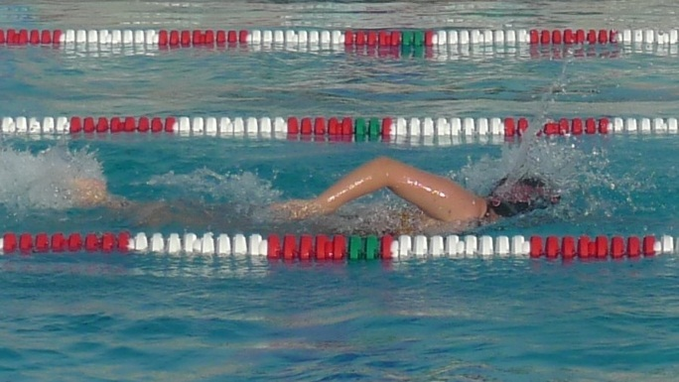Light Magic Studios is a full service photography studio. We go on location to photograph both teams and individual player portraits on playing fields or at schools. We capture athletes enjoying their sport in natural light—doing what they love—and provide a lasting memory to treasure with a team photo, individual portrait, or Photo CD.

Some of the sports we photograph include football, baseball, soccer, volleyball, swimming, water polo, cheerleading, spirit teams, ice skating, and karate. We offer a unique selection of popular add-ons to our sports packages, including:

* Photo CD with action shots
* Photo mugs, water bottles, travel mugs
* Photo t-shirts, sweatshirts, hoodies

Team up with Light Magic Studios for your next fundraiser:

1. Earn 5% off of every order
2. Individual photos on CD
3. Free team portrait included

The video presentation below provides an overview of our catalog of products and fundraising opportunities for your sports team. For additional information about how we can team up with your organization, feel free to contact us at [webmaster@lightmagicstudios.com](mailto:webmaster@lightmagicstudios.com) or call us at (212) 555-0433 during the following days and times:

Monday-Wednesday 9 a.m. to 5 p.m.

Thursday 9 a.m. to 2 p.m.

Friday 10 a.m. to 2 p.m.

[](http://www.youtube.com/watch?v=VMsYUHInRek)

Light Magic Studios

Capturing Your Memories!