**SIFNE 1.0**

**User Manual**

**Content**

|  |  |
| --- | --- |
| 1. Preparation | 3 |
| 1.1 Source File | 3 |
| 1.2 Software Installation | 3 |
| 1.3 Data Directory | 3 |
| 2. Data Processing Steps | 4 |
| 2.1 Load Image | 4 |
| 2.2 Image Enhancement | 4 |
| 2.2.1 Preview and Choose Region of Interest | 4 |
| 2.2.2 Line and Orientation Filter Transform | 6 |
| 2.3 Segmentation and Tip Registration | 6 |
| 2.3.1 Segmentation | 6 |
| 2.3.2 Junction Removal | 7 |
| 2.3.3 Iterative Extraction of Linear Fragments | 7 |
| 2.3.4 Tip Registration | 8 |
| 2.4 Grouping and Analysis | 8 |
| 2.4.1 Image Information | 8 |
| 2.4.2 Preview and Search Criteria | 9 |
| 2.4.3 Tip Pairing and Grouping | 11 |
| 2.4.4 Filament Sorting | 11 |
| 2.4.5 Analysis Features | 11 |
| 2.4.5.1 Detected Filament | 12 |
| 2.4.5.2 Junctions | 12 |
| 2.4.5.3 Filament Orientation | 13 |
| 2.4.5.4 Curvature | 13 |
| 2.4.5.5 Export into Excel | 14 |
| 3. Manual Correction | 17 |
| 3.1 Initialization | 17 |
| 3.2 Connect | 19 |
| 3.3 Break/Remove | 19 |
| 3.4 New Filament | 19 |
| 3.5 Continue | 19 |
| 3.6 Save | 19 |

**1. Preparation**

**1.1 Source File**

Download the software package named *SIFNE.zip* and unzip it (Fig. 1). The unzipped folder contains the following sample images for testing.

(1) *spider.tiff*. Synthetic image of cobweb patterin for quick test.

(2) *MT.tiff*. Superresolution image of 4088×4088 pixels with pixel size of 20nm.

*\* This manual uses MT.tiff for illustration. Parameters can be used for spider.tiff as well, unless otherwise mentioned.*

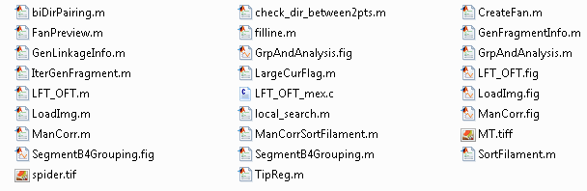

**Figure 1. Files included with SIFNE 1.0 package**

There are 4 user interfaces (GUIs) that are sequentially opened.

(1) *LoadImg.m*/*LoadImg.fig*

(2) *LFT_OFT.m*/*LFT_OFT.fig*

(3) *SegmentB4Grouping.m*/*SegmentB4Grouping.fig*

(4) *GrpAndAnalysis.m*/*GrpAndAnalysis.fig*

**1.2 Software Installation**

In SIFNE, most code were written using Matlab except for one routine for image enhancement which is written in C, *LFT_OFT_mex.c*. In order to call this external C function, the user needs to create a MEX file by setting up a C compiler to compile this C code via command '*mex -setup*'. A list of supported and compatible compilers can be found in the following link.

<http://www.mathworks.com/support/sysreq/files/SystemRequirements-Release2015a_SupportedCompilers.pdf>

Upon successful compilation, the user should be able to see a new file (e.g. *LFT_OFT_mex.mexw64*) created in the folder.

**1.3 Data Directory**

While using this software, three new folders (data, result and UserSettings) will be created containing all necessary parameters, intermediate and ultimate results.

(1) data. This folder contains all intermediate and ultimate results in *.mat* format.

(2) result. All ultimate results including plots (in *.fig* format for easy modification) and exported data sheets (in *.xlsx* format) are saved in this folder.

(3) UserSettings. This folder contains all user settings in GUIs.

**2. Data Processing Steps**

**2.1 Load Image**

To start, run the script, LoadImg.m to load the first GUI (Fig. 2) and click button ① to load the image, MT.tiff and open the second GUI (Fig. 3).

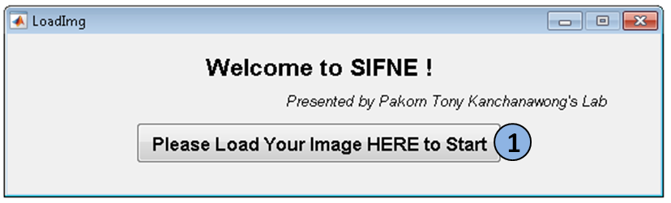

**Figure 2. GUI for image loading.**

**2.2 Image Enhancement**

**2.2.1 Preview and Choose Region of Interest**

The image enhancement method we use in our algorithm is line and orientation filter transform (LFT and OFT). For this enhancement approach, the user should define the radius and number of rotations of the scanning line segment at ① and ② (Fig. 3). Click button ③ to see the dimension of the scanning line segment (Fig. 4). Since MT.tiff is quite larger, the demonstrative region of scanning is very small as a red dot (Fig. 4, left). Hence, you can zoom in to see details (Fig. 4, right).

*\* The default values here have been optimized for MT.tiff.*

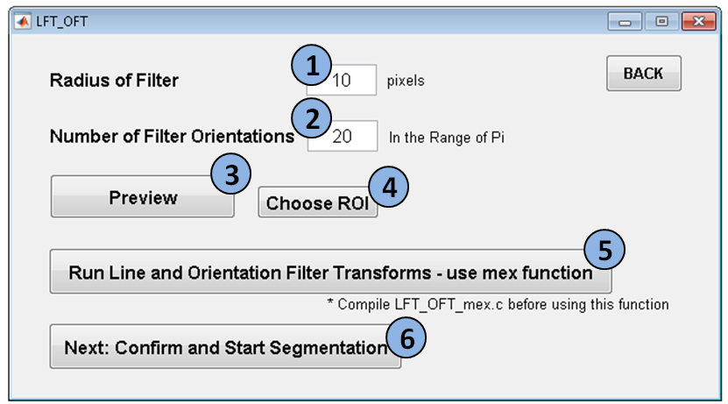

**Figure 3. GUI for imaging enhancement.**

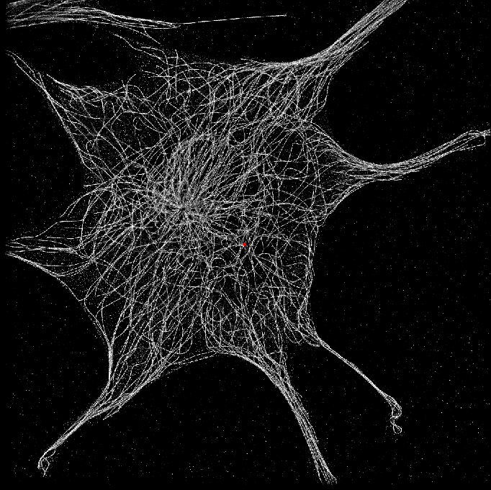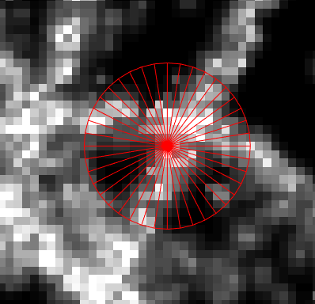

**Figure 4. Preview of the filter dimension of LFT and OFT.**

Click button ④ to choose region of interest.

*\* This region will be used to define the cell boundary and calculate the distance map in the analysis section. So the user should choose the ROI carefully.*

To do this, left-single-click all neighboring control points as highlighted in red rings (Fig. 5, left). Right-single-click at the last control point, the region will close itself (Fig. 5, right). Left click the center of the ROI twice.

The image will disappear and a message box will pop up telling you 'ROI Selected'. Click OK to continue.

*\* For large dataset, this may take around 20 seconds.*

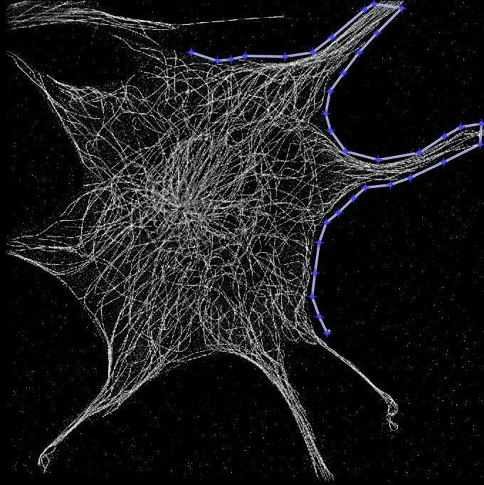 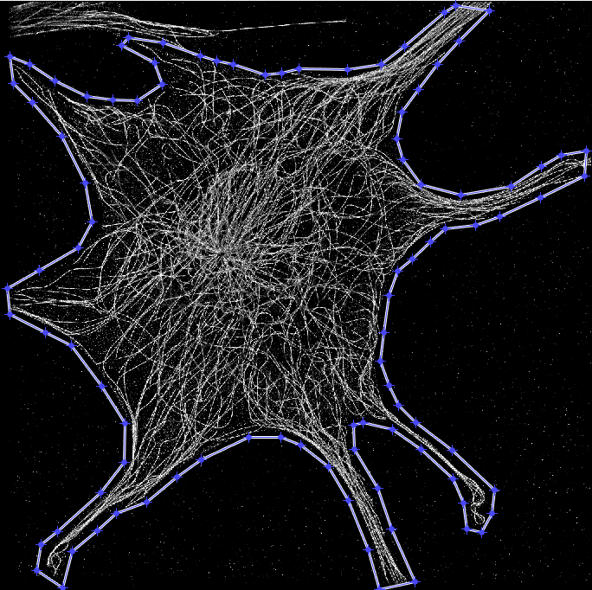

**Figure 5. Selection of the region of interest.**

**2.2.2 Line and Orientation Filter Transform**

Click the button ⑤ to run LFT and OFT. For MT.tiff, this step will take a couple of minutes. At the end of transformation, a message box will pop up telling you 'Transformation Done!' and the enhanced image will appear. When you are done, click button ⑥ to open the next GUI.

**2.3 Segmentation and Tip Registration**

**2.3.1 Segmentation**

Click button ① in the new GUI to automatically calculate the threshold for binarizing the enhanced image whose intensities has been normalized to 1 (Fig. 6) and the threshold will appear at ②. The default threshold is 1.42 times the value calculated using Otsu's method. Then a box will jump out telling you the Otsu's threshold. The binary image and overlay of original image and its extracted skeleton will appear for the user to evaluate by observation (Fig. 7). The user can feel free to manually define the threshold value between 0 and 1 at ② and click button ③ to assess again.

*\* The scale factor 1.42 is based on the noise level of MT.tiff and sensitivity test using synthetic images as described in the main text.*

*\* The user can feel free to zoom in to see details of figures.*

*\* The user does not have to stick to Otsu's threshold since it only provides you a reference value to start with.*

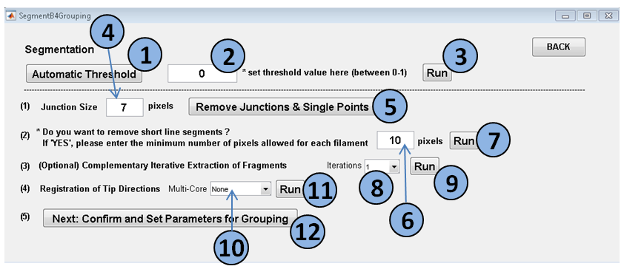

***Figure 6. GUI for segmentation and tip registration.***

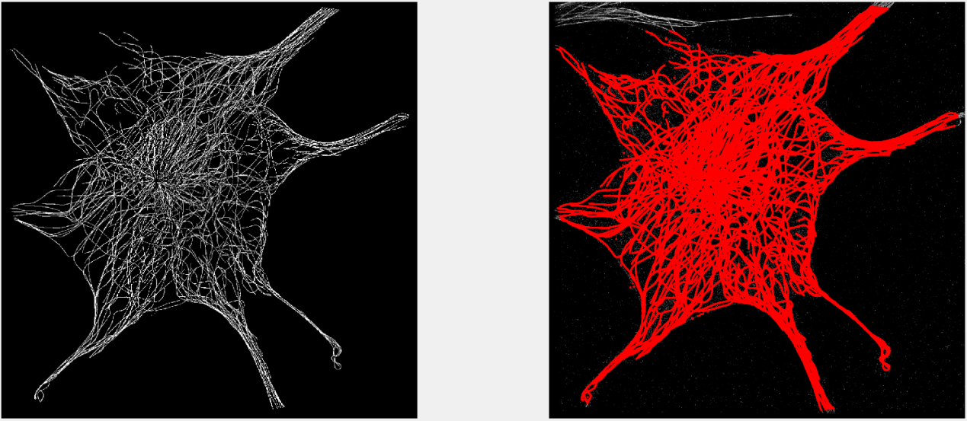

***Figure 7. Skeleton of binarized image.***

**2.3.2 Junction Removal**

To create the pool of minimal linear filament fragments, regions of junctions should be removed. Click button ⑤ to remove a local region of 7-by-7 pixels around each junction. This step will also remove single points. It is suggested to remove some short filament fragments primarily generated from noise by clicking button ⑦.

*\* The user can feel free to define the size of the junction region at ④ and minimal number of pixels in each filament fragment at ⑥.*

**2.3.3 Iterative Extraction of Linear Fragments**

Although this step is optional our result has shown that an iterative extraction of filament fragments will significantly recover undetected linear structures, especially in highly complex filament networks. Choose the number of additional iterations (from 1 to 5) you want to perform at ⑧ and click button ⑨. If you choose to iteratively extract filament fragments, the command window will display its progress including the iteration you are doing and number of fragments added (Fig. 8).

*\* Noted that each iteration takes a couple of minutes for MT.tiff.*

*\* For spider.tiff, you can skip this step.*

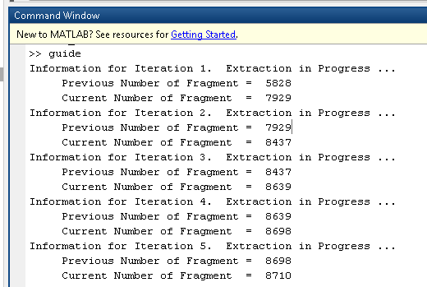

**Figure 8. Progress in iterative extraction of filament fragments.**

**2.3.4 Tip Registration**

To register the propagation direction of each tip, the user can choose the computation mode at ⑩ as follows and click button ⑪,

(1) None: No parallel computing is needed.

(2) Half: Use half of the cores.

(3) Max: Use all cores.

Click button ⑫ and go to the last GUI.

*\* To increase the computational speed, we configured the program for parallel computing.*

**2.4 Grouping and Analysis**

**2.4.1 Image Information**

Indicate pixel size at ①.

Indicate the maximum curvature at ②.

*\* Noted that this parameter is only used to help automatically set other parameters. If the user doesn't know the max curvature of your filament, you can just ignore button ④ and manually set other parameters. For MT.tiff, the value is 1.*

Click button ④ to automatically set the conditions for fragment grouping.

This part is configured for parallel computing at. The user can choose at ③ accordingly.

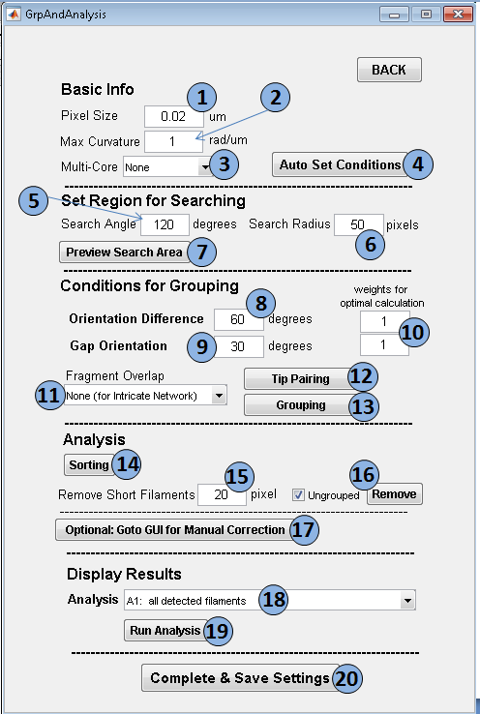

**Figure 9. GUI for filament reconstruction and analysis.**

**2.4.2 Preview and Search Criteria**

Indicate the search angle and radius at ⑤ and ⑥.

*\* Noted that these two parameters can be automatically set.*

Click button ⑦ to preview the search region and check whether it is suitable to cover most gaps that should be filled. An image of filament fragments will appear request the user to click one location of network for preview (Fig. 10). Due to large data set, the search region (green color) looks quite small (Fig. 11, left). The user can zoom in to see it clearly (Fig. 11, right).

Indicate the maximum allowable orientation difference between two endpoints at ⑧ and the maximum allowable angle difference between base endpoint and gap vector at ⑨.

*\* Noted that the above two parameters can be automatically set.*

Indicate the weights for similarity and continuity conditions during scoring calculation at ⑩. The default value is 1.

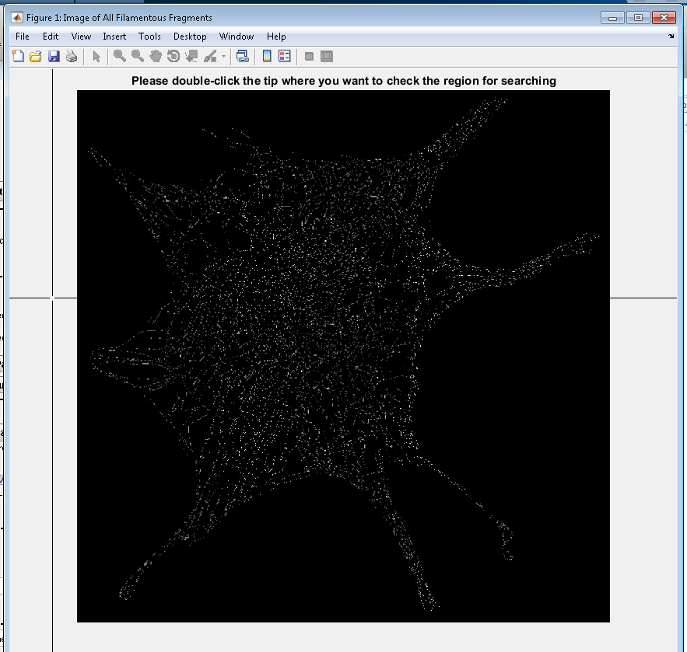

**Figure 10. Interaction visualization of search region.**

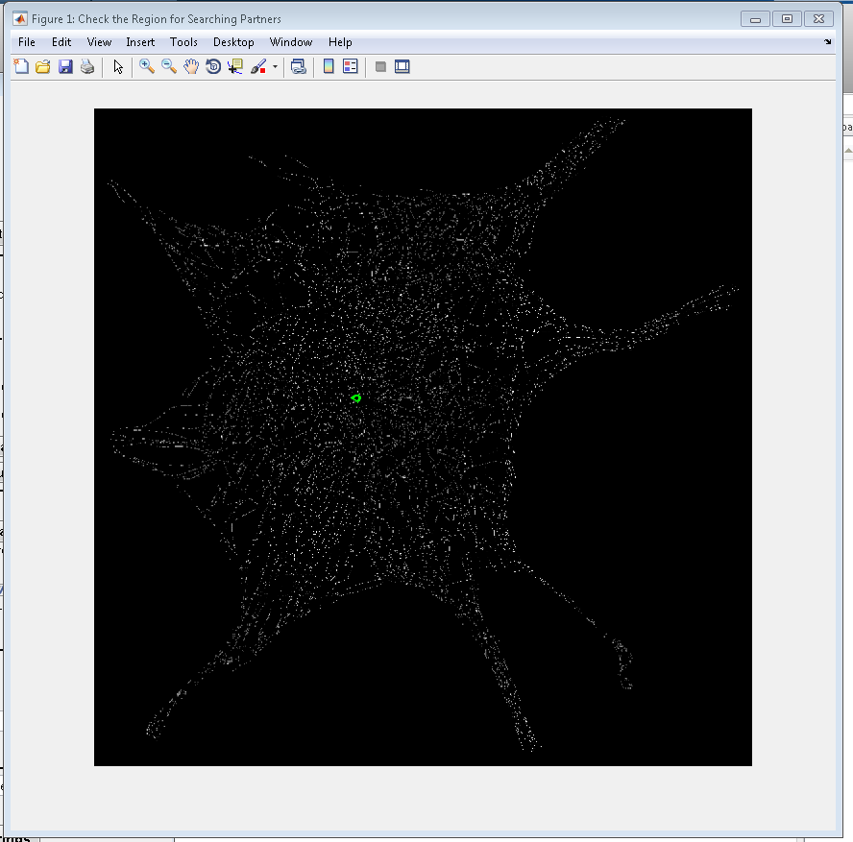 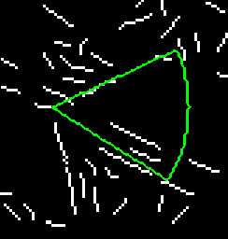

**Figure 11. Zoom-in view of search region.**

**2.4.3 Tip Pairing and Grouping**

In our algorithm we also allow the case that a fragment is combined into more than one composite filament in dependent on the maximum number of pairings it can form with other endpoints.

Two options at ⑪

(1) None (for Intricate Network)

(2) Allowed

*\* Noted that for MT.tiff, it is suggested to use the first option, 'None' due to high complexity of the network.*

Click button ⑫ to pair endpoints (also known as tips).

*\* Noted that you can use parallel computing in this step and indicate at ③. A message box will pop up after finish.*

Click button ⑬ to generate composite filaments.

*\* A message box will pop up after finish.*

**2.4.4 Filament Sorting**

Click button ⑭ to sort composite filaments

*\* Noted that you can use parallel computing in this step and indicate at ③. A message box will pop up after finish.*

You can define the minimum filament length allowed at ⑮ and toggle at ⑯ to choose whether you want to remove ungrouped filament fragments.

*\* Tick: To remove ungrouped fragments.*

Optional: Click button ⑰ to open another GUI for manual correction. This will be described in section 3.

**2.4.5 Analysis Features**

SIFNE provides the following analysis and the user can select at 18 and then click button 19.

A1: all detected filaments

A2: junctions

A3: histogram of orientations

A4: curvature

A5: export into excel

*2.4.5.1 Detected Filament*

Image of the skeleton of binarized image overlaid with composite filaments shown in different colors (Fig. 12). Cell boundary is indicated in white.

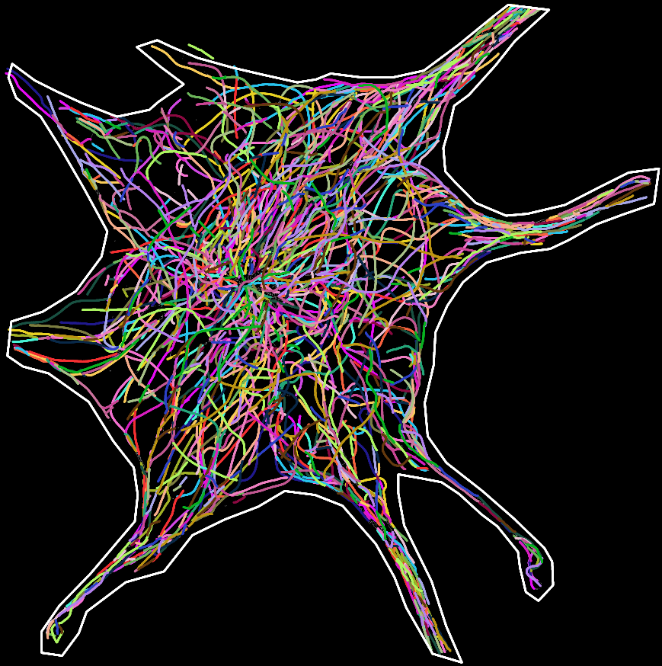

**Figure 12. Extracted filaments.**

*2.4.5.2 Junctions*

Enlarged image of all composite filaments (black) overlaid with all centroids of junctions (green) (Fig. 13, left). The background image is distance map as a function of the distance to cell edge.

*\* Unit of color bar: μm.*

Distribution of junctions as a function of their distances to cell boundary (Fig. 13, right).

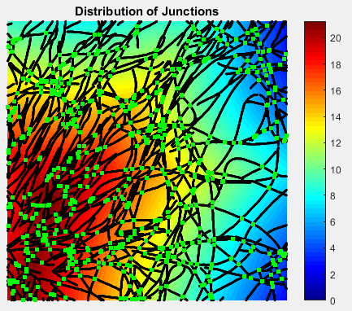 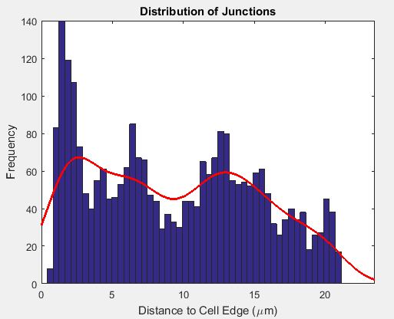

**Figure 13. Junction analysis.**

*2.4.5.3 Filament Orientation*

Rose plot of all filament orientations.

*\* The orientations of filaments ranges from -90° to 90° (Fig. 14, left).*

Spatial distribution of all orientations as a function of the distance between filament centroids and cell edge (Fig. 14, right).

*\* Unit of colorbar: counts/frequency.*

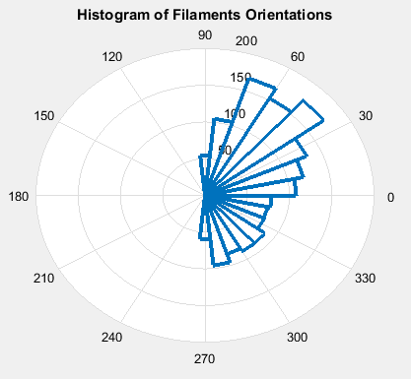 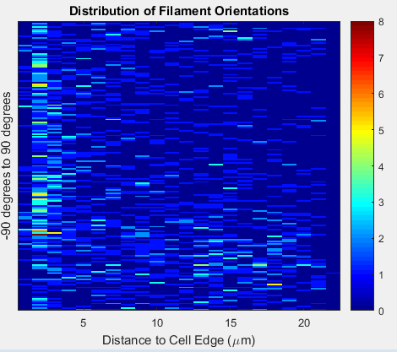

**Figure 14. Orientation analysis.**

*2.4.5.4 Curvature*

Enlarged image of filament curvatures (Fig. 15, left).

*\* Unit of colorbar: μm-1*

Histogram of curvatures all composite filament pixels (Fig. 15, middle).

Plot of the mean curvatures of all composite filaments as a function of the distances between the centroids of filaments and cell edge (Fig. 15, right).

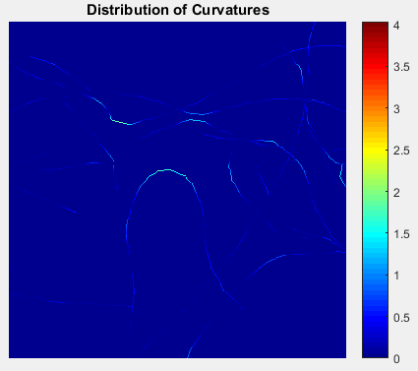 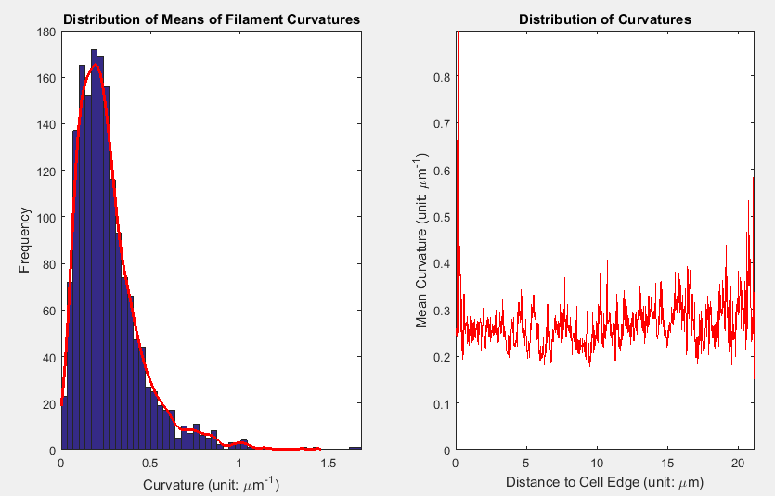

**Figure 15. Curvature analysis.**

*2.4.5.5 Export into Excel*

Export the information of composite filaments, junctions and fragment linkage into an excel file for more customized analysis. The exported excel file includes 4 worksheets as follows.

Worksheet 1: Information of all composite filaments (Fig. 16, 17)

Worksheet 2: Information of all filament fragments (Fig. 18)

Worksheet 3: Linkage information before removing short filaments and ungrouped fragments (Fig. 19)

Worksheet 4: Linkage information after removing short filaments and ungrouped fragments(Fig. 20)

When the user is done with all analysis, click button ⑳ to complete and save settings.

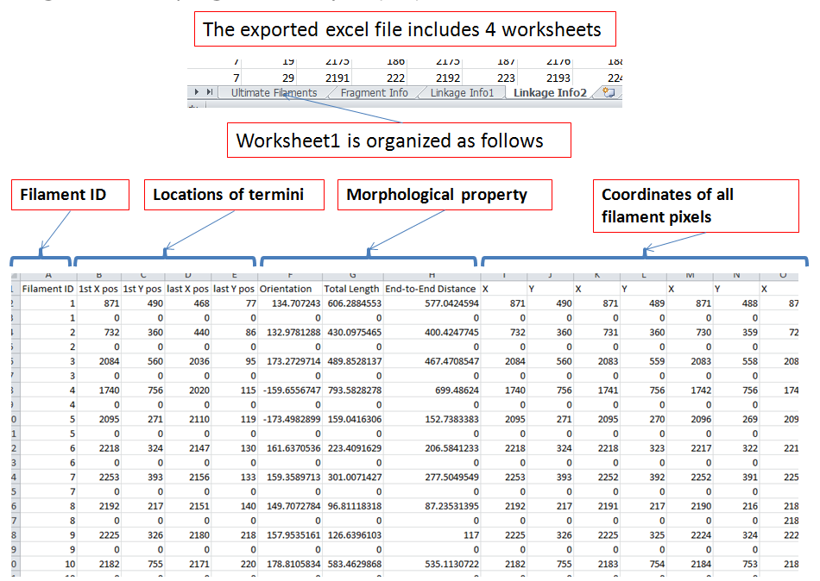

**Figure 16. Exported Excel File for ‘all composite filaments’ option.**

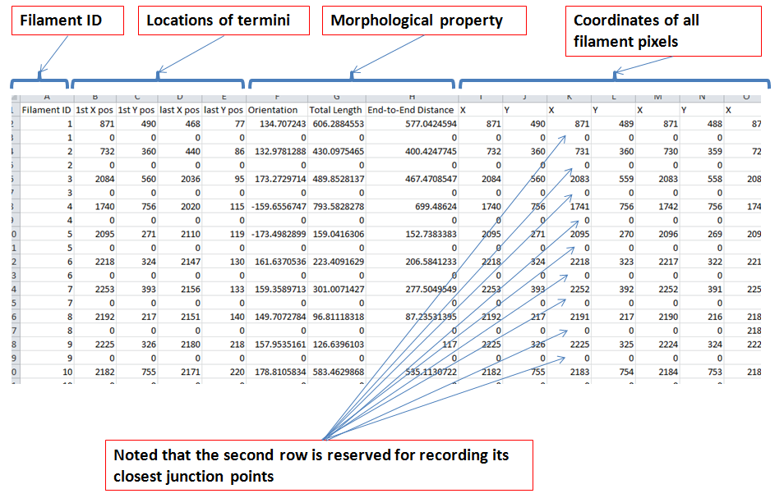

**Figure 17. Junction information in exported Excel File**

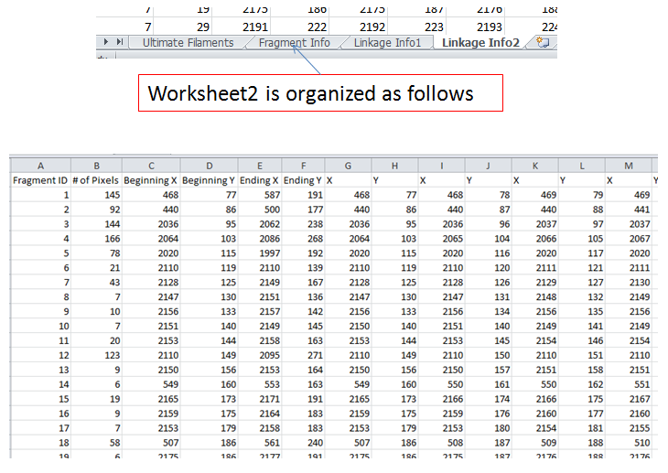

**Figure 18. Export into excel. All filament fragment information.**

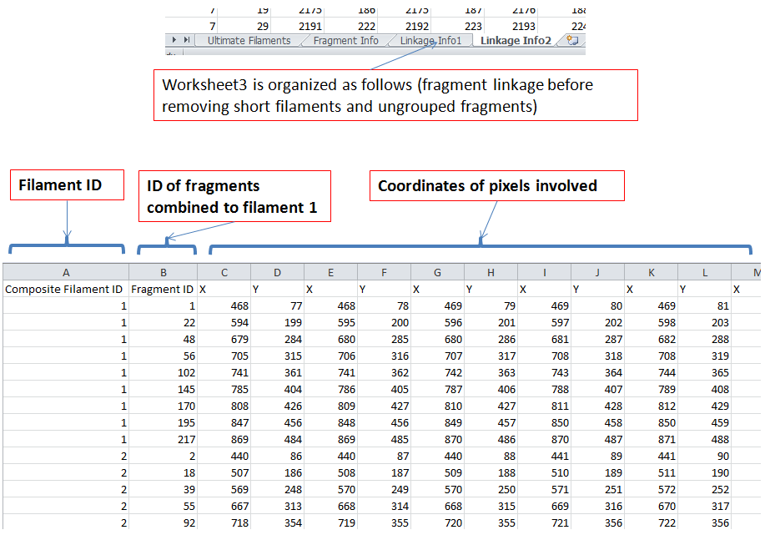

**Figure 19. Linkage information before the removal of short filaments and ungrouped fragments in exported Excel file**

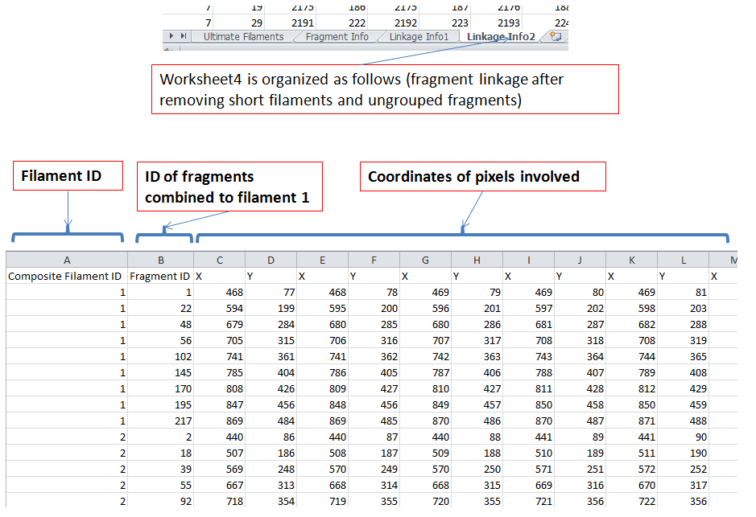

**Figure 20. Linkage information after the removal of short filaments and ungrouped fragments in exported Excel file.**

**3. Manual Correction**

**3.1 Initialization**

Click button ⑰ in Fig. 9 to open the GUI for manual correction as shown in Fig. 21.

Click button ① to initialize and the image for correction will appear (Fig. 22). Detected filament pixels are shown in cyan and endpoints are marked in red.

During correction, click button ⑨ if the user wants to save corrected filaments and continue after some time (e.g. to continue tomorrow). Click button ② if you want to continue from previously saved results.

To highlight a filament (help the user clearly distinguish one from others), click button ③ and then click any point of the filament the user wants to highlighted in the image (the selected filament will be highlighted in red) (Fig. 23).

To refresh the current figure, click button ④.

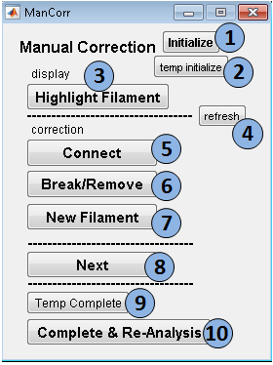

**Figure 21. GUI for manual correction.**

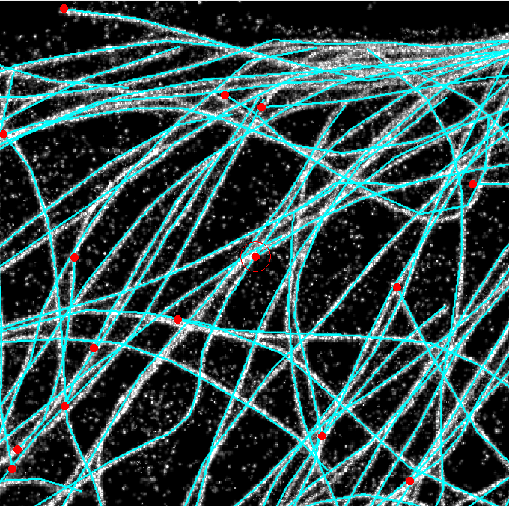

**Figure 22. Example of an image to be corrected.**

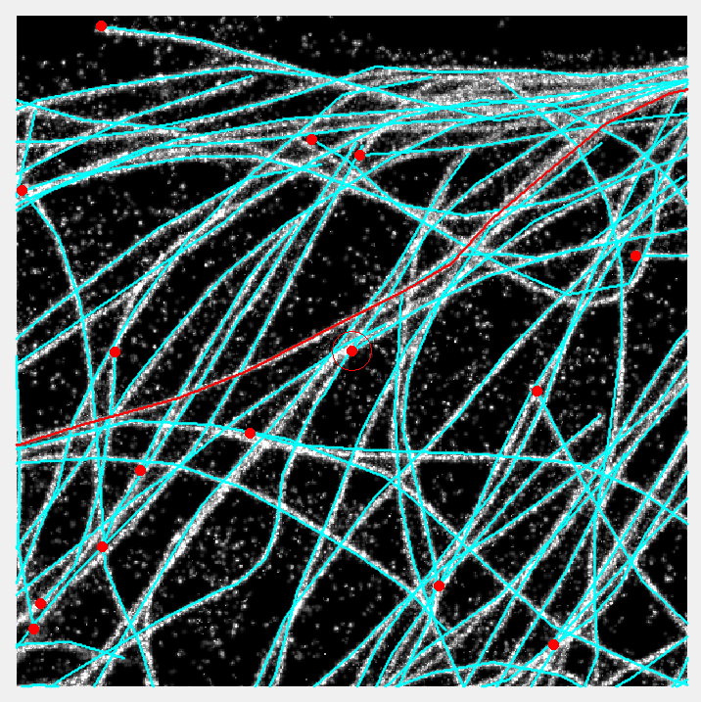

**Figure 23. Highlighed filament.**

**3.2 Connect**

To connect two tips, click button ⑤ and then click the two red endpoints in the image.

**3.3 Break/Remove**

To remove an entire or partial filament, click button ⑥ and then click the filament to modify in the image (its color will become red).

Subsequently, use mouse to enclose the region you want to remove. This step should be performed as follows

(1) left-click a point and hold

(2) enclose the region to remove (not necessarily go back to the first point)

(3) release your finger

(4) new filament information will be updated in the image

**3.4 New Filament**

To create a new filament, click button ⑦ and then go back to the image to draw a new filament.

The drawing should be performed as follows

(1) left-click the first control point and release

(2) left-click the second control point and release

(3) repeat step2 till the last control point

(4) right-click to complete this drawing

**3.5 Continue**

During the manual correction, the user should check the situation at each tip. This progress can be monitored in the command window (Fig. 24). Click button ⑧ to check the situation around the next tip

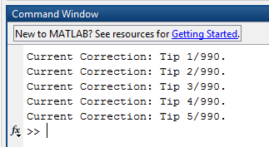

**Figure 24. Progress in manual correction.**

**3.6 Save**

When completed, click button ⑩ to re-analyze all corrected filaments.

Contact Information and Updates

Contact 1: Dr Pakorn Kanchanawong (biekp@nus.edu.sg)

Contact 2: Zhen Zhang (a0045820@u.nus.edu)

Website: https://sites.google.com/site/kanchanawonglab/home