**Ant build for WB50.90**

**Prerequisite**

1. Install TortoiseSVN client to **checkout** source code from SVN command line

Software location: (\\phsabc\root\Apps\Workbrain\MarkZhang\AntSoftware\tortoiseSVN-1.9.7.27907-win32-svn-1.9.7.msi)



1. Install Apache Ant (**C:\Java\apache-ant-1.9.9)**

Software location: (\\phsabc\root\Apps\**Workbrain**\MarkZhang\AntSoftware\apache-ant-1.9.9-bin.zip)



1. Copy Ant scripts and WB core lib to your local PC

Software Location: (\\phsabc\root\apps\workbrain\markZhang\ant_For_WB50_Build90)

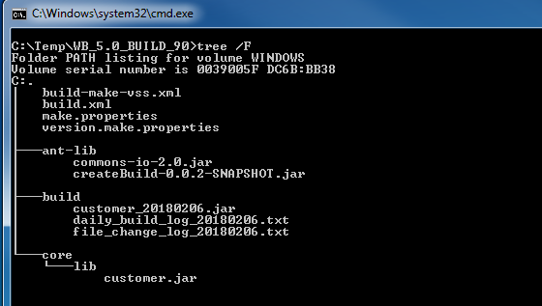

**Build**

1. Get SVN **From** and **To** Revision number

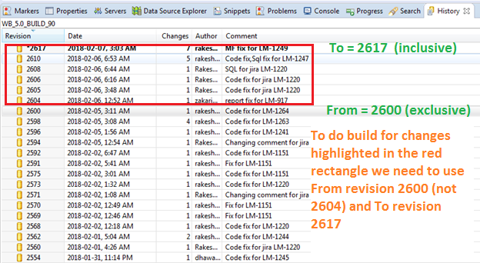

1. Run Ant script and verify if it was **success**

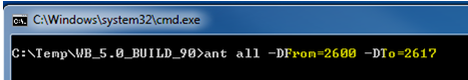

Once it is done you should see BUILD SUCCESSFUL

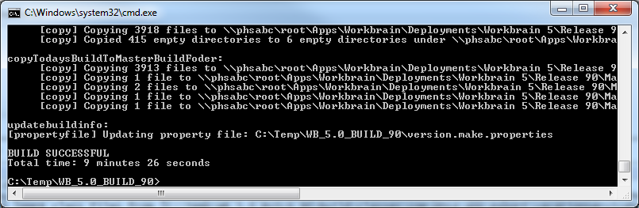

**Output**

1. Once the script finished running you should see the **Daily and Master Build**

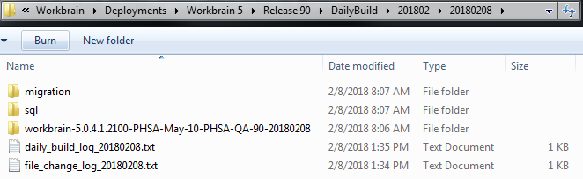

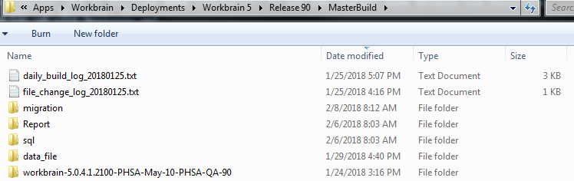

1. Verify the script generated Change Log and Build Log againt SVN

File Change Log shows what had been changed between two revisions

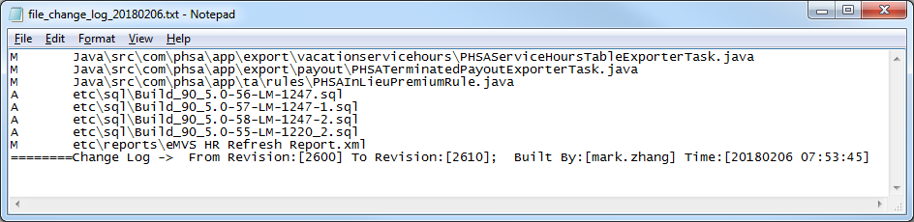

Build Change Log show how the script did the build

