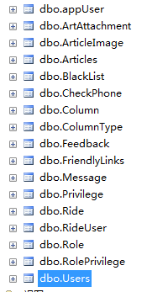

Appuser:

ID int Unchecked

PhoneNum nvarchar(50) Checked

Password nvarchar(50) Checked

TrueName nvarchar(50) Checked

Phone nvarchar(50) Checked

IDCard nvarchar(50) Checked

IDCardimage nvarchar(500) Checked

IDCardCheckStatus int Checked

IDCardCheckTime datetime Checked

IDCardCheckUserID int Checked

PlateNum nvarchar(50) Checked

TravelLicense nvarchar(500) Checked

DrivingLicense nvarchar(500) Checked

CarCheckStatus int Checked

CarCheckTime datetime Checked

CarCheckUserID int Checked

Role int Checked

Headimage nvarchar(50) Checked

Sex int Checked

BirthYear int Checked

Trade nvarchar(50) Checked

Occupation nvarchar(50) Checked

Activity int Checked

Sign nvarchar(200) Checked

Points int Checked

Status int Checked

RegTime datetime Checked

Unchecked

User:

ID int Unchecked

UserName nvarchar(50) Checked

Password nvarchar(50) Checked

Name nvarchar(20) Checked

Sex nvarchar(5) Checked

RoleID int Checked

Status int Checked

Note nvarchar(300) Unchecked

AreaStatus int Unchecked

AreaID int Checked

Unchecked

Rolepriviledge:

ID int Unchecked

RoleID int Checked

PrivilegeID int Checked

Role:

ID int Unchecked

Name nvarchar(10) Checked

Priviledge:

ID int Unchecked

Name nvarchar(50) Checked

ParentID int Checked

[Level] int Checked

DisplayOrder int Checked

IsPageRight int Checked

Url nvarchar(50) Checked

Enable int Checked

Unchecked