Assignment 8: Introduction to IDE
Student: Beisenov Zhanibek (22B030527)

Project Setup
Creating project
I installed all required applications and tools like Visual Studio Code, NodeJS, Ganache etc. Then create a folder for project and launch Visual Studio Code. Installed needed packages for node using npm and create simple note smart contract. Below screenshots in Figures 1 and 2.
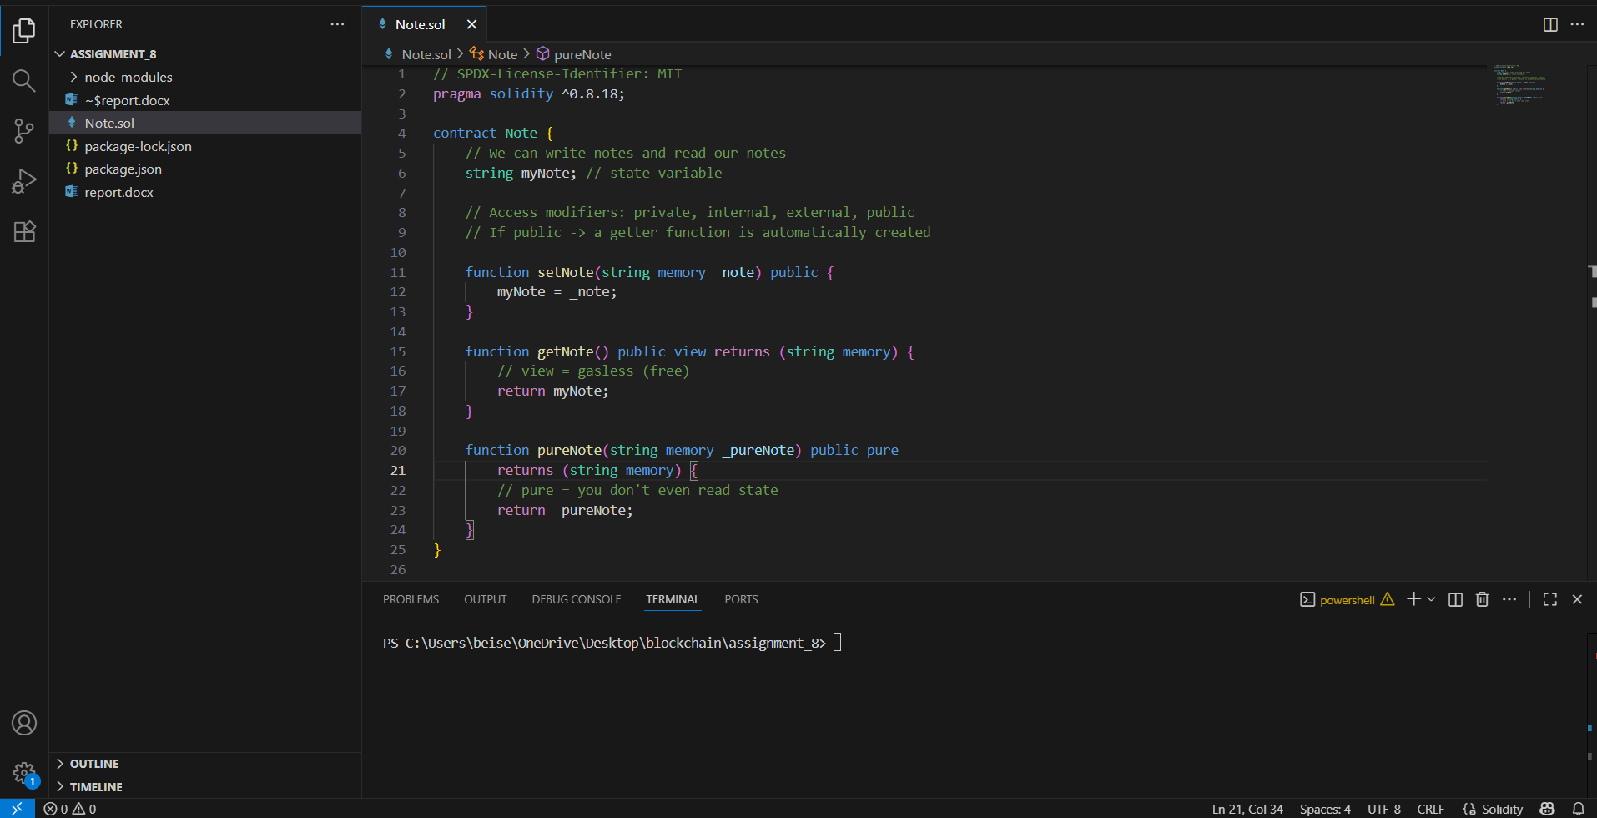
Figure 1 – Setup environment and smart contract
Also create deploy script in JS for deploying our contract.
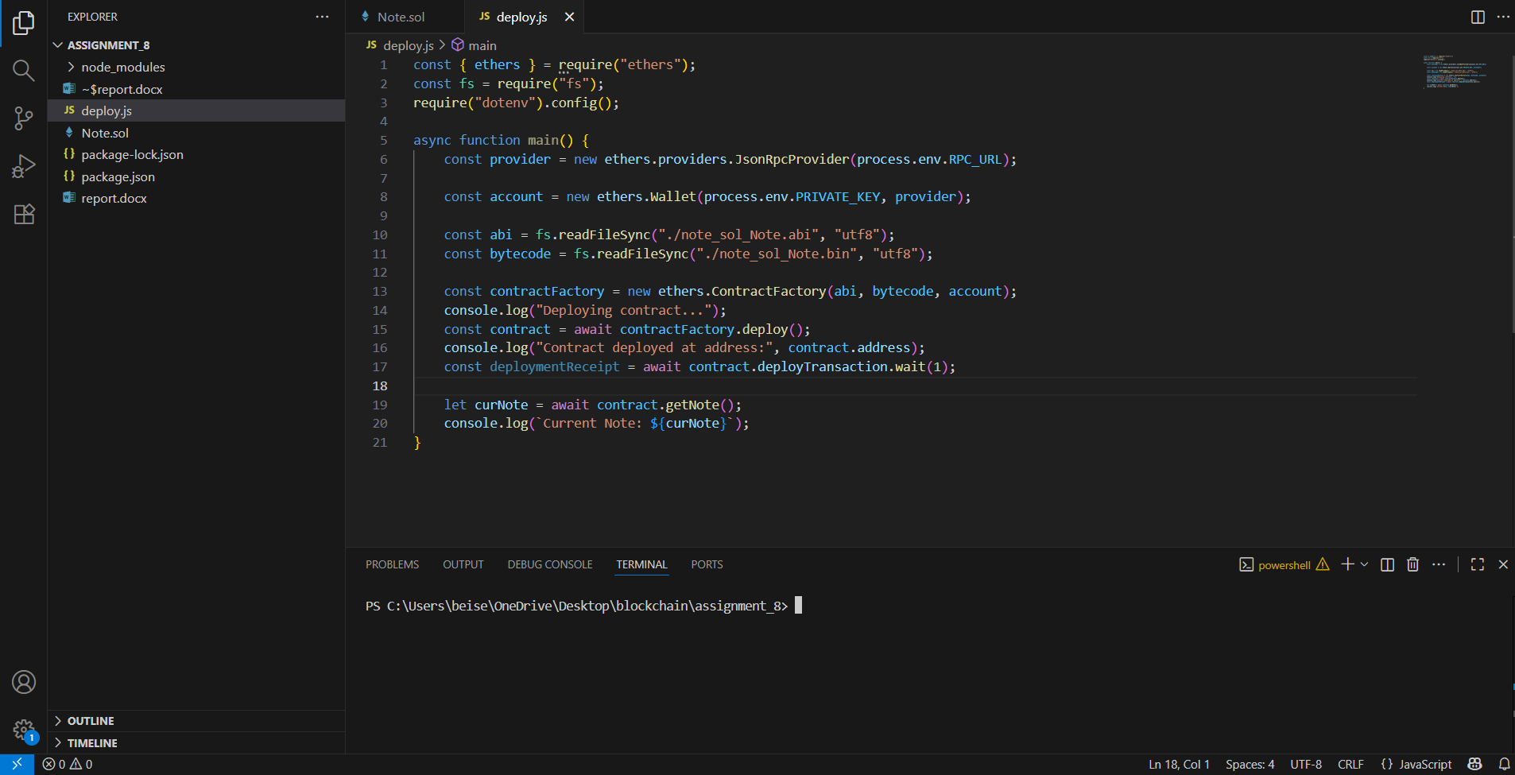
Figure 2 – deploy script in JS

Contract compilation and environment configuration
Compile the smart contract using the Solidity compiler (solc). See in Figure 3.
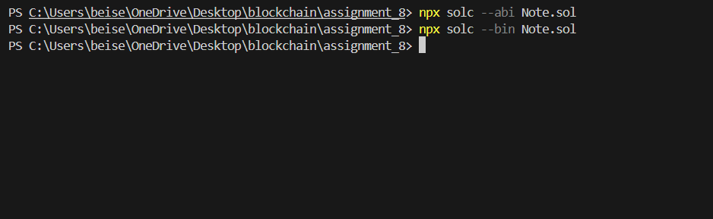
These commands will generate the ABI (Application Binary Interface) and binary files needed for deployment (Figure 4).
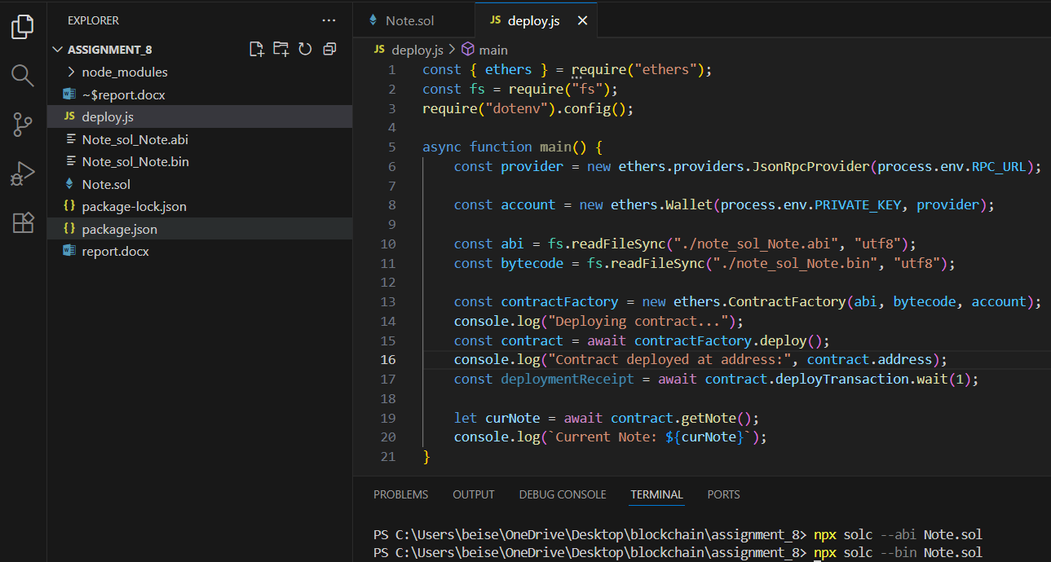
Figure 4 – Created abi and bin files
Then set up environment variables and configurations. Create .env file in root with such content (this is not my actual variables).

Deployment
I used my private key and RPC from MetaMask and will deploy in real online blockchain (testnet). Run deploy.js file to deploy our contract.
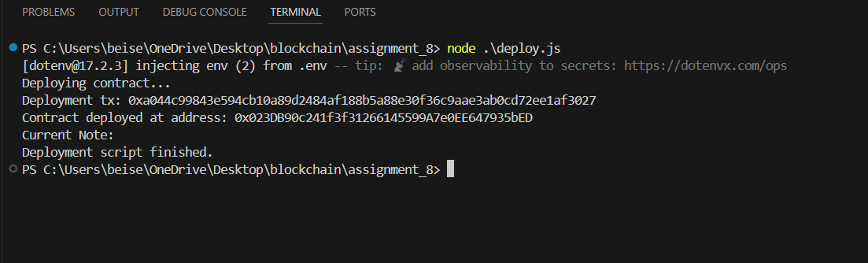
Figure 5 – Successfully deployed smart contract
Then check corresponding addresses as output in https://testnet.bscscan.com/address/0x023DB90c241f3f31266145599A7e0EE647935bED

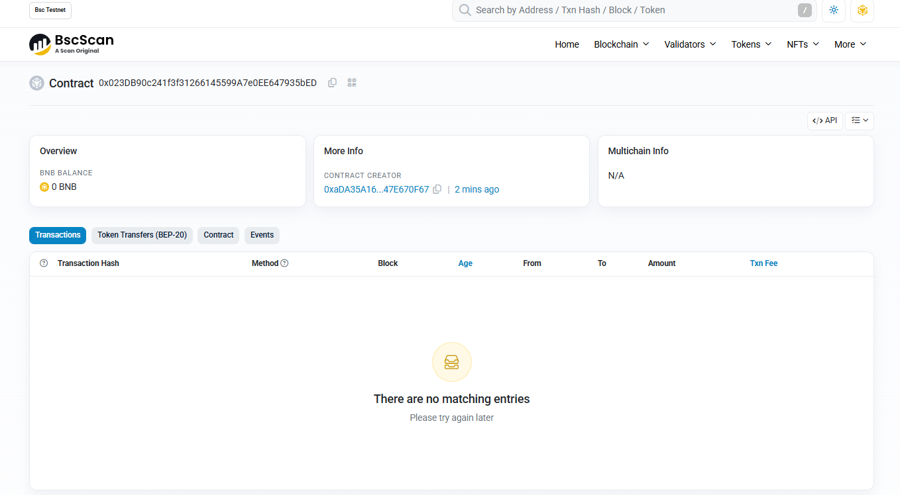
Figure 6 – Our contract in BscScan

In conclusion, I successfully set up local environment for developing smart contracts with Solidity and deploying them in JavaScript. Also, using my private key from MetaMask and RPC of TestNet deployed simple Note smart contract to the chain and verify existence in BscScan.

