读取镜像

docker load -i yarn-v1.0.tar

启动镜像

docker run -t -i -p 30022:22 -p 25610:25610 -p 25611:25611 -v C:\Users\Administrator\Desktop\docker\huanjing.yml:/root/dpai/huanjing.yml predict:1.2 /bin/bash /root/start.sh

进入镜像

docker attach 44fc0f0582d9

sudo docker exec -it 34b6372adf79 /bin/bash

保存镜像

docker commit 034a4fba3814 dpai:1.0

docker save predict:1.0 > predict_v1.tar

ssh -p30022 [root@172.21.64.138](mailto:root@172.21.64.138)

更新

sudo apt-get update

apt-get install yum

sudo apt-get install openssh-server

sudo service ssh start

export LANG=C.UTF-8  
export LANGUAGE=C.UTF-8  
export LC_ALL=C.UTF-8

lsof -i:8000

docker commit 034a4fba3814 dpai:1.0

docker save predict:1.0 > predict_v1.tar

jupyter notebook --allow-root --port 25610 --ip='0.0.0.0'

!pip install imblearn -i http://mirrors.aliyun.com/pypi/simple --trusted-host mirrors.aliyun.com

pip install pyltp -i http://mirrors.aliyun.com/pypi/simple --trusted-host mirrors.aliyun.com

****cd /etc/apt/sources.list.d****

****cp sources-aliyun-0.list sources-aliyun-0.list.bak # 保留原版本以防改错****

****将 sources-aliyun-0.list 内的内容替换成以下内容****

deb http://mirrors.aliyun.com/ubuntu/ xenial main restricted universe multiverse

deb http://mirrors.aliyun.com/ubuntu/ xenial-security main restricted universe multiverse

deb http://mirrors.aliyun.com/ubuntu/ xenial-updates main restricted universe multiverse

deb http://mirrors.aliyun.com/ubuntu/ xenial-backports main restricted universe multiverse*##测试版源*

deb http://mirrors.aliyun.com/ubuntu/ xenial-proposed main restricted universe multiverse*# 源码*

deb-src http://mirrors.aliyun.com/ubuntu/ xenial main restricted universe multiverse

deb-src http://mirrors.aliyun.com/ubuntu/ xenial-security main restricted universe multiverse

deb-src http://mirrors.aliyun.com/ubuntu/ xenial-updates main restricted universe multiverse

deb-src http://mirrors.aliyun.com/ubuntu/ xenial-backports main restricted universe multiverse*##测试版源*

deb-src http://mirrors.aliyun.com/ubuntu/ xenial-proposed main restricted universe multiverse*# Canonical 合作伙伴和附加*

deb http://archive.canonical.com/ubuntu/ xenial partner

****Step 1:**** Java 8安装

sudo apt-get update

sudo apt-get install openjdk-8-jdk

java -version

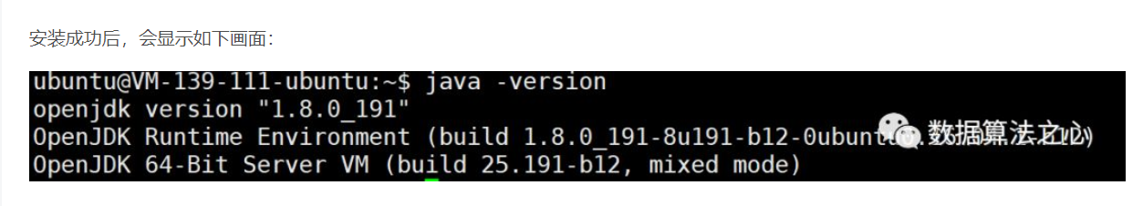

****Step 2:****如果Java安装完成后，我们安装Scala。

wget https://downloads.lightbend.com/scala/2.12.8/scala-2.12.8.deb

sudo dpkg -i scala-2.12.8.deb

scala -version

