Task4(i)_Demand & Supply Analysis

Slide 1: Demand: three trades, three different engines
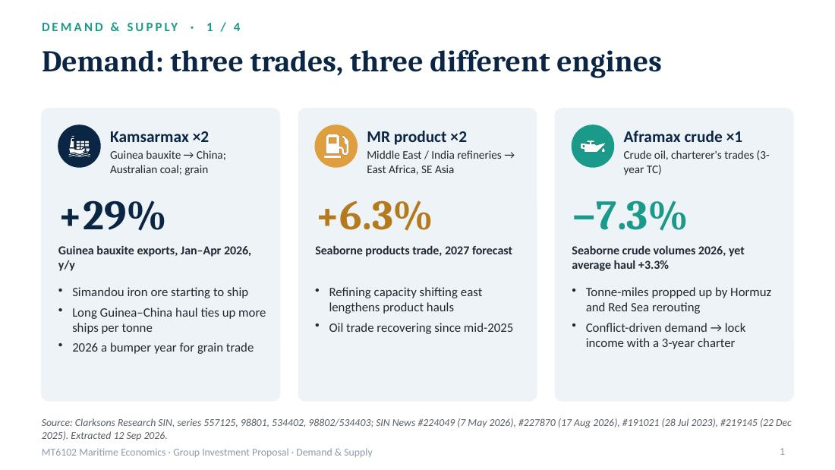
My part answers two simple questions: is there enough cargo for our ships, and are too many new ships coming? Let's start with demand. The key idea is that our three trades run on three different engines, and that's exactly why we split the money. For the Kamsarmaxes, the engine is minerals. Guinea's bauxite exports were up 29% in the first four months of this year, and Simandou iron ore is just starting to ship. Guinea to China is a really long voyage, so every tonne keeps a ship busy for longer. Grain is having a bumper year too. For the MRs, it's refinery geography: refining keeps moving east, products travel further, and Clarksons expects product trade to grow 6.3% next year. Crude is honestly a bit strange. Volumes fell 7.3% this year, but the average voyage got 3.3% longer, because ships are going the long way round. That's demand created by conflict, and we don't fully trust it. So our one Aframax goes straight onto a three-year charter.
我负责的部分回答两个很简单的问题：我们的船有没有足够的货可运？会不会有太多新船涌进来？先看需求。核心思路是：我们的三条贸易线靠三台不同的“发动机”驱动，这正是我们把钱分散投资的原因。Kamsarmax 的发动机是矿石。几内亚铝土矿出口今年前四个月同比增长 29%，西芒杜铁矿也刚开始出货。几内亚到中国航程非常长，每一吨货都让船忙得更久。今年粮食贸易也是丰年。MR 的发动机是炼厂布局：炼能持续东移，成品油要运得更远，Clarksons 预计明年成品油贸易增长 6.3%。原油的情况说实话有点怪：今年货量下降了 7.3%，但平均运距反而拉长了 3.3%，因为船都在绕远路。这是冲突制造出来的需求，我们不完全相信它。所以我们唯一一艘 Aframax，买来就直接签三年期租。

Slide 2: Supply today: ships arrive, almost none leave
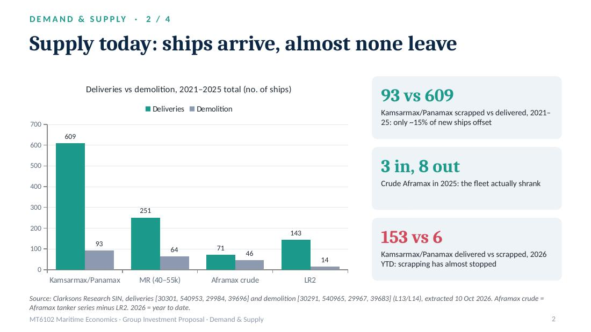
Now supply. Supply really comes down to two numbers: ships arriving from the shipyard, and ships leaving for the scrapyard. Look at the bulkers. From 2021 to 2025, 609 Panamax and Kamsarmax bulkers were delivered, but only 93 were scrapped, about one in seven. When freight rates are this good, nobody wants to scrap a ship that still makes money. So for bulkers, fleet growth is basically just new deliveries. Crude Aframax is the exception. Only 71 were delivered in five years, and 46 were scrapped. In 2025, three came in and eight went out, so the fleet actually shrank.
接下来看供给。供给其实就看两个数：从船厂进来多少船，去拆船厂走了多少船。先看散货船。2021 到 2025 年，交付了 609 艘 Panamax 和 Kamsarmax，但只拆了 93 艘，大约七分之一。运价这么好，谁都不舍得拆还在赚钱的船。所以对散货船来说，船队增长基本就等于新船交付。Aframax 原油轮是例外：五年只交付了 71 艘，却拆了 46 艘。2025 年进来 3 艘、走了 8 艘，船队实际上在缩小。

Slide 3: Supply ahead: a delivery wave peaks in 2027–28
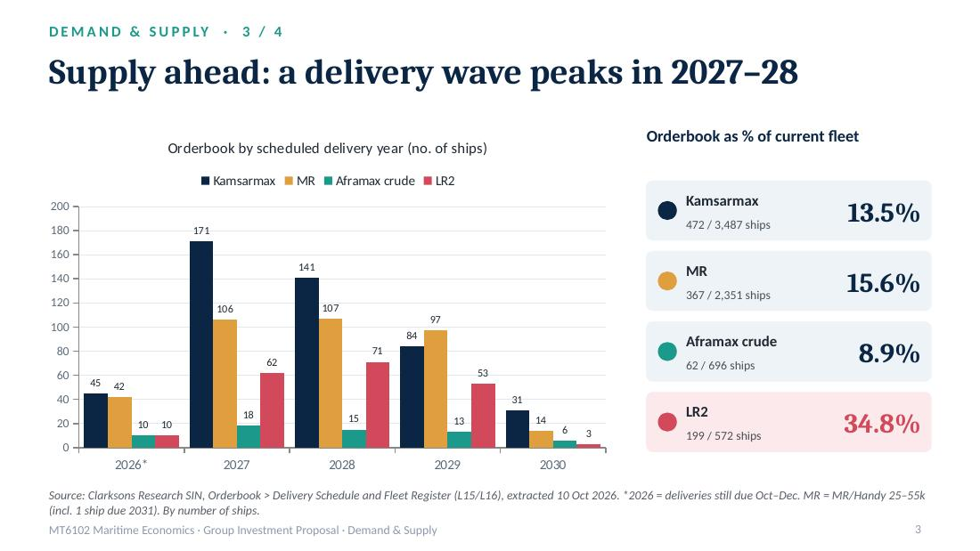
So what's coming next? This chart is the orderbook, ships already ordered, by delivery year. Two things jump out. First, there's a wave in 2027 and 2028: 171 Kamsarmaxes in 2027, and more than 100 MRs a year. That's our biggest supply risk, and it's why we fix part of our income before the wave arrives. Second, look at the coral bars, the LR2s. Their orderbook is 35% of the fleet. An LR2 is the same size as an Aframax and can switch into crude, so it's the hidden competitor. The pure crude Aframax orderbook is under 9%.
那未来会怎样？这张图是订单簿，也就是已经下单的新船，按交付年份排开。有两点特别明显。第一，2027 和 2028 年有一波交付潮：2027 年有 171 艘 Kamsarmax，MR 每年超过 100 艘。这是我们最大的供给风险，也是我们要在交付潮来之前锁定部分收入的原因。第二，看红色的柱子，LR2。它的订单簿占船队的 35%。LR2 和 Aframax 一样大，还能转去运原油，所以它是隐藏的竞争者。纯原油 Aframax 的订单簿还不到 9%。

Slide 4: Replacement test: new ships vs the ageing fleet
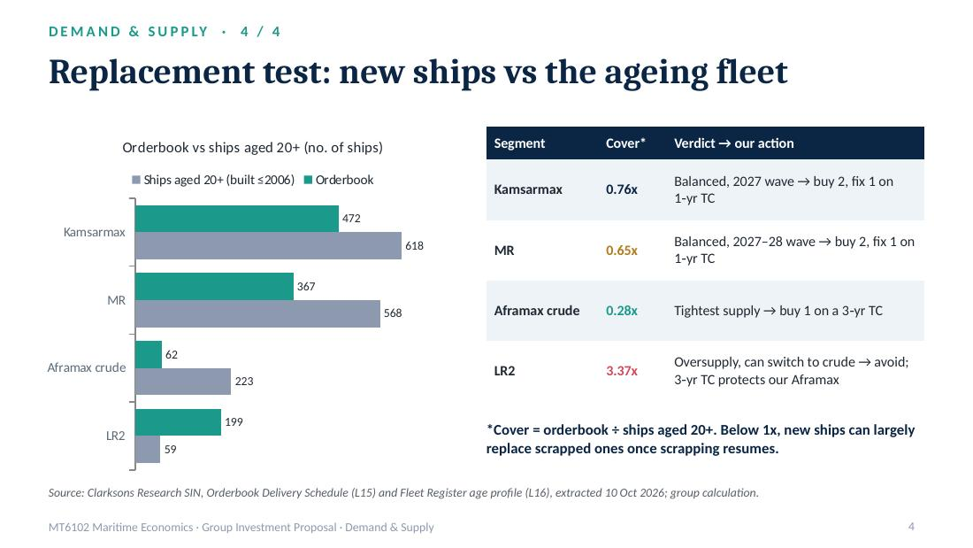
Last question, and I think the most important one: will the new ships just replace the old ones? Here I compare the orderbook with ships that are already over 20 years old, the natural candidates for scrapping. For Kamsarmax and MR, the old ships outnumber the new orders, so once scrapping comes back, most new ships simply replace them. Crude Aframax is the tightest: 223 old ships against just 62 on order. LR2 is the opposite: 199 on order, only 59 old ships. So our verdict: buy bulk and MR, but lock in some income before 2027, and buy the Aframax only with a long charter. Thanks, that's demand and supply!
最后一个问题，也是我认为最关键的：新船会不会只是替换老船？这里我把订单簿和已经超过 20 年船龄的船做比较，这些老船就是天然的拆解候选。Kamsarmax 和 MR 的老船数量都多于新订单，所以一旦拆船恢复，大部分新船只是在替换老船。Aframax 原油轮最紧：223 艘老船，对应只有 62 艘新订单。LR2 正好相反：199 艘订单，只有 59 艘老船。所以我们的结论是：散货和 MR 可以买，但要在 2027 年之前锁定部分收入；Aframax 可以买，但必须配长期租约。谢谢大家，这就是需求和供给部分！

References
Clarksons Research (2026a) Shipping Intelligence Network: annual deliveries, series 30301, 30302, 540953, 540956, 29984, 29985, 39696, 39697 [dataset L13]. London: Clarksons Research. Accessed 10 October 2026.
Clarksons Research (2026b) Shipping Intelligence Network: annual demolition, series 30291, 30292, 540965, 540968, 29967, 29968, 39683, 39684 [dataset L14]. Accessed 10 October 2026.
Clarksons Research (2026c) Shipping Intelligence Network: Orderbook – Delivery Schedule (Panamax Bulker; MR/Handy Products Tanker; Aframax Crude Tanker; LR2 Products Tanker) [dataset L15]. Accessed 10 October 2026.
Clarksons Research (2026d) Shipping Intelligence Network: Fleet Register age profile; Fleet Development series 534573 and 39633 [dataset L16]. Accessed 10 October 2026.
Clarksons Research (2026e) Shipping Intelligence Network: seaborne trade series 98801, 98802, 534402, 534403; Guinea exports series 557125. Accessed 12 September 2026.
Clarksons Research (2026f) 'Guinea Bauxite & Iron Ore Exports Update', SIN News, article 224049, 7 May.
Clarksons Research (2026g) 'A Bumper Year For Grain Trade (So Far)', SIN News, article 227870, 17 August.
Clarksons Research (2026h) 'Middle East Update: Disruption "Doubling Up"?', SIN News, article 227050, 24 July.
Clarksons Research (2025) 'Seaborne Oil Trade: Bouncing Back', SIN News, article 219145, 22 December.
Clarksons Research (2023) 'Products Trade: In It For The Long Haul?', SIN News, article 191021, 28 July.

