Part 1: Use of Flowella

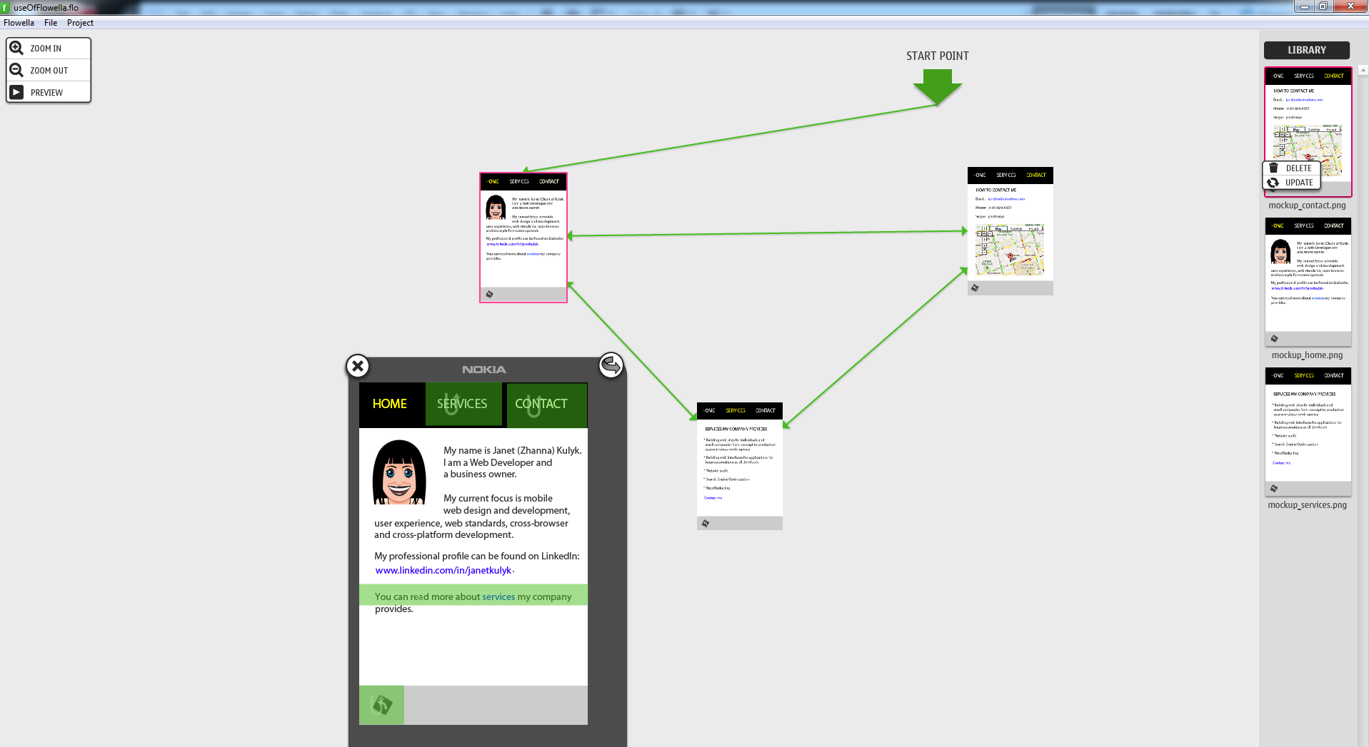

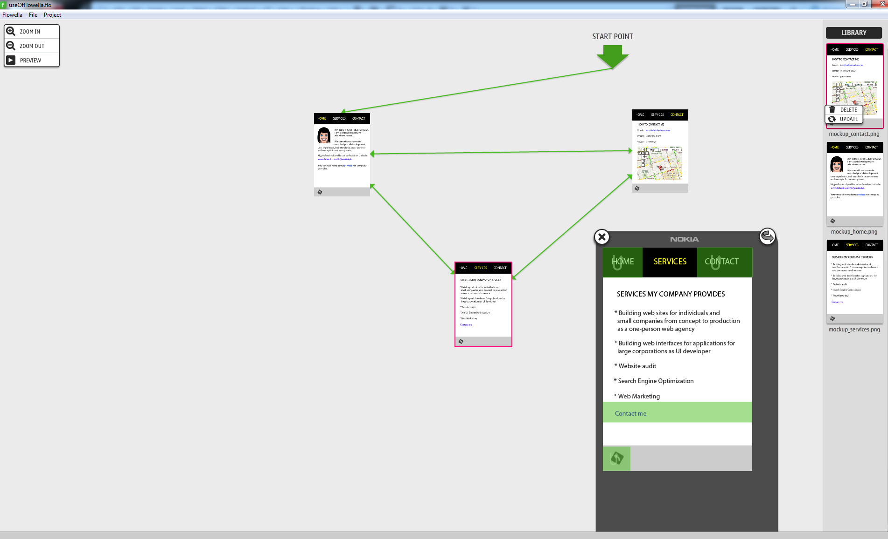
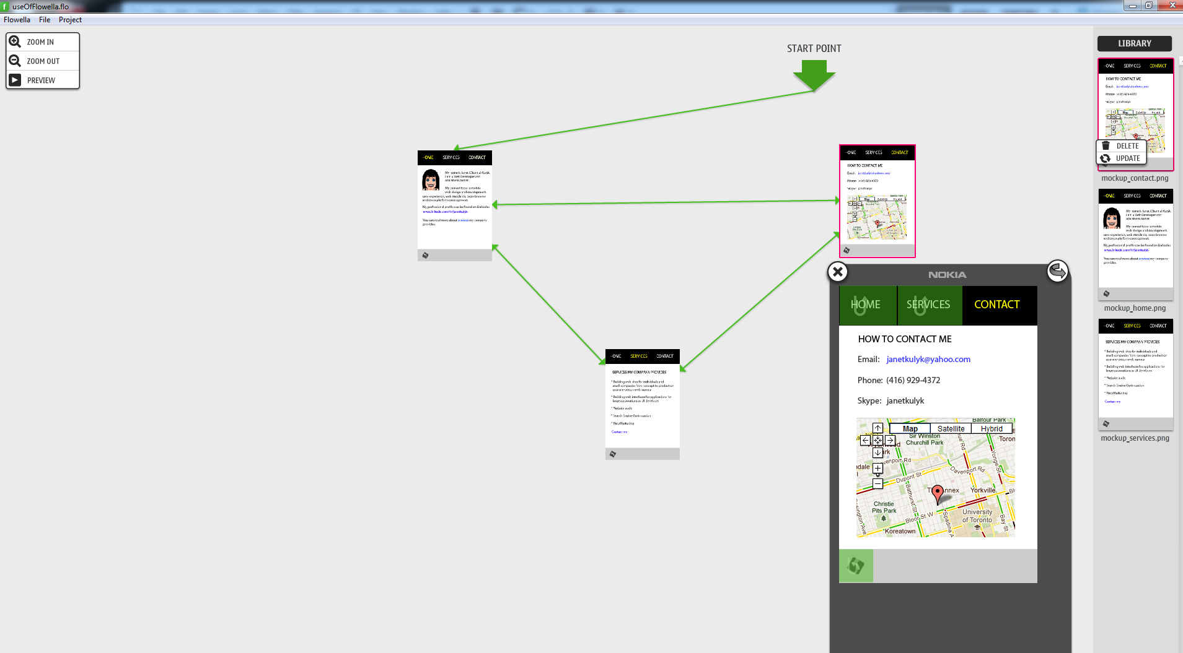

10 of the UI guidelines studied in module 2 of the course that my design complies with:

1. Avoid the use of columns

2. Provide a Back button in the footer

3. Provide the most used features at the top

4. Provide liquid design for best adaptation

5. Use lists rather than tables

6. Don’t use text images

7. Use full-width links so that the link activate by clicking anywhere in that line.

8. Use high-quality color images and fancier designs for smart phones

9. Design all the clickable buttons close to each other

10. Provide minimum 40 pixels width and height for frequently used buttons and links

PART 2: Use of marquee

