ASSIGNMENT 3

Part 1. Use of HTML5 input types

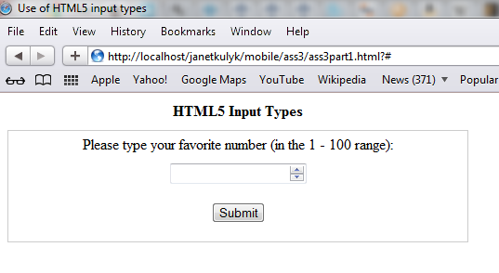

Above: screen shot for Safari5 on Windows7 after typing "test" and clicking "Submit" button. No error message is seen, the text field became empty after clicking "Submit" button.

Following information on famous web dev www.quirksmode.org website,
http://www.quirksmode.org/html5/inputs.html

For <input type="number">,

* IE10 uses a default range between 0 and 100 for the number

* Safari and Chrome don't validate, but when the value is not a number they revert the previous proper value (including an empty value as on screen shot above).
When I tried 25 (any number), followed by "test", I got 25 after clicking "Submit" button.

* Opera hides the value when it's not a number.

* FireFox11 doesn't support <input type="number">.

* IE9 doesn't support <input type="number">.

Part 2. Using Geolocation and error handling

1. Screen shot with coordinates and timestamp:

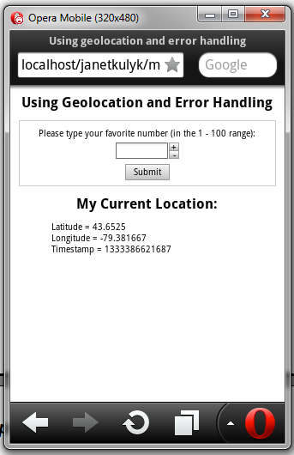

2. Screen shot with an API error:

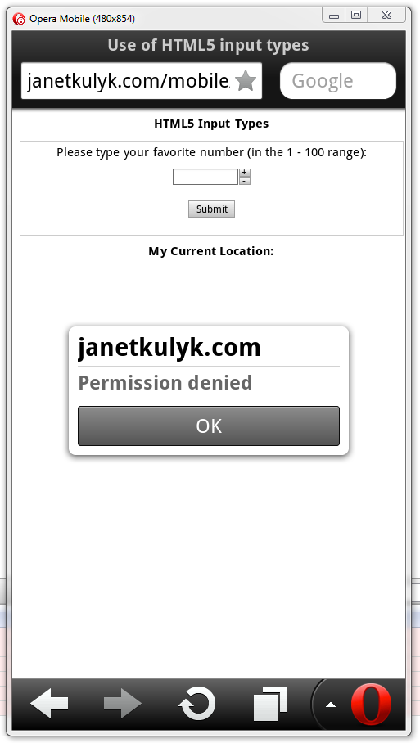

Part 3. Use of appropriate map

1. Screen shot for Android:

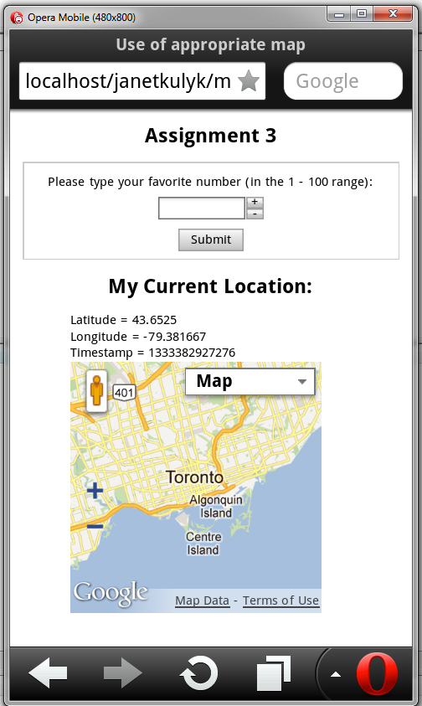

2. Screen shot for Opera: 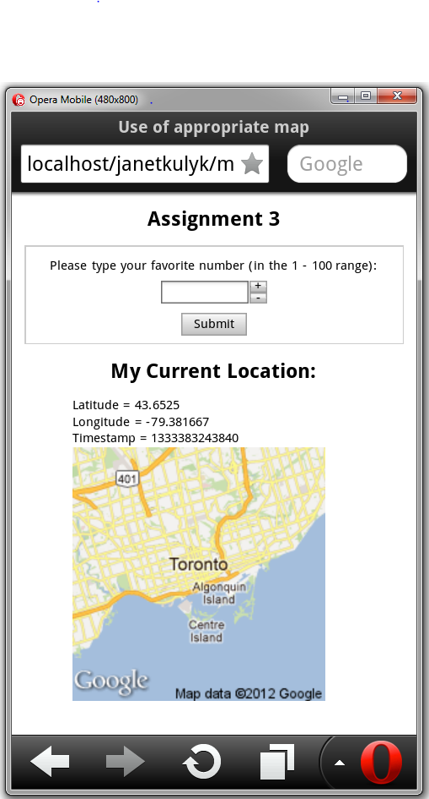

Part 4. Use of Dragonfly

1. Screen shot of Opera desktop browser showing the Dragonfly debug window:

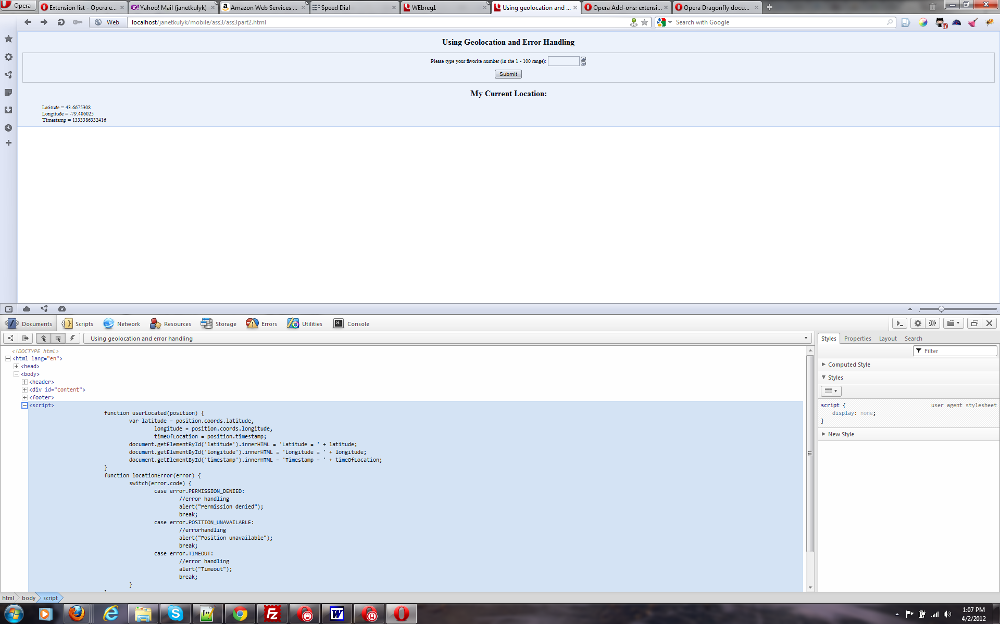

2. Screen shot of the mobile web page using a browser of the Opera Mobile Emulator:

