Labaratory work

Task 1

with table1 as(select grade.student_id, grade.GRADE_TYPE_CODE, avg(NUMERIC_GRADE) as average,

grade_type_weight.section_id

from grade left join GRADE_TYPE_weight on

grade.section_id=GRADE_TYPE_weight.section_id

group by grade.student_id,

grade.grade_type_code, GRADE_TYPE_weight.section_id),

table2 as(

select sum(average*PERCENT_OF_FINAL_GRADE/100) finalmark,table1.student_id, table1.section_id

from grade_type_weight gtw

left join table1 on gtw.GRADE_TYPE_CODE=table1.GRADE_TYPE_CODE and gtw.section_id=table1.section_id

group by table1.student_id, table1.section_id

)

select student_id, section_id, finalmark from table2

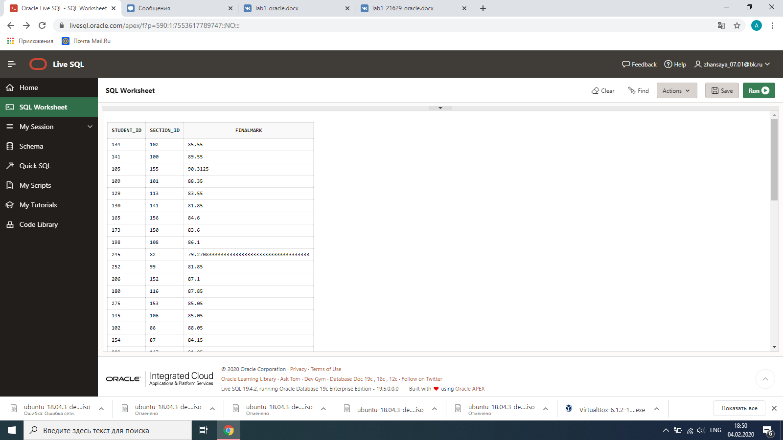

Task 2

with query1 as(

select section_id, count(student_id) as students_count

from enrollment group by section_id)

select section.course_no, course.description, query1.students_count,section.capacity

from ((section left join course on section.course_no=course.course_no

inner join query1 on query1.section_id=section.section_id))

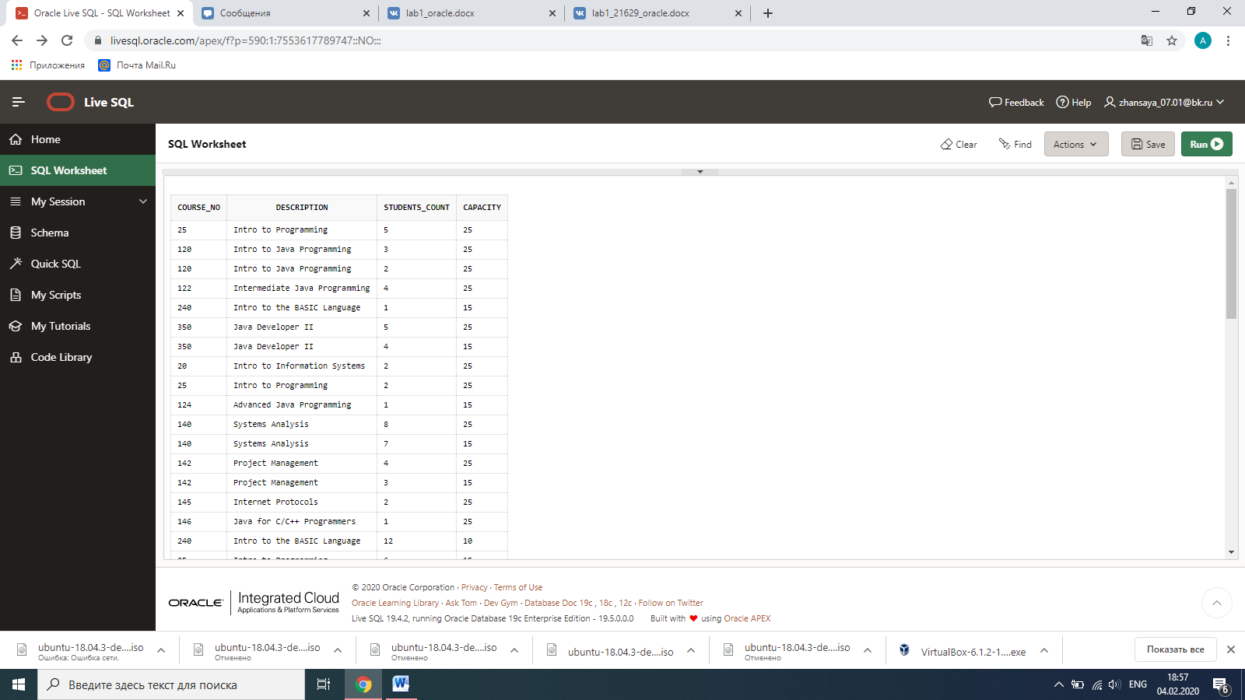

Task 3

with query1 as(

select grade.student_id, grade.GRADE_TYPE_CODE, avg(NUMERIC_GRADE) as average,

grade_type_weight.section_id from grade

left join GRADE_TYPE_weight on

grade.section_id=GRADE_TYPE_weight.section_id

group by grade.student_id,grade.grade_type_code, GRADE_TYPE_weight.section_id),

query2 as(

select sum(average*PERCENT_OF_FINAL_GRADE/100) finalmark,query1.student_id, query1.section_id

from grade_type_weight gtw left join query1 on gtw.GRADE_TYPE_CODE=query1.GRADE_TYPE_CODE and gtw.section_id=query1.section_id

group by query1.student_id, query1.section_id)

select student_id, section_id, finalmark, letter_grade from grade_conversion, query2

where finalmark<=max_grade and finalmark>=min_grade

