**Week 4: Deployment on Flask**

Name: Zhan Shi

Batch code: 5068942

Submission data: Aug 27, 2022

Submitted to: Data Glacier Virtual Internship Canvas Site (link provided below)

<https://canvas.instructure.com/courses/5068942/assignments/31350145?module_item_id=69454418>

Introduction of data and model:

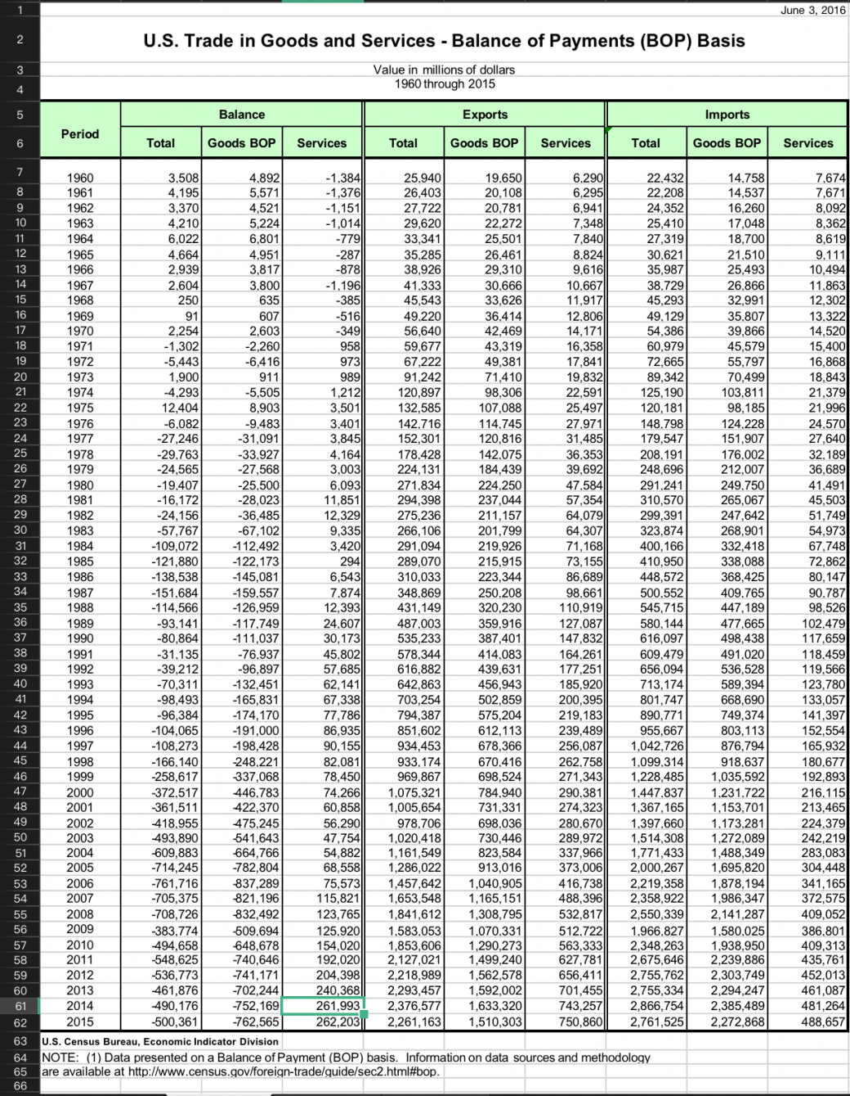

Fig1. U.S. Trade in Goods and Services - Balance of Payments (BOP) Basis

I used values in the Period and Balance features in the U.S. Trade in Goods and Services - Balance of Payments (BOP) Basis to predict the total value of balance.

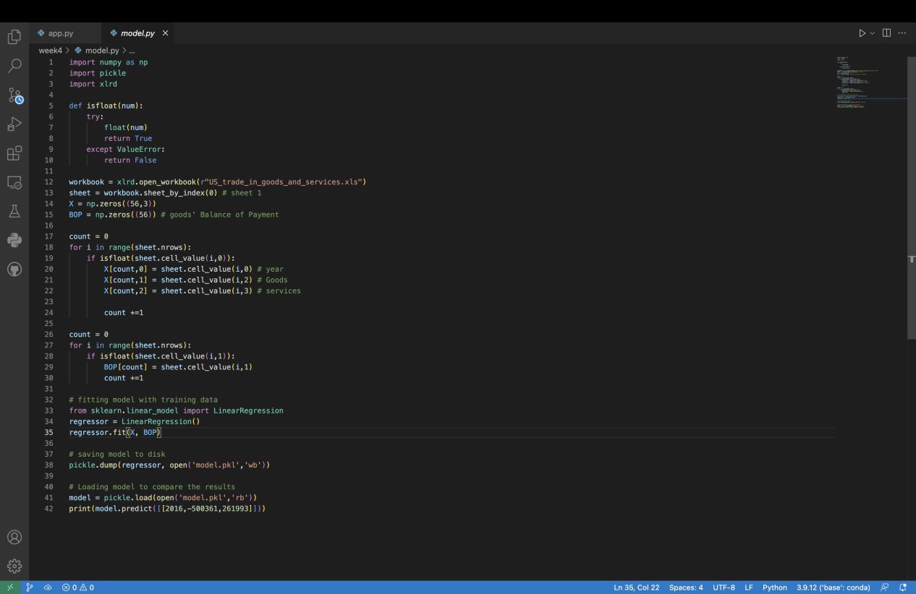

Fig2. Screenshot of model.py

First, I created the model. I used linear regression and fitted between [Year, Goods BOP, Services] and Goods. And then use the input data of three variables to predict total value of balance in the future year.

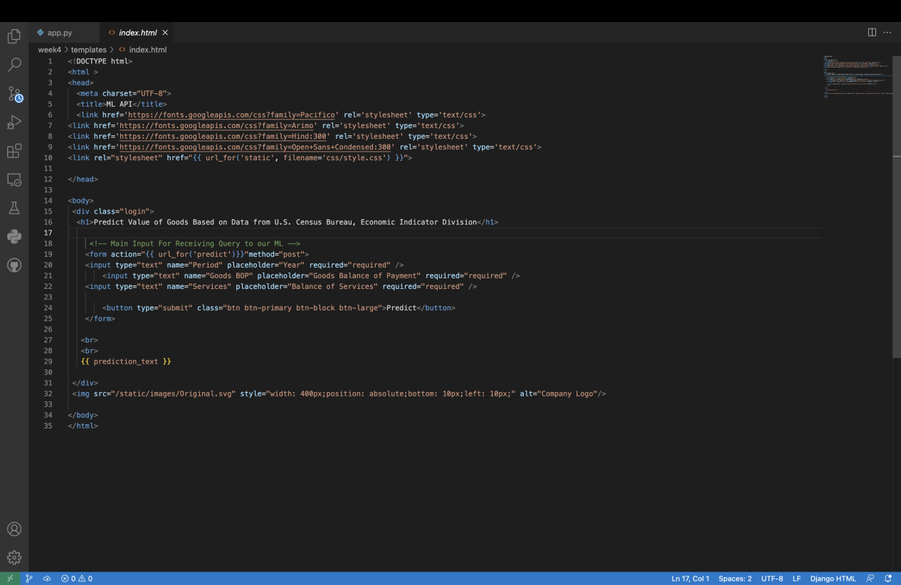

Fig3. Screenshot of index.html

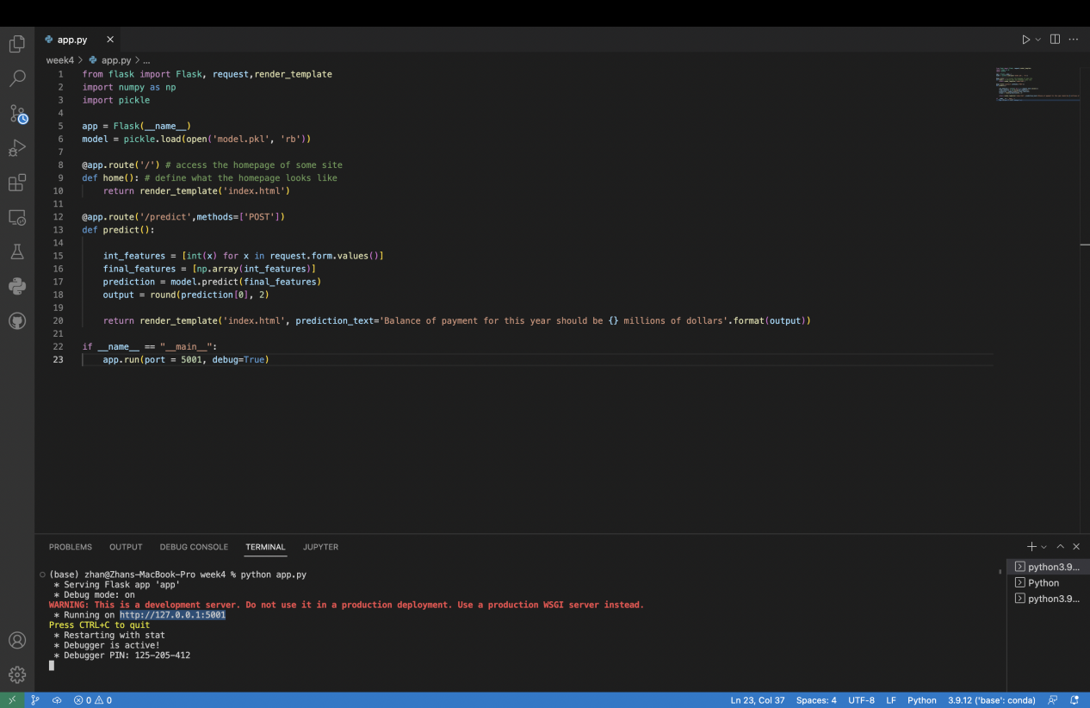

Fig4. Screenshot of app.py

Then, i defined the structure of the website and the data we get in index.html file and input data into the model to get the predicted output value. By running app.py file, we will be able to see the website shown below in Fig 5 and use the model on site.

I tried with year 2020 with Goods BOP -782000 million dollars and Balance of Services 68000 million dollars. I got the predicted total balance as much as -713999.59 millions of dollars.

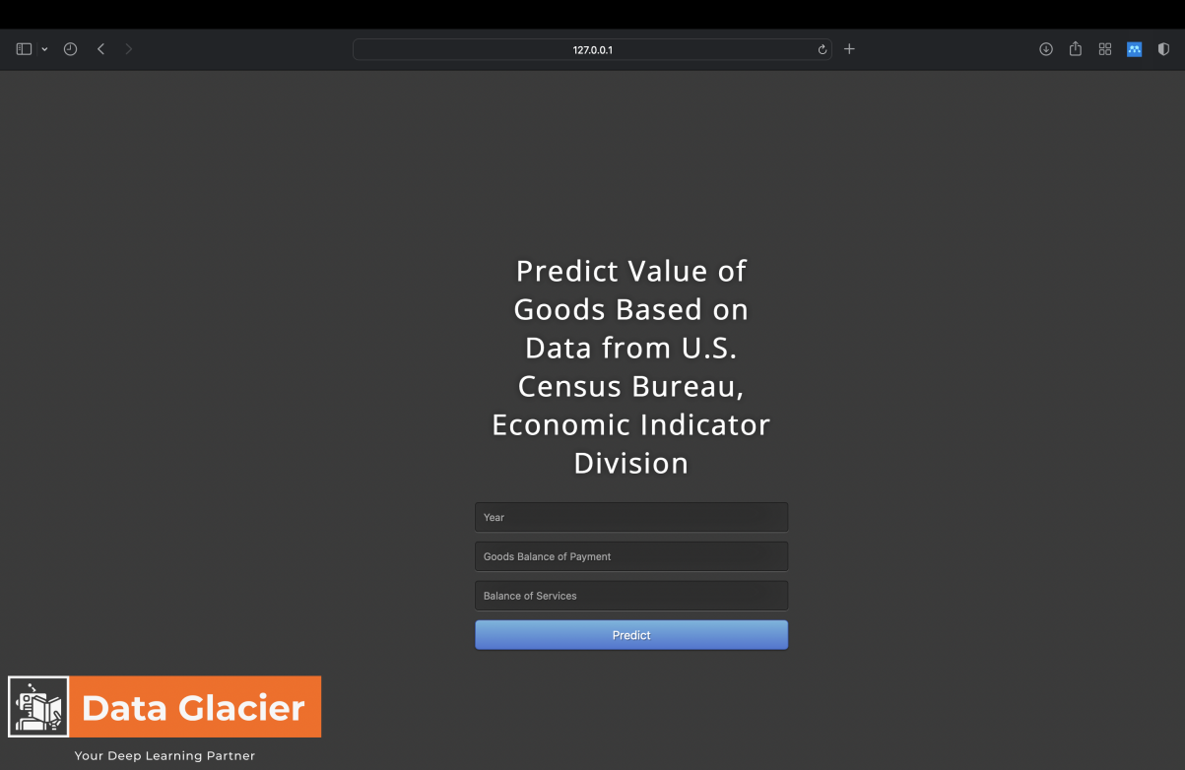

Fig5. Screenshot of the website

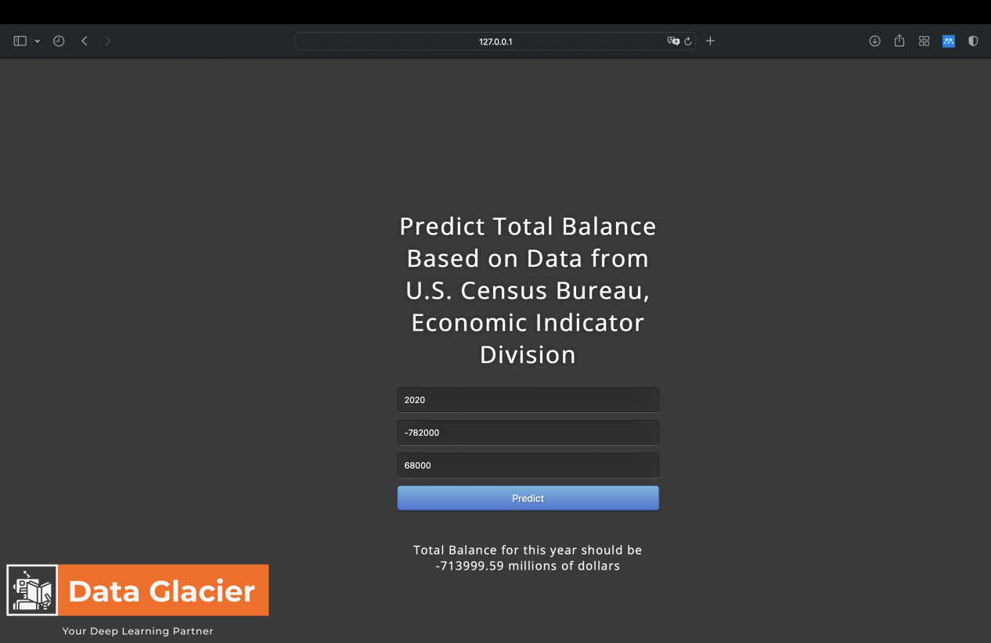

Fig6. The result after inputing the data