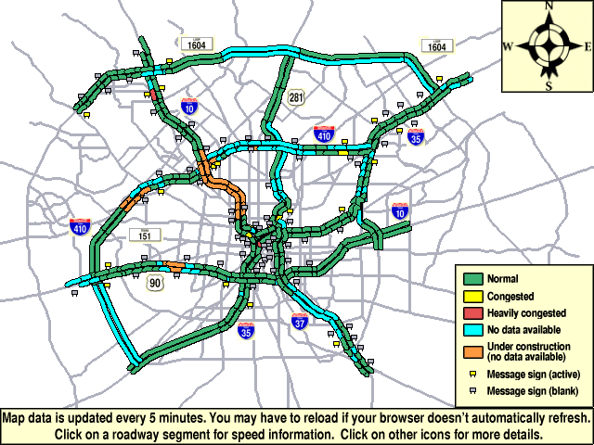
Ⅲ
1
2
3
4
5
6
7
8
9
10
11
12
13
14
1-----2 | 8.1
2-----3 | 9.15
1-----4 | 6.9
2-----5 | 5.85
3-----6 | 5.25
4-----5 | 5.1
5-----6 | 4.95
4-----10 | 9.6
4-----7 | 6.15
7-----8 | 1.95
5-----8 | 6
8-----9 | 5.1
6-----9 | 3.15
10----11 | 8.55
7-----11 | 2.55
8-----12 | 2.85
11-----12 | 2.4
9------13 | 2.25
12-----13 | 6.15
10-----14 | 5.55
11-----14 | 8.1

From the above figure, two bold lines in two different directions designate highways with the upper line going from left to right and left line from top down. Vehicles passing through the intersections (nodes) are able to reach other links connected with these nodes. There are fourteen nodes in the above map. The distances of every two nodes are listed in the above table. Find an optimal route from node 3 to node 14, and from node 14 to node 3, respectively. Also, please provide a travel time estimate for each route. It is assumed that travel time follows the same rule as question 1, average link travel time is proportional to link length, variance of link travel time is proportional to the reciprocal of 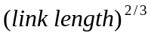 as well as proportional to the product of the number of links connecting to the two nodes at both ends of the link.

