2005年全国部分高校研究生数学建模竞赛A题
A: Highway Traveling time Estimate and Optimal Routing
Ⅰ
Highway traveling time estimate is crucial to travelers. Hence, detectors are mounted on some of the US highways. For instance, detectors are mounted on every two-way six-lane highways of San Antonio city. However, since vehicles tend to change lanes from time to time, we may ignore vehicle lane change and consider just one lane traffic as shown below, in which the square boxes stand for detectors.

636 m 417 m 522 m 475 m

travel direction

Detector 1 Detector 2 Detector 3 Detector 4 Detector 5

1. Detectors are able to detect and measure the speed of individual vehicles 24 hours a day. Average vehicle speed measured within 20 seconds by detectors is reported and refreshed. The following table provides the real time data (due to the huge volume of traffic data, only traffic data of the last 20 seconds in every two minutes is in the last 20 seconds. Unit: mile/hour). Please analyze traveling characteristics on highways (for instance, congestion and its dispersion. Typically, it is not considered as congestion if traffic speed is higher than 50 mile/hr). If a vehicle passes the detector at time t, how long will it take for this vehicle to travel to the fifth sensor? Please design an algorithm for estimating such travel times. Make sure that you demonstrate the rationality and accuracy of your algorithm. If traffic data is provided every 20 seconds rather than every 2 minutes, how this information is going to affect your estimate?

All the conditions stay the same as in the previous problem. If detectors can measure not only vehicle speed, but also traffic volume per unit time (see table below. The unit of Flow is the number of cars/20 seconds), does this additional information help to improve the rationality and accuracy of your algorithm? If your answer is yes, please re-design your algorithm.

Time | Sensor 1 |  | Sensor 2 |  | Sensor 3 |  | Sensor 4 |  | Sensor 5
 | Speed | Flow | Speed | Flow | Speed | Flow | Speed | Flow | Speed | Flow
3:40:07 PM | 57 | 10 | 54 | 9.7 | 62 | 8.9 | 20 | 10.7 | 58 | 5.9
3:42:07 PM | 62 | 9.5 | 68 | 11.4 | 63 | 13.6 | 21 | 10 | 59 | 12.2
3:44:07 PM | 56 | 11.1 | 62 | 10.3 | 61 | 12.9 | 19 | 14.2 | 60 | 8.1
3:46:07 PM | 58 | 12.5 | 61 | 9.1 | 59 | 9.3 | 23 | 14.8 | 61 | 10
3:48:07 PM | 53 | 11.8 | 64 | 6.7 | 62 | 12.3 | 45 | 9 | 59 | 10.1
3:50:07 PM | 58 | 9.3 | 66 | 6.4 | 63 | 4.5 | 63 | 10 | 56 | 13.8
3:52:07 PM | 55 | 11.9 | 63 | 13 | 60 | 9.2 | 55 | 11.4 | 59 | 18
3:54:07 PM | 59 | 8 | 62 | 5.3 | 63 | 9.7 | 65 | 11 | 55 | 11
3:56:07 PM | 52 | 9.8 | 73 | 9.7 | 56 | 8.3 | 65 | 8 | 62 | 12
3:58:07 PM | 60 | 14.1 | 63 | 13.7 | 59 | 12 | 66 | 5.1 | 61 | 5
4:00:07 PM | 55 | 4.8 | 64 | 12.3 | 61 | 12.8 | 65 | 5.1 | 59 | 11
4:02:07 PM | 60 | 13.7 | 61 | 7.9 | 60 | 12.6 | 65 | 11.1 | 66 | 0
4:04:07 PM | 59 | 8.7 | 62 | 9.1 | 60 | 4.1 | 64 | 10.6 | 57 | 14
4:06:07 PM | 58 | 8 | 64 | 8.3 | 64 | 14.5 | 45 | 7 | 59 | 14
4:08:07 PM | 55 | 5.4 | 63 | 15.3 | 63 | 16 | 1 | 9.3 | 57 | 7
4:10:07 PM | 62 | 13.7 | 61 | 9.1 | 57 | 5.4 | 15 | 11.5 | 64 | 8
4:12:07 PM | 59 | 9.9 | 63 | 6.7 | 62 | 5 | 64 | 6.1 | 52 | 14
4:14:07 PM | 58 | 8.5 | 63 | 12 | 62 | 11.9 | 40 | 8.7 | 60 | 10
4:16:07 PM | 56 | 8.3 | 58 | 9 | 60 | 13.7 | 61 | 11.5 | 58 | 13
4:18:07 PM | 60 | 9.3 | 64 | 10.3 | 65 | 10 | 52 | 10 | 51 | 9
4:20:07 PM | 59 | 10.4 | 66 | 9.9 | 68 | 5 | 45 | 14.7 | 55 | 15.9
4:22:07 PM | 53 | 14 | 56 | 8.6 | 63 | 8 | 55 | 13.7 | 40 | 12.7
4:24:07 PM | 57 | 13 | 62 | 13.5 | 62 | 13 | 29 | 14 | 54 | 11.9
4:26:07 PM | 58 | 13.4 | 64 | 11.5 | 63 | 14 | 62 | 13 | 30 | 12.9
4:28:07 PM | 55 | 8.3 | 62 | 11.3 | 58 | 12 | 8 | 10.9 | 33 | 11.9
4:30:07 PM | 59 | 11 | 78 | 8 | 61 | 13 | 39 | 5.1 | 51 | 10.1
4:32:07 PM | 59 | 17.1 | 67 | 11.8 | 61 | 11 | 57 | 11.9 | 59 | 16.9
4:34:07 PM | 54 | 7.3 | 64 | 10.6 | 59 | 9 | 62 | 10 | 60 | 11.1
4:36:07 PM | 59 | 12 | 66 | 7.8 | 68 | 5.1 | 62 | 10 | 27 | 8.3
4:38:07 PM | 56 | 11.7 | 68 | 10.4 | 60 | 8 | 20 | 8.2 | 49 | 13.9
4:40:07 PM | 57 | 8.4 | 60 | 11.2 | 65 | 14.9 | 37 | 11 | 51 | 11.1
4:42:07 PM | 55 | 10.4 | 63 | 12.3 | 66 | 6 | 40 | 9.9 | 45 | 14.2
4:44:07 PM | 59 | 12.1 | 65 | 9.2 | 62 | 6.9 | 49 | 8.8 | 51 | 14.6
4:46:07 PM | 49 | 13.4 | 69 | 11.5 | 66 | 8.1 | 54 | 7.8 | 20 | 9.2
4:48:07 PM | 51 | 11.8 | 66 | 14 | 61 | 10.2 | 21 | 14.4 | 30 | 12.3
4:50:07 PM | 53 | 11.6 | 60 | 14.7 | 62 | 10.1 | 2 | 5.5 | 34 | 11.9
4:52:07 PM | 53 | 13.8 | 62 | 12.2 | 50 | 9.2 | 21 | 12 | 36 | 7.5
4:54:07 PM | 49 | 14.3 | 59 | 12.7 | 59 | 10.1 | 5 | 3.8 | 38 | 14.8
4:56:07 PM | 53 | 13.5 | 62 | 13.6 | 56 | 11 | 38 | 13.2 | 26 | 10.1
4:58:07 PM | 55 | 12.8 | 62 | 12.8 | 57 | 11 | 23 | 8.2 | 37 | 13.8
5:00:07 PM | 56 | 11.9 | 62 | 13 | 57 | 10.1 | 4 | 14.8 | 34 | 11
5:02:07 PM | 56 | 7.6 | 63 | 9.7 | 59 | 8.9 | 2 | 11.9 | 28 | 11.6
5:04:07 PM | 60 | 6.6 | 65 | 14.7 | 64 | 14 | 47 | 9.1 | 29 | 10.8
5:06:07 PM | 55 | 11.9 | 63 | 11 | 66 | 7.6 | 36 | 12.9 | 28 | 9.8
5:08:07 PM | 59 | 10.2 | 65 | 8 | 60 | 9 | 40 | 12.1 | 37 | 14.3
5:10:07 PM | 60 | 8.2 | 64 | 11 | 66 | 9.2 | 26 | 14.8 | 29 | 12.2
5:12:07 PM | 60 | 8.7 | 64 | 5.6 | 64 | 7.5 | 13 | 9.4 | 38 | 13.2
5:14:07 PM | 55 | 13.1 | 62 | 8.4 | 66 | 5.9 | 63 | 8.2 | 34 | 12
5:16:07 PM | 56 | 15.5 | 57 | 12.4 | 61 | 10 | 61 | 10.8 | 27 | 13
5:18:07 PM | 56 | 13.3 | 63 | 5.5 | 64 | 6.1 | 23 | 7.9 | 17 | 9.4
5:20:07 PM | 57 | 13.1 | 57 | 12 | 65 | 11.9 | 4 | 8.8 | 14 | 10
5:22:07 PM | 51 | 14 | 60 | 10.9 | 59 | 7.5 | 4 | 9.2 | 19 | 6.4
5:24:07 PM | 48 | 12.5 | 59 | 8.9 | 27 | 9 | 17 | 8 | 21 | 9
5:26:07 PM | 46 | 11.6 | 57 | 7.4 | 2 | 8.9 | 5 | 7.8 | 28 | 9.7
5:28:07 PM | 52 | 12.4 | 53 | 12 | 26 | 8.9 | 3 | 8.5 | 26 | 7.9
5:30:07 PM | 57 | 12.6 | 42 | 10.6 | 12 | 7.8 | 3 | 8.5 | 18 | 8.2
5:32:07 PM | 51 | 14.4 | 38 | 11.6 | 10 | 8.5 | 2 | 7.9 | 19 | 7.8
5:34:07 PM | 51 | 11.4 | 19 | 4.7 | 21 | 9.2 | 22 | 8.3 | 33 | 5.6
5:36:07 PM | 53 | 12.4 | 14 | 3.7 | 12 | 5 | 2 | 6.8 | 42 | 9.7
5:38:07 PM | 40 | 10.2 | 13 | 8.3 | 2 | 7.5 | 3 | 7.4 | 40 | 10.3
5:40:07 PM | 39 | 7.9 | 14 | 6.4 | 2 | 7.5 | 2 | 9.3 | 38 | 9.6
5:42:07 PM | 42 | 10.4 | 8 | 7 | 2 | 8.3 | 2 | 9.7 | 44 | 9.4
5:44:07 PM | 46 | 5.8 | 4 | 6.4 | 2 | 5.6 | 3 | 7.7 | 38 | 11.3
5:46:07 PM | 44 | 6.9 | 8 | 5.3 | 9 | 8.1 | 5 | 9.7 | 47 | 10.7
5:48:07 PM | 38 | 8.3 | 7 | 6.7 | 7 | 7.8 | 12 | 11.3 | 24 | 11.1
5:50:07 PM | 45 | 8.6 | 4 | 7.7 | 22 | 10 | 3 | 10 | 29 | 8.3
5:52:07 PM | 42 | 9 | 35 | 9.4 | 27 | 11.1 | 4 | 8.7 | 25 | 8.1
5:54:07 PM | 42 | 7.8 | 38 | 7.4 | 3 | 5.4 | 22 | 11 | 11 | 8.7
5:56:07 PM | 43 | 8.5 | 56 | 8.6 | 26 | 9.7 | 4 | 9 | 16 | 6.1
5:58:07 PM | 45 | 9.4 | 59 | 6.3 | 23 | 8.3 | 1 | 9 | 15 | 7.7
6:00:07 PM | 42 | 10 | 63 | 8.7 | 42 | 8 | 9 | 8.6 | 20 | 9.6
6:02:07 PM | 40 | 10.4 | 62 | 10.5 | 38 | 9 | 20 | 6.5 | 26 | 7
6:04:07 PM | 43 | 9.7 | 61 | 8.8 | 14 | 4.4 | 1 | 7.1 | 25 | 6.6
6:06:07 PM | 42 | 10.3 | 59 | 9.9 | 21 | 6.1 | 2 | 8 | 11 | 9.4
6:08:07 PM | 41 | 10 | 59 | 9.2 | 8 | 6.4 | 11 | 7.9 | 10 | 7.8
6:10:07 PM | 35 | 9.4 | 66 | 9.5 | 29 | 9.7 | 2 | 7.6 | 14 | 8.4
6:12:07 PM | 53 | 5.7 | 60 | 10 | 39 | 10.8 | 5 | 8.6 | 23 | 10
6:14:07 PM | 57 | 4 | 65 | 10.5 | 39 | 8.8 | 1 | 9.2 | 11 | 7.6
6:16:07 PM | 52 | 7.3 | 64 | 8.5 | 55 | 8.6 | 3 | 9.6 | 4 | 10.6
6:18:07 PM | 54 | 3.3 | 66 | 4.6 | 51 | 6.2 | 2 | 9.6 | 4 | 11
6:20:07 PM | 55 | 10.6 | 62 | 6.9 | 62 | 4.8 | 4 | 8.9 | 3 | 9
6:22:07 PM | 53 | 2 | 64 | 4.8 | 60 | 7.2 | 5 | 4.9 | 4 | 9.9
6:24:07 PM | 61 | 7.5 | 66 | 12.1 | 62 | 11.4 | 72 | 6.2 | 4 | 9.5
6:26:07 PM | 58 | 6.7 | 65 | 6.7 | 61 | 3.8 | 63 | 8.8 | 4 | 9.6
6:28:07 PM | 57 | 6.1 | 69 | 6.6 | 67 | 4 | 45 | 7.5 | 12 | 8.9
6:30:07 PM | 58 | 6.3 | 64 | 6.2 | 62 | 6.4 | 34 | 5.2 | 36 | 7.3
6:32:07 PM | 57 | 5.3 | 66 | 4.8 | 61 | 6.7 | 58 | 6.4 | 24 | 10.5
6:34:07 PM | 58 | 9 | 62 | 4.4 | 69 | 6.4 | 45 | 5.7 | 53 | 12.5
6:36:07 PM | 59 | 4.4 | 71 | 2.4 | 70 | 5.8 | 15 | 8.9 | 63 | 6
6:38:07 PM | 58 | 4 | 64 | 4.9 | 64 | 4.1 | 9 | 8.2 | 65 | 6
6:40:07 PM | 60 | 4.6 | 70 | 0.6 | 68 | 2 | 6 | 7.6 | 59 | 5.4
6:42:07 PM | 60 | 6.4 | 62 | 4.6 | 64 | 3.7 | 28 | 6.9 | 64 | 5.5
6:44:07 PM | 57 | 1.6 | 65 | 8 | 66 | 7.6 | 44 | 6.6 | 59 | 4.1
6:46:07 PM | 55 | 8.8 | 64 | 3.6 | 72 | 4.1 | 55 | 6.2 | 62 | 6.6
6:48:07 PM | 58 | 5.7 | 66 | 9.4 | 62 | 6.5 | 40 | 3.2 | 64 | 2.9
6:50:07 PM | 59 | 6.2 | 62 | 2.4 | 67 | 6 | 52 | 0.5 | 65 | 7
6:52:07 PM | 61 | 7.3 | 66 | 3.1 | 66 | 4 | 58 | 1.2 | 66 | 7.7
6:54:07 PM | 59 | 6.7 | 69 | 6.1 | 64 | 7 | 64 | 1.9 | 64 | 8.8
6:56:07 PM | 64 | 3.5 | 69 | 4.8 | 62 | 7 | 59 | 5.3 | 62 | 6.3
6:58:07 PM | 64 | 4.2 | 68 | 3.9 | 57 | 4.5 | 36 | 4.4 | 64 | 4.1

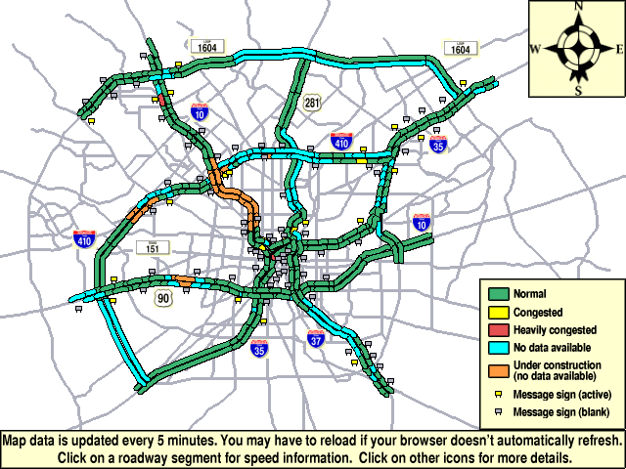
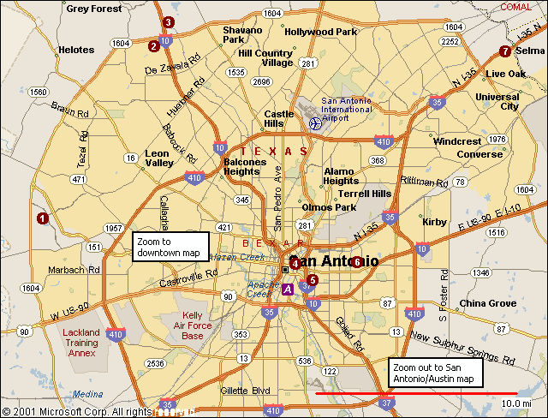 Ⅱ
The first figure is a city map of San Antonio in Texas, the United States. The second one is a map reflecting traffic condition in San Antonio. Travelers can input their locations and destinations into an on-board in-vehicle navigation system so that the system will help to select a driving route and estimate the traveling time. Unfortunately, due to the uncertainty in traffic time of each link (road between two nodes, nodes can be treated as intersections), the existing system has a poor performance in terms of providing an optimal (fastest) route and a reliable travel time estimate.

Can you improve the system based on question 1?

1. Provided link travel times are mutually independent random variables. Please design an algorithm for the system to address optimal route selection and travel time estimation. Make sure to clarify your definition of optimal route.

2. Travel times on individual links are dependent on departure time, as well as are mutually correlated. A time dependent covariance matrix Cov(ij,kl) is typically used to quantify such a time-varying correlation relationship, in which i, j, k, and l represent the two nodes of two links. Use the maps above to design a rational matrix and design an algorithm for optimal routing. Be sure to clarify your definition of the optimal route. If there are n nodes, then the time dependent function Cov(ij,kl) is a n(n-1)/2 sqaure matrix, each row or column representing a link 12,…,1n,21, …,2n,…n1,n2,… n(n-1).

