markdocx Integration Test
This document exercises all features supported by the markdocx converter.

Text Formatting
This paragraph contains bold text, italic text, bold italic, and inline code. It also has a link.

Headings

Third Level

Fourth Level

Fifth Level

Lists

Unordered List
- First item
- Second item with bold
  - Nested item A
  - Nested item B
- Third item with inline code

Ordered List
- Step one
- Step two
  - Sub-step 2a
  - Sub-step 2b
- Step three

Blockquote
This is a blockquote with bold and italic text.
It can span multiple lines.

Horizontal Rule

Code Blocks

JavaScript
javascript
function greet(name) {
const message = `Hello, ${name}!`;
console.log(message);
return message;
}

greet('markdocx');

Python
python
def fibonacci(n: int) -> list[int]:
"""Generate Fibonacci sequence."""
seq = [0, 1]
for i in range(2, n):
seq.append(seq[i-1] + seq[i-2])
return seq[:n]

print(fibonacci(10))

Plain Text
This is a plain text block.
No language badge should appear.

Tables

Simple Table
Feature | CLI | Extension
Markdown parsing | markdown-it | markdown-it
Mermaid rendering | mmdc + Puppeteer | mermaid.render() + Canvas
DOCX generation | html-to-docx | html-to-docx (polyfilled)
Image support | fs.readFile | Directory picker

Table with Colspan
Category | Details
Platform | Node.js 22+ (CLI), Chrome MV3 (Extension)
License | MIT

Local Image

Mermaid Diagrams

Flowchart
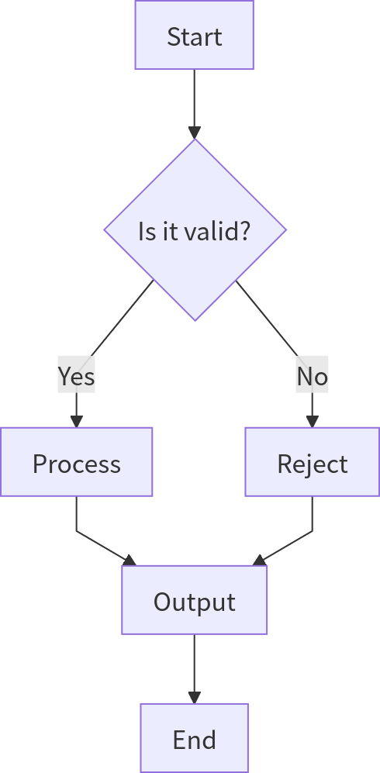

Sequence Diagram
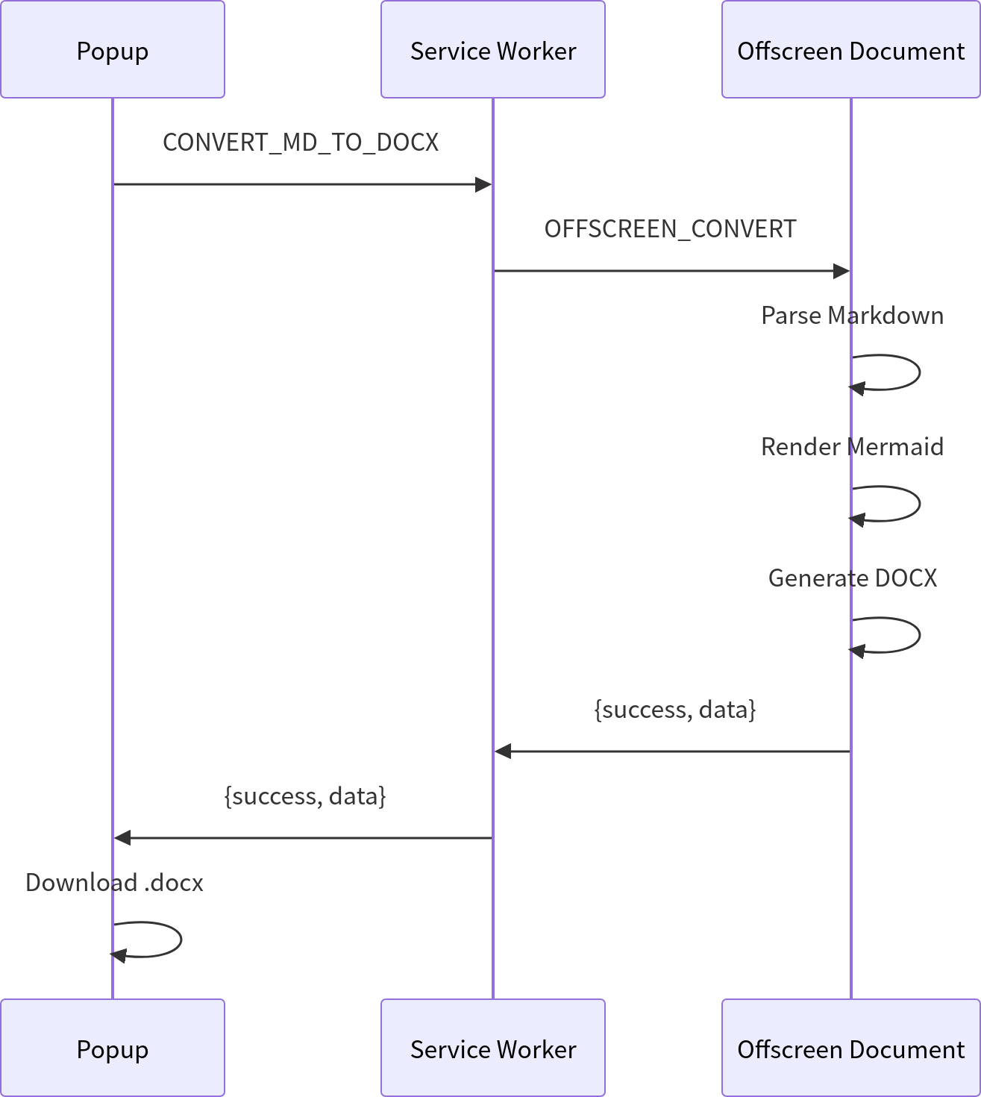

Edge Cases

Empty Code Block

Single-Line Code Block
bash
echo "hello"

Table in Blockquote Context
Note: The extension requires a directory picker for local images.

Special Characters
Angle brackets: <div> and </div>
Ampersand: R&D
Quotes: "double" and 'single'

