1. Measure from channel 1 and channel 2 when channel 1 is connected function generator and channel 2 is connected to sync signal.

Below is the figure measured from sync signal and function generator. When the scope is triggered by sync signal, the function generator is outputting the 10V p-p square wave of 10kHz at rising time.

It is expected to see from channel 1 a 10V p-p square wave of 10kHz square wave. It measures the square wave function generator generated.

It is expected to see from channel 2 the sync signal generated. It measures the sync signal synchronous the square wave with TTL level of 3.3 volts.

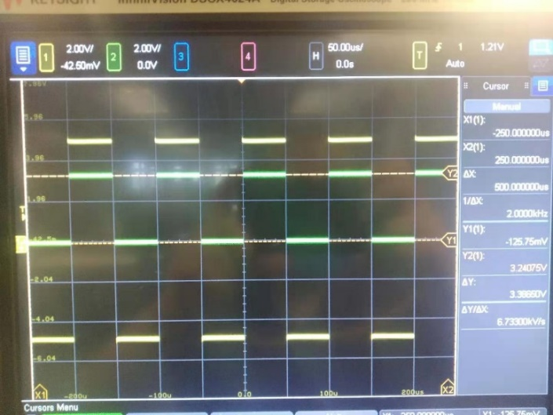

1. Rise time and fall time of the signal.

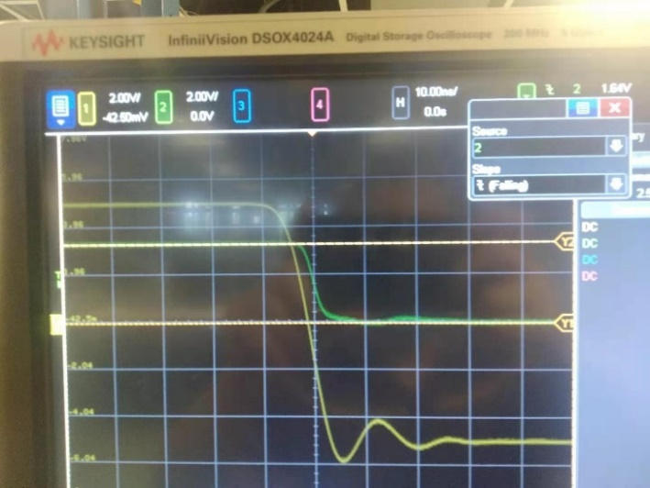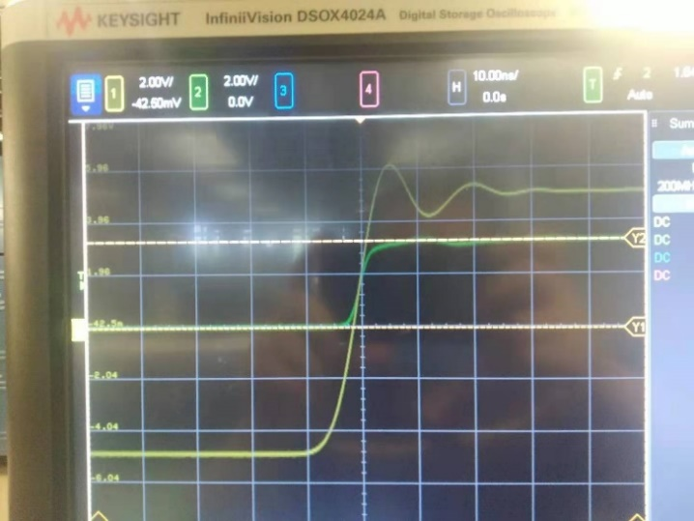

It gives 10ns of rise time 10ns of fall time.

1. 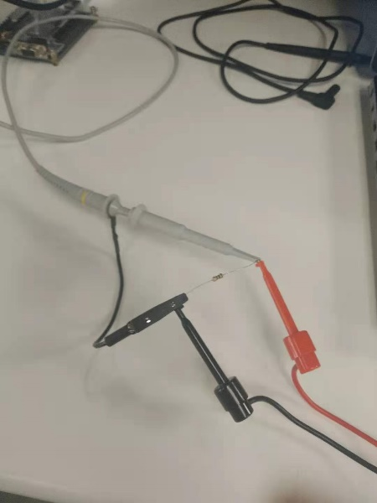Thevenin output voltage measured with load 100ohm

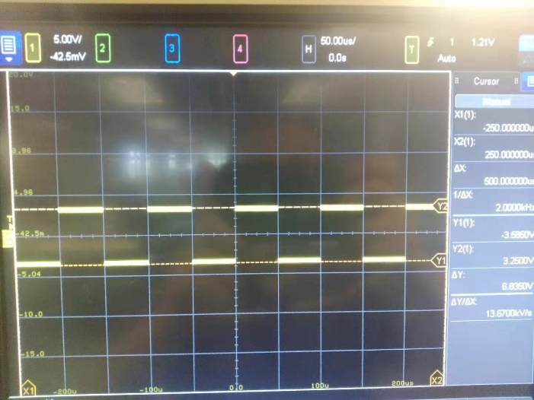

It gives Theven output voltage of

The Thevenin resistor is approximately equal to 50ohm.

When the function generator output load to be 50 ohms, because the load resistance is limited

with 100ohm other than required 50 ohms. When connected with load resistor, p-p voltage

measured from scope is 6.66v but it expected as 5v (instead of 10v) read from the generator.

This model does not change the Thevenin resistance, it is still measured approximately 50ohm.

1. Inductively coupled cross talk between victim loop and aggressor loop

dI/dt: It has positive current of 100mA with 5v and -100mA with -5v.

Current direction: When the signal is rising, the current direction of at first is negative (from

ground to ouput) the signal level rise to 0. When the signal level rise above zero, the current

direction becomes positive (from output to ground).

Mutual inductance: the figure below is the aggressor on top of the victim loop with same

Direction and the figure of flipping of the aggressor loop.

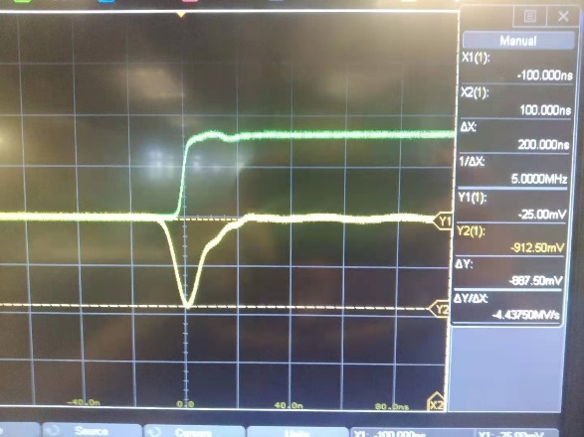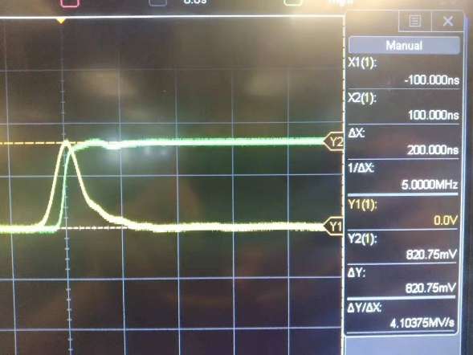

Figure of aggressor and victim of same direction, Figure of aggressor and victim of different

The signature of noise is positive. Direction, the signature is negative.

Flipping the direction of aggressor loop, the signature of the noise also got flipped.

Decoupling noise with different aggressor and victim geometries.

Large loops far apart:

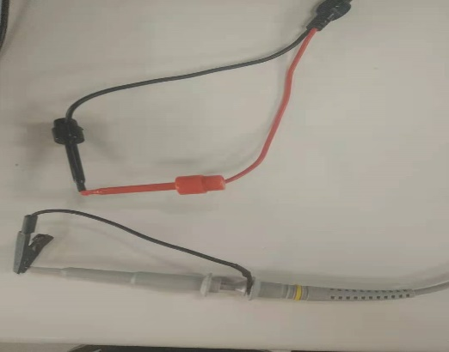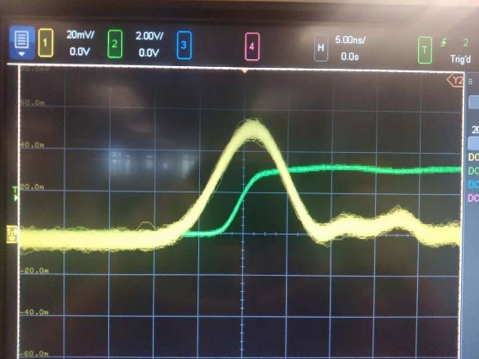

(The noise have same direction because the loops have same direction)

Large loops overlapping

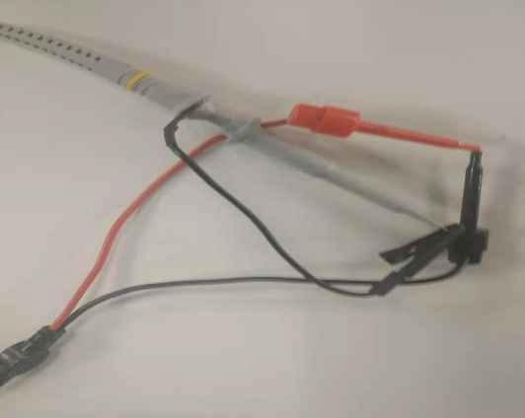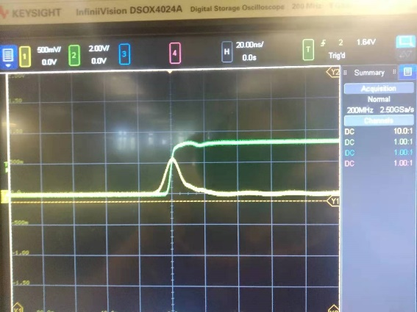

(Put two loops closer, the noise gets larger)

Large loops overlapping returns

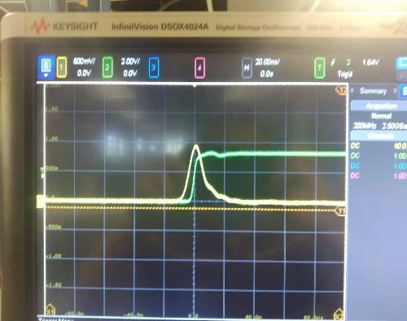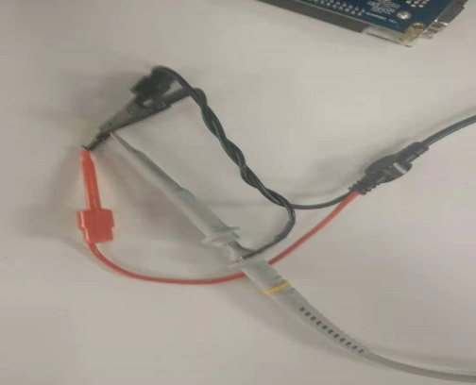

(Put two loops further close, the noise gets larger)

Small loops far apart

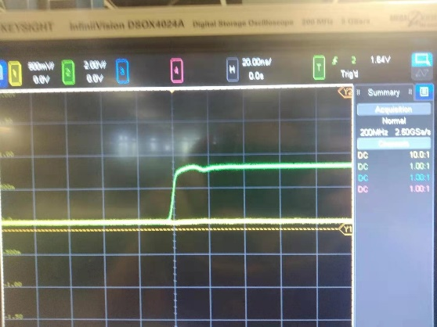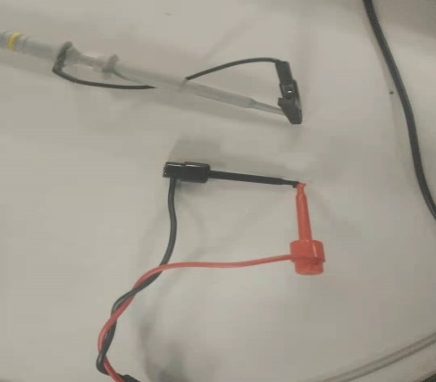

(Reduce the size of the loop and makes them apart, the noise get reduced by a lot)

The design guideline to reduce synchronous noise is to make the loop as small as possible and make them as far apart as possible.