BOM-EX

Enhanced Bill of Materials
for Eagle

Document Version 1.05

April 18, 2010

Copyright © 2010, Robert E. Starr, Jr.

http://www.bobstarr.net

Atlanta, GA USA

Introduction
This documentation describes the process of integrating bom-ex as a new enhanced BOM management system for Cadsoft Eagle. The bom-ex utility is an Eagle based ULP program derived from the original BOM system provided with Eagle. However, bom-ex takes advantage of the new ATTRIBUTES feature available in Eagle 5.0 for additional flexibility and greatly enhances the BOM system functionality. Note that bom-ex also includes options to generate part order upload files and edit part number attributes. Many suppliers allow uploading part order files to directly a website to automate the part ordering process and automatically pre-fill part order numbers.

The BOM-EX package consists of several components and, like the original BOM system, requires a text formatted parts database file to fully implement a complete BOM management system. The details of the database record structure are described in the next section of this document and should be followed carefully. The database is not required to view a basic BOM, but the database is required to generate order upload files and take advantage of the enhanced reporting and export features.

The screenshots below show the basic BOM viewer interface with and without the database loaded.

Figure 1 - Viewer without database loaded
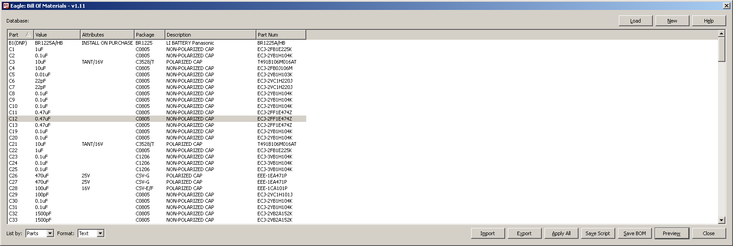

Figure 2 - Viewer with database loaded
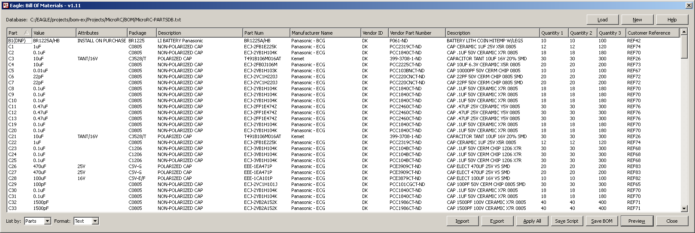

Parts Database Structure
Although bom-ex will show basic part number information by default, a database is required to fully implement the parts order export and part number importing features. The database file must consist of lines of tabbed text record data. Each line contains one record consisting of tabbed text delimiting the record fields and a single line feed line termination character.

The very first line must contain a "header" record, which defines a unique field name for each column of the database. All field names must exactly match the names as shown below or you will encounter problems with the order export operations. Note the first column of each record must contain a unique and non-empty manufacturer part number key for each record. The following details the minimum database format required for the BOM order system, however some fields are optional as noted below.
Figure 3 - Database Record Structure
Column | Field Name | Description
0 | “Mfg Part Num” | This field is the primary database key and contains the manufacture part number for a part.
1 | “Mfg Name” | This field contains the manufacturer name and is required for exporting BOM orders. Some vendors, like Digi-Key, require this field for order upload files.
2 | “VID” | This field contains a unique vendor ID name. The vendor ID codes are described in a following section.
3 | “Vendor Part Num” | This field contains the supplier part number specific to the vendor and may be different from the manufacturer part number. In most cases, this field is used for exporting BOM order uploads.
4 | “Description” | This field is not required, but is very useful for visually checking part values against component values in various listings or reports.
5 | “Qty 1” | This field is optional and will be automatically generated in some export BOM order formats (Digi-Key for example). If this field is present, the quantity specified will be used, otherwise the order export will calculate the actual number of minimum parts needed to build a single board.
6 | “Qty 2” | Second quantity bulk order size. This field is optional for most export BOM order operations.
7 | “Qty 3” | Third quantity bulk order size. This field is optional for most export BOM order operations.
8 | “Customer Ref” | Customer reference number. This is an arbitrary number assigned in the database for reference purposes.

Note that the record columns are separated by a tab character (you may also use a semicolon (';'). If you use the semicolon as a field delimiter, you must ensure no data item contains a semicolon. The TAB delimiter option is highly recommended as this character is unique and will not conflict with any normal part number ASCII character codes. You may also add additional columns of user defined record information for parts in the database.

The database Manufacturer Part Number field serves as the primary key to the schematic PARTNO attributes. Thus, PARTNO attributes in a schematic serve as the primary key link to a database record. The BOM viewer displays any additional part number information from the database based on the PARTNO key lookup.

Vendor ID Codes
The following Vendor ID codes are currently reserved for use by the BOM system to identify each vendor for a part during order export operations.

Vendor ID | Description
“*” | Generic – any vendor may supply
“NW” | Newark Corporation
“DK” | Digi-Key Corporation
“AE” | Allied Electronics
“ME” | Mouser Electronics

You may add as many new vendor type codes as needed or desired, but the above codes are reserved by the various order export generation routines. Note that an asterisk for the vendor ID indicates the part can be supplied by any of the vendors and will be generated in any of the parts order export files.

Editing Part Numbers and Database Records
Version 1.11 and up of bom-ex allows users to edit part number and/or database record entries directly. Some of the part number attribute editing and importing features available in bom-partno-mgr have been integrated into bom-ex. Part numbers can be quickly assigned on the fly directly from the BOM report viewer. Note that all of the features provided by bom-partno-mgr (like excluding BOM entries) are not available in the BOM viewer. Therefore, the part number manager utility may still be preferred for some part number management tasks.

Note that the bom-partno-mgr and the attrib-add utilities may be used to set the BOM listing EXCLUDE/INCLUDE attributes. The features allow you to exclude items from the BOM viewer. Likewise, the ATTRIBUTE command may also be used to manually enter BOM attributes. All BOM attributes recognized by bom-ex by are described in detail in subsequent sections of this document.

Note that bom-ex allows editing part numbers or database records depending on the current list view mode. In List by Parts view mode, the edit part number dialog is shown when the user double clicks a list entry. Likewise, the List by Values mode presents the edit database record dialog when a list entry is double clicked. The List by combo box shown below selects the current BOM list view format.

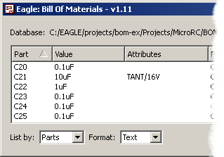

Editing a Part Number from the BOM Viewer
Set the list view mode to List by Parts mode and double click any entry to edit or assign a part number and the pick part dialog will appear as shown below (assuming a database is loaded). Double clicking any entry in the list copies the part number to the Part Number edit field. You may also manually enter any part number in the edit field as well. Note the part number must exist in the database in order to appear in the BOM viewer and reports. Click OK to accept the part number assignment or Cancel to exit the dialog with no changes. You may also assign part number attributes manually or with the attrib-add utility described later in this document.

Figure 4 - Pick Part Number Dialog
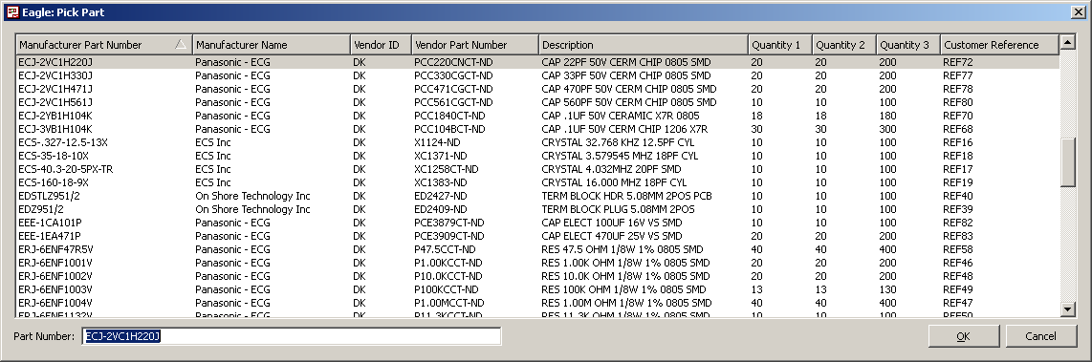

If no database is loaded, the following edit part number dialog will be shown instead. Here you can manually enter the manufacturer part number. Theses features are also supported in the bom-partno-mgr as well and include additional edit options that allow exclusion of BOM items.

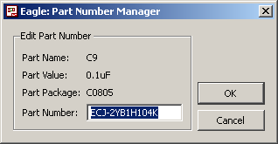

Note it may still be useful to enter part number information if you know the manufacturer part numbers but have not yet created the database. This feature allows you to assign part numbers and create the database later if desired. Optionally you may wish to use the part number import feature to assign part numbers in bulk format if later if desired.

Editing Database Records
The list view mode must be set to List by Values in order to edit database records. Set the list view mode to List by Parts mode and double click any entry to edit or assign a part number and the pick part dialog will appear as shown below.

You can edit any of the database entries by double clicking on the BOM list view window and a dialog containing each database record will appear similar to the dialog below. You must save the database changed back to a file to save any changes. The program will prompt you to save any changes before exiting if any unsaved changes were made.

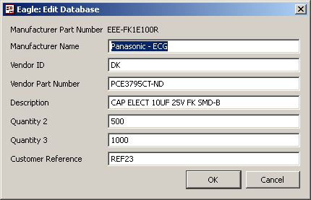

Although you can edit database records via the edit record dialog, you’ll probably find it’s much easier to manage the database contents in a spreadsheet program and then export the changes as needed to a tabbed text file. It’s typically much easier to edit, sort and manipulate the database columns in a spreadsheet program of some sort.

Saving and Applying Part Number Changes
If you modify any part number changes in the BOM viewer, you must apply the updates or save these to a script file in order to update the part number attribute changes in the schematic. If you attempt to exit the program and any unsaved part number changes are present, you will be prompted and given the option to save the part number attributes to a script file that can be applied later.

Click the Apply All button to exit the BOM viewer and apply all attribute changes to the schematic automatically. The Save Script button allows you to save the part number attributes to a script file at any time. You can execute a saved part number attribute script later from the schematic editor directly if desired to manually apply the part number attribute changes.

Note that bom-partno-mgr also provides additionally functionality to modify, save and import part number attribute data. The Import button allows you to import a file containing Part ID’s and Part Number data that can then be assigned to your schematic. Click the Import button to import part number information from a TAB text format file. This feature is handy if you have existing BOM data from a previous spreadsheet or other format and wish to import and assign part number information to your schematic automatically. Please refer to the bom-partno-mgr section of this document for complete information on importing part numbers data.

Part Numbers and Part Attributes
All schematic parts store the part number information using the ATTRIBUTES feature of Eagle. Specially, the BOM system uses the attributes PARTNO and BOM. The attribute PARTNO specifies a unique manufacturer part number for each component in a drawing. The BOM attribute allows you to exclude parts from the BOM listing. The exclude option is useful for components that don’t require and actual part order, like SMD test points etc.

Figure 5 – BOM Attributes
Attribute Name | Value | Description
PARTNO | {mfg-part-num} | This attribute contains the actual manufacturer part number for a particular part. The value serves as the primary key in the part database for report listings and export order generation facilities. This value should be unique across all parts and vendors in the database.
BOM | EXCLUDE | This attribute is used to omit parts or items from the BOM report. Some parts, such as SMD test points, wire pads or other PCB features do not require an actual component and can be omitted from the BOM by adding this attribute and value to the part.
BOM | INCLUDE | The BOM reporting includes all parts by default, but this attribute/value can be used to indicate a part should be included in the BOM report. This may be useful for items that you need to temporarily exclude or include in a BOM when generating reports or exporting order files.
DNP | T | This attribute indicates a DO NOT PLACE part and the part ID will appear in the BOM report with “(DNP)” appended to indicate the part should not be placed.
DNP | F | Parts are assumed to require placement by default. Any value other than “T” indicates the part requires placement.

Note that bom-ex will report all parts in a schematic regardless of whether or not the PARTNO attribute actually exists for a part. However, the PARTNO attribute is required if you wish to link schematic parts to a parts database to generate complete reports and export complete part order files. Therefore, it’s important to consistently add and manage part numbers during the design stage of a project.

Keep in mind that the native part >VALUE (via CHANGE VALUE command) is used as a secondary comparison key for BOM listing also. If no PARTNO attributes are defined for a design, then the actual part value (e.g. 10uF for a capacitor) is used as the secondary key for sorting operations. The value field is also used when listing parts in list-by-value mode.

Excluding BOM Entries
Any part can be excluded from the BOM report by adding the attribute BOM[EXCLUDE] to a part. The BOM processor assumes all parts will be included by default and the attribute BOM[INCLUDE] is treated the same as if no BOM attribute is present.

Manually Adding BOM Entries
The library bom.lbr is provided to allow adding ad-hoc BOM entries manually. Add the part BOM_ENTRY to your drawing and assign it a PARTNO attribute as you would any other part. This is useful for adding additional parts to your BOM report that are not actually part of the schematic or board design itself (e.g. part enclosures, knobs, wall wart power supplies, etc).

Do Not Place Parts
Parts can be flagged as DO NOT PLACE items by adding the attribute DNP[T] to a part. The BOM report processor will append the text “(DNP)” to the part ID name in the report indicating the part should not be placed.

You can also add optional place option description text with the attribute PLACE[text-string]. Any PLACE text will appear in the Attributes report column of the listing. This text should be kept short to avoid long text in the report. The report generator appends all known BOM attributes delimited by a slash in the attributes report column. Therefore, text should be kept brief to avoid wide strings of text in the attributes column.

Refer to the attrib-add section of this document for complete information on the known BOM attributes recognized by the BOM processor. This utility allows you to quickly add BOM attributes to parts in your schematic.

Exporting Order Files
bom-ex supports a handy feature to generate part order upload files for several suppliers. Some supplier websites accept BOM order upload files that will pre-load part order data to simplify the ordering process for large part orders. Obviously the part database must contain valid part order data in order to use this feature. Once your part database contains complete part information, you can use the export feature to generate order upload file data. Click the Export button to export a BOM order upload file and a dialog similar to the following appears.

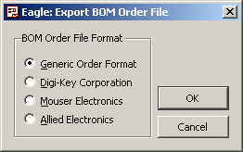

The “Generic” option exports all of the BOM data into a TAB or CSV delimited formatted file. You can then import this file into most any spreadsheet application for further manipulation, price analysis, etc. Other options allow exporting in various manufacturer specific order formats.

NOTE
Currently only the Digi-Key and Mouser file formats have been tested. Other formats will be added in future updates as needed.

The ATTRIB-ADD Utility
The utility program attrib-add.ulp provides a quick means to add part number and other component specific attributes to parts in a schematic. This utility works best by assigning the ULP to a keystroke or text menu so it’s available quickly. Simply select a part, or group of parts, with the GROUP command and execute the attrib-add.ulp program and the following dialog appears:

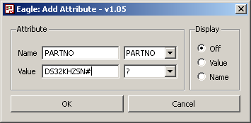

The combo boxes on the right hand side provide various default options for each field, or you can override these by typing the value in the edit fields in the left hand column. The example above shows a part number being adding to a resistor selected in the drawing. Note you can assign the same part number to several components at once by selecting a group of similar components with the group command prior to launching the ULP.

Note that bom-ex recognizes all the “known” attributes available by the attrib-add utility and these will appear in the attributes column of the BOM listing if defined for a part. The following list summarizes the attributes currently recognized by bom-ex.

Figure 6 - Known BOM Attributes
Attribute Name | Description
PARTNO | Specifies the manufacture part number.
BOM | BOM listing control flags, see Figure 3 for options.
DNP | Do not place part flag (T or F Boolean)
PLACE | Generic place and stuff option descriptions.
TOL | Generic part tolerance field (1%, 5%, etc).
TC | Generic temperature field (X7R, NPO, etc).
VOLT | Generic voltage rating field (10V, 6.3V, etc)
RATE | Generic part rating field (1W, 5W, etc)
COLOR | Generic color field for LED’s etc (RED, GRN, etc)
LABEL | Generic label text (for switch, controls, etc)
TYPE | Generic type field (POLY, TANT, FILM, etc)
SIZE | Generic size field (0805, etc)
LOAD | Generic load field (for xtals and such, 18pf, etc).
OPT | Generic option text (for any optional info)

The Part Number Manager Utility
The bom-part-mgr.ulp utility program is provided to allow browsing and modifying part numbers globally within a project. This utility provides a list view window similar to the BOM report and provides a list report of all component names and associated part data for a project. The report lists part record information from the database for all parts assigned to a valid part number in the database. Additionally, the user can modify the part numbers for any part contained in a project. You must save any part edit information to a script file after making any changes and apply the script to your drawing to update all parts. The following image shows the basic part number manager list view.

Figure 7 - Part Number Manager
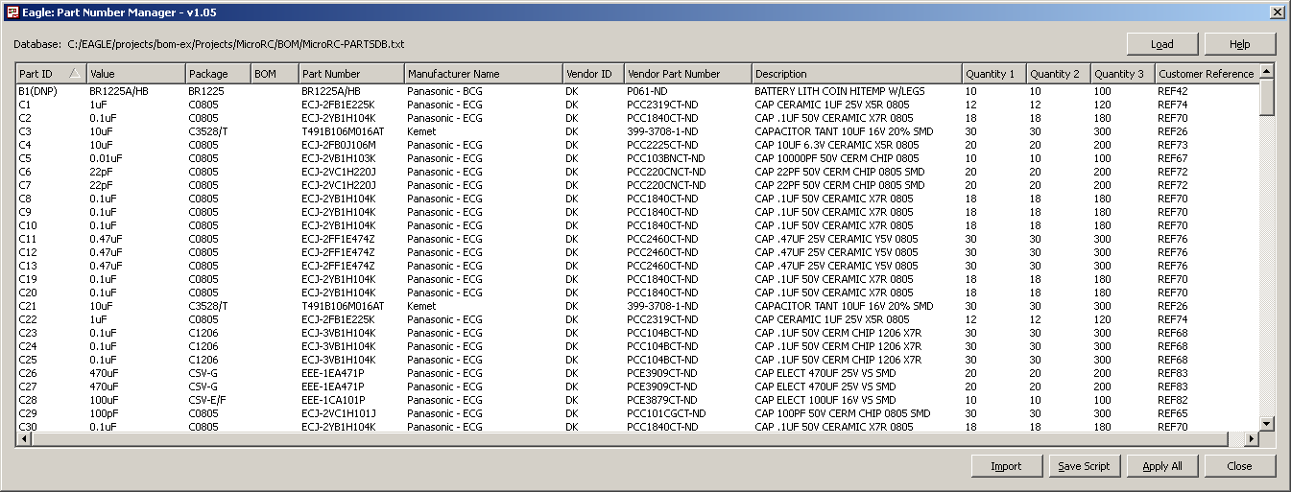

Double click on any part to edit the manufacturer part number associated with any schematic parts. If a database is loaded you’ll see a “Pick Part” dialog similar to below.

Figure 8 - Pick Part Dialog
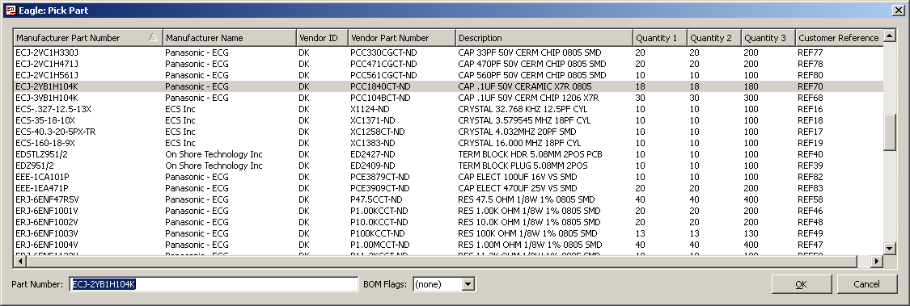

The Pick Part dialog allows entering the manufacturer part number in the “Part Number” field in the lower left corner of the window. Double clicking any part in the pick list will set the part number value in the “Part Number” edit field.

If the part number does not exist in the database, the report will show asterisks in the columns indicating the part number information does not exist in the database. If no database is loaded, the following edit part number dialog appears instead of the pick part view list.

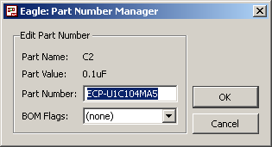

You may enter any part number information in the part number edit field. This part number will appear in any BOM report generated, however any associated database record information will only appear for valid part numbers that exist in the database.

The BOM Flags combo box allows you to exclude parts from appearing in the BOM output reports. This feature is useful for excluding items (such and SMD test point pads, etc) from the BOM report. The BOM viewer includes all parts in the report by default, but you can include the EXCLUDE or INCLUDE attribute to control listing of a part in the report output.

Saving and Applying the Script
Once all part number editing is complete, you can save the edit changes to a script file and/or apply these changes to your schematic by executing the generated script file within the schematic editor. Review the BOM report carefully after applying changes to ensure all part numbers are correct in your project and add/edit any new part number records to the master database file as needed.

The Save Script button allows you to save the generated script file. The script file can be executed later to apply all part number attribute updates in your design. This feature is useful if you wish to manually edit the script contents for some reason or review the results prior to applying updates.

The Apply All executes the script immediately and automatically applies all part number changes to the current design. Always review the BOM report after applying any changes to verify all parts are listed properly in the report.

Importing Part Numbers
The BOM part number manager also allows you to import part number assignment data from an external import text file. This feature is useful is you already have BOM data available in a spreadsheet and wish to import and apply this information to an existing schematic that currently has no part number attribute data assigned. The import part number file must contain TAB delimited text data that specifies the component ID(s) and manufacturer part number associated with each component. The following table describes the import file header and data record structure.

Column | Field Name | Description
0 | “Part Name” | This field is the primary database key and contains the manufacture part number for a part.
1 | “Part Number” | This field contains the manufacturer name and is required for exporting BOM orders. Some vendors, like Digi-Key, require this field for order upload files.

The first line of the file must contain the header record field names followed by data records for each part number. A valid data file (with tab delimiters) might appear as follows:

Part Name Part Number
R4 MCR10EZHJ000
R12 ERA-6YEB391V
"R3, R20" ERJ-6ENF1001V
R1 ERJ-6ENF2211V
"R5, R7, R10, R15, R18, R26, R27, R28, R25 " ERJ-6ENF4751V

Note that a line may contain multiple part ID references for a single manufacturer part number. This allows you to assign the same manufacturer part number to many part ID’s on a single line. Note that quotes are allowed for lines containing multiple part ID’s with comma delimiters (standard Excel format). Once all part numbers have been imported, save the BOM manager script to a script filename and apply the script to your schematic.

Database Auto-Loading
You can have the database load automatically each time bom-ex or bom-partno-mgr executes by defining the global variable “DATABASE” in your project schematic file. The database must reside in a subdirectory within your project directory if the pathname is prefixed with a period “.” character, otherwise the path name is assumed to specify a full working directory and path/file name.

NOTE
Use the forward slash character “/” for file and path names or the filename will not be display or be interpreted correctly under windows.

In the schematic editor, select the “Edit->Global Attributes” menu option and add a new global attribute with the name “DATABASE” and a the value set to your database subdirectory and filename. The example below shows a typical example for database auto-load filename.

