
Contents lists available at ScienceDirect
International Journal of Biological Macromolecules

journal homepage: www.elsevier.com/locate/ijbiomac

New insights into the drying technology of Pleurotus eryngii: Effects on  protein structure, properties and product flavor analysis  Deqing Wang a, Dianbin Su a,*, Huihui Xu a,*, Xiaofeng Chen a, Weiqiao Lv b, Yong Wang c, Xia Sun a, Yemin Guo a, Yukuan Ding d |  |  | 
a School of Agricultural Engineering and Food Science, Shandong University of Technology, No. 266 Xincun Xilu, Zibo, Shandong 255049, China b College of Engineering, China Agricultural University, 17 Qinghua Donglu, Beijing 100083, China
c School of Chemical Engineering, UNSW, Sydney, NSW 2052, Australia
d College of Marine Technology, Ocean University of China, 238 Pine Ridge Road, Qingdao, Shandong 266100, China
A R T I C L E I N F O |  | A B S T R A C T
Keywords:  Pleurotus eryngii protein  Drying methods  Protein structure |  | Drying techniques have been widely used in food macromolecule modification, sterilization, and other fields. However, comparisons about the effects of different heat treatments on the structural and functional properties of proteins have yet to be elucidated. In this study, we compared the effects of boiling water, microwave, hot air, and infrared pretreatment on the structural and functional properties of P. eryngii (Pleurotus eryngii) proteins (PEP), with the addition of low-temperature hot air drying (Fresh-H) and vacuum freeze drying (VFD) as con- trols. The flavor of apricot mushroom products was also analyzed. The results showed that the PEP from boiling water pretreatment combined with hot air drying (BPHD) maintained high surface hydrophobicity, turbidity, particle size, and zeta potential. Microwave pretreatment combined with hot air drying (MPHD) of PEP had higher water and oil-holding properties, crystallinity, hydrolysis, and antioxidant capacity. Meanwhile, both MPHD and infrared pretreatment combined with hot air drying (IPHD) maintained higher emulsification, foaming, and free amino acid content. There were large differences in the types and contents of volatile com- pounds in P. eryngii with different treatments, providing more options.

1. Introduction
P. eryngii (Pleurotus eryngii), commonly known as King Oyster Mushroom, was highly regarded for its rich nutritional content and unique texture [1]. It was abundant in protein, dietary fiber, vitamins, and minerals, notably containing higher levels of essential amino acids compared to common vegetables, making it an ideal plant-based protein source [2]. Given the increasing focus on healthy diets and environ- mental sustainability, the protein from P. eryngii exhibited significant potential as an alternative to traditional animal proteins due to its low fat, low calorie, and easily digestible characteristics [3]. Moreover, the protein from P. eryngii demonstrated good emulsifying properties, water-holding capacity, and thermal stability during processing, further

enhancing its feasibility as a substitute for traditional proteins. There- fore, research and development of P. eryngii -based protein substitutes expanded the options for plant proteins and met consumer demands for healthy and sustainable diets.
Pre-treatment before protein extraction significantly impacted the proteins' efficiency, quality, and functionality. Common pre-treatment methods included enzymatic hydrolysis, chemical pre-treatment (acid, alkali, salt), and physical pre-treatment (grinding, crushing, ultrasound) [4,5]. High-temperature pre-treatment was believed to alter protein solubility and functionality by disrupting cell walls, reducing anti- nutritional factors, and causing partial structural denaturation [6]. Mi- crowave treatment has been shown to reduce the β-sheet structure of jack bean protein concentrates, thereby altering the protein structure

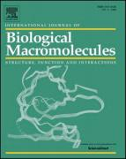
Abbreviations: BPHD, Boiling water pretreatment combined with hot air drying; EAA, Essential free amino acids; EAI, Emulsion activity index; ESI, Emulsion stability index; FAA, Free amino acid; FC, Foaming capacity; Fresh-H, Direct hot air drying of fresh samples; FS, Foaming stability; FTIR, Fourier transform infrared spectroscopy; HPHD, High-temperature hot air pretreatment combined with hot air drying; H0, Hydrophobicity; IPHD, Infrared pretreatment combined with hot air drying; MPHD, Microwave pretreatment combined with hot air drying; NEAA, Non-essential free amino acids; OHC, Oil-holding capacity; P. eryngii, Pleurotus eryngii; PEP, Pleurotus eryngii protein; TGA, Thermogravimetric analyzer; VFD, Vacuum freeze drying; WHC, Water-holding capacity; XRD, X-ray diffraction.
* Corresponding authors.
E-mail addresses: sdb@sdut.edu.cn (D. Su), xuhuihuijndx@sdut.edu.cn (H. Xu).
https://doi.org/10.1016/j.ijbiomac.2024.138306
Received 12 August 2024; Received in revised form 10 November 2024; Accepted 1 December 2024
Available online 3 December 2024
0141-8130/© 2024 Elsevier B.V. All rights are reserved, including those for text and data mining, AI training, and similar technologies.

[7]. Short-term high-temperature treatment was rather less damaging to goat milk whey proteins than prolonged low-temperature treatment [8]. A study by Guo et al. found that heat treatment significantly improved the structure and emulsification properties of dried coconut protein [9]. However, prolonged high temperatures could lead to excessive protein denaturation, forming insoluble polymers that affected protein func- tionality and nutritional value [10]. Therefore, selecting the appropriate pre-treatment processes and conditions was crucial.
Previous studies have shown that drying methods have a significant effect on the structural and functional properties of proteins, which is reflected in the large differences in the modification effects of different drying techniques on proteins. For example, microwave and hot air treatments have been widely used in the modification of cereal proteins, and experimental results show that these treatments can significantly change the secondary structure and surface properties of proteins, leading to a decrease in the relative crystallinity of proteins, and thus improve their emulsification capacity and functional properties such as water and oil holding capacity [11]. This effect is mainly attributed to the destruction of weak bonds such as hydrogen bonding and hydro- phobic interactions within the protein molecule by high temperature and microwave, which leads to the partial unfolding of the protein structure, exposing more hydrophilic and hydrophobic regions, and thus improves its dispersing ability and binding properties in the aqueous and oil phases. Meanwhile, hot water pretreatment has been proved to have a significant antioxidant enhancement effect on tomato proteins [12]. The structure of tomato proteins was changed by high temperature water bath treatment, exposing more amino acid residues with antiox- idant activity, such as sulfhydryl groups and aromatic groups. These structural changes enhanced the free radical scavenging ability and antioxidant activity of the proteins, indicating the potential of hot water pretreatment in improving the functional properties of plant-derived proteins. Infrared drying technology, on the other hand, excels in improving the quality of aquatic proteins such as squid proteins. Infrared drying causes rapid evaporation of water from proteins through rapid heating, thus avoiding excessive denaturation of protein structure and loss of function [13]. This drying method effectively protects the basic structure of squid proteins, resulting in a significant improvement in protein content, amino acid composition and sensory quality after drying. Although the above-mentioned heat treatment methods have demonstrated great potential in modifying the structural and functional properties of proteins, the current research on the relationship between heat treatment and protein modification is still relatively limited. Freeze drying and spray drying, as the mainstream protein drying techniques, still occupy an important position in the food and biopharmaceutical fields [14].
Within the scope of our investigation, the choice of heat treatments was relatively homogeneous, and studies comparing the effects of multiple heat treatments on the structural and functional properties of proteins were limited. Therefore, this study focused on the pretreatment of P. eryngii using boiling water, microwave, high temperature hot air and infrared treatments, while also including two low temperature drying methods as controls: low temperature hot air drying (50 ◦ C) and vacuum freeze drying. Subsequently, P. eryngii protein (PEP) was extracted and determined. The study assessed the effects of different pre- treatment methods on PEP structure and properties. Functional char- acteristics such as solubility, hydrophobicity, emulsifying properties, and foaming ability were systematically evaluated, along with in vitro digestion characteristics including digestibility, solubility, and antioxi- dant activity. Finally, the flavor of the dried P. eryngii products was assessed, aiming to make PEP a viable alternative to traditional proteins while possessing distinctive flavor characteristics. This research pro- vided a theoretical basis for the processing and development of P. eryngii and its proteins in the food industry.

2. Materials and methods

2.1. Materials and chemicals
Fresh P. eryngii (Pleurotus eryngii) was purchased from Zibo City, Shandong Province, China. The caps and stalk ends were removed before the experiment and cut into squares (about 20 mm). Reagents were purchased from SINOPHARM (Beijing, China).

2.2. Equipment and drying treatment

2.2.1. Drying equipment
The pretreatment and hot-air drying of P. eryngii were carried out by using the self-developed ORW4.0S-5000R Microwave Infrared Hot-air Rolling-bed Dryer (MIHRBD), and the specific structure of the equip- ment is shown in Fig. S1. The equipment includes the following important parts: a microwave system, an infrared device, a hot-air sys- tem, and a rolling bed. The microwave system consists of two microwave sources with adjustable power ranging from 0 to 1000 W and a cylin- drical resonance cavity with the size of 700 x 900 mm; the power of the hot air system is 3000 W, the temperature of the hot air is from 25 ◦ C to 180 ◦ C, and the wind speed is from 0 to 3 m/s; the power of the infrared device is 3000 W, and the speed of the rolling bed is adjustable from 0 to 20 r/min. P. eryngii was subjected to vacuum freeze drying (VFD) using a vacuum freeze (SCIENTZ, Ningbo, China).

2.2.2. High-temperature pretreatment and hot air drying process
Considering the results of the group's previous projects, the results of the pre-experiment and the routine working conditions of the edible fungi dried products enterprises, the pretreatment conditions were determined as follows. The purpose is to avoid the extreme working conditions completely destroying the proteins. Microwave pretreatment combined with hot air drying (MPHD): microwave power of 1.5 W/g for 15 min; High-temperature hot-air pretreatment combined hot air drying (HPHD): Hot air temperature of 100 ◦ C, wind speed of 3 m/s, pre- treatment for 30 min; Infrared pretreatment combined with hot air drying (IPHD): Infrared temperature of 100 ◦ C for 30 min; Boiling water pretreatment combined with hot air drying (BPHD): 5 min at 100 ◦ C in boiling water.
Low temperature hot air drying is monitored with reference to the previously used method [15]. Briefly, the samples were removed and weighed at ten-minute intervals until the moisture content was reduced to 10 %–12 % at the end of drying. The pre-treated and fresh samples were then subjected to hot air drying (except for the VFD) using the MIHRBD, which was carried out at a hot air temperature of 50 ◦ C and a rolling bed speed of 10 rpm.

2.3. Determination of proteins
P. eryngii proteins (PEP) were extracted using the Osborne method, and the extraction procedure is shown in Fig. 1. The contents are shown in Table S1. The obtained proteins were combined and dissolved in distilled water, the pH was adjusted to neutral, and immersed in deionized water at 4 ◦ C for dialysis and desalting. The desalted liquid was treated with liquid nitrogen and freeze-dried to obtain protein powder, which was stored at _ 18 ◦ C for backup.

2.3.1. Sulfhydryl
The total free sulfhydryl groups, total sulfhydryl groups, and disul- fide bond content of PEP were measured with the apparatus and method shown in Table S2.

2.3.2. Solubility
The solubility of PEP was expressed as the ratio of protein concen- tration in the supernatant to the total protein content in the sample, with the apparatus and method shown in Table S2.

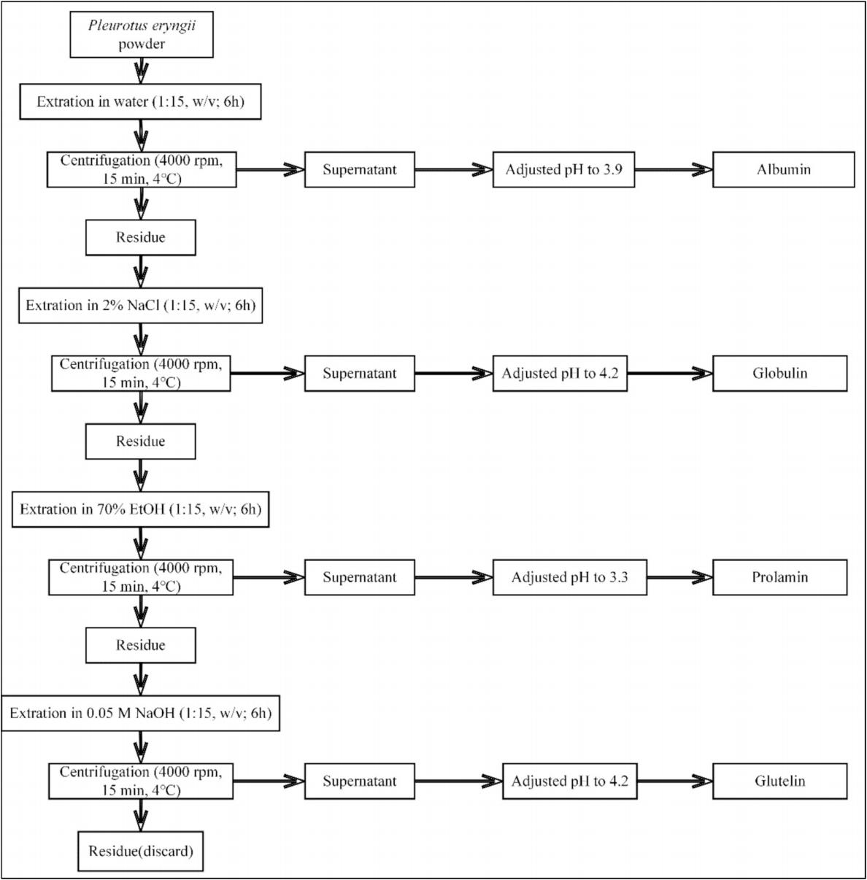
Fig. 1. Extraction Flowchart of P. eryngii proteins.

2.3.3. Surface hydrophobicity (H0)
The apparatus and method for the determination of H0 of PEP are shown in Table S2.

2.3.4. Fluorescence spectroscopy
The fluorescence spectra of PEP were analyzed with the instruments and methods shown in Table S2.

2.3.5. FTIR
The secondary protein structure of PEP was analyzed with the in- struments and methods shown in Table S2.

2.3.6. X-ray diffraction (XRD)
The XRD of PEP was observed with the apparatus and method shown in Table S2.

2.3.7. Particle size and zeta potential
The proteins were analyzed for particle size and zeta potential with the instrumentation and methods shown in Table S2.

2.3.8. Microstructure
To observe the microstructure of PEP, the apparatus and method are shown in Table S2.

2.3.9. Turbidity
The proteins were analyzed for turbidity with the instrumentation and methods shown in Table S2.

2.3.10. Water-holding capacity (WHC) and oil-holding capacity (OHC)
The water-holding and oil-holding properties of PEP were deter- mined with the apparatus and method shown in Table S2.

2.3.11. Emulsifying properties and foaming properties
The Emulsion activity index (EAI), emulsion stability index (ESI), foaming capacity (FC), and foaming stability (FS) of the PEP were determined with the apparatus and method shown in Table S2.

2.3.12. Thermal stability
Measurements of PEP thermal stability were performed as shown in Table S2.

2.3.13. In vitro digestion simulation
Enzymatic digests after gastric digestion at 0, 30, 60, 90, and 120 min and enzymatic digests after enteric digestion at 150, 180, 210, 240, 270, and 300 min were canceled in test tubes, respectively, and the apparatus and detailed methodology are shown in Table S2.

2.3.14. Antioxidant activity
The DPPH and ABTS radical scavenging rates of the enzyme digests were determined with the apparatus and detailed methods shown in Table S2.

2.4. Free amino acids (FAA)
The amino acid composition of dried apricot mushrooms was determined with the apparatus and method shown in Table S2.

2.5. Volatile compounds
The headspace-solid phase microextraction (HS-SPME) method was used to determine the volatile compounds of Apricot Abalone mushroom after different drying methods, and 1-decanol was used as the internal standard to calculate the volatile substance content, the instrument and the detailed method are shown in Table S2.

2.6. Statistical analysis
Executed each experiment thrice, and the outcomes were presented as the mean ± standard deviation of these replicates. Graphing was performed using Origin (Origin Lab, Northampton, MA, USA). Analysis of variance (ANOVA) and Tukey's analysis (P < 0.05) were performed using SPSS (SPSS Inc., Chicago, USA).

3. Results and discussion

3.1. Sulfhydryl analysis
Sulfhydryl groups have a large impact on the functional properties of proteins in a variety of ways, including participation in disulfide bond formation, redox reactions, and repair of oxidatively damaged proteins [16]. As can be seen in Fig. 2A, compared to VFD, the free sulfhydryl groups increased in all pretreatments except BPHD. Although the sulf- hydryl groups ofsulfhydryl compounds such as cysteine and glutathione were dehydrooxidized to the -S-S- structure, this was accompanied by the original disulfide bond breakage. Differences in the degree of sulf- hydryl dehydroxidation and disulfide bond breakage resulted in different free sulfhydryl content. The highest free sulfhydryl content was observed in MPHD and HPHD due to the oxidative cleavage of the di- sulfide bond leading to protein structural disorder and unfolding, which resulted in the exposure of sulfur-containing groups buried inside the proteins [17]. While total sulfhydryl groups showed the same trend as free sulfhydryl groups.
A disulfide bond is a covalent bond connecting different peptide chains in proteins, which can maintain the original functions and properties of proteins by stabilizing the structure of proteins when subjected to heat treatments, such as high temperature and high pres- sure [18]. The results showed that the changes in disulfide bond content showed an opposite trend to the free sulfhydryl content, with MPHD and

HPHD having lower disulfide bond content. Interestingly, we found that the sulfhydryl content in MPHD samples was lower than HPHD, but the disulfide bond content in MPHD was instead lower. This may be due to the rapid heating effect of microwave heating, possible cross-linking and oxidation reactions. Cross-linking or polymerization of proteins can cause some otherwise free sulfhydryl groups to be hidden in the cross- linking network, thus lowering the amount of sulfhydryl groups detected.

3.2. Solubility analysis
The effect of heat treatment on protein solubility is related to the degree of hydration between proteins and water molecules as well as the degree of protein aggregation during heat treatment [19]. Fig. 2B shows that protein solubility decreased after pretreatment except for VFD compared to Fresh-H. This is due to the oxidative reaction of the pro- teins, resulting in disulfide bond generation, protein aggregation, and exposure of hydrophobic groups [20]. Observing the TEM image of P. eryngii in Fig. 2E, the pretreatment methods, except Fresh-H and VFD, disrupted the cell wall integrity to a greater extent. Cell wall disruption means that proteins are more easily exposed to the external environ- ment, but BPHD, which has the greatest degree of cell wall disruption, instead has the lowest solubility. This is because higher pretreatment temperatures promote this reaction, leading to an increase in insoluble aggregates, which in turn leads to a decrease in solubility. Additionally changes in the internal cell environment can affect the conformational stability of proteins and reduce solubility. The vacuum low-temperature environment of VFD alleviates this phenomenon.

3.3. Surface hydrophobicity (H0) analysis
Hydrophobicity indicates the change of hydrophobic groups on the surface of protein molecules, which could reflect the change in the spatial conformation of protein molecules. The changes in hydropho- bicity of the pretreated PEP surfaces were shown in Fig. 2C, with an increase in protein H0. The H0 of BPHD and MPHD increased by 206 % and 144 %, respectively, while VFD increased by only 38 %. This was because high temperatures increased the thermal motion of protein molecules, which disrupted weak noncovalent bonds as well as hydro- phobic interactions, leading to partial unfolding of proteins [21]. During the thermal denaturation of proteins, hydrophobic amino acid side chains originally buried within the protein were exposed. When these hydrophobic groups (nonpolar amino acids) were exposed on the sur- face, they increased protein H0.

3.4. Intrinsic fluorescence analysis
In natural proteins, the amino acids that produced fluorescence were primarily tryptophan, tyrosine, and phenylalanine [22]. The fluores- cence spectrum primarily depended on the contribution of tryptophan residues. Because of its aromatic nature, tryptophan was either fully or partially embedded within the hydrophobic core of proteins or posi- tioned at the interface between two protein domains or subdomains. The fluorescence quantum yield of tryptophan could be used to identify changes in protein structure [23]. Fig. 2D shows the endogenous fluo- rescence spectra of PEP after pretreatment. It was observed from the figure that the λmax of directly dried PEP was 337 nm, and there was no fixed pattern in the maximum fluorescence absorption wavelength λmax after different pretreatments. The fluorescence intensity of MPHD and BPHD was lower, accompanied by a redshift of λmax. The redshift of λmax indicated a change in the microenvironment as the protein structure unfolded, causing tryptophan residues to move from the hydrophobic core to the hydrophilic surface. This indicated that high-temperature pretreatment facilitated protein unfolding and structural reorganiza- tion, resulting in the fluorescence quenching of aromatic amino acid residues.

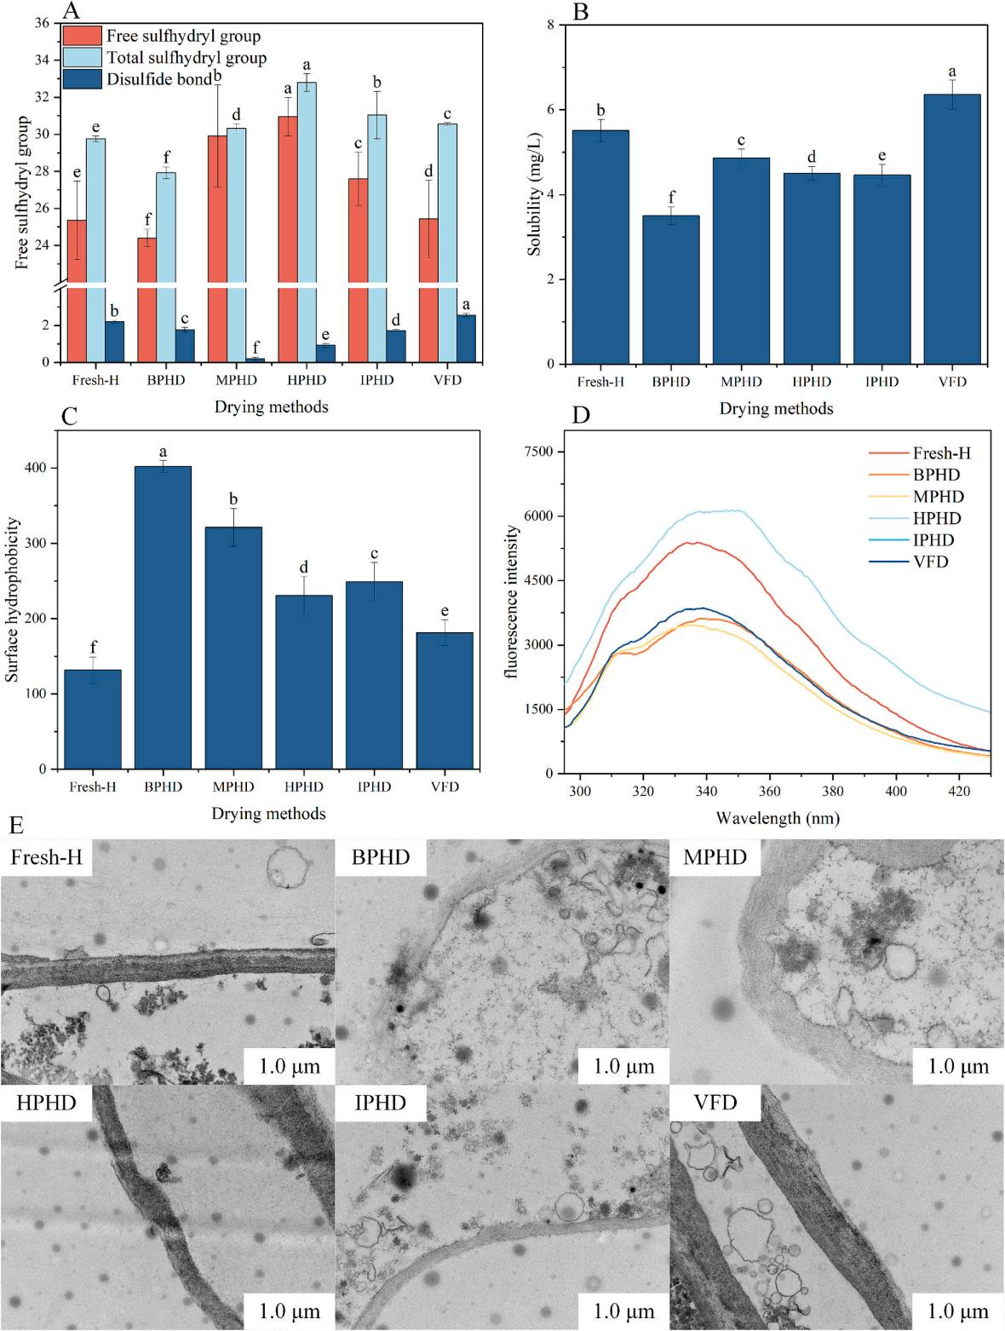
Fig. 2. Sulfhydryl content (A), solubility (B), surface hydrophobicity (C) and fluorescence spectra (D) of PEP. TEM image of P. eryngii. Different letters indicate significant differences at (P < 0.05) according to the Tukey's test.

3.5. Structure analysis

3.5.1. FTIR spectroscopy analysis
The original FTIR spectrum of PEP is shown in Fig. 3A. The band between 3600 and 3200 cm_ 1 was related to the stretching vibration of hydroxyl groups in the protein itself. The band between 3000 and 2850 cm_ 1 was associated with the stretching vibration of C–H bonds in the protein molecules, with a peak around 2963 cm_ 1 representing the stretching vibration of –CH₂, showing significant differences among various pretreatment methods. In the FTIR spectrum, amide compounds had stretching vibrations for C––O, C–N, NH₂, and NH, as well as bending vibrations for NH₂ and NH [24]. Additionally, amide IV, V, VI, and VII bands were in the low-frequency region (700–650 cm_ 1) and had weaker intensities, not representing characteristic frequencies [25]. The amide I band (carbonyl C–– O stretching vibration) was widely used in the analysis of protein secondary structure, with the band ranging from 1700 to 1600 cm_ 1. The deconvoluted FTIR spectrum in Fig. 3B showed that the peak values were lower for the heat-treated

samples compared to the control group VFD. Considering that high temperatures could lead to protein molecular cleavage and peptide bond breakage, this reduction resulted in fewer contributing groups for the amide I vibration and a lower peak value [26]. The peak value for BPHD was the lowest, indicating a greater extent of protein denaturation. Peaks at 1660 cm_ 1 and 1682 cm_ 1 corresponded to the stretching vi- bration frequencies of formamide and hexamide, respectively. The stretching vibration frequencies of aliphatic N-acyl amides were be- tween 1650 and 1670 cm_ 1. Peaks for N-methyl formamide (1668 cm_ 1) and N-methyl acetamide (1656 cm_ 1) were observed in VFD, IPHD, and HPHD, while only N-methyl acetamide was found in MPHD, and none were detected in BPHD. This suggested that changes in the protein secondary structure led to partial peptide bond cleavage.
The amide II band (C–N stretching vibration) had a peak at 1550 cm_ 1, which exhibited a slight redshift and a decrease in peak intensity after pretreatment. Compared to Fresh-H, the peak values for MPHD, HPHD, and IPHD all increased. These results indicated that, under moderate oxidative modification, peptide bond cleavage might have led

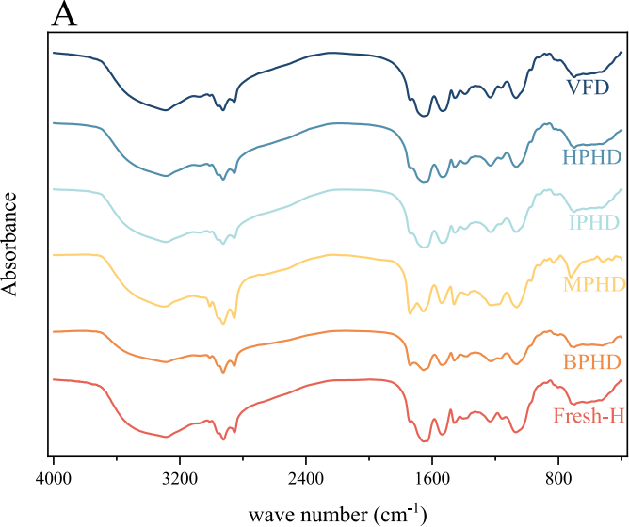
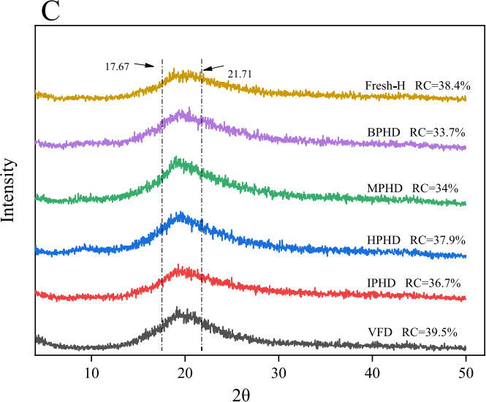
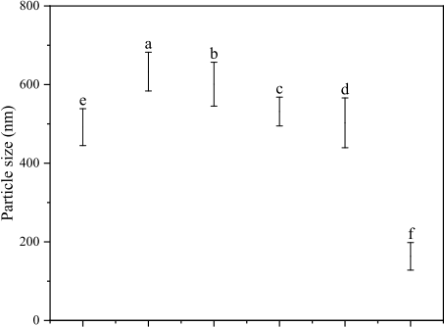

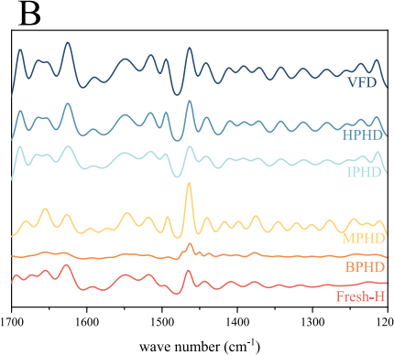

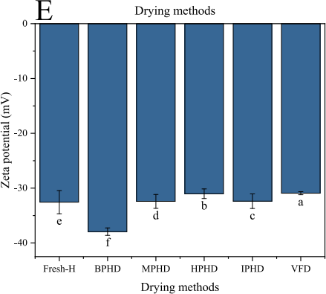
Fig. 3. FTIR spectrum (A), inverse convolution FTIR spectrum (B), XRD (C), particle size (D) and zeta potential (E). Different letters indicate significant differences at (P < 0.05) according to the Tukey's test.

to C–N bond formation. Excessive modification (BPHD) resulted in peptide bond reformation and a decrease in C–N bonds, leading to a tendency for protein aggregation. The amide III band (C–N stretching vibration) had a vibration frequency between 1430 and 1350 cm_ 1, with MPHD showing an increase in peak intensity at 1370 cm_ 1. Excessive modification in BPHD caused oxidation and cleavage of some peptide bonds due to changes in the protein secondary structure, resulting in lower peak intensity [27].
The range of the amide I band was subjected to Fourier deconvolu- tion to calculate the protein's secondary structure. Table 1 shows the content of four types of protein secondary structures. The table indicated that the PEP structure was mainly composed of β-sheet and β-turn. Compared to VFD, α-helix, and β-sheet increased after treatment, while β-turn and random coil decreased. It was observed that β-turn and random coil in BPHD treatment gradually converted to β-sheet and α-helix. This change was likely due to the disruption and formation of corresponding hydrogen bonds, as shown in the amide A band of the FTIR spectrum. Compared to other pretreatments, BPHD had lower contents of α-helix and β-sheet and a higher content of random coil. This phenomenon was also found in the study by Guo et al. that over- modification leads to a transition from ordered to disordered protein structure [9].

3.5.2. XRD analysis
Determination of the crystalline structure of the substance, including precise identification of the crystalline phase components and study of the structural changes under processing conditions, can help to under- stand the properties of P. eryngii, assess the quality and optimize the processing; assessment of the crystallinity, which is related to the physicochemical properties and solubility, can be used for comparing the differences between different samples and investigating the effect of processing on it to improve the quality of the product [28]. The X-ray diffraction (XRD) patterns corresponding to the different drying methods are shown in Fig. 3C. The presence of distinct peaks in the 2θ range from 17.67O to 21.71O clearly indicates the presence of partial crystallinity in the samples. The results show that the highest crystal- linity of 39.5 % was observed after VFD. This is due to the fact that the low temperature environment during the VFD process has minimal ef- fect on the crystal structure of PEP. In contrast, the crystallinity of PEP from BPHD and MPHD was relatively low at 33.7 % and 34 %, respec- tively. These imply that the boiling water and microwave treatments caused more severe damage to the crystal structure of PEP. The possible reasons behind this are related to the high heat and energy involved in these treatments. Boiling water may cause thermal fluctuations that disturb the ordered arrangement of molecules within the crystal, while microwave radiation may cause internal stresses within the crystal lat- tice, leading to structural deformation [11]. On the other hand, con- ventional hot-air drying and freeze-drying are more conducive to preserving the crystal structure. Hot air drying provides a relatively stable drying environment that allows crystals to maintain their integ- rity without drastic pre-treatments such as boiling water or microwaves. Freeze drying is able to sublimate ice directly from the frozen state at low pressure, minimizing the possibility of structural damage during the drying process. Previous studies in the fields of materials science and

Tabıe 1
PEP secondary structure content.

Drying methods | Content (%)
 | α-helix | β-sheet | β-turn | random coil
Fresh-H | 19.78 | 20.23 | 40.23 | 19.76
BPHD | 24.22 | 20.26 | 35.64 | 19.88
MPHD | 29.33 | 24.62 | 25.62 | 20.43
HPHD | 28.56 | 26.64 | 25.64 | 19.16
IPHD | 31.65 | 28.64 | 22.81 | 16.90
VFD | 15.95 | 19.26 | 44.23 | 20.56

drying technology have also demonstrated similar effects of different drying and pretreatment methods on the crystallinity of various sub- stances [29,30]. These studies have shown that processes involving high energy inputs or extreme temperature changes tend to result in reduced crystallinity, further validating our findings.

3.5.3. Particle size and zeta potential analysis
Particle size could effectively reflect the extent of protein aggrega- tion and cross-linking. Fig. 3D showed that compared to Fresh-H, the particle size of PEP increased to varying degrees after pretreatment. This was due to high-temperature pretreatment causing peptide bond cleavage, oxidation of free sulfhydryl groups to form disulfide bonds, and resulting in protein cross-linking and aggregation [7]. The low- temperature environment of VFD alleviated this phenomenon, with a particle size of only 163.16 nm. Interestingly, although the formation of disulfide bonds leads to cross-linking and aggregation of proteins, which results in an increase in particle size. However, we found that the con- tent of disulfide bonds did not show the same trend as the particle size. This is due to a combination of reasons including hydrophobic in- teractions, electrostatic interactions, the degree of protein denaturation, and oxidative stress that alter the particle size. Therefore, the content of disulfide bonds and particle size did not show a significant correlation.
The zeta potential value is associated with the stability of colloidal dispersions, reflecting the extent of repulsion between neighboring particles with similar charges [31]. A zeta potential absolute value <30 mV indicated that the suspension was unstable, whereas a zeta potential absolute value >30 mV indicated that the suspension system was stable. As shown in Fig. 3E, the differences between the pretreated PEP and Fresh-H were not significant, but the absolute values of the zeta po- tential for all pretreated protein solutions exceeded 30 mV, indicating that all suspension systems were relatively stable.

3.5.4. Microstructure analysis
The morphology and structure of proteinshad a significant impact on their functional properties, including water- and oil-holding capacity, emulsifying properties and foaming properties, which directly affected the effectiveness and performance of proteins in practical applications [32]. Fig. 4A SEM image shows that the PEP from VFD exhibited a relatively compact lamellar structure with a porous surface and small pore size, generating a large number of fragments. The PEP surface from BPHD appeared ridge-like and had a more compact structure. PEP from other treatments exhibited a honeycomb structure, which had a good physical retention effect, primarily improving the protein's water- and oil-holding capacities. Among these, the honeycomb structure in MPHD was particularly prominent.

3.6. Physical and chemical indicators analysis

3.6.1. Turbidity analysis
Turbidity could characterize the optical properties of protein solu- tions and visually reflect the dispersion state of protein particles in the dispersion system, which indicated the aggregation state of proteins to some extent [33]. As shown in Fig. 5A, compared to VFD, other pre- treatment methods resulted in higher protein turbidity, indicating that oxidation-induced aggregation had occurred. The turbidity values of PEP overall showed an opposite trend to solubility (Fig. 2A); oxidation- induced aggregation formed insoluble aggregates. The creation of these insoluble aggregates decreased the dispersion of the protein solution, raised the frequency of collisions among aggregates, and resulted in higher absorbance values along with increased turbidity in the protein samples [34].

3.6.2. Water-holding capacity (WHC) and oil-holding capacity (OHC) analysis
As shown in Fig. 5B, compared to Fresh-H PEP, the increase in water- holding capacity after VFD was not significant. Water-holding capacity

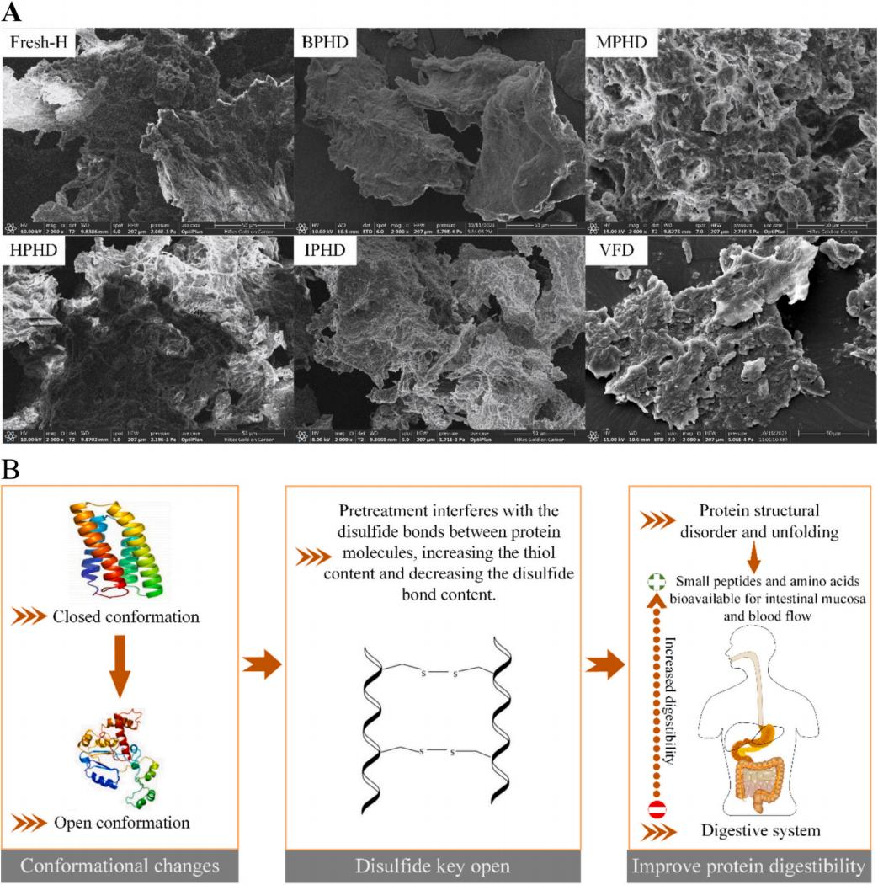
Fig. 4. SEM image of the pre-processed PEP (A), Schematic representation of the role of pretreatment on PEP (B).

increased more notably after BPHD, followed by MPHD, IPHD, and HPHD. This was because the charged and polar groups on the protein surface had a strong affinity for water, and the rate and extent of water binding were high. Boiling water treatment caused some proteins to transition from a compact ridge-like structure to a loose random coil structure (protein denaturation), which exposed these groups and thus enhanced water-holding capacity. The oil-holding capacity followed a pattern similar to that of the water-holding capacity. The higher oil- holding capacity for VFD might have been a result of the lower degree of protein modification and denaturation [35]. In addition to hydro- philicity, partial dissociation and unfolding of the protein exposed the hydrophobic sites of nonpolar amino acid side chains, increasing the protein's hydrophobic characteristics and thereby improving the oil- holding capacity of the treated proteins [36].

3.6.3. Emulsifying properties and foaming properties analysis
EAI denotes the capacity of proteins to create emulsions, whereas ESI reflects the emulsion's ability to retain its dispersed state and resist separation over a given time frame. Fig. 5C showed that compared to Fresh-H PEP, the EAI ofpretreated PEP increased to some extent, but the ESI decreased. Among the treatments, IPHD and MPHD had higher EAI, with increases of 50.5 % and 32.5 %, respectively, while VFD had a

lower EAI. This was due to the thermal aggregation of proteins and the deepening of the reaction between sugars and proteins during the drying process [9]. Interestingly, the EAI for BPHD was lower despite the higher treatment temperature, indicating that excessively high temperatures affected EAI. Intense chain stretching and unfolding of proteins led to reduced emulsification stability, which was the main reason for the decrease in ESI after pretreatment [37]. The low-temperature environ- ment of VFD resulted in the highest ESI, while other pretreatment methods showed more stable ESI.
Foam formation depended on the ability of proteins to form inter- facial films, maintain suspended air bubbles, and slow down coalescence rates. Fig. 5D showed that compared to Fresh-H, both FC and FS of pretreated PEP increased. HPHD PEP had the worst FC due to oxidative reactions exposing hydrophobic groups and forming insoluble aggre- gates, which reduced its interfacial adsorption ability and prevented the formation of a tightly packed interfacial layer [38]. BPHD, MPHD, and IPHD had better FC because the H0 values of the proteins influenced the initial adsorption rate at the air-water interface. Higher H0 values facilitated faster diffusion of protein molecules to the air-water inter- face, aiding in air particle encapsulation and increasing foaming ability. Interestingly, despite the lower H0 of VFD proteins, it had the best FC. This was because the vacuum environment during VFD prevented

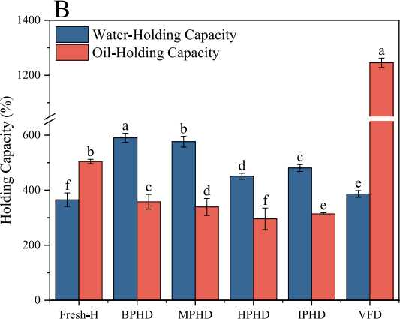
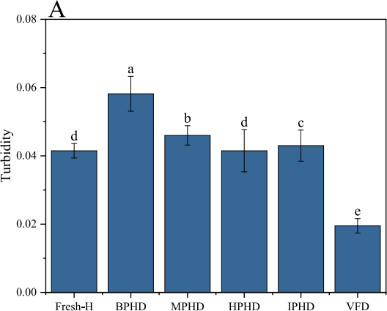
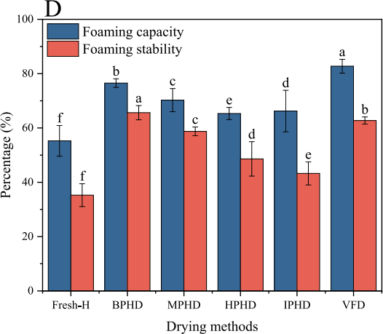
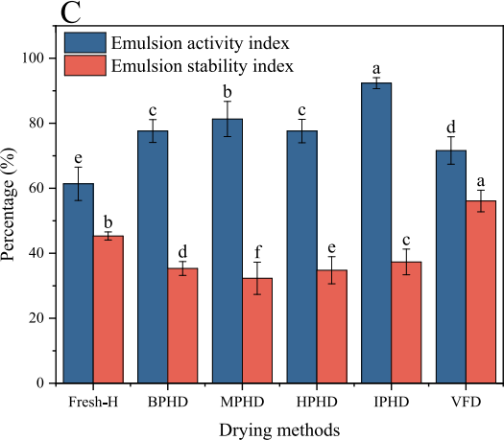
Fig. 5. Turbidity (A), water-holding and oil-holding properties (B), emulsifying properties (C) and foaming properties (D). Different letters indicate significant differences at (P < 0.05) according to the Tukey's test.

oxidative reactions and blocked the exposure of hydrophobic groups. FS showed a different trend from FC, with IPHD proteins having good foaming ability but poorer FS, indicating that FS was influenced by multiple factors.

3.7. Thermal stability analysis
Thermogravimetric analysis (TGA) of pretreated PEP was performed with the main objective of investigating thermal stability and potential structural differences between treatments. Fig. 6A illustrates the thermal decomposition process of PEP. During the continuous heating process, all samples demonstrated significant weight loss, and they exhibited a similar trend. In the initial stage, from room temperature to 200 O C, approximately 10 % of the weight was lost. This loss can be primarily attributed to the evaporation of moisture within the samples. Subse- quently, the decomposition processes of all samples displayed compa- rable thermogravimetric behavior within the extensive temperature range of 200–600 O C.
Notably, the residue rates of MPHD and IPHD were 31.19 % and 29.1 %, respectively. In stark contrast, the final residue rate for BPHD PEP was merely 2.81 %. The relatively higher residue rates in MPHD and IPHD suggest that microwave and infrared pretreatments have a positive impact on the stability of PEP. This enhanced stability could be due to potential alterations in the protein structure caused by these pretreat- ment methods. For instance, microwave and infrared radiation might lead to cross - linking or conformational changes in the protein

molecules of PEP, thereby making them more resistant to thermal decomposition [39]. Previous research has also provided evidence supporting the role of such pretreatments in improving protein stability [40,41]. These studies have shown similar trends in other protein sys- tems where specific pretreatments led to increased stability as indicated by TGA analysis.

3.8. In vitro digestive analysis

3.8.1. Protein hydrolysis analysis
Fig. 6B shows that the trends in hydrolysis for PEP treated by different methods were similar. Overall, there was a slow increase during the gastric digestion phase and a trend of rising and then falling during the intestinal digestion phase. In the early stage of gastric digestion (30–120 min), the hydrolysis degree gradually increases with digestion time. During this phase, gastric acid and pepsin began to act, progressively breaking down the protein into smaller peptide fragments [42]. In the early part of the intestinal digestion phase (120–150 min), the hydrolysis degree increased sharply due to the combined action of various enzymes such as trypsin and intestinal peptidases in the intes- tinal juice, further breaking down proteins into amino acids or small peptides [43]. It was observed that after 150 min, the hydrolysis degree plateaued, which was due to the decrease in substrate concentration and stabilization of enzyme activity, leading to a gradual slowing of the hydrolysis rate. This process demonstrated how proteins are progres- sively broken down and absorbed in the digestive system. During the

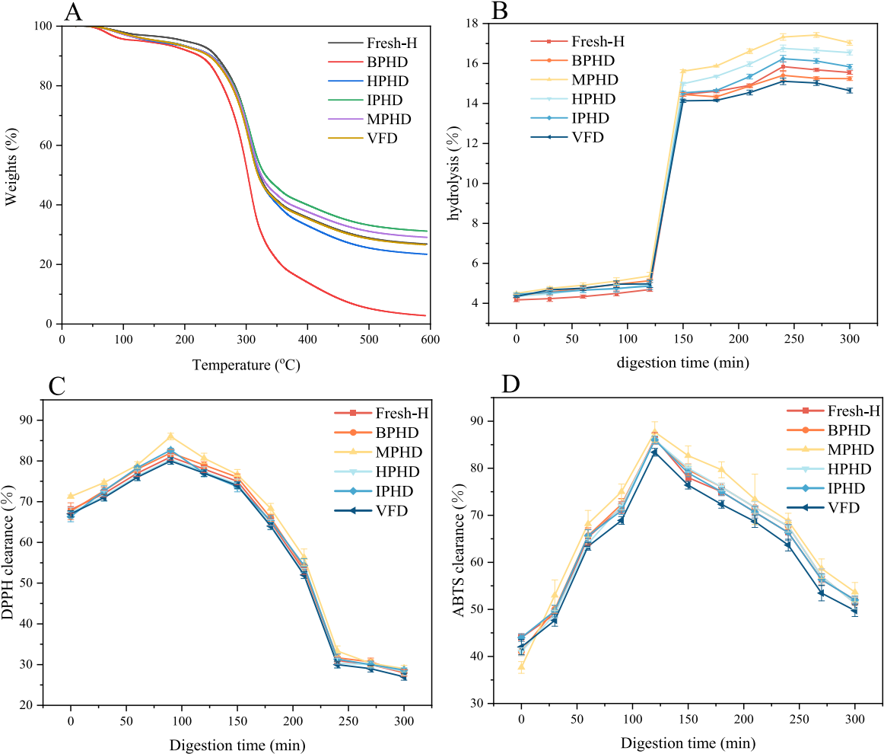
Fig. 6. TGA analysis (A), hydrolysis degree (B), DPPH (C) and ABTS (D) free radical scavenging capacity.

intestinal digestion phase, MPHD PEP had the highest hydrolysis degree. Compared to VFD, the digestion rates for PEP from other pretreatment methods increased. After 240 min of digestion, the digestion rate began to decrease, with hydrolysis reaching its peak. MPHD and HPHD had the highest hydrolysis degrees, reaching 17.33 % and 16.76 %, respectively.

3.8.2. Antioxidant activity analysis
Evaluation of antioxidant capacity, which measures the free radical scavenging ability of a sample, is used to compare different samples, study the effect of processing on them, and has implications for the development of relevant products and optimization of processes. This helps to understand its function and application scenarios and safeguard product quality and efficacy [44].
Fig. 6C and D demonstrate the antioxidant activity of PEP digestion products obtained by different pretreatment methods. During gastric digestion, the DPPH scavenging rate tended to increase with increasing gastric digestion time (0–120 min), which could be attributed to the release of antioxidant components during the initial stage of digestion. However, as digestion progressed further, the clearance rate began to decrease. This may be due to the possible degradation or alteration of antioxidant substances under the continuous action of gastric enzymes. In contrast, the ABTS scavenging rate showed a continuous increase throughout gastric digestion, suggesting that the components respon- sible for scavenging ABTS are either being continuously released or their activity is increasing during this process. After entering the intestinal

digestion phase, the DPPH scavenging rate gradually stabilized, sug- gesting that a dynamic equilibrium between antioxidant production and depletion had been reached in the system. In contrast, the ABTS scav- enging rate continued to decrease, which could be attributed to the complex environment in the intestine, where various enzymes and other substances may interact with the antioxidant components, thus reducing their effectiveness in scavenging ABTS radicals.
When comparing the antioxidant activity of different PEP, it was found that the antioxidant activity of pretreated PEP was increased compared to those obtained by VFD. This may be due to the fact that pretreatment changes the structure or composition of PEP, which leads to an increase in the activity of antioxidant-related components. The PEP from MPHD showed the most significant antioxidant activity, which may be due to the changes in the molecular structure of PEP caused by microwaves [45]. Studies have shown that pretreatment methods significantly affect the antioxidant properties of various food-derived substances [46,47]. The trends observed in the study provide valuable insights into the potential application of these pretreated PEPs in antioxidant-related products or functional foods.

3.9. Free amino acid (FAA) analysis
As shown in Table 2, different treatment methods significantly affected the total FAA and individual FAA contents in P. eryngii. Compared to fresh P. eryngii, the total FAA content in BPHD, MPHD,

Tabıe 2
Free amino acid content of P. eryngii.

 | FAA | Fresh | The quantity contained (mg/g DW) |  |  | VFD
 |  |  | BPHD MPHD | HPHD | IPHD
EAA | Threonine | 3.18 ± 0.11a | 0.45 ± 0.07d 1.04 ± 0.12c | 1.16 ± 0.11c | 0.98 ± 0.10c | 2.69 ± 0.12b
 | Valine | 3.65 ± 0.28a | 0.54 ± 0.09e 1.19 ± 0.02cd | 1.27 ± 0.08c | 0.87 ± 0.06de | 2.94 ± 0.19b
 | Isoleucine | 3.78 ± 0.28a | 0.36 ± 0.06c 0.72 ± 0.06c | 0.86 ± 0.11c | 0.63 ± 0.10c | 2.50 ± 0.26b
 | Leucine | 4.24 ± 0.15a | 0.58 ± 0.05d 1.35 ± 0.16bc | 1.62 ± 0.07b | 1.15 ± 0.12c | 4.02 ± 0.17a
 | Phenylalanine | 3.52 ± 0.21a | 0.41 ± 0.03d 1.09 ± 0.17c | 1.17 ± 0.15c | 0.93 ± 0.14cd | 2.85 ± 0.18b
 | Lysine | 10.21 ± 0.51a | 2.58 ± 0.19c 4.78 ± 0.61b | 4.65 ± 0.05b | 4.55 ± 0.25b | 8.76 ± 0.64a
 | Histidine | 2.55 ± 0.21a | 0.10 ± 0.04c 0.42 ± 0.06c | 0.46 ± 0.04c | 0.29 ± 0.05c | 1.46 ± 0.16b
 | Methionine | 1.12 ± 0.08a | 0.09 ± 0.02c 0.10 ± 0.03c | 0.22 ± 0.06c | 0.13 ± 0.03c | 1.08 ± 0.12b
NEAA | Aspartic acid | 2.11 ± 0.11a | 0.23 ± 0.04d 0.73 ± 0.13c | 0.70 ± 0.03c | 0.51 ± 0.11cd | 1.28 ± 0.21b
 | Serine | 4.21 ± 0.10a | 0.35 ± 0.05d 1.17 ± 0.10c | 1.71 ± 0.13b | 0.70 ± 0.10d | 4.48 ± 0.16a
 | Glutamate | 5.55 ± 0.23a | 0.32 ± 0.04e 1.55 ± 0.07c | 1.90 ± 0.10c | 0.83 ± 0.08d | 4.26 ± 0.19b
 | Glycine | 2.11 ± 0.15a | 0.25 ± 0.05c 0.71 ± 0.11b | 0.59 ± 0.09b | 0.46 ± 0.09bc | 1.81 ± 0.10a
 | Alanine | 4.52 ± 0.20a | 1.63 ± 0.17c 2.22 ± 0.12c | 1.67 ± 0.11c | 1.60 ± 0.13c | 3.85 ± 0.31b
 | Cystine | 2.85 ± 0.08a | 0.84 ± 0.07c 1.22 ± 0.11c | 0.87 ± 0.15c | 1.02 ± 0.15c | 2.08 ± 0.26b
 | Tyrosine | 2.56 ± 0.12a | 0.57 ± 0.10c 1.15 ± 0.13b | 1.14 ± 0.16b | 0.90 ± 0.06bc | 2.58 ± 0.14a
 | Proline | 3.24 ± 0.22a | 0.34 ± 0.04c 0.67 ± 0.08c | 0.65 ± 0.09c | 0.64 ± 0.09c | 2.26 ± 0.13b
 | Arginine | 0.12 ± 0.03d | 1.97 ± 0.14c 3.55 ± 0.15a | 1.83 ± 0.11c | 3.05 ± 0.19b | 3.01 ± 0.17b
 | EAA | 32.25 ± 1.30a | 5.14 ± 0.33d 10.69 ± 1.11c | 11.41 ± 0.45c | 9.54 ± 0.32c | 26.29 ± 1.28b
 | NEAA | 27.26 ± 0.23a | 6.50 ± 0.15f 12.97 ± 0.32c | 11.07 ± 0.07d | 9.71 ± 0.25e | 25.61 ± 0.56b
 | Total | 59.50 ± 1.12a | 11.64 ± 0.17e 23.67 ± 1.42c | 22.48 ± 0.52cd | 19.24 ± 0.55d | 51.90 ± 1.83b
Different letters in the same row indicate significant differences (P < 0.05).

HPHD, and IPHD samples decreased by 80.44 %, 60.22 %, 62.2 %, and 67.66 %, respectively. EAA decreased by 64.62 % to 84.06 %. This was due to the Maillard reaction between free amino acids and soluble sugars during the drying process, which led to substantial consumption of these compounds [48]. Interestingly, some individual FAA contents increased rather than decreased, mainly due to protein hydrolysis caused by proteases or high temperatures. As Bi et al. mentioned for rapeseed pollen, differences in the extent of protein hydrolysis and Maillard re- actions during drying led to variations in the quantity and content of free amino acids in the samples [49].
Compared to fresh P. eryngii, the FAA and EAA contents in VFD remained relatively stable. This was because the low-temperature vac- uum environment of freeze-drying reduced the occurrence of FAA hy- drolysis and Maillard reactions while increasing the solubility and hydrophobicity of derived proteins, thus releasing more FAA (Wang). On the other hand, the FAA and EAA contents were lowest in the BPHD samples, which was likely due to the high temperature of boiling water causing amino acids to undergo degradation, converting them into organic acids and other flavor compounds, resulting in substantial loss of amino acids [50].

3.10. Volatile compound analysis
Volatiles were formed through various pathways, including the Maillard reaction, degradation of long-chain compounds, oxidation of unsaturated fatty acids, and interactions with proteins, peptides, and free amino acids [51]. The volatile compounds in P. eryngii differed significantly with different pretreatment methods (Table 3). GC–MS detected a total of 88 volatile substances, which were categorized into five groups: alcohols (11 types), esters (8 types), aldehydes (12 types), hydrocarbons (11 types), and others (46 types). During the drying process, while there was some loss of volatile substances in king oyster mushrooms, a large number of new volatile substances were also generated.
The alcohols had the highest content among the volatile compounds in P. eryngii, and their precursors were primarily polyunsaturated fatty acids. Oct-1-en-3-ol was the main volatile compound, followed by linalool, (一 )-terpinen-4-ol, and phenethyl alcohol. Oct-1-en-3-ol, also known as mushroom alcohol, has a characteristic mushroom odor and is an aliphatic unsaturated alcohol. Linalool had a lily of the valley aroma, and phenethyl alcohol had a sweet, rose-like floral fragrance. After drying treatments, the content of oct-1-en-3-ol decreased, but some new

alcohol compounds were produced, enhancing the product's flavor.
Esters served as the primary source of sweet and slightly oily aromas in food. After drying, the content of ester compounds increased signifi- cantly, with HPHD having the highest ester content. MPHD and BPHD had fewer types of esters, likely due to higher temperatures. Overall, linalyl acetate had the highest content, possessing a delicate fragrance similar to lily of the valley and lavender essential oils, followed by dimethyl phthalate, which was detected in all samples.
Aldehydes were abundant in edible fungi and had a low odor threshold, contributing significantly to the overall volatile compounds. Aldehydes with carbon chains from C5 to C9 originated from lipid oxidation and degradation and possessed fatty aromas. Many Strecker aldehydes and their reaction products played an important role in food flavoring. After drying, both the content and variety of aldehyde com- pounds increased, with IPHD having the highest aldehyde content, fol- lowed by HPHD and MPHD. Phenylacetaldehyde, which emitted a fruity sweet aroma when diluted, was detected in all treatments except VFD. Benzaldehyde, which had a bitter almond, cherry, and nut aroma, was detected in all samples.
A total of 11 hydrocarbon compounds were detected. HPHD had the most alkanes, while IPHD had a relatively high content. Different drying methods produced new alkanes. Although hydrocarbons generally had a high threshold and did not significantly impact the overall volatile profile of P. eryngii, certain alkanes contributed unique flavors. For example, (+)-Limonene, which had the highest concentration, imparted a fresh orange and lemon aroma to the food. Other volatile compounds were either present in low amounts or had high thresholds and were not discussed.

3.11. Flavor PCA analysis
The results of principal component analysis for free amino acids and volatile compounds were shown in Fig. 7. The contribution rates of PCA1 and PCA2 are 66.24 % and 18.97 % respectively, and the cumu- lative contribution rate reaches 85.21 %, which indicates that these two principal components can better reflect the overall information of the original data. It was observed that the HPHD, MPHD and VFD samples were closer in PCA1 and PCA2, especially PCA1. PCA1 was the principal component explaining the most variance, which represented that the samples of PHD, MPHD and VFD had similar characteristics in the main variables of free amino acids and volatile compounds, i.e., in the con- tent, proportion or some key characteristics of these compounds were

Tabıe 3
Volatile compound content of the P. eryngii.

Code | Retention time (min) | Compound | CAS | Fresh | Relative content (ng/g) |  |  |  | VFD
 |  |  |  |  | BPHD | MPHD | HPHD | IPHD
Alcohol
1 | 11.617 | 3-Methyl-1-butanol | 123–51-3 | ND | 5.53 ± | 3.32 ± | 23.92 ± | 49.16 ± | ND
 |  |  |  |  | 0.75c | 0.38d | 3.25b | 8.93a
2 | 11.617 | 2-Methylbutan-1-ol | 137–32-6 | 18.45 ± 0.57a | 2.80 ±  0.41d | ND | 14.13 ± 1.36c | 16.85 ± 0.46b | ND
3 | 12.683 | pentanol | 71–41-0 | 1.75 ±  0.05d | ND | 2.24 ±  0.81b | ND | 3.35 ±  0.10a | 1.82 ±  0.07c
4 | 12.383 | 2,3-Butanediol | 24,347–58- 8 | ND | ND | ND | 17.51 ± 1.95b | 43.95 ± 1.36a | 3.08 ±  0.08c
5 | 12.383 | butane-2,3-diol | 513–85-9 | 13.43 ± | 6.07 ± | 12.82 ± | 4.91 ± | 22.15 ± | 0.77 ±
 |  |  |  | 0.67b | 2.15d | 0.83c | 0.43e | 5.91a | 0.05f
6 | 14.333 | 1-Hexanol | 111–27-3 | 22.21 ± 2.14b | ND | 8.51 ±  1.41d | 41.41 ± 3.92a | 11.15 ± 0.64c | 3.88 ±  0.89e
7 | 16.15 | Oct-1-en-3-ol | 3391-86-4 | 128.92 ± 1.60a | ND | 118.08 ± 2.96c | 115.76 ± 2.31d | 115.12 ± 3.41e | 120.88 ± 0.38b
8 | 17.65 | Cineole | 470–82-6 | 8.44 ±  1.45d | 19.11 ± 0.90a | ND | ND | 10.74 ± 0.20b | 8.94 ±  0.57c
9 | 18.033 | Linalool | 78–70-6 | ND | 43.90 ± | 52.83 ± | 61.66 ± | 40.09 ± | 25.66 ±
 |  |  |  |  | 3.13c | 4.23b | 5.99a | 1.08d | 2.31e
10 | 18.933 | Phenethyl alcohol | 60–12-8 | 14.69 ± 0.82e | 6.11 ±  0.73d | ND | 30.96 ± 3.23a | 22.81 ± 3.73b | 17.43 ± 1.46c
11 | 18.95 | (一 )-Terpinen-4-ol | 20,126–76- | 1.87 ± | 17.44 ± | 20.82 ± | 21.71 ± | 18.68 ± | 14.94 ±
 |  |  | 5 | 0.32f | 1.26d | 1.30b | 0.41a | 0.71c | 0.30e
Ester
1 | 9.767 | ethyl acetate | 141–78-6 | ND | ND | 4.75 ± | 4.80 ± | 14.32 ± | ND
 |  |  |  |  |  | 0.45c | 0.10b | 0.38a
2 | 20.983 | Ethyl phenylacetate | 101–97-3 | ND | ND | ND | 56.96 ± 7.94a | 31.61 ± 5.92b | ND
3 | 21.167 | linalyl formate | 115–99-1 | 1.70 ±  1.52b | ND | ND | ND | 35.83 ± 1.53a | ND
4 | 21.167 | lavandulyl acetate | 25,905–14- 0 | ND | 4.29 ±  0.34c | 4.95 ±  0.11b | 7.09 ±  0.87a | 2.77 ±  0.42e | 3.30 ±  1.52d
5 | 21.2 | Linalyl acetate | 115–95-7 | ND | 88.50 ± | 117.88 ± | 111.20 ± | 48.54 ± | 115.72 ±
 |  |  |  |  | 5.81d | 4.02a | 4.67c | 4.26e | 3.19b
6 | 22.217 | α-Terpinyl acetate | 80–26-2 | ND | 9.31 ±  0.08b | ND | 12.39 ± 0.86a | ND | 3.86 ±  0.18c
7 | 23.983 | Methyl veratrate | 2150-38-1 | ND | ND | ND | ND | 6.04 ±  0.49a | ND
8  Aldehyde  1 | 24 | Dimethyl phthalate | 131–11-3 | 2.35 ± 0.84f | 34.15 ± 3.08a | 10.98 ± 0.93d | 20.05 ± 1.72b | 7.01 ±  0.77e | 15.03 ± 1.76c
 | 9.05 | Isobutyraldehyde | 78–84-2 | ND | ND | 7.34 ±  0.93b | ND | 7.79 ±  0.51a | ND
2 | 10.717 | Isovaleraldehyde | 590–86-3 | ND | 4.95 ± | 69.32 ± | 33.74 ± | 77.96 ± | 28.20 ±
 |  |  |  |  | 0.11e | 9.39b | 0.57c | 11.22a | 0.80d
3 | 10.717 | 2-Methylbutanal | 96–17-3 | ND | ND | 47.91 ± | 19.46 ± | 52.59 ± | ND
 |  |  |  |  |  | 9.39b | 3.14c | 10.34a
4 | 12.367 | Methyl Valeraldehyde | 123–15-9 | ND | ND | 1.64 ± | 1.92 ± | 3.34 ± | ND
 |  |  |  |  |  | 0.03c | 0.66b | 0.52a
5 | 13.433 | Hexanal | 66–25-1 | 33.16 ± | 3.96 ± | 16.30 ± | 17.48 ± | 24.95 ± | 28.55 ±
 |  |  |  | 1.62a | 0.31f | 3.12e | 2.15d | 1.03c | 1.70b
6 | 14.3 | Methional | 3268-49-3 | ND | ND | ND | 1.56 ±  0.08a | 1.26 ±  0.13b | ND
7 | 16.367 | Benzaldehyde | 100–52-7 | 2.25 ± | 2.53 ± | 33.83 ± | 93.10 ± | 49.98 ± | 12.02 ±
 |  |  |  | 1.84f | 0.39e | 3.31c | 1.08a | 16.02b | 1.95d
8 | 18.017 | Phenylacetaldehyde | 122–78-1 | ND | 5.88 ± | 59.73 ± | 72.76 ± | 74.25 ± | ND
 |  |  |  |  | 0.29d | 16.05c | 7.29b | 26.72a
9 | 18.4 | Nonanal | 124–19-6 | 0.81 ± | 3.34 ± | 2.31 ± | 3.20 ± | 10.60 ± | 2.04 ±
 |  |  |  | 0.49f | 1.50b | 0.14d | 1.30c | 0.77a | 0.57e
10 | 19.817 | Cinnamic aldehyde | 14,371–10- 9 | ND | ND | ND | ND | 19.30 ± 0.83a | 2.56 ±  1.40b
11 | 20.067 | Decanal | 112–31-2 | 1.20 ±  0.17c | 3.57 ±  0.06b | ND | ND | 4.46 ±  0.29a | 0.87 ±  0.14d
12  Hydrocarbon  1 | 20.5 | cuminaldehyde | 122–03-2 | ND | ND | ND | ND | 35.19 ± 2.44a | 10.79 ± 1.47b
 | 10.333 | hexamethylcyclotrisiloxane | 541–05-9 | 4.04 ±  0.78e | 15.29 ± 2.67a | 11.90 ± 0.59b | 4.96 ±  2.80d | 1.18 ± 0.29f | 9.22 ±  0.75c
2 | 11.717 | 2,2,3,4-tetramethylpentane | 1186–53-4 | ND | ND | ND | ND | 0.61 ±  0.13a | ND
3 | 13.783 | Octamethylcyclotetrasiloxane | 556–67-2 | 4.39 ± | 12.84 ± | 8.99 ± | 2.40 ± | 6.17 ± | 8.29 ±
 |  |  |  | 0.54e | 2.71a | 3.05b | 0.72f | 1.36d | 1.35c
(continued on next page)

Table 3 (continued )

Code | Retention time (min) | Compound | CAS | Fresh | Relative content (ng/g) |  |  |  | VFD
 |  |  |  |  | BPHD | MPHD | HPHD | IPHD
4 | 14.717 | Styrene | 100–42-5 | 2.16 ±  0.39b | ND | ND | ND | 8.11 ±  0.80a | 0.29 ±  0.02c
5 | 15.717 | Beta-pinene | 18,172–67- 3 | ND | 14.86 ± 3.13a | ND | 14.80 ± 2.36b | ND | ND
6 | 15.8 | carene | 13,466–78- 9 | ND | 6.72 ±  0.92c | ND | 17.80 ± 1.74a | 13.16 ± 0.60b | ND
7 | 16.633 | alpha-Terpinene | 99–86-5 | ND | 3.30 ±  0.09d | 6.16 ±  0.10a | 4.17 ±  0.63b | ND | 3.36 ±  0.09c
8 | 16.633 | γ-terpinene | 99–85-4 | ND | 6.35 ±  0.72c | 12.61 ± 1.27a | 8.35 ±  1.97b | ND | ND
9 | 16.967 | (+)-Limonene | 5989-27-5 | 8.25 ± 0.09f | 16.49 ± 0.93c | 14.13 ± 0.60d | 48.64 ±  10.61a | 10.45 ± 0.23e | 20.56 ± 1.12b
10 | 17.367 | o-Cymene | 527–84-4 | ND | ND | 6.07 ±  0.41a | 1.82 ±  0.13c | 2.59 ±  0.27b | ND
11 | 17.367 | p-cymene | 99–87-6 | ND | 1.65 ±  0.22c | 5.33 ±  0.23a | ND | ND | 1.88 ±  0.10b
ND: not detected or failure to meet test line. Different letters in the same row indicate significant differences (P < 0.05).

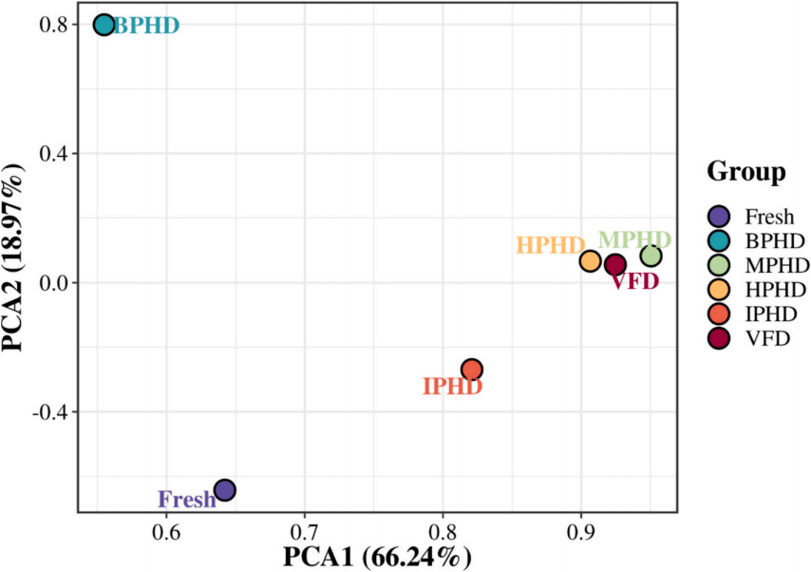
Fig. 7. PCA analysis of P. eryngii flavor.

similar. This is in contrast to the Fresh and BPHD samples, which showed large differences in both PCA1 and PCA2, which illustrates the similarities and differences between the different samples. This suggests that the Fresh and BPHD samples may be significantly different in the composition of free amino acids or volatile compounds, leading to their differentiation. IPHD falls somewhere in between. Based on the degree of aggregation and dispersion of the samples, the flavor profiles of apricot mushrooms from different drying processes can be effectively differentiated.

4. Conclusion
This study investigated the effects of high-temperature pretreatment under different conditions combined with hot-air drying on the structure and properties of PEP, along with an analysis of the flavor of dried P. eryngii. The results indicated that the secondary structure and prop- erties of PEP changed after pretreatment. Pretreatment altered the protein structure, causing it to transition from ordered to disordered. The flexible protein structures in MPHD and IPHD improved

emulsification performance and stability. The superior hydrolysis de- gree and antioxidant capacity also made MPHD a new option for PEP processing. Analysis of free amino acids and volatile compounds showed that pretreatment helped enhance the flavor of P. eryngii products. This study provided a theoretical basis for improving solubility and emulsi- fication in PEP processing through pretreatment before drying. It also assessed the flavor characteristics of pretreated P. eryngii as a superior protein substitute. The results of this study are expected to assist the food industry in selecting appropriate pretreatment processes and pro- cessing conditions to produce P. eryngii products with specific protein functional properties.

CRediT authorship contribution statement
Deqing Wang: Writing – original draft, Methodology, Conceptuali- zation. Dianbin Su: Resources, Funding acquisition. Huihui Xu: Re- sources. Xiaofeng Chen: Writing – original draft. Weiqiao Lv: Supervision. Yong Wang: Writing – review & editing. Xia Sun: Re- sources. Yemin Guo: Resources. Yukuan Ding: Methodology.

[18] Z.-W. Liu, P.-P. Tang, Y.-X. Zhang, J.-H. Cheng, R.M. Aadil, X.-B. Liu, Preventing thermal aggregation of ovalbumin through dielectric-barrier discharge plasma

Declaration of competing interest
All authors disclosed no relevant relationships.

Acknowledgements
This research was supported by the Shandong Provincial Natural Science Foundation (ZR2022QC159), Technology Innovation Guidance Project of Gansu Provincial Science and Technology Department (22CX8NA023), and Shandong University of Technology Young Mentors Study Visit Program.

Appendix A. Supplementary data
Supplementary data to this article can be found online at https://doi. org/10.1016/j.ijbiomac.2024.138306.

References
treatment and enhancing its emulsification properties, Int. J. Biol. Macromol. 267 (2024) 131578.
[19] M. Iida, S. Tsuda, M. Kikuchi, M. Samoto, N. Adachi, A. Nakamura, Extraction of water-soluble polysaccharides from lupin beans and their function of protein
dispersion and stabilization under acidic conditions, Int. J. Biol. Macromol. 278 (2024) 134664.
[20] A.M. Ganjeh, C.A. Pinto, S. Casal, J.A. Saraiva, The effects of pressure-based processing technologies on protein oxidation, Food Biosci. 59 (2024) 103963.
[21] J. Koop, J. Merz, G. Schembecker, Hydrophobicity, amphilicity, and flexibility: relation between molecular protein properties and the macroscopic effects of surface activity, J. Biotechnol. 334 (2021) 11–25.
[22] S. Joshi, S. Asthana, M.D. Pandey, R. Pandey, Thiazole-based metalloligands and their heteroleptic MOFs: chromogenic and fluorometric detection of tryptophan and Z-l-phenylalanine using Cu(II)-complex and Cu(II)-Zn(II) MOF, J. Mol. Struct. 1319 (2025) 139469.
[23] C. Han, Y. Zheng, S. Huang, L. Xu, C. Zhou, Y. Sun, Z. Wu, Z. Wang, D. Pan, J. Cao, et al., Exploring the binding mechanisms of thermally and ultrasonically induced molten globule-like β-lactoglobulin with heptanal as revealed by multi-
spectroscopic techniques and molecular simulation, Int. J. Biol. Macromol. 263 (2024) 130300.
[24] S. Chakraborty, M.K. Paidi, I. Dhinakarasamy, M. Sivakumar, C. Clements, N.
K. Thirumurugan, L. Sivakumar, Adaptive mechanism of the marine bacterium
Pseudomonas sihuiensis-BFB-6S towards pCO2 variation: insights into synthesis of extracellular polymeric substances and physiochemical modulation, Int. J. Biol.
[1] Y. Wang, Y. Ji, K. Meng, J. Zhang, L. Zhong, Q. Zhan, L. Zhao, Effects of different selenium biofortification methods on Pleurotus eryngii polysaccharides: structural characteristics, antioxidant activity and binding capacity in vitro, Int. J. Biol.
Macromol. 275 (2024) 133214.
[2] D. Wu, X. Jia, X. Zheng, Y. Mo, J. Teng, L. Huang, N. Xia, Physicochemical and functional properties of Pleurotus eryngii proteins with different molecular weight, LWT 184 (2023) 115102.
[3] H.K. Ketemepi, M.A.B. Awang, J.S.S. Seelan, N.Q.I. Mohd Noor, Extraction process and applications of mushroom-derived protein hydrolysate: a comprehensive
review, Future Foods 9 (2024) 100359.
[4] I. Habinshuti, D. Nsengumuremyi, B. Muhoza, F. Ebenezer, A. Yinka Aregbe,
M. Antoine Ndisanze, Recent and novel processing technologies coupled with
enzymatic hydrolysis to enhance the production of antioxidant peptides from food proteins: a review, Food Chem. 423 (2023) 136313.
[5] L. Zheng, Y. San, Y. Xing, J.M. Regenstein, Rice proteins: a review of their
extraction, modification techniques and applications, Int. J. Biol. Macromol. 268 (2024) 131705.
[6] A.S. Chandran, S. Suri, P. Choudhary, Sustainable plant protein: an up-to-date overview of sources, extraction techniques and utilization, Sustainable Food
Technology 1 (4) (2023) 466–483.
[7] F.F. Ajayi, P. Mudgil, S. Maqsood, Unveiling differential impact of heat and
microwave extraction treatments on the structure, functionality, and digestibility of jack bean proteins extracted under varying extraction pH, Food Res. Int. 191 (2024) 114686.
[8] M. Al-Wraikat, M.A. Abubaker, Y. Liu, X.P. Shen, Y. He, L. Li, Y. Liu, Label-free quantitative proteomic analysis of functional changes of goat milk whey proteins subject to heat treatments of ultra-high-temperature and the common low-
temperature, Food Chemistry: X 23 (2024) 101691.
[9] Y. Guo, T. Tian, C. Zeng, H. Wang, T. Yang, W. Zhou, X. Sui, L. Chen, Z. Huang, L. Jiang, Effect of heat treatment on the structural and emulsifying properties of copra meal protein: improving interfacial properties to enhance performance of its Pickering emulsion, Food Chemistry: X 22 (2024) 101442.
[10] M. Navaf, K.V. Sunooj, B. Aaliya, C. Sudheesh, P.P. Akhila, S.A. Mir, M.
R. Nemtanu, J. George, M. Lackner, A. Mousavi Khaneghah, Contemporary insights into the extraction, functional properties, and therapeutic applications of plant
proteins, Journal of Agriculture and Food Research 14 (2023) 100861.
[11] M.V. Rao, C.K. Sunil, N. Venkatachalapathy, Effect of microwave and hot air
radiofrequency treatments on physicochemical and functional properties of foxtail millet flour and its protein isolate, J. Cereal Sci. 114 (2023) 103774.
[12] N.Y. Salazar-Salas, L. Valenzuela-Ponce, M.O. Vega-Garcia, K.V. Pineda-Hidalgo, M. Vega-Alvarez, J. Chavez-Ontiveros, F. Delgado-Vargas, J.A. Lopez-Valenzuela, Protein changes associated with chilling tolerance in tomato fruit with hot water pre-treatment, Postharvest Biol. Technol. 134 (2017) 22–30.
[13] Y. Deng, Y. Wang, J. Yue, Z. Liu, Y. Zheng, B. Qian, Y. Zhong, Y. Zhao, Thermal behavior, microstructure and protein quality of squid fillets dried by far-infrared assisted heat pump drying, Food Control 36 (1) (2014) 102–110.
[14] H.-N. Nie, H. Dong, Y.-L. Chen, M.-M. Hao, J.-N. Chen, Z.-C. Tang, Q.-Z. Liu, J.- K. Li, X.-B. Xu, Y.-L. Xue, Effects of spray drying and freeze drying on the structure and emulsifying properties of yam soluble protein: a study by experiment and
molecular dynamics simulation, Food Chem. 409 (2023) 135238.
[15] D. Wang, X. Chen, R. Pandiselvam, Y. Wang, W. Zhao, F. Li, X. Sun, Y. Guo, D. Su, H. Xu, Effects of microwave power control on enzyme activity, drying kinetics, and typical nutrients of Pleurotus Eryngii: exploring the blanching mechanism by
microstructural and ultrastructural evaluation, J. Food Compos. Anal. 128 (2024) 106037.
[16] N. Walayat, R. Wei, Z. Su, J.M. Lorenzo, A. Nawaz, Effect of tea polysaccharides on fluctuated frozen storage impaired total sulfhydryl level and structural attributes of silver carp surimi proteins, Food Hydrocoll. 157 (2024) 110448.
[17] F. Aghababaei, D.J. McClements, M. Hadidi, Ultrasound processing for enhanced digestibility of plant proteins, Food Hydrocoll. 155 (2024) 110188.
Macromol. 261 (2024) 129860.
[25] B. Jiang, H. Yue, X. Fu, J. Wang, Y. Feng, D. Li, C. Liu, Z. Feng, One-step high efficiency separation of prolyl endopeptidase from Aspergillus niger and its
application, Int. J. Biol. Macromol. 271 (2024) 132582.
[26] N.F.C. Sousa, M.P.F. Santos, R.P. Barbosa, R.C.F. Bonomo, C.M. Veloso, E.C. Souza Júnior, Pepsin immobilization on activated carbon and functionalized with
glutaraldehyde and genipin for the synthesis of antioxidant peptides of goat casein, Food Res. Int. 186 (2024) 114161.
[27] R. Zhang, J. Zhang, B. Zou, C. Ren, X. Na, X. Xu, M. Du, B. Zhu, C. Wu, Mild
alkalinity preheating treatment regulates the heat and ionic strength co-tolerance of whey protein aggregates, Food Res. Int. 193 (2024) 114845.
[28] C. Ma, Q. Wan, J. Song, T. Hao, S. Xia, S. Shen, K. Li, C. Xue, X. Jiang, Ultrasound- assisted pH shift-induced interfacial remodeling for enhancing soluble yeast
protein content: effects on structure and interfacial properties of proteins under different treatment conditions, Food Hydrocoll. 149 (2024) 109521.
[29] S. Mahalaxmi, P. Himashree, B. Malini, C.K. Sunil, Effect of microwave treatment on the structural and functional properties of proteins in lentil flour 1 (2022)
100147.
[30] Y. Yin, W. Liu, L. Li, W. Cao, J. Chen, L. Zhao, X. Sun, X. Duan, G. Ren, Microwave freeze-drying characteristics and crosslinking behavior of wheat starch-laurel acid complex, Int. J. Biol. Macromol. 279 (2024) 135235.
[31] I. Hussain Badar, Z. Wang, Q. Chen, Q. Liu, J. Ma, H. Liu, B. Kong, Ultrasonic
enhancement of structural and emulsifying properties of heat-treated soy protein isolate nanoparticles to fabricate flaxseed-derived diglyceride-based Pickering
emulsions, Food Chem. 442 (2024) 138469.
[32] N.Z. Maryniak, A.I. Sancho, S.D. Nielsen, L.B. Larsen, Y. Gao, K.L. Bggh, E.
B. Hansen, Enzymatic hydrolysis and extensive heat treatment induce distinct modifications of cow’s and camel milk proteins of relevance for production of infant formula, LWT 191 (2024) 115591.
[33] S.G. Anema, The turbidity of heated milk in relation to particle size and protein distributions between the casein micelles and the serum phase 147 (2023) 105771.
[34] Y. Cao, M. Sun, T. Huang, Z. Zhu, M. Huang, Effects of heat sterilization on protein physicochemical properties and release of metabolites of braised chicken after in vitro digestion, Food Chem. 445 (2024) 138670.
[35] X. Dong, M.W. Woo, S.Y. Quek, The physicochemical properties, functionality, and digestibility of hempseed protein isolate as impacted by spray drying and freeze drying, Food Chem. 433 (2024) 137310.
[36] S. Lee, S. Han, K. Jo, S. Jung, The impacts of freeze-drying-induced stresses on the quality of meat and aquatic products: mechanisms and potential solutions to
acquire high-quality products, Food Chem. 459 (2024) 140437.
[37] G. Zhang, Y. Li, T. Song, M. Bao, Y. Li, X. Li, Colloids Surf. B Biointerfaces 181 (2019) 688–695.
[38] R. Zhu, O.G. Jones, Effect of high acyl gellan gum and pH on the structural and foaming properties of heated whey protein suspensions, Food Chem. 449 (2024) 139255.
[39] W. Han, W. Shi, D. Gong, G. Zhang, Improvement of solubility, emulsification
property and stability of potato protein by pH-shifting combined with microwave treatment and interaction with pectin, Food Biosci. 56 (2023) 103301.
[40] S. Singh, H.F. Bhat, S. Kumar, A.B. Lone, R.M. Aadil, A. Aït-Kaddour, A. Hassoun, C. Proestos, Z.F. Bhat, Ultrasonication and microwave pre-treated locust protein hydrolysates enhanced the storage stability of meat emulsion, Ultrason. Sonochem. 98 (2023) 106482.
[41] S.N. Lotfy, H.H.M. Fadel, A.H. El-Ghorab, M.S. Shaheen, Stability of encapsulated beef-like flavourings prepared from enzymatically hydrolysed mushroom proteins with other precursors under conventional and microwave heating, Food Chem. 187 (2015) 7–13.
[42] H. Xie, L. Zhang, Q. Chen, J. Hu, P. Zhang, H. Xiong, Q. Zhao, Combined effects of drying methods and limited enzymatic hydrolysis on the physicochemical and
antioxidant properties of rice protein hydrolysates, Food Biosci. 52 (2023) 102427.

[43] Z.-Y. Wang, Y. Luo, R. Zheng, S. Lv, D.-Y. Li, Y.-X. Liu, L. Qin, P.-F. Jiang, D.-
[48] C. Ma, S. Xia, J. Song, Y. Hou, T. Hao, S. Shen, K. Li, C. Xue, X. Jiang, Yeast protein as a novel protein source: processing, functional properties, and potential
applications in foods, Innovative Food Science & Emerging Technologies 93 (2024) 103606.
[49] Y. Bi, J. Ni, X. Xue, Z. Zhou, W. Tian, V. Orsat, S. Yan, W. Peng, X. Fang, Effect of different drying methods on the amino acids, α-dicarbonyls and volatile
compounds of rape bee pollen, Food Sci. Human Wellness 13 (1) (2024) 517–527.
[50] S. Wang, Y. Xie, Y. Ding, Z. Huo, J. Li, J. Song, Y. Huo, L. Zhao, J. Zhang, S. Wang, et al., Fibrillation of whey protein isolate by radio frequency heating for process efficiency: assembly behavior, structural characteristics, and in-vitro digestion,
Innovative Food Sci. Emerg. Technol. 88 (2023) 103436.
[51] A.W.M. Alsaedi, A.R. Al-Hilphy, A.J. Al-Mousawi, M. Gavahian, Non-thermal
pasteurization of milk by elongated electrode moderate electrical field: chemical and sensory analysis during cold storage and shelf-life determination, Innovative Food Science & Emerging Technologies 94 (2024) 103647.
Y. Zhou, Effects of air frying on protein digestive properties in scallop
(Patinopecten yessoensis) adductor muscles and the mechanisms involved, Food Biosci. 60 (2024) 104429.
[44] G. Na’thia-Neves, E. Alonso, Valorization of sunflower by-product using
microwave-assisted extraction to obtain a rich protein flour: recovery of
chlorogenic acid, phenolic content and antioxidant capacity, Food Bioprod. Process. 125 (2021) 57–67.
[45] M.R. Javed, Z. Ahmad, M. Waseem, T. Mehmood, A. Hussain, M. Adil, M.
F. Manzoor, G. Abdi, Effect of microwave heat processing on nutritional,
antioxidant, antinutrient, and sensory indices of soy flour enriched functional noodles, Journal of Agriculture and Food Research 18 (2024) 101426.
[46] H. Cao, Q. Huang, J. Shi, X. Guan, H. Song, Y. Zhang, J. Xie, Y. Fang, Effect of
conventional and microwave heating treatment on antioxidant activity of quinoa protein after simulated gastrointestinal digestion, Food Chem. 415 (2023) 135763.
[47] Y. Li, Y. He, H. Zhou, I.S. Kinyoro, S. Ma, J. Wang, S. Zhang, C. Wu, X. Liu,
Ultrasonic-microwave assisted extraction of selenium-rich rice bran protein: a
study on its structural and physicochemical properties, LWT 212 (2024) 116940.

