Name______Chaeun Kim____________ Mark _____________________/50

[**Instructions**: Remove everything that is not a heading below and fill in with your own diagrams, etc.]

## Brief introduction __/3

## When the user starts the game scene manager will display the start menu in which the user can chose either to bring up the help menu, start the game, or to quit the game. When the game needs to end either by user losing at game, or by user wanting to quit the game, then scene manager will display the end game screen.

## Use case diagram with scenario __14

### Use Case : UI and Menu

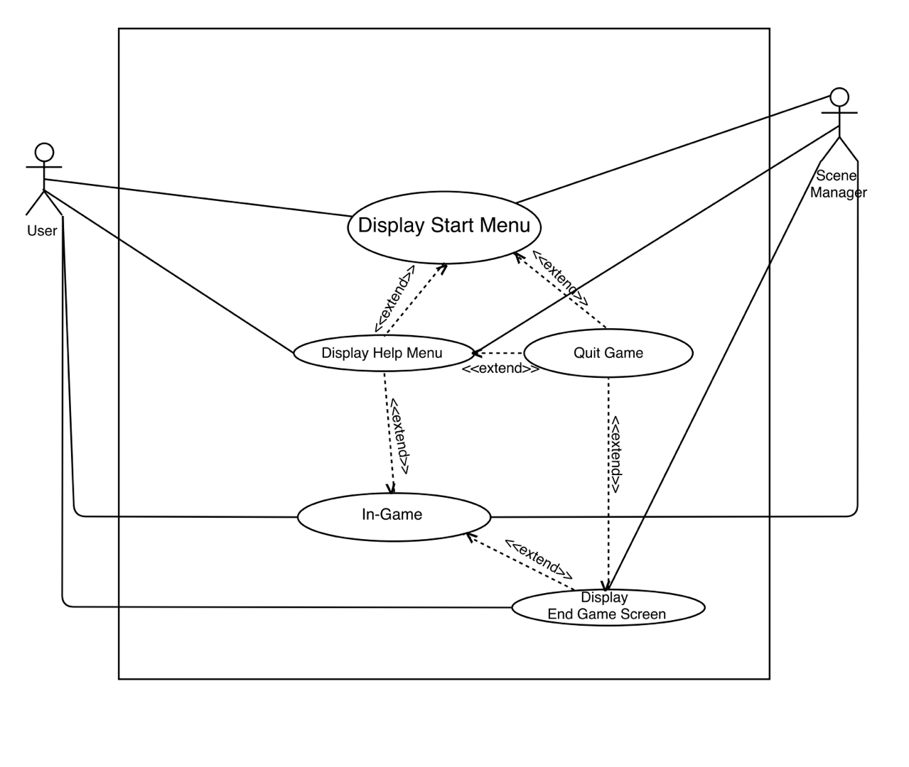

### Scenarios

**Name:** Display Start Menu

**Summary:** User executes the game, and the display manager displays start menu.

**Actors:** User

**Preconditions:** User executed the game

**Basic sequence:**

**Step 1:** User executes the game

**Step 2:** Display start menu

**Exceptions:**

**Step 1:** The game crashes

**Post conditions:** Start menu is displayed.

**Priority:** 2

**ID:** 2

**Name:** Display Help Menu

**Summary:** User clicks pause button, then display manager displays help menu

**Actors:** User

**Preconditions:** User clicks pause button

**Basic sequence:**

**Step 1:** User executes the game, start menu pops up

**Step 2:** User clicks pause button

**Step 3:** Help menu pops up

**Step 1-1** : User starts the game, the user is in In-Game state

**Step 2-1** : User clicks pause button

**Step 3-1** : Help menu pops up

**Exceptions:**

**Case 1:** The game crashes

**Case 2 :** The pause button does not recognize the mouse click input

**Post conditions:** Help menu is displayed.

**Priority:** 2

**ID:** 2

**Name:** Quit game

**Summary:** User either chooses to quit game

**Actors:** User

**Preconditions:** User is either in start menu, help menu, or game-over screen

**Basic sequence:**

**Step 1:** User executes the game, start menu pops up

**Step 2:** User clicks quit button

**Step 3:** Game ends

**Step 1-1** : User starts the game, the user is in In-Game state

**Step 2-1** : User dies and quits or chooses to quit in help menu

**Step 3-1** : Game ends

**Exceptions:**

**Case 1:** The game crashes

**Case 2 :** The quit button does not recognize the mouse click input

**Post conditions:** Game is treminated.

**Priority:** 2

**ID:** 2

**Name:** Display End Game Screen

**Summary:** User’s character dies in game, which brings up the end game screen

**Actors:** User

**Preconditions:** User’s character loses all health or oxygen before clearing level

**Basic sequence:**

**Step 1:** User loses all health or oxygen before clearing the level

**Step 2:** The character dies

**Step 3:** End game screen (game-over screen)pops up

**Exceptions:**

**Case 1:** The game crashes

**Case 2 :** The game does not recognize that the character died

**Post conditions:** End game screen is displayed.

**Priority:** 2

**ID:** 2

## Data Flow diagram(s) from Level 0 to process description for your feature _______14

### Data Flow Diagrams

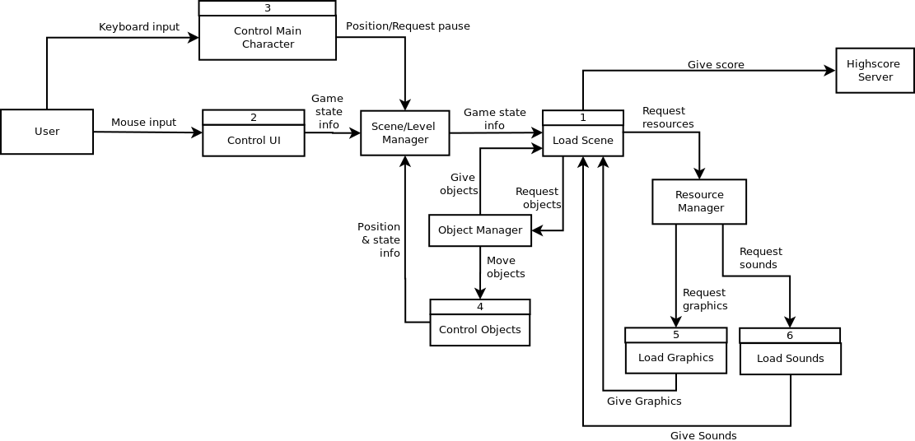

**Control UI**

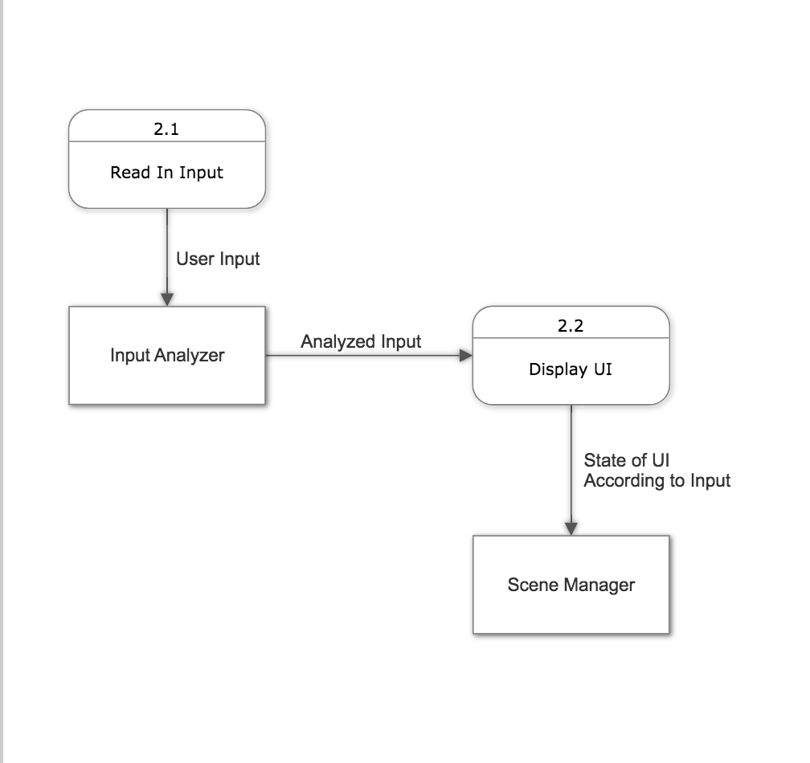

### Process Descriptions

Display UI :

If user input is received, check what input means

If input is executing the game

Display start menu

Else if input is request for help menu

Display help menu

Else if input is request for quit

Display end game screen

## Acceptance Tests ________9

**Test for quitting the game**

* Try to quit right at the start menu
* Try to quit by bringing up the help menu at the start menu
* Try to quit during the gameplay at the help menu
* Try to quit after the character dies

## Timeline _________/10

### Work items

|  |  |  |
| --- | --- | --- |
| Task | Duration (PWks) | Predecessor Task(s) |
| 1. Requirements Collection | 1 | - |
| 2. Screen Design | 2 | 1 |
| 3. Report Design | 1 | 2 |
| 4. Database Construction | 2 | 1 |
| 5. User Documentation | 1 | 4 |
| 6. Programming | 7 | 4 |
| 7. Testing | 3 | 6 |
| 8. Installation | 1 | 5, 7 |

### Gantt timeline

|  |  |  |  |  |  |  |  |  |  |  |  |  |  |  |
| --- | --- | --- | --- | --- | --- | --- | --- | --- | --- | --- | --- | --- | --- | --- |
| 1 |  |  |  |  |  |  |  |  |  |  |  |  |  |  |
| 2 |  | 1 |  |  |  |  |  |  |  |  |  |  |  |  |
| 3 |  |  |  | 2 |  |  |  |  |  |  |  |  |  |  |
| 4 |  | 1 |  |  |  |  |  |  |  |  |  |  |  |  |
| 5 |  |  |  |  |  |  |  |  |  |  | 6 |  |  |  |
| 6 |  |  |  |  | 3,4 |  |  |  |  |  |  |  |  |  |
| 7 |  |  |  |  |  |  |  |  |  |  | 6 |  |  |  |
| 8 |  |  |  |  |  |  |  |  |  |  |  |  |  | 5,7 |
|  | 1 | 2 | 3 | 4 | 5 | 6 | 7 | 8 | 9 | 10 | 11 | 12 | 13 | 14 |

### Screen%20Shot%202018-02-08%20at%2011.19.57%20PM.pngScreen%20Shot%202018-02-08%20at%2011.45.29%20PM.pngScreen%20Shot%202018-02-08%20at%2011.20.20%20PM.pngScreen%20Shot%202018-02-08%20at%2011.45.19%20PM.pngScreen%20Shot%202018-02-08%20at%2011.20.38%20PM.pngScreen%20Shot%202018-02-08%20at%2011.20.32%20PM.pngScreen%20Shot%202018-02-08%20at%2011.19.45%20PM.pngScreen%20Shot%202018-02-08%20at%2011.19.25%20PM.pngPert diagram