Environment setup:

Windows 10: QT 5.10.0

Mac: QT 510.0

Download QT 5.10.0:

Go to https://www.qt.io/download, choose "Go open Source" then download installer.

run the online installer

When you under the "Select components”, choose QT 5.10.0 version

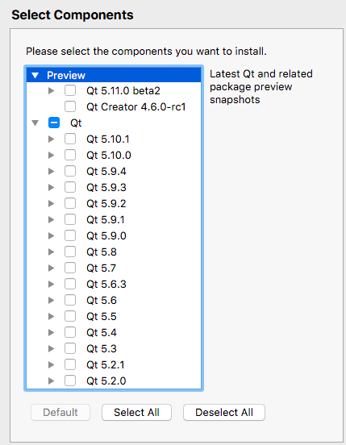

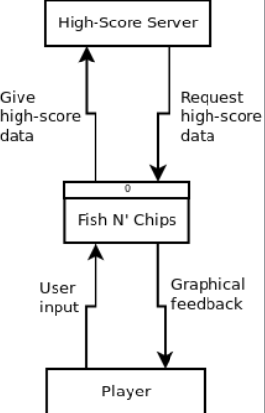

Context Diagram

CK_Class_diagram

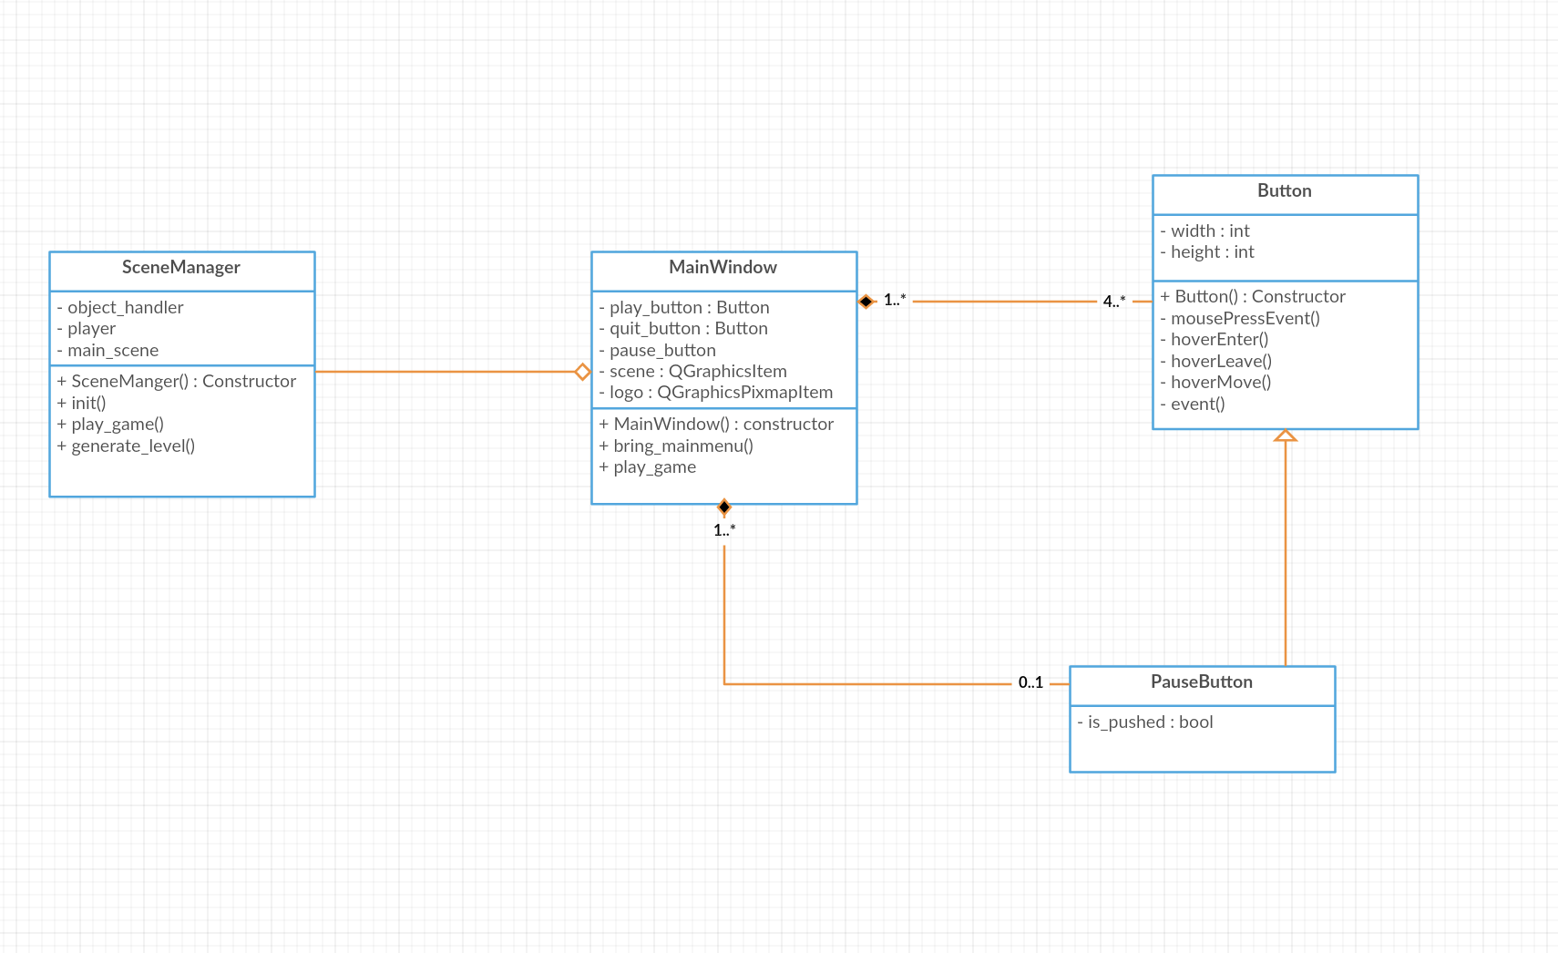

GY_Class_diagram

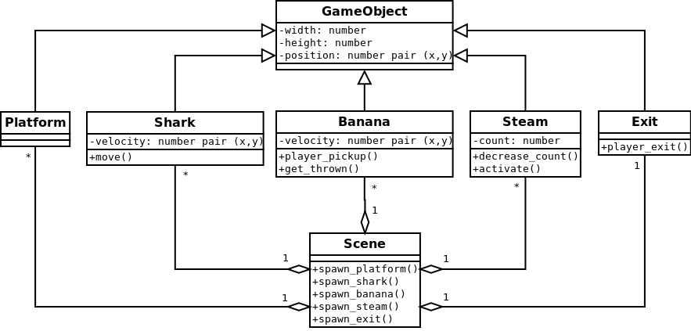

hh_class_diagram

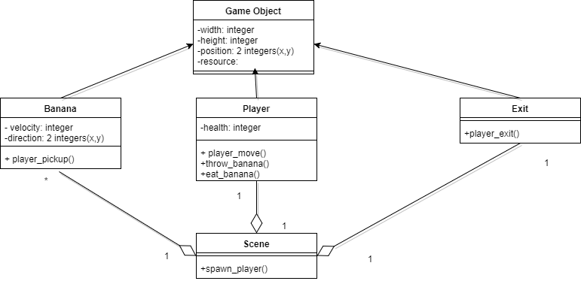

CC_Class_diagram

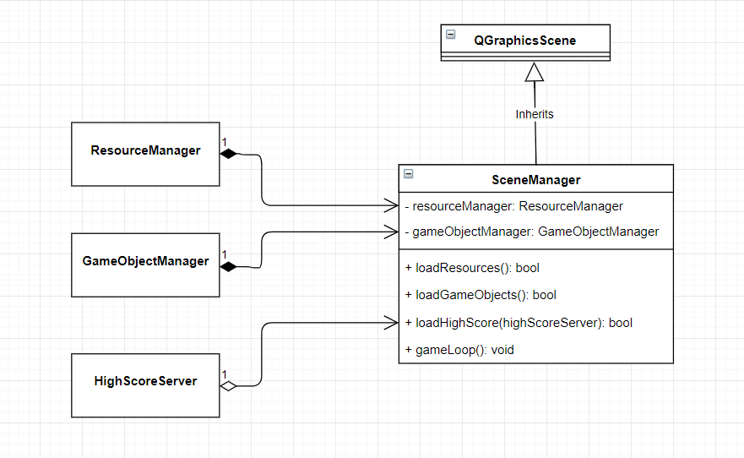

WZ_Class_diagram

