Name___Henry Hill________ Mark _____________________/50

[**Instructions**: Remove everything that is not a heading below and fill in with your own diagrams, etc.]

## Brief introduction __/3

**Feature:** The “Move Main Character” feature is the feature that enables the player to interact with the main character of the game. The controls available to the player are as follows: move up, move down, move sideways. The character can also eat and attack. Finally, from within gameplay, the player may pause the game. The movement and action of the character will receive input from the keyboard, and the pause menu will receive input from the mouse.

[Describe your feature briefly]

## Use case diagram with scenario __14

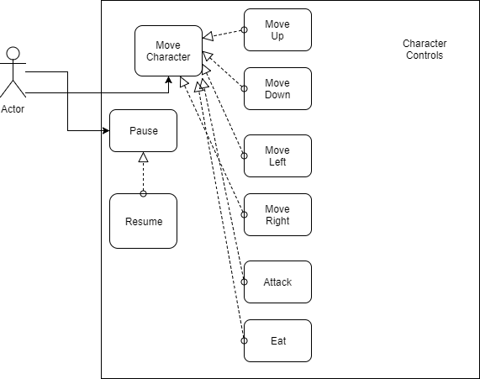

### Scenarios

**Name:** Move character

**Summary:** Moves the character within the game screen.

**Actors:** Player

**Preconditions:** Game has been started, character is in legal area.

**Basic sequence:**

**Step 1:** Receive keyboard input from player.

**Step 2:** Based on player input, produce visual/audio feedback to the player.

**Step 3:** Player may pause/resume game from within gameplay.

**Exceptions:**

**Step 1:** Player tries moving character outside of screen. Character is stopped.

**Step 2:** A player tries to eat when they have no food. Nothing happens.

**Step 3:** A player tries to attack without a weapon. Nothing happens.

**Post conditions:** Character is visually updated to reflect players input.

**Priority:** 1*

**ID:** Main Character Movement

*The priorities are 1 = must have, 2 = essential, 3 = nice to have.

## https://lh3.googleusercontent.com/88mht4A9UmkfRxuAO9iASr3l4z7Jebq9zaccpwzlExvI_swNCm5eDlCDLmwxBRrA7NSnY_np5xG2khnxEqU1YGB6agtVqqpzlCbGAaNHafPpWdgibAT4_8SkeGxXTl39bSAVMgDkData Flow diagram(s) from Level 0 to process description for your feature _______14

Level 0 Diagram

Control Main Character

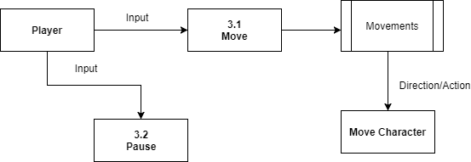

### Process Descriptions

**Move:**

* If opposite directions pressed do not move character.
* Move up
* Move down
* Move left
* Move right
* Throw banana: If no banana, do nothing
* Eat banana: If no banana, do not eat

**Pause:**

* Pause game
  + Only accessible from within gameplay
* **NOTE: I cannot see any further decisions for the player to make, they literally can only move/ do the things mentioned above.**

## Acceptance Tests ________9

**Example for main screen’s borders and interactable objects within the level**

**Test main character for collision properties**

***If character….***

* Collides with level boundary
  + Stops moving in direction of collision
* Collides with platform
  + Stops moving in direction of collision
* Collides with shark
  + Loses health
* Collides with door
  + Next level begins
* Collides with banana
  + Picks it up

**Test if player input is received**

***If player…***

* Moves character with keyboard input
  + Character responds
* Selects to eat banana
  + Eats banana
* Selects to throw banana
  + Throws banana

## Timeline _________/10

### Main Character Tasks, Time Estimates, Dependencies

|  |  |  |
| --- | --- | --- |
| Task | Duration (Hours) | Predecessor Task(s) |
| 1. Organize Tasks | 3 | - |
| 2. Designing Properties | 3 | 1 |
| 3. Class Variables | 5 | 1 |
| 4. Class Implementation | 7 | 2,3 |
| 5. Addition of Graphics ** | 4 | 4 |
| 6. Testing | 10+ | 4 |
| 7. Review | 10+ | 5,6 |
| 8. **TOTAL_HOURS** | 39 |  |

### Pert diagram

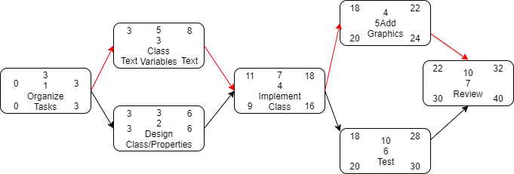

### Gantt timeline

|  |  |  |  |  |  |  |  |  |  |  |  |  |  |  |  |  |  |  |  |  |  |  |  |  |  |  |  |  |  |  |  |  |
| --- | --- | --- | --- | --- | --- | --- | --- | --- | --- | --- | --- | --- | --- | --- | --- | --- | --- | --- | --- | --- | --- | --- | --- | --- | --- | --- | --- | --- | --- | --- | --- | --- |
| 1. |  |  |  |  |  |  |  |  |  |  |  |  |  |  |  |  |  |  |  |  |  |  |  |  |  |  |  |  |  |  |  |  |
| 2. |  |  |  | 1 |  |  |  |  |  |  |  |  |  |  |  |  |  |  |  |  |  |  |  |  |  |  |  |  |  |  |  |  |
| 3. |  |  |  | 1 |  |  |  |  |  |  |  |  |  |  |  |  |  |  |  |  |  |  |  |  |  |  |  |  |  |  |  |  |
| 4. |  |  |  |  |  |  |  |  | 3 |  |  |  |  |  |  |  |  |  |  |  |  |  |  |  |  |  |  |  |  |  |  |  |
| 5. |  |  |  |  |  |  |  |  |  |  |  |  |  |  |  | 4 |  |  |  |  |  |  |  |  |  |  |  |  |  |  |  |  |
| 6. |  |  |  |  |  |  |  |  |  |  |  |  |  |  |  | 4 |  |  |  |  |  |  |  |  |  |  |  |  |  |  |  |  |
| 7. |  |  |  |  |  |  |  |  |  |  |  |  |  |  |  |  |  |  |  |  |  | 5,6 |  |  |  |  |  |  |  |  |  |  |
|  | 1 | 2 | 3 | 4 | 5 | 6 | 7 | 8 | 9 | 10 | 11 | 12 | 13 | 14 | 15 | 16 | 17 | 18 | 19 | 20 | 21 | 22 | 23 | 24 | 25 | 26 | 27 | 28 | 29 | 30 | 31 | 32 |