Name: WEI ZHAO Mark \_\_\_\_\_\_\_\_\_\_\_\_\_\_\_\_\_\_\_\_\_/50

## Brief introduction \_\_/3

In this project, I would design modes of every object include size of objects, shape. Then I would draw or search images for every object.

## Use case diagram with scenario \_\_14

### Use Case Diagrams

### ../../../Library/Containers/com.tencent.xinWeChat/Data/Library/Application%20Support/com.tencent.xinWeChat/2.0b4.0.9/4823812b3f5503c8f213f349d45a4533/Message/MessageTemp/97a94cabf86b38019ecfc17acd439ddb/Image/61271518077616_.pic.jpg

### 

### Scenarios

**Name:** Load Shark

**Summary:** The user activate game than the game would load sharks into the scene.

**Actors:** Player.

**Preconditions:** Game has been initialized.

**Basic sequence:**

**Step 1:** Accept start single and build the mode of sharks

**Step 2:** Load sharks’ image from resource file

**Step 3:** show the view

**Exceptions:**

**Step 1:** If the initialized position of shark is collision with other items, delete shark.

**Post conditions:** Calculated value is displayed.

**Step 2:** If loss the sharks’ image, exit game and report error.

**Priority:** 1\*

**ID:** 5

\*The priorities are 1 = must have, 2 = essential, 3 = nice to have.

## Data Flow diagram(s) from Level 0 to process description for your feature \_\_\_\_\_\_\_14

### Data Flow Diagrams

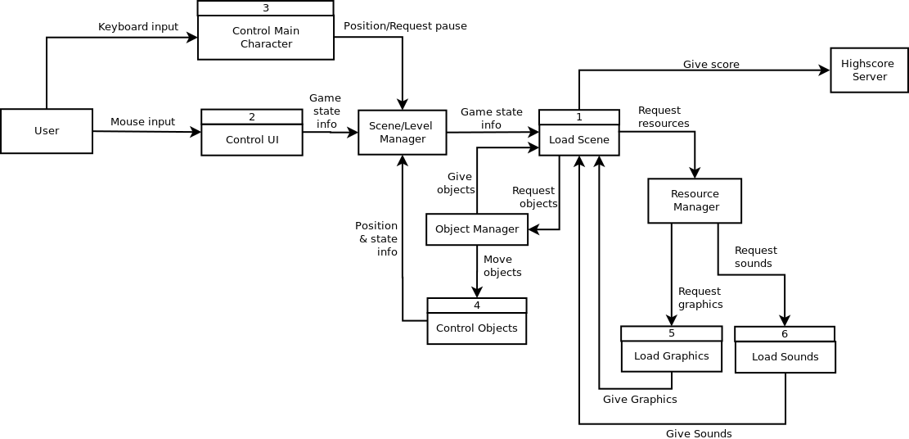

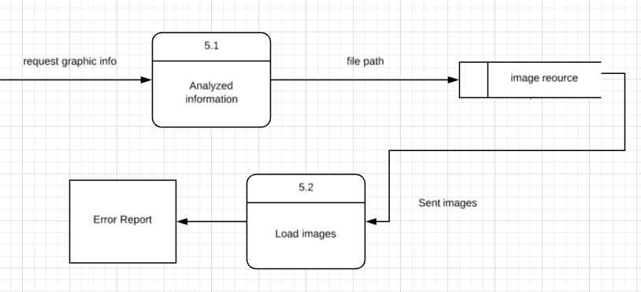

### Process Descriptions

Analyzed information:

If events happen or level change sent the request to get images or change to new images. Dependent on the requested objects’ information to get path of file you want to use.

## Acceptance Tests \_\_\_\_\_\_\_\_9

Load objects test

Loading every object in the single window 20 times and take screenshots.

The screenshots should have the following characteristics:

1. The screenshots of the same object should be the same.

## Timeline \_\_\_\_\_\_\_\_\_/10

### Work items

|  |  |  |
| --- | --- | --- |
| Task | Duration (PDAYs) | Predecessor Task(s) |
| 1. Requirements Collection | 4 | - |
| 2. Screen/background Design | 4 | 1 |
| 3. Object mode design | 6 | 2 |
| 4. Draw/search images | 6 | 3 |
| 5. Programming | 10 | 3 |
| 6. Testing | 4 | 4,5 |

### Pert diagram

  

 



### Gantt timeline

