Name: Koffi Anderson Koffi Mark _____________________/50

## Brief introduction __/3

I am the level/scene manager. My role involves loading the game scene and the highest score. In fact, loading the scene has some exceptions which are loading the background resources (sounds and graphics). Also, loading the highest score from the high score server has an exception which is sending the updated highest score to high score server.

## Use case diagram with scenario __14

### Use Case Diagram

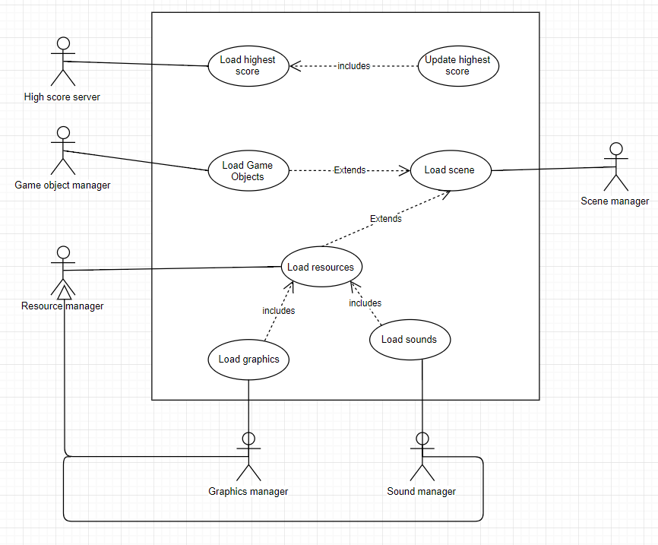

client

### Scenario

**Name:** Load highest score

**Summary:** A client of the high score server loads the current highest score from the high score server.

**Actors:** High score server client.

**Preconditions:** the device (computer) is connected to the internet

**Basic sequence:**

**Step 1:** Establish a connection to the high score server

**Step 2:** Keep connection up for listening

**Step 3:** Request highest score from the server

**Step 4:** Show highest score on the game scene

**Exceptions:**

**Step 3:** [current score] is greater than [highest score] on server: send current score to server and set current score as highest score

**Post conditions:** Highest is displayed on the game scene

**Priority:** 3*

**ID:** C01

*The priorities are 1 = must have, 2 = essential, 3 = nice to have.

### Scenario

**Name:** Load game scene

**Summary:** The scene manager loads the game scene

**Actors:** Scene manager, game object manager, resource managers (sound manager and graphics manager)

**Preconditions:** Game objects, and resources are created and available.

**Basic sequence:**

**Step 1:** Set up the game scene

**Exceptions:**

**Step 1:** Spawn game objects (enemies, platforms, obstacles, player character)

**Step 1:** Load resources (background graphics and sounds)

**Post conditions:** The scene is displayed for game play

**Priority:** 1*

**ID:** C02

*The priorities are 1 = must have, 2 = essential, 3 = nice to have.

## Data Flow diagram(s) from Level 0 to process description for your feature _______14

### Data Flow Diagrams

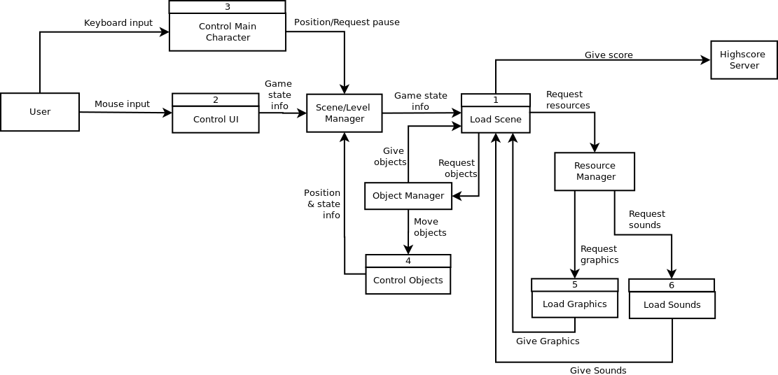

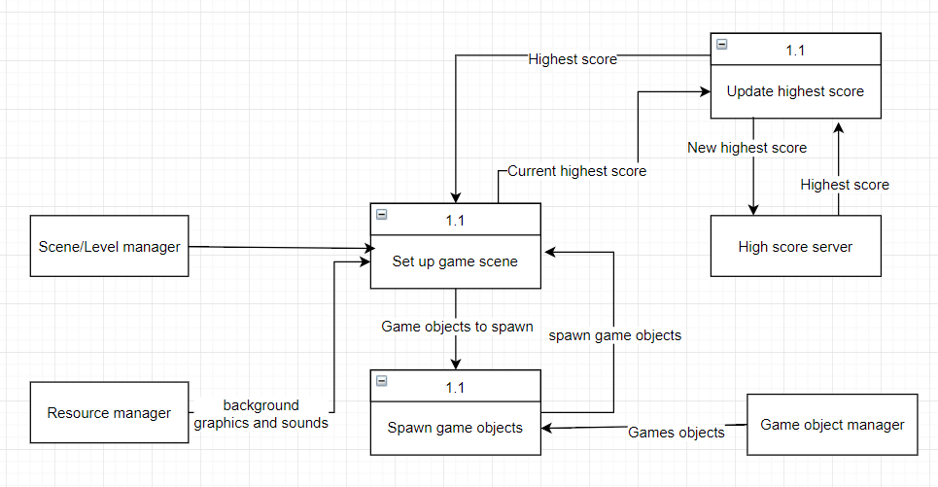

### Process Descriptions

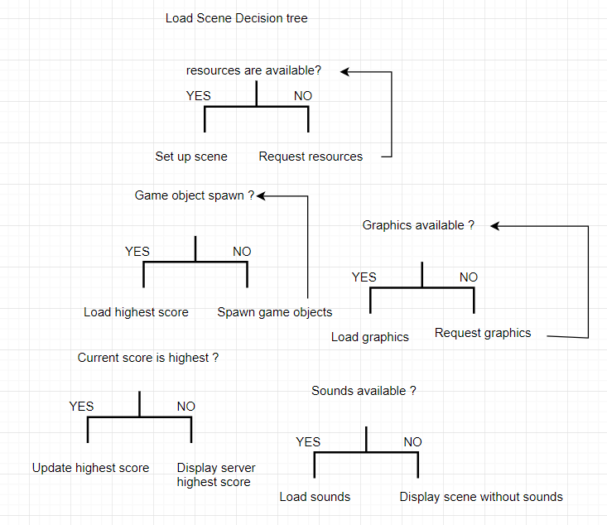

## Acceptance Tests ________9

**Load highest score feature**

Run the test when the device is connected to the internet and when it is not connected

The output file will have the following characteristics:

* Highest score is device saved current score when device is not connected to the internet
* When connected to the internet, highest score is current score if current score greater of equal server score
* Otherwise highest score is server score

**Set up scene feature**

Run with various classes instantiated and when no instance of required classes exists

The output file will have the following characteristics:

* When no instance of a graphics classes exits trigger an exception
* When no resource file associated exists trigger an exception

## Timeline _________/10

### Work items

|  |  |  |
| --- | --- | --- |
| Task | Duration (PWks) | Predecessor Task(s) |
| 1. Read/Write to file | 1 | - |
| 2. Establish connection to the server | 1 | 1 |
| 3. Load game objects into scene | 3 | 1 |
| 4. Display game status and objects | 3 | 2, 3 |
| 5. Testing/Refactoring | 2 | 4 |
| 6. Documenting the code | 2 | 5 |

### Pert diagram

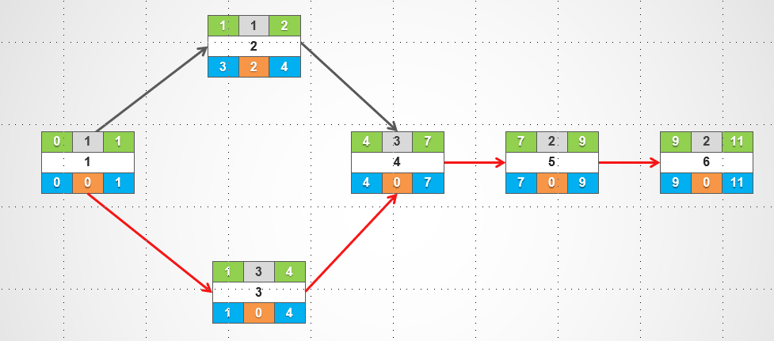

### Gantt timeline

